Cloud Computing Workshop with AWS

Detailed Project / Product Document

Project Information
Project Name: DailyFlow
Student Names: Noa Dinbar, Shir Luzon

1. Introduction
DailyFlow is a cloud-based web application designed to help busy young adults manage their daily responsibilities and well-being in one unified place. Today, most people rely on multiple disconnected apps-one for calendars, another for nutrition, another for workouts, and sometimes a separate wearable app for stress or recovery. This fragmentation creates friction: users lose time switching between tools, miss opportunities to plan healthy habits around real availability, and struggle to maintain consistent routines.
The core problem DailyFlow addresses is the difficulty of balancing a packed schedule with personal goals such as healthy eating, consistent exercise, and stress management. Busy users often face frequent context switching, last-minute schedule changes, and mental overload. As a result, even when users have good intentions, they may fail to follow through because planning and execution are spread across too many platforms.
DailyFlow provides a single workflow that starts from the user’s real calendar and builds suggestions around it.
On first use, the user completes a short questionnaire to define preferences (like dietary style such as vegan/vegetarian/gluten-free, fitness frequency goals, preferred times, and general lifestyle constraints). These preferences can later be adjusted in Settings. The application then presents five primary screens: Calendar, Meals & Grocery, Workouts, Stress & Breaks, and Overview.
A key part of DailyFlow is its integration with external services that users already rely on. The application connects with Google Calendar to reflect the user’s real schedule and to enable adding suggested items directly to the calendar. In addition, DailyFlow can incorporate Apple Watch signals to support stress-aware recommendations such as breaks and recovery-focused planning. For content generation, DailyFlow uses GenAI capabilities (OpenAI) to produce meal suggestions, workout ideas, and structured outputs such as grocery lists. Importantly, nutrition features are designed as general lifestyle recommendations for the general population, based on user-selected preferences and restrictions and are not intended as medical or clinical guidance.

2. System Architecture including AWS modules used per main component

Frontend Hosting - AWS Amplify (React)
Like you suggested, we chose AWS Amplify to host the React client because it is the most straightforward way for us to deploy and manage the frontend as part of AWS, with an easy deployment flow and clean integration with the rest of our AWS setup.

Backend (API) - AWS Lambda (Python)
We chose AWS Lambda for the backend because it lets us implement the API as lightweight serverless functions without managing servers. This fits our project needs and keeps the architecture simple while still supporting the main features: syncing with Google Calendar, calling OpenAI for recommendations, and receiving Apple Watch-related summaries from the user device.

Authentication - Amazon Cognito
We use Amazon Cognito for user authentication because it gives us a ready solution for sign-up/sign-in and user management inside AWS, instead of implementing authentication logic ourselves.

Database (NoSQL) - Amazon DynamoDB
Like you suggested, we chose DynamoDB because the system stores flexible application data (user preferences, calendar-related data, suggestions, integration tokens, and HRV-based stress summaries) and most access patterns are per user. DynamoDB fits this structure well.

Permissions - AWS IAM
We keep IAM to control access between AWS components and follow least-privilege permissions.

3rd-party tools

Google Calendar API: Needed to read the user’s schedule and to create/update events in a DailyFlow calendar.

OpenAI API: Used to generate personalized meal/workout/break suggestions and structured outputs like grocery lists.

Apple Watch: Provides HRV-based summaries to support stress-aware break recommendations.
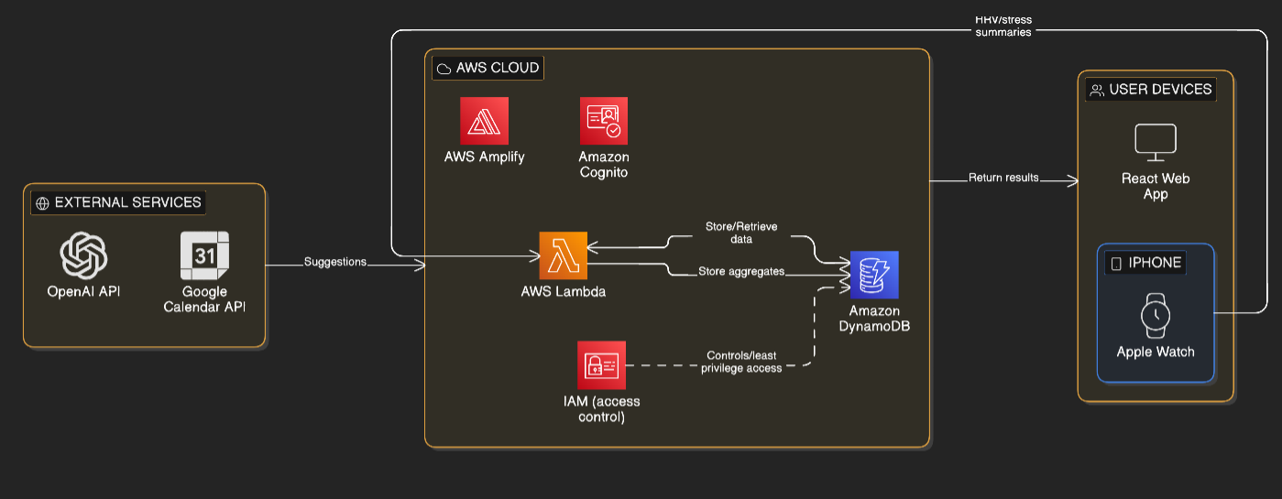

3. Data Base
We chose Amazon DynamoDB (NoSQL) because DailyFlow stores mostly flexible application data: user preferences, calendar-related data, AI-generated suggestions, integration tokens, and HRV-based stress summaries. Additionally, we followed our mentor’s advice.
The tables we chose:
- Users
- Integrations
- BusyBlocks
- DailyFlowEvents
- Suggestions
- HRV_Aggregates
Table details (columns + purpose)
1) Users- stores core user profile and personalization preferences.
Main columns:
  - user_id - unique identifier for the user
  - email - user email
  - display_name - user display name
  - created_at - when the user was created
  - dietary_tags - like vegan / vegetarian / gluten_free
  - workout_goal_per_week - number of workouts per week
  - preferred_time_buckets - morning / noon / afternoon / evening
2) Integrations- stores third-party connection data (Google), including tokens and sync state.
Main columns:
  - user_id - links the integration to a user
  - refresh_token - token used to access Google APIs over time
  - scopes - which Google permissions the user approved
  - dailyflow_calendar_id - the ID of the DailyFlow Google Calendar
  - last_busy_sync_at - last time we refreshed BusyBlocks
3) BusyBlocks- stores availability data as busy time ranges, excluding the DailyFlow calendar.
Main columns:
  - user_id - links busy blocks to a user
  - date - the day this busy block belongs to
  - start_time - busy block start time
  - end_time - busy block end time
  - updated_at - last update time for this record
Notes:
  - BusyBlocks are refreshed for the next month to keep availability up to date.
  - DailyFlow-created events are not stored here; they are stored in DailyFlowEvents.
4) DailyFlowEvents- stores events created by DailyFlow in the DailyFlow Google Calendar.
Main columns:
  - user_id - links the event to a user
  - event_id - internal unique ID for the event
  - type - meal / workout / relax
  - start_time - event start time
  - end_time - event end time
  - google_event_id - the event ID returned by Google Calendar
  - status - planned / updated / cancelled
  - updated_at - last update time

5) Suggestions- stores AI-generated suggestions and if the user accepted them.
Main columns:
  - user_id - links the suggestion to a user
  - suggestion_id - unique ID for the suggestion
  - type - meal / workout / relax
  - generated_at - when the suggestion was generated
  - content_json - the suggestion content
  - accepted - true/false
  - linked_event_key - reference to the matching DailyFlow event if accepted
6) HRV_Aggregates- stores aggregated HRV/stress patterns by weekday and time-of-day bucket.
Main columns:
  - user_id - links summaries to a user
  - weekday - MON / TUE / WED / THU / FRI / SAT / SUN
  - time_bucket - MORNING / NOON / AFTERNOON / EVENING
  - avg_hrv - average HRV value for this bucket
  - avg_stress_score
  - count - number of samples in this bucket
  - last_updated - when this aggregate was last updated
Relationships between tables
- Users & Integrations
Each integration record belongs to a user, connected by user_id.
- Users & BusyBlocks
Busy time ranges are stored per user. Records are connected by user_id and represent busy periods for a specific date and time range.
- Users & DailyFlowEvents
All DailyFlow-created calendar events are stored per user using user_id. These events are managed by our system (create/update/cancel) inside the DailyFlow Google Calendar.
- Users & Suggestions
AI-generated suggestions are stored per user using user_id, so we can track the user’s recent suggestions and acceptance history.
- Suggestions & DailyFlowEvents
When a user accepts a suggestion, we create a calendar event and connect the suggestion to the created event using linked_event_key.
- Users & HRV_Aggregates
HRV/stress summaries are stored per user using user_id and grouped by weekday and time_bucket. These aggregates are used for the Overview screen and for planning relax times/activities based on stress patterns.
The diagram:
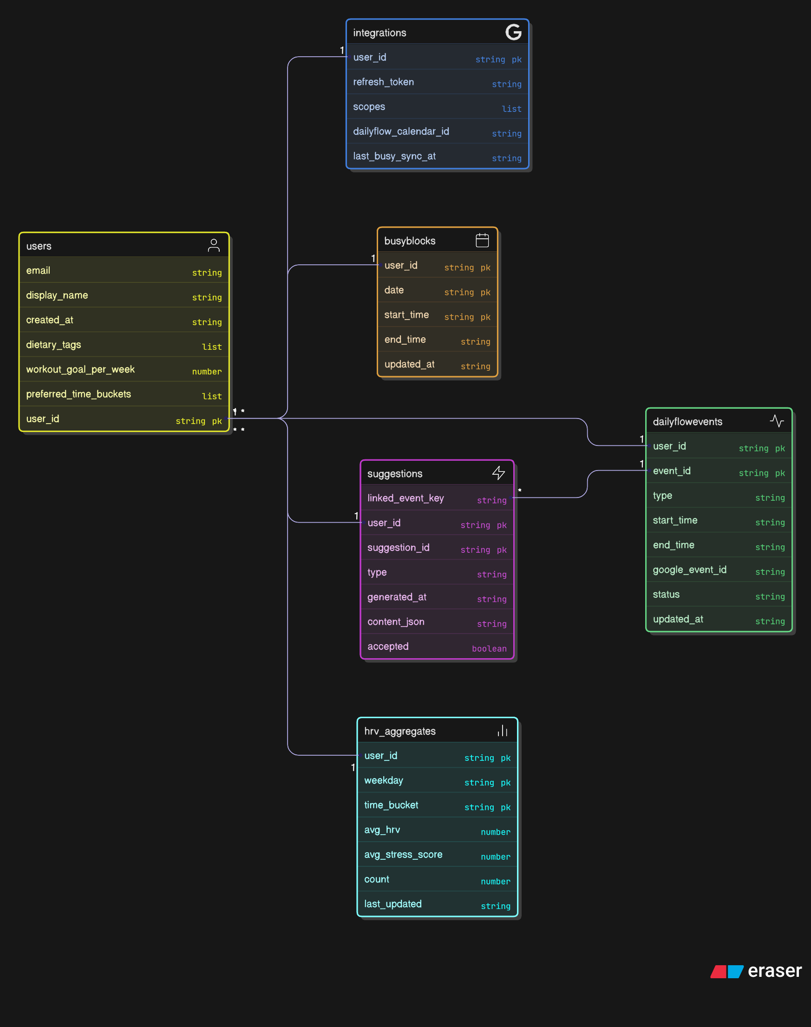

4. Flow charts
We have 4 main operational flows that cover all core features.
      - Setup & Integrations Flow
This flow describes the first-time setup: the user signs in, completes the initial questionnaire and connects Google Calendar. After permission approval, the backend stores the integration data and creates a “DailyFlow” Google Calendar. This flow ensures the system has the user’s preferences and the required calendar access before planning anything.
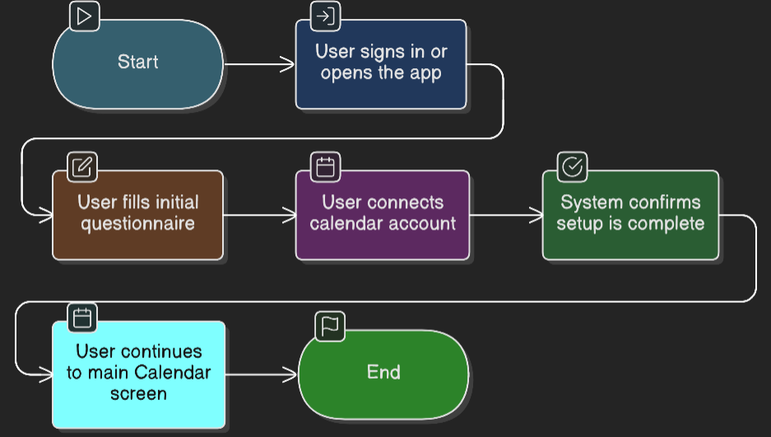
      - Availability Sync Flow (BusyBlocks)
This flow shows how the system keeps an up-to-date view of the user’s availability. The backend periodically refreshes busy time ranges from the user’s existing Google calendars and stores them as BusyBlocks for the next month. This data is used to avoid overlaps and to schedule suggested activities only inside free time slots.
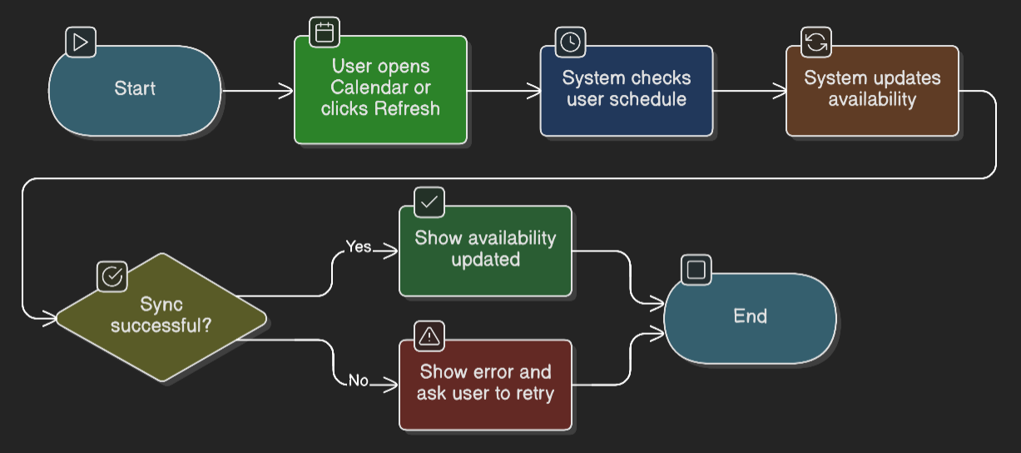
      - Generate & Schedule Flow (Shared for Meals, Workouts, and Breaks)
This shared flow represents the main planning loop used across multiple screens. The user selects a period (like this week) and requests suggestions. The backend loads the user’s preferences and availability, calls OpenAI to generate personalized suggestions, and stores them. If the user accepts a suggestion, the system creates an event in the DailyFlow Google Calendar, saves the event details, and links the accepted suggestion to the created calendar event.
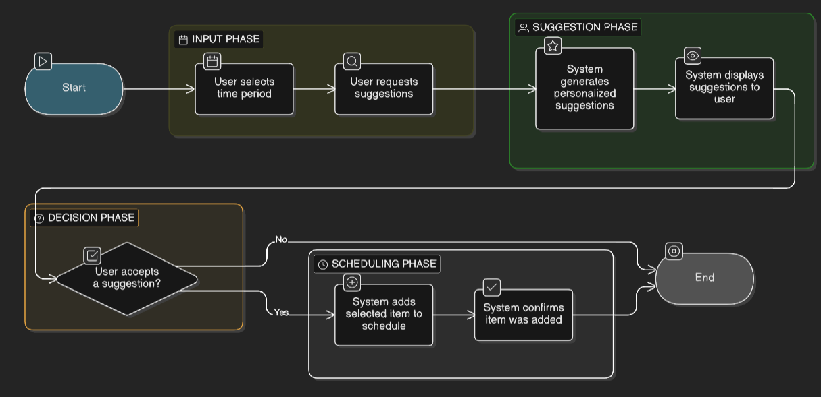
      - Stress & Breaks Flow (HRV-based)
This flow focuses on the smartwatch. HRV/stress summaries are received and aggregated into patterns by weekday and time-of-day buckets. The Stress & Breaks screen uses these aggregates to highlight potentially stressful periods and to recommend short activities from an activity bank. The user can add a selected activity to the calendar and mark activities as favorites.
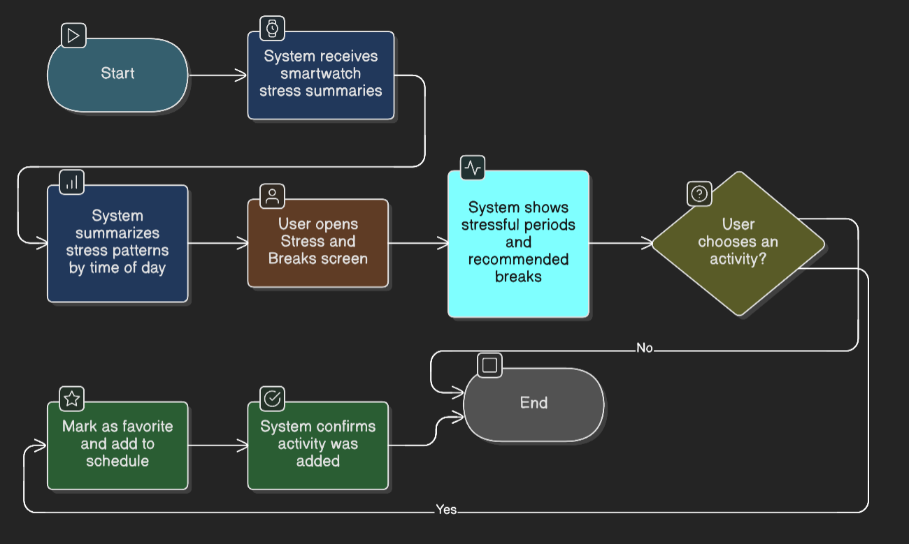

5. Screen mockups

Calendar screen - shows the user’s daily/weekly schedule, combining existing calendar events with suggested items from DailyFlow.
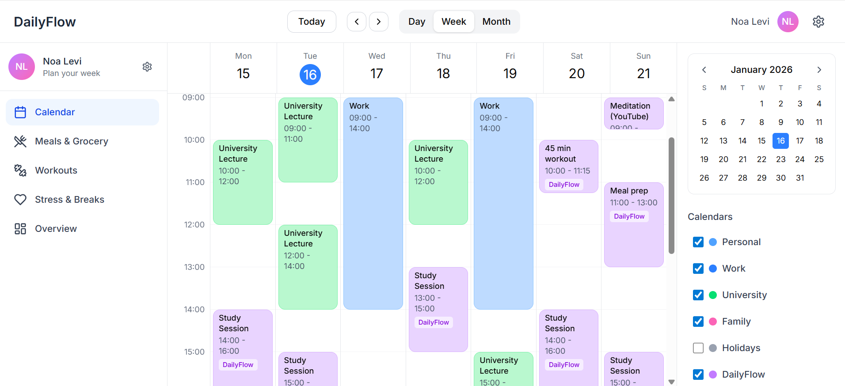

Meals & Grocery screen - displays suggested meals and simple meal-prep ideas based on the user’s preferences and generates a basic grocery list for the selected period.
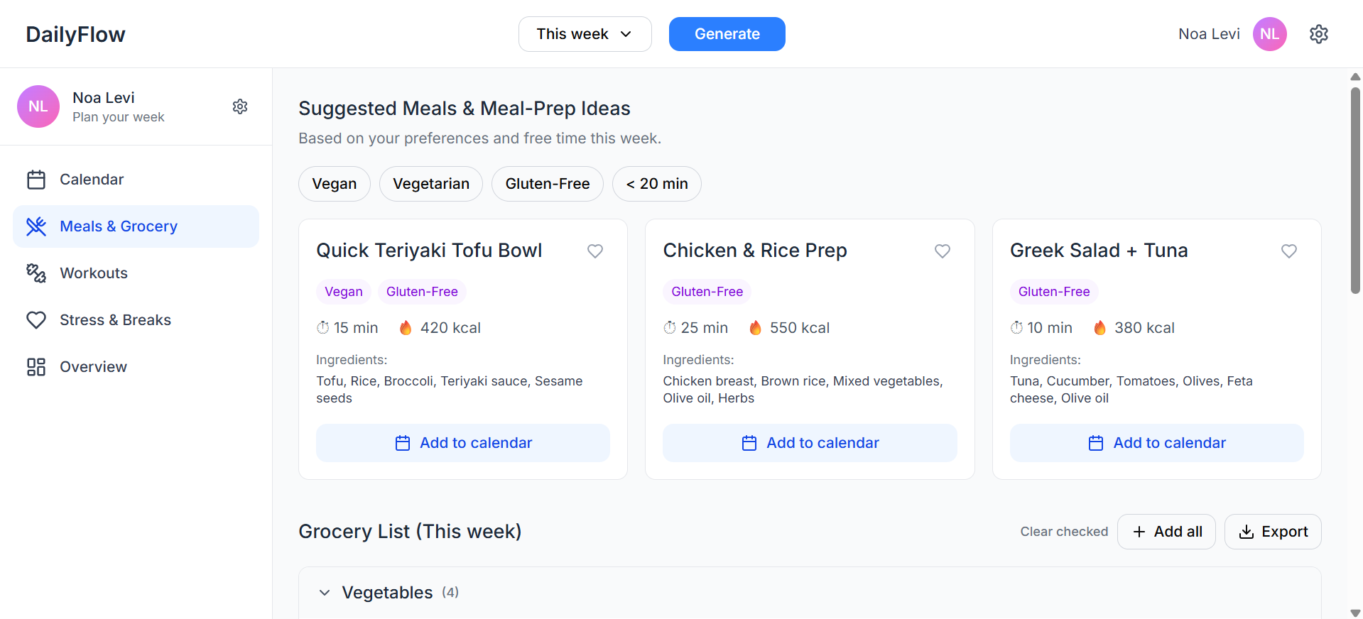
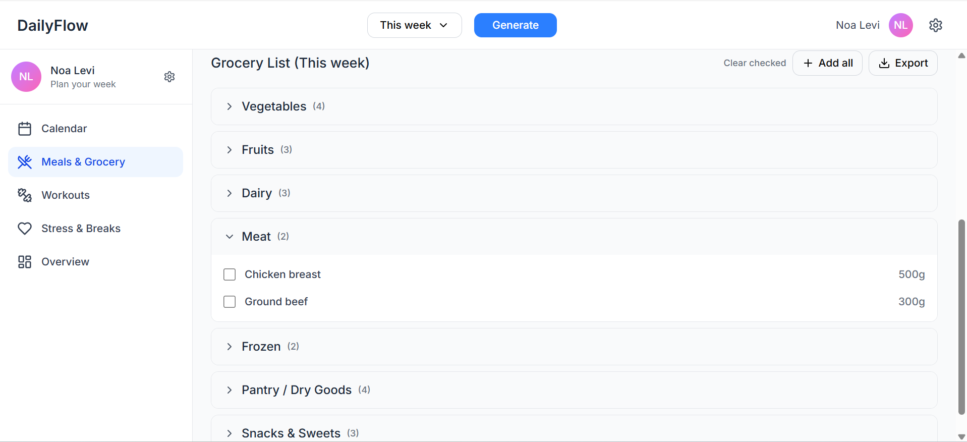

Workouts screen - plans exercise sessions according to the number of workouts per week the user requested and their available free time.
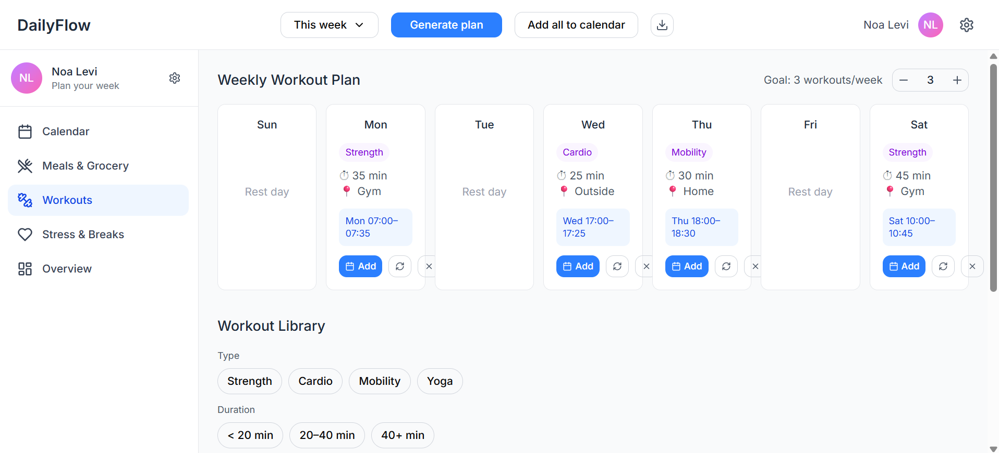
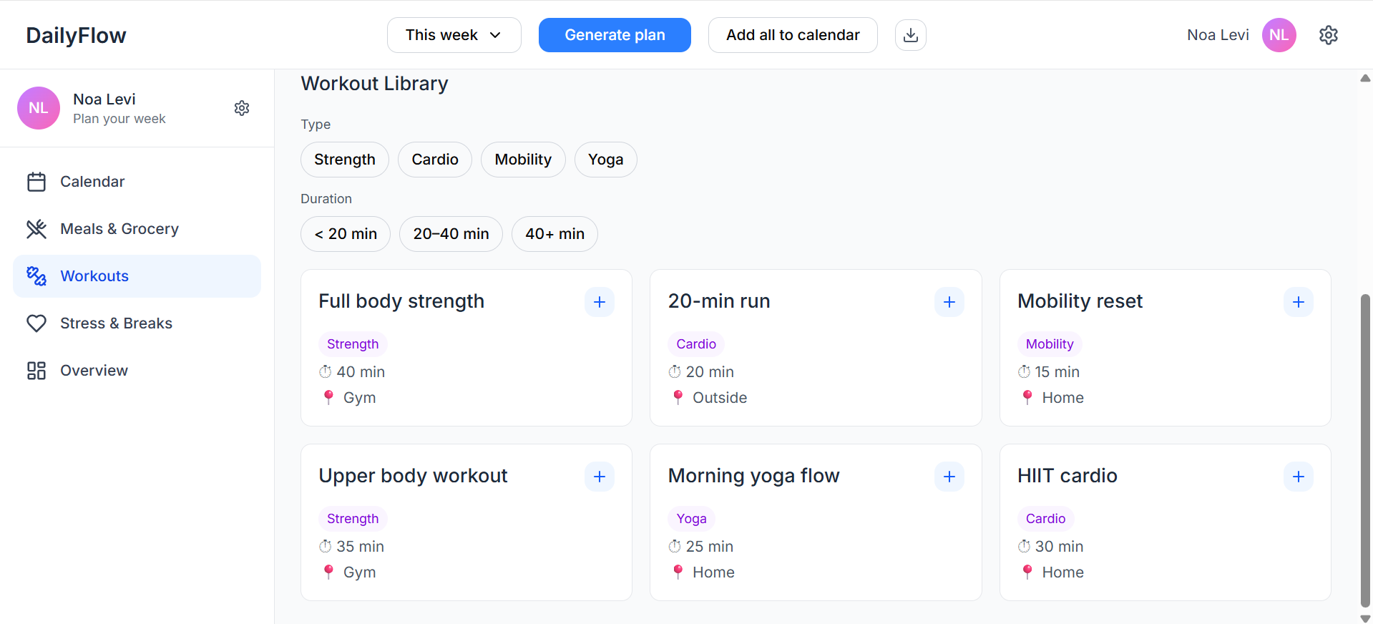

Stress & Breaks screen - if an apple watch is connected, shows busy or potentially stressful times and offers short breaks or meditations that can be added to the calendar.
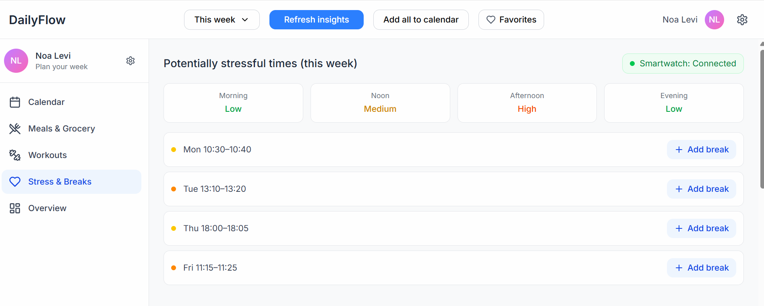
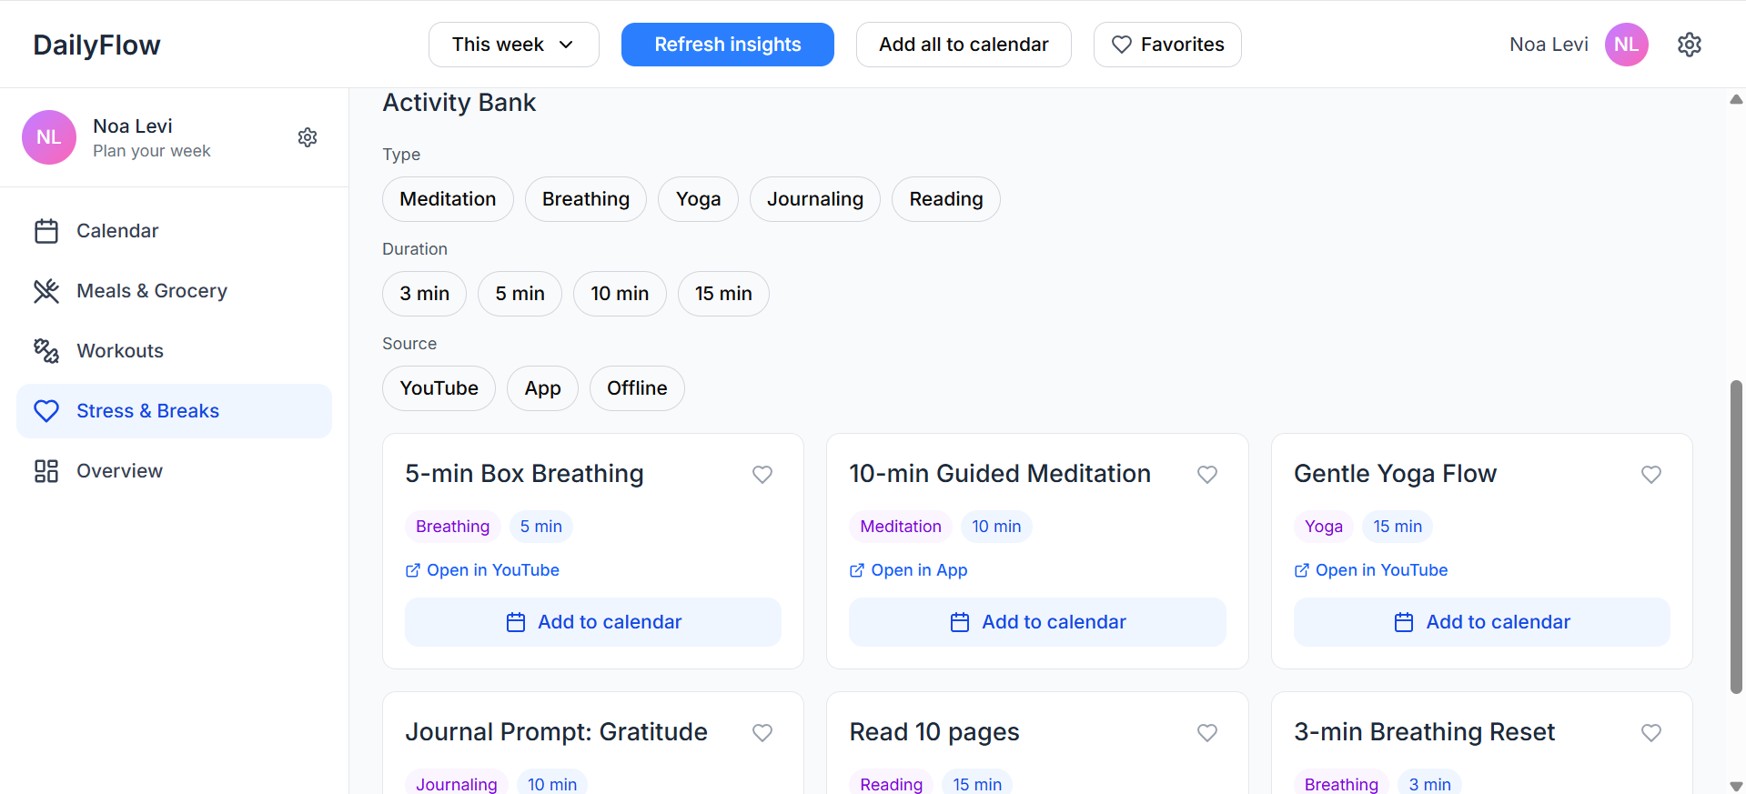

Overview screen - gives a simple summary of the week, so the user can use this information to understand their patterns and draw conclusions about their routine.
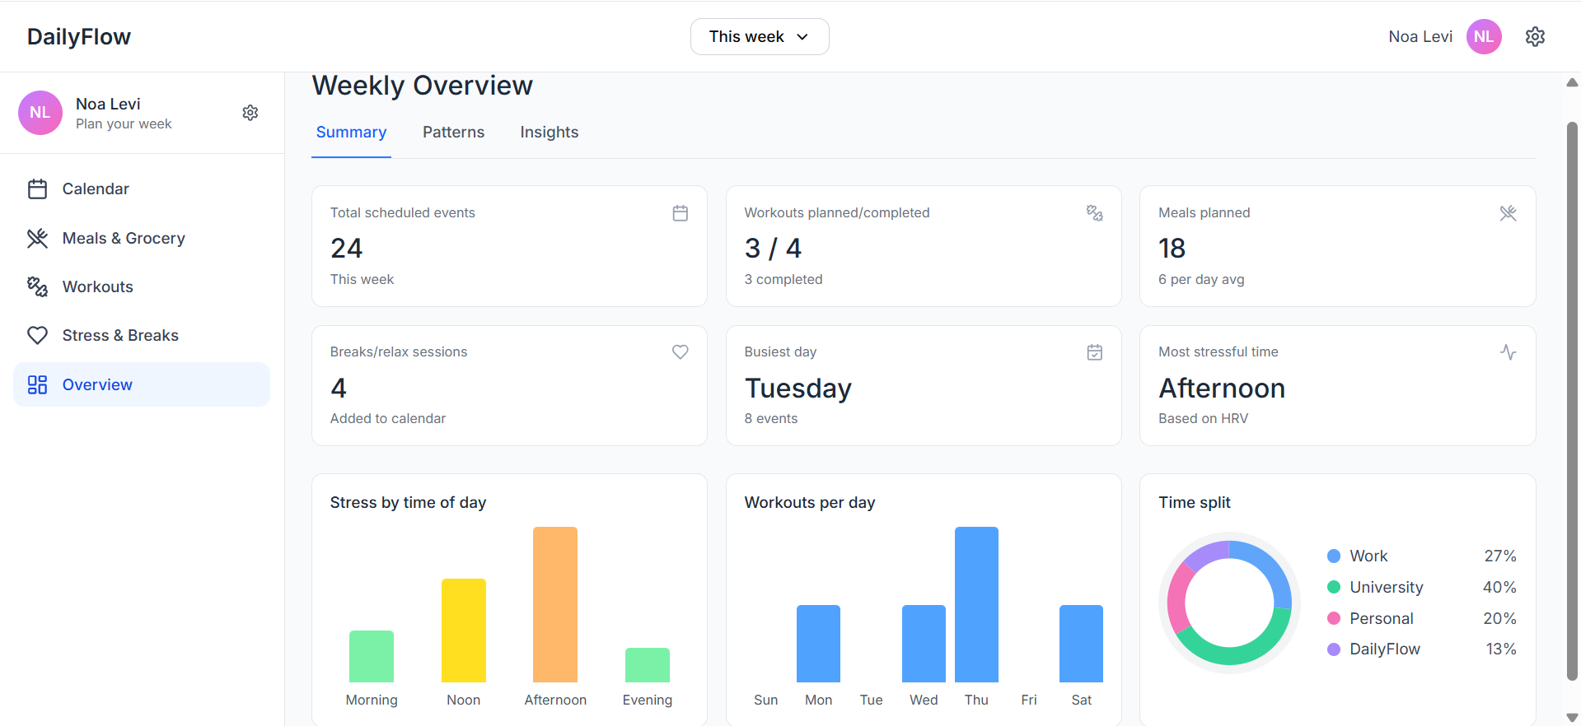
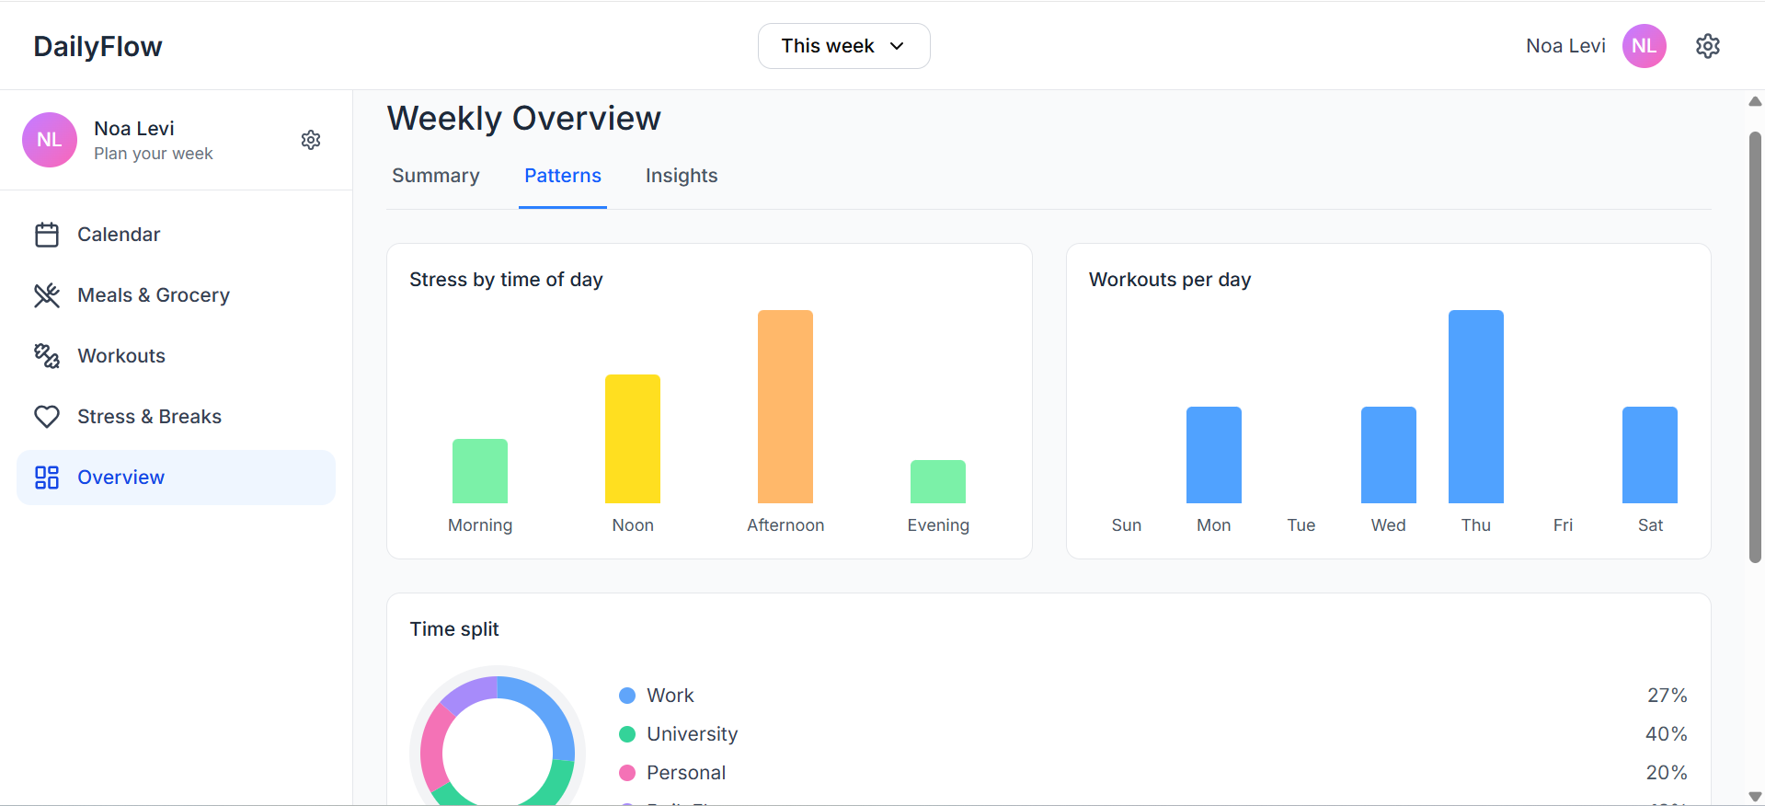
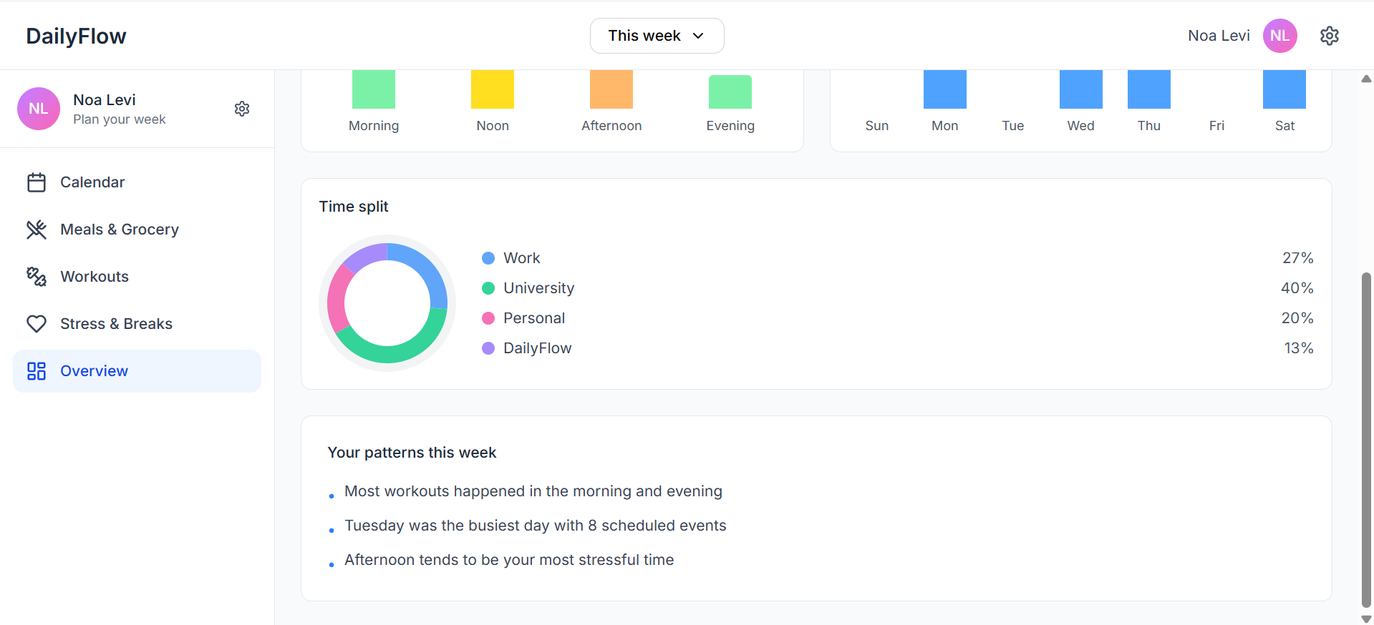
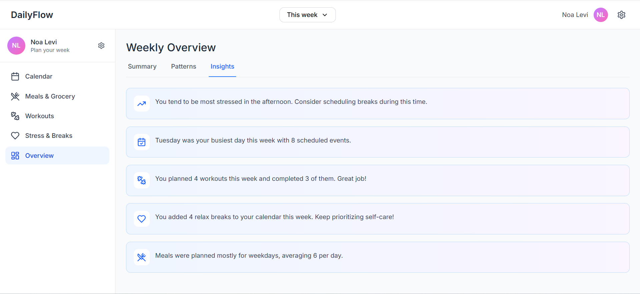

6. Development tools
We will use PyCharm to develop and debug the backend in Python, and the client side will be built with React.js.
For version control and teamwork, we will use Git and GitHub, working with branches and pull requests to review changes before merging.
We will test and debug our API using Postman, together with Python logging and console output for troubleshooting.
For documentation we write the proposal and design in Microsoft Word, and we create diagrams using Eraser.
We will also use AI tools during development: GitHub Copilot for code suggestions while coding, a college-provided OpenAI API token, ChatGPT and Google Gemini.

7. Submission Details
https://github.com/noadinbar/DailyFlow.git

