Master Degree in Computational Social Sciences
2025-2026

Master Thesis
Political selection and reproduction of political elites in the Spanish far right.

Noah Emanuel Fürup
Francisco Villamil
Madrid, 18th of September 2026

AVOID PLAGIARISM
The University uses the Turnitin Feedback Studio program within the Aula Global for the delivery of student work. This program compares the originality of the work delivered by each student with millions of electronic resources and detects those parts of the text that are copied and pasted. Plagiarizing in a TFM is considered a Serious Misconduct, and may result in permanent expulsion from the University.

[Include this code in case you want your Master Thesis published in Open Access University Repository] This work is licensed under Creative Commons Attribution – Non Commercial – Non Derivatives

ABSTRACT
Since its breakthrough in 2018 and 2019, Vox has become the third political force in Spain, yet little is known about how it decides on who its represatives are. This thesis studies Vox's political selection from the supply side, asking where the party takes its electable candidates from and how those placed in electable positions differ from those placed just below them. It builds an original dataset of the 39,419 people who stood on a Vox list in every European, general, regional and local election between 2014 and 2026, it contrast it to the candidates of PP, Ciudadanos and other Spanish far right parties that occupied VOX’x electoral space, as well as with members of Vox's satellite organisations. An electability threshold based on the pre-electoral seat estimates of the CIS approximates the seats the party could expect when it drew up each list. A network analysis of the party's electable candidates and satellite members shows that most of them had no previous political career and that former PP candidates form the largest external pool, but that the network is held together by a small core in which the members of satellite organisations such as DENAES, Disenso and ISSEP, and the veterans of the far right, are far more central than their numbers suggest. Comparing the 42 candidates placed within the threshold in the general election of July 2023 with the 137 placed just below it, Fisher's exact tests and logit models show that a past in another party and, above all, having stood for Vox during its years without seats (2013-2017) increase the odds of an electable position. Women are placed less often in electable positions, mostly because the party's early loyalists are men, while occupation does not distinguish the two groups.

Keywords: Vox; political selection; candidate selection; radical right parties; closed lists; social network analysis.

TABLE OF CONTENTS
1. INTRODUCTION 1
2. THEORETICAL FRAMEWORK 4
3. METHODOLOGY 14
4. RESULTS 18
5. CONCLUSION AND DISCUSSION 26
REFERENCES 29
APPENDIX A. ADDITIONAL FIGURES AND TABLES 32

1. INTRODUCTION
Since its entry into the Andalusian Parliament in December 2018 and into the Congress of Deputies in April 2019, Vox has become the third largest political force in Spain, becoming a stable political force at every level of government. The party has left its mark on the Spanish political system: its discourse has normalized far-right rhetoric on immigration, gender, and territorial unity, while its populist tactics, through its unhinged social media communication and confrontational rhetoric, among other things, have pushed Spain into a level of political polarization not seen in more than 40 years of democracy (Rama et al., 2021). Furthermore, its presence in regional coalition governments with the People's Party (PP) in Castille and Leon, the Valencian Community, Aragon, Extremadura, and Murcia, along with its possible future as a governing partner at the national level, makes it a crucial party to study. Around the party, a network of organisations has taken shape: the foundation DENAES, which predates Vox and was chaired by Santiago Abascal; the think tank Fundación Disenso;; the trade union Solidaridad; the youth association Revuelta; the book publisher Homo Legens; and the Madrid branch of ISSEP, the “sociology” training institute founded by Marion Maréchal, niece of Marine Le Pen. It is through Disenso that Vox has penetrated in the transnational far right network that brings right-wing actors from Spain, Latin America, Europe and the US together (GPAHE, 2025).
Most of what we know about Vox, however, comes from the demand side: who votes for it and why. Its initial support has been linked to opposition to Catalan independence, Spanish nationalism and concern about immigration (Turnbull-Dugarte, 2019; Rama et al., 2021). Much less attention has been paid to the party as an organisation, and in particular to the people behind the party. Political selection has been a topic of growing interest in political economy, as scholars have sought to understand how electoral institutions influence the quality, competence, and integrity of the politicians who ultimately hold office (Besley, 2005). Specifically, an "internalist perspective" has been developing in recent years in order to understand the radical right, shifting the attention away from demand-side, structural explanations, toward supply-side factors related to the parties themselves, particularly their organizational institutionalization and leadership (Ortiz Barquero et al., 2024).
Indeed, the kind of cadres a party recruits conditions whether an electoral breakthrough turns into electoral persistence (Art, 2011; Ortiz Barquero et al., 2024). In PR list electoral systems such as Spain, the topic is specially interesting, since candidates have unequal posibilities of actually getting elected. Taking up the assumption that parties position their top candidates first in the lists (Crutzen et al, 2024), this thesis studies precisely who ends up being selected as top candidates by VOX and why. It asks two specific questions: Where does Vox take its electable candidates from? How do top candidates differ from filler candidates within closed lists?
In order answer them, an original dataset composed by the 39,419 people who stood on a Vox list in every european, general, regional and local election between 2014 and 2026, and link them to the candidates of PP, Ciudadanos (Cs) VOX’s satellite organizations and other radical right parties that have occupied VOX’s political niche before them of the historical Spanish far right. Three things are done with that data: first, a social network analysis is conducted to confirm that VOX is far from being an entrepreneurial party, but that its core is surrounded by professional politicians from other parties from the historical far right; second, an electability threshold created with CIS’s pre-electoral polls models the information available when the list was drawn up to the party's main decision body, the National Executive Committee (CEN), thus recreating the seats that Vox could expect when presenting their electoral lists; lastly, a logistic regression is fitted to predict whether a candidate is placed within or just below the electability threshold of their constituency, using their sex, occupation, previous party/organization ties and candidacies in 2013-2017 as predictors.
The results point that most of VOX's electable candidates had no previous political career and joined during the surge that followed the Andalusian breakthrough, while former PP candidates form the largest external pool. The network, however, is held together by a small centre in which members of the satellite organisations and veterans of the historical far right weigh far more than their raw numbers. Within the lists, the party favours candidates with a past in other parties and, above all, those who stood for Vox during its years without seats, which also largely explains why women are placed less often in electable positions. Occupation, by contrast, does not distinguish the candidates the party sends to parliament from those it leaves just below the threshold.
The thesis is organised as follows. The next section reviews the literature on political selection and on the organisation of radical right parties, deriving the hypotheses of the thesis. The third section describes the data and the design. The fourth presents the results, first on the trajectory and territorial implantation of the party, then on the origin of its electable candidates (RQ1) and finally on who is placed in electable positions (RQ2). The last section discusses the findings and their limitations.

2. THEORETICAL FRAMEWORK
Political selection is the process in which voters or political parties select politicians (Aragón, 2010). For the purposes of this thesis, the focus will be put on the mechanisms of political selection put forward by parties in Proportional Representation (PR) electoral systems, present in the majority of countries in Europe (see Figure 1). There is evidence that suggests that the specific political leaders that get to be elected have a big impact in policy outcomes in general (Dal Bó & Finan, 2018). Research in India suggests that issues prioritised by women get more funding when women politicians are selected for the presidency of village councils (Chattopadhyay & Duflo, 2004), while, in general, countries led by more educated leaders tend to grow faster economically (Besley et al., 2011). Furthermore, rather than affirming that political economy must reject systemic issues, this thesis claims that social relations between individuals, specifically within and between parties, can also shed light into systemic aspects, such as the rise of the far right.
Figure 1
Electoral System Families in Europe
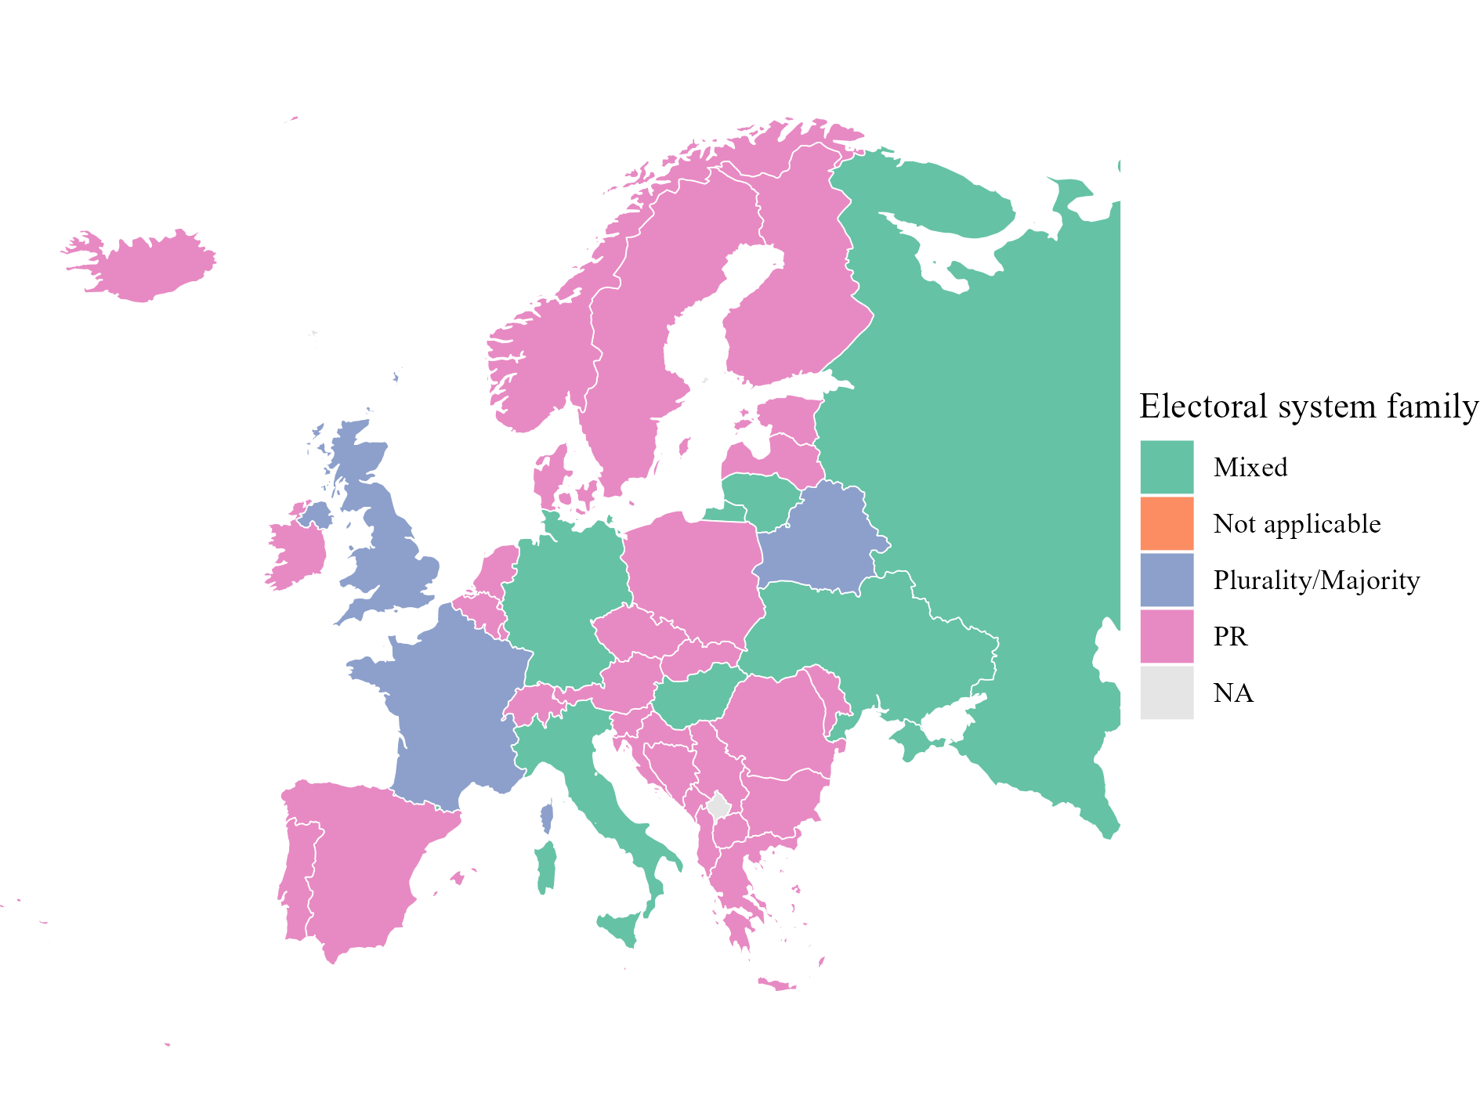
Note. Electoral system of the national legislature, latest year available. Self elaboration using data from the IDEA Electoral System Design Database.
In PR electoral systems specifically, it seems that parties favour loyalty above other variables when selecting candidates. Galasso and Nannicini (2015) test this by using Italian national election data of 2013. They show that party officers and former MPs are overrepresented in positions where they will probably get elected. In addition, Papagni et al. (2023) demonstrate by a DiD design that a shift from open lists to a closed lists system resulted in less educated politicians.
In this paper the focus is on the political selection of VOX, the first radical right party that has reached congress representation since Fuerza Nueva’s Blas Piñar, former public official during the dictatorship, couldn’t keep his seat after the 1982 election with his party. Originating from reconversion.es, a platform critical of Mariano Rajoy’s presidency, VOX was founded in 2013 as a splinter party of the then ruling People’s Party (PP) that aspired to occupy a new political niche to the right of the party by combining neoliberal economics with identitary Spanish nationalism, the former two souls of the party (Casals, 2020). The story of VOX is arguably also the story of its hyper-leader, Santiago Abascal Conde, the person behind reconversion.es who was a professional politician from a very young age. Son of a PP deputy himself, Abascal founded VOX alongside 9 other figures drawn from the more right-wing currents of PP, spearheaded by former president Aznar (see Table 1), many of whom were connected to think tanks such as Abascal’s Fundación para la Defensa de la Nación Española (DENAES) or the Aznar-linked Fundación para el Análisis y el Estudio (FAES) (Rama et al., 2021). The ties between Aznar and VOX’s first leadership go deep: seven out of ten of its leaders have ties to Aznar or were even directly designated to public roles by him (Sangiao, 2018).
Table 1
Founders of Vox
Name | Relationship with Vox | Origin
Alejo Vidal-Quadras | First party President and Candidate for the 2014 European elections | President of the Catalan branch of the PP, member of its national executive; Director of FAES, DENAES
Ana Velasco Vidal-Abarca | Militant | Villasneros Foundation
Cristina Seguí | Ex-militant | -
Enrique Álvarez López | Militant | -
Ignacio Camuñas Solís | Ex-Vice-President and ex-President | Co-founder and ex Minister of UCD
Iván Espinosa de los Monteros | Spokesman, former Vice-President, ex-General Secretariat | Ex-Secretary of DENAES
José Antonio Ortega Lara | Militant | Ex-militant of the PP
José Luis González Quirós | Second President (ad interim), ex-militant | UCD, CDS, ex-militant of PP, FAES
María Jesús Prieto-Laffargue | Ex-militant | General Direction in the first Aznar Government (PP)
Santiago Abascal | President | PP, President of DENAES
Source: Rama et al. (2021).
After a prolonged period without electoral representation (2014-2017), usually called the "years in the wilderness" in the literature, a series of high-profile public stunts, such as Ortega Smith’s swim from the border to Gibraltar in 2016 to plant a Spanish flag and VOX’s role in the prosecution of Catalan secessionist leaders in 2017, helped raise their notoriety. This growing appeal crystallised in the 2018 Andalusian elections, when VOX won 12 seats with a 10.97 % of the vote (see Figure 2). Before 2018 though, VOX had only managed to secure 14 municipal councillors in May 2015.
Figure 2
Vox's Share of the Valid Vote in General and European Elections, 2014–2024
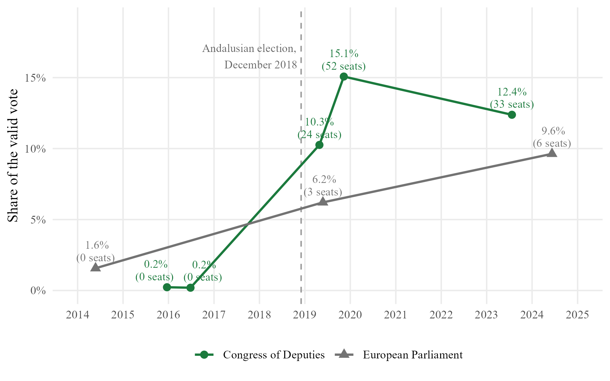
Note. Seats won in brackets. In the European Parliament, Vox obtained a fourth seat after Brexit (2020). Data from the Ministry of the Interior (infoelectoral) and the Junta Electoral Central.
The four phases of VOX’s expansion can be seen in Figure 3: the progress made in 2018 was consolidated in 2019, obtaining 24 seats in the Congress of Deputies in April and 52 in November, after an electoral repetition. Together with 522 municipal councillors, 3 European parliamentaries and 47 autonomical deputies in the May local/autonomical elections, the once small party suddenly had to find people to fill all these positions with people they didn’t necessarily have: membership rose from fewer than 5,000 in 2017 to more than 56,000 in 2019 (Barrio et al., 2021), yet quality candidates were a liability. Ahead of the May 2019 local elections, a branch in the Basque Country recruited candidates through Telegram, asking only for a copy of their identity card and offering to sign their acceptance of the candidacy for them, especially if they were women, which they lacked (Borraz, 2019). Recruitment remained an issue for a long time, specifically in regions with a a strong non-spanish national identity. Since then, Vox has held representation at every level of government, reaching 33 seats in the Congress in 2023, 1545 municipal councillors in the local elections of the same year, 6 European parliamentarians in 2024 and reaching government in the autonomies of Murcia, Castilla y León, Valencia, Aragón and Extremadura, as well as in small cities such as the capitals of Valladolid, Burgos, Guadalajara, Toledo and Ciudad Real (Europa Press, 2023).
Figure 3
Vox's Vote and Its Access to Regional Government, by Phase
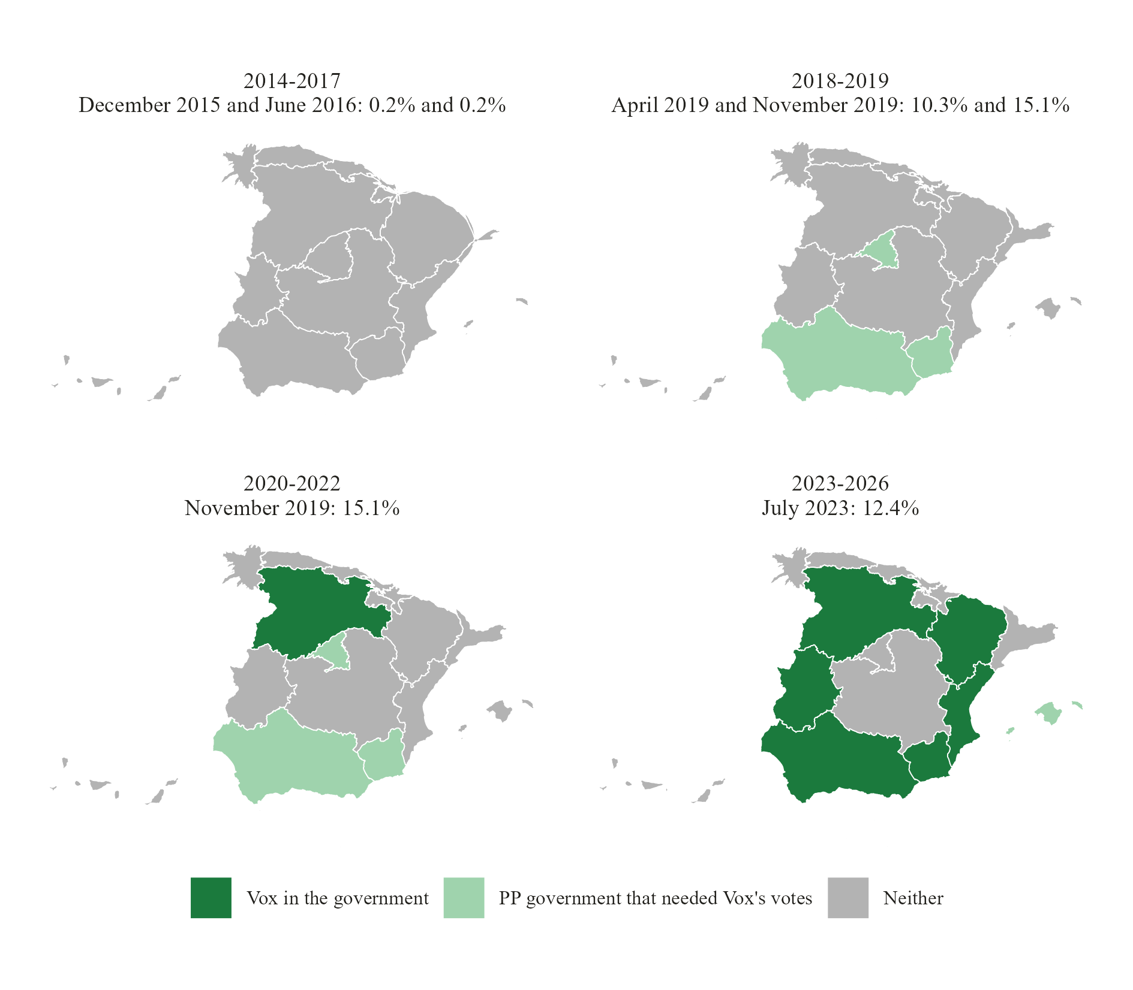
Note. Contiguous cartogram: each region is resized by its area times Vox's share of the valid vote in the general elections of the phase, relative to its national share Colour: Vox held a post in the regional government, or its votes were needed to invest a PP president, at any point of the phase. Data from the Ministry of the Interior (infoelectoral).
From Turnbull-Dugarte (2019) we know that Vox’s support was at first strongly associated with opposition to Catalan independence, Spanish nationalism, and concerns about immigration. Figure 4 is a replication of the model Rama et al. (2021) made to study VOX support. Four political determinants of support for Vox: right-wing ideological positioning, catholic religiosity and a stance against catalan secessionism and immigration in favour of a strong sense of spanish identity.
Figure 4
Political Determinants of the Vote for Vox, November 2019
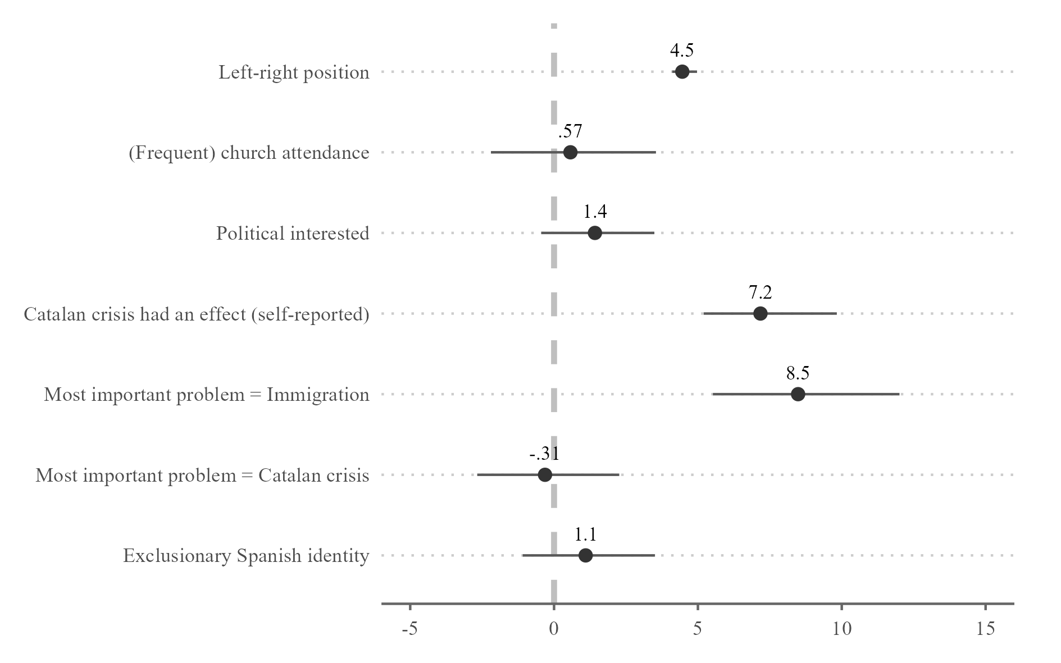
Note. Average marginal effects on the probability of voting Vox, in percentage points, with 95% confidence intervals. Controls not shown: gender, age, subjective class, education, income, rurality and autonomous community fixed effects. Replication of Rama et al. (2021, fig. 4.12) with CIS study 3269 (2019), n = 3,133.
There has been less focus in the analysis of its supply side. Indeed, light has been shed in the particularities that Vox’s ideology has to offer. According to Rama et al., (2021), five salient issues can be observed: the defense of a national way of life in contrast to peripheral nationalisms; law and order, translated into a punitive turn; a focus on immigration as security issue; a defense of traditional values in contrast to feminism and “gender ideology”; and a welfare state expansion in a nativist fashion. Other cleavages, such as the climate cleavage, have also been engrained in VOX’s discourse between 2019 and 2023, yet this could only be a response to a given demand, since it was around 2019 when climate movements were the strongest and given the chance to legislatively protect the environment or to favour market interests, the party systematically chose the latter (Ungureanu & Popartan, 2024).
Yet, an aspect of the supply side which hasn’t taken that much attention is VOX’s organization and its candidate selection processes. This requires a party-centric “internalist perspective”, rather than the “externalist perspective” that focuses on the demand and takes the far right’s breakthrough as a direct consequence of economic, political, or social crisis (Ortiz Barquero et al., 2024). In this “internalist” research lane, focus has been put on the importance of strong organizations to achieve electoral stability and persistence, in particular on the quality of the activists a party can attract., Art (2011) for instance shows that radical right parties which recruited politically experienced and comparatively moderate cadres were electorally more persistent, whereas those dependant on activists socialised in extremist milieus remained stigmatised. What matters according to Ortiz Barquero et al. (2024) is how a party develops mechanisms to manage dissent, how they recruit competent and credible candidates and personnel and how they establish territorial consistency. It is along this lines where our first research question emerges:
RQ1: Where does Vox take its electable candidates from?
As noted above, the PP has historically brought together the whole spectrum of the Spanish right, from liberals and Christian democrats to the Franco nostalgic right (Fernández-Villaverde and Sanz, 2025) and its capacity to absorb the latter is the usual explanation for why Spain long lacked a relevant populist radical right party (Alonso and Rovira Kaltwasser 2015). As a splinter of PP, Vox broke this pattern from inside and therefore started with a political capital that none of its radical right predecessors had enjoyed: its leader, Santiago Abascal, had spent two decades in the PP, holding local and Basque seats and posts in Esperanza Aguirre's regional government and for a long time he was also surrounded by a significant entourage of people drawn from these circles. PP is the first and most obvious recruitment pool of Vox, as well as Cs, the other party that competed in that space when VOX had its breakthrough.
H1a: Candidates with previous ties to the PP or Cs will be more likely to be in an electable position.
Yet, that didn’t mean that there were more extremist parties on the right of PP. Since the transition, there is a rich history of far right parties that tried to occupy that political niche with almost no success. Table 2 shows all the relevant far right parties that have existed after the francoist dictatorship, from the Francoist right to the radical right that followed the lead of Le Pen’s Front Nationale in France, with ultra-catholic, neo-nazi and personalist parties in between. It is well documented that some high-profile candidates of Vox were in the cadres of some of these parties. Some of them, such as Plataforma per Catalunya (PxC) were absorbed by VOX which can be read as a direct response to their lack of political talent on the ground after 2019 (Casals i Meseguer, 2026) Other far right parties, as well as VOX’s own satellite organizations could therefore be a second recruitment pool and one that carries exactly the stigma that Art (2011) identifies as an obstacle to electoral persistence. The latter organizations were created ad hoc to promote qualified candidates after 2019, when VOX’s decision-making processes started to become ever-more centralized in an attempt to corporativize the party. Thus:
H1b: Candidates with previous ties to other far right parties will be more likely to be in an electable position.
Over the years, has passed from being a relatively open party, where candidates where chosen in primaries among members, to become a very centralized organization. Candidate selection is now monopolized in the National Executive Commite (CEN), a centralized body of twelve individuals who has to compose every candidate list leaving provincial branches and members without a real say (Barrio et al., 2021). Candidates started to become disciplined when having their own agenda, which made a significant amount of candidates exit the party, with some calling the party out for being “sectarian” (cita). One of VOX’s satellite organization, ISSEP, has courses offered to counselors that include modules such as “Culture War” and “Political Leadership”, among others (cita). This and the lack of autonomical counterpowers makes us infer that CEN treasures loyalty and quasi-corporative message discipline. As of 2026, all of its founding members except Abascal have left the party, which leads to think that internal currents are severely punished (cita el mundo). Thus:
H2: Candidates who went through the "years in the wilderness" with Vox will systematically be placed in more electable positions.
Surely, it is impossible to get inside the mechanisms of the candidate selection of a given party. Such an endeavour would require to be ever-present in the board where the decisions are taken on who the candidates of a given election will be. In this sense, Dal Bó et al. (2017) acknowledge three data limitations that any study of political selection will have: the lack of information of both elected and non-elected candidates of the party, the difficulties of measuring the quality of a given candidate and of measuring its social origin, which might not be completely capturable by proxies such as occupation.
Nevertheless, the lists themselves contain the next best comparison group of a non-elected candidate: those candidates placed just below the electability threshold of their constituency. They were considered and accepted by the leadership but they were not given a position that would become a seat. Comparing them with the candidates placed above the threshold within the same election and constituency isolates the decision that matters among people who have already passed the party's filter. It is in that sense that second question asks:
RQ2: How do candidates placed in electable positions differ from those placed just below the electability threshold in their sociodemographic profile, prior affiliations and party office?
Populist radical right parties have long been described as Männerparteien (Mudde 2007), which makes sex a variable that might differentiate electable candidates to non electable candidates in the context of the radical right. Since 2007, article 44 bis of the LOREG requires every Spanish electoral list to include at least 40 per cent of each sex and to keep that balance between each five positions. Yet, the law didn’t regulate the order within the lists until 2024, when the so called zipper lists became mandatory. Thus, a party that expects only one or two seats per constituency, as VOX does in most provinces, can comply with the law while systematically putting women in unelectable positions.
H2: Women Candidates will be less likely to be in positions above the electability threshold.
Following what was shown before, the recruitment of quality candidates became a priority for VOX after 2019. Yet, after modelling VOX’s electoral success with candidates of the 2019 general election, Ortiz Barquero et al. (2021) concluded that socioeconomic status measured as ISCO rankings was not a predictive variable, pointing that homogeneity along VOX’s cadres is due. Therefore:
H4: Candidates above the threshold will not have higher ISCO level than candidates below the threshold

3. METHODOLOGY
In order to respond to our research questions, a unique dataset of candidates of Spanish political parties has been created. This dataset consists of all the candidates that Vox has ever proclaimed. The dataset was extracted from the official lists published by the Official Gazette of the State (BOE) before each general election, as well as the lists published by each autonomical gazette before the local and autonomical elections. In this way, the dataset will contain the candidate’s name, sex, the election in which they were in the ballot, chamber, circumscription, position within the list and whether the candidate was elected or not. A Github repository by Jaime Obregon (2020) was used for general and European election candidates. This repository covers all the candidates for the general elections from 1989 to 2019, and for the European elections from 1987 to 2020. The remaining general elections that took place in 1989, 1993, 2023 and the European elections of 2024 are downloaded directly from the Ministry's own website. As a limitation, the Congress candidate lists for the general elections of 1977, 1979, 1982, 1986 and 2000 could not be found, since the Ministry’s page only listed the 350 deputies actually elected and not the presented candidates.
The autonomical and local elections lists were extracted from each autonomies’ gazette using, an AI tool, Anthropic’s Claude, which has been used to extract the candidates at these levels. To ensure that this procedure is reproducible, guidelines on prompt engineering were followed (see Chen et al., 2025) and the following prompt was used:
You're a Computational Social Scientist. I want you to search for every candidate list of all autonomical elections in Spain from 2015 to 2026 of the following parties: Vox. You have to get into the web and recopilate the following variables for each election:
election: election (write it in like this: "autonomous_2015_05", where 2015 would be the year and 05 the month where the election took place) year: year of the election chamber: the chamber (such as Parlament of Andalucia, Parlament of Catalonia...) province: the province that was being represented by the candidate list_position: the position of the candidate within that list candidate: the candidate's full name is_titular: whether he was the titular of that seat or he was a substitution candidate (TRUE/FALSE), is_elected: whether he was elected (TRUE/FALSE) abbreviation: the abbreviation of the party's name.
In order to get the candidates of the other parties with ties to Vox, the same procedure was used. These parties were chosen after reviewing the literature that maps the parties with documented members that have previously been part of one of these parties, specifically from Casals i Meseguer (2020), Casals i Meseguer (2026), Ramos (2021) and Rama et al. (2021).
Finally, in order to get the names of the people linked to Vox’s satellite organizations, the Internet Archive’s web crawler tool, Wayback Machine, is exploited: for each organization, its API was queried for the path prefixes that hold the team of the organization, retrieving changes within the websites and capturing one capture per page and year. In this way, we get the names and roles of the team, staff or board members of a given organization. It was planned to manually search in LinkedIn the students of ISSEP by filtering people that have self-reported having studied at ISSEP Madrid. Given that LinkedIn data cannot be scraped without the company's permission, and that there is a pattern of individuals either representing VOX before attending a course and then continuing to do so, or not working for VOX before the course and only working for it afterward without representing the party, analyzing this pattern falls outside the scope of this thesis. Still, it remains a possible avenue for future research.
After collecting all the data, four variables have been added to the Vox candidates dataset: foreseeable seat gains before list composition, previous membership to any party, previous membership to any organization and sex.
The foreseeable seat gains before the list composition variable is extracted using CIS’s pre-electoral surveys where they publish, in the weeks immediately preceding each contest, an estimate of the number of seats each party is expected to obtain. This electability threshold has been created based on polls prior to a given election. Since the CIS did not publish a constituency-level breakdown for all local elections, the variable takes the number of seats the party actually obtained in that same constituency in the previous election of the same type (autonomous, general or municipal). The purpose of the variable is to approximate the information available to the CEN at the moment the lists were drawn up. Positions at or above that threshold can be regarded as electable positions, whereas positions further down the list are assumed to be considered as not achievable. In this way, the candidates that the CEN didn’t want to select can be obtained, becoming our contrafactual. The paper selects three below the electability threshold to make the comparison between the chosen candidates and the not chosen ones.
In order to create the previous organization or party membership variables, the names of every dataset are normalized and crossed to the names of Vox candidates. There are two limitations that have to be accounted for in the case of these variables: common names and candidates that were in other parties but not in a list of another candidate. Ultimately, this will lay as a limitation, since the amount of common names is not big enough to make it worth it to go through every name. Yet, a manual check of the previous party memberships for the candidates that got an NA and are in electable positions or just below is performed. An important note is that the previous part is crucial here since that is what makes the variable qualify to be an independent variable. This is controlled for because both the organization and party datasets state when the page started to indicate that a given person has been part of an organization or when someone was a candidate for election for another party. Finally, a complementary variable will state the precise party/organization a person is or has been part of.
Other complementary variables are also set. First, the sex variable has to be adjusted to be adjusted because when joining the autonomical and municipal data, these have missing values. In order to harmonize this variable, INE data on female/male names was used.
To answer RQ1, a network of Vox's electable candidates is built. Its nodes are the people placed at least once within the electability threshold of a Vox list, the heads of municipal lists that won a seat, and the members of the party's satellite organisations. Two candidates are linked when they stood in the same election, national, regional or municipal, even if in different constituencies and even in elections where they were no longer electable. Two members of the same satellite organisation are also linked. The previous party and the satellite organisation of each person are node attributes. A high degree therefore reflects having stood in many elections or in large ones, such as general elections, which include 52 constituencies. The network is described with its degree, betweenness centrality and degree assortativity, and its communities are detected with the Louvain method. The expectation is that the central nodes will be surrounded by people with ties to other parties.
In order to answer the second research question, a logistic regression will be fit to predict the candidates above the threshold. The sample of candidates will be the candidates above the threshold and three candidates below the threshold for each circumscription. The first group makes up 42 and the second 137. The independent variables used for the regression are the following sociodemographic variables: sex, occupation, previous party/organization. Choosing only three candidates below the threshold is a limitation, as it may not fully capture the characteristics of the broader pool of candidates. The candidates placed at the top of electoral lists are also likely to differ systematically in variables that are and cannot be easily measured, such as personal relationship with members of the board. Nevertheless, it gets exponentially difficult to gather information on candidates the further you go down the list, which arguably makes the decision justifiable.

4. RESULTS
In its relatively short life-span (2014-2026), Vox presented 39,419 unique candidates, managing to secure 2,062 candidates which were elected at least once: 73 in national elections, 180 in autonomical elections and 1,869 as municipal councillors, 60 of which held a seat in more than one legislative level (see Table 3). Of those candidates, women make up 43 per cent, yet when measuring it in the small group of unique candidates placed within the expected seats of their list makes up 680 out of the 39,419, from which 37.9 % are women.
Table 3
Vox Candidates by Level of Election, 2014–2026
Variable | National | Autonomical | Municipal | Total
Candidacies | 2504 | 4244 | 41442 | 48190
Different people | 1890 | 3680 | 37927 | 39419
Different people elected | 73 | 180 | 1869 | 2062
Elections | 8 | 19 | 3 | 30
Women (%) | 44.8 | 46.5 | 42.9 | 43.3
Elected (%) | 4.8 | 6 | 5 | 5.1
Within expected seats (%) | 4 | 4.3 | 1.2 | 1.6
Seat in previous election (%) | 13.9 | 6 | 0.6 | 1.8
Ran for another party before (%) | 15.9 | 12 | 7.9 | 8.7
In the CEN before the election (%) | 2.24 | 0.4 | 0.06 | 0.2
Organic position in Vox (%) | 6.07 | 2.8 | 0.33 | 0.84
Note. One row per candidacy, except the counts of people. Total: all levels together, so a person elected at two levels is counted once. Sex of municipal candidates inferred from the forename (INE). Own dataset from infoelectoral and the official gazettes.
Figure 5 represents that small group of VOX’s electable candidates as a network. The resulting network has 1,551 nodes and 22,162 edges. Almost two thirds of the nodes (989, 63.8 per cent) form a single connected component, while 454 remain isolated, which represent the top candidates of municipal elections who then ended up not being electable in any other election.
Figure 5
Network of Vox's Electable Candidates and Satellite Members, by Previous Party
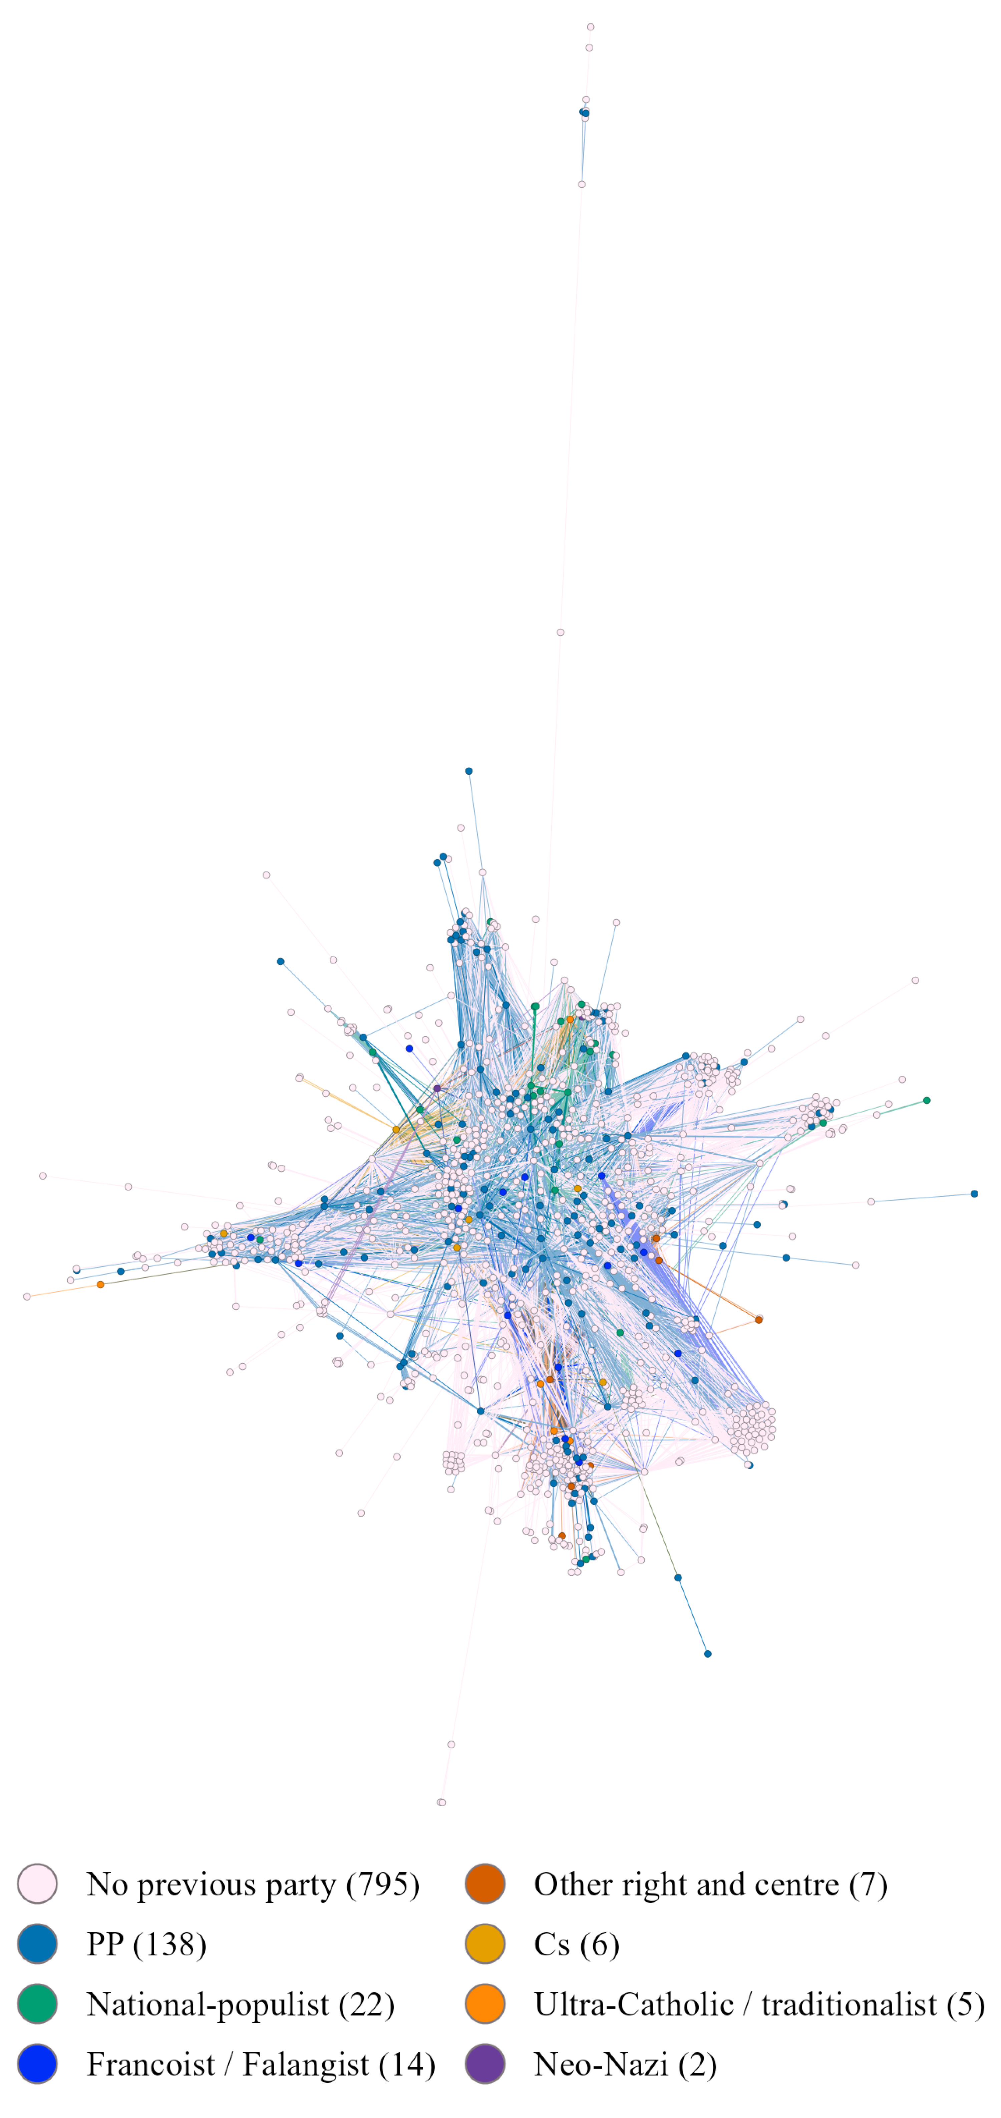
Note. Connected component of the network: 989 of the 1,551 nodes (the 454 isolated heads of municipal lists and the smaller components are filtered out). Two nodes are linked when they stood in the same election or belong to the same satellite organisation. Colour: family of the party the candidate had stood for before Vox (the one candidate with a previous left-wing party is included in the national-populist colour). Drawn with Gephi. Own dataset.
As can be seen, the prediction stated before in which the central nodes to be surrounded by people from other parties is tested: Santiago Abascal, the party's leader and a former PP politician who chaired DENAES and now chairs Disenso, sits at the very centre of the network together with the national leadership. The ten candidates with most ties are Manuel Mariscal (395 ties), a former PP member linked to ISSEP; Rocío de Meer (391), also from ISSEP; Abascal himself (387); Pablo Sáez Alonso-Muñumer (367), from Disenso; Iván Espinosa de los Monteros (360), Joaquín Robles (359) and Ricardo Chamorro (359), all three from DENAES; María de la Cabeza Ruiz Solas (354) and María de los Reyes Romero Vilches (352), with no previous party or organisation on record; and Lourdes Méndez Monasterio (350), a former PP candidate. Seven of these ten belong to a satellite organisation, and none comes from the historical far right. When looking at the network brokers, the candidates who most often connect otherwise distant parts of the network. The main broker is Jorge Cutillas, a veteran of Fuerza Nueva, Juntas Españolas and Alternativa Española, followed by David García Gomis, José Ignacio Arias Moreno and two members of satellite organisations, Carlos Flores Juberías (ISSEP) and Francisco José Contreras (Disenso and HazteOir). This suggests that, in parts where they don’t have enough political capital, they reach to more extreme profiles. The network is also clearly hierarchical: the degree assortativity of -0.26 shows that well-connected nodes tend to be linked to poorly connected ones. Candidates coming from the far right, although few, also sit close to the centre (a median of 14 ties), well above former PP candidates (a median of two), whose large number is spread across the periphery of regional and municipal lists.
The core is populated by the national leadership, and to a large extent by the members of Vox's satellite organisations. Among the ten candidates with most ties, Santiago Abascal, Iván Espinosa de los Monteros and Joaquín Robles belong to DENAES, Manuel Mariscal and Rocío de Meer works atISSEP, and Pablo Sáez to Disenso. More generally, the 41 satellite members who stood for Vox are the best-connected group in the network. This is most probably so because most satellite were created after Vox became an institutionalized party. An interesting case is Carlos H. Quero, a madrilenian doctorate in History who decided to be in the first promotion of ISSEP students with no prior recorded political experience. He became a national deputy for Malaga a year after and is now a CEN member. In the network, he has 95 edges, but half are non candidate ISSEP members, going down to 44 edges. This could indicate that having been in a previous party means different things for different people, which makes political selection more complex to model.
Finally, community detection shows that, indeed, the network models VOX’s organization fairly well. Doing a Louvain algorithm community detection shows that the network is organised territorially around a national core. Most of its 17 communities correspond to an autonomy. There are two that do not correspond to any, which are the national core formed by the Congress and European Parliament lists of the leadership, and a community dominated by satellite members (77 of its 102 nodes), where the think-tank and training circles of Disenso and ISSEP are put together with the party's delegation in the European Parliament. There are also two communities which are non-candidates that are only part of a satellite group. Vox thus recruits its electable candidates from a broad and largely new base, but that base is held together by a small centre in which satellite organisations and veterans of the far right weigh far more than their raw numbers suggest.
Figure 6
Communities of the Network of Vox's Electable Candidates (Louvain Method)
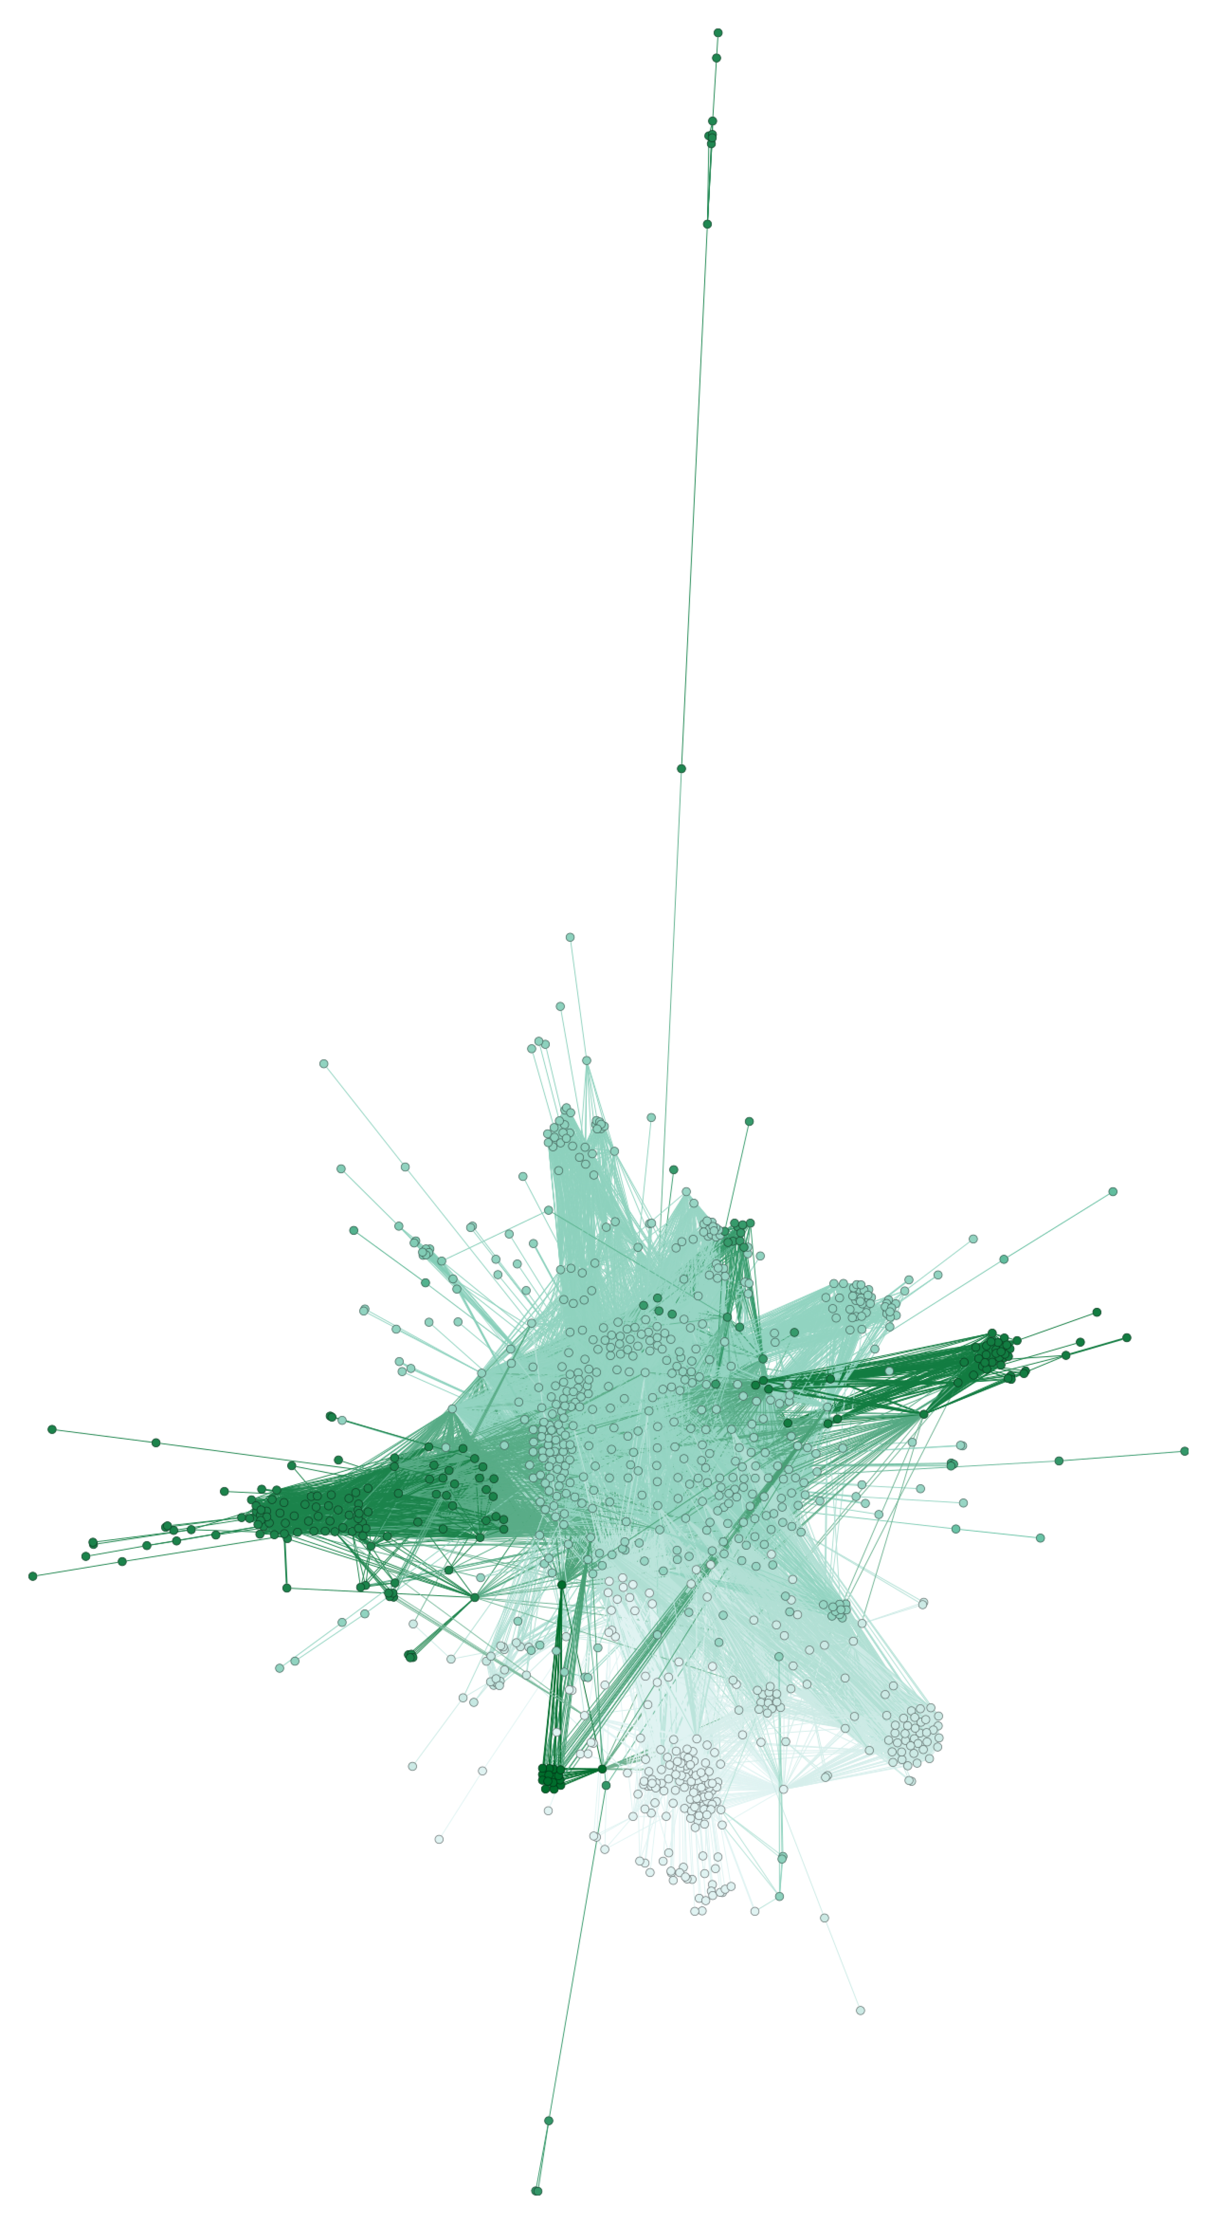
Note. Communities detected with the Louvain method in Gephi on the connected component (989 nodes, 18 communities); each shade of colour is a community. Own dataset.
To answer the second research question, a comparison between the candidates placed within the electability threshold of their constituency in the Congress election of July 2023 with the three titular candidates placed immediately below it has been done. The sample includes 179 candidates, 42 within the threshold and 137 below it. Each hypothesis is tested with Fisher's exact tests, logit models with standard errors clustered by constituency and, as a check, conditional logit models that only compare candidates from the same constituency, which leaves 42 electable candidates across the 32 constituencies that have candidates in both groups (Tables 4 and 5).
Table 4
Candidates Within and Just Below the Electability Threshold, Congress, July 2023
Variable | Within the threshold | Just below it | Fisher p
Candidates | 42 | 137
Women | 11 (26.2%) | 68 (49.6%) | 0.008
Managers (ISCO 1) | 8 (19.0%) | 14 (10.2%) | 0.176
Professionals (ISCO 2) | 29 (69.0%) | 46 (33.6%) | <0.001
Other occupations (ISCO 3-9) | 3 (7.1%) | 16 (11.7%) | 0.570
Occupation unknown | 2 (4.8%) | 61 (44.5%) | <0.001
Stood for another party before | 16 (38.1%) | 22 (16.1%) | 0.004
of which PP or AP | 13 (31.0%) | 19 (13.9%) | 0.020
of which Cs | 1 (2.4%) | 2 (1.5%) | 0.554
of which historical far right | 4 (9.5%) | 1 (0.7%) | 0.011
On a Vox list in 2013-2017 | 14 (33.3%) | 8 (5.8%) | <0.001
Note. Number of candidates and share of each group. Fisher p: exact test of each variable against the group. A candidate can have stood for several parties. Own dataset; occupations from the press and official CVs.
The network analysis points in the direction of H1, which is tested with the comparison of candidates 38.1 % of the electable candidates had stood for another party, against 16.1 per cent of those placed just below the threshold (Table 4) The effect holds when occupation and sex are controlled for and when seniority in the party is added. Within the same constituency the estimate keeps its direction but loses significance, which is unsurprising given the small number of comparisons. The former PP dominates on both sides of the threshold, with 13 of the 16 electable candidates with a party past and 19 of the 22 below it, which supports H1a. The historical far right, by contrast, appears almost only above the threshold: four electable candidates had stood for Fuerza Nueva, Democracia Nacional or FE de las JONS, against a single candidate below it. This points in the direction of H1b, although the numbers are too small to test it on its own.
Table 5
Odds of Being Placed in an Electable Position, Congress Candidates, July 2023
Variable | (1) | (2) | (3) | (4) | (5)
Managers (ISCO 1) |  | 2.75 | 2.41 | 1.78 | 3.23
 |  | (0.53, 14.19) | (0.47, 12.37) | (0.31, 10.06) | (0.48, 21.85)
Professionals (ISCO 2) |  | 3.30* | 2.83 | 2.38 | 2.18
 |  | (0.94, 11.66) | (0.81, 9.85) | (0.63, 9.00) | (0.44, 10.94)
Occupation unknown |  | 0.20* | 0.19* | 0.16** | 0.22
 |  | (0.03, 1.17) | (0.03, 1.12) | (0.03, 0.82) | (0.03, 1.85)
Female | 0.36*** | 0.53 | 0.55 | 0.75 | 0.92
 | (0.17, 0.76) | (0.23, 1.21) | (0.23, 1.33) | (0.28, 2.02) | (0.36, 2.35)
Stood for another party before |  |  | 2.34** | 2.98*** | 2.47
 |  |  | (1.12, 4.86) | (1.37, 6.51) | (0.77, 7.92)
On a Vox list in 2013-2017 |  |  |  | 8.14*** | 5.23**
 |  |  |  | (2.59, 25.56) | (1.48, 18.44)
Model | Logit | Logit | Logit | Logit | Conditional logit
Observations | 179 | 179 | 179 | 179 | 133 (32 constituencies)
Note. Dependent variable: placed within the electability threshold. Odds ratios, with 95% confidence intervals in brackets from standard errors clustered by constituency (logits); the conditional logit (5) compares candidates of the same constituency, so it only uses the constituencies with candidates in both groups. Reference categories: men, occupations of ISCO groups 3–9. * p < .10. ** p < .05. *** p < .01.
A third of the electable candidates (33.3 per cent) had already been on a Vox list between 2013 and 2017, against 5.8 per cent of those below the threshold, and this remains the largest effect in the full model (OR 8.14, 95% CI 2.59–25.56) and within constituencies (OR 5.23, 95% CI 1.48–18.44). The veterans who were recycled from one list to the next when the party had nothing to offer are, once it has seats to distribute, those who receive them. Women make up 26.2 per cent of the electable candidates but 49.6 per cent of those placed just below the threshold. The odds of an electable position are thus almost three times higher for men (OR for women 0.36, p = .008), and the gap persists within constituencies (OR 0.38, p = .017). This is the pattern that the balanced-presence rule allows: parity is respected in each block of five positions, but not in the one or two positions that translate into seats. The gap, however, largely disappears once the other variables are taken into account: it shrinks when occupation is controlled for (OR 0.53, p = .13) and vanishes when seniority is added (OR 0.75, p = .57). The reason is that the veterans of 2013-2017, whom the party rewards, are overwhelmingly men: women are 18.2 per cent of them, against 47.8 per cent of the rest. The disadvantage of women is therefore real, but it operates mainly through loyalty: by rewarding the cadres of its most marginal years, Vox reproduces the male composition of that founding core. H3 is supported descriptively, although the direct effect of sex is not robust to the controls.
Lastly, among the candidates whose occupation could be identified, 92.5 per cent of the electable candidates and 78.9 per cent of those below the threshold belong to ISCO major groups 1 and 2, managers and professionals. The difference, however, is not significant (Fisher's p = .18; professionals against other occupations, OR 3.30, p = .063), and it weakens further with the controls. This result must be read with caution, because information on occupation is unevenly distributed: it could not be found for 4.8 per cent of the electable candidates but for 44.5 per cent of those below the threshold, since less known candidates leave fewer traces online. The results are therefore consistent with H4, but the available information does not allow it to be confirmed.

5. CONCLUSION AND DISCUSSION
This thesis asked where Vox takes its electable candidates from and how it chooses among them. Vox recruits them from a broad and largely new base: most had never stood for another party, and former PP candidates, the largest external pool, sit on the periphery of regional and municipal lists. The network, however, is held together by a small, hierarchical core formed by the national leadership and the members of satellite organisations such as DENAES, Disenso and ISSEP, while a few veterans of the historical far right act as its main brokers. The PP gave Vox its founders, but the party that composes its lists today relies on an organisational ecosystem of its own.
Within the lists, a past in another party raises the odds of an electable position, although the small sample calls for caution about the size of the effect. The clearest result is loyalty: candidates who stood for Vox in 2013-2017, when it had no seats to offer, are several times more likely to be placed in an electable position (H2). Women are underrepresented in those positions, but mainly because the loyalists the party rewards are overwhelmingly men, so H3 holds descriptively rather than as a direct effect. Occupation does not distinguish the two groups, in line with H4.
These results speak to the internalist literature on the radical right (Art, 2011; Ortiz Barquero et al., 2024). Rather than placing experienced politicians from the mainstream right at the top of its lists, Vox has built its own infrastructure of recruitment and rewarded loyalty above prior experience, the kind of selection that Galasso and Nannicini (2015) describe for closed-list systems. If Art (2011) is right, the price may be a narrower and more homogeneous cadre.
The study has limitations. Links between people rest on name matching, which may miss people or confuse homonyms; a previous party is only observed when the person stood on another list; the electability threshold is an approximation; and the comparison of candidates is limited to 179 people in one election, with scarce occupational data for less known candidates. Future research could extend the comparison to regional and municipal lists, follow the people trained by ISSEP, and compare Vox with other radical right parties under closed lists, such as Chega.

REFERENCES
Alonso, S., & Rovira Kaltwasser, C. (2015). Spain: No country for the populist radical right? South European Society and Politics, 20(1), 21–45. https://doi.org/10.1080/13608746.2014.985448
Aragón, F. M. (2010). Candidate nomination procedures and political selection: Evidence from Latin American parties (STICERD Economic Organisation and Public Policy Discussion Paper No. EOPP003). London School of Economics and Political Science.
Art, D. (2011). Inside the radical right: The development of anti-immigrant parties in Western Europe. Cambridge University Press. https://www.cambridge.org/core/books/inside-the-radical-right/3F5D61322289F9CCCD95E21FBD017DEC
Barrio, A., Alonso Sáenz de Oger, S., & Field, B. N. (2021). VOX Spain: The organisational challenges of a new radical right party. Politics and Governance, 9(4), 240–251. https://doi.org/10.17645/pag.v9i4.4396
Besley, T. (2005). Political selection. Journal of Economic Perspectives, 19(3), 43–60. https://doi.org/10.1257/089533005774357761
Besley, T., Montalvo, J. G., & Reynal-Querol, M. (2011). Do educated leaders matter? The Economic Journal, 121(554), F205–F227. https://academic.oup.com/ej/article-abstract/121/554/F205/5079434
Borraz, M. (2019, April 21). Entrar en las listas de Vox: Un mensaje, un DNI, ningún filtro y el partido falsifica la firma. elDiario.es. https://www.eldiario.es/politica/entrar-vox-euskadi-telegram-control_1_1597931.html
Casals i Meseguer, X. (2020). De Fuerza Nueva a Vox: De la vieja a la nueva ultraderecha española (1975-2019). Ayer. Revista de Historia Contemporánea, 118(2), 365–380. https://doi.org/10.55509/ayer/118-2020-14
Casals i Meseguer, X. (2026). Historia de la Plataforma per Catalunya y análisis de su legado en Vox y Aliança Catalana (2003-2024). Historia y Política: Ideas, Procesos y Movimientos Sociales. https://doi.org/10.18042/hp.2026.AL.02
Centro de Investigaciones Sociológicas. (2019). Estudio 3269: Postelectoral elecciones generales 2019 [Data set]. https://www.cis.es
Chattopadhyay, R., & Duflo, E. (2004). Women as policy makers: Evidence from a randomized policy experiment in India. Econometrica, 72(5), 1409–1443. https://doi.org/10.1111/j.1468-0262.2004.00539.x
Chen, W., Fang, Y., Fu, S., Xu, F., & Wei, X. (2025). Optimizing prompts for large language models: A causal approach [Preprint]. arXiv. https://arxiv.org/abs/2602.01711
Crutzen, B. S. Y., Konishi, H., & Sahuguet, N. (2024). The best at the top? Candidate ranking strategies under closed list proportional representation. Political Science Research and Methods, 12(4), 706–728. https://doi.org/10.1017/psrm.2024.10
Dal Bó, E., & Finan, F. (2018). Progress and perspectives in the study of political selection. Annual Review of Economics, 10, 541–575. https://doi.org/10.1146/annurev-economics-080217-053221
Dal Bó, E., Finan, F., Folke, O., Persson, T., & Rickne, J. (2017). Who becomes a politician? The Quarterly Journal of Economics, 132(4), 1877–1914. https://academic.oup.com/qje/article-abstract/132/4/1877/3859758
Europa Press. (2023, June 17). Vox entra en 140 gobiernos municipales, entre ellos Valladolid, Burgos, Guadalajara, Toledo y Ciudad Real. https://www.europapress.es/nacional/noticia-vox-entra-140-gobiernos-municipales-ellos-valladolid-burgos-guadalajara-toledo-ciudad-real-20230617172707.html
Fernández-Villaverde, J., & Sanz, C. (2025). How substitutable are the classical and radical right? Journal of Public Economics, 252, 105521. https://doi.org/10.1016/j.jpubeco.2025.105521
Galasso, V., & Nannicini, T. (2015). So closed: Political selection in proportional systems. European Journal of Political Economy, 40, 260–273. https://doi.org/10.1016/j.ejpoleco.2015.04.008
International IDEA. (n.d.). Electoral System Design Database [Data set]. https://www.idea.int/data-tools/data/electoral-system-design
Maldita.es. (2024, February 29). [Registry of political parties of the Ministry of the Interior]. https://maldita.es/malditodato/20240229/partidos-politicos-registro-ministerio-interior/
Mudde, C. (2007). Populist radical right parties in Europe. Cambridge University Press.
Obregón, J. (2026). infoelectoral [Repository]. GitHub. https://github.com/JaimeObregon/infoelectoral
Ortiz Barquero, P., Benítez Espinosa, A., & Aragón Morales, A. M. (2021). Organización partidista y rendimiento electoral. Una aproximación al caso de la derecha radical en España. RIPS: Revista de Investigaciones Políticas y Sociológicas, 20(2). https://doi.org/10.15304/rips.20.2.7840
Ortiz Barquero, P., González-Fernández, M. T., & Ruiz Jiménez, A. M. (2024). The role of organizational institutionalization in electoral sustainability. A comparative analysis of the Spanish far right: Fuerza Nueva and VOX. Social Science History, 48(1), 41–63. https://doi.org/10.1017/ssh.2023.17
Papagni, E., Baraldi, A. L., & Alfano, M. R. (2023). Ballot structure and political selection. Evidence from changes in electoral rules. Journal of Comparative Economics, 51(1), 324–347. https://doi.org/10.1016/j.jce.2022.10.001
Rama, J., Zanotti, L., Turnbull-Dugarte, S. J., & Santana, A. (2021). VOX: The rise of the Spanish populist radical right. Routledge. https://www.taylorfrancis.com/books/9781000394481
Ramos, M. (2021). De los neocón a los neonazis. Rosa Luxemburg Stiftung. https://freepress.coop/project/de-los-neocon-a-los-neonazis-rosa-luxemburg-stiftung/
Sangiao, S. (2018, November 29). Los orígenes de Vox: El aznarato y la lucha contra ETA. ctxt.es | Contexto y Acción. http://ctxt.es/es/20181129/Politica/23127/vox-aznar-eta-esperanza-aguirre-sergio-sangiao.htm
Turnbull-Dugarte, S. J. (2019). Explaining the end of Spanish exceptionalism and electoral support for Vox. Research & Politics, 6(2). https://doi.org/10.1177/2053168019851680
Ungureanu, C., & Popartan, L. A. (2024). The green, green grass of the nation. A new far-right ecology in Spain. Political Geography, 108, 102953. https://doi.org/10.1016/j.polgeo.2023.102953

APPENDIX A. ADDITIONAL FIGURES AND TABLES

Github Repository:

https://github.com/noah-furup/VOX-s-Political-Selection
Figure A.1
Family Tree of the Spanish Far Right, 1975–2026
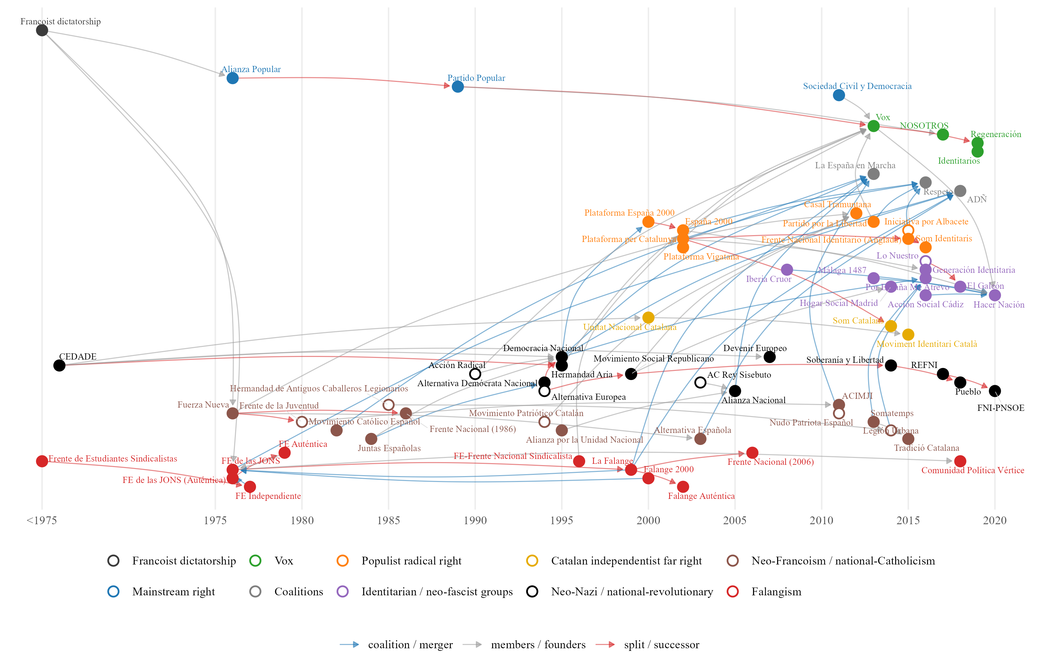
Note. Each arrow goes from an organisation to the one that came out of it, joined a coalition with it or took its members. Hollow dots: approximate year. Own elaboration from Ramos (2021), Casals (2020) and Wikipedia (Falangist parties).
Table A.1
Vox's Satellite Organisations
Organisation | Type | Founded | Link with Vox | Members identified | Vox candidates
HazteOir | Association (lobby) | 2001 | Ultra-Catholic lobby, ally of Vox | 19 | 3
DENAES | Foundation | 2006 | Founded and chaired by Santiago Abascal before Vox | 18 | 6
CitizenGO | Online platform | 2013 | International platform of HazteOir | 0 | 0
Homo Legens | Publishing house | 2017 | Publisher of Vox leaders (Intereconomia group) | 4 | 0
Disenso | Foundation (think tank) | 2020 | Think tank of Vox, chaired by Santiago Abascal | 29 | 7
ISSEP | Training institute | 2020 | Madrid branch of Marion Marechal's institute; trains Vox cadres | 52 | 8
Solidaridad | Trade union | 2020 | Trade union promoted by Vox | 8 | 4
Revuelta | Youth association | 2023 | Launched by Vox affiliates and employees | 5 | 3
Note. Members identified: board members and staff found in the archived websites (Wayback Machine), the BOE (Solidaridad) and the press (Revuelta, Homo Legens). Vox candidates: members who stood on a Vox list.
Figure A.2
Vox Councillors Elected in the Municipal Elections of May 2015
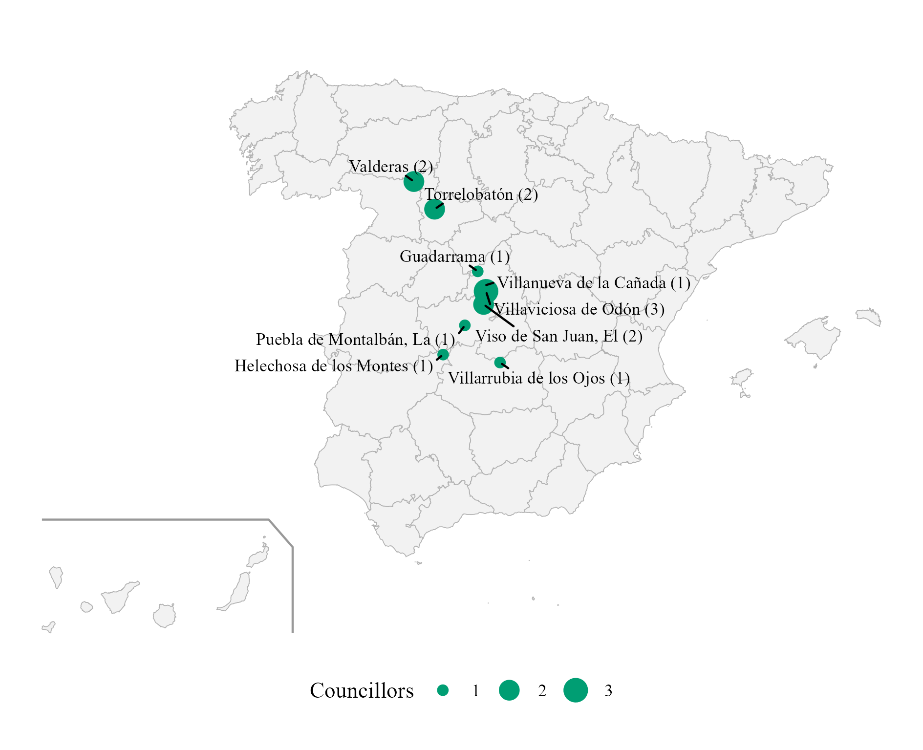
Note. Number of councillors in brackets. These were the only seats Vox held before 2018. Own dataset from infoelectoral.
Table A.2
Vox Electoral Results by Election
Level | Election | Lists | Candidates | Expected seats | Seats won | Lists with seats
National | European, May 2014 (European Parliament) | 1 | 54 | 0 | 0 | 0
National | General, December 2015 (Congress) | 30 | 226 | 0 | 0 | 0
National | General, December 2015 (Senate) | 29 | 70 | 0 | 0 | 0
National | General, June 2016 (Congress) | 34 | 239 | 0 | 0 | 0
National | General, June 2016 (Senate) | 33 | 76 | 0 | 0 | 0
National | General, April 2019 (Congress) | 52 | 350 | 37 | 24 | 18
National | General, April 2019 (Senate) | 52 | 143 | 0 | 0 | 0
National | European, May 2019 (European Parliament) | 1 | 54 | 5 | 3 | 1
National | General, November 2019 (Congress) | 52 | 350 | 21 | 52 | 33
National | General, November 2019 (Senate) | 52 | 57 | 0 | 2 | 2
National | General, July 2023 (Congress) | 51 | 343 | 28 | 33 | 24
National | General, July 2023 (Senate) | 51 | 154 | 2 | 0 | 0
National | European, June 2024 (European Parliament) | 1 | 61 | 6 | 6 | 1
Autonomical | Regional, March 2015 | 8 | 109 | 0 | 0 | 0
Autonomical | Regional, May 2015 | 27 | 560 | 0 | 0 | 0
Autonomical | Regional, September 2016 | 1 | 25 | 0 | 0 | 0
Autonomical | Regional, December 2018 | 8 | 109 | 1 | 12 | 8
Autonomical | Regional, April 2019 | 3 | 99 | 6 | 10 | 3
Autonomical | Regional, May 2019 | 38 | 757 | 9 | 37 | 10
Autonomical | Regional, July 2020 | 7 | 150 | 0 | 1 | 1
Autonomical | Regional, February 2021 | 4 | 135 | 9 | 11 | 4
Autonomical | Regional, May 2021 | 1 | 136 | 9 | 13 | 1
Autonomical | Regional, February 2022 | 9 | 81 | 8 | 13 | 8
Autonomical | Regional, June 2022 | 8 | 109 | 21 | 14 | 8
Autonomical | Regional, May 2023 | 35 | 786 | 50 | 79 | 26
Autonomical | Regional, February 2024 | 4 | 75 | 0 | 0 | 0
Autonomical | Regional, April 2024 | 3 | 75 | 1 | 1 | 1
Autonomical | Regional, May 2024 | 4 | 135 | 11 | 11 | 4
Autonomical | Regional, December 2025 | 2 | 65 | 12 | 11 | 2
Autonomical | Regional, February 2026 | 3 | 67 | 12 | 14 | 3
Autonomical | Regional, March 2026 | 9 | 82 | 18 | 14 | 9
Autonomical | Regional, May 2026 | 8 | 109 | 16 | 15 | 8
Municipal | Municipales, May 2015 | 120 | 2622 | 0 | 14 | 9
Municipal | Municipales, May 2019 | 695 | 12228 | 10 | 522 | 343
Municipal | Municipales, May 2023 | 1655 | 26592 | 500 | 1545 | 886
Note. Titular candidates only. Expected seats: candidates placed within the expected seats of their list. Own dataset from infoelectoral and the official gazettes.
Table A.3
Vox Members of Regional Governments
Region | Name | Position | From | To | Vox candidate in that election
Castilla y León | JUAN GARCIAGALLARDO FRINGS | Vicepresidente de la Junta de Castilla y León | 20/04/2022 | 11/07/2024 | Yes
Castilla y León | GONZALO SANTONJA GOMEZAGERO | Consejero de Cultura, Turismo y Deporte | 20/04/2022 | 11/07/2024 | No
Castilla y León | GERARDO DUENAS MERINO | Consejero de Agricultura, Ganadería y Desarrollo Rural | 20/04/2022 | 11/07/2024 | No
Castilla y León | MARIANO VEGANZONES DIEZ | Consejero de Industria, Comercio y Empleo | 20/04/2022 | 11/07/2024 | Yes
Comunidad Valenciana | VICENTE BARRERA SIMO | Vicepresidente Primero y Conseller de Cultura y Deporte | 17/07/2023 | 11/07/2024 | No
Comunidad Valenciana | ELISA NUNEZ SANCHEZ | Consellera de Justicia e Interior | 17/07/2023 | 11/07/2024 | No
Comunidad Valenciana | JOSE LUIS AGUIRRE LARRAURI | Conseller de Agricultura, Ganadería y Pesca | 17/07/2023 | 11/07/2024 | Yes
Extremadura | MARIA DEL CAMINO LIMIA | Consejera de Gestión Forestal y Mundo Rural | 20/07/2023 | 05/10/2023 | No
Extremadura | IGNACIO HIGUERO DE JUAN | Consejero de Gestión Forestal y Mundo Rural | 05/10/2023 | 11/07/2024 | No
Aragón | ALEJANDRO NOLASCO ASENSIO | Vicepresidente Primero y Consejero de Desarrollo Territorial, Despoblación y Justicia | 12/08/2023 | 12/07/2024 | Yes
Aragón | ANGEL SAMPER SECORUN | Consejero de Agricultura, Ganadería y Alimentación | 12/08/2023 | 12/07/2024 | No
Región de Murcia | JOSE ANGEL ANTELO PAREDES | Vicepresidente y Consejero de Interior, Emergencias y Ordenación del Territorio | 15/09/2023 | 12/07/2024 | Yes
Región de Murcia | JOSE MANUEL PANCORBO DE LA TORRE | Consejero de Fomento e Infraestructuras | 15/09/2023 | 12/07/2024 | Yes
Extremadura | OSCAR ARTURO FERNANDEZ CALLE | Vicepresidente y Consejero de Desregulación, Servicios Sociales y Familia | 30/04/2026 | in office | Yes
Extremadura | JUAN JOSE GARCIA LOBATO | Consejero de Agricultura, Ganadería y Medio Natural | 30/04/2026 | in office | No
Aragón | ALEJANDRO NOLASCO ASENSIO | Vicepresidente Primero y Consejero de Desregulación, Bienestar Social y Familia | 04/05/2026 | in office | Yes
Aragón | ARANZAZU SIMON PEREZ | Consejera de Agricultura, Ganadería y Alimentación | 04/05/2026 | in office | Yes
Aragón | LUIS FRANCISCO BIENDICHO GRACIA | Consejero de Medio Ambiente y Turismo | 04/05/2026 | in office | Yes
Castilla y León | CARLOS POLLAN FERNANDEZ | Vicepresidente Primero y Consejero de Desregulación, Familia y Ayudas Sociales | 15/06/2026 | in office | Yes
Castilla y León | JOAQUIN ANTONIO PINO | Consejero de Agricultura, Ganadería, Medio Rural y Política Ambiental | 15/06/2026 | in office | No
Castilla y León | JOSE ALBERTO DIAZ PICO | Consejero de Cultura, Turismo y Deporte | 15/06/2026 | in office | Yes
Andalucía | MANUEL GAVIRA FLORENTINO | Vicepresidente Segundo y Consejero de Turismo, Justicia, Desregulación y Administración Local | 10/07/2026 | in office | Yes
Note. Data from the official gazettes of the autonomous communities and the press.
Figure A.3
Provinces Where Vox Ran a Congress List, General Elections 2015–2023
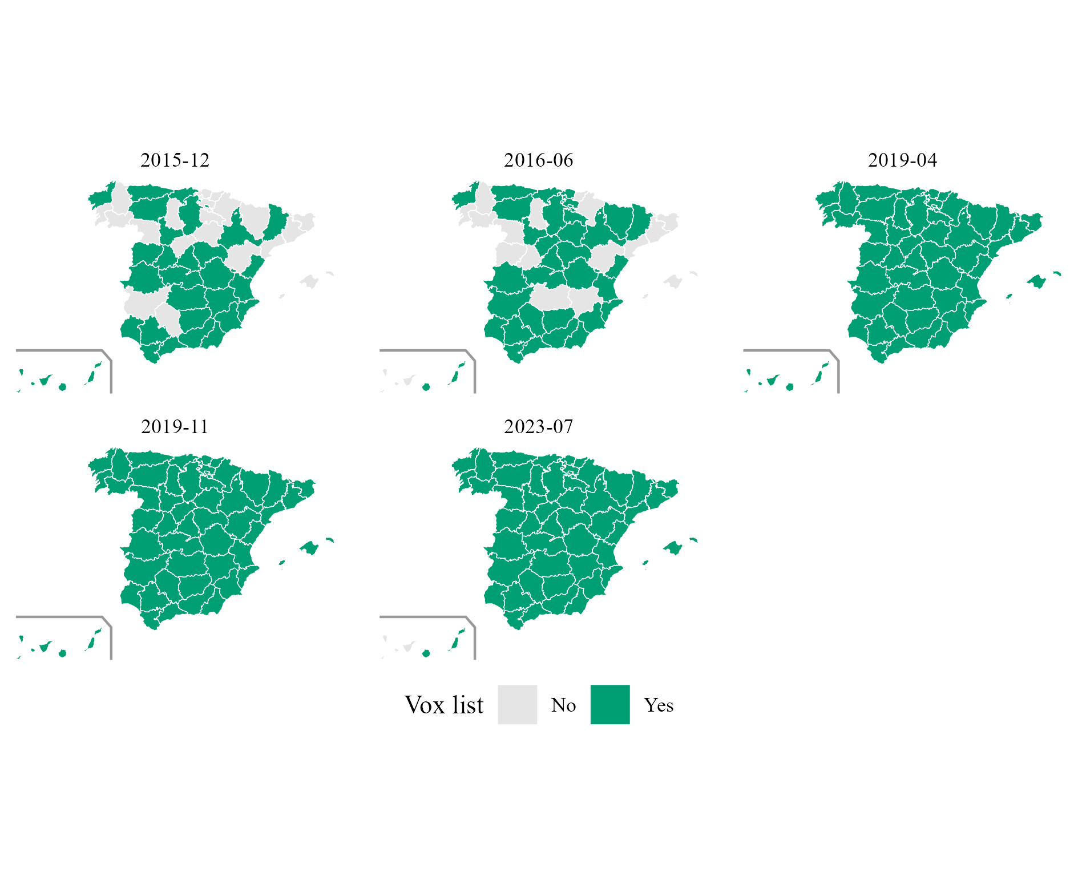
Note. Own dataset from infoelectoral.
Figure A.4
Constituencies Where Vox Ran in the Regional Elections of 2015–2017
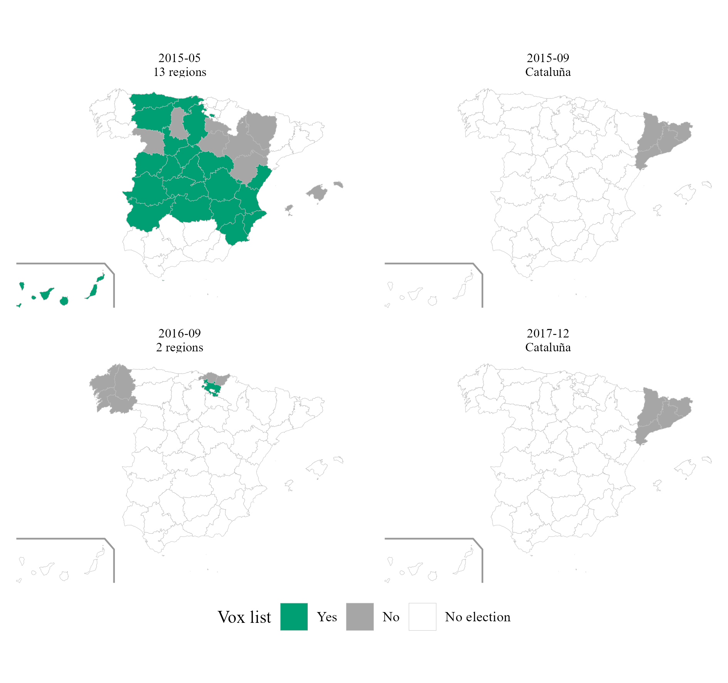
Note. No election: the region did not hold an election on that date. Own dataset from the official gazettes.

The data and code are located in the following Github Repository: https://github.com/noah-furup/VOX-s-Political-Selection

