Figure 1
Electoral System Families in Europe
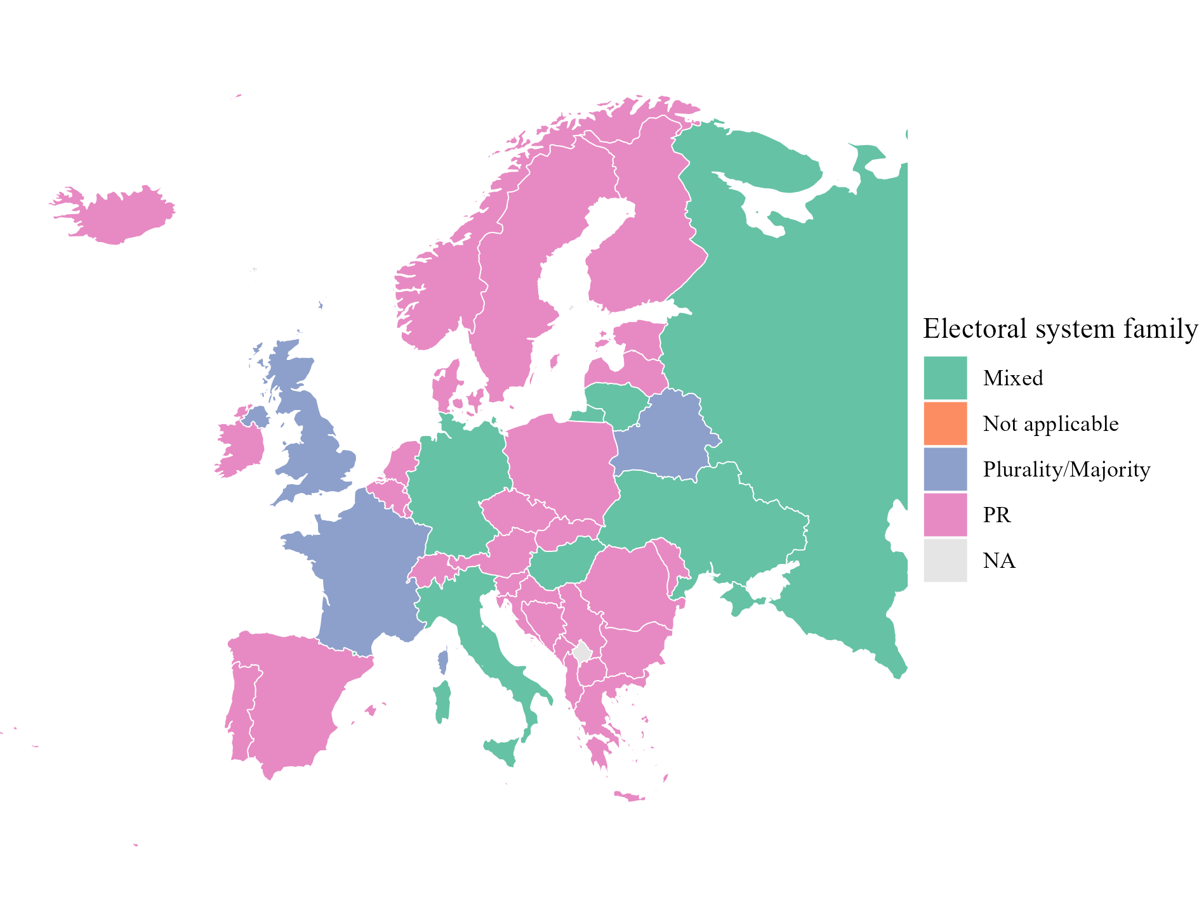
Note. Electoral system of the national legislature, latest year available. Data from the IDEA Electoral System Design Database.
Table 1
Founders of Vox
Name | Relationship with Vox | Origin
Alejo Vidal-Quadras | First party President and Candidate for the 2014 European elections | President of the Catalan branch of the PP, member of its national executive; Director of FAES, DENAES
Ana Velasco Vidal-Abarca | Militant | Villasneros Foundation
Cristina Seguí | Ex-militant | -
Enrique Álvarez López | Militant | -
Ignacio Camuñas Solís | Ex-Vice-President and ex-President | Co-founder and ex Minister of UCD
Iván Espinosa de los Monteros | Spokesman, former Vice-President, ex-General Secretariat | Ex-Secretary of DENAES
José Antonio Ortega Lara | Militant | Ex-militant of the PP
José Luis González Quirós | Second President (ad interim), ex-militant | UCD, CDS, ex-militant of PP, FAES
María Jesús Prieto-Laffargue | Ex-militant | General Direction in the first Aznar Government (PP)
Santiago Abascal | President | PP, President of DENAES
Note. Own elaboration from Casals (2020), Rama et al. (2021) and Sangiao (2018).
Figure 2
Vox's Share of the Valid Vote in General and European Elections, 2014–2024
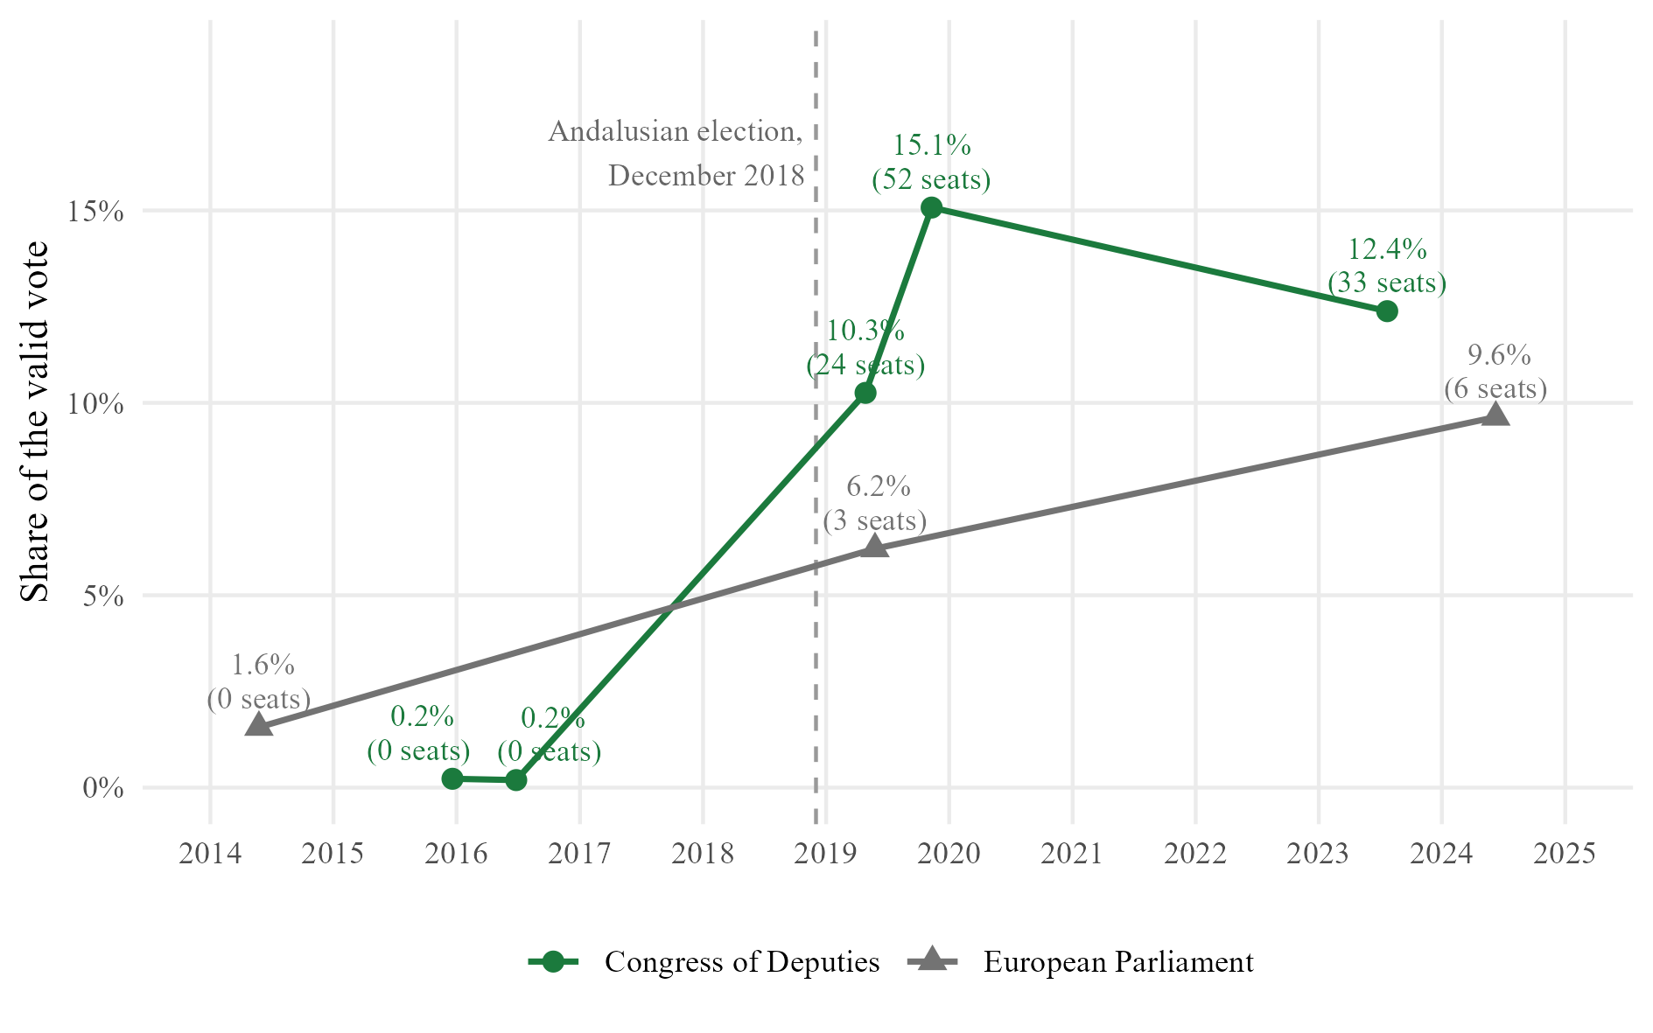
Note. Seats won in brackets. In the European Parliament, Vox obtained a fourth seat after Brexit (2020). Data from the Ministry of the Interior (infoelectoral) and the Junta Electoral Central.
Figure 3
Political Determinants of the Vote for Vox, November 2019
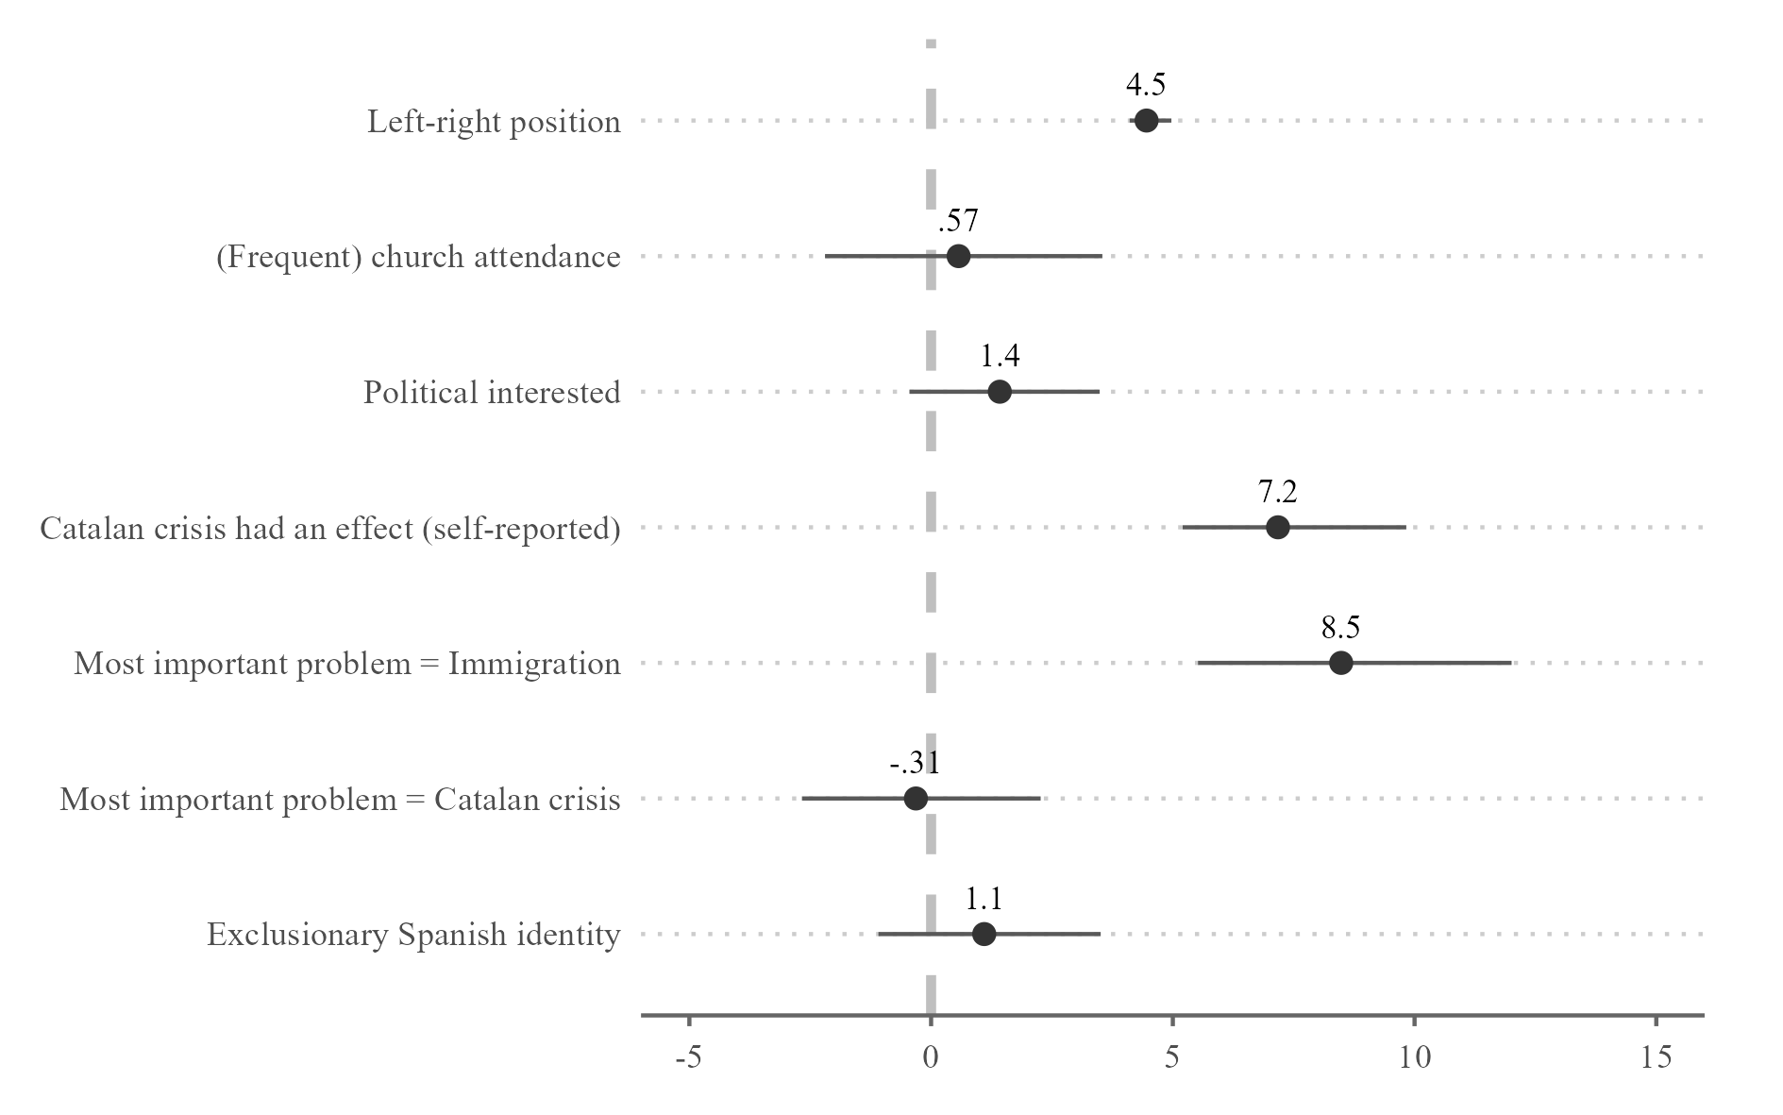
Note. Average marginal effects on the probability of voting Vox, in percentage points, with 95% confidence intervals. Controls not shown: gender, age, subjective class, education, income, rurality and autonomous community fixed effects. Replication of Rama et al. (2021, fig. 4.12) with CIS study 3269 (2019b), n = 3,133.
Table 2
Far-Right and Right-Wing Populist Parties Registered Since 1976
Party | Abbreviation | Registered | Cancelled
FALANGE ESPAÑOLA DE LAS J.O.N.S. | FE de las JONS | 04/10/1976
FUERZA NUEVA | F.N. | 19/10/1976 | 10/12/1982
FALANGE ESPAÑOLA AUTENTICA | F.E.A. | 17/01/1979 | 03/10/2023
CENTRO DEMOCRATICO Y SOCIAL | C.D.S. | 23/08/1982
JUNTAS ESPAÑOLAS |  | 27/06/1986
FRENTE NACIONAL |  | 24/11/1986 | 20/07/1994
PARTIDO DEL TRABAJO Y EMPLEO-AGRUPACION RUIZ MATEOS "TRABAJO Y EMPLEO" | TYE. | 30/08/1989
GRUPO INDEPENDIENTE LIBERAL | G.I.L. | 28/02/1992 | 06/09/2004
DEMOCRACIA NACIONAL | D.N. | 25/05/1995
ALIANZA NACIONAL | A.u.N. | 23/01/1996 | 11/10/2023
LA FALANGE | FE | 24/03/1999
MOVIMIENTO SOCIAL REPUBLICANO | M.S.R. | 30/11/1999
FALANGE 2.000 | FE-2.000 | 11/01/2000
PLATAFORMA PER CATALUNYA | PxC | 05/04/2002 | 17/12/2020
FALANGE AUTENTICA | FAu | 30/04/2002
ESPAÑA 2000 | E-2000 | 17/07/2002
ALTERNATIVA ESPAÑOLA | AES | 21/04/2003 | 09/01/2023
ALTERNATIVA DE GOVERN | Alternativa de Govern | 12/04/2010
JUNTS PER TABARNIA - VIA DEMOCRÁTICA | VD | 31/01/2011
SOCIEDAD CIVIL Y DEMOCRACIA | SCD | 20/06/2011
PARTIDO POR LA LIBERTAD | PxL | 25/02/2013 | 19/09/2019
SOBERANÍA Y LIBERTAD | S. y L. | 17/11/2014
SOM IDENTITARIS | SOMI | 16/02/2016
"NOSOTROS" PARTIDO DE LA REGENERACIÓN SOCIAL | N+ | 03/08/2017
FRENTE: NACIONAL IDENTITARIO, PARTIDO NACIONALSOCIALISTA OBRERO ESPAÑOL | FNI-PNSOE | 15/03/2018
ADÑ | ADÑ | 15/10/2018
PUEBLO | PLO | 27/03/2023
Note. Parties selected following Casals (2020). Cancelled: date on which the party was struck off the registry. Data from the Ministry of the Interior registry of political parties (Maldita, 2024; update of September 2026).

Figure 4
Family Tree of the Spanish Far Right, 1975–2026
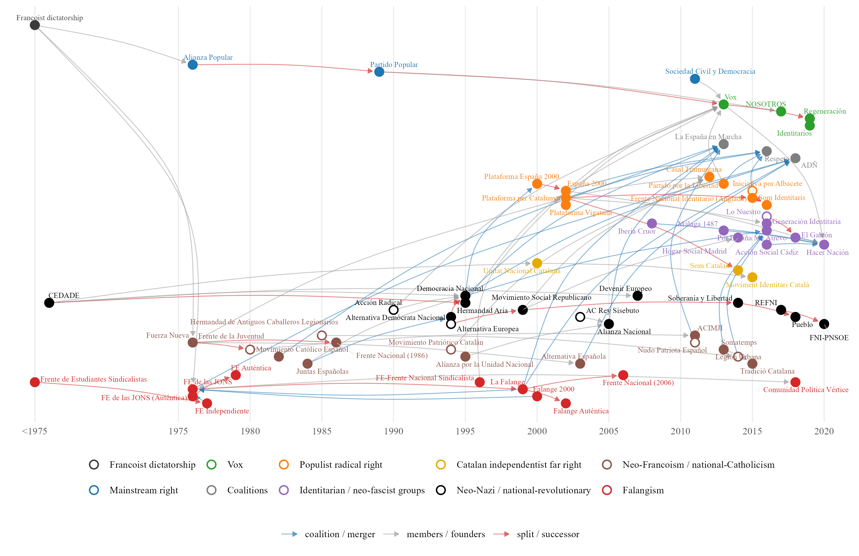
Note. Each arrow goes from an organisation to the one that came out of it, joined a coalition with it or took its members. Hollow dots: approximate year. Own elaboration from Ramos (2022), Casals (2020) and Wikipedia (Falangist parties).

Table 3
Vox's Satellite Organisations
Organisation | Type | Founded | Link with Vox | Members identified | Vox candidates
HazteOir | Association (lobby) | 2001 | Ultra-Catholic lobby, ally of Vox | 19 | 3
DENAES | Foundation | 2006 | Founded and chaired by Santiago Abascal before Vox | 18 | 6
CitizenGO | Online platform | 2013 | International platform of HazteOir | 0 | 0
Homo Legens | Publishing house | 2017 | Publisher of Vox leaders (Intereconomia group) | 4 | 0
Disenso | Foundation (think tank) | 2020 | Think tank of Vox, chaired by Santiago Abascal | 29 | 7
ISSEP | Training institute | 2020 | Madrid branch of Marion Marechal's institute; trains Vox cadres | 52 | 8
Solidaridad | Trade union | 2020 | Trade union promoted by Vox | 8 | 4
Revuelta | Youth association | 2023 | Launched by Vox affiliates and employees | 5 | 3
Note. Members identified: board members and staff found in the archived websites (Wayback Machine), the BOE (Solidaridad) and the press (Revuelta, Homo Legens). Vox candidates: members who stood on a Vox list.
Table 4
Vox Candidates by Level of Election, 2014–2026
Variable | National | Autonomical | Municipal | Total
Candidacies | 2504 | 4244 | 41442 | 48190
Different people | 1890 | 3680 | 37927 | 39419
Different people elected | 73 | 180 | 1869 | 2062
Elections | 8 | 19 | 3 | 30
Women (%) | 44.8 | 46.5 | 42.9 | 43.3
Elected (%) | 4.8 | 6 | 5 | 5.1
Within expected seats (%) | 4 | 4.3 | 1.2 | 1.6
Seat in previous election (%) | 13.9 | 6 | 0.6 | 1.8
Ran for another party before (%) | 15.9 | 12 | 7.9 | 8.7
In the CEN before the election (%) | 2.24 | 0.4 | 0.06 | 0.2
Organic position in Vox (%) | 6.07 | 2.8 | 0.33 | 0.84
Note. One row per candidacy, except the counts of people. Total: all levels together, so a person elected at two levels is counted once. Sex of municipal candidates inferred from the forename (INE). Own dataset from infoelectoral and the official gazettes.
Table 5
Vox Electoral Results by Election
Level | Election | Lists | Candidates | Expected seats | Seats won | Lists with seats
National | European, May 2014 (European Parliament) | 1 | 54 | 0 | 0 | 0
National | General, December 2015 (Congress) | 30 | 226 | 0 | 0 | 0
National | General, December 2015 (Senate) | 29 | 70 | 0 | 0 | 0
National | General, June 2016 (Congress) | 34 | 239 | 0 | 0 | 0
National | General, June 2016 (Senate) | 33 | 76 | 0 | 0 | 0
National | General, April 2019 (Congress) | 52 | 350 | 37 | 24 | 18
National | General, April 2019 (Senate) | 52 | 143 | 0 | 0 | 0
National | European, May 2019 (European Parliament) | 1 | 54 | 5 | 3 | 1
National | General, November 2019 (Congress) | 52 | 350 | 21 | 52 | 33
National | General, November 2019 (Senate) | 52 | 57 | 0 | 2 | 2
National | General, July 2023 (Congress) | 51 | 343 | 28 | 33 | 24
National | General, July 2023 (Senate) | 51 | 154 | 2 | 0 | 0
National | European, June 2024 (European Parliament) | 1 | 61 | 6 | 6 | 1
Autonomical | Regional, March 2015 | 8 | 109 | 0 | 0 | 0
Autonomical | Regional, May 2015 | 27 | 560 | 0 | 0 | 0
Autonomical | Regional, September 2016 | 1 | 25 | 0 | 0 | 0
Autonomical | Regional, December 2018 | 8 | 109 | 1 | 12 | 8
Autonomical | Regional, April 2019 | 3 | 99 | 6 | 10 | 3
Autonomical | Regional, May 2019 | 38 | 757 | 9 | 37 | 10
Autonomical | Regional, July 2020 | 7 | 150 | 0 | 1 | 1
Autonomical | Regional, February 2021 | 4 | 135 | 9 | 11 | 4
Autonomical | Regional, May 2021 | 1 | 136 | 9 | 13 | 1
Autonomical | Regional, February 2022 | 9 | 81 | 8 | 13 | 8
Autonomical | Regional, June 2022 | 8 | 109 | 21 | 14 | 8
Autonomical | Regional, May 2023 | 35 | 786 | 50 | 79 | 26
Autonomical | Regional, February 2024 | 4 | 75 | 0 | 0 | 0
Autonomical | Regional, April 2024 | 3 | 75 | 1 | 1 | 1
Autonomical | Regional, May 2024 | 4 | 135 | 11 | 11 | 4
Autonomical | Regional, December 2025 | 2 | 65 | 12 | 11 | 2
Autonomical | Regional, February 2026 | 3 | 67 | 12 | 14 | 3
Autonomical | Regional, March 2026 | 9 | 82 | 18 | 14 | 9
Autonomical | Regional, May 2026 | 8 | 109 | 16 | 15 | 8
Municipal | Municipales, May 2015 | 120 | 2622 | 0 | 14 | 9
Municipal | Municipales, May 2019 | 695 | 12228 | 10 | 522 | 343
Municipal | Municipales, May 2023 | 1655 | 26592 | 500 | 1545 | 886
Note. Titular candidates only. Expected seats: candidates placed within the expected seats of their list. Own dataset from infoelectoral and the official gazettes.
Figure 5
Vox Councillors Elected in the Municipal Elections of May 2015
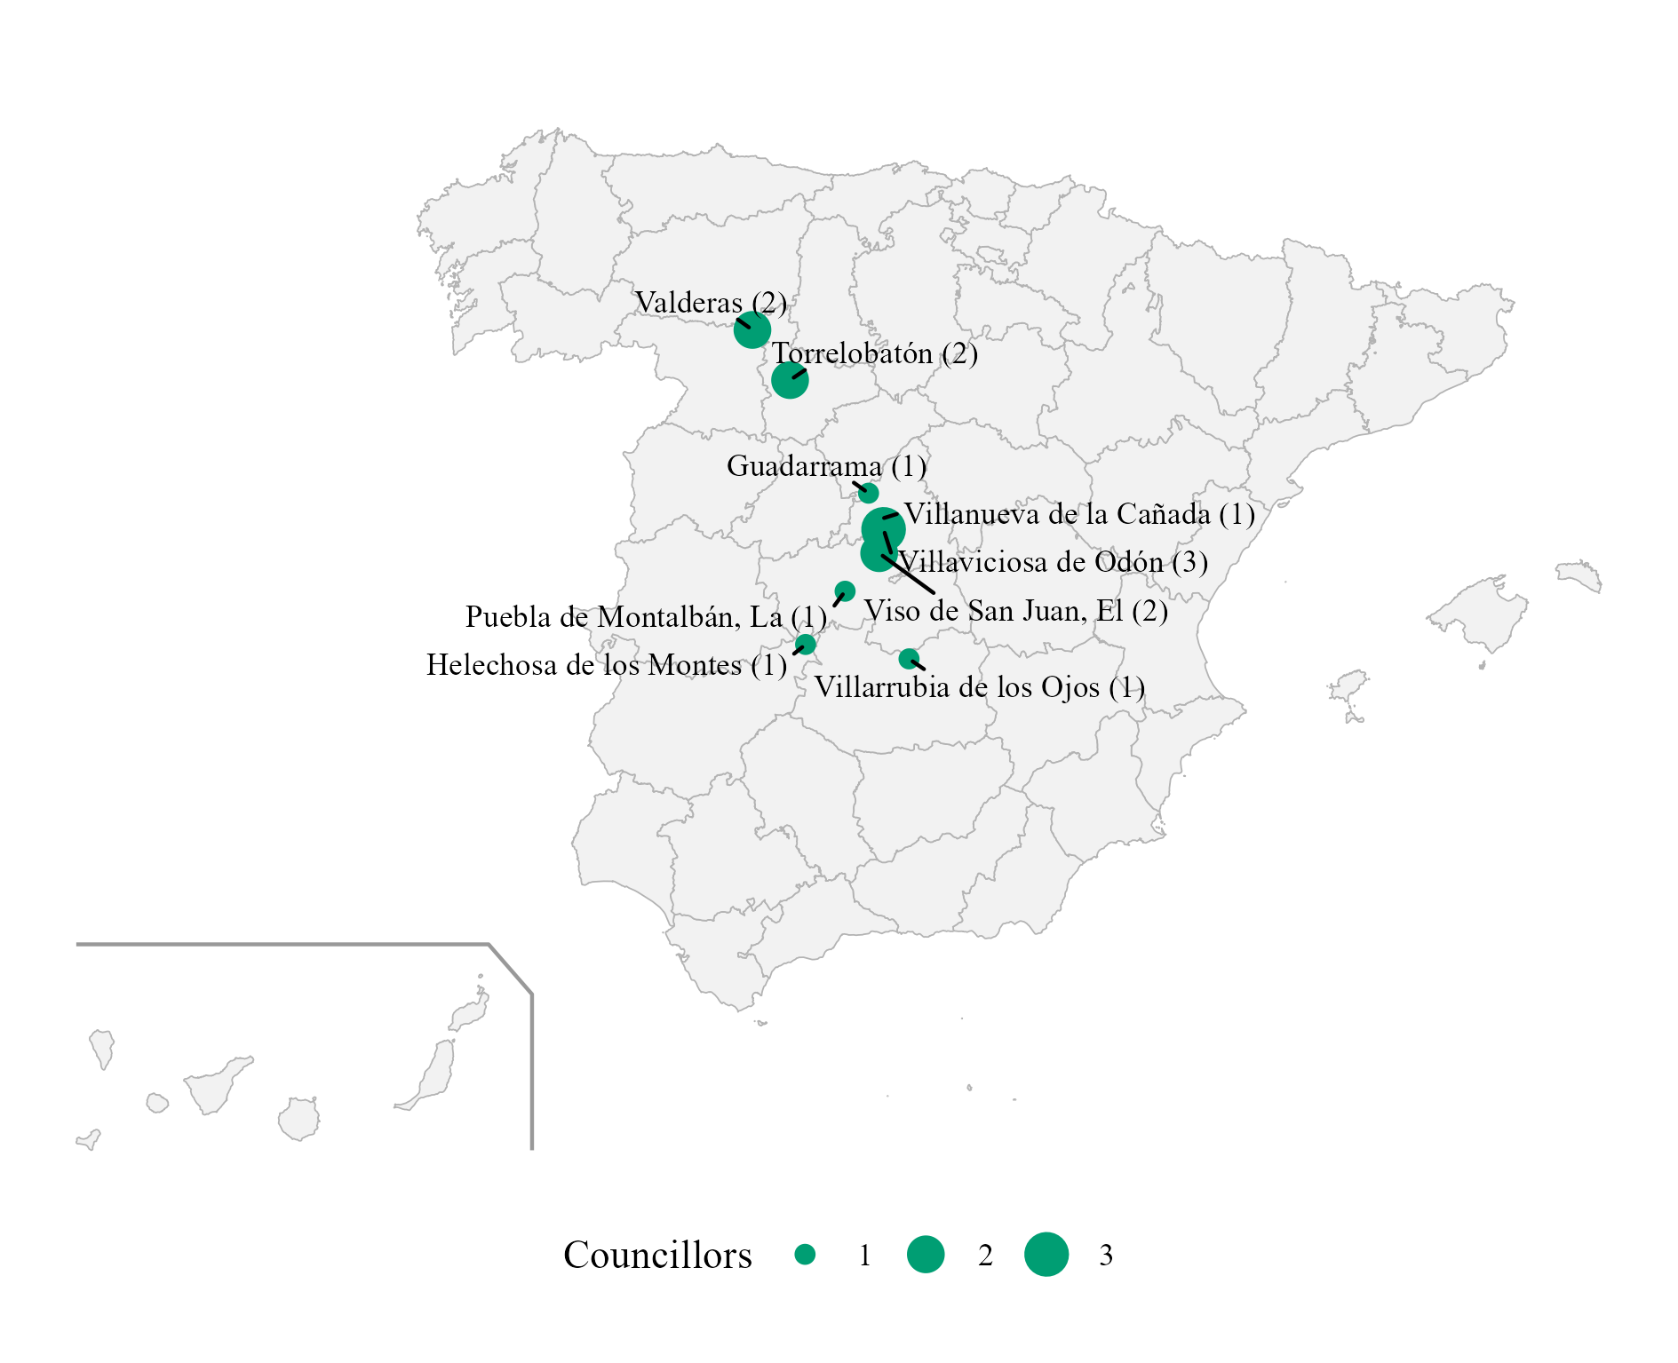
Note. Number of councillors in brackets. These were the only seats Vox held before 2018. Own dataset from infoelectoral.
Figure 6
Vox's Vote and Its Access to Regional Government, by Phase
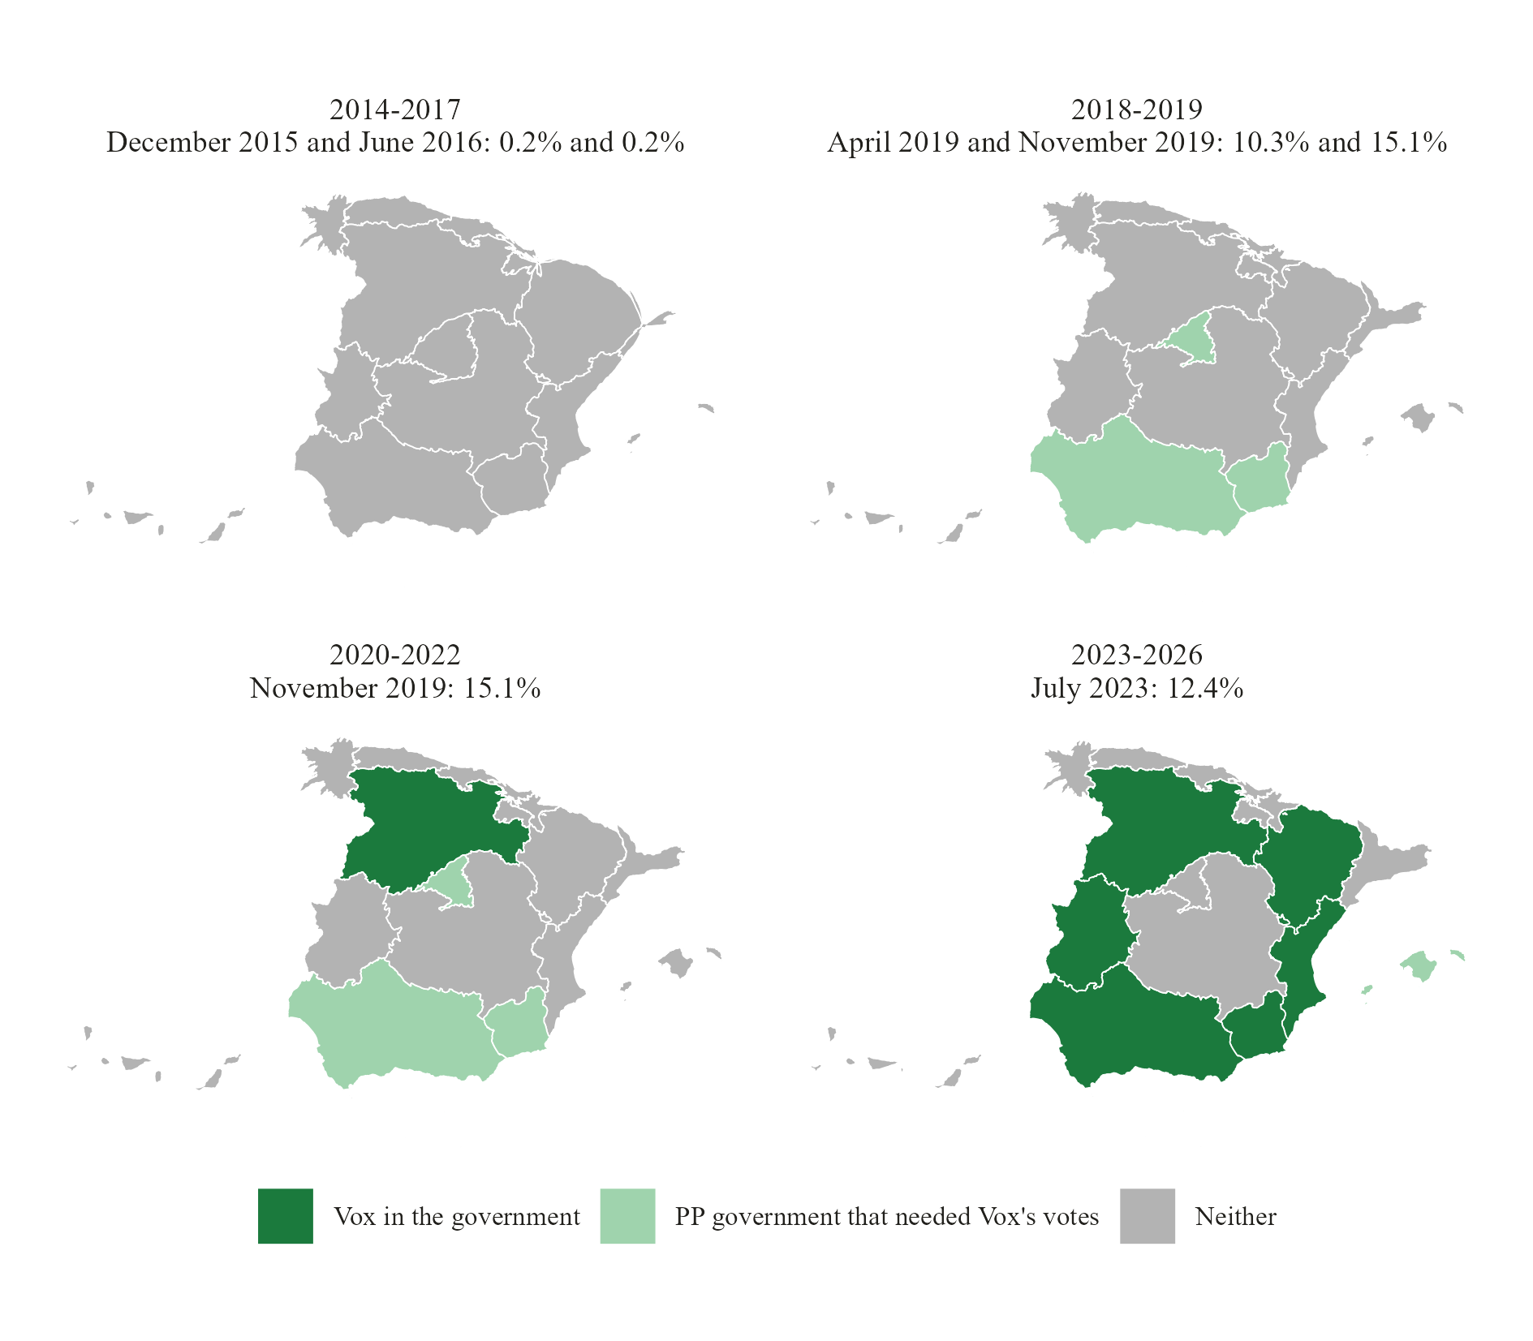
Note. Contiguous cartogram: each region is resized by its area times Vox's share of the valid vote in the general elections of the phase, relative to its national share (a region where Vox did not run keeps 5% of its size). Colour: Vox held a post in the regional government, or its votes were needed to invest a PP president, at any point of the phase. The Canary Islands are moved next to the peninsula. Data from the Ministry of the Interior (infoelectoral).
Table 6
Vox Members of Regional Governments
Region | Name | Position | From | To | Vox candidate in that election
Castilla y León | JUAN GARCIAGALLARDO FRINGS | Vicepresidente de la Junta de Castilla y León | 20/04/2022 | 11/07/2024 | Yes
Castilla y León | GONZALO SANTONJA GOMEZAGERO | Consejero de Cultura, Turismo y Deporte | 20/04/2022 | 11/07/2024 | No
Castilla y León | GERARDO DUENAS MERINO | Consejero de Agricultura, Ganadería y Desarrollo Rural | 20/04/2022 | 11/07/2024 | No
Castilla y León | MARIANO VEGANZONES DIEZ | Consejero de Industria, Comercio y Empleo | 20/04/2022 | 11/07/2024 | Yes
Comunidad Valenciana | VICENTE BARRERA SIMO | Vicepresidente Primero y Conseller de Cultura y Deporte | 17/07/2023 | 11/07/2024 | No
Comunidad Valenciana | ELISA NUNEZ SANCHEZ | Consellera de Justicia e Interior | 17/07/2023 | 11/07/2024 | No
Comunidad Valenciana | JOSE LUIS AGUIRRE LARRAURI | Conseller de Agricultura, Ganadería y Pesca | 17/07/2023 | 11/07/2024 | Yes
Extremadura | MARIA DEL CAMINO LIMIA | Consejera de Gestión Forestal y Mundo Rural | 20/07/2023 | 05/10/2023 | No
Extremadura | IGNACIO HIGUERO DE JUAN | Consejero de Gestión Forestal y Mundo Rural | 05/10/2023 | 11/07/2024 | No
Aragón | ALEJANDRO NOLASCO ASENSIO | Vicepresidente Primero y Consejero de Desarrollo Territorial, Despoblación y Justicia | 12/08/2023 | 12/07/2024 | Yes
Aragón | ANGEL SAMPER SECORUN | Consejero de Agricultura, Ganadería y Alimentación | 12/08/2023 | 12/07/2024 | No
Región de Murcia | JOSE ANGEL ANTELO PAREDES | Vicepresidente y Consejero de Interior, Emergencias y Ordenación del Territorio | 15/09/2023 | 12/07/2024 | Yes
Región de Murcia | JOSE MANUEL PANCORBO DE LA TORRE | Consejero de Fomento e Infraestructuras | 15/09/2023 | 12/07/2024 | Yes
Extremadura | OSCAR ARTURO FERNANDEZ CALLE | Vicepresidente y Consejero de Desregulación, Servicios Sociales y Familia | 30/04/2026 | in office | Yes
Extremadura | JUAN JOSE GARCIA LOBATO | Consejero de Agricultura, Ganadería y Medio Natural | 30/04/2026 | in office | No
Aragón | ALEJANDRO NOLASCO ASENSIO | Vicepresidente Primero y Consejero de Desregulación, Bienestar Social y Familia | 04/05/2026 | in office | Yes
Aragón | ARANZAZU SIMON PEREZ | Consejera de Agricultura, Ganadería y Alimentación | 04/05/2026 | in office | Yes
Aragón | LUIS FRANCISCO BIENDICHO GRACIA | Consejero de Medio Ambiente y Turismo | 04/05/2026 | in office | Yes
Castilla y León | CARLOS POLLAN FERNANDEZ | Vicepresidente Primero y Consejero de Desregulación, Familia y Ayudas Sociales | 15/06/2026 | in office | Yes
Castilla y León | JOAQUIN ANTONIO PINO | Consejero de Agricultura, Ganadería, Medio Rural y Política Ambiental | 15/06/2026 | in office | No
Castilla y León | JOSE ALBERTO DIAZ PICO | Consejero de Cultura, Turismo y Deporte | 15/06/2026 | in office | Yes
Andalucía | MANUEL GAVIRA FLORENTINO | Vicepresidente Segundo y Consejero de Turismo, Justicia, Desregulación y Administración Local | 10/07/2026 | in office | Yes
Note. Data from the official gazettes of the autonomous communities and the press.
Figure 7
Provinces Where Vox Ran a Congress List, General Elections 2015–2023
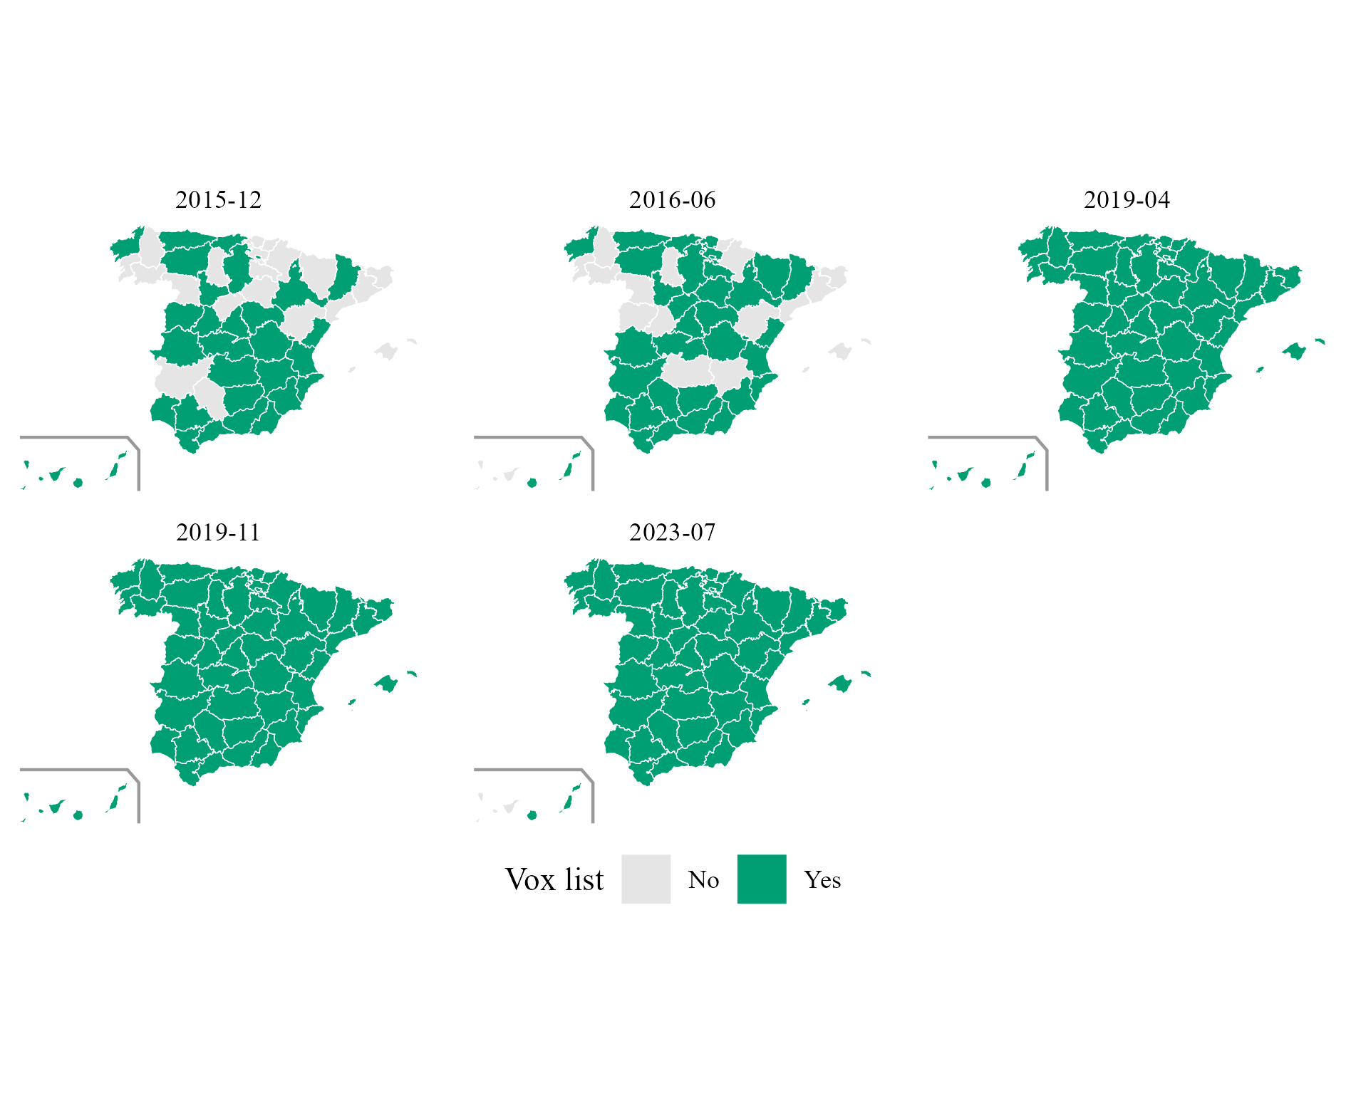
Note. Own dataset from infoelectoral.
Figure 8
Constituencies Where Vox Ran in the Regional Elections of 2015–2017
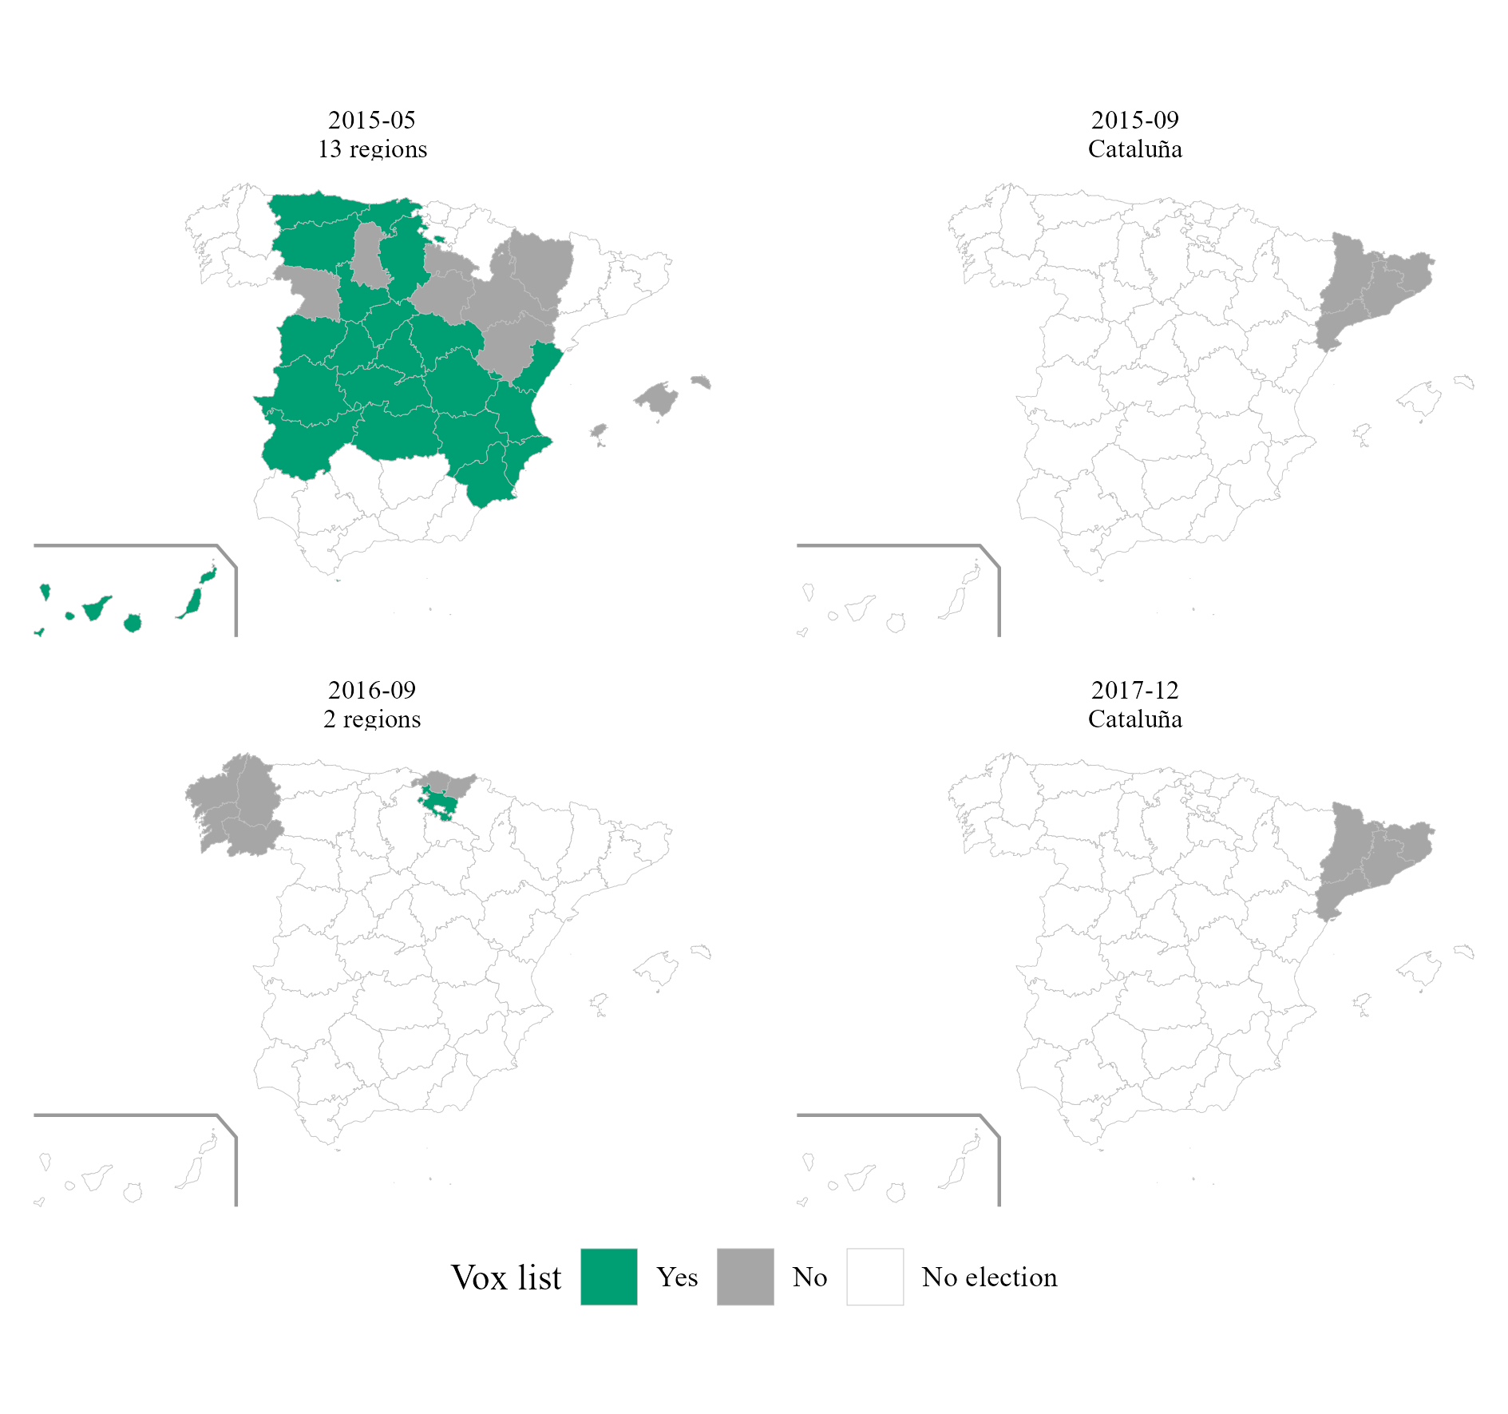
Note. No election: the region did not hold an election on that date. Own dataset from the official gazettes.
Figure 9
Network of Vox's Electable Candidates and Satellite Members
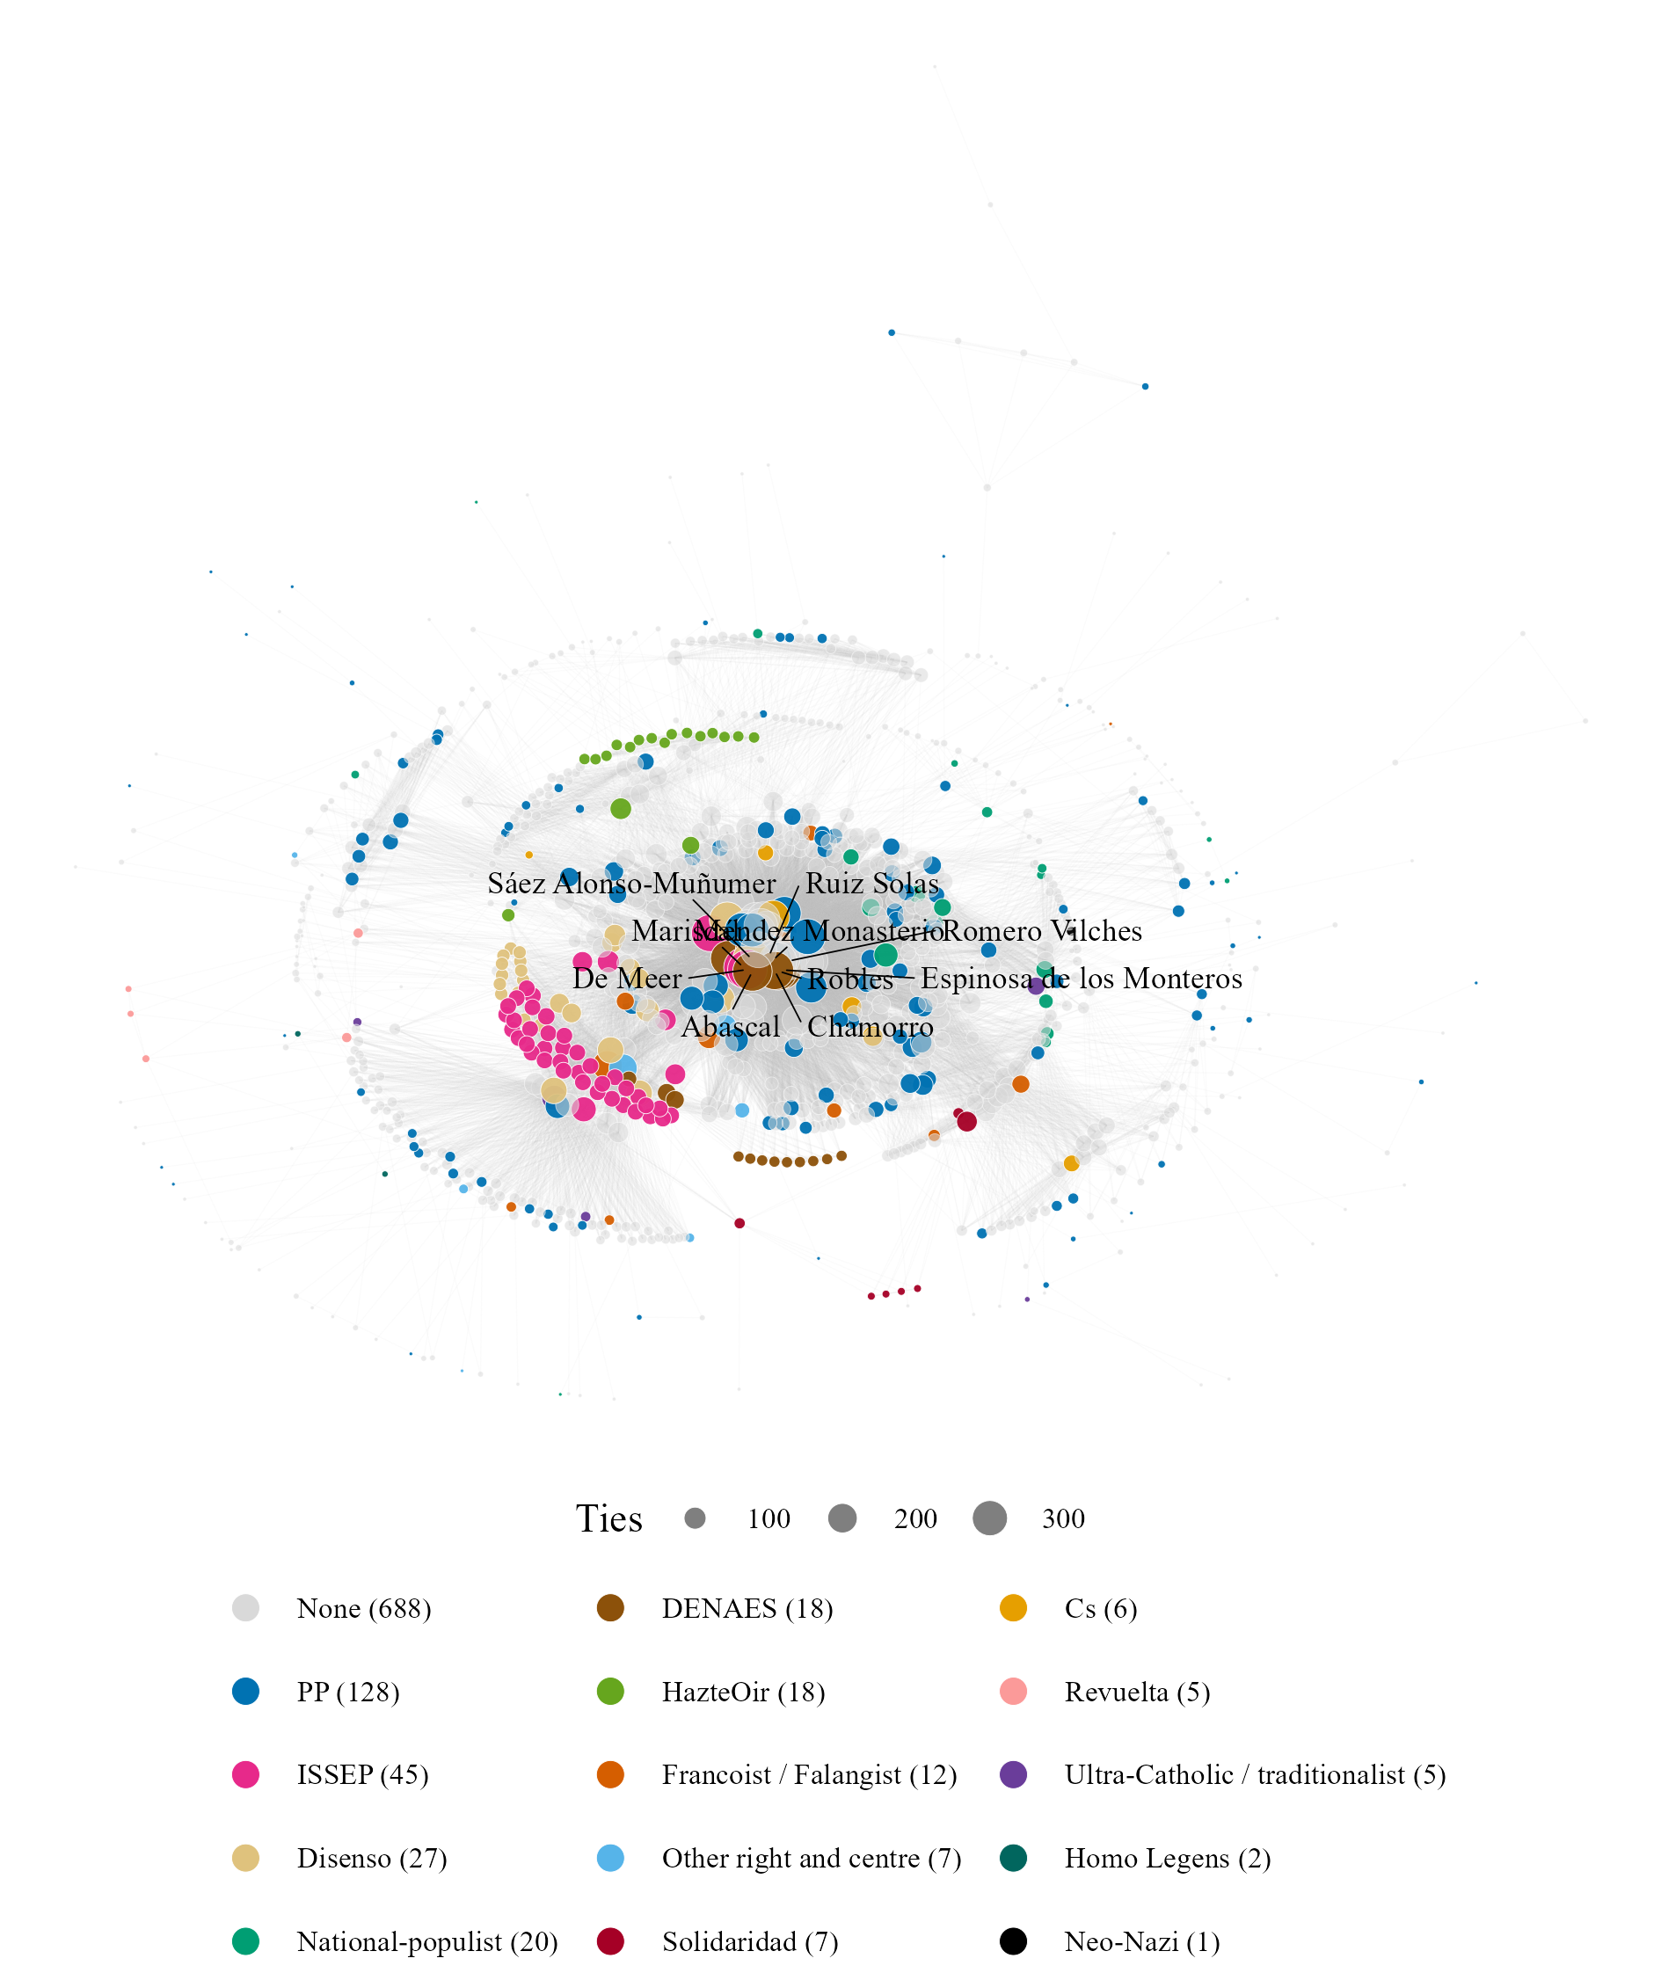
Note. Connected component: 989 of the 1,551 nodes (the 454 isolated heads of municipal lists and the smaller components are not drawn). Two nodes are linked when they stood in the same election or belong to the same satellite organisation. Colour: previous party family or satellite organisation; size: number of ties; the ten best-connected candidates are labelled. Own dataset.
Table 7
Candidates Within and Just Below the Electability Threshold, Congress, July 2023
Variable | Within the threshold | Just below it | Fisher p
Candidates | 42 | 137
Women | 11 (26.2%) | 68 (49.6%) | 0.008
Managers (ISCO 1) | 8 (19.0%) | 14 (10.2%) | 0.176
Professionals (ISCO 2) | 29 (69.0%) | 46 (33.6%) | <0.001
Other occupations (ISCO 3-9) | 3 (7.1%) | 16 (11.7%) | 0.570
Occupation unknown | 2 (4.8%) | 61 (44.5%) | <0.001
Stood for another party before | 16 (38.1%) | 22 (16.1%) | 0.004
of which PP or AP | 13 (31.0%) | 19 (13.9%) | 0.020
of which Cs | 1 (2.4%) | 2 (1.5%) | 0.554
of which historical far right | 4 (9.5%) | 1 (0.7%) | 0.011
On a Vox list in 2013-2017 | 14 (33.3%) | 8 (5.8%) | <0.001
Note. Number of candidates and share of each group. Fisher p: exact test of each variable against the group. A candidate can have stood for several parties. Own dataset; occupations from the press and official CVs.
Table 8
Odds of Being Placed in an Electable Position, Congress Candidates, July 2023
Variable | (1) | (2) | (3) | (4) | (5)
Managers (ISCO 1) |  | 2.75 | 2.41 | 1.78 | 3.23
 |  | (0.53, 14.19) | (0.47, 12.37) | (0.31, 10.06) | (0.48, 21.85)
Professionals (ISCO 2) |  | 3.30* | 2.83 | 2.38 | 2.18
 |  | (0.94, 11.66) | (0.81, 9.85) | (0.63, 9.00) | (0.44, 10.94)
Occupation unknown |  | 0.20* | 0.19* | 0.16** | 0.22
 |  | (0.03, 1.17) | (0.03, 1.12) | (0.03, 0.82) | (0.03, 1.85)
Female | 0.36*** | 0.53 | 0.55 | 0.75 | 0.92
 | (0.17, 0.76) | (0.23, 1.21) | (0.23, 1.33) | (0.28, 2.02) | (0.36, 2.35)
Stood for another party before |  |  | 2.34** | 2.98*** | 2.47
 |  |  | (1.12, 4.86) | (1.37, 6.51) | (0.77, 7.92)
On a Vox list in 2013-2017 |  |  |  | 8.14*** | 5.23**
 |  |  |  | (2.59, 25.56) | (1.48, 18.44)
Model | Logit | Logit | Logit | Logit | Conditional logit
Observations | 179 | 179 | 179 | 179 | 42
Note. Dependent variable: placed within the electability threshold. Odds ratios, with 95% confidence intervals in brackets from standard errors clustered by constituency (logits); the conditional logit (5) compares candidates of the same constituency. Reference categories: men, occupations of ISCO groups 3–9. * p < .10. ** p < .05. *** p < .01.

