Rexburg Eats Site Plan

James Hoyal

WDD 130

Overview

Purpose
This website is a local restaurant review site for Rexburg, Idaho. It lets me share honest reviews of places I have eaten and helps other students and locals find good food nearby. It is a simple, fun site that is easy to build with basic HTML and CSS.

Audience
My instructor (Brother Alvey) in WDD 130, BYU-Idaho students looking for places to eat near campus, and Rexburg locals who want honest food recommendations.

Branding

Website Logo


Style Guide

Color Palette
Primary | Secondary | Accent 1 | Accent 2
#2D3748 | #2B6CB0 | #E2E8F0 | #FFFFFF

Typography

Heading Font: Georgia

Paragraph Font: Arial

Navigation
Home About Reviews

Content

HOME PAGE: A heading that says “Discover the Best Eats in Rexburg”, a large food photo, and a short welcome paragraph. Below that, a “Featured Reviews” section with three restaurant cards showing a photo, restaurant name, star rating (1–5 stars), and a one-sentence description. REVIEWS PAGE: A heading that says “All Reviews” and a list of every restaurant reviewed, each with a photo, name, star rating, and two to three sentences about the food and experience. ABOUT PAGE: A heading that says “About This Site”, a photo of myself, and a short paragraph about who I am and why I started reviewing local restaurants in Rexburg.

Wireframes

Home
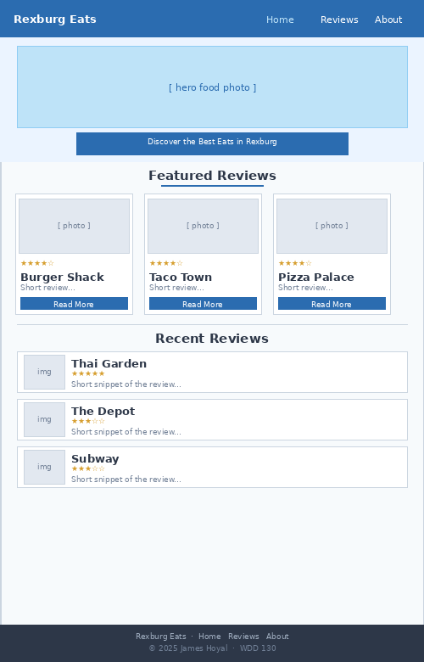

About
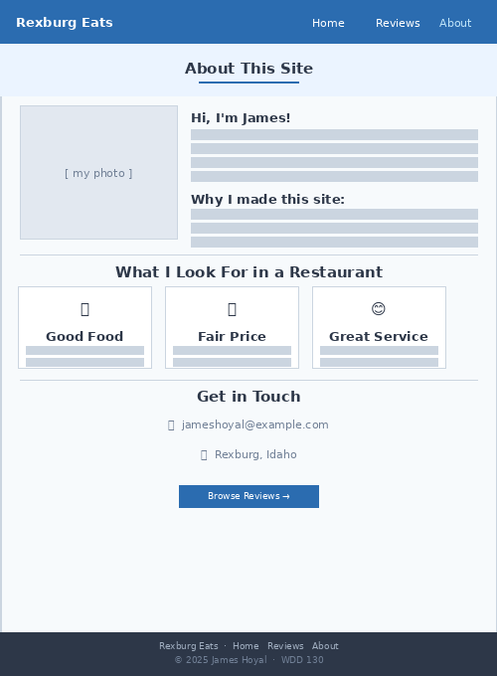

Reviews
