NOR and NAND Flash Memory:
There are two types of flash memory – Nor and Nand.
Flash memory is a non-volatile storage, Non-volatile memory doesn't require power to retain data.
NOR and NAND use different logic gates, the fundamental building block of digital circuits in each memory cell to map data.
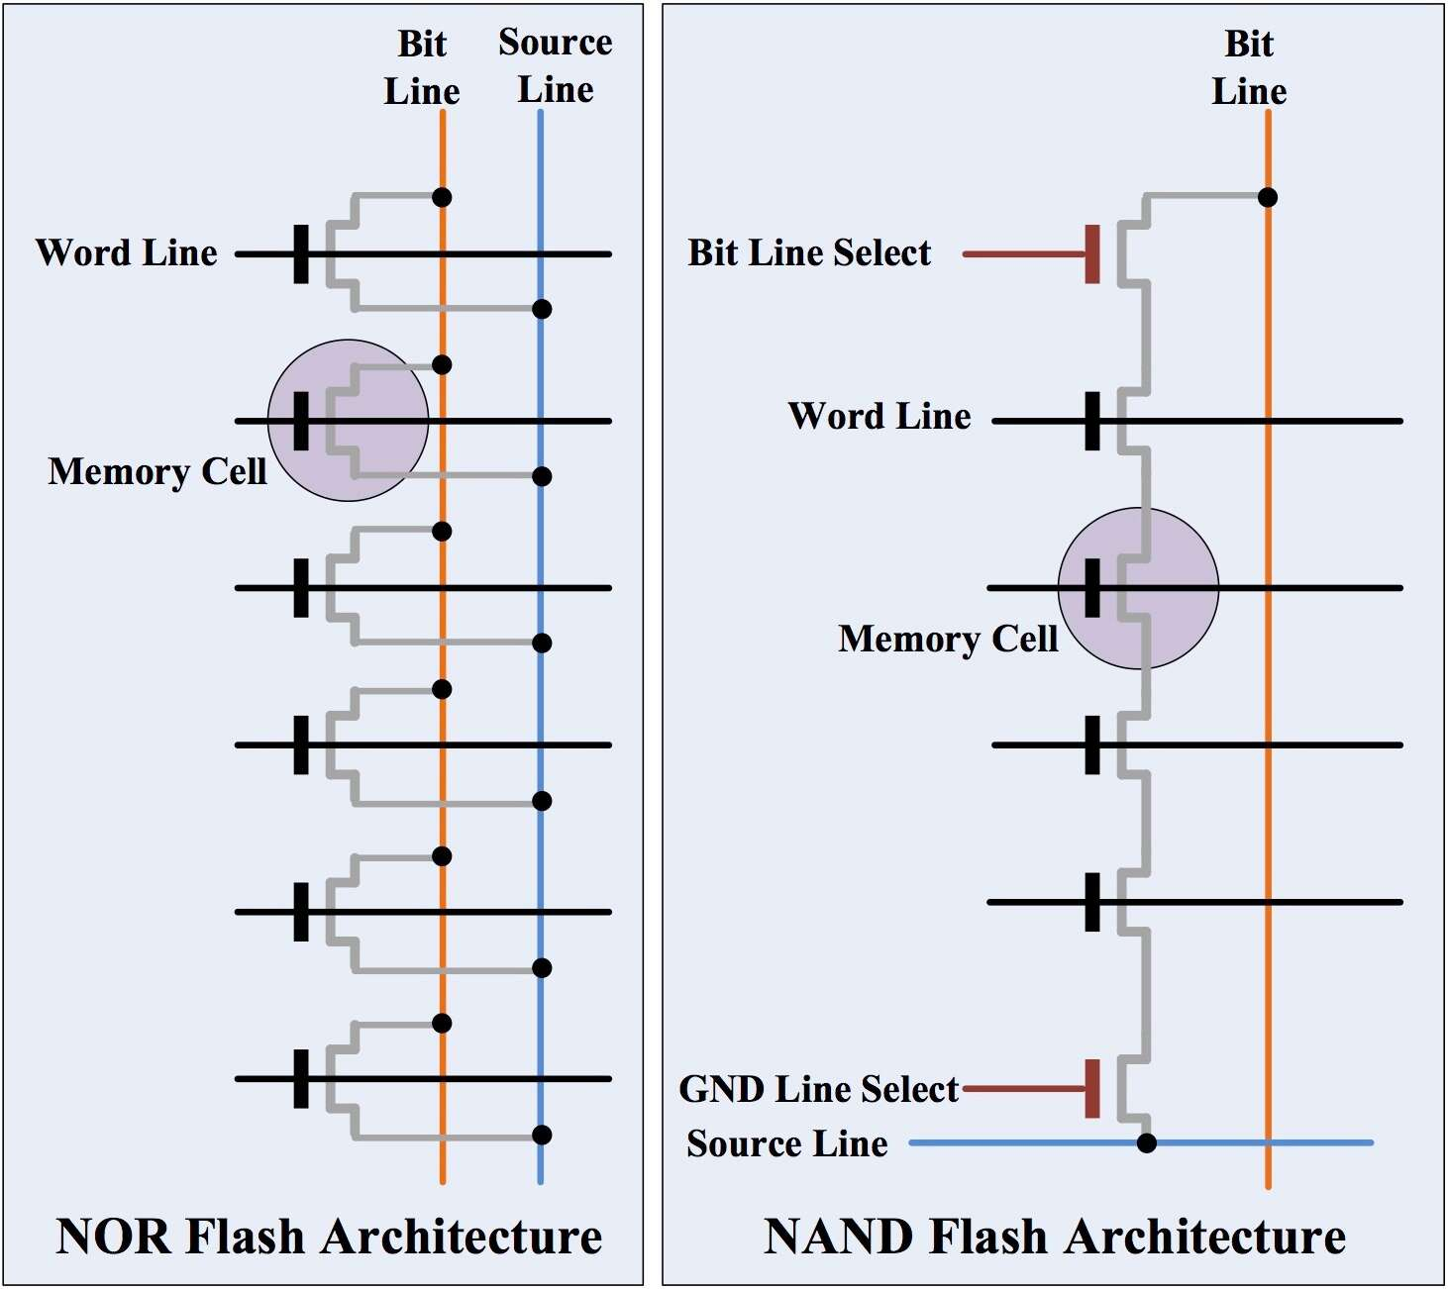

NOR flash vs. NAND flash
NOR Flash:
NOR flash is faster to read than NAND flash, but it's also more expensive due to its larger cell size and it takes longer to erase and write new data.
Use for loading first boot, because of its fast reading option. Used at mobile phones, medical devices etc.
In FPGA it will be used for loading the FPGA at startup!
NAND Flash:
NAND has a higher memory capacity than NOR, faster to erase and write but slower to read.
Used at digital cameras, Usb flash drive and other sd cards devices etc.

