SPI protocol:
The Serial Peripheral Interface (SPI) is a synchronous serial communication interface specification used for short-distance communication, primarily in embedded systems.
SPI Simple connection between master and slave:
SPI devices communicate in full duplex mode using a master-slave architecture with a single master. The master device originates the frame for reading and writing. Multiple slave-devices are supported through selection with individual slave select (SS), sometimes called chip select (CS), lines.
The SPI bus specifies four logic signals:
- SCLK: Serial Clock (output from master)
- MOSI: Master Out Slave In (data output from master)
- MISO: Master In Slave Out (data output from slave)
- SS Or CS: Slave Select or Chip Select(often active low, output from master)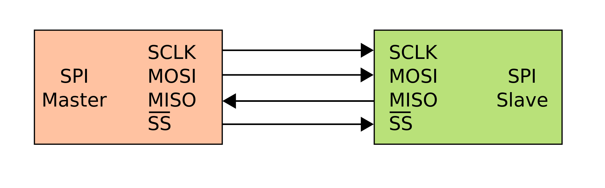

For this course we will use Micron QSPI NOR Flash, the model is: MT25QL128ABA8E12-0SIT
The right clock for our flash is CPOL=1 and rising edge (blue lines)
For the MISO and MOSI see CPHA = 1.
