

MOUNTKENYA UNIVERSITY
SCHOOL OF COMPUTING AND INFORMATICS
DEPARTMENT OF INFORMATION TECHNOLOGY

PROJECT TITLE:
ORIENTACORE INFORMATION MANAGEMENT SYSTEM

BY: VERA MICHAEL
REG NO: BIT/2024/46612

This project proposal submitted in partial fulfilment of requirement for the Mount Kenya university award of bachelor of science in information technology

DECLARATION
I hereby declare that the information presented in this project proposal is accurate and truthful to the best of my knowledge. I am committed to conducting this project with integrity, diligence, and professionalism, adhering to all ethical guidelines and academic standards. This proposal represents my genuine effort to contribute to the development of a career resource system and achieve the stated objectives outlined herein.
Name: VERA MICHAEL
Signature ……………………………………….............................
Date……………………………………….......................................

Name.................................................................................................
Signature...........................................................................................
Dare..................................................................................................

DEDICATION
This project is dedicated to my dear parents for their unwavering financial and emotional support. I also extend my heartfelt appreciation to my classmates and lecturers, whose encouragement and guidance have strengthened me throughout my course.

ACKNOWLEDGEMENT
I thank all those who devoted their energy, resources and time to the success of this project. The foremost ultimate thankyou goes to my determined and ever encouraging project lecturer Dr Ndinda, no words can explain my gratitude for her ever-helping hand through this process. However, I can’t forget the support that both my school administration and my family have granted me through this process.

ABSTRACT
In contemporary academic environments, the psychological, emotional, and developmental wellbeing of students is crucial for academic success and social adjustment. Despite the growing recognition of the importance of guidance and counselling, many schools, particularly in Kenya and Sub-Saharan Africa, continue to rely on manual, paper-based systems that are inefficient, prone to errors, and unable to provide timely interventions. These traditional systems limit data analysis, hinder proactive support, and reduce the overall effectiveness of counselling services, especially in institutions with high student-to-counsellor ratios. The rapid digital transformation in education has largely bypassed the guidance and counselling sector, leaving a critical gap in managing student welfare digitally. The proposed Orient Core Information System addresses this gap by providing a centralized, automated, and user-friendly digital platform for managing counselling sessions, conducting career assessments, tracking academic and behavioural progress, and generating actionable reports. By digitizing records and integrating monitoring dashboards, OrientaCore enables counsellors to deliver accurate, data-driven, and timely interventions, thereby enhancing student support, improving decision-making, and promoting holistic development. This study focuses on the design and implementation of OrientaCore to modernize counselling services, improve operational efficiency, and empower educational institutions to provide consistent and effective guidance to students.

Table of Contents
DECLARATION i
DEDICATION ii
ACKNOWLEDGEMENT iii
ABSTRACT iv
LIST OF ABBREVIATIONS ix
CHAPTER ONE: INTRODUCTION 1
1.1 Introduction 1
1.2 Background of the Study 2
1.3 Problem Statement 2
1.4 Problem Solution 3
1.5 Objectives 3
1.5.1 General Objective 3
1.5.2 Specific Objectives 3
1.6 Research Questions 3
1.7 Scope of Study 4
1.8 Justification 4
1.9 Risks and Mitigation 4
1.10 System Requirements 5
1.10.1 Hardware Requirements 5
1.10.2 Software Requirements 6
1.11 Budget 8
1.12 Gantt Chart 8
CHAPTER TWO: LITERATURE REVIEW 9
2.1 Introduction 9
2.2 Review of Existing Counselling and Career Guidance Systems 9
2.3 Integration Gaps in Current Platforms 11
2.4 Research Contributions and Innovations 12
2.5 Limitations in Previous Counselling Systems 12
2.6 Comparative Analysis of Systems 12
2.7 Summary 13
CHAPTER THREE: RESEARCH METHODOLOGY 14
3.0 Introduction 14
3.1 Research Design 14
3.2 Target Population 15
3.3 Sample Design 15
3.3.1 Sampling Technique 15
3.4 Data Collection Methods 16
3.5 Data Analysis 16
3.6 Data Presentation Methods 17
3.7 Ethical Considerations 17
CHAPTER FOUR: SYSTEM ANALYSIS AND REQUIREMENT MODELING 18
4.1 Introduction 18
4.2 Description of the Implemented System 18
4.3 Modelling Tools 19
4.3.1 Use Case Diagram 19
4.3.2 Activity Diagram 20
4.3.3 Entity Relationship Diagram (ERD) 21
4.1 Requirement Modeling of the Current System 22
4.4.1 Requirement Specification 22
4.4.2 Functional Requirements 22
4.4.3 Non-Functional Requirements 22
4.5 System Requirements 23
4.5.1 Hardware Requirements 23
4.5.2 Software Requirements 23
CHAPTER FIVE: SYSTEM DESIGN 24
5.1 Introduction 24
5.2 Description of the New System 24
5.3 Input Design 24
5.3.1 Wireframe of Input Design 25
5.4 System Architecture 26
5.5 Database Design 27
5.5.1 Conceptual Design (ER Diagram) 27
5.5.2 Logical Design 28
5.6 Security Design 28
5.6.1 Authentication and Access Control 28
5.6.2 Data Protection and Validation 29
5.7 Output Design 29
CHAPTER SIX: SYSTEM IMPLEMENTATION 32
6.1 Introduction 32
6.2 Tools Used for Coding and Testing 32
6.2.2 Coding Tools 32
6.2.2 Testing Tools 32
6.3 System Coding Process 33
6.4 System Test Plan 33
6.5 Change-Over Techniques 34
6.6 Deployment and User Training 34
CHAPTER SEVEN: LIMITATIONS, CONCLUSIONS AND RECOMMENDATIONS 35
7.1 Introduction 35
7.2 System Evaluation 35
7.3 System Limitations 36
7.4 Conclusion 36
7.5 Recommendations 36
REFERENCES 38
APPENDICES 40
APPENDIX I: Questionnaire for Students 40
APPENDIX II: Interview Guide for Academic Staff / Counsellors 41
APPENDIX III: System Architecture Description 41
APPENDIX IV: Sample User Interaction / Dialog Flow 42
APPENDIX V: Sample Code Snippet (Career Assessment Module) 42
APPENDIX VI: Budget Breakdown 43
APPENDIX VII: Gantt Chart Outline 43
APPENDIX VIII: Consent Form 44
APPENDIX IX: Sample Code Snippet 44

Table 1: Budget 8
Table 2:Gantt Chart 8
Table 3 System Test Plan 35

Figure 1 Use Case Diagram 19
Figure 2 Activity Diagram 20
Figure 3 Entity Relationship Diagram (ERD) 21
Figure 4: Login Page 26
Figure 5 :Session Booking Form 27
Figure 6: Conceptual Design (ER Diagram) 28
Figure 7: Users Table 29
Figure 8: Sessions Table 29
Figure 9: Assessment Report 30
Figure 10 Notification 31
Figure 11 exportable (PDF or Excel) Report 32

LIST OF ABBREVIATIONS
AfDB – African Development Bank
API – Application Programming Interface
CBC – Competency-Based Curriculum
CEMIS – County Education Management Information System
DBMS – Database Management System
FGD – Focus Group Discussion
HTML – Hypertext Markup Language
ICT – Information and Communication Technology
JCSE – Kenya Certificate of Secondary Education
KCPE – Kenya Certificate of Primary Education
JWT – JSON Web Token
MyMajors – MyMajors (career guidance platform)
NACOSTI – National Commission for Science, Technology, and Innovation
OS – Operating System
PHP – Hypertext Preprocessor
UNESCO – United Nations Educational, Scientific and Cultural Organization
URL – Uniform Resource Locator
WHO – World Health Organization

CHAPTER ONE: INTRODUCTION

1.1 Introduction
In today’s dynamic and increasingly complex academic environments, the psychological, emotional, and developmental wellbeing of students has become a cornerstone for academic success and social adjustment. The importance of providing timely, structured, and confidential guidance and counselling services has never been more crucial, especially within learning institutions where students face academic pressures, mental health challenges, peer influence, social expectations, and uncertainties about their future careers.
Traditionally, counselling services in schools focused primarily on remedial interventions responding to crises rather than preventing them. With growing awareness of the impact of mental health and career uncertainty on student performance, the scope of guidance and counselling has expanded. Counsellors are now expected to engage students proactively in personal development, academic planning, conflict resolution, and career decision-making. Despite this, many institutions continue to rely on outdated, manual processes such as paper files, handwritten notes, and unstructured interviews. These methods are inefficient, prone to error, limit confidentiality, and delay interventions, especially in institutions with high student-to-counsellor ratios.
The global acceleration of digital transformation has significantly influenced how education and support services are delivered. From e-learning systems to digital libraries and automated attendance tools, educational institutions increasingly embrace technology to enhance operational efficiency. However, the guidance and counselling department remains largely underserved in this digital shift. Schools often lack dedicated digital platforms to manage sessions, assess student needs, track academic and behavioural progress, or generate actionable reports. This technological gap undermines the potential of counselling programs to function effectively.
The proposed OrientaCore Information System addresses this gap. It is designed to be a comprehensive, user-friendly, and secure platform for managing guidance and counselling operations, conducting career assessments, and tracking student progress. By digitizing counselling records, automating career profiling, and integrating dashboards for monitoring students over time, OrientaCore enables counsellors to provide accurate, timely, and data-driven interventions.

1.2 Background of the Study
Guidance and counselling services were introduced in Kenya in the 1970s to respond to growing student needs for psychosocial and academic support. Over the years, these services evolved from informal peer-advice structures to formal departments within schools. Despite the overall technological advancement in education, counselling remains under-digitalized.
The lack of centralized, reliable, and user-friendly digital counselling platforms leads to delayed interventions, challenges in performance tracking, and limited reporting for institutional decision-making. The digitization of student welfare processes is therefore long overdue. OrientaCore will not only store information securely but also facilitate assessments and progress tracking, supporting holistic student development.

1.3 Problem Statement
Current counselling systems in schools are largely manual, relying on paper-based records, handwritten notes, and unstructured interviews to manage student information. These traditional methods are inefficient and prone to errors, making it difficult for counsellors to track student progress effectively. The absence of a centralized digital platform leads to poor record keeping, delays in interventions, and limited ability to analyse behavioural and academic trends. Students’ needs may go unaddressed due to these inefficiencies, resulting in delayed support for academic, social, or emotional challenges. In addition, counsellors face high workloads, especially in institutions with large student populations, which further reduces the quality and timeliness of services. The lack of automation also limits data-driven decision-making, making it harder for school administrators to implement strategic improvements in student support. Overall, the current manual systems fail to provide comprehensive, timely, and proactive guidance for students.

1.4 Problem Solution
The proposed system, OrientaCore, offers an automated and centralized digital platform designed to overcome the shortcomings of current manual counselling systems. It allows counsellors to efficiently manage student information, schedule sessions, and securely store records in a structured format. The system includes career assessment tools, enabling students to make informed choices regarding their academic and career paths. It also tracks both academic and behavioural trends over time, helping counsellors identify students who may need additional support. Reports and dashboards provide administrators with actionable insights for planning interventions and improving service delivery. By streamlining data entry, retrieval, and analysis, OrientaCore reduces the workload on counsellors while enhancing the accuracy and consistency of student information. Ultimately, the system empowers schools to deliver timely, data-driven, and proactive counselling services to all students.

1.5 Objectives

1.5.1 General Objective
To design and implement a digital guidance and counselling system to enhance service delivery, student support, and informed decision-making in learning institutions.

1.5.2 Specific Objectives
- To develop a web-based counselling system for session management and record keeping.
- To incorporate career assessment tools to guide students in making informed choices.
- To integrate student progress tracking features (academic, behavioural).
- To provide counsellors and administrators with analytical reports for intervention.

1.6 Research Questions
- How can digitization improve efficiency in student counselling services?
- What core modules are necessary for a counselling management system?
- How should data be collected, stored, and analysed securely?
- What career assessment methods can be integrated into the system?

1.7 Scope of Study
The study focuses on secondary and tertiary learning institutions within Kenya. The system targets counsellors, students, and administrators as end-users. Key features include career assessments, progress tracking, and digital management of counselling sessions. The system complements, rather than replaces, traditional counselling.

1.8 Justification
With growing demand for digital transformation in student support services, a system like OrientaCore bridges the gap in data collection, analysis, and timely intervention. It is scalable, secure, and customizable for different institutional needs. The system improves service delivery, enhances student experience, and reduces administrative burden.

1.9 Risks and Mitigation
Data Breach and Unauthorized Access
Mitigation: Multi-level authentication, data encryption, and role-based access control.
System Downtime
Mitigation: Reliable hosting, automatic failover, and scheduled maintenance.
Resistance to Technology Adoption
Mitigation: User training, demonstrations, and involvement in design/testing.
Budget Constraints
Mitigation: Prioritize essential features, use open-source tools, and seek institutional support.
Data Loss Due to System Failure or Attacks
Mitigation: Regular backups, disaster recovery protocols, and security monitoring.
Internet Connectivity Challenges
Mitigation: Offline-first design, low-bandwidth optimization, and SMS-based notifications.
System Misuse or Internal Sabotage
Mitigation: Activity logging, ICT policies, and monitoring access patterns.
Privacy Concerns
Mitigation: Secure data handling, consent, and compliance with local data protection policies.
Compatibility Issues
Mitigation: ICT infrastructure audit and cloud/local deployment options.
Security Vulnerabilities
Mitigation: Regular security testing, patch updates, and secure coding practices.

1.10 System Requirements
To ensure the smooth development, deployment, and operation of the OrientaCore Information System, both hardware and software components are essential. These requirements have been carefully selected to balance performance, cost-efficiency, scalability, and ease of maintenance within a typical school or institutional environment in Kenya.

1.10.1 Hardware Requirements
Client Computers (Counsellors & Admin Use)
- Minimum: Intel Core i3 processor, 4GB RAM, 250GB HDD
- Recommended: Intel Core i5+, 8GB RAM, SSD storage
- Purpose: Used by counsellors and administrators to access the system’s dashboard, manage student profiles, schedule sessions, and generate reports. Institutional Server (for local deployment)
- Minimum: Quad-core processor, 8GB RAM, 1TB HDD, Linux-compatible
- Purpose: Hosts the OrientaCore system in cases where internet/cloud access is limited. Cloud deployment may replace the need for an on-site server.
Internet Router and LAN Setup
- Purpose: Required for internet access, system synchronization, and enabling multiple users to access the platform concurrently across different departments.
Tablets or Mobile Devices (Optional)
Android tablets (2GB RAM+, 8” screen size recommended)
- Purpose: For mobile data entry during classroom visits, student surveys, and remote counselling sessions.
Backup Power Supply (UPS)
- Purpose: Ensures system remains operational during power outages, preventing data loss and hardware damage.
Printer
- Purpose: For printing session reports, consent forms, or school-wide counselling reports as needed.

1.10.2 Software Requirements
Operating System (OS)
- Server: Linux (Ubuntu, CentOS) or Windows Server
- Client Machines: Windows 10/11 or Ubuntu Desktop
Purpose: Provides the base environment to run backend/frontend applications.
Web Server Software
Apache HTTP Server or NGINX
- Purpose: Handles HTTP requests between the client and server components.
Database Management System (DBMS)
MySQL or PostgreSQL
Purpose: Stores structured data such as student profiles, session records, assessment scores, and logs.

Backend Development Framework
Django (Python), Laravel (PHP), or Express (Node.js)
Purpose: Facilitates backend development for APIs, business logic, session handling, and system security.
Frontend Technologies
HTML5, CSS3, JavaScript
- Frameworks: React.js or Vue.js
- Purpose: Builds the user interface that counsellors, students, and administrators interact with.
Authentication and Security Tools
JSON Web Tokens (JWT), OAuth2.0
Browser Compatibility
Google Chrome, Mozilla Firefox, Microsoft Edge
- Purpose: System should function smoothly across all major web browsers to ensure user accessibility.

1.11 Budget
Item | Estimated Cost (KES)
Data collection (surveys, interviews) | 15,000
Software tools and licenses | 30,000
System development (chatbot design & coding) | 50,000
Testing and evaluation | 20,000
Hosting and deployment | 25,000
Documentation and reporting | 10,000
Miscellaneous | 10,000
Total | 160,000
Table 1: Budget

1.12 Gantt Chart
Activity | Month 1 | Month 2 | Month 3 | Month 4 | Month 5 | Month 6
Problem Analysis & Requirements | █████
System Design & Prototyping |  | █████
System Development |  |  | █████ | █████
Testing & Refinement |  |  |  |  | █████
Evaluation & Documentation |  |  |  |  |  | █████
Table 2:Gantt Chart

CHAPTER TWO: LITERATURE REVIEW

2.1 Introduction
In recent years, education systems globally have begun to recognize the value of structured, data-driven guidance and counselling services. Technological solutions have been instrumental in revolutionizing academic administration, but guidance and counselling services—especially in developing countries—have lagged in adopting such innovations. This chapter reviews related literature on existing counselling information systems, examines the evolution of digital guidance tools, and identifies theoretical and practical gaps that the proposed OrientaCore Information System seeks to fill.
Education is no longer solely about imparting academic knowledge; it now includes addressing students' social, emotional, and career needs. According to the World Health Organization (WHO), nearly 10–20% of adolescents globally experience mental health conditions, and many remain undiagnosed or untreated (WHO, 2022). Schools are ideal environments for early identification and intervention. Yet, without digital tools, the ability to respond effectively remains limited.
Kenyan schools, like many in Africa, have traditionally relied on manual documentation for guidance and counselling. This approach is not only time-consuming and prone to loss but also fails to provide long-term tracking of student development. The digitization of these services would not only streamline workflows but also enable data-driven decisions that support timely interventions. The OrientaCore Information System aims to bridge this gap by offering an integrated platform tailored to Kenya’s educational and infrastructural context.

2.2 Review of Existing Counselling and Career Guidance Systems
Several digital platforms have been developed globally and regionally to support students in academic counselling, behavioural support, and career planning. These systems differ in terms of design, accessibility, regional customization, and how well they integrate with institutional workflows.
One notable example is Naviance, a U.S.-based college and career readiness platform widely adopted in American high schools. Developed by Hobsons (2021), Naviance provides students with tools such as career interest inventories based on Holland Codes, personality assessments, goal tracking modules, and college application planning features. It also integrates with academic data to provide a holistic view of college readiness. Key features include tools for profiling career interests, integration with U.S. colleges and standardized testing systems like the SAT/ACT, and modules for goal setting and task management. However, lessons drawn from its use highlight that despite its rich functionality, Naviance is highly tailored to the American education system. It is expensive for adoption in developing countries, lacks localized career data, and requires infrastructure that many African schools lack—making it unsuitable or inaccessible for many institutions in contexts such as Kenya (Hobsons, n.d.; Counselor1Stop, n.d.).
MyMajors is another online diagnostic tool designed to assist students in identifying suitable college majors based on their individual strengths and interests (MyMajors, 2022; Grupe, 2002). It emphasizes a quick, user-friendly diagnostic process through brief surveys, offering career recommendations accordingly. While it is efficient for initial exploration, it lacks advanced functionalities such as integration with student academic records, behaviour tracking, or personalized follow-up. Its key strength lies in the simplicity of its use and its relevance for tertiary education institutions. However, a major limitation is its inability to support the more complex counselling needs of secondary and post-secondary learners, particularly in resource-limited settings.
In the Kenyan context, the County Education Management Information System (CEMIS) serves as a government platform used in certain counties for tracking student enrolment and academic performance. According to Otieno & Wango (2021), CEMIS is highly effective for generating reports on enrolment trends, student transfers, and national exam results like KCSE/KCPE. Its primary benefit is administrative efficiency in reporting and data tracking. Nonetheless, the major gap is its complete lack of modules for psychosocial, behavioural, or emotional development tracking. This reveals a pressing need for systems that move beyond academic reporting to support the holistic development of students.
Another widely discussed tool is OpenEMIS, a modular and open-source education management system supported by UNESCO and deployed in over 20 countries including Uganda and Bangladesh (UNESCO, 2018). The system’s major advantage is its flexibility and customizability, allowing institutions to adapt data fields and workflows to fit local contexts. However, its implementation often demands high ICT capacity and technical infrastructure. The downside is that without built-in counselling functionalities and given the technical skill required for deployment, its use is limited in schools with minimal technological support or guidance counselling personnel.
According to Otieno & Wango (2021), about 72% of Kenyan schools still depend on manual methods—mostly handwritten notebooks—for guidance and counselling. This manual documentation poses major challenges, including vulnerability to physical damage, lack of confidentiality, and difficulties in consistent follow-up. The implications of these findings are significant: without secure and efficient digital platforms, schools are unable to ensure effective record-keeping, consistent tracking of students’ progress, or timely interventions. This demonstrates the urgent need for user-friendly, secure, and digitally enabled counselling systems in Kenyan schools.
Across Africa, career guidance platforms remain underdeveloped and underutilized. A study by the African Development Bank (2020) found that most African countries lack structured digital career guidance tools in schools. One example is Career Planet, a mobile application in South Africa that offers basic career guidance. While innovative, the app’s reach is constrained by low smartphone penetration and limited digital literacy among learners in many rural and underserved areas. This reinforces the lesson that for digital guidance platforms to succeed in African settings, they must be mobile-optimized, culturally appropriate, and capable of functioning in environments with limited internet access and digital infrastructure.

2.3 Integration Gaps in Current Platforms
Most reviewed systems fail to unify academic, behavioural, and psychosocial information. They either emphasize academics (like CEMIS) or career readiness (like Naviance) but rarely both. The absence of integrated dashboards limits the ability of counsellors to detect patterns across data types. OrientaCore is designed to bridge this integration gap. By offering modules for academic progress, behavioural incidents, emotional wellbeing, and career aspirations, it empowers counsellors to deliver holistic and proactive support.

2.4 Research Contributions and Innovations
This project contributes to the advancement of student support systems by offering tools specifically designed for the realities of Kenyan schools, such as limited internet connectivity and the need for offline functionality. It integrates academic performance data, behavioural records, and career guidance information into a single platform, enabling counsellors to make informed, data-driven interventions. Additionally, the system aligns with national education policies, including the Competency-Based Curriculum (CBC) and Vision 2030, promoting holistic student development. These innovations build upon the work of Wango (2013), who emphasizes the importance of structured counselling services, and Ndirangu et al. (2019), who demonstrate the positive relationship between counselling support and academic performance. By embedding these evidence-based practices into a centralized, user-friendly digital platform, the OrientaCore system enhances the effectiveness, accessibility, and impact of school counselling in Kenyan contexts

2.5 Limitations in Previous Counselling Systems
Many existing counselling systems, despite their innovative features, exhibit significant limitations that hinder their effectiveness in school settings. Government-run platforms tend to be over-centralized and inflexible, offering limited adaptability for individual schools. Additionally, most global systems assume consistent electricity, reliable internet connectivity, and a high level of digital literacy, conditions that are often unavailable in many Kenyan schools. High licensing costs further restrict access for public institutions, while data is frequently siloed, preventing integration of academic, emotional, and career information needed for holistic student support. OrientaCore addresses these challenges by providing a flexible, lightweight, and locally tailored platform that integrates multiple aspects of student wellbeing while remaining accessible and practical for diverse school contexts.

2.6 Comparative Analysis of Systems
A comparative analysis of existing counselling and guidance platforms reveals several critical differences when measured against OrientaCore, particularly in academic data integration, career assessment capabilities, behavioural tracking, and adaptability to local contexts. Naviance excels in career assessment through personality profiling and college matching but lacks integration with academic performance data and behavioural tracking, and its design is rigidly tailored to the U.S. education system, limiting its applicability in African contexts. MyMajors focuses exclusively on career matching using brief questionnaires, without linking to academic records or monitoring student behaviour, and offers minimal customization for schools in resource-limited settings. CEMIS provides effective academic tracking and administrative reporting but does not include career assessment or behavioural monitoring functionalities. OpenEMIS offers modularity and local customization options, yet implementing behavioural or career modules often requires advanced ICT skills and financial resources. In contrast, OrientaCore seamlessly integrates all four dimensions, enabling schools to monitor academic performance, track behavioural incidents, assess emotional wellbeing, and provide structured career guidance. Designed with local constraints in mind—such as offline access, affordability, and cultural relevance—OrientaCore offers a comprehensive, student-centred solution that combines best international practices with the practical realities of Kenyan school environments.

2.7 Summary
This literature review has shown that existing systems do not adequately serve the guidance and counselling needs of Kenyan students. The few systems in use are either too narrow, too costly, or not designed for school environments in Africa. OrientaCore stands out by integrating student wellbeing, behaviour monitoring, academic progress, and career planning—all in a mobile-friendly, easy-to-use platform.
Additionally, the system’s design is rooted in practical research and real-world needs, with the flexibility to adapt to diverse school settings. The knowledge gained from this review provides a strong foundation for OrientaCore’s development and underscores the need for evidence-based digital innovation in the counselling space.

CHAPTER THREE: RESEARCH METHODOLOGY

3.0 Introduction
Research methodology refers to the systematic process of identifying, collecting, analysing, and interpreting data in order to achieve the objectives of a study (Kumar, 2020). For the development of the OrientaCore Information System, which is a student-focused educational and psychological solution, the methodology blends empirical research with user-cantered system design. This chapter outlines the systematic procedures used to gather, analyse, and interpret data that informed the system’s development. It details the research design, target population, sampling methods, data collection techniques, data analysis, presentation strategies, and the ethical standards observed throughout the research process (Kothari, 2004). By choosing a methodological framework that bridges both technical development and social sciences, the project ensures that the resulting solution is not only functional but also rooted in real user needs, institutional context, and the realities of Kenyan education settings (Otieno & Wango, 2021).

3.1 Research Design
The study employed a mixed-methods research design, integrating both qualitative and quantitative approaches (Creswell, 2014). This decision was informed by the complex nature of the problem being addressed—combining human behaviour, administrative systems, and technological interventions. Quantitative methods were particularly useful for collecting structured, numerical data, such as the frequency of counselling sessions per week, average time spent with each student, and the percentage of institutions already using any form of digital guidance (AfDB, 2020). On the other hand, qualitative methods provided rich descriptive insights into stakeholders' experiences, perceptions, preferences, and frustrations with current tools and processes (Wango, 2013). The integration of descriptive survey research enabled the collection of data from a broader population, while case study elements helped the researchers to understand in detail how a few schools had implemented semi-digital counselling workflows (Otieno & Wango, 2021). Together, these strategies facilitated triangulation, enhancing both the validity and reliability of the findings (Mugenda & Mugenda, 2003).

3.2 Target Population
The study’s target population included individuals who either deliver, manage, or benefit directly from counselling services in academic institutions. This included school counsellors and headteachers responsible for designing and delivering psychosocial and academic guidance, career officers in colleges and universities who advise students on further studies or job market readiness, ICT coordinators and administrators who oversee implementation and management of digital systems, and students, specifically those in Form 3 and 4, as well as second- and third-year students in universities and colleges, who are the primary users and beneficiaries of counselling services (Ndirangu, Mwangi, & Ochieng, 2019). This broad and inclusive population allowed the research to gain multiple perspectives—strategic, technical, and experiential—on the limitations of current systems and the anticipated benefits of the proposed solution (UNESCO, 2018).

3.3 Sample Design

3.3.1 Sampling Technique
A purposive sampling strategy was adopted, focusing on individuals with relevant experience and direct engagement in school counselling or educational technology (Creswell, 2014). This non-random method ensured that the data collected was highly specific, credible, and aligned with the research objectives. Participants were selected from both urban and semi-urban institutions in Nairobi, Kiambu, and Nakuru counties. These regions were chosen for their diverse education environments, access to infrastructure, and willingness of institutions to participate in technology-related research (AfDB, 2020). The final sample size included 50 participants: 5 school counsellors, 3 ICT administrators, 2 school principals, and 40 students (split evenly between high schools and colleges/universities). This balanced mix enabled the study to compare expectations and experiences across roles, age groups, education levels, and institutional setups (Otieno & Wango, 2021).

3.4 Data Collection Methods
To ensure comprehensive data capture, the study adopted five complementary data collection methods, each serving a unique purpose. Structured questionnaires were administered to counsellors and students, including both closed-ended (e.g., Likert scale) and open-ended questions to assess the frequency of counselling service usage, satisfaction with current processes, awareness of digital tools, and desired features in a future system (Mugenda & Mugenda, 2003). Semi-structured interviews were conducted with selected school counsellors, ICT administrators, and principals to explore issues in greater depth, including institutional challenges, system expectations, and historical attempts to digitize guidance (Wango, 2013). Researchers conducted on-site observations in three schools, recording how counselling sessions were managed, how documents were stored, and how students accessed services (Otieno & Wango, 2021). Document analysis involved reviewing counselling files, referral logs, student progress reports, and institutional policies to highlight lack of standardization, difficulties in retrieval, and gaps in historical data (UNESCO, 2018). Two focus group discussions were held—one with students and one with experienced counsellors—to facilitate dialogue on user expectations, design preferences, and ethical concerns like confidentiality and access control (Ndirangu et al., 2019).

3.5 Data Analysis
The data collected from all the above methods were rigorously analysed using both statistical and thematic approaches. Quantitative data from questionnaires were analysed using Microsoft Excel and SPSS, with descriptive statistics (percentages, frequencies, mean scores) summarizing user demographics and general trends in counselling usage and satisfaction (Creswell, 2014). Qualitative data from interviews and FGDs underwent thematic analysis, with responses manually coded into categories such as “challenges with current systems,” “desired system features,” and “barriers to implementation” (Wango, 2013). Emerging themes were compared across participants to identify consistent patterns and divergent views. This dual approach ensured that the study not only measured trends but also understood their underlying causes and context (Kumar, 2020).

3.6 Data Presentation Methods
Findings were presented using a variety of visual and narrative formats to enhance clarity and accessibility. Tables displayed demographic breakdowns and response frequencies (Mugenda & Mugenda, 2003). Pie charts and bar graphs illustrated preferences and usage patterns, such as the percentage of students who had visited a counsellor in the past year (AfDB, 2020). Narrative summaries highlighted key quotes and insights from FGDs and interviews (Otieno & Wango, 2021). Infographics were considered for presenting the system feature wish-list in a student-friendly format for future design reference (UNESCO, 2018). This multi-format approach ensured that both technical and non-technical audiences could understand and interpret the findings effectively (Hobsons, 2021).

3.7 Ethical Considerations
Ethical integrity was foundational to the entire research process. Informed consent was obtained from all participants, who were clearly informed of the study’s goals, procedures, and their rights (Resnik, 2020). Data collected were anonymized, with no personal identifiers used, and all files were stored in encrypted formats to ensure confidentiality (Kothari, 2004). Participation was voluntary, with respondents free to decline or withdraw at any time (Kumar, 2020). Institutional permissions were sought from school heads and college deans before engaging with staff or students or accessing institutional records (Otieno & Wango, 2021). All data were used strictly for academic and developmental purposes, and findings were not shared with third parties without consent. By adhering to these principles, the study-maintained trust and complied with national and institutional research ethics guidelines, including those provided by NACOSTI in Kenya (Resnik, 2020).

CHAPTER FOUR: SYSTEM ANALYSIS AND REQUIREMENT MODELING

4.1 Introduction
This chapter presents a detailed analysis of the implemented OrientaCore Information System (OCIS), focusing on requirement modelling, user interactions, and overall system behaviour. It defines the system boundaries, key stakeholders, and the diagrams that represent how the system functions. The OrientaCore System was designed to automate counselling, career assessment, and student progress tracking in educational institutions, ensuring data accuracy, better communication, and efficient service delivery between counsellors, students, and administrators.

4.2 Description of the Implemented System
The implemented OrientaCore Information System (OCIS) is a web-based platform developed to automate and streamline counselling, career assessment, and student progress tracking processes in academic institutions. The system replaces traditional manual counselling methods, which were time-consuming, error-prone, and heavily dependent on paper records, with a centralized, efficient, and secure digital platform. It serves three primary user roles Administrators, Counsellors, and Students each equipped with a customized dashboard that supports specific operations. Administrators oversee the entire platform by managing user accounts, monitoring counselling sessions, and generating institutional reports. Counsellors manage counselling schedules, conduct career assessments, record session outcomes, and track student progress, while students interact with the system to book sessions, take assessments, and access personalized feedback.
The OrientaCore Information System integrates several key functionalities that collectively enhance the efficiency and reliability of counselling and career management within academic institutions. The system features automated student registration and profiling, allowing centralized storage of student records and counselling histories for easy access and tracking. It also provides an online counselling session booking and feedback module that enables students to schedule appointments, receive feedback, and communicate with counsellors seamlessly. In addition, the system incorporates career assessment tools such as questionnaires, automated test scoring, and analytical reports to assist in guiding students toward suitable career paths based on their abilities and interests. Student progress tracking and report generation are also automated, enabling counsellors to monitor individual development over time and produce detailed performance summaries for institutional reporting. Furthermore, the platform ensures secure data management and communication among users through role-based access control, data encryption, and protected message exchanges between students, counsellors, and administrators. Collectively, these functionalities streamline the counselling process, improve data integrity, and foster a more effective and transparent guidance environment.

4.3 Modelling Tools

4.3.1 Use Case Diagram
The use case diagram illustrates the main system users and their interactions with the system functionalities. It highlights how administrators, counsellors, and students interact with modules such as counselling sessions, career tests, and report management.
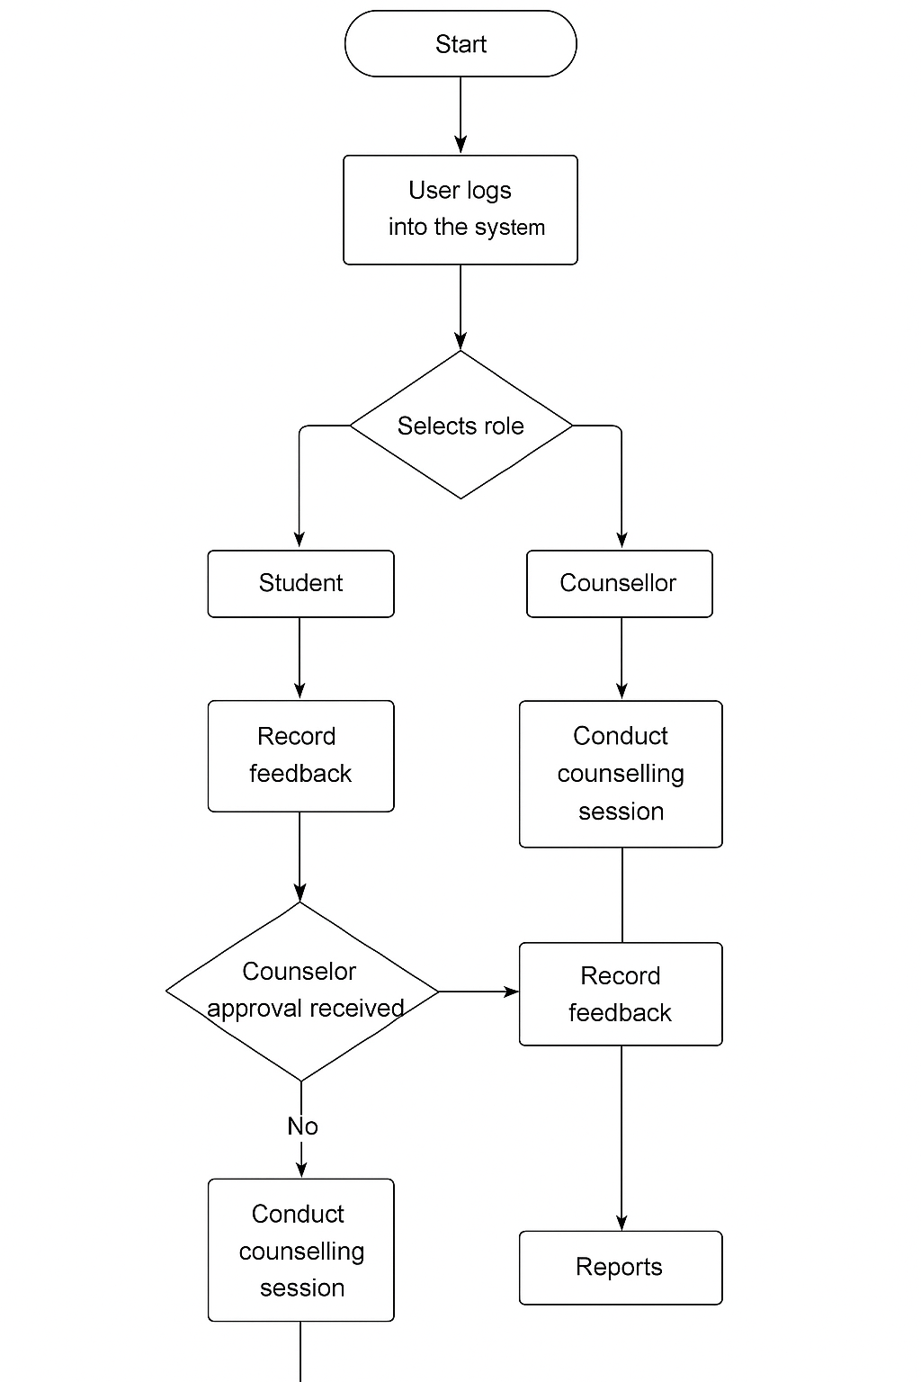
Figure 1 Use Case Diagram

4.3.2 Activity Diagram
The activity diagram represents the workflow of the system, showing sequential steps in operations such as logging in, booking counselling sessions, and generating reports. It defines decision points, system responses, and the flow of activities between users.

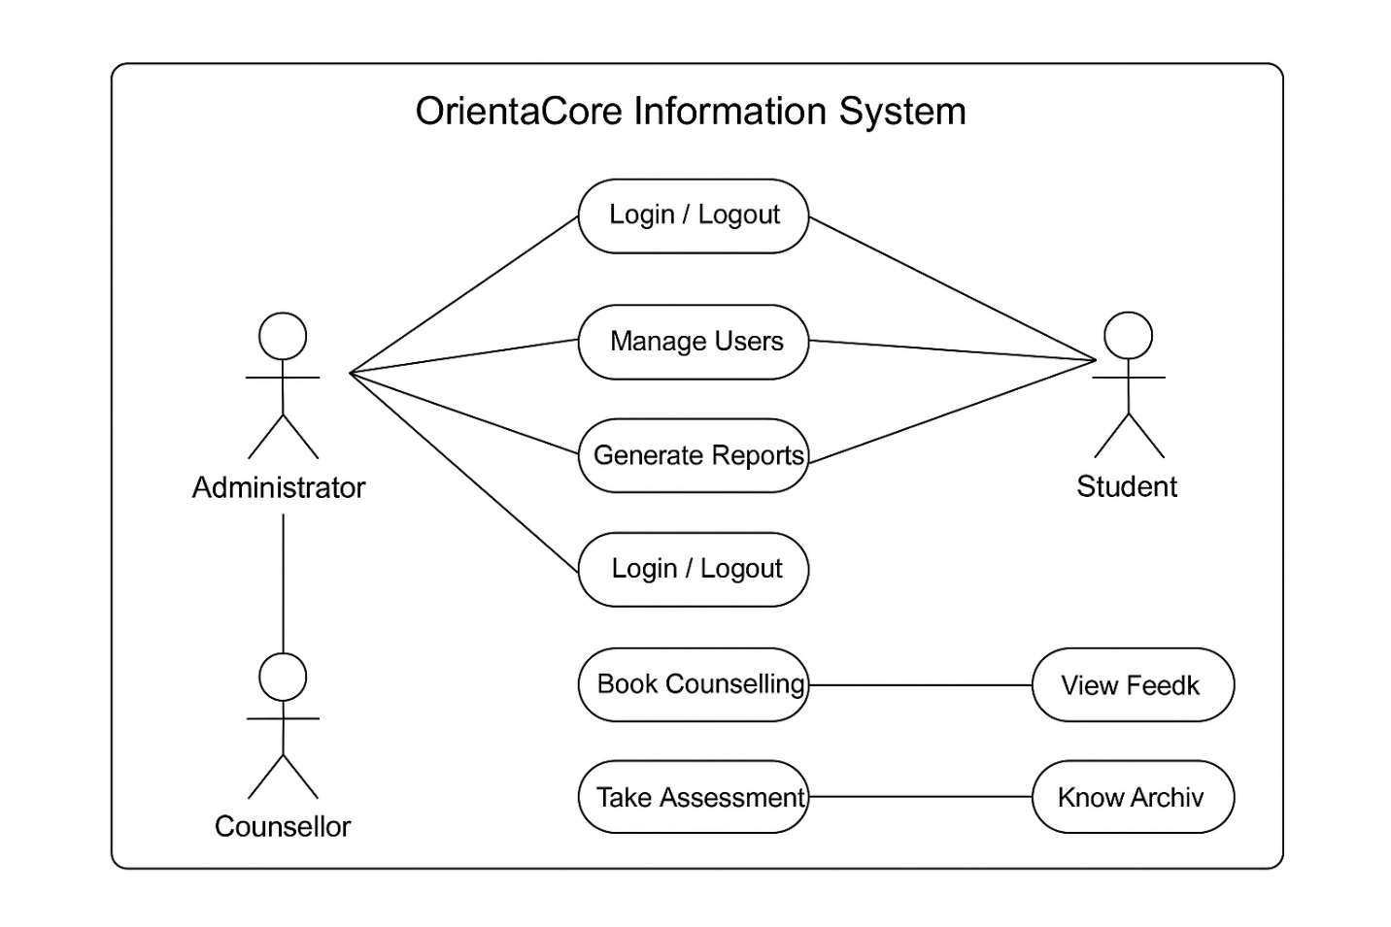
Figure 2 Activity Diagram

4.3.3 Entity Relationship Diagram (ERD)
The ERD shows the relationships among entities in the OrientaCore database, such as Students, Counsellors, Sessions, Assessments, and Reports. It helps in visualizing how data is structured and interlinked for efficient storage and retrieval.

Counsellor
generate
produce
report
assessment
takes
session
books
Student
Admin
register
conduct

Figure 3 Entity Relationship Diagram (ERD)

4.1 Requirement Modelling of the Current System
The current manual counselling process in most institutions involves physical records, face-to-face scheduling, and manual assessment scoring. This system digitizes those processes.

4.4.1 Requirement Specification
Information was gathered through observation, interviews, and questionnaires with counsellors and students. Findings revealed inefficiencies in booking sessions, tracking progress, and managing student data. The system was designed to ensure improved accessibility, faster communication, and automated reporting.

4.4.2 Functional Requirements
The OrientaCore Information System (OCIS) was developed to meet specific functional requirements that define its core operations and ensure user efficiency. The system provides secure user authentication, enabling administrators, counsellors, and students to log in with unique credentials and access features based on their roles. It supports online counselling session management, allowing students to book, reschedule, or cancel appointments, while counsellors can approve and record feedback for each session. The system also includes a career assessment module that enables students to take aptitude and personality tests, which are automatically scored and analysed to guide career choices. Additionally, counsellors can track student progress across multiple sessions and generate comprehensive reports summarizing counselling outcomes and performance trends. The system also provides notification alerts to remind users about upcoming sessions and feedback updates. Together, these functionalities ensure that OrientaCore delivers an organized, efficient, and data-driven counselling experience.

4.4.3 Non-Functional Requirements
In addition to the functional aspects, the OrientaCore Information System (OCIS) was developed to meet several non-functional requirements that ensure system quality, efficiency, and reliability. The system emphasizes usability, offering a simple, intuitive, and user-friendly interface that allows both technical and non-technical users—such as counsellors and students—to navigate effortlessly. It upholds a high level of security through role-based access control, password encryption, and restricted database privileges to protect sensitive counselling data. The system’s availability is guaranteed by its web-based nature, allowing authorized users to access services at any time and from any location. Scalability was also considered, ensuring that the system can accommodate a growing number of users and sessions without compromising performance. In terms of performance, OrientaCore delivers fast response times and optimized database queries to support smooth operation across devices. Furthermore, the system is built with maintainability in mind, using modular PHP and MySQL code structures that simplify updates, debugging, and feature enhancements. These non-functional requirements collectively ensure that OrientaCore remains secure, accessible, efficient, and adaptable to institutional needs.

4.5 System Requirements

4.5.1 Hardware Requirements
The OrientaCore Information System (OCIS) requires basic but reliable hardware components to ensure smooth functionality and performance. The system operates effectively on a standard personal computer or laptop equipped with at least an Intel Core i5 processor or its equivalent, and a minimum of 4 GB RAM to support multitasking and efficient processing of data. It also requires at least 256 GB of storage capacity to host system files, user data, and database records. A display resolution of 1024 × 768 pixels or higher is recommended for clear viewing of the system’s web interfaces. External peripherals such as a printer and scanner may also be used for report printing and document uploads when necessary. These hardware specifications ensure that the system runs efficiently without lag or data processing delays.

4.5.2 Software Requirements
The OrientaCore Information System operates in a web-based environment that utilizes open-source software tools to minimize costs and enhance flexibility. The system runs on Windows 10 or 11, or any compatible Linux distribution, and requires the XAMPP server package, which integrates Apache, PHP, and MySQL for local deployment and testing. The backend is developed using PHP 8+ for server-side scripting, while the frontend utilizes HTML5, CSS3, and JavaScript to provide a responsive and interactive user interface. MySQL serves as the primary database management system for storing user records, session data, and reports. For optimal performance, the system should be accessed using a modern web browser such as Google Chrome, Mozilla Firefox, or Microsoft Edge, all of which ensure compatibility with the latest web standards. These software components collectively create a stable, secure, and scalable environment for implementing the OrientaCore platform.

CHAPTER FIVE: SYSTEM DESIGN

5.1 Introduction
This chapter presents the system design of the OrientaCore Information System (OCIS), building upon the findings from the analysis phase. It outlines how the proposed system has been structured in terms of architecture, modules, database organization, and user interfaces. The chapter explains how the design ensures system usability, scalability, and security while addressing the challenges identified in the manual guidance and counselling processes.
The OrientaCore system was designed following object-oriented and modular development principles to enhance maintainability and scalability. The design process focused on providing a user-friendly interface for counsellors, students, and administrators while ensuring secure data handling and effective communication among all stakeholders.

5.2 Description of the New System
The OrientaCore Information System is a web-based counselling and career guidance management platform developed to automate the entire counselling process—from session booking and progress tracking to report generation and communication between counsellors and students.
The system is designed with three main user roles:
- Administrator: Manages users, oversees counselling activities, and generates analytical reports.
- Counsellor: Schedules and conducts counselling sessions, provides feedback, and updates student progress records.
- Student: Books counselling appointments, completes career assessments, and views feedback or progress reports.
Each user logs in using credentials assigned by the administrator. Once authenticated, the user is redirected to a customized dashboard displaying role-specific tasks and information.

5.3 Input Design
The input design of OrientaCore emphasizes data accuracy, user convenience, and system efficiency. Every data entry form has been designed to minimize errors and simplify data capture across all modules.
Design Objectives:
- Ensure user-friendly input forms with clear labels and help text.
- Maintain consistency in input layout and validation messages.
- Enable both client-side and server-side validation for security and accuracy.
Design Considerations:
- Consistency: All input fields such as text boxes, dropdown menus, and buttons maintain a uniform style throughout the system.
- Validation: Input data such as email addresses, student IDs, and phone numbers are validated to prevent invalid entries.
- Navigation: Buttons such as Submit, Cancel, and Back are strategically positioned for intuitive navigation.
- Accessibility: The forms are mobile-responsive and tested across different browsers.

5.3.1 Wireframe of Input Design
The following wireframes illustrate key input interfaces.

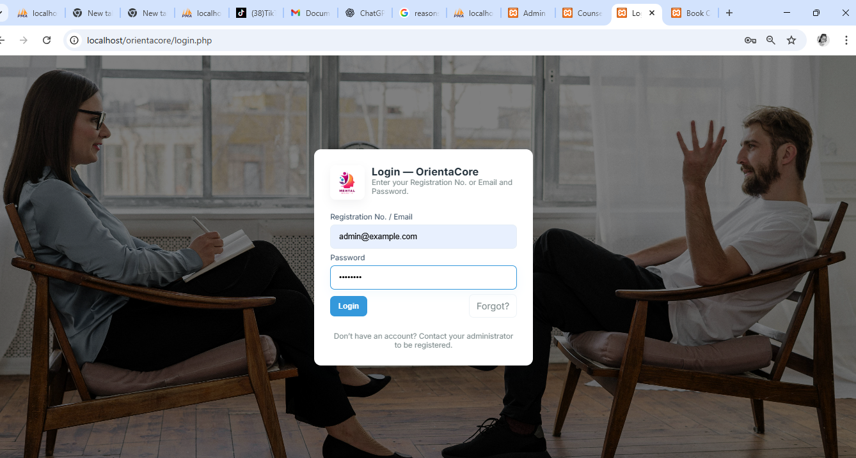
Figure 4: Login Page
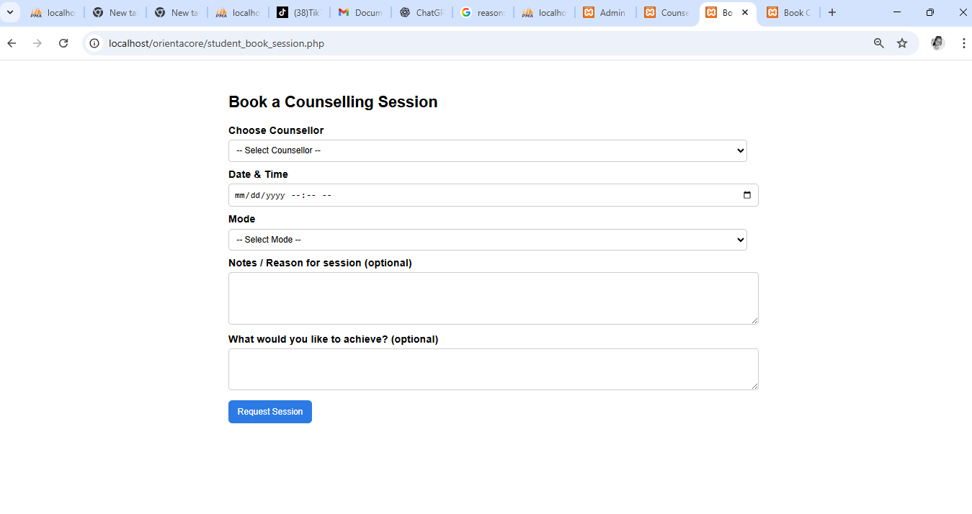
Figure 5 :Session Booking Form

5.4 System Architecture
The OrientaCore system adopts a three-tier architecture model to separate the system’s presentation, business logic, and data management layers.
- Presentation Layer: Developed using HTML, CSS, and JavaScript to provide an interactive and responsive user interface.
- Application/Logic Layer: Built using PHP for processing user requests, managing sessions, validating inputs, and handling communication between frontend and backend.
- Data Layer: Managed using MySQL, which stores student records, session logs, counsellor data, and reports.

5.5 Database Design

5.5.1 Conceptual Design (ER Diagram)
The Entity Relationship Diagram (ERD) defines the logical structure of the database. It represents the major entities and their relationships.
Main Entities:
- Users: Stores user credentials and roles (Admin, Counsellor, Student).
- Sessions: Contains details of counselling appointments and feedback.
- Assessments: Stores career test questions, results, and recommendations.
- Progress Reports: Tracks student growth and counselling history.

Student
takees
Counsellor
report
assessment
session
books
Admin
register
conduct

produce

generate

Figure 6: Conceptual Design (ER Diagram)

5.5.2 Logical Design
Table 1: Users Table
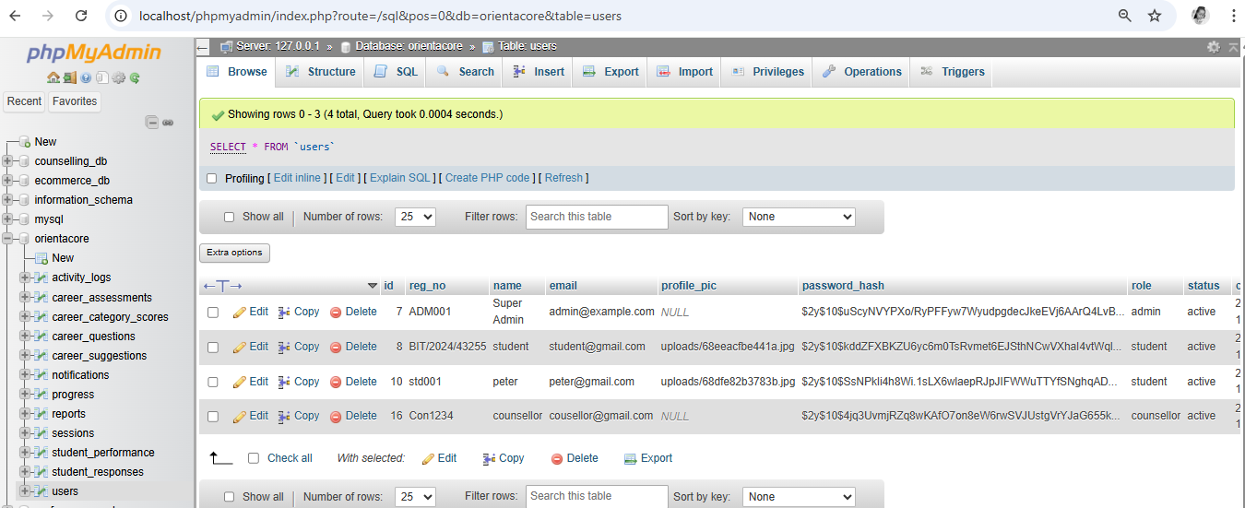
Figure 7: Users Table
Table 2: Sessions Table
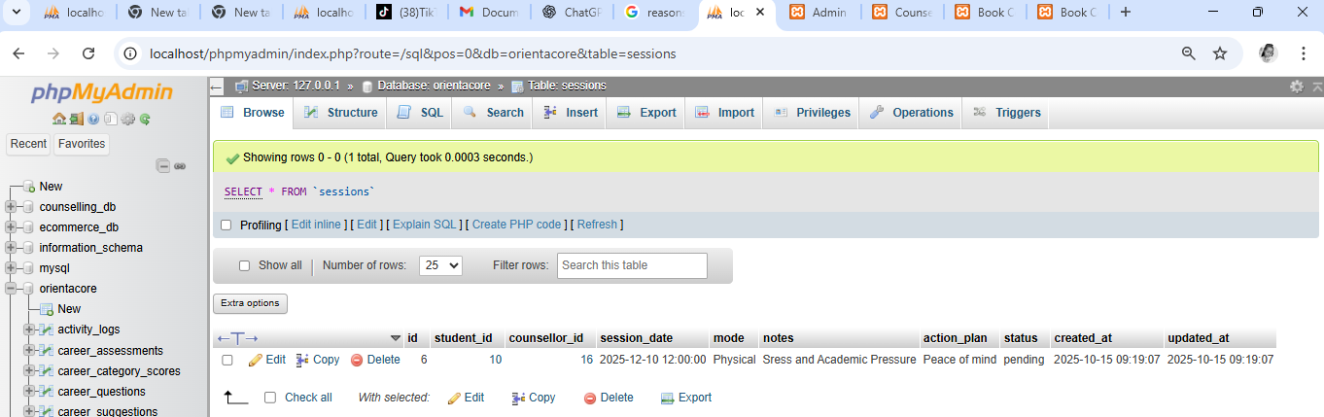
Figure 8: Sessions Table

5.6 Security Design

5.6.1 Authentication and Access Control
Access to OrientaCore is role-based, meaning users can only access modules relevant to their roles.
- Passwords are encrypted using PHP’s password hash () function.
- Session management restricts access to unauthorized users.
- Admin activity logs track changes and updates for accountability.

5.6.2 Data Protection and Validation
- Input fields use both client-side (JavaScript) and server-side (PHP) validation.
- The system uses prepared SQL statements to prevent SQL injection attacks.
- Data backups are scheduled regularly to avoid data loss.
- HTTPS protocol is implemented to secure communication between client and server.

5.7 Output Design
The system’s output includes reports, counselling summaries, assessment results, and notifications. Output interfaces are designed to be clear, concise, and exportable (PDF or Excel).
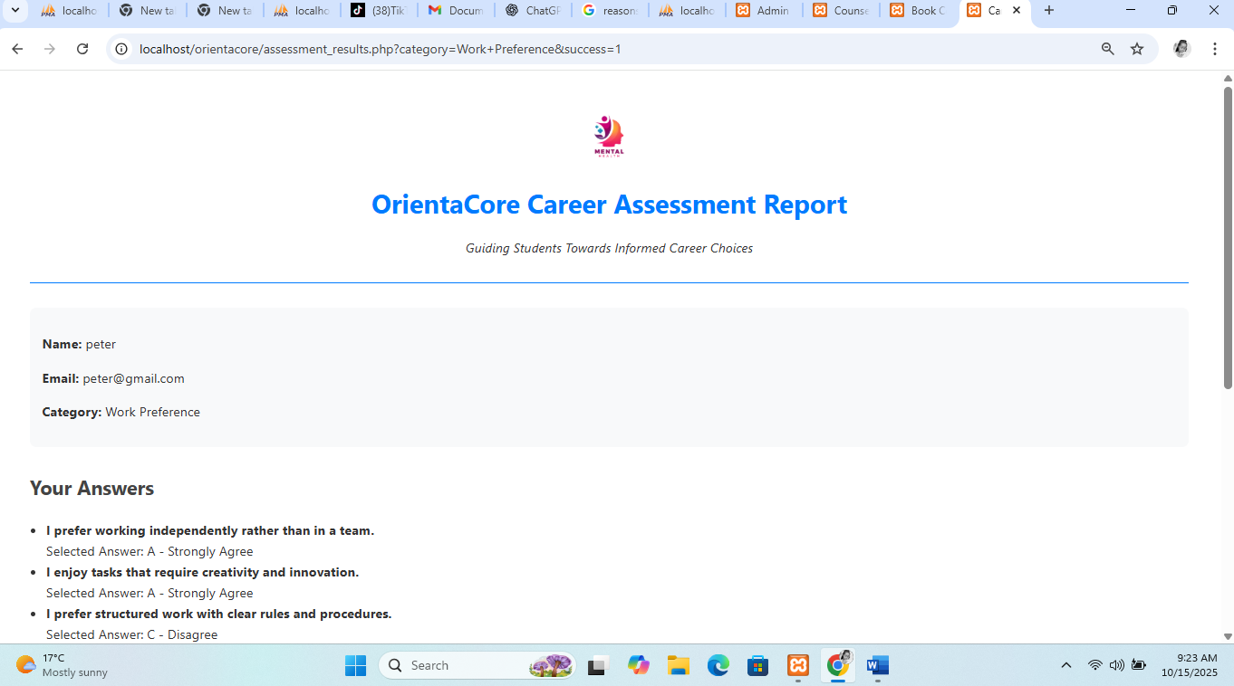
Figure 9: Assessment Report

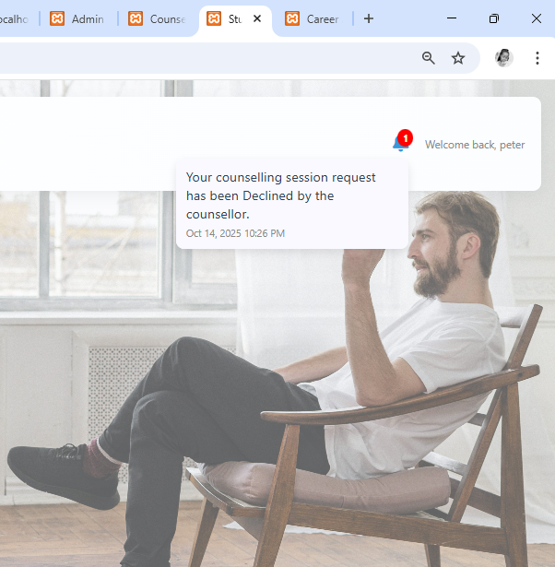
Figure 10 Notification

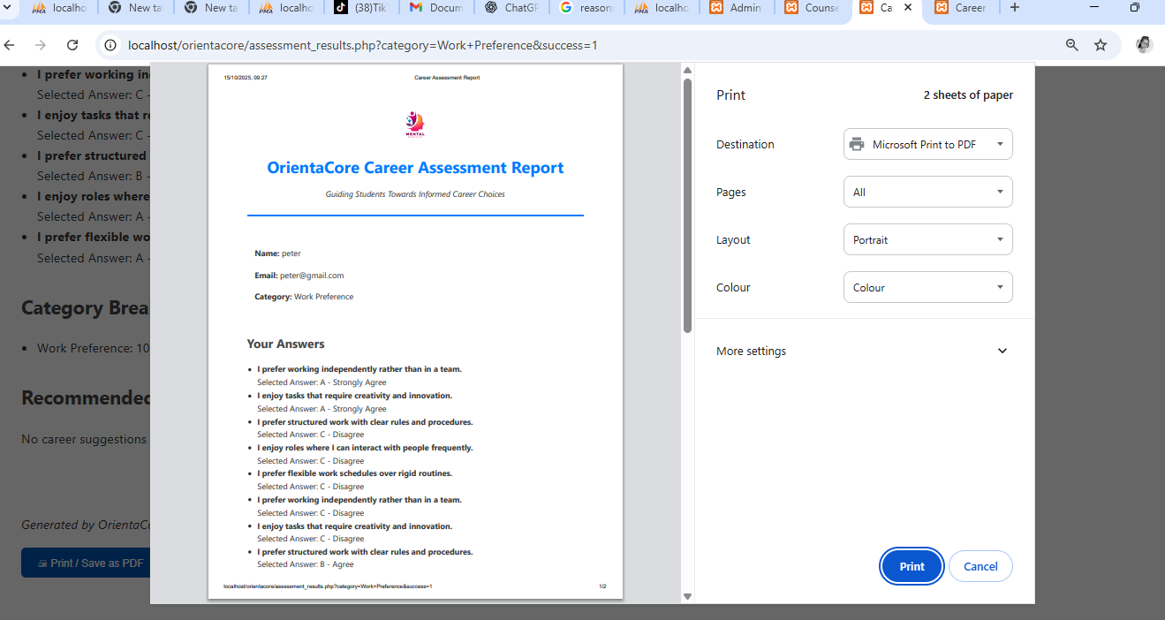
Figure 11 exportable (PDF or Excel) Report

CHAPTER SIX: SYSTEM IMPLEMENTATION

6.1 Introduction
This chapter presents the implementation of the OrientaCore Information System (OCIS), detailing the activities that converted the system design into a functional and operational software application. Implementation is a key stage in system development, where code, data, and processes are integrated to achieve the objectives outlined in the previous
chapters. The process included coding, testing, database integration, deployment, and user training.

6.2 Tools Used for Coding and Testing
The successful implementation of OrientaCore relied on a variety of development tools chosen for efficiency, compatibility, and open-source availability. These tools supported programming, testing, debugging, and version control.

6.2.2 Coding Tools
HTML5 and CSS3: Used for webpage layout, structure, and styling. CSS provided visual consistency and responsiveness.
JavaScript: Added dynamic interactivity and client-side validation.
PHP: Implemented server-side logic such as user authentication, session handling, and data processing.
MySQL: Served as the backend database to store all system data.
XAMPP: A local server used for development and testing.
phpMyAdmin: A GUI for managing the MySQL database.
Visual Studio Code: Provided an integrated environment for writing and testing code efficiently.

6.2.2 Testing Tools
Google Chrome Developer Tools: Used for inspecting HTML/CSS and debugging JavaScript.
Postman: Tested communication between the client interface and backend.
Git and GitHub: Tracked source code changes and maintained version control.
W3C Validator: Checked HTML/CSS compliance with web standards.

6.3 System Coding Process
The coding process followed a modular approach, ensuring each part of the system was independently developed and tested. The core modules included authentication, counselling session booking, career assessment, feedback recording, and report generation. Each module was written in PHP, connected to the MySQL database, and tested individually before integration. The login module verifies credentials using hashed passwords for security. After validation, users are directed to their specific dashboards. counsellors manage sessions, students make bookings and view feedback, while administrators manage accounts and generate reports. The modular coding ensured scalability and made debugging easier during the testing phase.

6.4 System Test Plan
System testing is essential to confirm that all functionalities operate as expected. The testing of OrientaCore was guided by black-box testing principles, emphasizing inputs and expected outputs rather than internal code logic.
Objectives were; to Verify each module performs correctly, ensure security mechanisms such as authentication and access control work properly, confirm accurate data storage and retrieval and Validate system performance and responsiveness.
Environment Setup: Operating System: Windows 10, Local Server: XAMPP, Database: MySQL, Browsers: Chrome, Firefox, Devices: Laptop and Smartphone
Test Case | Test Description | Expected Result | Actual Result
Login | Check login using valid/invalid credentials | Access granted or denied | Successful
Session Booking | Book counselling session with valid data | Session saved | Successful
Feedback | Submit counselling notes | Feedback stored | Successful
Assessment | Take and submit assessment | Score displayed | Successful
Report | Generate student | Report generated | Successful
Table 3 System Test Plan

6.5 Change-Over Techniques
System change-over is the transition from the manual counselling process to the new OrientaCore system. A phased approach was chosen to reduce implementation risk and ensure user adaptability. During each phase, components of the old system were replaced gradually by the new one
Phased Implementation Steps:
1. Phase One: Deploy authentication and dashboard modules.
2. Phase Two: Introduce session management and feedback modules.
3. Phase Three: Implement report generation and data analytics.
4. Phase Four: Final migration and full rollout.
This method allowed users to adapt progressively while enabling developers to monitor performance and address any issues before
complete adoption. Alternative methods such as direct and parallel change-over were considered but rejected due to higher risks
and redundancy in data handling.

6.6 Deployment and User Training
After successful local testing, the system was deployed to a live web server environment. The deployment involved setting up the MySQL database, configuring the PHP environment, and linking the system to a secure HTTPS domain. The process ensured data security and accessibility from remote locations. User training was conducted to ensure all stakeholders could efficiently use the system. Counsellors were trained on how to manage student sessions and feedback, administrators were taught to generate reports, and students were guided on how to
book counselling appointments. The training sessions were both physical and virtual, allowing participants to interact directly with the system under supervision.

CHAPTER SEVEN: LIMITATIONS, CONCLUSIONS AND RECOMMENDATIONS

7.1 Introduction
The following section outlined the main insight garnered during the whole process development and implementation.

7.2 System Evaluation
The evaluation of the OrientaCore Information System was conducted after implementation and testing to determine whether
the system met its intended goals.
Functionality: All modules, including user registration, session management, and reporting, performed as expected.
Usability: The system interface was simple, intuitive, and user-friendly. Users required minimal training to navigate
and operate the system effectively.
Reliability: The system consistently performed its intended functions without failures during testing and pilot trials.
Security: Authentication and role-based access control ensured data confidentiality and prevented unauthorized access.
Performance: The system demonstrated efficient response times and handled concurrent user requests effectively.
Feedback from counsellors, students, and administrators confirmed that the system improved accessibility, reduced paperwork,
and provided a reliable database for managing counselling sessions and reports.

7.3 System Limitations
Despite its success, the OrientaCore Information System faced several limitations during and after development, The system is primarily designed for web-based environments and requires stable internet connectivity for full functionality. It does not include advanced analytics such as predictive performance tracking or automated report summaries. The system lacks integration with mobile platforms, limiting accessibility for users without computers. During deployment, minor delays were experienced when handling large data queries, suggesting the need for further optimization. The pilot phase covered a limited number of users; large-scale implementation might reveal additional performance requirements.

7.4 Conclusion
The OrientaCore Information System successfully addressed the challenges associated with manual counselling management in educational institutions. Through its digital architecture, the system improved efficiency, reduced administrative workload, and enhanced record keeping and accessibility. It provides a centralized platform for students, counsellors, and administrators to interact and manage counselling data securely. The project highlights the critical role of information systems in educational service delivery. It also demonstrates how automation and digital tools can strengthen decision-making and student support mechanisms. The successful implementation of the system confirms that ICT can be leveraged to improve counselling operations and contribute to institutional growth.

7.5 Recommendations
Based on the findings and evaluation, the following recommendations are proposed to enhance and sustain the effectiveness of the OrientaCore Information System:
Mobile Application Integration: Develop a mobile version of the system to increase accessibility for students and counsellors using smartphones.
Enhanced Analytics: Incorporate data analytics tools to generate detailed insights into student progress and counselling trends.
Cloud Hosting: Migrate the system to a cloud environment to improve performance, availability, and data recovery. User Support and Maintenance: Establish continuous system monitoring and provide regular maintenance and updates.
Training Expansion: Conduct regular training sessions to help new users adapt quickly and maximize the benefits of the system.
Scalability: Expand the system’s capacity to accommodate more users and institutions in the future.

REFERENCES
African Development Bank. (2020). Digital transformation in Africa: Education and skills development. African Development Bank Group.
African Development Bank. (2020). African Development Bank report on digital tools in education.
African Population & Health Research Centre. (2022). Kenya – National adolescent mental health survey (K-NAMHS). https://aphrc.org/wp-content/uploads/2022/10/K-NAMHS-report_2022.pdf
Counselor1Stop. (n.d.). Naviance. https://counselor1stop.org/wiki/naviance/
Grupe, F. H. (2002). An internet-based expert system for selecting an academic major. Computers & Education, 38(4), 323–336. https://doi.org/10.1016/S0360-1315(02)00006-6
Hobsons. (2021). Naviance overview. https://www.naviance.com/
MyMajors. (2022). Career matching tool. https://www.mymajors.com/
Ndirangu, L., Mwangi, P., & Ochieng, K. (2019). Impact of school counselling programs on student academic performance in Kenya. Journal of Educational Research and Reviews, 7(2), 45–57. https://doi.org/10.33495/jerr.v7i2.45-57
Otieno, C., & Wango, G. (2021). Challenges of guidance and counselling services in Kenyan schools.
American Psychological Association. (2020). Publication manual of the American Psychological Association (7th ed.).
Corey, G. (2017). Theory and practice of counselling and psychotherapy (10th ed.). Cengage Learning.
Gibson, R., & Mitchell, M. (2016). Introduction to counselling and guidance (6th ed.). Pearson.
Mwangi, J. (2021). Digital transformation of student counselling systems in Kenyan universities. International Journal of ICT Research, 9(3), 44–53.
Njeri, P. (2020). Adoption of online appointment systems in higher learning institutions. Journal of Education Technology, 15(2), 78–89.
Rogers, C. (2003). Client-cantered therapy. Houghton Mifflin.
Silicule, R. (2019). Designing automated counselling systems. African Journal of Computing, 8(1), 12–21.
Tanui, D. (2022). Web-based student progress tracking systems. Computing and Information Systems Review, 4(2), 25–33.
World Health Organization. (2019). Guidelines on mental health and counselling services. WHO Press.

APPENDICES

APPENDIX I: Questionnaire for Students
OrientaCore – Digital Guidance and Counselling System
Instructions:
Please answer the following questions honestly. The information collected will be used strictly for academic purposes.
Section A: Demographic Information
Year of Study:
- 1st Year
- 2nd Year
- 3rd Year
- 4th Year
School/Department: ___________________________
Section B: Counselling Experience
3. How do you currently access counselling services?
- Face-to-face sessions
- Scheduled appointments
- Through referral by teacher/administrator
Have you ever faced challenges in accessing counselling services?
- Yes
- No
If yes, what challenges did you face?
- Long waiting times
- Lack of privacy or confidentiality
- Limited sessions / counsellor availability
- Unclear guidance or advice
Other: ____________________

Section C: System Awareness & Acceptance
6. Would you find a digital platform like OrientaCore helpful for counselling support?
- Yes
- No
Which services would you like the system to offer?
- Schedule counselling sessions
- Track academic and behavioural progress
- Career guidance and assessments
- Frequently asked questions about school policies
- General student support information
How likely are you to use the system regularly?
- Very likely
- Likely
- Neutral
- Unlikely
- Very unlikely

APPENDIX II: Interview Guide for Academic Staff / Counsellors
What major challenges do students face when seeking counselling support?
What common questions or concerns do students bring to counselling sessions?
Do you think a digital platform like OrientaCore can reduce staff workload? Explain.
Which aspects of counselling should be automated or supported by the system?
What institutional policies must be considered when designing a digital counselling platform?
What improvements would you suggest to enhance student guidance and counselling services?

APPENDIX III: System Architecture Description
Components:
User Interface (Web/Mobile)
Counselling Engine (Session Management & Career Assessment Modules)
Backend API (Python/Django or PHP/Laravel)
Database (MySQL/PostgreSQL)
Authentication Module (JWT/OAuth 2.0)
Logging & Analytics Module
Workflow Summary:
Student logs into the system and requests support.
Counselling engine processes the request and fetches relevant data.
Backend retrieves student academic, behavioural, and career information.
Response or recommendations generated.
Student receives a personalized response through the platform.

APPENDIX IV: Sample User Interaction
Academic Strength Assessment
Interest Inventory Test
Personality & Career Match Test
Would you like guidance on how to interpret your results?"

APPENDIX V: Sample Code Snippet (Career Assessment Module)
{
"intent": "career_assessment_request",
"examples": [
"Which career assessment is suitable for me?",
"I want to know my strengths and suitable courses",
"Suggest career tests based on my interests"
]
}

APPENDIX VI: Budget Breakdown
Item | Estimated Cost (KES)
Data collection (surveys, interviews) | 15,000
Software tools and licenses | 30,000
System development (platform design & coding) | 50,000
Testing and evaluation | 20,000
Hosting and deployment | 25,000
Documentation and reporting | 10,000
Miscellaneous | 10,000
Total | 160,000

APPENDIX VII: Gantt Chart Outline
Activity | Month 1 | Month 2 | Month 3 | Month 4 | Month 5 | Month 6
Problem Analysis & Requirements | █████
System Design & Prototyping |  | █████
System Development |  |  | █████ | █████
Testing & Refinement |  |  |  |  | █████
Evaluation & Documentation |  |  |  |  |  | █████

APPENDIX VIII: Consent Form
I agree to participate in this research. I understand that:
My participation is voluntary.
My identity will remain confidential.
The information provided is for academic purposes only.
Name: ___________________________
Signature: _______________________
Date: ____________________________

APPENDIX IX: Sample Code Snippet
Login code
<?php
require 'db.php'; // Unified PDO connection

$error = "";
if ($_SERVER["REQUEST_METHOD"] === "POST") {
$identifier = trim($_POST['reg_no'] ?? '');
$password = $_POST['password'] ?? '';
if ($identifier && $password) {
// Fetch user by reg_no or email
$stmt = $pdo->prepare("SELECT * FROM users WHERE reg_no = :id OR email = :id LIMIT 1");
$stmt->execute(['id' => $identifier]);
$user = $stmt->fetch(PDO::FETCH_ASSOC);
if ($user) {
// Check password
if (password_verify($password, $user['password_hash'])) {
$status = strtolower(trim($user['status']));
if ($status !== 'active') {
$error = "Your account is not active yet. Please wait for admin approval.";
} else {
// Set session variables
$_SESSION['user_id'] = $user['id'];
$_SESSION['name'] = $user['name'];
$_SESSION['role'] = $user['role'];
$_SESSION['email'] = $user['email'];
$_SESSION['reg_no'] = $user['reg_no'];
// Redirect based on role
switch ($user['role']) {
case 'admin':
header("Location: admin_dashboard.php");
break;
case 'counsellor':
header("Location: counsellor_dashboard.php");
break;
case 'student':
header("Location: student_dashboard.php");
break;
default:
$error = "Unknown role assigned.";
}
exit;
}
} else {
$error = "Invalid registration number/email or password.";
}
} else {
$error = "No account found with that registration number or email.";
}
} else {
$error = "Please enter your login details.";
}
}
?>
<!doctype html>
<html lang="en">
<head>
<meta charset="utf-8" />
<meta name="viewport" content="width=device-width,initial-scale=1" />
<title>Login — OrientaCore</title>

<!-- Google font (optional) -->
<link href="https://fonts.googleapis.com/css2?family=Inter:wght@300;400;600;700&display=swap" rel="stylesheet">
<style>
:root{
--accent: #3498db;
--accent-dark: #2980b9;
--muted: #7f8c8d;
--bg: #f4f6f9;
--card-radius: 12px;
}
*{box-sizing:border-box}
body {
margin: 0;
font-family: "Inter", system-ui, -apple-system, "Segoe UI", Roboto, "Helvetica Neue", Arial;
color: #20303a;
min-height: 100vh;
display: flex;
align-items: center;
justify-content: center;
padding: 24px;
background: url('back.jpg') no-repeat center center fixed;
background-size: cover;
position: relative;
}

body::before {
content: "";
position: fixed;
inset: 0; /* shorthand for top, right, bottom, left = 0 */
background-color: rgba(0, 0, 0, 0.5); /* black overlay with 50% opacity */
z-index: 0;
pointer-events: none;
}
.login-card{
position: relative;
z-index: 2;
width: 380px;
max-width: calc(100% - 48px);
background: #ffffff;
border-radius: var(--card-radius);
box-shadow: 0 12px 30px rgba(17,24,39,0.08);
padding: 28px;
display:flex;
flex-direction:column;
gap:12px;
}
.brand { display:flex; gap:12px; align-items:center; margin-bottom:6px; }
.brand .logo {
width:60px; height:60px; border-radius:10px; object-fit:cover;
box-shadow: 0 6px 18px rgba(24, 25, 26, 0.06);
}
.brand h2 { margin:0; font-size:18px; color:#22303a; letter-spacing:0.2px; }
.lead { color:var(--muted); font-size:13px; margin-bottom:6px; }
form { display:block; margin-top:4px; }
label { display:block; font-size:13px; color:#34495e; margin-bottom:6px; }
input[type="text"], input[type="password"] {
width:100%;
padding:12px 14px;
border: 1px solid #e6eef6;
border-radius:8px;
font-size:14px;
outline:none;
transition: box-shadow .15s ease, border-color .15s ease;
}
input:focus { box-shadow: 0 6px 18px rgba(52,152,219,0.06); border-color: var(--accent); }

.actions { display:flex; gap:10px; margin-top:8px; align-items:center; justify-content:space-between; }

.btn {
background: var(--accent);
color: #fff;
border: 0;
padding: 10px 14px;
border-radius: 8px;
cursor:pointer;
font-weight:600;
transition: transform .12s ease, background .12s ease;
}
.btn:hover { background: var(--accent-dark); transform: translateY(-2px); }
.secondary {
background: transparent;
color: var(--muted);
border: 1px solid #eef3f7;
padding: 10px 12px;
border-radius: 8px;
cursor: pointer;
}

.error {
background: #fff3f3;
color: #7a1f1f;
border: 1px solid #ffd6d6;
padding: 10px 12px;
border-radius: 8px;
font-size:13px;
}
.foot {
margin-top:12px;
font-size:13px;
color:var(--muted);
text-align:center;
}
</style>
</head>
<body>
<div class="bg-wrap" aria-hidden="true"></div>

<main class="login-card">
<div class="brand">
<img src="logo.jpg" alt="OrientaCore" class="logo">
<div>
<h2>Login — OrientaCore</h2>
<div class="lead">Enter your Registration No. or Email and Password.</div>
</div>
</div>

<?php if ($error): ?>
<div class="error" role="alert"><?= htmlspecialchars($error) ?></div>
<?php endif; ?>

<form method="post" novalidate>
<div>
<label for="reg_no">Registration No. / Email</label>
<input id="reg_no" name="reg_no" type="text" required value="<?= isset($_POST['reg_no']) ? htmlspecialchars($_POST['reg_no']) : '' ?>">
</div>

<div style="margin-top:8px;">
<label for="password">Password</label>
<input id="password" name="password" type="password" required>
</div>

<div class="actions">
<button type="submit" class="btn">Login</button>
<a href="forgot_password.php" class="secondary" style="text-decoration:none;">Forgot?</a>
</div>
</form>

<div class="foot">
Don’t have an account? Contact your administrator to be registered.
</div>
</main>
</body>
</html>

