# Document on how to create SD card image from source code

1. Insert microSD card to a card reader.
2. Open Raspberry Pi Imager v1.4. Select ‘RASPBERRY PI OS LITE (32-BIT)’ for the operating system, select the microSD card just inserted for the ‘SD Card’, then click ‘Write’

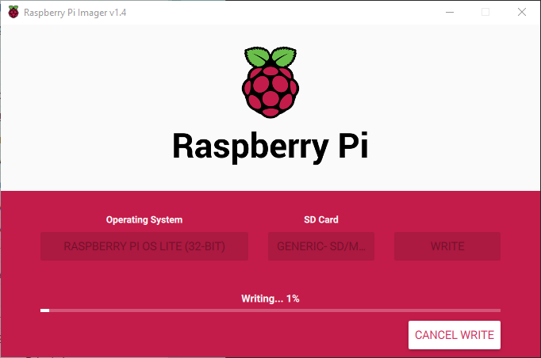

1. When write is done, unplug the SD card and re-insert the SD card to the card reader.
2. A new drive will be shown in Windows Explorer.

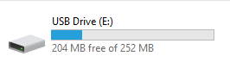

1. Place the file “ssh” and “wpa_supplicant.conf” to the drive. This is to enable the wireless connection on the Pi to make the following setup steps easier.
2. Edit the “wpa_supplicant.conf” with notepad. Replace the ssid and psk with the wireless network SSID and password that is available.

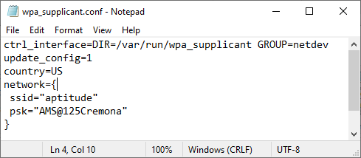

1. Unplug the SD card. Insert the SD card to the SD card slot of a Raspberry Pi Zero W.
2. Power up the RPi by connecting a micro-USB power cable to the PWR micro-USB connector on the RPi.
3. Remotely connect to the Raspberry Pi with SSH. Make sure the PC is also connected to the same wireless network as Raspberry Pi. Open a terminal window, type in: ssh [pi@raspberrypi.local](mailto:pi@raspberrypi.local).
4. If cannot connect, it is possible that the router doesn’t support name resolution. You can find the IP address of the raspberry pi on the router admin page, then connect with `ssh [pi@192.168.xxx.xxx`](mailto:pi@192.168.xxx.xxx%60) (replace xxx with the ip address you find)
5. Type in the default password is ‘rasperry’ when prompt for password.
6. Install and configure Apache2. Type in the following command in SSH.
   * sudo apt install apache2
   * sudo a2enmod proxy proxy_http proxy_ajp rewrite deflate headers proxy_balancer proxy_connect proxy_html
   * sudo nano /etc/apache2/sites-available/000-default.conf
   * <VirtualHost *:80>
   * ProxyPreserveHost On
   * ProxyPass / http://127.0.0.1:88/
   * ProxyPassReverse / http://127.0.0.1:88/
   * </VirtualHost>
   * Save the file by Ctrl+X then Enter.
   * sudo systemctl reload apache2
7. Install git by type in the following command `sudo apt install git`.
8. Type in the following commands: wait to finish after each command.
   * Cd /
   * sudo git config --global credential.helper store
   * sudo git clone <https://github.com/AptitudeCodebase/covid_sensor.git>
   * Username for 'https://github.com': AptitudeCodeBase
   * Password for 'https://AptitudeCodeBase@github.com': [user github token, gph_ereoXXXXX]
9. If the github account is not accessible, you can also use secure copy to copy the source code to the root folder directly.
   * On your PC, under the folder with source code, open terminal (or power shell).
   * scp –r ./path-to-source-code pi@<pi-remote-address>:/home/pi/<pathname>
   * Then you can SSH to the Pi and move source code to root folder
   * sudo mv /home/pi/<pathname> /
10. Download the Image setup script from github. This is a public repo.
    * Cd /
    * Sudo git clone https://github.com/rocksnow1942/ReaderImage_Setup.git
    * cd ReaderImage_Setup
    * sudo python3 install.py
    * Choose option 1
    * Now the script will install required libraries.
11. After all packages are installed, the terminal will display the new host name for the raspberry Pi. If you are connecting to Pi with the hostname, then write down the new hostname, and use this for the SSH connection below.
12. Reboot RPi by type in ‘sudo reboot’. If the connection was lost, simply power cycle the RPi.
13. After the RPi reboot, use ssh to login to the RPi again.
    * This setup script assumes the aptitude wifi network is available.
    * If not available, RPi will turn to hotspot mode. If that is the case, look for Wi-Fi hotspot with SSID AMS-xxx (the xxx is randomly generated)
    * Connect your PC to the RPi hotspot, default password is ‘aptitude’ (no quote, all lower case).
    * After connection, you can ssh to Pi with ssh [pi@192.168.0.1](mailto:pi@192.168.0.1)
    * If want to connect RPi to Wi-Fi network, edit the wpa_supplicant file then power cycle. /etc/wpa_supplicant/wpa_supplicant-wlan0.conf
14. Run cleanup scripts before make the SD card image.
    * Cd /ReaderImage_Setup
    * Sudo python3 install.py
    * Choose option 12. Clean up system for clone SD card
15. Power off the RPi and take out the SD card.
16. Insert SD card to SD card reader and connect to PC.
17. Open win32 – disk imager. Select the target SD card and enter the name of the image file to save. Click ‘Read’.

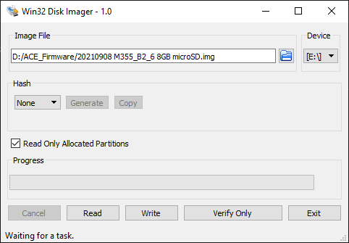

1. Wait until the image is created.
2. Shrink the image on PC running Ubuntu 18.04.
3. Use a virtual machine running Ubuntu 18.04 is recommended.
4. Copy the image file created to the Ubuntu machine.
5. Install the pishrink script by enter the following command in terminal:
   * wget https://raw.githubusercontent.com/Drewsif/PiShrink/master/pishrink.sh
   * chmod +x pishrink.sh
   * sudo mv pishrink.sh /usr/local/bin
6. Shrink the image by enter the following command in terminal:
   * Sudo pishrink.sh <filename of the original image file> <destination file name>
7. Copy the shrunk image file to desired storage location.