
RHINO
AppSumo submission packet
Copy, codes setup, and upload-ready media
Offer: 1 AppSumo code · $5 one time · Unlimited Apple silicon Macs · Lifetime product updates

Prepared for the AppSumo partner editor
August 12, 2026 | rhinovoice.app

Submitter quick start
Everything needed for the listing is in this packet and the adjacent assets folder.
- Open Rhino's draft listing in the AppSumo partner editor
- Paste each labelled field from this packet into the matching editor field
- Choose Codes, set 1 code to $5, and set the maximum code count to 1
- Upload the company icon, hero image, and four screenshots from the assets folder
- Save the draft and resolve any editor validation warnings
- Preview the listing, verify the code-redemption flow, then submit for review
Publishing gate: The code-redemption system is still being built. Do not publish the deal until a real AppSumo test code redeems end to end and unlocks Rhino correctly.

Manual items
- Company website is auto-filled by AppSumo
- Trust signals require real verification URLs and may be left blank if unavailable
- LinkedIn founder URL is optional and intentionally omitted
- Integrations should be left blank because Rhino works systemwide and has no direct integrations

Files to send with this document
- assets/company-icon-512.png
- assets/hero-1920x1080.jpg
- assets/01-home.jpg
- assets/02-models.jpg
- assets/03-dictionary.jpg
- assets/04-history.jpg

Basic information
Paste each value into the identically named AppSumo editor field.
Product name
Rhino
Category
Productivity Choose the closest available option from AppSumo's searchable list
Tagline
Private voice-to-text dictation for Mac
Secondary tagline
Talk naturally and type anywhere
Unique selling proposition
Unlike cloud dictation tools, Rhino transcribes and cleans up speech on your Mac, so your audio and words stay private while polished text appears in any app.
TL;DR

- Hold Fn, speak, and insert polished text into any Mac app
- Keep audio, transcripts, history, and AI cleanup on your Mac
Alternative to
Wispr Flow, Typeless, MacWhisper Select only values AppSumo offers in its searchable list
Integrations
Leave blank Rhino works systemwide and has no direct integrations
Best for
Entrepreneurs, freelancers, content creators Select the closest available buyer types
Limits checked: Product name 5/75 · Tagline 39/100 · Secondary tagline 32/140 · USP 158/255 · TL;DR bullets 57/128 and 60/128

Highlighted feature 1
Paste this title and its bullets into one feature story, then pair the indicated screenshot.
Section header
Dictate anywhere without sending your voice anywhere
Title
Turn speech into text in any Mac app
Bullets
- Hold Fn and talk while Rhino records from your active microphone
- Release the key to insert the transcript wherever your cursor is
- Double-press the shortcut to dictate hands-free, then press again to stop
Screenshot to pair
Rhino Home dashboard with local dictation stats
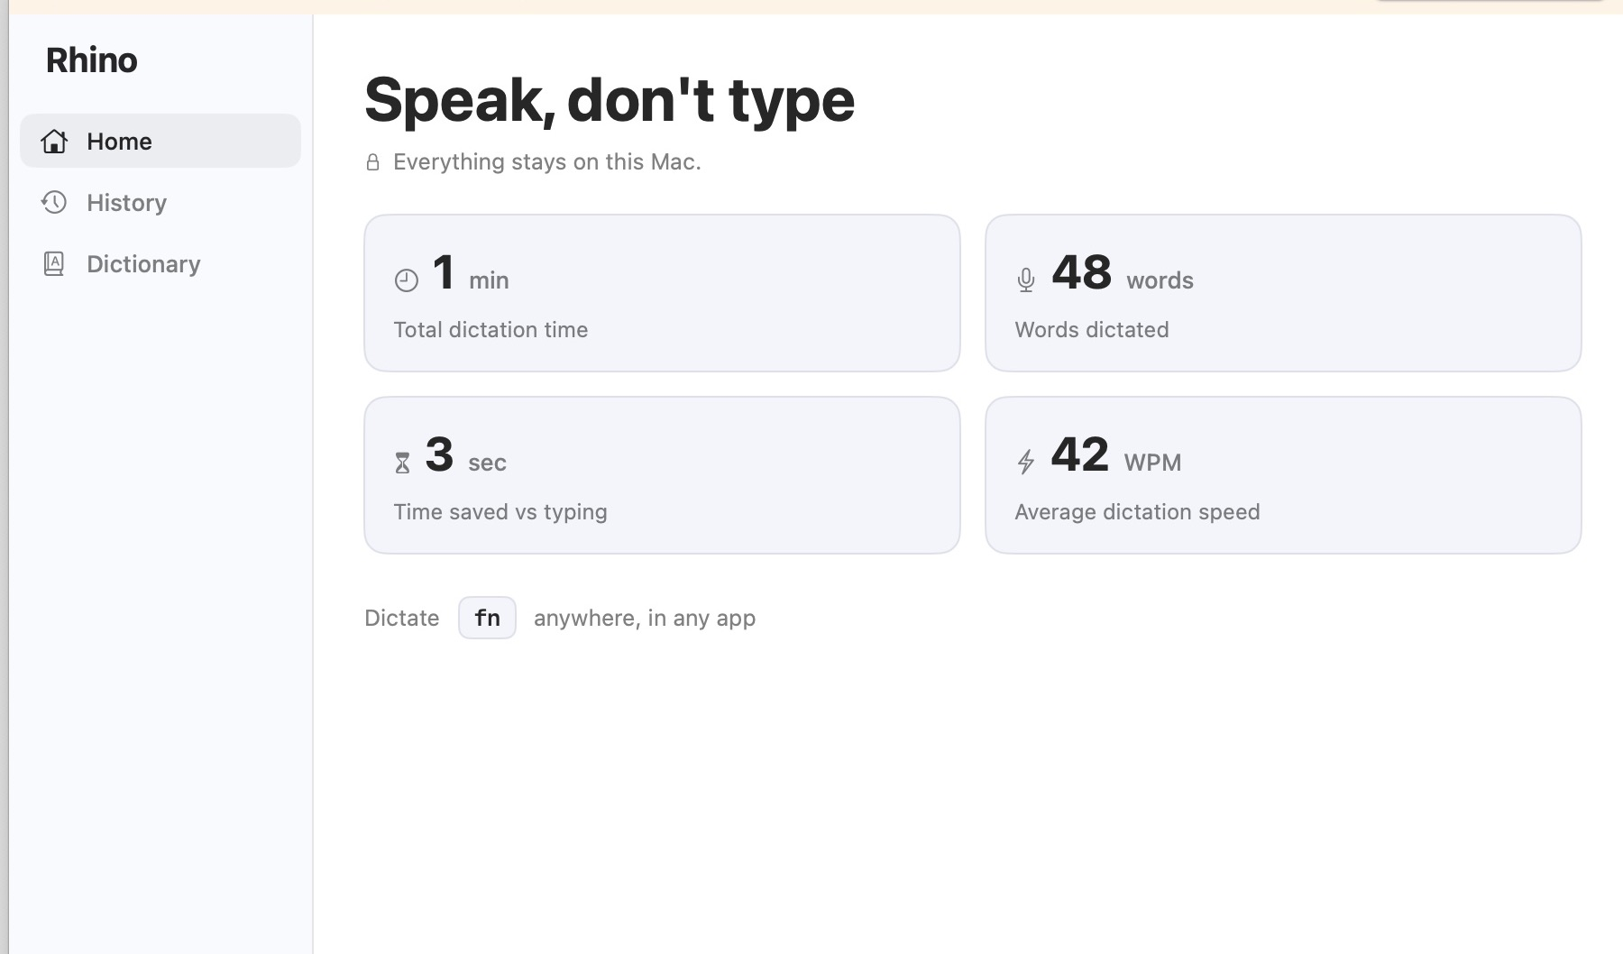
Upload file: assets/01-home.jpg | Alt text: Rhino Home dashboard

Highlighted feature 2
Paste this title and its bullets into one feature story, then pair the indicated screenshot.
Title
Keep every dictation private
Bullets
- Transcribe on-device with Whisper or Parakeet speech models
- Clean up locally with optional embedded AI for punctuation and casing
- Work offline after your chosen models have been downloaded
- Skip accounts and telemetry because dictation does not depend on cloud services
Screenshot to pair
On-device Whisper and Parakeet model settings
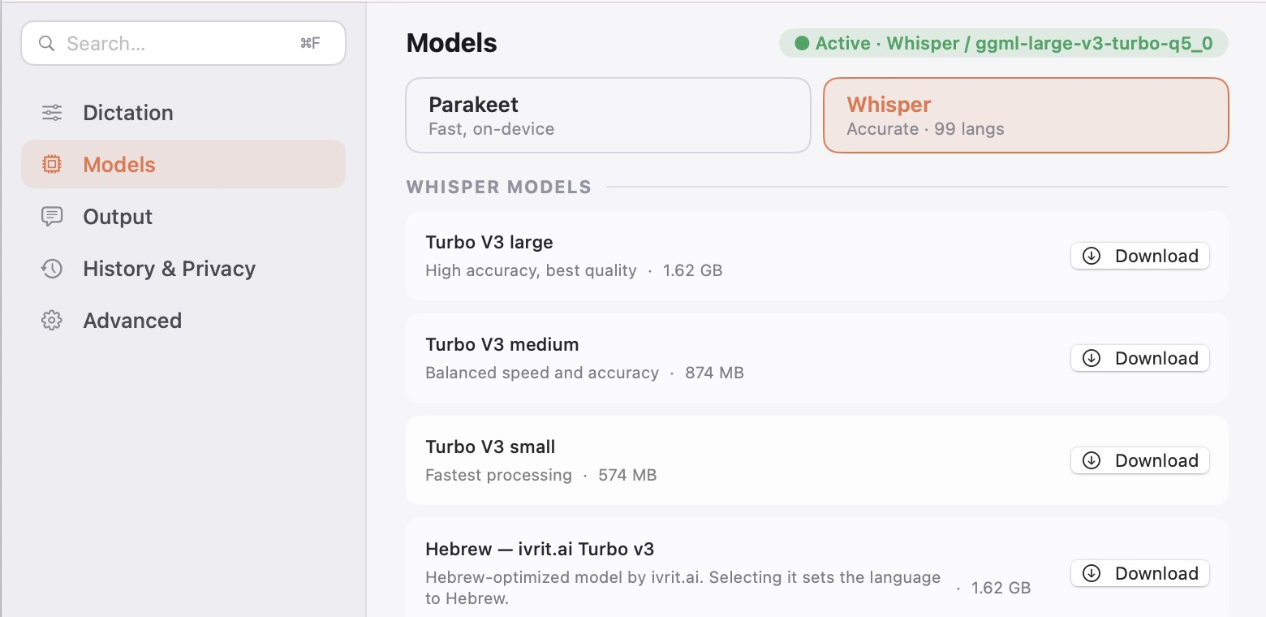
Upload file: assets/02-models.jpg | Alt text: On-device model settings

Highlighted feature 3
Paste this title and its bullets into one feature story, then pair the indicated screenshot.
Title
Make Rhino understand how you write
Bullets
- Teach Rhino your vocabulary with custom replacements for names and jargon
- Search local history to find previous dictations stored on your Mac
- Track words and time saved from the Home screen
- Turn off history whenever you do not want transcripts stored
Screenshot to pair
Personal dictionary with sample names and brand terms
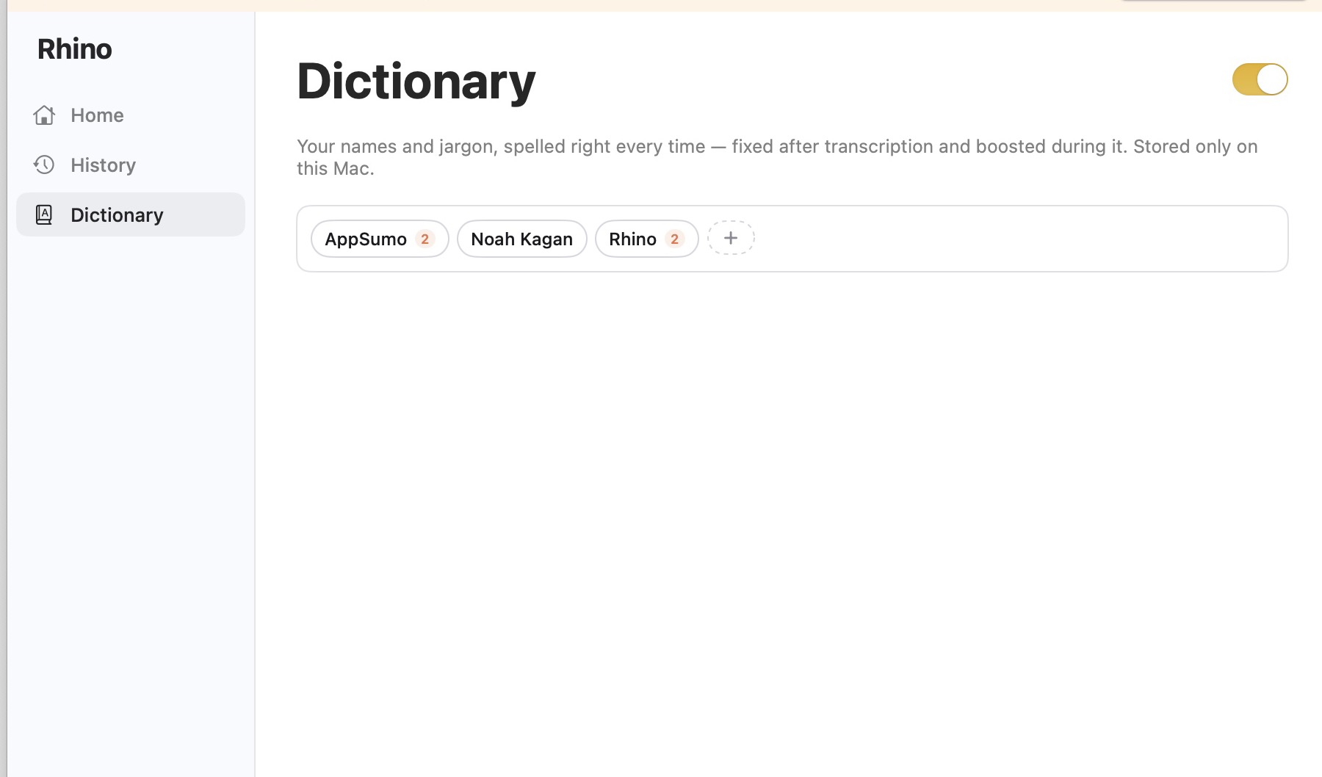
Upload file: assets/03-dictionary.jpg | Alt text: Personal dictionary rules

Highlighted feature 4
Paste this title and its bullets into one feature story, then pair the indicated screenshot.
Title
Reuse every recording
Bullets
- Rerun saved recordings with a different local speech model
- Transcribe audio files by dropping them into Rhino or using the command line
- Review past dictations without sending recordings to a remote server
Screenshot to pair
Local searchable dictation history with model details
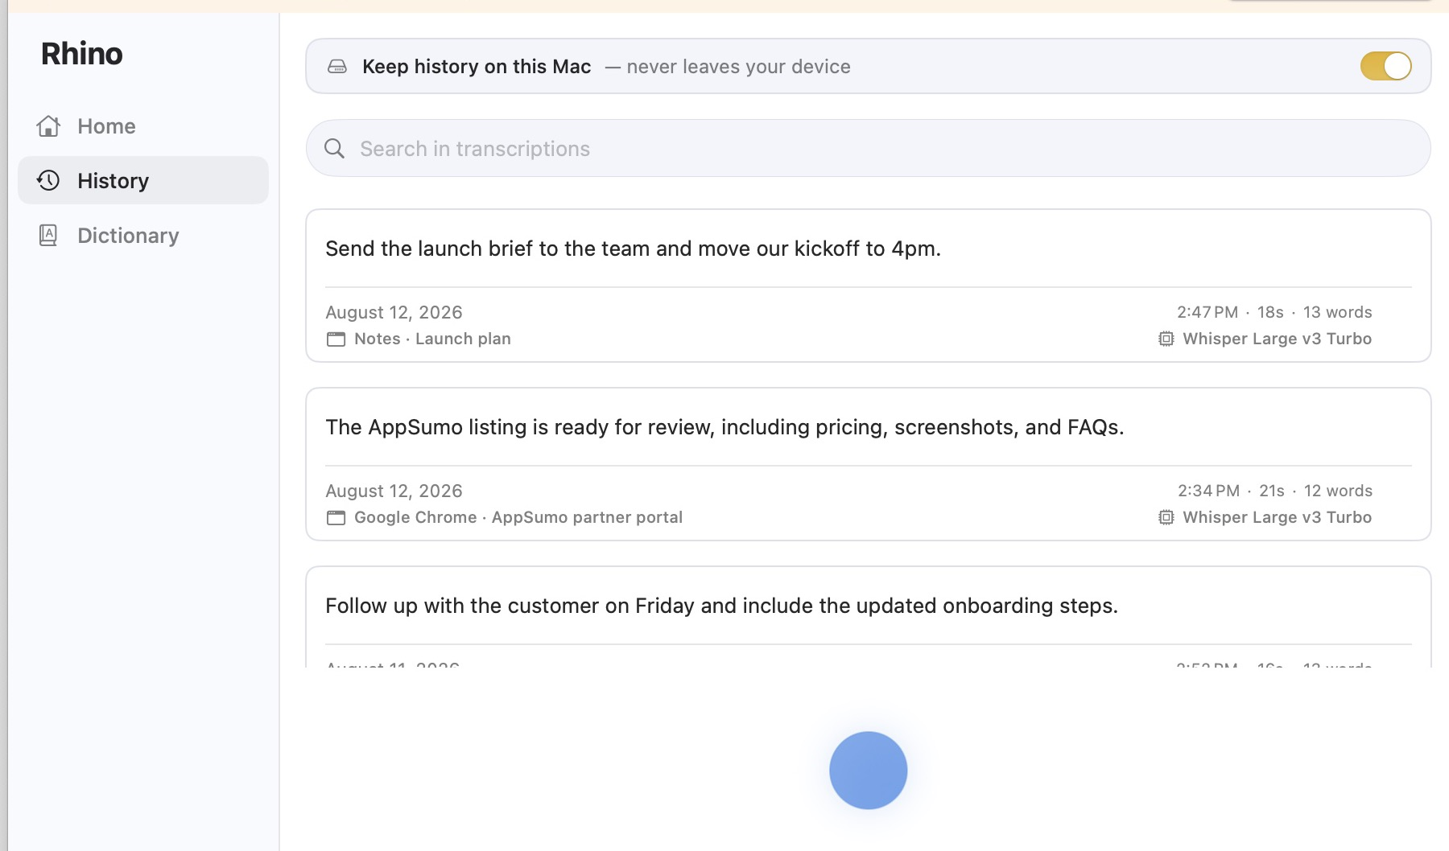
Upload file: assets/04-history.jpg | Alt text: Local history and stats

Pricing
Use AppSumo's Codes pricing model. Do not select Licensing.
Pricing model
Codes
1 code
$5
Maximum code count
1 Do not enable stacking because the base code already includes unlimited Mac installations

Feature matrix
Feature | 1 code
Mac installations | Unlimited
Dictation usage | Unlimited
Lifetime product updates | Included
On-device transcription | Whisper and Parakeet
Optional local AI cleanup | Included
Custom dictionary | Included
Local history and stats | Included
Audio-file transcription | Included
Redemption method: AppSumo codes. The redemption system is being built and must pass an end-to-end test before publication.

Product story
Paste the narrative as three separate paragraphs.
Headline
Why I built Rhino
Founder narrative
I founded AppSumo, so I have spent years trying software that promises to save people time. I kept coming back to the same problem with dictation tools: many send sensitive conversations to the cloud or add more complexity than I want from a Mac app. I wanted to speak naturally and have clean text appear wherever I was working, without wondering who else could access my words.
I built Rhino as privacy-first dictation software for entrepreneurs, freelancers, creators, and anyone who thinks faster than they type. Speech recognition, optional AI cleanup, history, and personal dictionary data stay on the Mac. After the models are downloaded, Rhino can turn speech into text even when Wi-Fi is off.
I am keeping Rhino small and focused. My goal is to keep improving transcription quality and speed while protecting the local-first promise: talk, get useful text, and keep your voice on your own computer.
Name | Noah Kagan
Role | Founder
Founded | 2026
Headquarters | Austin, TX
Team size | Solo
Stage | Indie
Funding | Bootstrapped

FAQ
Create eight question-and-answer pairs. Keep each answer under two sentences.
Q1. Is this lifetime access?
Yes. One code includes lifetime access to Rhino and future product updates.
Q2. How do I redeem my AppSumo code, and how many Macs can I use?
Follow the redemption instructions included with your AppSumo purchase. One code gives you access on unlimited Apple silicon Macs.
Q3. Does my voice or transcript leave my Mac?
No. Audio, transcripts, history, and optional AI cleanup stay on your Mac; Rhino only connects for signed update checks and model downloads you start.
Q4. Can Rhino work without an internet connection?
Yes. After you download your chosen speech model and optional cleanup model, dictation works offline.
Q5. What are the system requirements?
Rhino requires an Apple silicon Mac running macOS 14 or later. Intel Macs are not currently supported.
Q6. Which apps does Rhino work with?
Rhino inserts text into the Mac app where your cursor is active. It needs Microphone and Accessibility permissions, and modifier-only shortcuts such as Fn also require Input Monitoring.
Q7. Can I control or delete my dictation history?
Yes. History stays on your Mac, and you can turn it off, delete individual recordings, clear everything, or set retention limits.
Q8. What support and refund coverage do I get?
Email noah@appsumo.com for support. AppSumo purchases are covered by AppSumo's 60-day money-back guarantee.
Helpful link
Changelog: https://rhinovoice.app/changelog

Media upload guide
All upload files are in the assets folder beside this document.
Slot | File | Alt text
Company icon | company-icon-512.png | Rhino app icon
Hero | hero-1920x1080.jpg | Rhino Home dashboard
Screenshot 1 | 01-home.jpg | Rhino Home dashboard
Screenshot 2 | 02-models.jpg | On-device model settings
Screenshot 3 | 03-dictionary.jpg | Personal dictionary rules
Screenshot 4 | 04-history.jpg | Local history and stats

Hero image
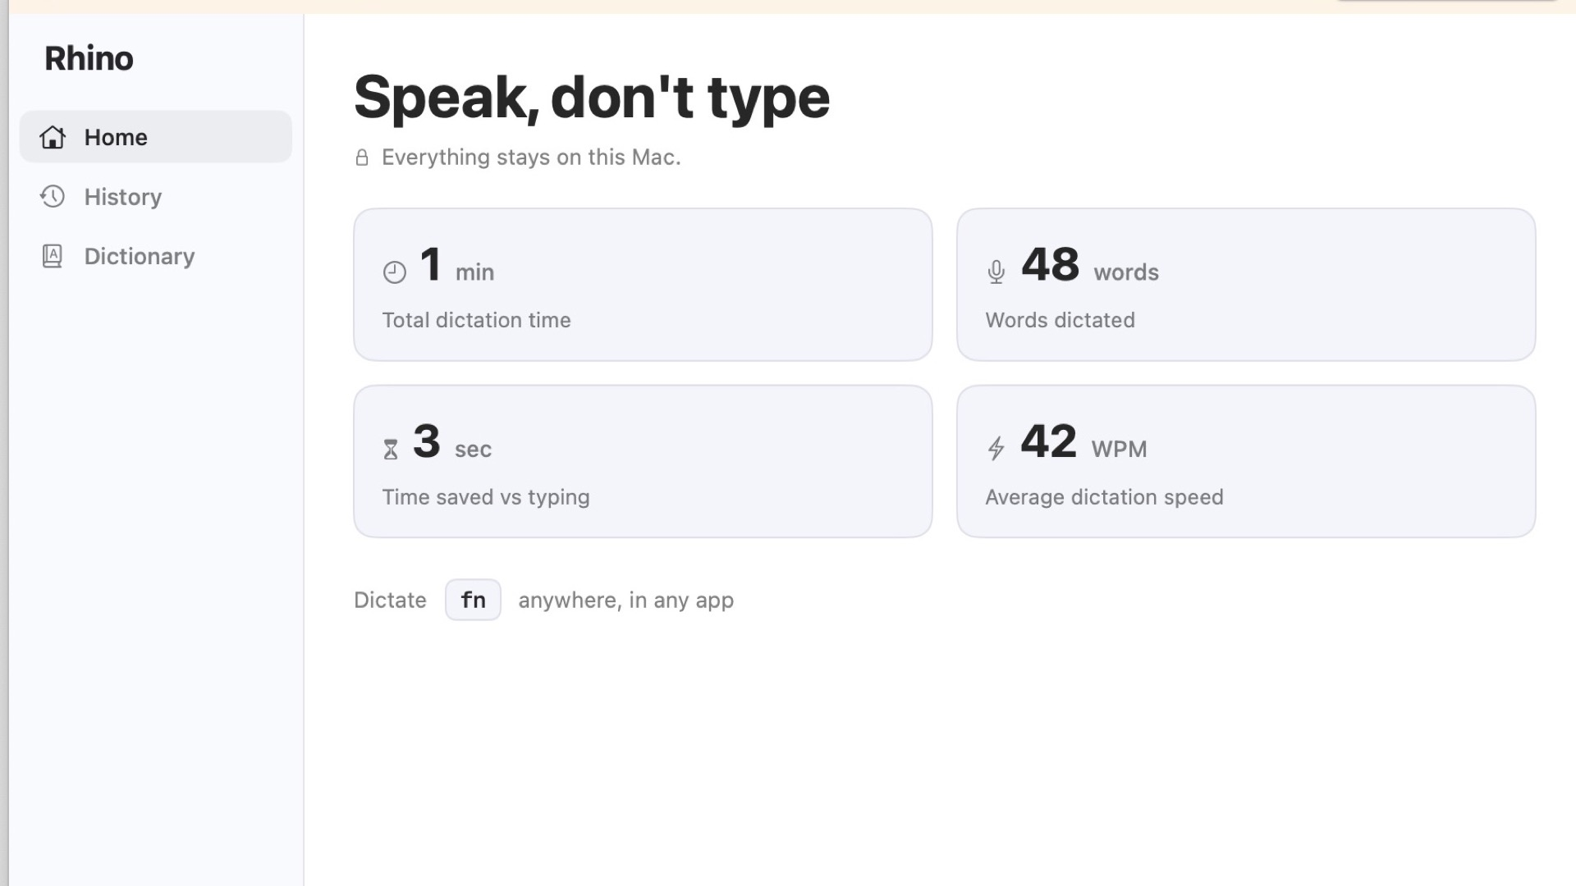
1920 × 1080 JPG, under 5 MB
Media checked: Icon is 512 × 512 · Hero is 1920 × 1080 · Four screenshots use current Rhino v0.1.3 UI and synthetic demo data

Final preflight
Complete this checklist immediately before submitting the listing for AppSumo review.
- Product name, taglines, USP, and exactly two TL;DR bullets are present
- Four feature stories are paired to screenshots in the stated order
- Pricing model says Codes, not Licensing
- One code costs $5 and maximum code count is 1
- Unlimited Apple silicon Mac usage and lifetime updates are explicit
- Founder facts read Solo, Indie, Bootstrapped, Austin, TX, and 2026
- All eight FAQ pairs are entered
- Website and any real trust-signal URLs are correct
- A real AppSumo test code redeems successfully
- Preview contains no validation errors, accidental monthly pricing, or unsupported claims
Ready to submit: Once the redemption test passes and the preview matches this packet, submit the draft for AppSumo review.

