# Problem One

## Problem Statement

In class we covered the capacitated fixed-charge facility location problem. Rewrite the model formulation to account for a fixed number of possible facility types (e.g., small, medium, large) that can be built at each site. Each type has a certain capacity and a location-dependent fixed cost. Define the parameters and decision variables clearly.

## Assumptions

Per the problem statement, I will attempt the new model formulation but not the Lagrangian Relaxation.

## Solution Approach

Per the course notes [1], a standard capacitated fixed charge problem can be conceptualized as:

$$min\sum_{j}{f_{j}x_{j}+α\sum_{j}{\sum_{i}{d_{ij}y_{ij}h_{i}}}}$$

Such that

$$y_{ij}≤x_{j}, ∀i,j$$

$$\sum_{j}{y_{ij}=1}, ∀i$$

$$\sum_{i}{h_{i}y_{ij}≤k_{j}x_{j}, ∀j}$$

$$x_{j}∈\left\{0,1\right\}, ∀j$$

$$y_{ij}∈\left\{0,1\right\}, ∀i,j$$

In this model formulation, $j$ represents a candidate facility location and $i$ a customer location, such that $i,j$ depicts a combination of customer and facility. Given this, $f_{j}$ is the fixed cost of constructing facility $j$ while $x_{j}$ is the build-status of facilities. In order to supplement the fixed costs, the operating costs are amortized using the coefficient $α$. Operating costs are constructed based upon the distance between customers and facilities $d_{ij}$, the selected facility serving a customer $y_{ij}$, and the demand of each customer $h_{i}$.

Building upon this model formulation, we now expand the model to include a discrete set of facility types, for instance small, medium, and large. Such a model is extensively studied and documented in literature, including by Lee in 1991 [2] and Ting and Lu in 2016 [3]. The most straightforward conceptualization of this model, which admittedly may not be the easiest to solve computationally, adds facility type as an additional index $k$ as well as appropriate capacity constraints, as outlined below. For this formulation, I assume that facility capacity varies but the products produced by each type of facility are the same, and as such any facility type can meet any demand. I also assume that each facility type has a different fixed cost to construct but the same operating costs and as such no change occurs in the cost to service customers outside of construction.

$$min\sum_{k}{\sum_{j}{f_{jk}x_{jk}}}+α\sum_{j}{\sum_{i}{d_{ij}y_{ijk}h_{i}}}$$

Such that

$$y_{ijk}≤x_{jk}, ∀i,j$$

$$\sum_{j}{y_{ijk}=1}, ∀i$$

$$\sum_{i}{h_{i}y_{ijk}≤k_{jk}x_{jk}, ∀j,k}$$

$$x_{j}∈\left\{0,1\right\}, ∀j$$

$$y_{ij}∈\left\{0,1\right\}, ∀i,j$$

$$k∈\left\{0,1,2\right\}, or any other conceptualization of facility type$$

# Problem Two

## Problem Statement

We now focus on the simpler uncapacitated fixed-charge facility location (UFL) problem. The attached Excel file “data49points.xls” contains the x- and y-coordinates of 49 points in a 10-by-10 square, each of which is both a demand point and a candidate location for facility construction. The Excel file also contains the facility construction cost and the demand at each point. The distance between any two points can be measured by the **Euclidean** metric. Suppose the costs are properly prorated such that the objective is to **minimize (total facility costs) + 75x(total demand-distance**). Complete the following tasks.

Implement the Lagrangian relaxation solution algorithm to solve the UFL problem instance with these 49 points. You may relax any constraints from the problem. You may use any programming language of your choice (e.g., C++, C#, MATLAB, VBA). Please report the best solution (number and location of facilities) found, the remaining optimality gap (if any), the computation time, and the computer platform used. Please plot the convergence process (upper bound and the best lower bound) over iterations. Please also submit your algorithm source code.

## Solution Approach

The detailed solution approach is documented in the provided Jupyter Notebook, designed to run using Python 3.6. The documented code is provided both as Jupyter notebook and as a PDF printout. In general, the model is formulated as an uncapacitated fixed charge with relaxation upon the constraint $\sum_{j}{y_{ij}=1, }∀i$, as per the course notes [1]. The Lagrangian Relaxation algorithm is implemented per the supplemental course notes [4]. I have employed two different techniques for solving the relaxed problem given a set of relaxation coefficients, termed in the code *u_vars*. One approach employs an open source mixed integer programming solver called ORTOOLs, while the other utilizes the heuristic termed in the course notes [1].

The primary variation in the attached code from the course notes is in the calculation of step size $t^{k}$, which has been set as a constant for this assignment. The rationale, as can be observed in the exploratory analysis within the Jupyter notebook, is that the denominator of the suggested algorithm becomes smaller as the constraint is less violated, causing the step size to increase. This leads to large decreases of *u_vars*, causing the solution to change dramatically as constraint violation decreases, which is opposite the intuitive direction.

Given this adaptation of $t^{k}$ to a constant and provided with identical values of *u_vars*, both approaches are observed to provide identical solutions. For each generated solution, a feasible solution can then be constructed by utilizing the selected facility locations and assigning each customer to the nearest facility per the course notes. All code was run on a Microsoft Surface Pro laptop running Microsoft Windows 10 Professional with an Intel i5-6300U processor with 2 cores (2 threads per core) rated at 2.40GHz, and 8GB of RAM. The heuristic solution runs faster than the non-optimized generic solver, as might be expected, converging in approximately 15 seconds for the heuristic solver and 74 seconds for the ORTOOLs based solver. Both solutions select five candidate locations, with an objective function value of $801,840.66. Figure 1 and Figure 2 present these solutions as calculated.

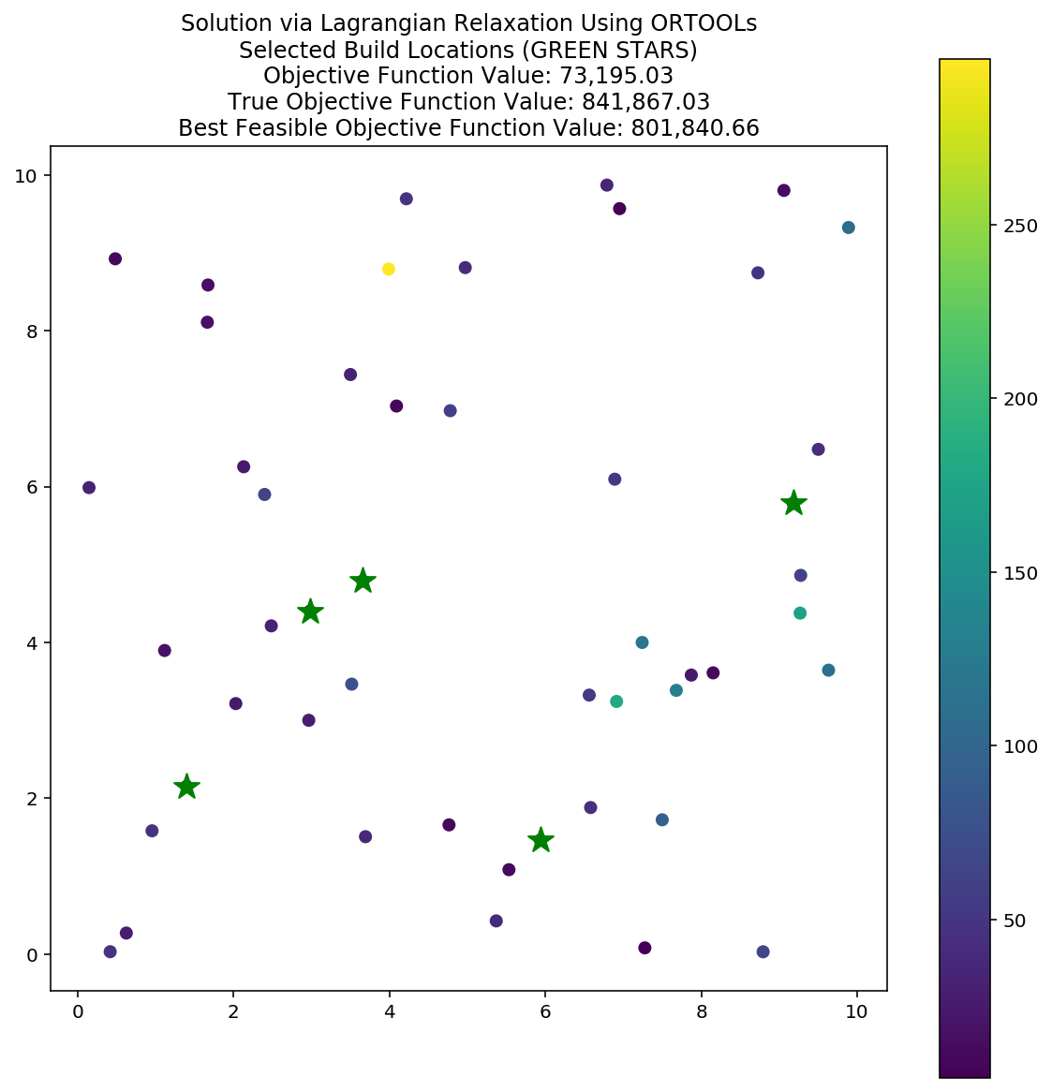

Figure . Solution generated using ORTOOLs solver

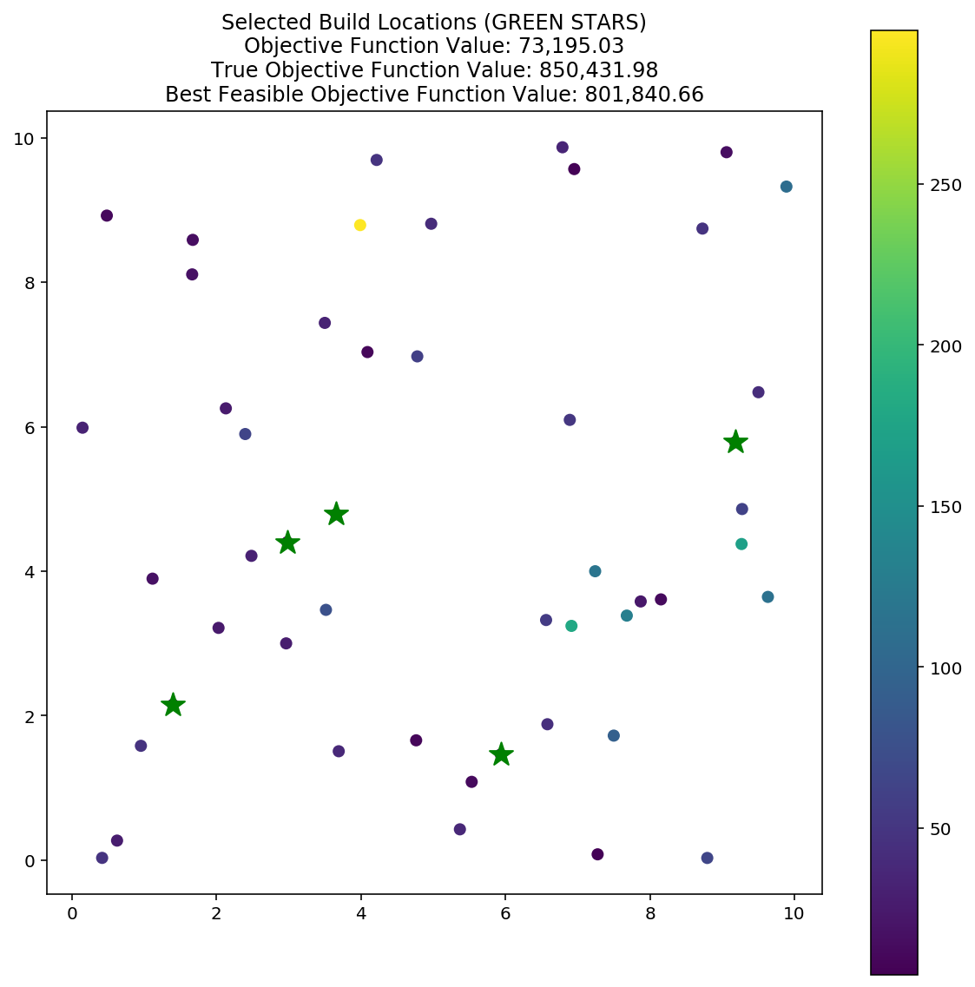

Figure . Solution generated using heuristic solver

Figure 3 presents the five facilities selected for construction: 42, 43, 45, 47, and 48.

Figure . Facilities selected for construction

As seen in Figure 1, an optimality gap is still observed, in this case $40,026. For the second solution approach illustrated in Figure 2, the optimality gap is $48,591. Neither optimality gap is desirable, as per the course instruction it is expected that the optimality gap should be zero. This process is presented in Figure 4. An additional surprising part of these results is the clustering of two stars adjacent to each other.

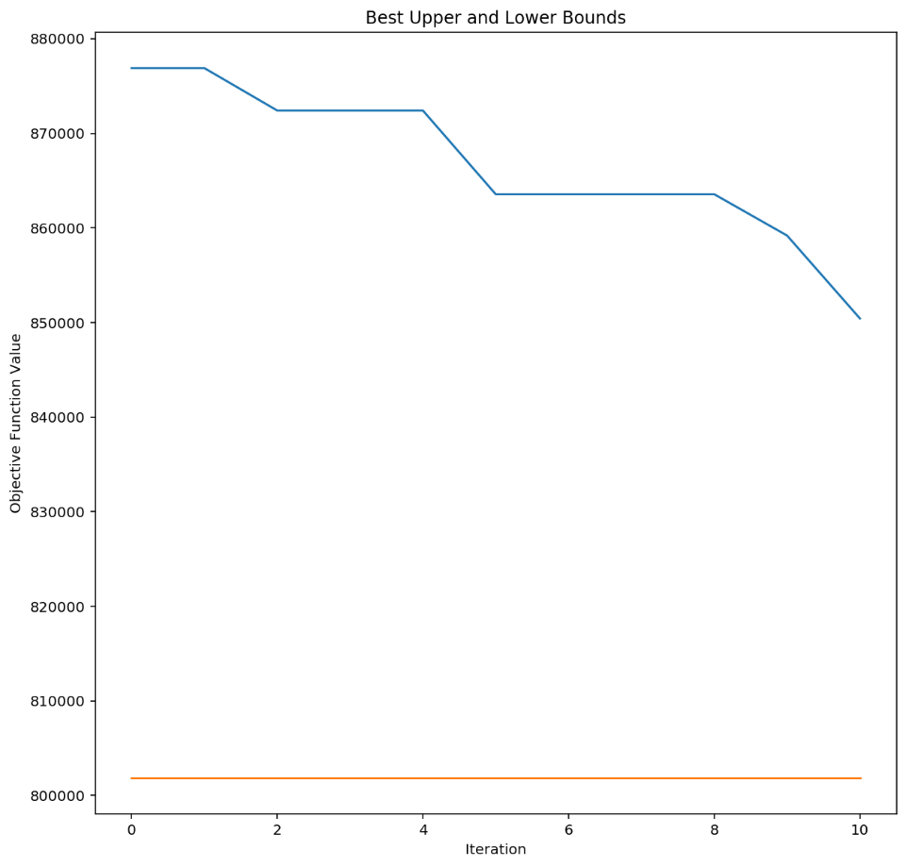

Figure . Convergence over iterations

# Works Cited

[1] Y. Ouyang, “Discrete Location Models,” 2019.

[2] C. Y. Lee, “An optimal algorithm for the multiproduct capacitated facility location problem with a choice of facility type,” *Comput. Oper. Res.*, vol. 18, no. 2, pp. 167–182, 1991.

[3] C.-J. Ting and K.-R. Lu, “A LAGRANGIAN RELAXATION FOR CAPACITATED SINGLE ALLOCATION P -HUB MEDIAN PROBLEM WITH MULTIPLE CAPACITY LEVELS Ching-Jung Ting Department of Industrial Engineering and Management , Yuan Ze University Kuo-Rui Lu Department of Industrial Engineering and Mana,” pp. 1–13, 2016.

[4] Y. Ouyang, “Lagrangian Relaxation,” 2019.