

**[SudMig]**

**Sudan: Monitoring Migrant Movements Related to the 2023 Conflict**

**Final project report**

Submitted by

Stamatina Tounta | Noah Greupner

12232428 | 12235957

Integrated Project: SDI Services Implementation

Winter term 2023/24

Table of Contents

1. Project Overview 3

a. General information 3

b. Context 3

c. Goals and objectives 4

d. Stakeholders 4

e. Non-goals 5

2. Spatial Data Infrastructure (SDI) 5

a. Components 5

b. SDI Architecture 6

3. Milestones & deliverables 7

a. Milestones 7

b. Deliverables 8

4. Work packages 9

a. WP0: Project Management 10

b. WP1: Topic and Data Identification 12

c. WP2: Data Processing 13

d. WP3: Services Creation 15

e. WP4: Data Communication 16

5. Project results 18

6. Challenges 20

7. Learnings and successes 20

8. Signatures of principal investigators 21

# Project Overview

The SudMig project has been developed as part of the IP: SDI course of the Applied Geoinformatics Master’s programme in the winter term 2023/24. This first chapter provides an overview of the project. This includes general information, the project’s practical context, the stakeholders, goals and objectives, and non-goals which were not covered within the project’s scope.

## General information

|  |  |
| --- | --- |
| Acronym | SudMig |
| Name | Sudan: Monitoring Migrant Movements Related to the 2023 Conflict |
| Short description | The SudMig project aims at developing an interactive dashboard that provides valuable insights into the latest Sudanese internal migration. This is done by developing a well-founded underlying SDI (Spatial Data Infrastructure) strategy for the efficient and transparent gathering, processing, and sharing of the migration geodata and the effective visualization in an informative dashboard. The SudMig dashboard thereby supports the Fake United Nation’s decision-making processes related to the 2023 military conflict which causes millions to flee to other parts of the country and neighbouring countries. |
| Contractor | Fake United Nations (FUN) |
| Authors | Stamatina Tounta, Student, University of Salzburg  Noah Greupner, Student, University of Salzburg |
| Project duration | 03.10.2023 - 15.02.2024 |

## Context

The SudMig project and its outcomes were requested by the FUN due to the urgent need for information of refugee movements in Sudan. Since mid-April 2023, there has been an ongoing military crisis happening in Sudan. Especially in the capital city of Khartoum but also in other parts of the country two parties, namely the Sudanese Armed Forces (SAF) and the Rapid Support Forces (RSF) are fighting. Thus, Sudan is facing one of the largest global refugee crises, with a huge and unpredictable impact on the civilian society. About 15% of the whole society has been forced to flee from home to other parts of the country or into neighbouring countries (mainly Chad, Central African Republic, Egypt, Ethiopia, and South Sudan). Around 25 million people (every second person) need humanitarian assistance, making Sudan the largest displacement crisis in the world. In addition to the terrifying displacement situation, disease outbreaks (cholera, measles, malaria, and dengue fever) are increasing due to the disruptions of basic public health services, and hampered access to medicine, medical supplies, water, and electricity. Furthermore, about 18 million people are facing acute hunger due to high food insecurity, classified in IPC Phase 3 or above.

All these facts highlight the importance of projects like SudMig for the analysis of refugee movements, the detection and allocation of resources and shortages, the monitoring of camp capacities, and the coordination and cooperation between different UN authorities and NGOs.

## Goals and objectives

The main objective of our projects was represented by the effective communication of ongoing spatiotemporal movements of Internally Displaced People (IDPs) in Sudan to the Fake United Nations. It aimed at creating an interactive dashboard as the main outcome which provides spatiotemporal information about the current total number of IDPs, the temporal development of the IDP numbers, and the direction and intensity of the movements (aggregated at the level of federal states). This was done by developing and implementing a service-oriented and transparent Spatial Data Infrastructure that integrated our migration statistics and appropriate geodata. Some of the sub-objectives encompassed: 1) the collection and storage of recent open data on Sudan's internal migration in a DBMS with at least the following attributes: total numbers of recently displaced individuals, state of displacement of IDPs, states of origin of IDPs; 2) the publication of a set of (standardized) web services for modern and transparent data communication and usage; 3) the development of an interactive dashboard that supports data analytics and decision-making processes within the FUN authorities; 4) the effective project management, including documentation and the sharing of important documents on a GitLab page to ensure transparency.

## Stakeholders

The Sudan military conflict represents one of the largest humanitarian crises today. Thus, an informative dashboard was urgently needed to support decision-making processes for specific FUN authorities. These authorities include, for example, the FUNHCR, FUNDP, or FUNOCHA. Proto personas were developed and characterized by different attributes (name, organization, role, main tasks, and location) to ensure that the project outcomes and the stakeholder’s requirements were exactly consistent. The proto personas are represented by Nadia (Field Coordinator at FUNHCR), Malik (Humanitarian Analyst at FUNOCHA), and Kathrin (Data Specialist at FUNDP). Although all of them have different roles in their organizations, they all rely on data on internal migration in Sudan. Stakeholders in these positions, therefore, benefit immensely from our dashboard, as it provides at-a-glance information on migration flows between the states over the past months.

Table 1: Proto personas

|  |  |  |  |
| --- | --- | --- | --- |
| Name | Nadia | Malik | Kathrin |
| Organization | FUNHCR* | FUNOCHA** | FUNDP*** |
| Role | Field Coordinator | Humanitarian Analyst | Data Specialist |
| Main task | Coordination of on-the-ground UNHCR activities | Humanitarian data analysis and resource allocation | Analyzing development data and trends |
| Location | Sudan | Genf | New York |
| Needs and goals | * + - Fast information on current refugee movements   + - Monitoring camp capacities   + - Coordination with other UN agencies and NGOs | * + - Refugee information for humanitarian needs   + - Analysis of resource allocations and shortages   + - Derive security information | * + - Understanding of socioeconomic impacts of refugee movements   + - Identification of development projects in affected areas   + - Collaboration with other UN agencies and government entities |

*FUNHCR = Fake United Nations High Commissioner for Refugees

**FUNOCHA = Fake United Nations Office for the Coordinator of Humanitarian Affairs

***FUNDP = Fake United Nations Development Program

## Non-goals

The dashboard is intended to inform expert groups within the FUN architecture. Some level of expertise about the 2023 conflict is, therefore, a prerequisite to fully capturing and understanding the dashboard, analysing the data, and making appropriate decisions. Furthermore, the project did not aim to:

* monitor general (working) migration movements, as it only addresses IDPs who were forced to flee due to the current crisis
* monitor internal migration that is not related to the 2023 conflict
* monitor IDPs before April 2023
* monitor immigration or emigration across the country’s borders

# Spatial Data Infrastructure (SDI)

A Spatial Data Infrastructure (SDI) is a framework that includes spatial data, metadata, users, and tools, that are interconnected and can be used interactively to manage spatial data efficiently and flexibly. The SudMig project was developed upon a sophisticated SDI that integrates various technologies, adheres to industry standards, and implements policies that prioritize accessibility and interoperability.

## Components

**Technology and tools**

Talking first about the technological aspects of the SDI, the desktop GIS ArcGIS Pro was deployed for data integration purposes, including geocoding. It was also used for importing the data in a PostGIS database. This database is built on PostgreSQL with a spatial extension, specifically designed to handle spatial data effectively and was utilized in the SudMig project as data storage. PostGIS is compliant with the Simple Feature Access ISO 19125 standard, set by both the Open Geospatial Consortium (OGC) and the International Organization for Standardization (ISO).

To publish View and Download services, the web server ArcGIS Server was utilized. This server supports a range of Open Geospatial Consortium (OGC) standards, such as Web Feature Service (WFS) and Web Map Service (WMS), as well as ArcGIS-specific services like Feature and Map Image Layers which were all useful in the SudMig project. While we implemented the WFS and WMS versions of our data for sharing and distribution purposes in GitLab, the ArcGIS Feature and Map Image Services were used to build our dashboard, due to the better implementation of those services in the Esri software environment.

For the easy and transparent access to the SudMig metadata, they were uploaded to a metadata catalogue. Geonetwork was chosen as the catalogue to publish the metadata and can be accessed through the University’s Geoserver: [*https://geoserver22s.zgis.at/geonetwork/srv/eng/catalog.search#/home*](https://geoserver22s.zgis.at/geonetwork/srv/eng/catalog.search#/home).

For data visualization, the web-based GIS software ArcGIS Insights was deployed which is a data analysis and visualization tool within the Esri ecosystem.

**Policies & Institutional Arrangements**

SudMig adheres to widely-known standards of the geospatial domain, ensuring transferability and interoperability. Care was taken to share Web Services (WMS and WFS) which are compliant with the Open Geospatial Consortium (OGC). In addition to that, ISO-compliant metadata (ISO19139) was published, so that our data is properly documented and described and our data storage followed the Simple Feature Access standard (ISO19125), which defines a common storage and access model for spatial features. Furthermore, we made use of the paradigm for Open Data and Open Government by acquiring data from the United Nations Office for the Coordination of Humanitarian Affairs (OCHA), making our data resources accessible to a wide range of users.

## SDI Architecture

The project’s Spatial Data Infrastructure (SDI) architecture is graphically presented in Figure 1 below. The SDI is based on statistical data that were geocoded using administrative boundary data (geodata). After pre-processing the data were imported into an ArcGIS Enterprise enabled PostGIS database.

The metadata creation followed the ISO 19139 standard, which, based on the ISO 19115-3:2016, defines an XML schema and a logical model in UML for geographic metadata. Once created, the metadata files were then published to the Z_GIS Geonetwork, a data catalogue to manage, edit and store geospatial metadata.

From the PostGIS database, the data were published as Web Services, both OGC-compliant and ArcGIS Services. The ArcGIS server was the host of these services which can be accessed through the University’s Geoportal. The data were published as OGC Web Feature Services (WFS) and Web Map Services (WMS) and as ArcGIS Feature Layers and Map Image Layers, depending on the data type and the functionality we would like to provide to the end user.

The published Web Services were used in a Web GIS in the form of a dashboard, particularly ArcGIS Insights to communicate the results of our project by creating interactive maps and graphs.

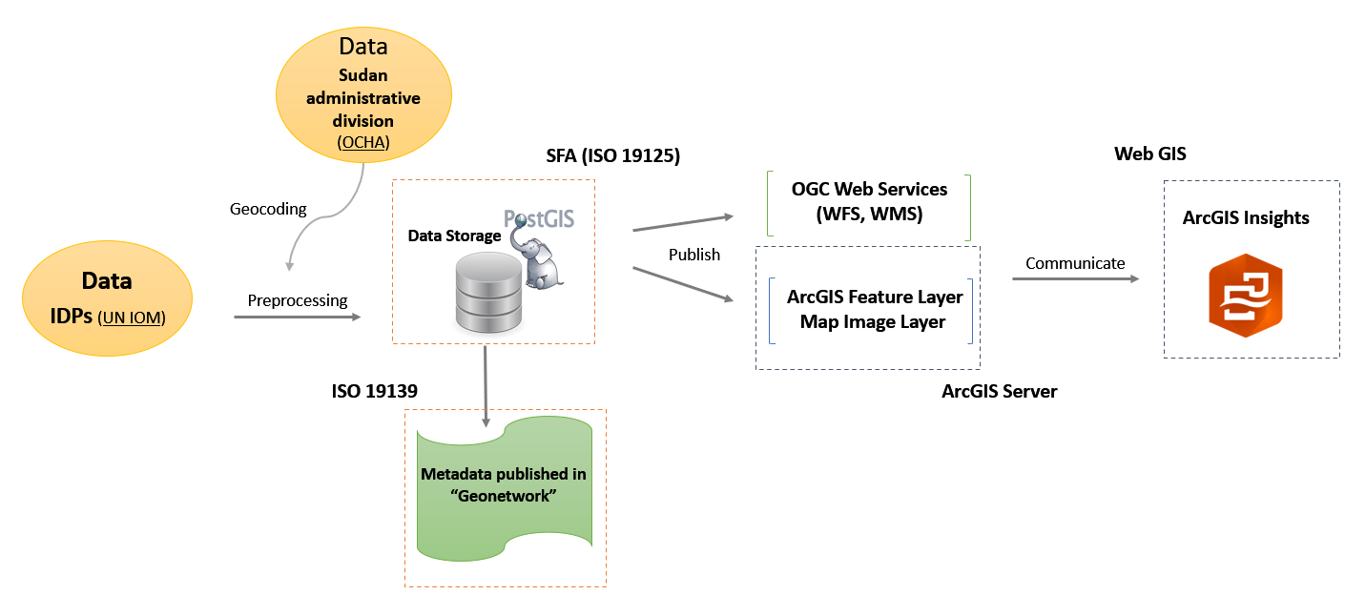

Figure 1: SDI Architecture

# Milestones & deliverables

For each work package (WP), different milestones were set to keep track of the most important tasks that need to be completed in each WP. Similar to the milestones, deliverables were also defined for each work package to consolidate the expected outcomes for each WP.

## Milestones

An overview of the project milestones is provided in Figure 2 and Table 3 below.

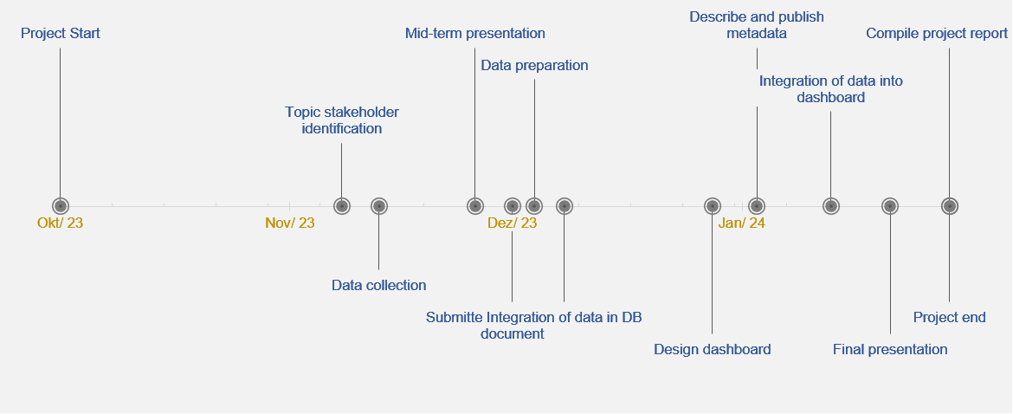

Figure 2: Timeline of the project milestones

Table 2: Project milestones

|  |  |  |
| --- | --- | --- |
|  | Name | Date of Completion |
| M1 | Topic and stakeholder identification | 10.11.2023 |
| M2 | Data collection | 15.11.2023 |
| M3 | Mid-term presentation | 28.11.2023 |
| M4 | Submitted project overview document | 03.12.2023 |
| M5 | Data preparation | 06.12.2023 |
| M6 | Integration of data in DB | 10.12.2023 |
| M7 | Establish Web Service(s) | 20.12.2023 |
| M8 | Design dashboard | 30.12.2023 |
| M9 | Describe and publish metadata | 05.01.2024 |
| M10 | Integration of data into dashboard | 15.01.2024 |
| M11 | Final presentation | 23.01.2024 |
| M12 | Compilation of project report | 31.01.2024 |

## Deliverables

The final deliverables are summarized in the table below and the corresponding access links are added.

Table 3 Project deliverables

|  |  |  |
| --- | --- | --- |
| Deliverable | WP | Link |
| Project proposal (overview document) | WP0 | <https://git.sbg.ac.at/s1095729/sdi_sudan_migration/-/blob/main/Project_management/SudMig_ProjectProposal.pdf> |
| Mid-term presentation | <https://git.sbg.ac.at/s1095729/sdi_sudan_migration/-/blob/main/Project_management/SudMig_MidTermPresentation.pdf> |
| Final presentation | <https://git.sbg.ac.at/s1095729/sdi_sudan_migration/-/blob/main/Project_management/SudMig_FinalPresentation.pdf> |
| Gantt Chart | <https://git.sbg.ac.at/s1095729/sdi_sudan_migration/-/blob/main/Project_management/SudMig_GanttChart.pdf> |
| GitLab documentation | <https://git.sbg.ac.at/s1095729/sdi_sudan_migration/-/wikis/home> |
| Timesheets | <https://git.sbg.ac.at/s1095729/sdi_sudan_migration/-/blob/main/Project_management/SudMig_TimeSheet_NG.xlsx>  <https://git.sbg.ac.at/s1095729/sdi_sudan_migration/-/blob/main/Project_management/SudMig_Timesheet_ST.xlsx> |
| Final report | <https://git.sbg.ac.at/s1095729/sdi_sudan_migration/-/tree/main/Documentation> |
| Project Idea Document | WP1 | <https://git.sbg.ac.at/s1095729/sdi_sudan_migration/-/blob/main/Project_management/SudMig_ProjectIdea.pdf> |
| Database with ready-to-publish data* | WP2 | <https://git.sbg.ac.at/s1095729/sdi_sudan_migration/-/blob/main/Data/SudMig_IDPs_Dataset.gdb.zip> |
| WFS (IPDs) | WP3 | <https://geoportal22s.zgis.at/portal/home/item.html?id=04b5f563e7bc4b8cae4676131e07c910> |
| ArcGIS Feature Layer (IDPs) | <https://geoportal22s.zgis.at/portal/home/item.html?id=9efd45088c284194b4236bd8120fec73> |
| WMS (Sudan Admin. Boundaries) | <https://geoportal22s.zgis.at/portal/home/item.html?id=b7b966b7392e4024b8a3c997340c0571> |
| WFS (Sudan Admin. Boundaries) | <https://geoportal22s.zgis.at/portal/home/item.html?id=8ce1513870c744e7a5ef5b870a2a24e5> |
| ArcGIS Map Image Layer (Sudan Admin. Boundaries) | <https://geoportal22s.zgis.at/portal/home/item.html?id=82cee616cd2e4e58817dc5b9661ddbc2> |
| Metadata (IDPs) | WP4 | <https://geoserver22s.zgis.at/geonetwork/srv/eng/catalog.search#/metadata/94E6A048-19FD-48DE-9254-831D2BEF9DA4> |
| Metadata (Sudan Admin. Boundaries) | <https://geoserver22s.zgis.at/geonetwork/srv/eng/catalog.search#/metadata/2faa663d-e8ca-44d0-af33-014c3c1e521d> |
| Interactive dashboard | <https://geoportal22s.zgis.at/portal/apps/insights/index.html#/view/94ecaf65cf844b3b8994069b97a63b90> |

*The data were also added to the PostGIS database. The File Geodatabase was only created for easy data distribution.

# Work packages

The project was divided into five Work Packages, which are graphically presented below and will be analysed in detail in this chapter. The WP included project management, project definition and data identification, data processing and publishing and finally data communication. The subtasks defined for each WP are presented in the diagram below (figure 3).

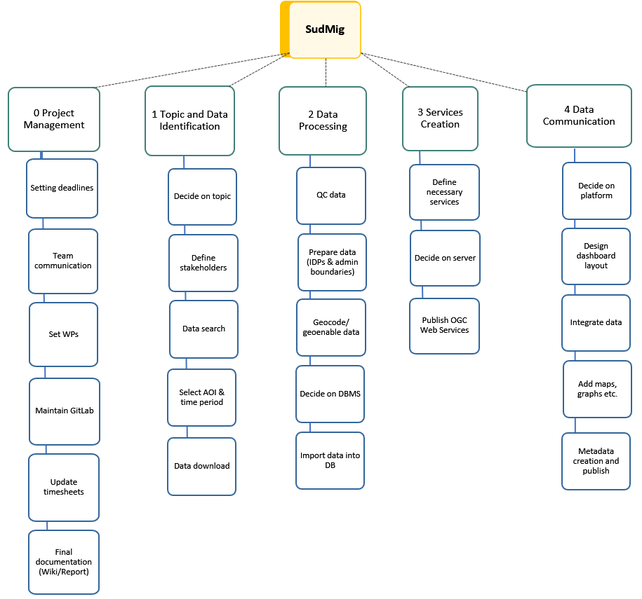

Figure 3: Work breakdown diagram

## WP0: Project Management

**Objectives and tasks**

Effective management as an integral part of every scientific or business project. In the SudMig project, the management was mainly organized in GitLab. This is a web-based DevOps lifecycle tool that provides a Git repository, issue-tracking, and wikis. Using GitLab ensured effective, transparent, and valuable management structures and processes.

The WP objectives and tasks encompassed the following:

* Providing overall project coordination and management, facilitating a dynamic and adaptive implementation of the project and its results
* Maintaining a GitLab page for the project to share progress with stakeholders
* Compilation and submission of the project overview document, the mid-term and final presentations and the final project report

**Workflow**

The workflow of WP0 was not structured along a step-by-step process but involved the development and maintenance of several individual components and documents:

**Gantt chart**

Gantt charts are commonly used in project management. On the left of the chart is a list of the activities and along the top is a time scale. Each activity is represented by a bar; the position and length of the bar reflect the start date, duration, and end date of the activity. In the SudMig project, the chart helped to get an overview of the tasks and sub-tasks, track the current and the next scheduled activities and supported the time management.

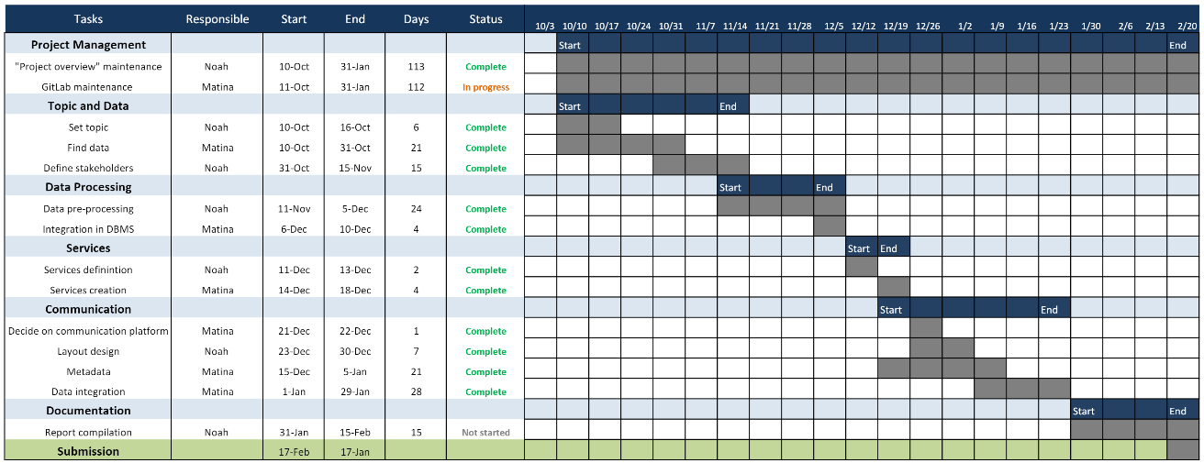

Figure 4: Screenshot of the Gantt chart in a late phase of the project.

**GitLab**

Besides the wiki and the repository, where all important documents regarding data, metadata, and project management were updated regularly, GitLab was also used heavily for the tracking of the sub-tasks. This was done by using a Kanban Board integrated into GitLab. A Kanban Board is an agile project management approach that supports tracking the upcoming, current, and finished sub-tasks of a project. To set up the issues, labels were created for each work package and aligned to the individual sub-tasks. In addition to that, activities and time records were tracked and the due date was updated, if an issue could not be finished in time.

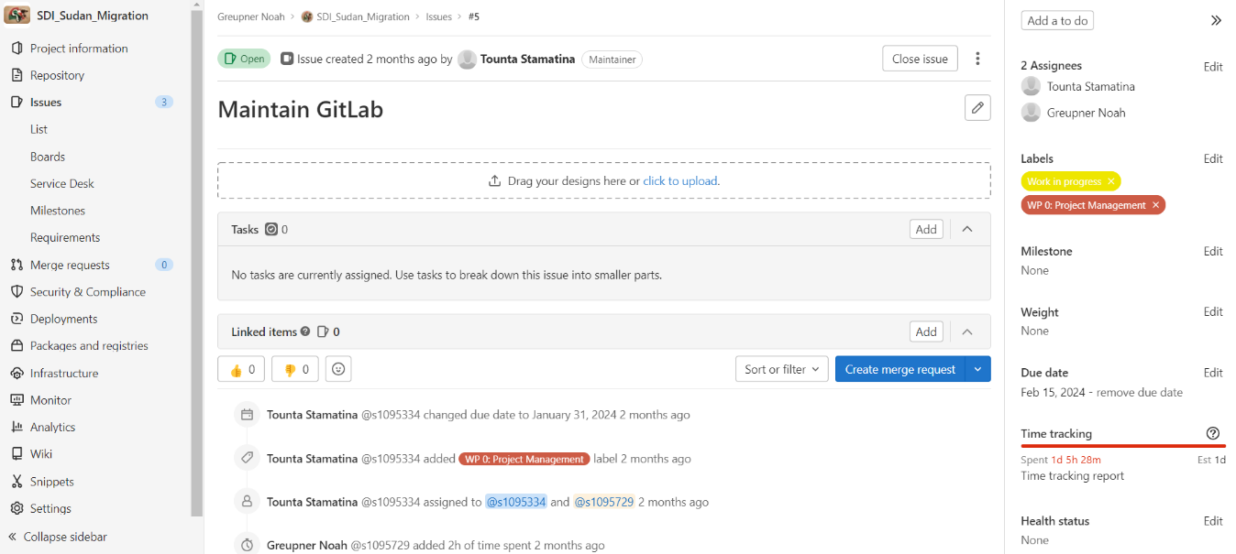

Figure 5: Screenshot of the 'Maintain GitLab' issue.

|  |
| --- |
|  |
|  |  |

**Timesheets**

Time sheets were updated during the whole project duration. A link to them is available in the deliverables table in Chapter 3.

## WP1: Topic and Data Identification

**Objectives and tasks**

* find an interesting and current topic/issue on migration and select an AOI (area of interest)
* define stakeholders and proto personas
* identify appropriate data sources for the topic using official and reliable organizations
* download data - considering their parameters, their size, and time limitations for pre-processing and integration

**Workflow**

First, a topic was defined by conducting a brainstorming for several days. The decision to support the United Nations by providing a dashboard monitoring the internal Sudanese migration was easy in the end, due to the terribleness of the conflict and its implications on the lives of millions of people. Simultaneously to setting up the topic, proto-personas were created (table 1), to which we could align the development process of the project.

**Data identification**

Secondly, several data sources were identified where we could obtain valuable data for our purposes.

The main data sources are the following:

"Sudan Displacement Situation - IDPs [IOM DTM]" provided by the International Organization for Migration (IOM): <https://data.humdata.org/dataset/sudan-displacement-situation-idps-iom-dtm>. This dataset includes by-weekly updates on the displacement situation (including many different variables) in Sudan since April 2023, when the crises started. The data are provided as .xlsx files. For this project, datasets were chosen in monthly intervals from May to November 2023, ensuring that the variables needed for this project were included in each dataset.

Regarding geo-data, the "Subnational Administrative Boundaries of Sudan" dataset was obtained from OCHA and provided by the Information Management Working Group (IMWG): <https://data.humdata.org/dataset/cod-ab-sdn>.

## WP2: Data Processing

**Objectives and tasks**

* identify software for data pre-processing (clean, restructure, and merge raw datasets)
* clean, restructure, and merge raw datasets
* geocode the migration data with existing geodata
* integration of the final dataset into a PostGIS database

**Workflow**

The workflow for this work package started with the data cleaning. For this step, the important information was extracted from the respective datasets for every month and combined in a new dataset. The information included in the final dataset was the "date", "number of IDPs (Internally Displaced Persons)" documented on that date, "state of origin" and "state of displacement". As the data structure needed to be changed to allow for the visualization of internal migration flows, the relational operator UNPIVOT was utilized in MS Excel to create rows out of the column list:

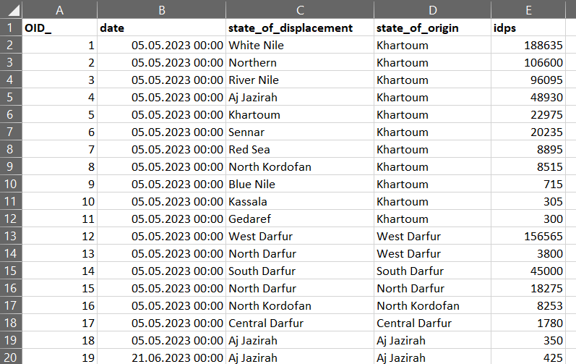

Figure 6: Snapshot of the statistical table

Subsequently, the data were geocoded using the ArcGIS Pro software by joining the created data table with the shapefile containing the administrative boundaries of Sudan (Administrative Level 1) as vector polygon data (figure 7):

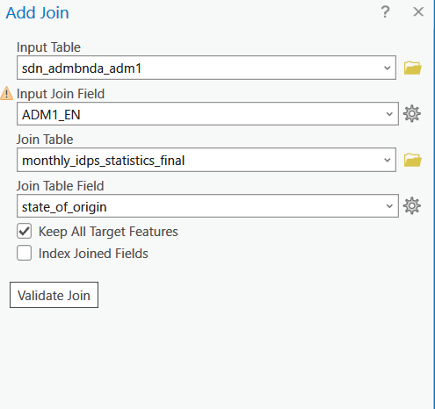

Figure 7: Add join tool

**Data optimization for ArcGIS Insights**

As a further step, the data were optimized for visualization in ArcGIS Insights as the goal was to create a map showing the internal migration flows in Sudan using arrows. For that, the data needed to be processed in a way that they could be used later in ArcGIS Insights. First, the administrative boundaries were converted into points (centroids) and were geocoded using the statistical table created above using the "state of origin" column for the join. For the statistical table, attribute indices for the "date", "state of origin" and "state of displacement" were added before the join, to optimize attribute retrieval and creation of links. After that, a pair of x, and y coordinates was calculated and a final join was performed (figure 8), this time using the "state of displacement" as a join column. In this way, two geometry columns will be created in ArcGIS Insights, one for the "state of origin" and one for the "state of displacement".

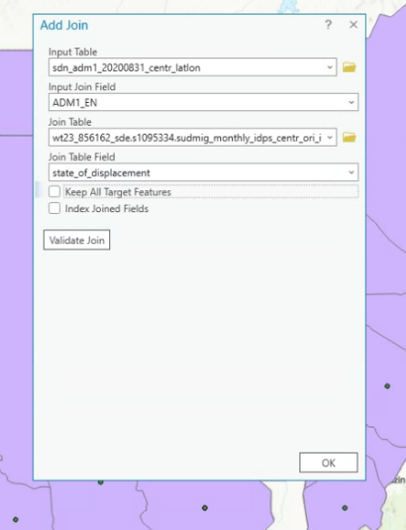

Figure 8: Consecutive joins

**Importing data into the PostGIS Database**

In the last step, the joined datasets were uploaded into an ArcGIS-enabled PostGIS database. Care was taken to use "PG_GEOMETRY" as the input key. In the database itself, the data was further processed by altering the column names and converting zero values into NULL values through SQL queries, for optimizing visualization in the dashboard. A snapshot of our main dataset in the PostGIS database in provided in figure 9.

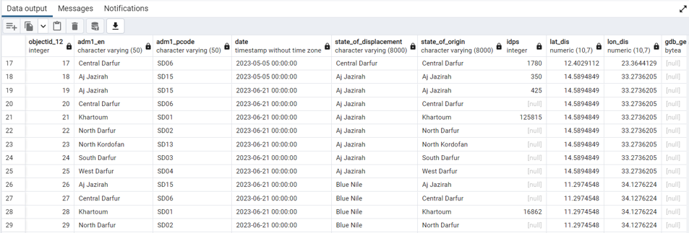

Figure 9: Snapshot of our dataset into the PostGIS Database

## WP3: Services Creation

**Objectives and tasks**

* define required services
* decide on the service host (e.g. GeoServer, ArcGIS Server)
* publish Web Services that can be shared across different software or platforms

**Workflow**

After the datasets were added to the PostGIS Database, ArcGIS Pro was used to publish the datasets as Web Services. In particular, the monthly IDPs statistical dataset ("SudMig Monthly IDPs") was published as an OGC Web Feature Service ([WFS](https://geoportal22s.zgis.at/portal/home/item.html?id=04b5f563e7bc4b8cae4676131e07c910)) and as an ArcGIS [Feature Layer](https://geoportal22s.zgis.at/portal/home/item.html?id=9efd45088c284194b4236bd8120fec73), so that it can be easily used in ArcGIS Insights. Additionally, the states of Sudan (admin level 1) were published as an OGC Web Map Service ([WMS](https://geoportal22s.zgis.at/portal/home/item.html?id=b7b966b7392e4024b8a3c997340c0571)) to allow easy visualization and as a [WFS](https://geoportal22s.zgis.at/portal/home/item.html?id=8ce1513870c744e7a5ef5b870a2a24e5) to provide analysis possibilities. Additionally, an ArcGIS [Feature Layer](https://geoportal22s.zgis.at/portal/home/item.html?id=68c4d4972d3a40bdba805a64502ab5fe) and [Map Image Layer](https://geoportal22s.zgis.at/portal/home/item.html?id=82cee616cd2e4e58817dc5b9661ddbc2) were published, to allow for better functionality in the ArcGIS environment. A visualization of selected published web services is provided in figure 10.

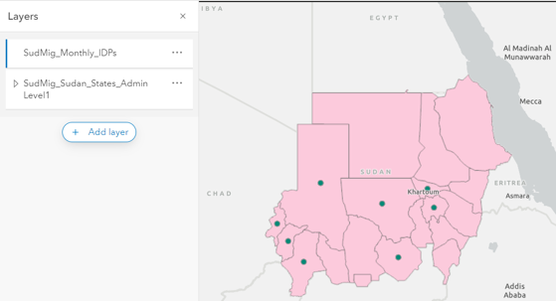

Figure 10: Adding and visualizing the WFS statistical layer and WMS Admin L1 layer on a web map

## WP4: Data Communication

**Objectives and tasks**

The WP4 was dedicated to building a spatiotemporal dashboard visualising the IDPs’ movements and additional statistics for FUN decision-makers, with metadata published in a geospatial catalogue. The WP encompassed the following objectives and tasks:

* Communicate the data in a way that is tailored to the stakeholder’s needs
* Decide on software for the dashboard
* Design dashboard layout
* Integrate the data into the dashboard and display them using maps and graphs
* Describe the data according to ISO 19139 metadata standard and publish it in XML format to a geospatial catalogue

**Workflow**

**Software**

The decision on which software to use for the dashboard was the first step in WP4. There were several options to consider, including ArcGIS Dashboards, Apache Superset, QGIS Dashboards, ArcGIS Insights etc. However, not all of them offer the same functionalities. For the project purpose of visualizing IDP movements within Sudan, the possibility to create an origin-destination map with arrows for the movements between the federal states was important. Thus, a decision was made to use ArcGIS Insights as a web application for the dashboard, allowing us to create such a map interactively and powerfully. ArcGIS Insights is a data analysis and visualization tool developed by Esri. It allows for exploring and analyzing spatial data and create interactive maps, charts, and tables to visualize the data and analysis results. These visualizations can be easily customized and shared with others. A workbook was set up in ArcGIS Insights to start working on the subsequent tasks.

**Layout design**

Before integrating the dataset into the dashboard, a broad dashboard layout design was required. Of course, this initial design differs from the final product, however, it was necessary to identify the main components of the dashboard and the alignment of those on the dashboard (map, information card, Total Number, temporal development, filter etc.). The image below shows the intended alignment of the components in a very early stage of the workflow. Additionally, the layout design phase also encompassed aspects like the colouring of the dashboard, title, logo, and other general settings and design aspects.

**Data integration**

Data was integrated into the ArcGIS Insights using the web services which were published in [Workpackage 3](https://git.sbg.ac.at/s1095729/sdi_sudan_migration/-/wikis/WP3-Services-Creation) A major part here was the creation of the map. For this, additional columns had to be created in the data structure of the [dataset](https://git.sbg.ac.at/s1095729/sdi_sudan_migration/-/tree/main/Data), representing x and y coordinates for the state of displacement. These x and y coordinates could further be deployed in ArcGIS Insights to execute the "Enable Location" functions that derives a new geometry column for these coordinates. Using this workflow, the origin-destination map with arrows between the IDPs' state of origin and the state of displacement could be generated for the dashboard.

**Metadata**

The metadata of the datasets were published and added to the [repository](https://git.sbg.ac.at/s1095729/sdi_sudan_migration/-/tree/main/Metadata) as XML files. Moreover, they are available in the [PLUS Z_GIS Geonetwork](https://geoserver22s.zgis.at/geonetwork/srv/eng/catalog.search#/metadata/94E6A048-19FD-48DE-9254-831D2BEF9DA4) (figure 11). To create the metadata, ArcGIS Pro was used and the metadata standard was set to ISO 19139 in the settings. Subsequently, both datasets (IDPs and administrative boundaries) were opened in ArcGIS Pro by retrieving from the PostGIS database and the metadata was added. Especially important were the License and Lineage fields, as well as the description of each attribute in the table, which are valuable information for the user. As a last step, the metadata was exported as .xml and .html (human-readable) files.

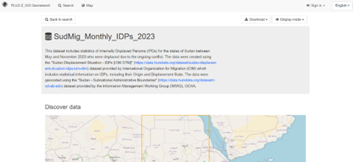

Figure 11: Metadata published in Geonetwork

# Project results

The dashboard was created with ArcGIS Insights, finalized in January 2024 and can be accessed using this [link](https://geoportal22s.zgis.at/portal/apps/insights/index.html#/view/94ecaf65cf844b3b8994069b97a63b90). It consists of several individual components, each of them visualizing important spatial or temporal information which contributes to the dashboard as a compilation of charts and maps being tailored to the needs of the FUN. An overview of the dashboard is provided in figure 12 below.

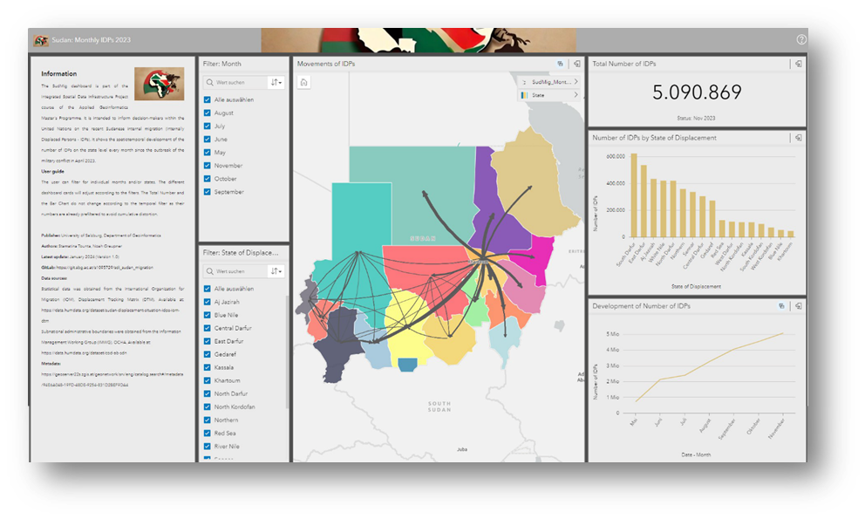

Figure 12: Final Dashboard

The individual components of the dashboard are now described in more detail:

**Information card:**

One of the most important, if not the most important element of the dashboard is the information panel. It contains a general description of the objectives of the dashboard, a short user guide as well as links and additional information about the data, the metadata, the authors, and the licensing. Taking the psychological fact into account that people tend to visually scan media like dashboards from the upper left corner, the information panel is attached on the upper left side of the dashboard to introduce the user to the dashboard first.

**Predefined filters:**

The predefined filters "Filter: Month" and "Filter: State of Displacement" can be adjusted to the user's needs. The map and the three cards on the right side adjust based on these filters, allowing the user to filter the data in a temporal (months) and spatial (states) way. The filters are attached next to the information panel to guide the user from left to right, before dealing more with the map and the charts on the right side.

**Migration Flow Map:**

The map in the middle builds the dashboard's core and is mainly responsible for conveying information on the IDPs' movements. It changes based on the predefined filters and is built of a WFS representing the Sudanese administrative borders and a WFS that represents the IDP movements. The latter contains two geometries, representing the state of origin and the state of displacement of the IDPs. This enables an origin-destination map with arrows in ArcGIS Insights. In the dashboard, the arrows' thickness is weighted according to the number of IDPs moving from one respective state to the other. The map is interactive, and it can be zoomed in and out and selections can be made.

**Total IDP number chart:**

The card represents the total number of IDPs briefly. As the dataset uses cumulative IDP statistics, the total number is already prefiltered by the authors to show only the IDPs as of November 2023. Thus, the "Filter: Month" filter cannot be applied here.

**IDP numbers by state of displacement:**

The bar chart shows the numbers of IDPs according to the respective state of displacement and is therefore intended to identify those states facing the most migratory pressure. This is heavily important for the dashboard usage by our proto personas who need to allocate resources and monitor camp capacities. The bar chart is interactive, and the map adjusts based on the selected state.

**IDP number development chart:**

The line chart focusses more on the temporal component of the internal migration and provides information on the overall trend of the development of the IDP numbers. This could be enabled because of the "date" column in the data structure. Although there is a decrease in the gradient of migrants, the number is still increasing heavily. The line chart is also interactively coupled with the map. Since the underlying dataset is cumulative, the line chart is pre-filtered and therefore limited when it comes to applying the "Filter: Month" filter.

# Challenges

This chapter addresses challenges and obstacles. The following table (table 4) lists and describes those that occurred during the project, the impact that those challenges have had on the project and the actions taken to address them.

Table 4: Challenges

|  |  |  |
| --- | --- | --- |
| Description | Impact | Actions taken |
| Cumulative nature of the acquired datasets from OCHA | Wrong statistics in the dashboard charts | Filters were applied for affected charts. Limited filtering possibilities remain but are uninfluenceable |
| Original datasets were not consistent regarding the way they provided the information | Tedious data cleaning and no automatization possible | Compilation of datasets into one large dataset and application of relational operator UNPIVOT in MS Excel |
| Specific data structure required for ArcGIS Insights | The initial ArcGIS Feature Layer not suitable for the creation of the migration flow map | Restructuring of the dataset (adding x and y coordinates for state of displacement) |
| Internal displacement within the same federal state | No visualization possible in final migration flow map | Increased accuracy between origin and displacement centroids |
| Limited visualization capabilities of ArcGIS Insights | Scale of the dashboard not consistent with differing screen size | No solution possible due to internal software issues |
| Limitation to edit an ArcGIS Insights workbook from two accounts | Could not work independently and meetings had to be scheduled making the process slightly more time consuming | Had to work and edit together from one account |

# Learnings and successes

This chapter deals with learnings and successes during the project phase. Since the authors are still students with non-IT backgrounds, there were several new learnings and takeaways which they can incorporate in the next university and business projects.

**Project management**

One of the biggest experiences we gained has been the organization and management of the project. Although SudMig is a relatively small university project, the number of hours that need to be spent for project management were underestimated. However, this motivates us to generously estimate the working hours in our next projects, not only for project management but also for other tasks like data pre-processing and cleaning which were much more time-intensive than previously expected.

**ArcGIS Insights**

The usage of ArcGIS Insights as a previously not known software extends our portfolio of software skills.

**Spatial Data Infrastructure**

With the help of the SudMig project, we were also able to gain new experience regarding SDI. We were already familiar with some of the aspects, such as data collection and cleaning. However, new problems and challenges also arose here, which had to be solved and which ultimately helped us grow.

However, we were entering new ground with data management in geodatabases in particular and were able to gain initial experience here, also with regard to possible problems that can arise here during the import and further processing of data sets.

Other SDI components, such as the publishing of web services and the incorporation of metadata standards in geodata, were previously only known to us from theoretical lectures and we were now able to apply them in practice. The previous theoretical knowledge helped us to understand the background of the various standards and policies and to quickly grasp the technical interactions between the SDI components and apply them in practice.

In conclusion, the SudMig project was successfully finished in time. We developed a spatial data infrastructure workflow for creating an interactive dashboard with recent data on internal displacement flows in Sudan which can be used by the Fake United Nations. We can therefore proudly declare the project objectives to be successfully achieved by the University of Salzburg and are sure that the SudMig dashboard will provide a huge impact for its incorporation into the work processes of the FUN.

# Signatures of principal investigators

Salzburg, 17.02.2024

Stamatina Tounta Noah Greupner