# Project Overview Document

## Project information

|  |  |  |  |  |
| --- | --- | --- | --- | --- |
| Project |  | | | |
| Acronym | SudMig | | | |
| Title | Sudan: Monitoring Migrant Movements related to the 2023 conflict | | | |
| Period | Start: | 03.10.2023 | End: | 31.01.2024 |
| Principal investigator | Stamatina Tounta, Noah Greupner | | | |
| Contractor | United Nations | | | |
| Logo |  | | | |

## Document version

|  |  |  |  |  |  |
| --- | --- | --- | --- | --- | --- |
| Nr. | Date | Version | Altered chapters | Type of altering | Author |
| 1 | 18.10.2023 | 1.1 | all | Creation | ST, NG |
| 2 | 09.11.2023 | 1.2 | 3.1 | Addition | ST, NG |
| 3 | 23.11.2023 | 1.3 | all | Addition, Deletion | ST |
| 4 | 28.11.2023 | 1.4 | all | Addition, Deletion | NG |
| 5 | 29.11.2023 | 1.5 | all | Addition | ST, NG |

## Project Content and Project Goals

|  |
| --- |
| Content & Goals |
| Project description |
| The SudMig project aims at developing an interactive dashboard that provides valuable insights on the latest Sudanese internal migration. This is done by developing a well-founded underlying SDI (Spatial Data Infrastructure) strategy for the efficient and transparent gathering, processing, sharing of the migration data and the effective visualization in an informative dashboard. The dashboard, thereby, supports United Nation’s decision-making processes related to the 2023 military conflict which causes millions to flee to other parts of the country and to neighbouring countries.  Different parameters related to Sudanese internal migration, such as the number of Internally Displaced People (IDPs), their origin and destination within Sudan, the demographics as well as geocoded data, like Sudan’s administrative boundaries, will be collected, organized, and visualized effectively. The data will be organized and stored in a PostgreSQL (PostGIS) database management system and published with standardized web-services, such as the OGC Web Map Service and Web Feature Service. Finally, the data will be integrated into the SudMig dashboard, so that our important migration parameters and trends can create impact by being communicated to the decision-makers briefly and at a glance. |
| Project purpose, benefits and target group description |
| Our project aims at identifying the movements of IDPs within Sudan. The outcome of the project will be an interactive dashboard which will provide spatiotemporal information about the current total number of IDPs, the temporal change of migration, and the direction and intensity of the movements (aggregated at level of federal states).  The Sudan military conflict represents one of the largest humanitarian crises today. Thus, a informative dashboard is urgently needed to support decision-making processes for specific United Nations authorities. These authorities include, for example, the UNHCR, UNDP, or UNOCHA. Our proto personas are represented by Nadia (Field Coordinator at UNHCR), Malik (Humanitarian Analyst at UNOCHA), and Kathrin (Data Specialist at UNDP). Although all of them have different roles in their organizations, they all rely on up-to-date data on internal migration in Sudan. Stakeholders in these positions, therefore, benefit immensely from our dashboard, as it provides at-a-glance information on migration flows between the states over the past months (since the outbreak of the conflict). |
| Project objectives (please also include a listing of the sub-goals) |
| The main objective of our projects is represented by the effective communication of ongoing spatiotemporal movements of Internally Displaced People (IDPs) in Sudan to the United Nations. This is done by developing and implementing an service-oriented and transparent Spatial Data Infrastructure that integrates our migration statistics and appropriate geodata. Some of the sub-objectives contain:   * Collect and store open and up-to-date data on Sudan's internal migration in a DBMS   + parameters: total (estimate) numbers of recently displaced individuals, state of displacement of IDPs, states of origin of IDPs, permanent population of each state * Share a set of (standardized) geo-services for data sharing and communication * Develop an interactive dashboard that supports data analytics and decision-making processes within the United Nations Authorities * Project management: document, manage, and share the project in GitLab |
| Non-Goals |
| The project does not aim to:   * monitor general (working) migration movements, as it only addresses IDPs who were forced to flee due to the current crisis. * internal migration that is not related to the 2023 conflict * Internal migration before April 2023. * monitor immigration or emigration across the country’s borders   Furthermore, the dashboard is intended to inform expert groups within the United Nations architecture. Some level of expertise about the 2023 military crisis is, therefore, a prerequisite to fully capturing and understanding the dashboard, analyzing the data, and making appropriate decisions. |

## Frame of the project

|  |
| --- |
| Context |
| Up-to-date status |
| The project topic selection is done. Furthermore, appropriate datasets to be used have been identified. Data have been retrieved from the Humanitarian Data Exchange (HDX) portal provided by OCHA (United Nations Office for the Coordination of Humanitarian Affairs) services. Specifically, data from the “Sudan Displacement Situation - IDPs [IOM DTM]” dataset provided by the "International Organization for Migration" (IOM) (available at: <https://data.humdata.org/dataset/sudan-displacement-situation-idps-iom-dtm>) will be used to display the following variables: “Total estimate of recently displaced individuals”, “State of displacement of IDPs”, “States of origin of IDPs”. Additionally, the “Sudan - Subnational Administrative Boundaries” (available at: <https://data.humdata.org/dataset/cod-ab-sdn>) will be used and joined with the previously mentioned data to integrate spatial information. In addition to that, the GitLab page has been created and will be provided with the requested information within the next days.  Subsequent steps will mainly include the data cleaning and the geocoding using R or GIS. Further, the integration and manipulation of the data in the Z_GIS PostGIS database must be done. |
| Project setting |
| Current challenges:   * Coherency of the data (there are slight data changes from September 2023 onwards). This requires pre-processing of the data to ensure consistency and interoperability * Geocoding of the data * Data structure must be developed to fit the needs of the dashboard |

|  |  |  |  |  |  |
| --- | --- | --- | --- | --- | --- |
| Dates | | | | | |
| Time period | | | | | |
| Start: | | 03.10.2023 | | End | 31.01.2024 |
| Important Dates | | | | | |
| 1 | 03.10.2023 | | Kick-off | | |
| 2 | 28.11.2023 | | Mid-term presentation | | |
| 3 | 23.01.2024 | | Final presentation | | |
| 4 | 31.01.2024 | | Report submission | | |

## Resources & Budget

|  |
| --- |
| Project Team |
| Projekt Lead |
| Stamatina Tounta (B.Sc. Geography): Project leader, project management, EO specialist |
| Project Team |
| Noah Greupner (B.Sc. Geography): Geospatial expert, project management, geovisualization |

|  |
| --- |
| Resources |
| Personal costs |
| 2 experts (100 hours, respectively) |
| Project costs |
| 30.000€ |
| Other Costs |
| 2.500€ |

## Project structure, description and risk matrix

### Work packages overview:

|  |  |  |
| --- | --- | --- |
| WP | Name | Time Frame |
| 0 | Project Management | 10.10.2023 – 31.01.2024 |
| 1 | Topic and Data Identification | 03.10.2023 - 10.11.2023 |
| 2 | Data Processing | 11.11.2023 - 30.11.2023 |
| 3 | Services Creation | 01.12.2023 - 20.12.2023 |
| 4 | Data Communication | 21.12.2023 - 15.01.2024 |

### Work Breakdown Structure (WBS)

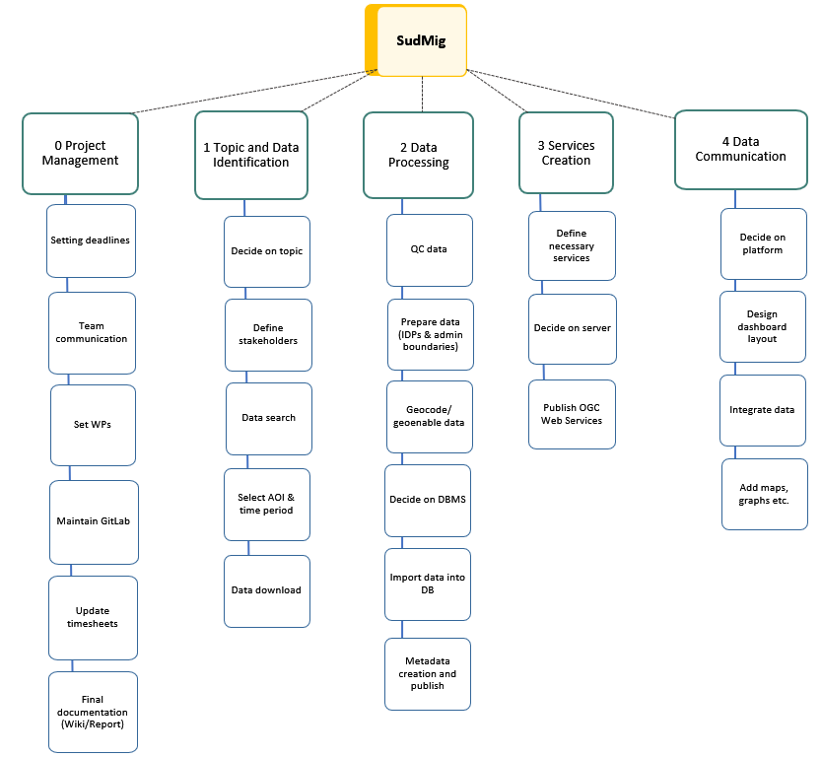

*Figure 1 Work breakdown Structure*

## Detailed work plan

|  |  |  |  |  |
| --- | --- | --- | --- | --- |
| WP 0 | Project management |  | | 10.10.2023 – 31.01.2024 |
| WP Lead | | | **WP team** | |
| Stamatina Tounta | | | Noah Greupner | |
| Objectives | | | | |
| * provide overall project coordination and management, facilitating a dynamic and adaptive implementation of the project and its results; * maintain a GitLab page for the project to share progress with stakeholders; * compilation and submission (presentation) of the mid-term and the final project report | | | | |
| Content & Tasks | | | | |
| Setting deadlines, internal team communication, creation of time plan, identification of WP, maintaining GitLab, compilation of the final report | | | | |
| Expected results | | | | |
| Effective, transparent, and valuable management structures and processes. | | | | |
| Milestones & Deliverables | | | | |
| M3: Mid-term presentation  M4: Submitted project overview document  M11: Final presentation  M12: Compilation of project report  D2: Mid-term presentation  D3: Project overview document  D8: GitLab documentation  D9: Final presentation  D10: Final project report | | | | |

|  |  |  |  |  |
| --- | --- | --- | --- | --- |
| WP 1 | Topic and Data Identification |  | | 10.10.2023 - 15.11.2023 |
| WP Lead | | | **WP team** | |
| Noah Greupner | | | Stamatina Tounta | |
| Objectives | | | | |
| The objectives are to find an interesting topic on migration, identify appropriate data to communicate and define stakeholders in the form of proto personas. | | | | |
| Content & Tasks | | | | |
| * Decide on a topic that fits our interest, the current world challenges, and sufficient data are available * Search for available datasets regarding migration through official and reliable organizations (e.g. United Nations, Eurostat etc.) * Select an Area of Interest * Identify appropriate datasets that correspond to our topic, for both demographic parameters and geographic data (administrative boundaries) * Select a time period / time steps * Download datasets, considering the parameters they provide, their size, and time limitations for pre-processing and integration * Define a stakeholder group / audience to which the dashboard is communicated | | | | |
| Expected results | | | | |
| * Come up with a topic regarding a specific country or countries, the population that we would like to study/monitor (e.g. migrants, refugees, asylum seekers), the timeframe and the target group/ stakeholders for our final product (dashboard) * Obtain a dataset containing different demographic parameters and a geographic dataset that can be joined with the first. | | | | |
| Milestones & Deliverables | | | | |
| M1: Topic and stakeholder identification  M2: Data collection  D1: Project idea document | | | | |

|  |  |  |  |  |
| --- | --- | --- | --- | --- |
| WP 2 | Data Processing |  | | 11.11.2023 – 05.01.2024 |
| WP Lead | | | **WP team** | |
| Stamatina Tounta | | | Noah Greupner | |
| Objectives | | | | |
| Data pre-processing and integration into a Database Management System (DBMS) | | | | |
| Content & Tasks | | | | |
| * Check the data quality and identify possible challenges for their processing and overall usage * Decide on software to be used for data preparation (e.g. R or Python) and import into the PostGIS DB (e.g. QGIS or ArcGIS or through the pgAdmin 4 command line) * Prepare the IDPs data * Prepare the administrative Boundaries dataset * Join with administrative boundaries-data geocoding * Select the DBMS, probably PostgreSQL, that will be used * Decide on how the data will be imported, e.g. individual tables for each timestep or combine (additional timestep column would be needed), keep each variable separately or combine * Import the data into the PostGIS database * Describe the data according to ISO 19115 metadata standard & publish these metadata in XML format (ISO 19139:2007) to a geospatial catalogue | | | | |
| Expected results | | | | |
| Nicely organized and pre-processed dataset(s) in the DBMS that are ready to be published as services. Also, create a geospatial catalogue that describes the datasets. | | | | |
| Milestones & Deliverables | | | | |
| M5: Data preparation  M6: Integration of data in DB  M9: Describe and publish metadata  D4: Database with ready-to-publish data  D6: Published metadata in geospatial catalogue | | | | |

|  |  |  |  |  |
| --- | --- | --- | --- | --- |
| WP 3 | Services Creation |  | | 10.12.2023 - 20.12.2023 |
| WP Lead | | | **WP team** | |
| Noah Greupner | | | Stamatina Tounta | |
| Objectives | | | | |
| Publish web services that can be shared across different software and platforms. | | | | |
| Content & Tasks | | | | |
| * Define the services needed (OGC WMS & WFS, ArcGIS Image & Feature Layer) * Decide on service host (Geoserver, ArcGIS Server etc.) * Publish web service(s) | | | | |
| Expected results | | | | |
| * Published web services containing our migration geodata | | | | |
| Milestones & Deliverables | | | | |
| M7  : Establish Web Service(s)  D5  : Published Web Service(s) | | | | |

|  |  |  |  |  |
| --- | --- | --- | --- | --- |
| WP 4 | Data Communication |  | | 21.12.2023 – 15.01.2024 |
| WP Lead | | | **WP team** | |
| Stamatina Tounta | | | Noah Greupner | |
| Objectives | | | | |
| Communicate the data in an appropriate way, which is tailored to the stakeholders. The final product will be an interactive dashboard integrating and geospatially visualizing the migration data. | | | | |
| Content & Tasks | | | | |
| * Decide on a software/platform * Design dashboard layout * Integrate data into the dashboard and display them using maps and graphs | | | | |
| Expected results | | | | |
| A spatiotemporal dashboard visualizing Sudanese internal migration movements and additional statistics for UN decision-makers. | | | | |
| Milestones & Deliverables | | | | |
| M8: Design dashboard  M10: Integration of data into dashboard  D7: Published dashboard | | | | |

## Milestone plan

|  |  |  |
| --- | --- | --- |
|  | Name | Date Completion |
| M1 | Topic and stakeholder identification | 10.11.2023 |
| M2 | Data collection | 15.11.2023 |
| M3 | Mid-term presentation | 28.11.2023 |
| M4 | Submitted project overview document | 03.12.2023 |
| M5 | Data preparation | 06.12.2023 |
| M6 | Integration of data in DB | 10.12.2023 |
| M7 | Establish Web Service(s) | 20.12.2023 |
| M8 | Design dashboard | 30.12.2023 |
| M9 | Describe and publish metadata | 05.01.2024 |
| M10 | Integration of data into dashboard | 15.01.2024 |
| M11 | Final presentation | 23.01.2024 |
| M12 | Compilation of project report | 31.01.2024 |

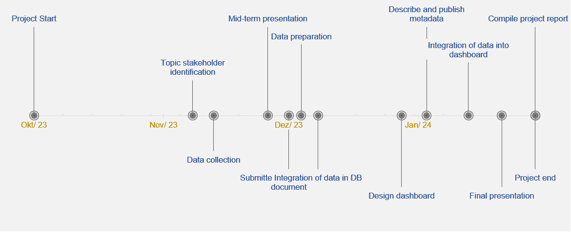

Figure 2 Milestones

## Gantt Chart

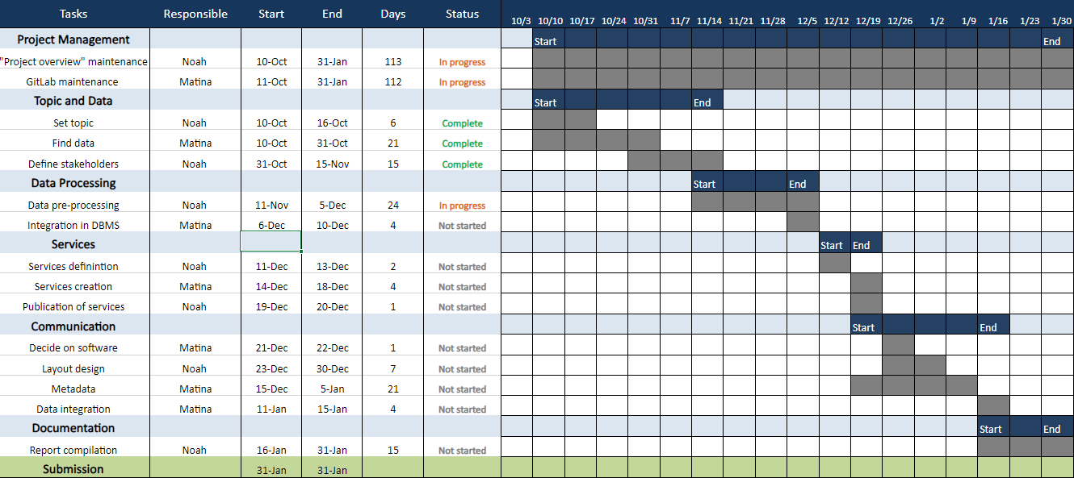

Figure 3 Gantt Chart

## Risk matrix

|  |  |  |  |  |
| --- | --- | --- | --- | --- |
|  | Risk | Mitigation Strategy | Type | Update |
| 1 | No appropriate data | Adapt topic | L | 03.11.2023 |
| 2 | Raw data inconsistency | Manipulation of datasets to achieve uniformness | M | 26.10.2023 |
| 3 | Data integration in database | Search online for the most efficient way to handle that | H | 29.11.2023 |
| 4 | Data integration in dashboard | Formulate data to ensure dashboard functionality | M | 29.11.2023 |

## Additional comments

|  |
| --- |
| Comments |
|  |

## Approval

|  |  |  |  |
| --- | --- | --- | --- |
| Approval | | | |
| Approval: | Date: | |  |
|  | |  | |
| Signature principal investigator | | Signature project lead/contractor | |

## Workload distribution

*Describe the team workload distribution in % per WP*

*WP0: ST = 50%; NG = 50%*

*WP1: ST = 60%; NG = 40%*

*WP2: ST = 30%; NG = 70%*

*WP3: ST = 50%; NG = 50%*

*WP4: ST = 40%; NG = 60%*

*WP5: ST = 70%; NG = 30%*

## Attachments

*Attachment 1: Gantt Chart (monthly updated).*