OpenAmbient V0.1 Hardware Design Documentation

Table of contents
Overview 2
Introduction: 2
PCB 3D render pictures: 3
Blocks Description: 5
ESP32S3: 6
List of pin connections: 6
Strapping pins: 9
JTAG Interface: 9
Pins GPIO35/36/37: 10
I2C Interface: 10
USB, User Button, Boot and reset: 10
SIM7080G Modem: 11
Built-in sensors: 11
Power Supply Scheme: 11
Testing: 12
Testpoints: 12
Do Not Place options: 13
PCB Layout: 15
WiFi/BLE antenna placement: 15
Vendor recommendations, taken from "ESP32-S3 Hardware Design Guidelines" 17
Layer stackup: 17
Controlled impedance: 18
USB: 18
RF tracks: 19
PCB Manufacturing Information: 23
Summary of manufacturing files: 23
Manufacturing specifications: 24

Overview
This document details the main aspects of the hardware design for the OpenAmbient Revision V0.1 project. The following information is included:
- Overall PCB architecture.
- Detailed description of each block comprising the PCB.
- Firmware-related information, such as MCU pins used, I2C addresses, configurations, etc.
- PCB layout aspects, such as PCB stack-up used, Floorplan, Controlled Impedance, etc.
- Testing information, such as testpoint description, PCB configurations, etc.
- Manufacturing Information.

Introduction:
The OpenAmbient Hardware uses an ESP32 module (ESP32-S3-WROOM) as WiFi and BLE modem, a SIMCOM SIM7080G as LTE module and GNSS receiver, and a rich set of sensors and power management components.
Below is a brief description of the PCB main characteristics:
- Wireless connectivity:
  - LTE-M/NB-IoT (external antenna).
  - WiFi and BLE (built-in antenna).
  - GPS (external antenna).
- Built-In sensors:
  - Temperature.
  - Humidity.
  - PIR.
  - Air Quality.
  - Accelerometer.
  - Microphone.
  - Light (LUX and Spectral).
  - Particulate Matter.
- Power:
  - 1 cell Li-Ion battery supply.
  - Built-in Li-Ion battery charger.
  - USB-C connector for battery charging.
- User interface:
  - User button.
  - User RGB LED.
- Testing and debugging:
  - USB-C 2.0 FS for ESP32 flashing and debugging.
  - Testpoints and different configurations using DNP components.

PCB 3D render pictures:
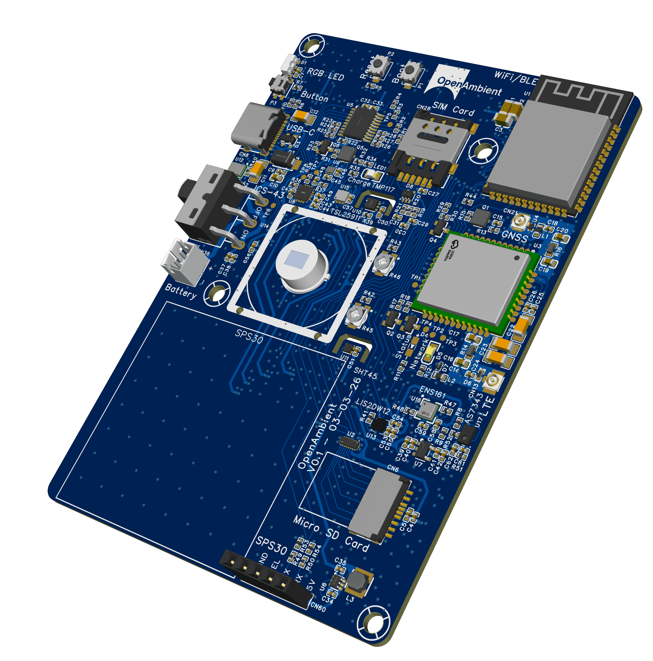
Oblique View
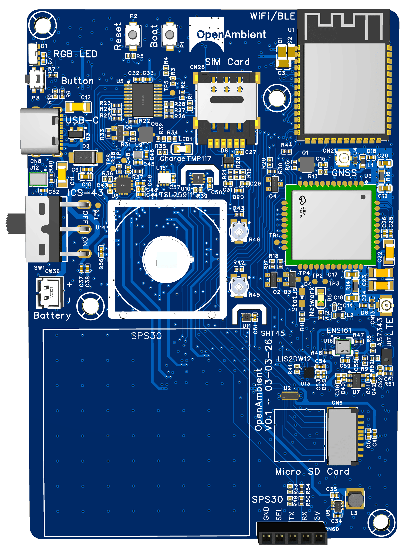
Top View
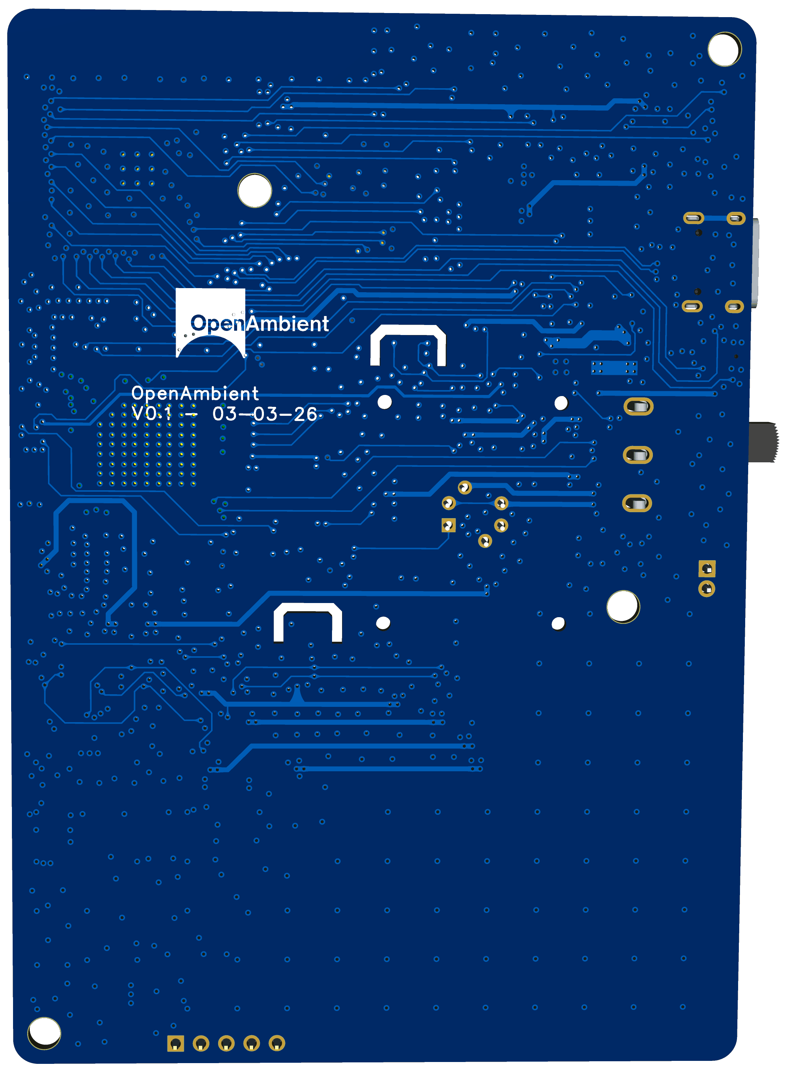
Bottom View

Blocks Description:
The schematic of the PCB comprises the following blocks:
- ESP32S3 SoC and surrounding circuitry.
- SIM7080G LTE modem and its surrounding circuitry.
- Power System.
- Built-in sensors.

Signal Block Diagram:
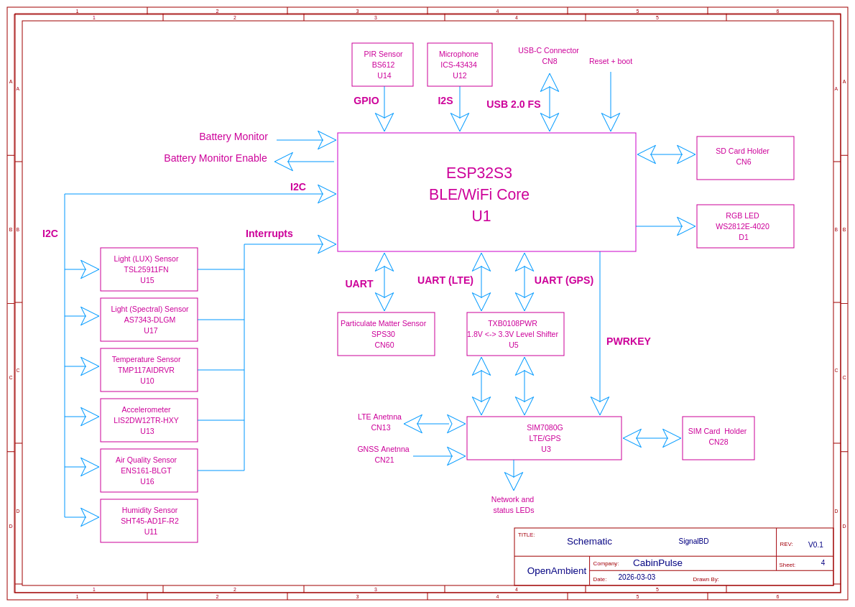

ESP32S3:
The ESP32S3 module exact part number is: ESP32-S3-WROOM-1-N16R8:
- Built-in WiFi/BLE antenna.
- 16MB of embedded QSPI Flash memory.
- 8MB of embedded OSPI PSRAM memory.

List of pin connections:
ESP32 Module pin name | ESP32 SoC pin name | Device connected | In/Out (as from ESP32) | Description
IO4 | GPIO4 | USER RGB | Out | RGB LED data.
IO5 | GPIO5 | USER BUTTON | In | General Purpose user button.
IO6 | GPIO6 | GNSS UART TX | In | SIM7080G GNSS UART interface, TX signal.
IO7 | GPIO7 | GNSS UART RX | Out | SIM7080G GNSS UART interface, RX signal.
IO15 | XTAL_32K_P | LTE UART RX | Out | SIM7080G LTE UART interface, RX signal.
IO16 | XTAL_32K_N | LTE UART TX | In | SIM7080G LTE UART interface, TX signal.
IO17 | GPIO17 | I2C SCL | Out | I2C bus SCL signal.
IO18 | GPIO18 | I2C SDA | In/Out | I2C bus SDA signal.
IO8 | GPIO8 | INT TMP117 | In | TMP117 temperature sensor interrupt line.
IO19 | GPIO19 | USB D- | In/Out | Debug/flash USB negative data line.
IO20 | GPIO20 | USB D+ | In/Out | Debug/flash USB positive data line.
IO3 | GPIO3 | Not used. | ----- | Strapping pin.
IO46 | GPIO46 | Not used. | ----- | Strapping pin.
IO9 | GPIO9 | SIM7080G PowerKey | Out | PowerKey signal for SIM7080G.
IO10 | GPIO10 | EN GPS | Out | GNSS Supply enable signal, active high.
IO11 | GPIO11 | EN BAT monitor | Out | Battery monitor circuitry enable.
IO12 | GPIO12 | MIC SD | In | ICS-43434 Microphone data signal.
IO13 | GPIO13 | MIC WS | Out | ICS-43434 Microphone Word Select signal.
IO14 | GPIO14 | MIC SCK | Out | ICS-43434 Microphone clock signal.
IO21 | GPIO21 | INT LIS2DW12 | In | LIS2DW12 Accelerometer interrupt line.
IO47 | SPICLK_P | INT ENS161 | In | ENS161 Air Quality sensor interrupt line.
IO48 | SPICLK_N | INT AS7343 | In | AS7343 Light Spectrum sensor interrupt line.
IO45 | GPIO45 | Not used. | ----- | Strapping pin.
IO0 | GPIO0 | Boot | In | Boot signal to trigger the bootloader. Used to flash the device by USB.
IO35 | GPIO35 | Not used | Not used | This signal is used by internal PSRAM and cannot be used for other purposes.
IO36 | GPIO36 | Not used | Not used | This signal is used by internal PSRAM and cannot be used for other purposes.
IO37 | GPIO37 | Not used | Not used | This signal is used by internal PSRAM and cannot be used for other purposes.
IO38 | GPIO38 | MOTION BS612 | In | BS612 PIR sensor trigger line.
IO39 | MTCK | SD SC | Out | SPI Chip Select signal for SD Card.
IO40 | MTDO | SD MOSI | Out | SPI MOSI signal for SD Card.
IO41 | MTDI | SD SCLK | Out | SPI serial clock signal for SD Card.
IO42 | MTMS | SD MISO | In | SPI MISO signal for SD Card.
RXD0 | U0RXD | SPS30 UART RX | Out | SPS30 particulate matter sensor RX signal.
TXD0 | U0TXD | SPS30 UART TX | In | SPS30 particulate matter sensor TX signal.
IO2 | GPIO2 | INT TSL25911 | In | TSL25911 Light (LUX) sensor interrupt line.
IO1 | GPIO1 | BAT monitor | In | Battery monitor analog voltage, equal to VBAT/2. Must be enabled first using EN BAT monitor.

Strapping pins:
The ESP32-S3 has 4 strapping pins:
- GPIO0
- GPIO3
- GPIO45
- GPIO46

These pins are sampled right after reset and define the behavior of the chip during booting. GPIO0 is used to trigger the bootloader and flash the device using USB-C. None of the other pins were used, so they read their corresponding default configuration.

JTAG Interface:
The JTAG interface is not accesible, the device must be flashed by USB-C.

Pins GPIO35/36/37:
Pins GPIO35, GPIO36 and GPIO37 are used internally by the ESP32S3 built-in PSRAM (Octa SPI interface), so they cannot be used nor connected externally. For that reason, they have been left unconnected.

I2C Interface:
The I2C interface allows communication from the ESP32S3 to most sensors. The following table details the specific devices that can be reached using I2C and their corresponding I2C address (7-bit):
- TMP117AIDRVR temp sensor: 1001000 (0x48).
- LIS2DW12TR accelerometer: 0011000 (0x18).
- SHT45 humidity sensor: 1000100 (0x44).
- TSL25911 Light (LUX) Sensor: 0101001 (0x29).
- AS7343 Light (Spectral) Sensor: 0111001 (0x39).
- ENS161 Air Quality Sensor: 1010011 (0x53).

The pull-ups resistors used for the I2C interface are 10kOhm, for both the SCL and SDA signals.

USB, User Button, Boot and reset:
The board includes a boot button to place the ESP32 in boot mode and allow it to boot from USB. UART butting is not possible (due to the UART pins being used for other purposes).
The user button is active low, and has a hardware-level pull-up, so its corresponding ESP32 pin doesn't need to have the internal pull-up activated.
The USB interface is used to flash and debug the ESP32 through the built-in USB-JTAG converter.
The ESP32 can be reset by either the reset button.

SIM7080G Modem:
To design the SIM7080G circuitry, the official SIMCOM documentation was followed:
- Hardware Design Guidelines.
- Product Specification.

The SIM7080G is connected to the ESP32-S3 through 2 UART ports, one used to send AT commands and intended for LTE and another one for GNSS.
ESD protection and dummy matching networks are included for both GNSS and LTE antennas. The GPS antenna connector provides 3.3V to supply an active antenna.
The module has two LEDs: A network LED that shows connectivity status and a general status LED.
A 3.3V to 1.8V level shifter is used to match the 1.8V signals from the SIM7080G and the 3.3V signals from the ESP32S3.
The Power Key signal can be used to reset the module from the ESP32 firmware.

Built-in sensors:
The board features the following built-in sensors:
- TMP117: Temperature (I2C plus interrupt).
- LIS2DW12: Accelerometer (I2C plus interrupt).
- ICS-43434: Microphone (I2S).
- SHT45: Humidity sensor (I2C).
- BS612: PIR sensor (GPIO).
- AS7343: Light (Spectral) sensor (I2C plus interrupt).
- TSL25911: Light (LUX) sensor (I2C plus interrupt).
- ENS161: Air Quality sensor (I2C plus interrupt).
- SPS30: Particulate Matter sensor, through external connector (UART).

Power Supply Scheme:
The following picture shows the power supply scheme of the PCB:
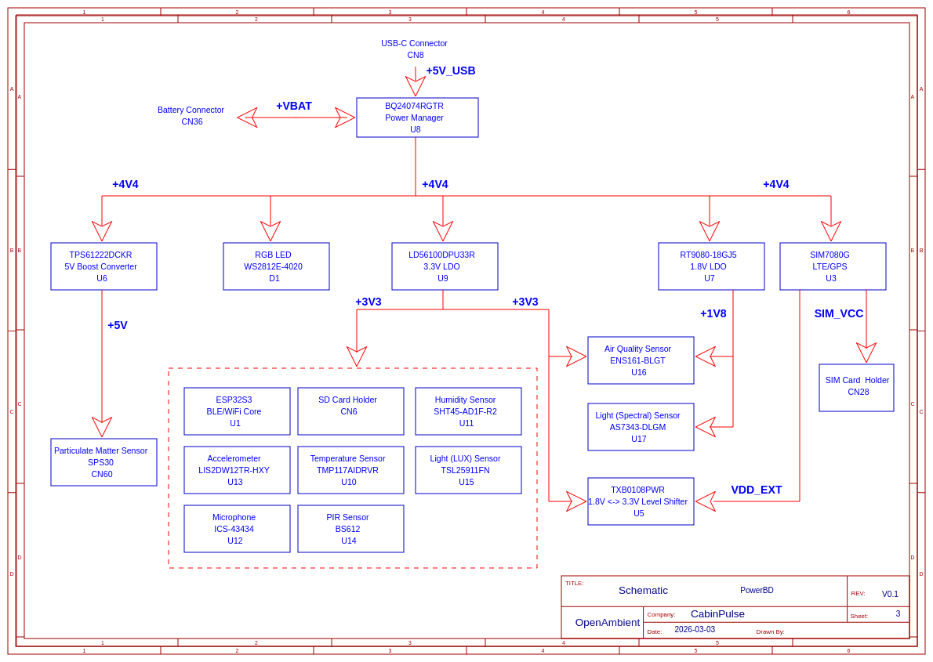
The battery charging and discharging are managed by the BQ24074 device. This device generates the 4.4V rail, which supplies all other components directly or indirectly.
To generate the 3.3V for the ESP32 and sensors, an LD56100 LDO is used. Some sensors require 1.8V as well, so the RT9080-18 is included as 1.8V LDO. Finally, a 5V boost converter is included to supply the SPS30, implemented using a TPS61222.
A battery monitoring circuitry is included to allow measuring the battery voltage at the ESP32 firmware level.

Testing:

Testpoints:
To aid in testing, several testpoints are provided in the PCB:
Designator | Description
TP1 | SIM7080G Boot configuration.
TP2 | SIM7080G USB 2.0 DP signal.
TP3 | SIM7080G USB 2.0 DM signal.
TP4 | SIM7080G USB VBUS.
TP5 | SIM7080G UART 1 DTR signal (3.3V level).
TP6 | 4.4V supply rail.
TP7 | BQ24074 ILIM signal.
TP8 | BQ24074 ISET signal

Do Not Place options:
The board has several components marked as DNP that can be used to solve potential EMC/EMI and crosstalk issues, as well as antenna impedance mismatch issues:

Designator | Default Value | On behavior | Off Behavior | Comments
C38 | Not placed | ----- | ----- | Used to add capacitance to VBAT node in case it is needed.
C44 | Not placed | ----- | ----- | Used to add capacitance to +4V4 node in case it is needed.
C29 | Not placed | ----- | ----- | Used to smooth rise and fall times in case of crosstalk or EMC/EMI issues with SIM card interface.
C30 | Not placed | ----- | ----- | Used to smooth rise and fall times in case of crosstalk or EMC/EMI issues with SIM card interface.
C31 | Not placed | ----- | ----- | Used to smooth rise and fall times in case of crosstalk or EMC/EMI issues with SIM card interface.
C16 | Not placed | ----- | ----- | Used to match LTE antenna in case of mismatch.
C17 | Not placed | ----- | ----- | Used to match LTE antenna in case of mismatch.
R14 | 0R | ----- | ----- | Used to match LTE antenna in case of mismatch.
C19 | Not placed | ----- | ----- | Used to match GNSS antenna in case of mismatch.
C20 | Not placed | ----- | ----- | Used to match GNSS antenna in case of mismatch.
R16 | 0R | ----- | ----- | Used to match GNSS antenna in case of mismatch.
C3 | Not placed | ----- | ----- | Used to reduce bouncing at reset button.

PCB Layout:

Routing:
To route the tracks, orthogonal routing in the top and bottom layer was used, leaving both the in1 and in2 inner layers as dedicated GND planes. Also, plenty of stitching vias were used where signals transitioned from one layer to the other.
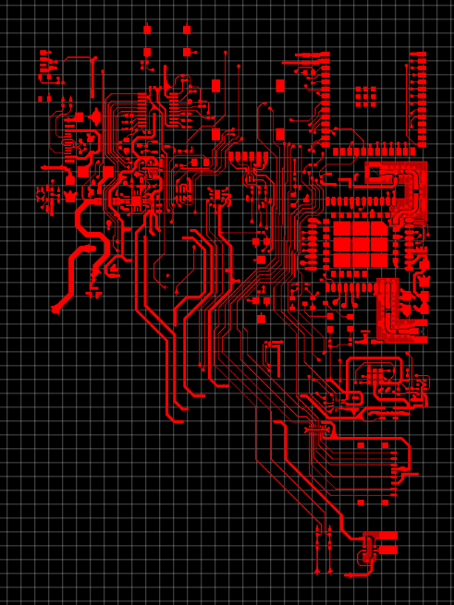
Top layer routing
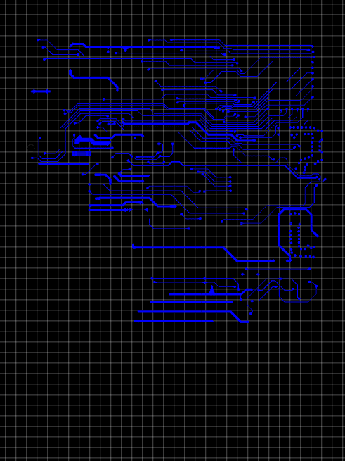
Bottom layer routing
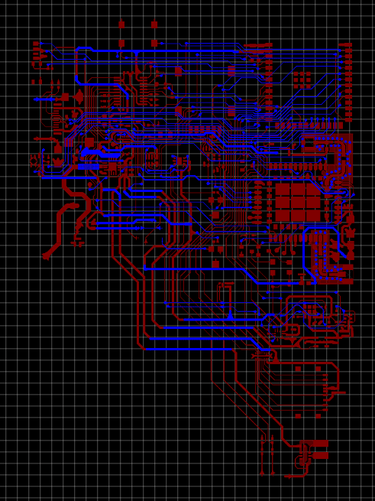
Top and Bottom layers routing superposed

WiFi/BLE antenna placement:
The ESP32-S3 was placed following the vendor recommendations to maximize the antenna performance and reduce potential EMC/EMI issues:
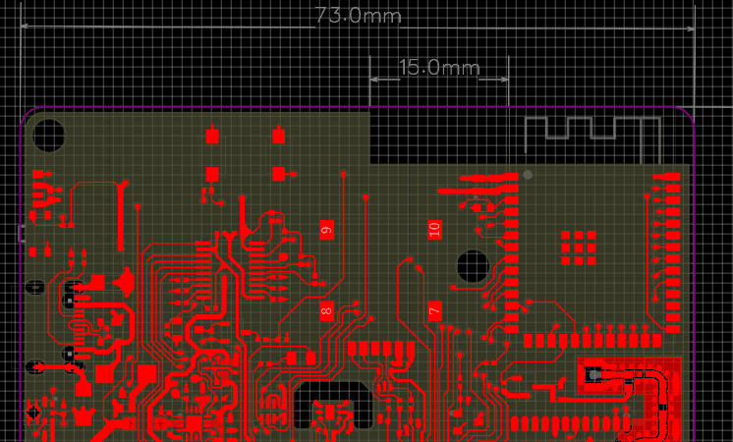
Wifi/BLE antenna placement in the board
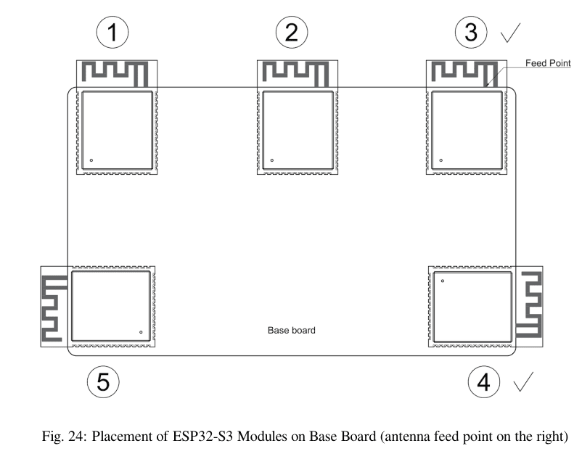
Vendor recommendations, taken from "ESP32-S3 Hardware Design Guidelines"
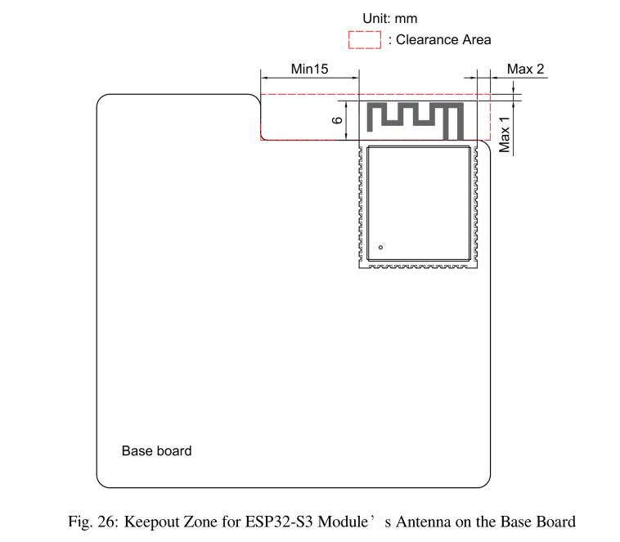

Vendor recommendations, taken from "ESP32-S3 Hardware Design Guidelines"

Layer stackup:
The following 4 layers stackup was used (JLC04161H-3313):
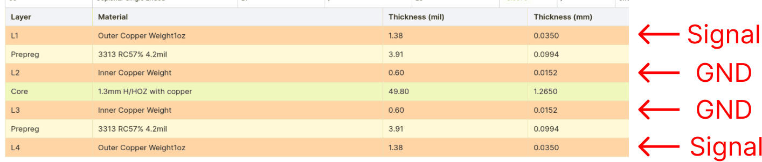
This is the cheapest 4-layer stackup available from JLCPCB.
This signal/GND scheme ensures proper EMC/EMI and signal integrity behavior.

Controlled impedance:
Two types of tracks need controlled impedance in this design:
- USB 2.0 differential pair.
- RF tracks, such as LTE and GPS.

USB:
The USB track width and spacing was calculated using JLCPCB official impedance calculator for 90 Ohms differential (recommended for USB 2.0):
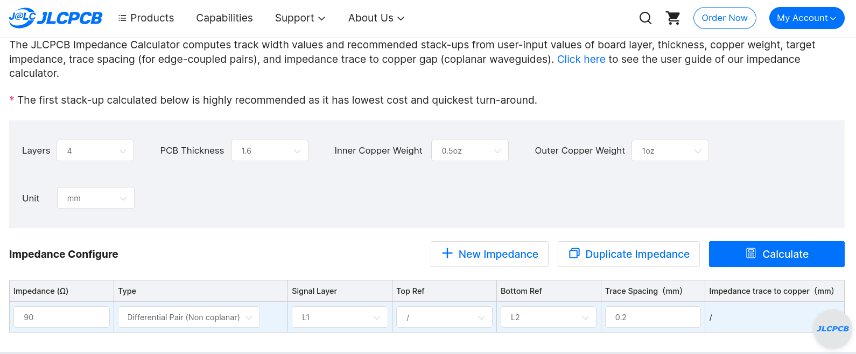
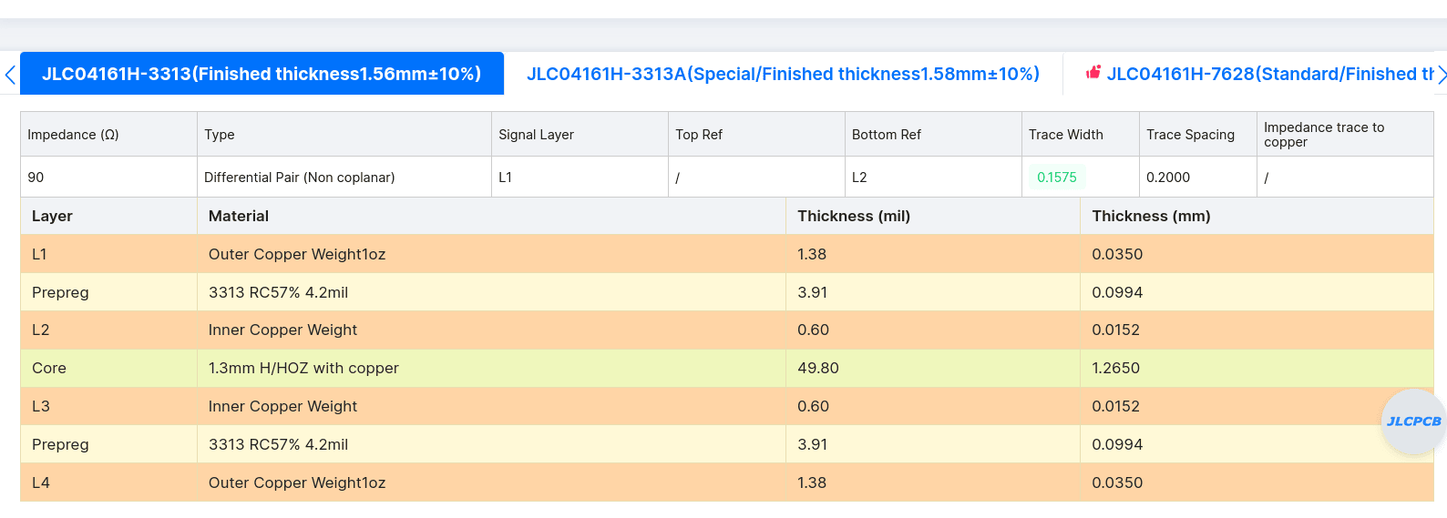
The result was
- Trace width: 0.15mm
- Trace spacing: 0.2mm

The next image shows the USB differential pair routed with the former properties:
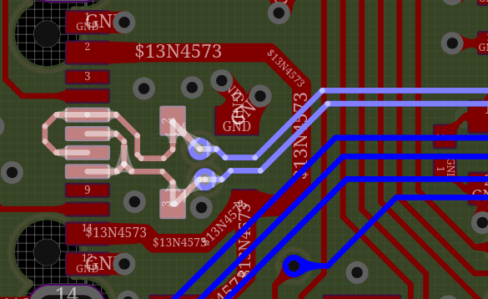

RF tracks:
The following points were taken into consideration when laying out the GPS and LTE tracks:
- To increase track width (and then, accuracy), instead of using L2 as reference, L3 was used instead.
- Curved routing was used.
- The transmission line type chosen was "Single Ended Coplanar Microstrip"

The resulting track width was 0.65mm, shown below:
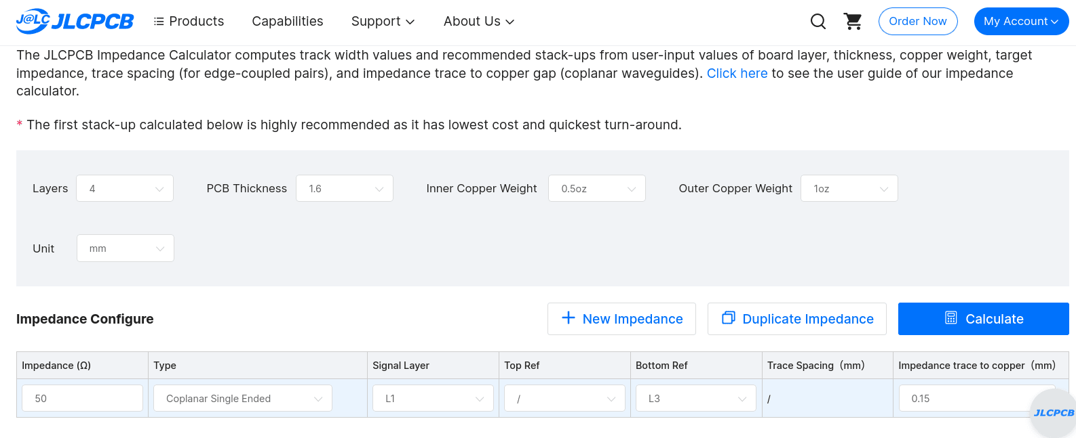
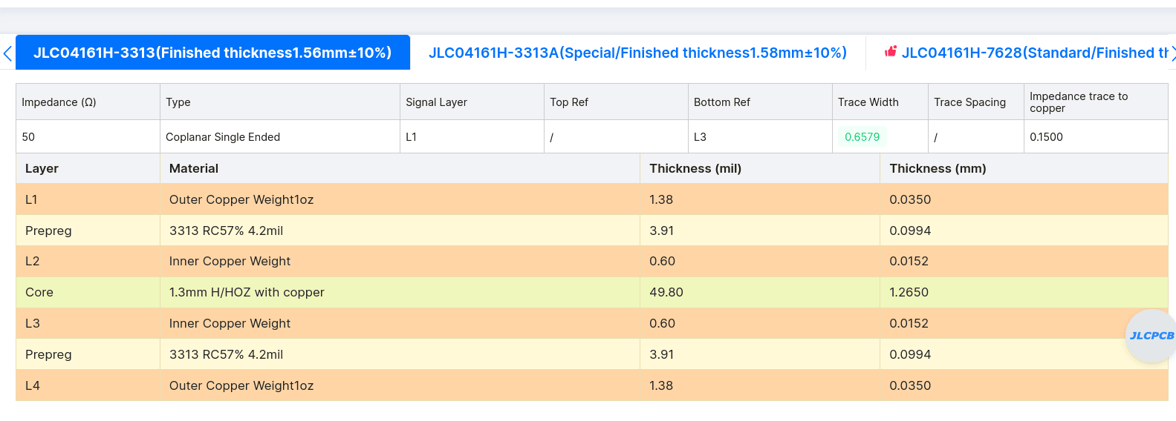
In the following pictures, the tracks routed are shown:
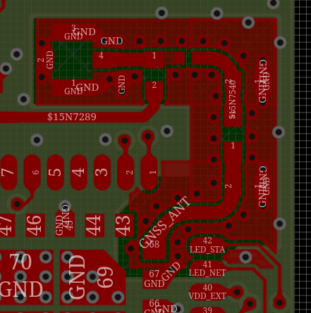
GPS track, Top layer
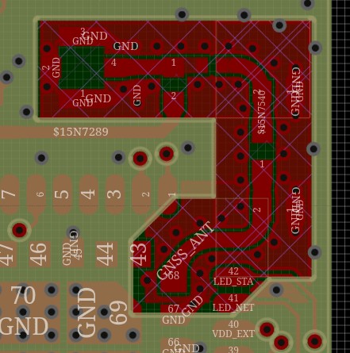
GPS track, In1 layer
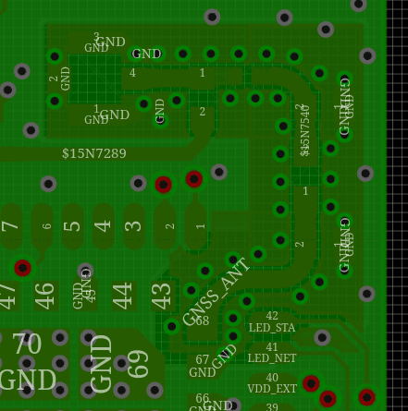
GPS track, in2 layer
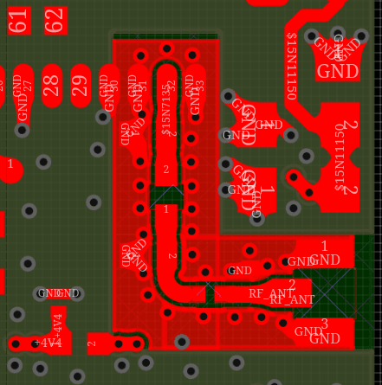
LTE track, top layer
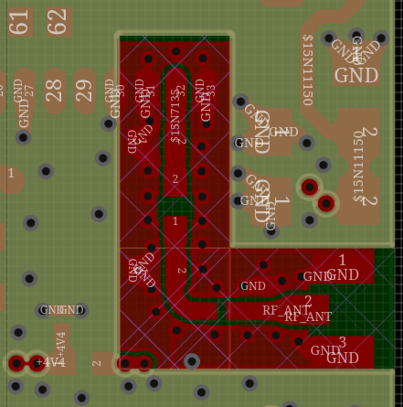
LTE track, in1 layer
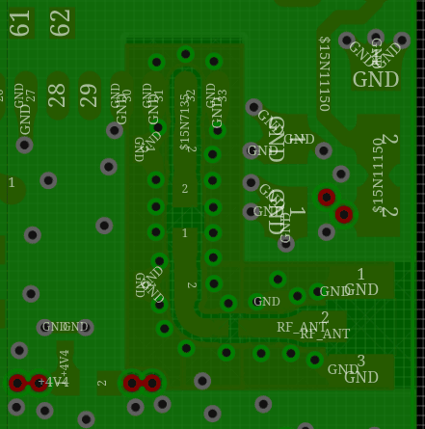
LTE track, in2 layer

PCB Manufacturing Information:

Summary of manufacturing files:
- Gerber files: gerber-OpenAmbient-V0_1-03-03-26.zip
- BOM: BOM-OpenAmbient-V0_1-03-03-26.csv
- Pick and Place: PnP-OpenAmbient-V0_1-03-03-26.csv

Manufacturing specifications:
- Layers: 4
- PCB thickness: 1.6mm.
- Surface finish: ENIG.
- Outer copper layer weight: 1 Oz.
- Inner copper layer weight: 0.5 Oz.
- Stackup: JLC04161H-3313
- Impedance control: Yes (+-10%).
- Min hole size: 0.3mm
- Min track width: 0.15mm
- Min copper clearance: 0.15mm

