LEGO AI Sorting Machine

Assembly & Configuration Guide

March 2026

Table of Contents
(Update field after opening in Word: right-click → Update Field)

Before You Begin
Required Tools & Equipment
Before assembly, gather the following tools. Most are standard workshop items; a few are specific to machine assembly and electronics work. You do not need every item for every step—a well-organized workspace will make the build faster and more enjoyable.
For mechanical assembly, you'll need hex keys (4mm for M5 bolts, 2mm for M3, 1.5mm for M2), a soldering iron (25–40W, with solder and flux), wire strippers (18–22 AWG), a crimping tool for Dupont connectors, a digital multimeter, flush cutters for filament trimming, and a small Phillips screwdriver. If cutting aluminum extrusion, have a miter saw with a metal-cutting blade or a hacksaw with a fine-tooth blade (32 TPI), plus a metal file for deburring.
Workspace setup matters. Choose a well-lit table or workbench with plenty of space (at least 2m × 1m). Use an ESD mat if you have one—it protects electronic components from static discharge. Organize small hardware (bolts, T-nuts, servo mounts) into labeled bins or containers so you can find items quickly. Have a small tray or magnetic pad for loose screws while working on subassemblies.
Safety is critical. Always unplug the power supply before making any wiring changes or removing components. Handle PCBs (the Raspberry Pi, PCA9685 boards, and stepper driver) by their edges only—avoid touching components. The 3D-printed PLA and PETG parts are strong but can crack if over-tightened; tighten bolts by hand and then add no more than 1/4 turn with a wrench. Wear safety glasses when cutting extrusion and use a dust mask when sanding or spray-painting 3D parts. Keep a first-aid kit nearby and work sober and alert.

Assembly Checklist
Item | Qty / Notes
Raspberry Pi 5 (8GB) | 1x — Raspberry Pi OS must be pre-installed
Pi Camera Module 3 | 1x — CSI ribbon cable included
NEMA 17 stepper motor | 1x — 1.8°/step, 40mm body length
TMC2209 stepper driver board | 1x
SG90 micro servos | 31x (buy 35 for spares)
PCA9685 PWM driver boards | 2x
2020 aluminum extrusion | 7.2m total (6× 1m lengths)
M5 T-nuts + bolts | 50+ pieces
M3 hardware kit | For servo mounting (100+ pieces)
608 ball bearings | 4x
Flat belt (70mm silicone) | 600mm length
LED strip (white, 5V) | 30cm
MOSFET module (IRLZ44N) | 1x
5V 10A power supply | 1x
12V 2A power supply | 1x
5V 5A USB-C power (Pi) | 1x
3D-printed parts | See design document for full print list
Small mirror (50×50mm) | 1x — for scanning chamber

Phase 1 — Frame Assembly

Cutting the Extrusion
Label each piece with masking tape before cutting to avoid confusion later. For cutting, use a miter saw equipped with a metal-cutting blade, or use a hacksaw with a fine-tooth blade (32 TPI minimum). Measure twice, cut once. After cutting, deburr all cut edges with a metal file and wipe away any chips with a damp cloth.

Extrusion Cut List
Piece | Length | Qty | Purpose
Vertical uprights | 700 mm | 4 | Main structural columns
Upper horizontal (width) | 400 mm | 2 | Belt support, top frame
Upper horizontal (depth) | 350 mm | 2 | Belt support, cross-bracing
Lower horizontal (width) | 400 mm | 2 | Bin tray support
Lower horizontal (depth) | 350 mm | 2 | Bin tray support
Mid horizontal (depth) | 350 mm | 2 | Gate tree mounting

Assembling the Frame
- Follow these steps to build a square, rigid frame:
- Lay two 700 mm uprights parallel on a flat surface, 400 mm apart (outside-to-outside).
- Connect at the top with one 400 mm horizontal using M5 T-nuts and corner brackets. Slide T-nuts into the slot BEFORE tightening bolts.
- Connect at the bottom with another 400 mm horizontal. You now have an H-shaped side panel.
- Repeat Steps 1–3 to create an identical second side panel.
- Stand both panels upright and connect them with 350 mm depth pieces at the top, middle, and bottom on both sides (6 pieces total).
- Check squareness: measure both diagonals on each face. They should match within 2 mm. Adjust before final tightening.
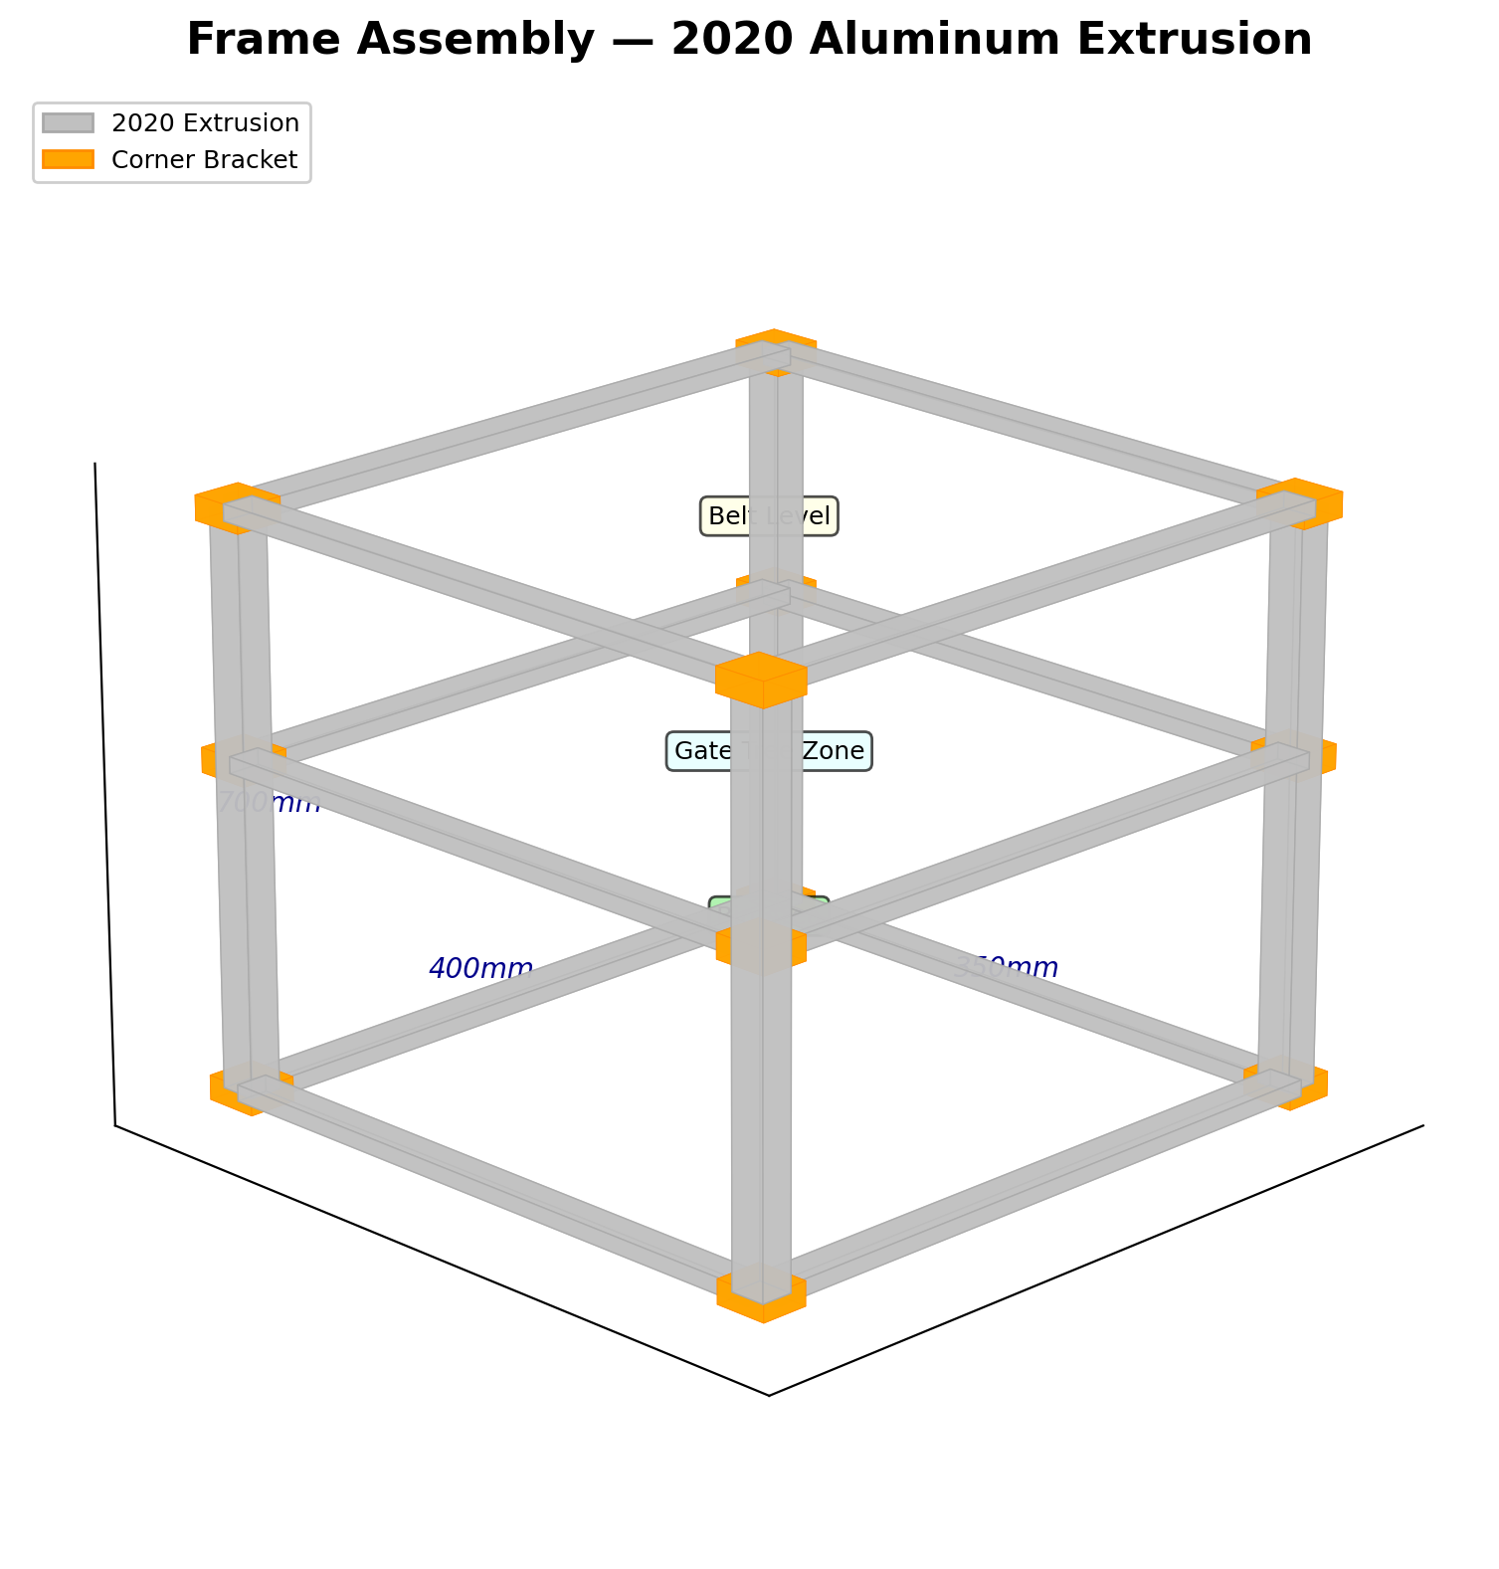
Figure 1: Aluminum extrusion frame — isometric view showing all members and zone labels.

Tips for a Square Frame
- Use a machinist's square or large carpenter's square against each corner.
- Tighten bolts in a star pattern (opposite corners) to prevent racking.
- If diagonals don't match, loosen all bolts on the skewed face, push the long diagonal shorter, and retighten.
- Consider adding diagonal bracing (a short piece of extrusion corner-to-corner on the back face) if the frame wobbles.

Phase 2 — Belt Assembly

Roller Preparation
Press two 608 bearings into each printed roller (one for the drive roller, one for the idler). The bearing bores should be a tight press fit. If loose, use a tiny drop of Loctite 638 threadlocker. Place the rollers into their bearing housings and bolt the housings to the upper frame rails using M5 bolts and T-nuts. Verify both rollers spin freely by hand.

Motor Installation
Mount the NEMA 17 stepper motor to its printed bracket using four M3×8 screws. Attach the bracket to one of the upper vertical uprights with M5 T-nuts. The motor shaft should align with the drive roller—use a short section of 5 mm-to-5 mm shaft coupler, or press the roller directly onto the motor shaft if the bore fits. Spin by hand to verify smooth rotation.

Belt Installation & Tensioning
Loop the silicone belt around both rollers. Slide the idler roller toward the feed end until the belt is taut but not overly tight—you should be able to deflect it about 5 mm with a finger push at the midpoint. Lock the tensioner bracket. Spin the drive roller by hand and verify the belt tracks center. If it drifts, slightly angle the idler roller to correct.

Side Rail Installation
Clip the two printed side rails onto the extrusion, centered over the scanning zone. They should stand 15 mm above the belt surface. These rails guide bricks through the camera scanning area.
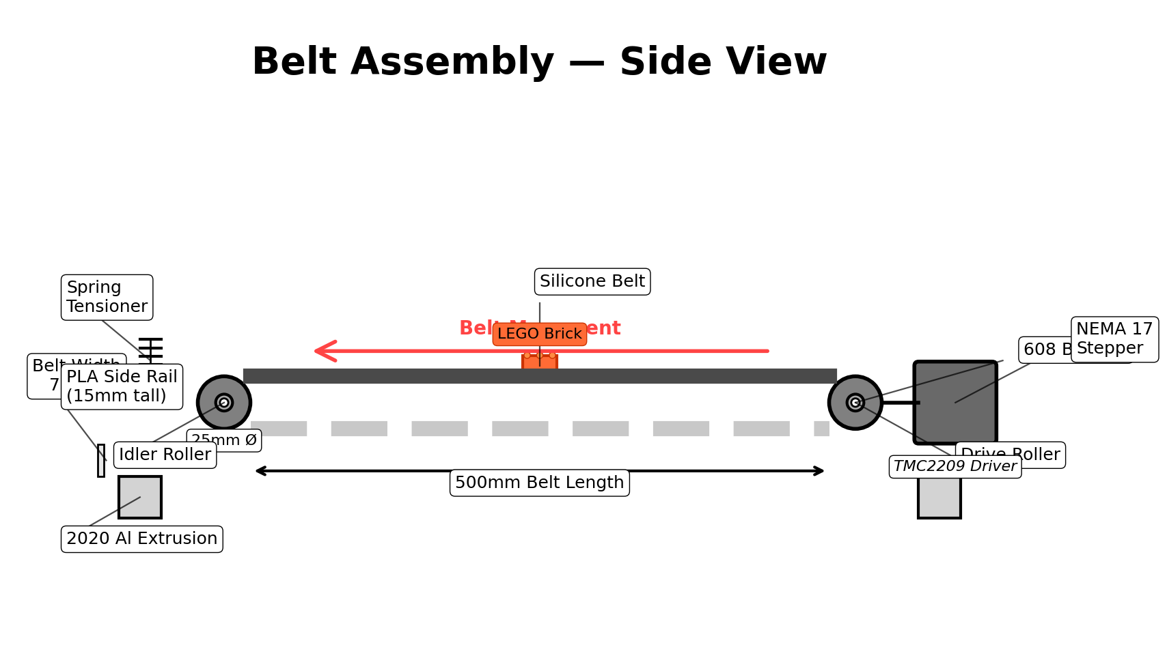
Figure 2: Belt assembly — side view showing drive/idler rollers, motor, and tensioning mechanism.

Phase 3 — Scanning Chamber

Printing the Chamber
Print the 4 chamber pieces in white PLA or PETG for durability:
- Base tray: Print as-is (open side up). Estimated time: ~2 hours. NO supports needed.
- Middle ring: Print as-is (it's a tube). Estimated time: ~1.5 hours. NO supports needed.
- Top cap: Print UPSIDE-DOWN (ceiling face on build plate). Estimated time: ~2 hours. NO supports needed.
- Mirror bracket: Print with flat face down (45° wedge). Estimated time: ~30 minutes. NO supports needed.
Print settings: Use 0.2 mm layer height, 20% infill, and 3 perimeters. All interior surfaces must be smooth with no support scarring—inspect before assembly.

Chamber Assembly
- Stack the pieces using the tongue-and-groove alignment features:
- Place the base tray on a flat surface.
- Lower the middle ring onto it—the tongue from the base fits into the groove on the middle ring.
- Lower the top cap (right-side up now) onto the middle ring.
- Secure with M3 bolts through the walls, or use cyanoacrylate glue on the tongue joints.
- If the pieces are not printed in white, paint all interior surfaces matte white using flat white spray paint in light coats.

Mirror Installation
Apply a thin line of hot glue or two-part epoxy to the back of the mirror bracket. Press it against the rear interior wall of the chamber. The bracket holds the 50×50 mm mirror at exactly 45°. Slide the mirror glass into the bracket slot. The 45° mirror allows the camera to capture both a top-down view and a side profile of the brick in a single frame.

LED & Camera Installation
Press the LED strip (white, 5V) into the lip channel around the interior ceiling. Route the power wire out through the exit hole in the rear wall. Mount the Pi Camera Module 3 onto the camera mount bracket using M2 screws. Bolt the bracket to the mounting ring on top of the chamber. Verify the camera lens points straight down through the hole.
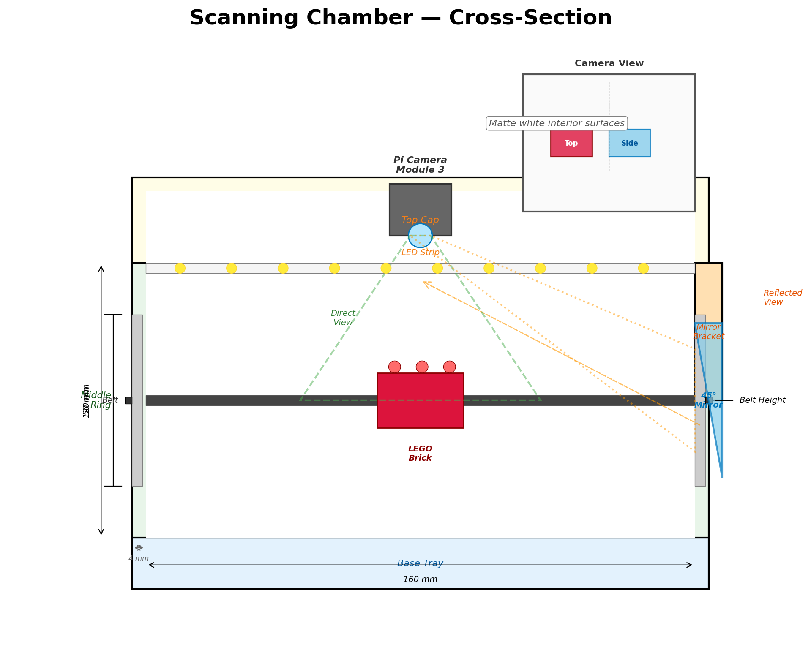
Figure 3: Scanning chamber cross-section — showing the 4-piece construction, camera, 45° mirror, and LED lighting.

Testing the Scanner
Before proceeding, test the scanner and camera:
python main.py --test-camera
Place a LEGO brick inside the chamber. You should see both a top-down view and a side profile (reflected from the mirror) in the same camera frame. Adjust the mirror angle if the side view is cut off.

Phase 4 — Gate Tree Assembly

Printing the Modules
You need 31 identical Y-junction gate modules, 31 flap inserts, and 31 servo mount clips. Print in PETG for durability. At approximately 8 modules per batch, this takes about 4 batches over ~22 hours of print time. Each flap is small and prints in about 8 minutes. Verify all parts are printed at 0.2 mm layer height with no visible layer gaps.

Individual Module Assembly
- For each of the 31 modules, follow these steps:
- Snap the two module halves together (if a 2-piece design).
- Insert the lightweight PLA flap into the pivot slot.
- Thread the pivot pin (a short piece of 1.75 mm filament works perfectly).
- Snap the SG90 servo into the servo mount clip.
- Attach the servo horn to the flap arm using the provided screw.
- Test: manually rotate the servo—the flap should swing smoothly left and right with no binding.

Building the Tree Structure
Build the gate tree from top to bottom:
- Level 1: Mount 1 gate module at the top, directly below the belt exit point.
- Level 2: Mount 2 gates below Level 1, each receiving one output.
- Level 3: Mount 4 gates below Level 2, connecting to Level 2 outputs.
- Level 4: Mount 8 gates below Level 3, connecting to Level 3 outputs.
- Level 5: Mount 16 gates at the bottom level, the final sorting layer.
Each level stacks below the previous using printed connector brackets. Use the gate tree frame brackets to secure the entire structure to the mid-height horizontal extrusion members. The whole tree angles approximately 30° from vertical for optimal brick flow.
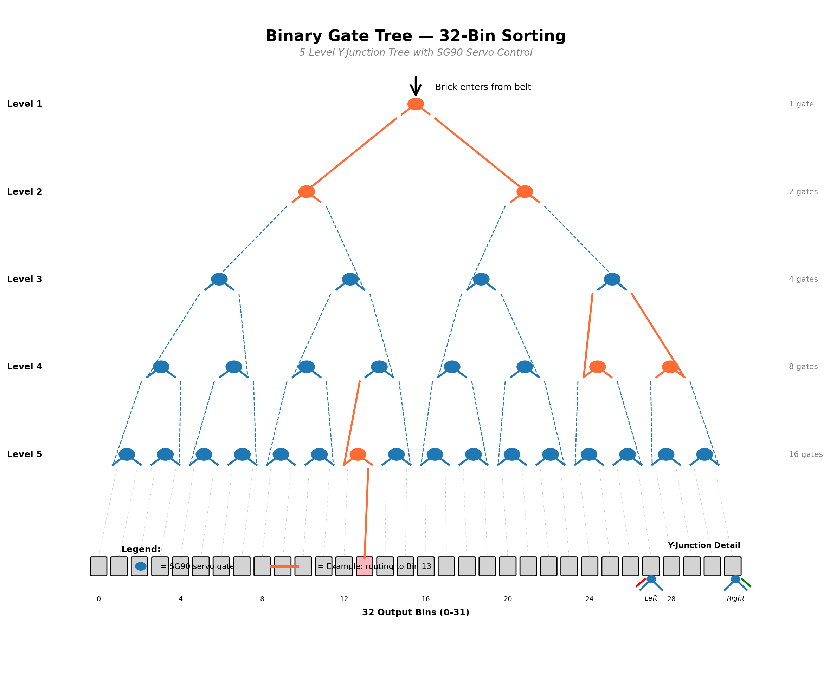
Figure 4: Binary gate tree — 5-level structure with 31 gates routing to 32 output bins. Orange path shows example routing to Bin 13.

Output Bin Installation
Mount the 8 output bin brackets to the lower vertical uprights, spacing them evenly to hold your plastic bins across the 32 gate tree outputs. Each bin bracket has a front lip to prevent the bin from sliding off during operation.

Phase 5 — Electronics & Wiring

Electronics Enclosure
Mount the Raspberry Pi 5 inside the printed electronics enclosure using the built-in standoffs. This keeps the Pi protected and organized. Mount both PCA9685 PWM driver boards on their mount plates inside the enclosure as well.

I2C Servo Drivers
Connect PCA9685 #1 to the Raspberry Pi's I2C bus:
- SDA → GPIO 2
- SCL → GPIO 3
Daisy-chain PCA9685 #2 from #1. Ensure the address jumper on #2 is set for 0x41 (solder jumper on the board). Connect servos 0–15 to board #1, servos 16–30 to board #2. Power both boards' V+ terminals from the 5V 10A supply.

Stepper Driver
Wire the TMC2209 stepper driver:
- STEP → GPIO 17
- DIR → GPIO 18
- EN → GPIO 27
- VMOT → 12V supply
- GND → Common ground
Connect the NEMA 17 motor's 4 wires to the TMC2209 motor outputs (A1, A2, B1, B2). Check motor wiring with a multimeter—each coil pair should show 1–5 ohms of resistance.

LED & Sensor Wiring
Connect the MOSFET gate to GPIO 12 through a 1 kΩ resistor. Connect the MOSFET drain to the LED strip negative terminal, and the source to ground. Connect the LED strip positive to the 5V servo supply. For the optional IR break-beam sensor, connect the signal line to GPIO 25 with a 10 kΩ pull-up resistor to 3.3V.

Power & Grounding
CRITICAL: Connect all three power supply grounds together on a common ground bus. Use thick wire (18 AWG or larger) for the servo 5V supply—31 servos can draw significant current during simultaneous moves. Keep all power wires short and secure them with cable ties. Verify polarity twice before connecting power.
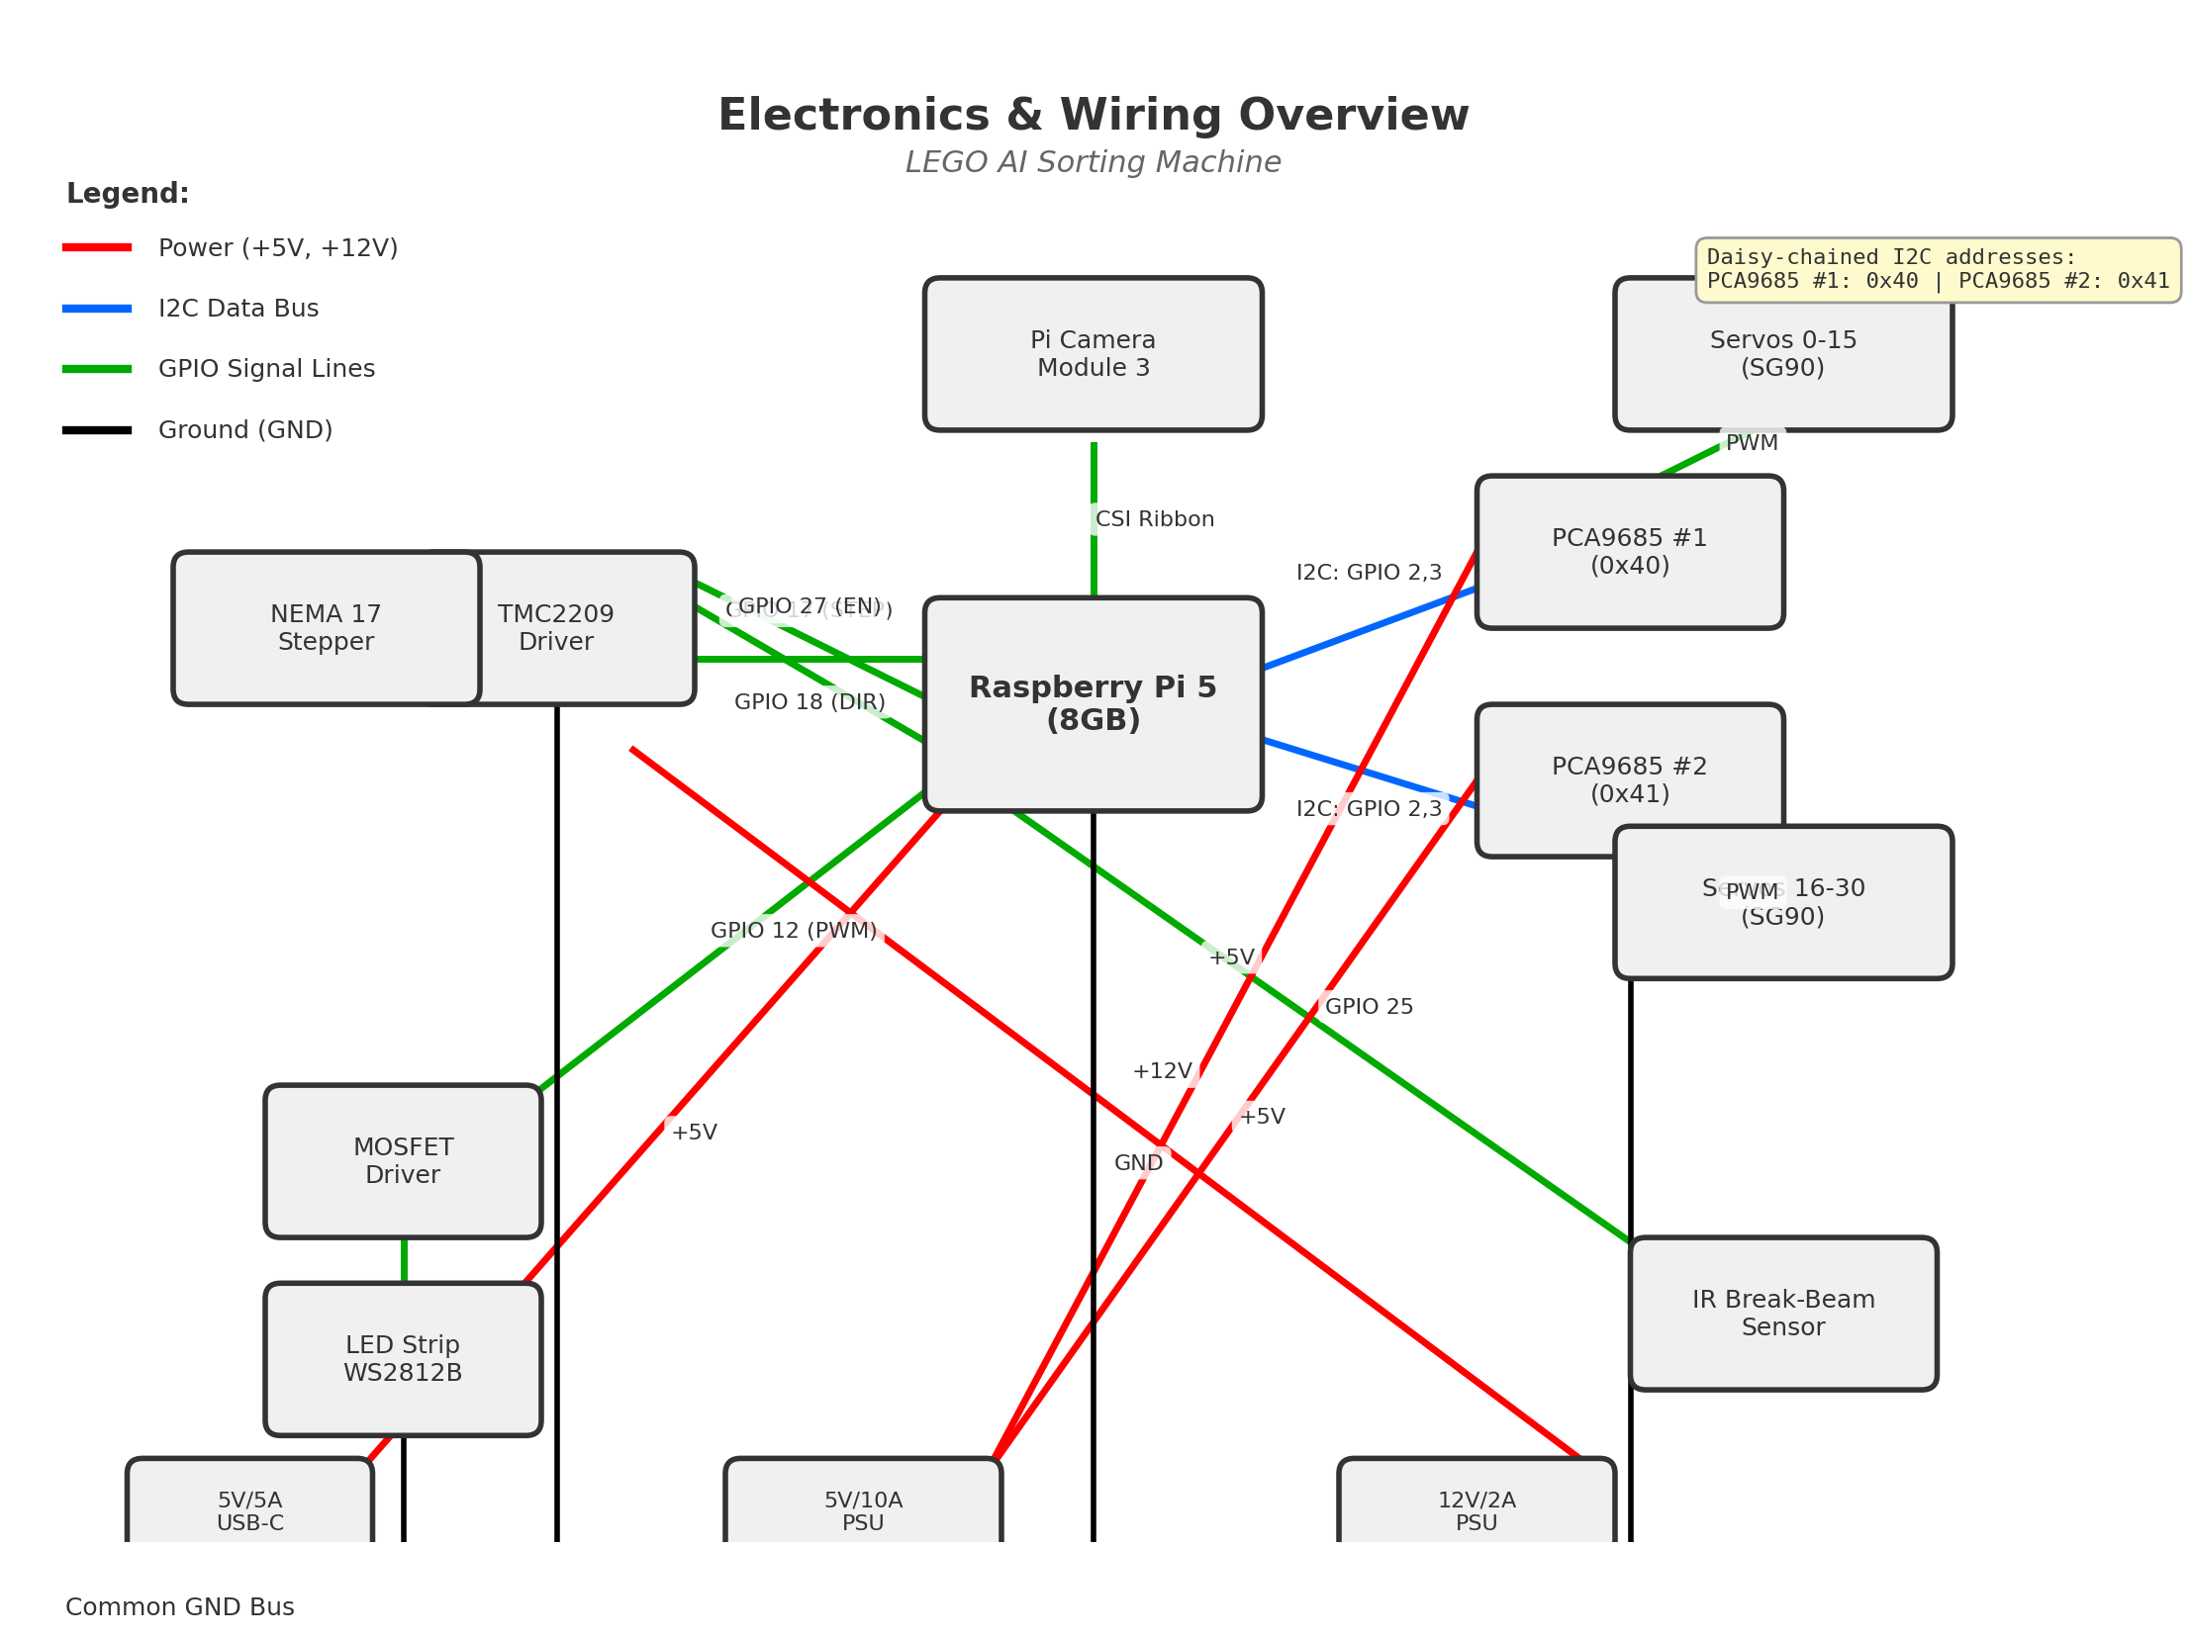
Figure 5: Electronics wiring overview — block diagram showing all connections, GPIO pins, and power distribution.

Software Setup

Raspberry Pi OS
Install Raspberry Pi OS (64-bit Bookworm) using the Raspberry Pi Imager tool. After installation, boot the Pi and open a terminal. Run 'sudo raspi-config' to enable: the camera interface, I2C, and SSH for remote access. Connect to WiFi during setup—it is required for Brickognize API calls.

Installing Dependencies
Install Python dependencies:
cd ~/lego-sorter
pip install -r requirements.txt --break-system-packages
pip install RPi.GPIO adafruit-circuitpython-pca9685 adafruit-circuitpython-motor --break-system-packages

Configuration (config.yaml)
Edit config.yaml in the project root directory. Key configuration sections:
- belt: step_pin, dir_pin, speed_mm_per_sec (start at 35), steps_per_mm (calibrate this!)
- scanner: resolution, motion_threshold (start at 2500, lower = more sensitive), led_brightness
- classifier: confidence_threshold (start at 0.65, raise to 0.75 once tuned), unknown_bin (31)
- sorter: pca9685_addresses [0x40, 0x41], servo_min_pulse/max_pulse, left_angle/right_angle
- rebrickable: api_key (get free key at rebrickable.com/api/), target_sets list
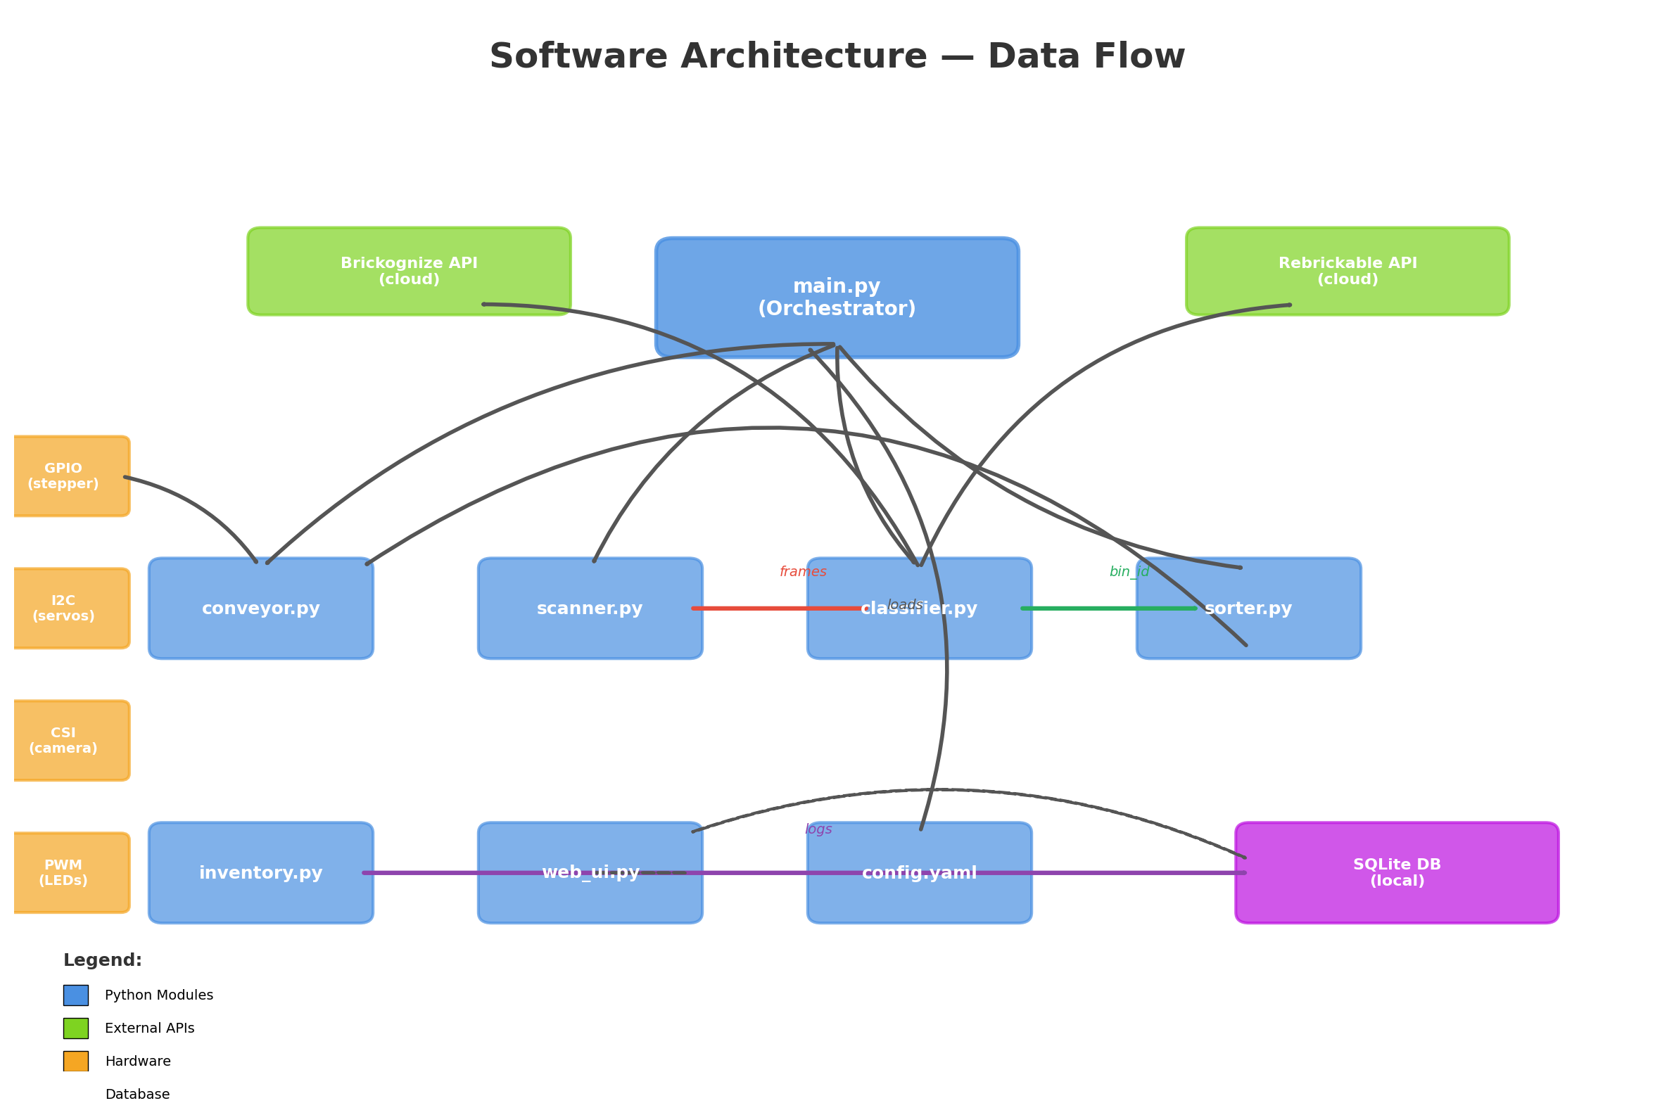
Figure 6: Software architecture — data flow between modules, APIs, and hardware interfaces.

Bin Assignment Configuration
The bin_assignments section in config.yaml controls how sorted bricks are routed to output bins. The classifier extracts a category name from the Brickognize response, then performs a prefix match against the bin_assignments keys. The first matching key determines the bin. Keep bin 31 reserved for unknowns or unusable parts.

Default Bin Assignments (Sample)
Category Prefix | Bin #
Plate | 0–3
Brick_2x4 | 4–7
Brick_2x2 | 8–11
Brick_1x4 | 12–14
Brick_1x2 | 15–18
Brick_1x1 | 19–22
Slope | 23–25
Minifig_Head | 26
Minifig_Body | 27
Minifig_Legs | 28
Wheel | 29
Axle | 30
Unknown/Unsorted | 31

Tips:
- Start with the defaults. After your first sorting session, check which bins overflow.
- Split high-volume categories across two or more bins.
- If building a specific set, organize by set components rather than part type.
- Always reserve bin 31 for unknowns—it will catch classification edge cases.

First Run & Calibration

Component Tests
Run each test mode to verify individual components:
python main.py --test-camera: Verify you see a clear image with both top-down and side profile views.
python main.py --test-classify photo.jpg: Test on a known brick; verify correct identification.
python main.py --test-gates: Cycles all 31 servos left and right; verify smooth mechanical movement.
python main.py --web-only: Starts the dashboard without hardware; verify web interface loads.

Calibration Steps
Belt speed: Place a brick on the belt, time how long to traverse 100 mm. Adjust steps_per_mm until actual distance matches.
Camera focus: Auto-focus should handle this, but verify sharpness on the dashboard camera feed. Clean the lens if fuzzy.
Motion threshold: Lower the threshold if bricks pass without triggering. Raise it if ambient vibration causes false triggers.
Confidence threshold: Run 20+ test bricks. If too many go to 'unknown', lower the threshold. If misidentifications are common, raise it.
Gate calibration: Verify each servo's left_angle and right_angle actually direct bricks fully left/right. Adjust by 5° increments.
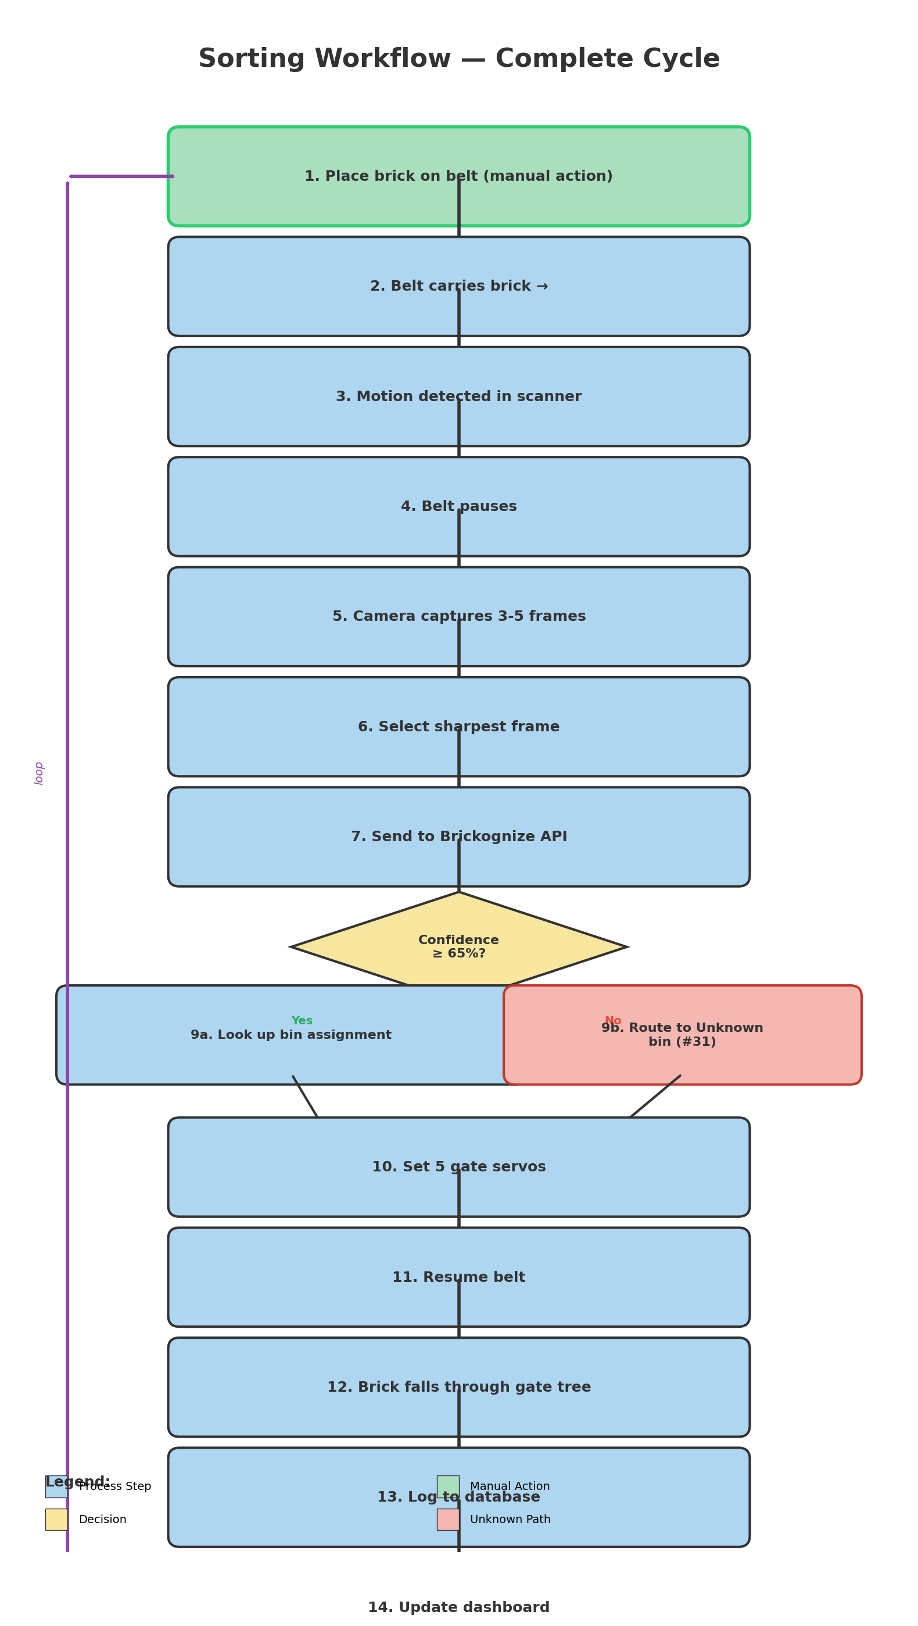
Figure 7: Complete sorting workflow — from manual brick placement through classification, routing, and logging.

Web Dashboard Guide
Open a web browser on any device connected to the same WiFi network. Navigate to http://<pi-ip>:5000 (replace <pi-ip> with your Raspberry Pi's IP address, visible in raspi-config or using 'hostname -I'). The dashboard displays:
- Live camera feed (updates every 2 seconds)
- Real-time statistics (total sorted, bricks per minute, average confidence)
- Set completion progress bars for each registered Rebrickable set
- Control buttons (Start/Stop/Pause, belt speed slider, individual gate test buttons)

To load a Rebrickable set: In the Rebrickable section, enter the set number (e.g., '42100-1') and click 'Load'. The system pulls the full parts list from Rebrickable. As bricks are sorted, the progress bar fills. Click 'Export Missing CSV' to generate a BrickLink-compatible CSV file for ordering missing parts.

Troubleshooting
Reference this table when encountering issues:
Symptom | Likely Cause | Solution
Belt doesn't move | ENABLE pin (active low) not pulled LOW, 12V supply missing, or TMC2209 wiring error | Check ENABLE pin is LOW, verify 12V supply voltage with multimeter, inspect motor wiring
Servos don't respond | I2C address conflict, 5V servo supply not connected, or address jumpers set wrong | Run 'i2cdetect -y 1' to see all I2C addresses, verify 5V supply on both PCA9685 boards, check address jumpers
Camera feed is black | CSI ribbon cable loose, camera not enabled in raspi-config, or lens obstruction | Reseat the CSI ribbon, run raspi-config and enable camera, clean the lens
API returns low confidence | Poor lighting, dirty mirror, brick not centered, or wrong orientation | Increase LED brightness in config, clean mirror with soft cloth, adjust brick position, try different angles
Bricks jam in gate tree | Flap clearance too tight, rough edges, shallow tree angle, or servo angles wrong | Sand flap edges smooth, increase tree angle to ~30°, adjust servo left_angle/right_angle ±5°
Dashboard won't load | Flask server not running, wrong Pi IP, or firewall blocking port 5000 | Verify Flask is running, use 'hostname -I' to get Pi IP, check firewall rules allow port 5000
Wrong bin assignment | Category name mismatch or incorrect prefix in config.yaml | Check classifier.py output log for exact category names, update bin_assignments section

