Orpheus Requirements Specification

Version 1.0

April 19, 2021

Use this Requirements Specification template to document the requirements for your product or service, including priority and approval. Tailor the specification to suit your project, organizing the applicable sections in a way that works best, and use the checklist to record the decisions about what is applicable and what isn't.

This document contains instructions and examples which are for the benefit of the person writing the document and should be removed before the document is finalized.

To regenerate the TOC, select all (CTL-A) and press F9.

**Table of Contents**

**[YOURPROJECT] REQUIREMENTS SPECIFICATION 1**

**VERSION 1.0 1**

**APRIL 19, 2021 1**

**1.** **EXECUTIVE SUMMARY 3**

1.1 Project Overview 3

1.2 Purpose and Scope of this Specification 3

**2.** **PRODUCT/SERVICE DESCRIPTION 3**

2.1 Product Context 4

2.2 User Characteristics 4

2.3 Assumptions 5

2.4 Constraints 6

2.5 Dependencies 6

**3.** **REQUIREMENTS 7**

3.1 Functional Requirements 7

3.2 Non-Functional Requirements 5

*3.2.1* *Product Requirements 5*

**3.2.1.1** **User Interface Requirements** 6

**3.2.1.2** **Usability** 6

**3.2.1.3** **Efficiency** 6

3.2.1.3.1 Performance Requirements 6

3.2.1.3.2 Space Requirements 6

**3.2.1.4** **Dependability** 6

**3.2.1.5** **Security** 7

*3.2.2* *Organizational Requirements 7*

**3.2.2.1** **Environmental Requirements** 7

**3.2.2.2** **Operational Requirements** 7

**3.2.2.3** **Development Requirements** 7

*3.2.3* *External Requirements 7*

**3.2.3.1** **Regulatory Requirements** 7

**3.2.3.2** **Ethical Requirements** 7

**3.2.3.3** **Legislative Requirements** 7

3.2.3.3.1 Accounting Requirements 7

3.2.3.3.2 Security Requirements 7

3.3 Domain Requirements 7

**4.** **USER SCENARIOS/USE CASES 7**

* 1. User Scenarios 13

4.2 Use Cases 19  
4.3 Use Cases extended 22  
4.4 Activity Diagrams 23  
4.5 State Diagrams 26 Executive Summary

## Project Overview

This project will create an interactive platform where people can search and find information related to the music sold and performed in the store. In the past years, we've seen the internet grow exponentially, and at the same time we've also witnessed similar growth in the area of ecommerce. Every year, more businesses open websites of their own in order to stake a claim on the World Wide Web. At the same time, websites don't have to be expensive, they can be quite easy to create, and they do in fact make a huge difference in a business's growth and sustainability. Developing a website creates an informational hub for a business. This website can be used to explain the products, services, and unique value proposition. A website leaves the possibility to fully explain to potential customers why this business is the superior choice over other competitors. Many stores, even though they might have great quality products, they do not get the acknowledgement they deserve. This website helps increase the number of customers in this store by creating an environment where customers can get services from everywhere. Unlike physical materials that need to be distributed, a website can be everywhere at once.

Despite the fact that this is not an online store, in a way to pick sales, this website has been created where users can book many services from their homes. The products sold are for example: instruments, cd's, vinyls, record players, accessories of all kinds in regards to music. Customers today are in love with shopping online. The vast majority of customers buy products through eCommerce websites, and will often choose to buy a product over the internet if they can get a better price than they could from a local store. Other reasons for online shopping include convenience, time-saving, and greater ease of comparing options. This website will let users enter giveaways, an opportunity for the store to be identified, and customers are reminded of the business when they're ready to make a purchase.

The employers will be able to check the stock though this website, manage products and services and keep track of items. This website is going to be very beneficial to employers, because it creates an opportunity to organize the products and services, and give customers a more organized outlook on their stock. There are also going to be technicians managing bookings, informing shopkeepers and administrators of the materials they’ve run out of, keep track of services most often offered, and keep track of days and time slots most requested. Musicians, as a crucial part of the services extended to the customers have a possibility to manage their own bookings, inform shopkeepers and administrators of the materials they’ve run out of, and keep track of services most often offered and of days and time slots most requested.  
The most important chain in this website mainframe are the admins, whom keep track of productivity of staff, check stock and salaries of staff, order personalization’s, stock and personalization’s via third parties. They are the organizers of "meet and greets" and giveaways. Two very important duties of admins are to manage the database, and control the marketing of the business.

## Purpose and Scope of this Specification

|  |
| --- |
| •Purpose: |
|  | -Providing a physical space where music enthusiast can engage with their passion and explore new music. |
|  | -Offering online shopping for people who cannot visit the store physically. |
|  | -Offering a wide range of music genres. |
|  | -Providing a platform for artists to showcase their work. |
|  | -Foster a sense of community and camaraderie among music fans, creating a common space for people to bond over their love music. |
|  |  |
|  | •Scope: |
|  | -Focusing on music recordings and related merchandise. |
|  | -Selling music-related merchandise such as t-shirts, posters and other memorabilia. |
|  | -Providing music education and supporting new artists. |
|  | -Social and cultural experiences that music can offer. |

# Product/Service Description

In this section, describe the general factors that affect the product and its requirements. This section should contain background information, not state specific requirements (provide the reasons why certain specific requirements are later specified).

## Product Context

A musical online shop is an e-commerce platform that specializes in selling musical instruments, equipment, and accessories to musicians and music enthusiasts. This online shop allows customers to browse a wide range of products, compare prices, and purchase items from the comfort of their own homes. It should be easy to use and very friendly including admin and user interface working together nicely including a schedule calendar for musicians where they can see about booking dates.

## User Characteristics

Clients:

|  |  |
| --- | --- |
|  | • Buying cd’s/vinyl’s |
|  | • Buying accessories |
|  | • Booking music related events |
|  | • Entering in giveaways |
|  | • Booking music lessons |
|  | • Requesting personalisation’s |
|  | • Adding items to cart |
|  | Shopkeepers: |
|  | • Checking stock |
|  | • Ordering personalisation’s |
|  | • Ordering stock |
|  | • Managing giveaways |
|  | • Managing meet and greets with guest musicians |
|  | • Keep track of items most often in clients carts |
|  | • Keep track of items most often sold out |
|  | Technicians: |
|  | • Managing their bookings |
|  | • Informing shopkeepers and administrators of the materials they’ve run out of |
|  | • Keep track of services most often offered |
|  | • Keep track of days and time slots most requested |
|  | Musicians: |
|  | • Managing their bookings |
|  | • Participating in meet and greets |
|  | • Keep track of days and time slots most requested |
|  | Admins: |
|  | • Keeps track of productivity of staff |
|  | • Checks salaries of staff |
|  | • Checking stock |
|  | • Ordering personalisation’s |
|  | • Ordering stock |
|  | • Organises meet and greets |
|  | • Organises giveaways |
|  | • Manages the database |
|  | • Is in charge of marketing |
|  | • Orders personalisation’s via third parties |

## Assumptions

Assumptions:

- Cost Category:

~ The cost spent for the purchase and maintenance of the resources will stay within the planned budget by the project manager.

~ Salary costs for those working on the project will be within the expected assumption.

~ Wages of any subcontractors and indirect costs such as space rental, utilities, and office supplies will stay within the expected budget.

~ The total cost of daily operations will remain unchanged.

~ The total budget of the project will not exceed and can cover back the capital used.

- Technology Category:

~ If technical errors arise, the IT support team is able to provide a solution.

~ The system of the project is compatible, functions properly, and is stable for the project to take place smoothly.

~ Technical project managers are able to communicate efficiently to lead teams, explain goals and responsibilities and discuss business strategies.

~ The chosen programming languages are appropriate for the task at hand.

~ The chosen database technology is appropriate for the scale and complexity of the data being managed.

~ The project assumes that the chosen security measures, such as firewalls and encryption, will be effective in protecting the software from cyber-attacks.

- Human Category:

~ The staff is proficient with the English language

~ The clients have a basic knowledge of smart devices

~ Team members can communicate effectively with each other and with stakeholders to ensure that expectations are aligned.

~ Customers will be satisfied with the final product and will continue to use it over time.

~ Managers will provide clear direction and guidance to team members, and will support them when issues or challenges arise.

- Process Category:

~ The methodology used is effective.

~ The staff has the necessary skills and knowledge to efficiently follow the methodology

~ The project plan is well-defined and includes all the necessary tasks and milestones required to complete the project.

~ The project team will be able to handle changes in scope or requirements effectively and adjust the project plan accordingly.

- Legal Category:

~ Any intellectual property used in the project is properly licensed or owned by the project team and does not infringe on the rights of others.

~ Any contracts or agreements related to the project are legally binding and enforceable.

~ The project team has obtained any necessary permits or licenses required to complete the project.

## Constraints

Every client, shopkeeper, technician, musician, administrator must sign up and log in with their personal usernames and passwords

• Basic internet connection is required for logging in and dealing with different events

• Electric energy must be constantly flowing at a high voltage in the shop as most of the instruments cannot operate without it. In case of power outage private generators must be active at any time.

## Dependencies

A customer must be logged in to set up online or custom orders, meets and greets with different musicians, sign up in giveaways or set an appointment with the technicians

• Musicians must be logged in to see their participation timetable in different events and meet and greets

• Technicians need to be logged in to see their personal agendas and appointments with specific clients

• Administrators can handle all shopkeepers, technicians and different events happening in their shop, including setting up giveaways, meetings with the musicians or concerts in the shop

• Administrators can keep track of shopkeepers and technicians’ general information, sales, activities, profits, but technicians and shopkeepers cannot keep track of administrators’ information

• Meet and greets cannot happen if the musicians are not available at that specific day/time

• Orders cannot happen if the specific item intended to order is out of stock/is not supported by the shop

• The client cannot set up a tech appointment if the technician is not available at that specific day/time

• Stock can be checked by shopkeepers, but only the administrator can restock the needed items

# Requirements

* Describe all system requirements in enough detail for designers to design a system satisfying the requirements and testers to verify that the system satisfies requirements.
* Organize these requirements in a way that works best for your project. See Appendix DAppendix D, Organizing the Requirements for different ways to organize these requirements.
* Describe every input into the system, every output from the system, and every function performed by the system in response to an input or in support of an output. (Specify what functions are to be performed on what data to produce what results at what location for whom.)
* Each requirement should be numbered (or uniquely identifiable) and prioritized.

See the sample requirements in Functional Requirements, and System Interface/Integration, as well as these example priority definitions:

**Priority Definitions**

| **Req#** | **Requirement** | **Comments** | **Priority** | **Date Rvwd** | **SME Reviewed / Approved** |
| --- | --- | --- | --- | --- | --- |
| R_01 | The program offers different information for each user depending on their level | Clients, Shopkeepers, Technicians, Musicians and Admins each have access to different data | 1 | 7/13/04 | Bob Dylan, Mick Jagger |
| R_02 | Admins have access to all data on the system, and can oversee and override the data of the staff | Hierarchy of business | 1 | 7/13/04 | Bob Dylan, Mick Jagger |
| R_03 | Clients can check out items even if they’re not in stock | Offers a clear idea of what items can be purchased from our store | 1 | 7/13/04 | Bob Dylan, Mick Jagger |
| R_04 | Client is warned that an item is not in stock | Doesn’t allow for disillusions | 1 |  |  |
| R_05 | The system tells the client when an item is expected to be back in stock | Would be better for the client to have that information | 3 |  |  |
| R_06 | The client must be signed in to add items to cart | Gives assurance to the staff that the items aren’t being reserved by bots/pranksters | 2 |  |  |
| R_07 | The client must provide a way of payment to complete the registration process | Credit/Debit Card, PayPal account etc. | 1 |  |  |
| R_08 | The client can look at available dates for repairs and book online |  | 1 |  |  |
| R_09 | The client can add preferences on days they take book repairs on their profile, and are recommended staff based on that | Purely for the clients benefit, having the staff reach out to them with offers | 3 |  |  |
| R_10 | The client can choose to follow certain artists/products by a brand, and get notified for new arrivals/restocks | Makes the service more personalized per customer | 2 |  |  |
| R_11 | Clients can access customer service while signed in |  | 1 |  |  |
| R_12 | Clients can access a helping AI without needing to have an account |  | 2 |  |  |
| R_13 | Clients can enter giveaways with while signed in | In order to have info on the winner | 2 |  |  |
| R_14 | Clients can request personalization’s while signed in | In order to have a way to secure payment | 1 |  |  |
| R_15 | Clients can post reviews on each service they receive | To make sure all service is satisfactory | 1 |  |  |
| R_16 | Shopkeepers can modify items | Declare them in/out of stock | 1 |  |  |
| R_17 | Shopkeepers can add/remove items completely from the site | New arrivals/ items not expected to return | 1 |  |  |
| R_18 | Managing giveaways | Checking if the winner is an active profile, if the requirements to win the giveaway have been obeyed | 2 |  |  |
| R_19 | Confirming the personalization’s and starting the process | Checking with the third party who would actually do the personalization and confirming details | 1 |  |  |
| R_20 | Checking which items are most often added to carts | Getting info on the client preferences | 2 |  |  |
| R_21 | Checking which items are most often sold out and the quantities available | Getting info on the client preferences | 2 |  |  |
| R_22 | Replying to online queries from clients | Providing online customer service | 1 |  |  |
| R_23 | Makes notes of which items need to be restocked |  | 1 |  |  |
| R_24 | Technicians can see in which days/hours they have requests |  | 1 |  |  |
| R_25 | Technicians can confirm or request to change the hour of said appointment |  | 1 |  |  |
| R_26 | Technicians can make the hours in which they’re available public | In case of not working full time/due to personal reasons | 2 |  |  |
| R_27 | Technicians can keep track of services most often requested | In order to know which services are most needed so focus and prices can be properly placed | 2 |  |  |
| R_28 | Technicians can keep track of days/timeslots most often requested | In order to know which services are most needed so focus and prices can be properly placed | 2 |  |  |
| R_29 | Musicians can see the days on which events will happen and can elect to join |  | 1 |  |  |
| R_30 | Musicians can host meet and greet events | In order to offer a special type of event | 1 |  |  |
| R_31 | Musicians can access data on which of their events had the most participants | So as to know on which events to focus on joining | 2 |  |  |
| R_32 | Admins can see the data of each shopkeeper | So they know which is most talented in selling | 1 |  |  |
| R_33 | Admins can see the data of each technician | Seeing how often they cancel and reasons why | 1 |  |  |
| R_34 | Admins can see the data of each musician | Seeing how often they join evens, so as to know with whom to continue partnership | 1 |  |  |
| R_35 | Admins check the stock |  | 1 |  |  |
| R_36 | Admins organize meet and greets | Decides date and time | 2 |  |  |
| R_37 | Admins organize giveaways | Decides when and what to give away | 2 |  |  |
| R_38 | Admins get to see which items are the most sought after | So they can adjust stock and prices | 2 |  |  |
| R_39 | Admins get to see which items are most added to cart but not bought | So they can consider the price of said product | 2 |  |  |
| R_40 | Admins get to pick which social media to highlight |  | 3 |  |  |
|  |  |  |  |  |  |

## Non-Functional Requirements

**In here try to use the Structure given at slide 13 in Requirements Engineering Lecture Slides, with main categories of:**

### Product Requirements

* + Requirements which specify that the delivered product must behave in a particular way e.g. execution speed, reliability, etc.

#### **User Interface Requirements**

In addition to functions required, describe the characteristics of each interface between the product and its users (e.g., required screen formats/organization, report layouts, menu structures, error and other messages, or function keys).

#### **Usability**

Include any specific usability requirements, for example,

Learnability

* The user documentation and help should be complete
* The help should be context sensitive and explain how to achieve common tasks
* The system should be easy to learn

(See <http://www.usabilitynet.org/>)

#### **Efficiency**

##### Performance Requirements

Specify static and dynamic numerical requirements placed on the system or on human interaction with the system:

* Static numerical requirements may include the number of terminals to be supported, the number of simultaneous users to be supported, and the amount and type of information to be handled.
* Dynamic numerical requirements may include the number of transactions and tasks and the amount of data to be processed within certain time period for both normal and peak workload conditions.

All of these requirements should be stated in measurable form. For example, "95% of the transactions shall be processed in less than 1 second" rather than “an operator shall not have to wait for the transaction to complete”.

##### Space Requirements

#### **Dependability**

**Availability**

Include specific and measurable requirements for:

* Hours of operation
* Level of availability required
* Coverage for geographic areas
* Impact of downtime on users and business operations
* Impact of scheduled and unscheduled maintenance on uptime and maintenance communications procedures
* Reliability (e.g., acceptable mean time between failures (MTBF), or the maximum permitted number of failures per hour).

**Reliability**

**Monitoring**

Include any requirements for product or service health monitoring, failure conditions, error detection, logging, and correction.

**Maintenance**

Specify attributes of the system that relate to ease of maintenance. These requirements may relate to modularity, complexity, or interface design. Requirements should not be placed here simply because they are thought to be good design practices.

**Integrity**

#### **Security**

Specify the factors that will protect the system from malicious or accidental access, modification, disclosure, destruction, or misuse. For example:

* encryption
* activity logging, historical data sets
* restrictions on intermodule communications
* data integrity checks

Specify the Authorization and Authentication factors. Consider using standard tools such as Pub Cookie.

### Organizational Requirements

Requirements which are a consequence of organizational policies and procedures e.g. process standards used, implementation requirements, etc.

#### **Environmental Requirements**

#### **Operational Requirements**

#### **Development Requirements**

### External Requirements

* + Requirements which arise from factors which are external to the system and its development process e.g. interoperability requirements, legislative requirements, etc.

#### **Regulatory Requirements**

#### **Ethical Requirements**

#### **Legislative Requirements**

Specify the requirements derived from existing standards, policies, regulations, or laws (e.g., report format, data naming, accounting procedures, audit tracing). For example, this could specify the requirement for software to trace processing activity. Such traces are needed for some applications to meet minimum regulatory or financial standards. An audit trace requirement may, for example, state that all changes to a payroll database must be recorded in a trace file with before and after values

##### Accounting Requirements

##### Security Requirements

## Domain Requirements

Everything related to the domain that might be needed in the project shall be mentioned here. Sometimes the domain Requirements might be thought of as part of either functional or non-functional requirements.

Please provide all necessary non-functional requirements, similar to the requirements explained in the lesson slides or in the textbook.

# **User Scenarios/Use Cases**

* 1. **User Scenarios:**

**Client**

**S_U1 Client is not logged in**

1. Client can see all products available for sale
2. Client can see all products out of stock at the moment (if they’re still up on the site)
3. Client can access the helper AI
4. Client can start the registration process or sign in to an existing account
5. Client can see the technician services offered but cannot make appointments
6. Client can see a timeline of previous giveaways/events but cannot become part of the upcoming ones

**S_U2 Client is registering**

1. Client clicks on the “registration” button
2. Client provides the requested information (name, contact information, payment options)
3. Client adds a password
4. Client clicks “Complete”

**S_U3 Client is signing in**

1. Client clicks on the “sign in” button
2. Client enters their username and password
3. If they do not recall their password they click the “forgot my password” button and receive a new temporary password in their email
4. Client clicks the “Ok” button

**S_U4 Client is signed in**

1. Client can see all products available
2. Client can see all products currently out of stock
3. Client can request personalization’s
4. Client can request appointments with technicians
5. Client can enter giveaways
6. Client can try to join events
7. Clients can talk to customer service
8. Client can leave reviews on products or staff

**S_U5 Client adding to cart**

1. Client chooses the products they like
2. Client clicks the “add to cart” button
3. Client is shown items other clients have often bought along with said product

**S_U6 Client checking out**

1. Client finishes adding products to cart
2. Client clicks the “Your Cart” button
3. Client rechecks if they want to buy all the products in the cart
4. Client is asked to confirm their postal address
5. Client is presented a window with the total amount to be paid and is asked if they wish to proceed with making the payment with the card linked on their account
6. If the payment is confirmed the client will be informed on the date the items are expected to arrive, otherwise they’re asked to provide another payment method. If no such method is provided the client will be returned to their “Your Cart” menu

**US7: Entering Giveaways**

1. Client will be presented with the product/s in giveaway as soon as entering the site.  
2. Client can see the details on the giveaway such as the timeframe of applying and end-date.  
3. If not already, client needs to go through the process of signing up with his/her personal information to then be able to enter the giveaway.  
4. Client needs to click “Enter giveaway”.  
5. Client needs to fulfill all listed requirements before officially being part of the giveaway.  
6. Client clicks “Complete”.

**US8: Making Custom Orders**

1. Client will be presented with “custom orders” page when entering the site.  
2. The page will display all brands the shop has partnership with and that offer the custom order option.  
3. When interacting with a brand, it will show all available options for personalization.  
4. Client can select different options for the selected base instrument such as material (wood types, plastic, carbon fiber), color, string types (guitar, piano, violin, cello), pickups(guitars), tiles(pianos) and so on, where each special part is added to the overall price of the instrument.  
5. Upon finishing the custom order, if the client is not logged in already, they are obliged to so the order can be completed.  
6. The item is added to cart and the client can continue with the check-out process.

**US9: Setting up appointments**

1. Client will be presented with “Technical Support” page as soon as entering the site.  
2. The page will display alternatives of technical support depending on your instrument (guitar tech-guy will not be the same as the piano or drum tech-guy) or sound system.  
3. Upon selecting the specific tech-support, their calendar of appointments will be shown, displaying the hours/days they are free to set up an appointment or are busy with other customers.  
4. The customer can select an hour/day for an appointment and click “Confirm Appointment” to finalize it.

5. If the client is not logged in already, they need to log in before the appointment is finalized.  
6. Client needs to provide their personal client details in the site to the tech-support upon meeting them so the service can proceed.  
7. Upon the instruments fixing/upgrade, a notification is sent to the client via their contact information, along with the bill that can be paid immediately at the shop upon instrument pickup or via the customer account online.

**US10: Contacting customer service**

1. Client will be presented with “Customer Service” page as soon as entering the site.  
2. Upon entering the page, a wide variety of issues that customers usually have will be displayed to the client.  
3. Client must be logged in if the concern is regarding one of their orders, personalization’s, participations in events or giveaways and other issues with personal client information.  
4. When clicking one of these issues, depending on their complexity, the links can either redirect the client to an automated AI with the answers or to workers of the shop (having a hard time logging in can be supported by an AI that walks the client through the process rather than consuming the time of the worker that might deal with something much more complex).  
5. Client can state their own issues not displayed in the general tab via the option “Other”.  
6. In cases of contacting the workers, clients can either wait for their response online in the site or be notified via their contact information provided from their account.

**US11: Leaving a review**

1. Client needs to be logged in to leave a review.  
2. The option “leave a review” will appear after purchasing a product, receiving customer service, attending an event, or receiving technical support.  
3. After clicking the option, the client can leave a “star-rating” and write their review on the item, service or event including a header and their detailed message.  
4. Reviews will be public to all other customers and staff and will be taken under consideration for a better experience.  
5. Foul or offensive comments in reviews will immediately take the entire review down and the customer dealt with depending on the scale of issue.

**S_U12 Shopkeeper is signing in**

1. Shopkeeper clicks on the "sign in" button
2. Shopkeeper enters their username and password
3. If they do not recall their password, they click the "forgot my password" button and receive a new temporary password in their email
4. Shopkeeper clicks the "Ok" button.

**S_U13 Shopkeeper is adding an item**

1. Shopkeeper clicks on the "add item" button.
2. Shopkeeper provides the requested information: required -> name, image, item code, quantity, unit price, supplier information, purchase order number, date of purchase, location in the warehouse, expiration (if needed). optional -> description, weight, dimensions.
3. Shopkeeper clicks "Complete" button.

**S_U14 Shopkeeper is updating an item**

1. Shopkeeper opens the wanted item page.
2. Shopkeeper clicks on the "Edit" button.
3. Shopkeeper makes changes to the item's information.
4. Shopkeeper clicks "Complete" button.
5. Shopkeeper is prompted to confirm their changes.

**S_U15 Shopkeeper is communicating with client**

1. Shopkeeper will be presented with "Online Customers Waiting For Help" page as soon as entering the site, if none are waiting they will be presented with the contact information of clients requesting assistance.
2. Once connected with the client, shopkeeper will give continuous answers to the questions of the client.
3. When the information is received and the conversation is finished, the interaction will be recorded and saved.

**S_U16 Shopkeeper is managing giveaways**

1. Shopkeeper clicks on the "create giveaway" button.
2. Shopkeeper creates a plan for the giveaway, including the item or items to be given away, the quantity of items, and the timeframe for the giveaway.
3. As customers open the software, the system informs them of the giveaway and provides them with the necessary information about how to participate.
4. Shopkeeper evaluates the success of the giveaway by reviewing the participation rates, customer feedback, and any other relevant metrics, and saves this information to inform future giveaways or promotional activities.

**S_U17 Shopkeeper is accepting personalizations:**

1. Shopkeeper discusses the details of the personalization with the customer,including the desired design, size, placement, and any other relevant specifications.
2. Shopkeeper clicks on "add personalized item" button
3. Shopkeeper creates an order for the personalized product and enters the customer's information, including their name, contact information, and payment details.
4. Shopkeeper clicks on "forward to vendor" button
5. In the list of vendors, shopkeeper will click the appropriate one.
6. Shopkeeper will click "forward order" button.
7. Shopkeeper adds the item to the system.
8. When the item is ready, shopkeeper contacts the customer to let them know that their personalized product is ready for pickup or shipping.
9. After item is picked up, shopkeeper updates the item in the system.

**S_U18 Technician is signing in**

1. Technician clicks on the "sign in" button.
2. Technician enters their username and password.
3. If they do not recall their password, they click the "forgot my password" button and receive a new temporary password in their email.
4. Technician clicks the "Ok" button.

**S_U19 Technician is adding dates/hours available**

1. Technician logs into their scheduling system using their credentials.
2. They navigate to the "Availability" section of the system.
3. Technician selects the dates they are available to work from the calendar and marks them as available.
4. They enter the hours they are available to work on each day.
5. Technician clicks on the "Save" button to add their availability to the system.

**S_U20 Technician is accepting appointments**

1. Technician logs into their scheduling system using their credentials.
2. They navigate to the "Appointments" section of the system.
3. Technician sees a list of available appointments and selects the one they want to accept.
4. They click the "Accept" button to confirm the appointment or "Reject" button to decline it. If they choose to reject the appointment ,the system will remove it from their calendar and notify the costumer.
5. The appointment is added to their calendar and the customer is notified.

**S_U21 Admin is signing in**

1. Admin enters their username and password
2. If they do not recall their password, they click the "forgot my password" button and receive a new temporary password in their email
3. Admin clicks the "Ok" button.

**S_U22 Admin is adding an item**

1. Admin clicks on the "add item" button.
2. Admin provides the requested information: required -> name, image, item code, quantity, unit price, supplier information, purchase order number, date of purchase, location in the warehouse, expiration(if needed). optional -> description, weight, dimensions.
3. Admin clicks "Complete" button.

**S_U23 Admin is modifying an item**

1. Admin opens the wanted item page.
2. Admin clicks on the "Modify" button.
3. Admin makes changes to the folder.
4. Admin clicks "Complete" button.
5. Admin is prompted to confirm their changes.

**S_U24 Admin is seeing data on sales**

1. Admin clicks on "Sales" button.
2. Admin checks the data on sales.

**S_U25 Admin is organizing giveaways**

1. Admin clicks on the "organize giveaway" button.
2. Admin buys the items needed for the giveaway.
3. Admin sends the items to the store.

**S_U26 Admin is organizing events**

1. Admin clicks on the "create event" button.
2. Shopkeeper creates a plan for the event, including the artist or artists performing, and the timeframe for the event.
3. As customers open the software, the system informs them of the event and provides them with the necessary information.
4. Event evaluates the success of the event by reviewing the participation rates, customer feedback, and any other relevant metrics, and saves this information to inform future artists or events.

**S_U27 Admin is seeing data on staff**

1. Admin clicks on the "Staff" button.
2. Admin can see the data all staff members.

**S_U28 Admin is seeing reviews**

1. Admin clicks on the "Review" button.
2. Admin checks the reviews of the shop.
   1. **Use cases**

**Use case nr 1 Signed in Client**

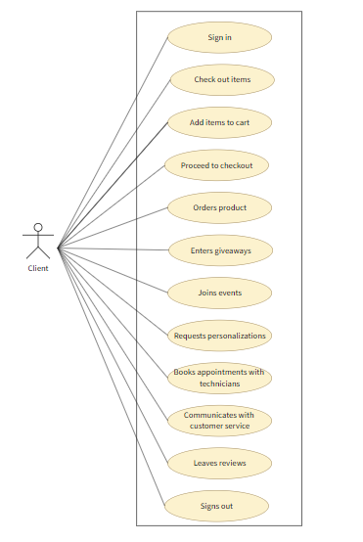

**Use case 2 Not Signed in Client**

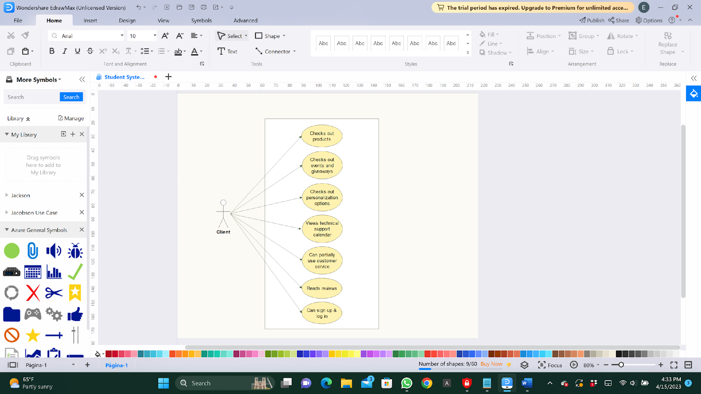

**Use case nr 3: Shopkeeper**

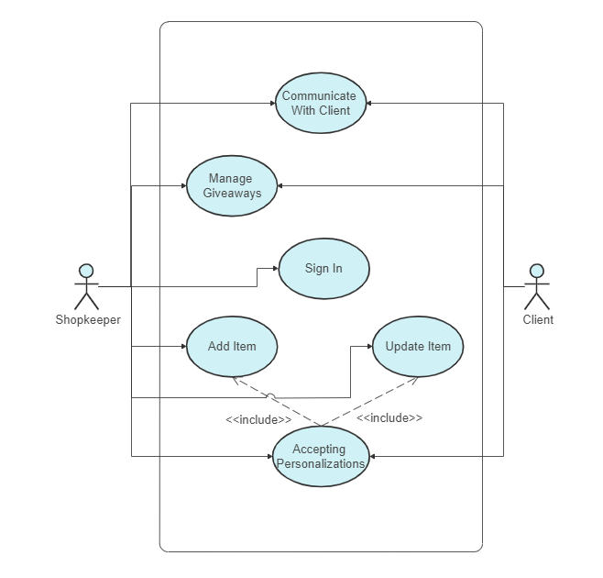

**Use case nr 4 Technician**

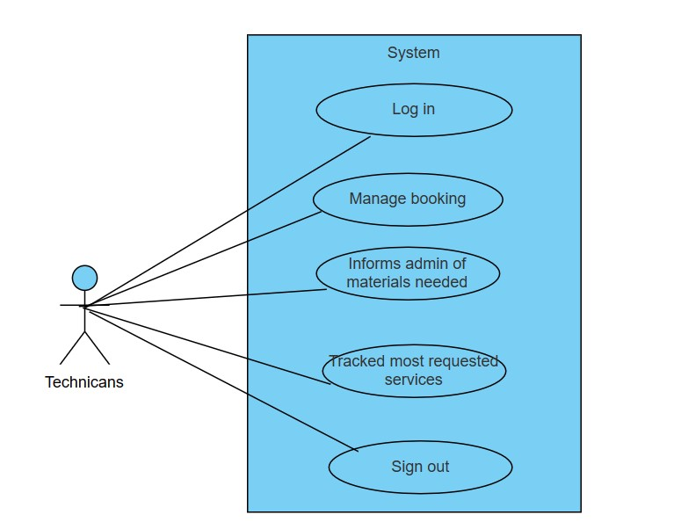

**Use case nr 5 Music Guest**

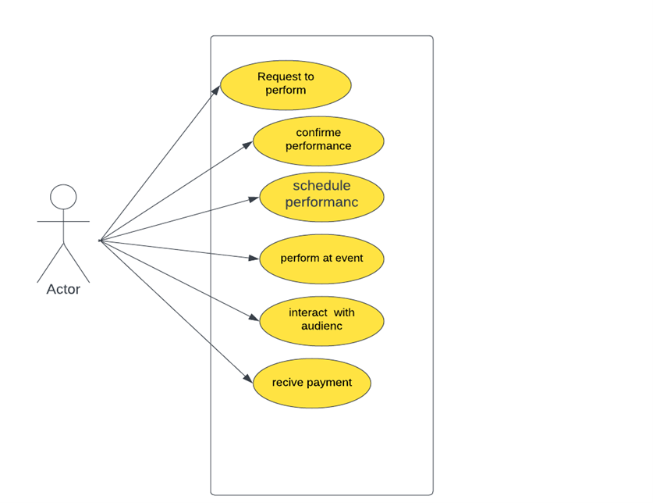

**Use case nr 6 Admin**

**Use case nr 7 General**

* 1. **Use case expanded**

Coming soon

* 1. **Activity Diagrams**

**Signing up**

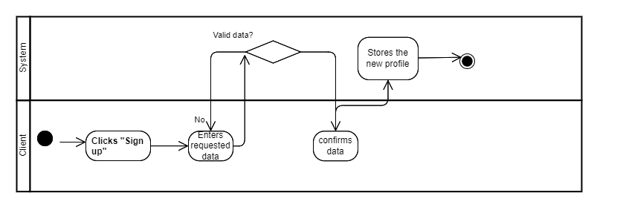

**Signing in**

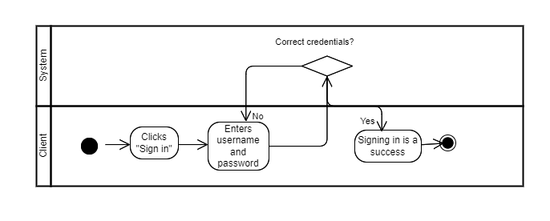

**Client talking to customer service**

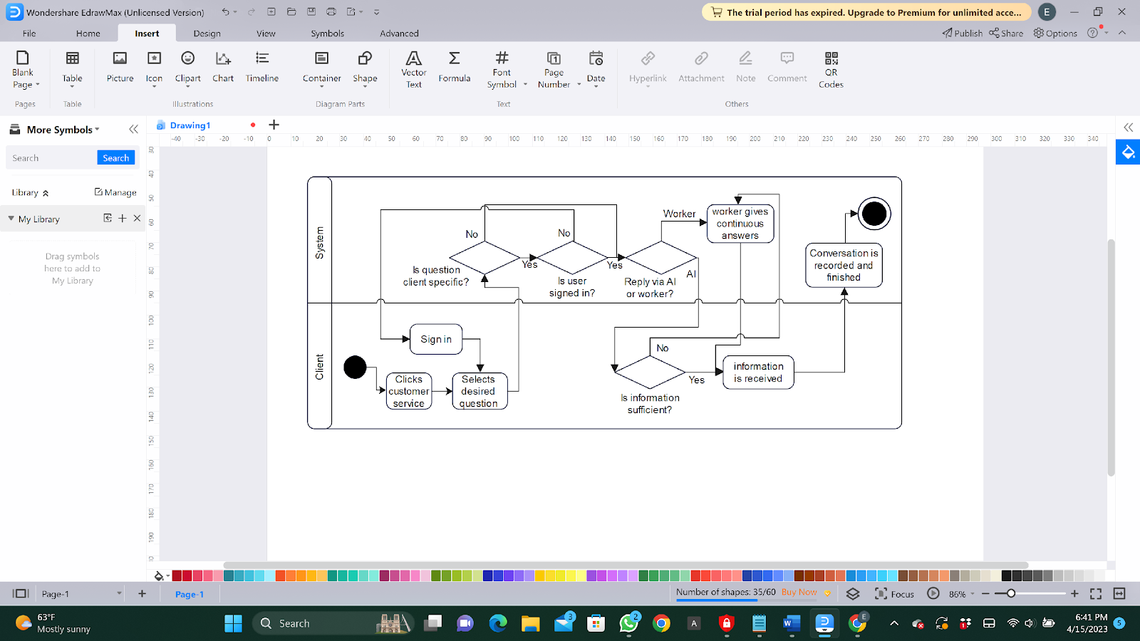

**Client adding to cart**

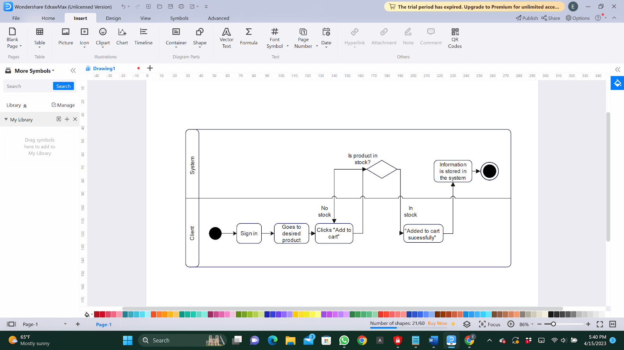

**Client Entering Giveaways**

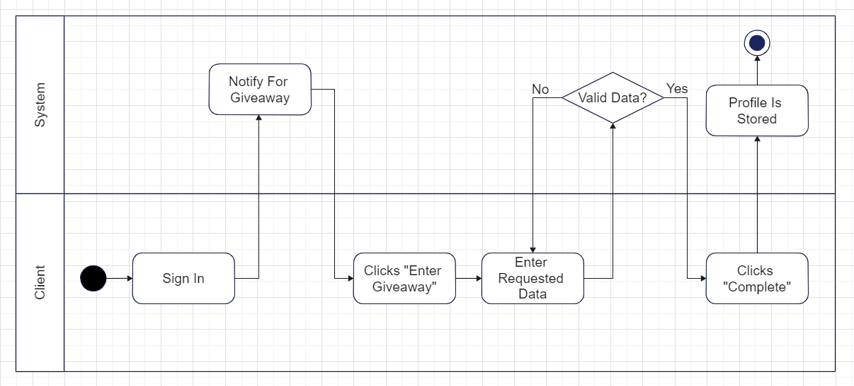

**Client requesting Personalizations**

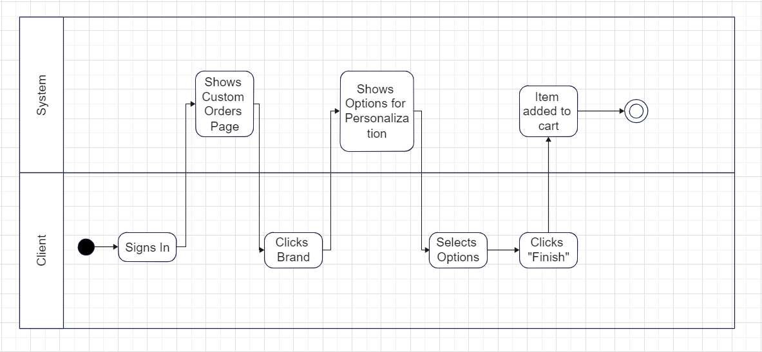

**Client making appointment with technician**

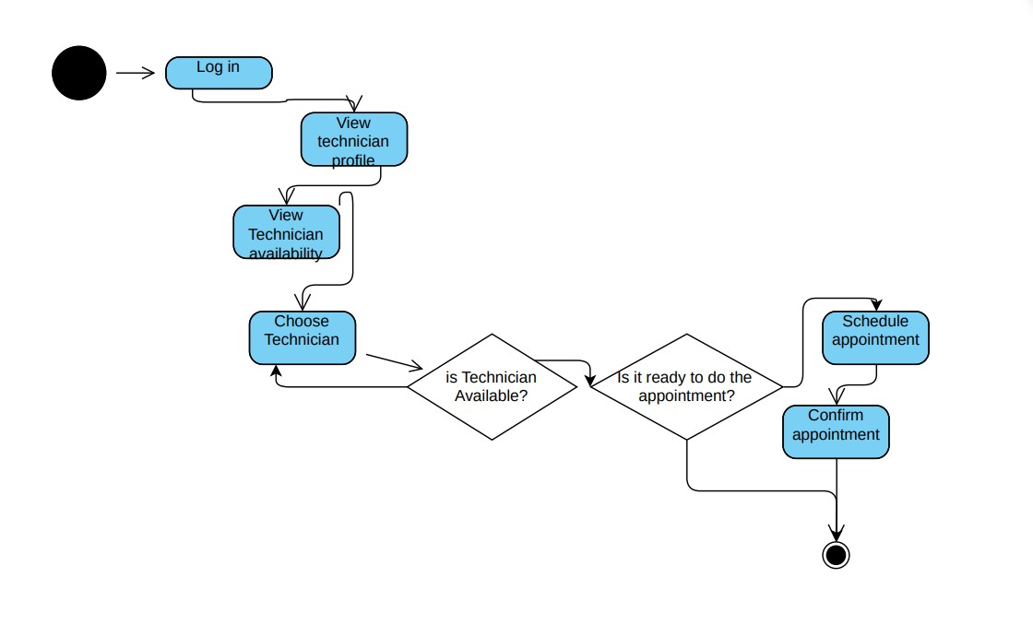

* 1. **State Diagrams**

**Client** 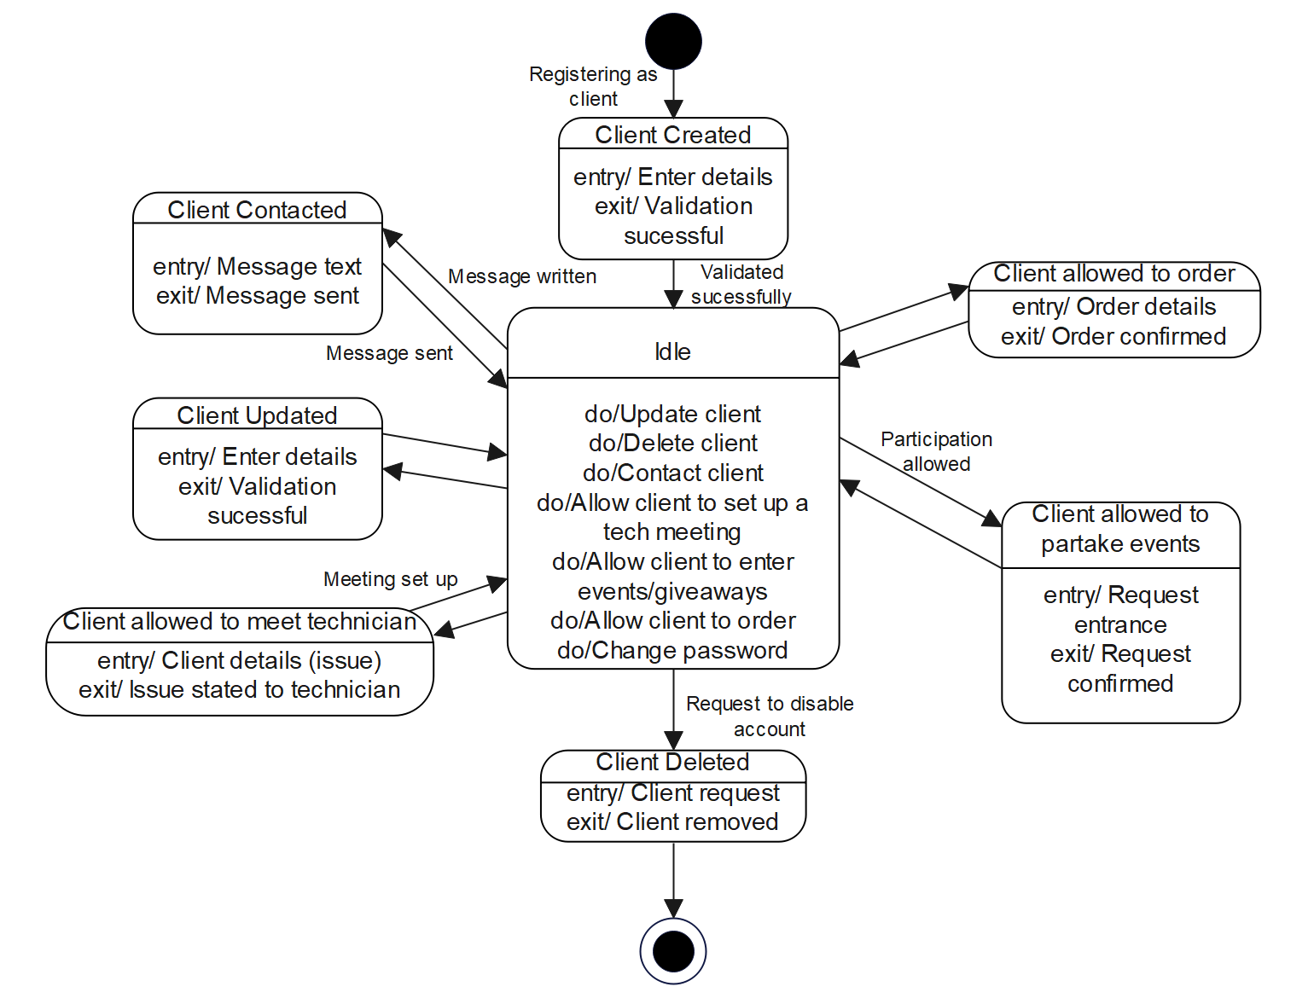

Technician

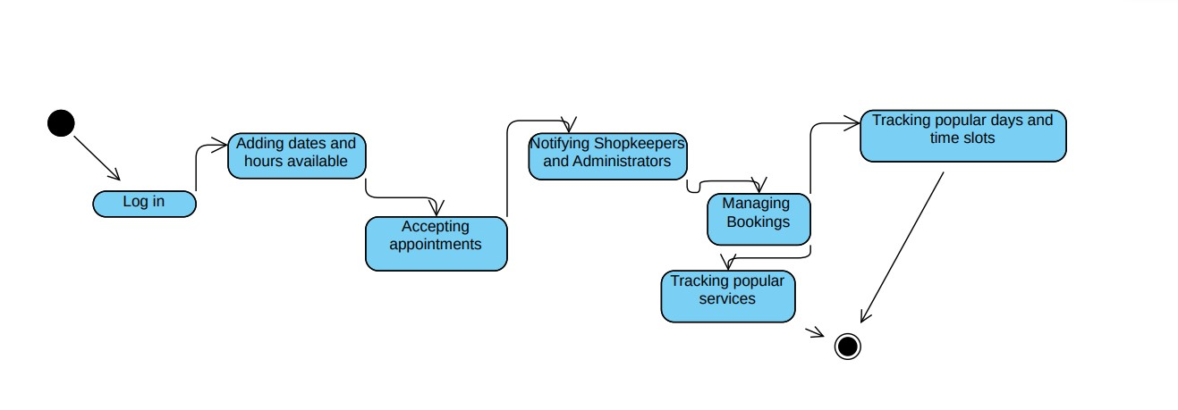

Client ordering

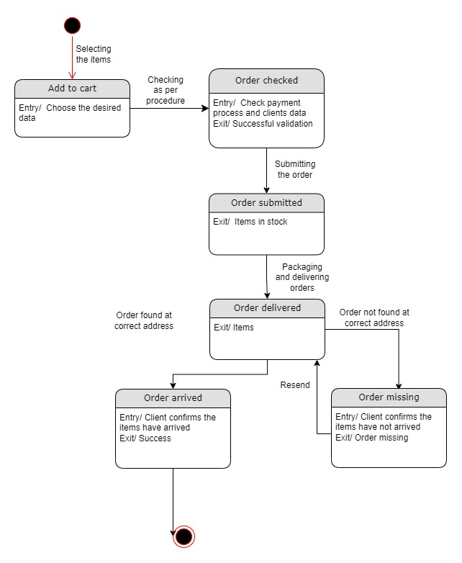

Client requesting personalization’s

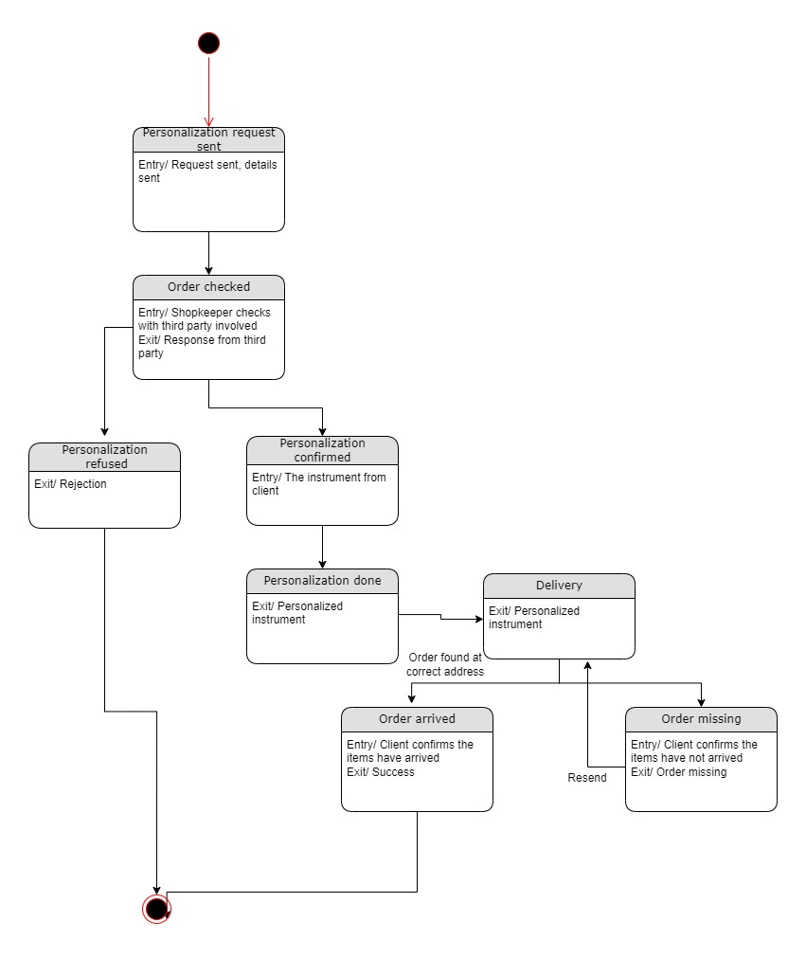

Payment

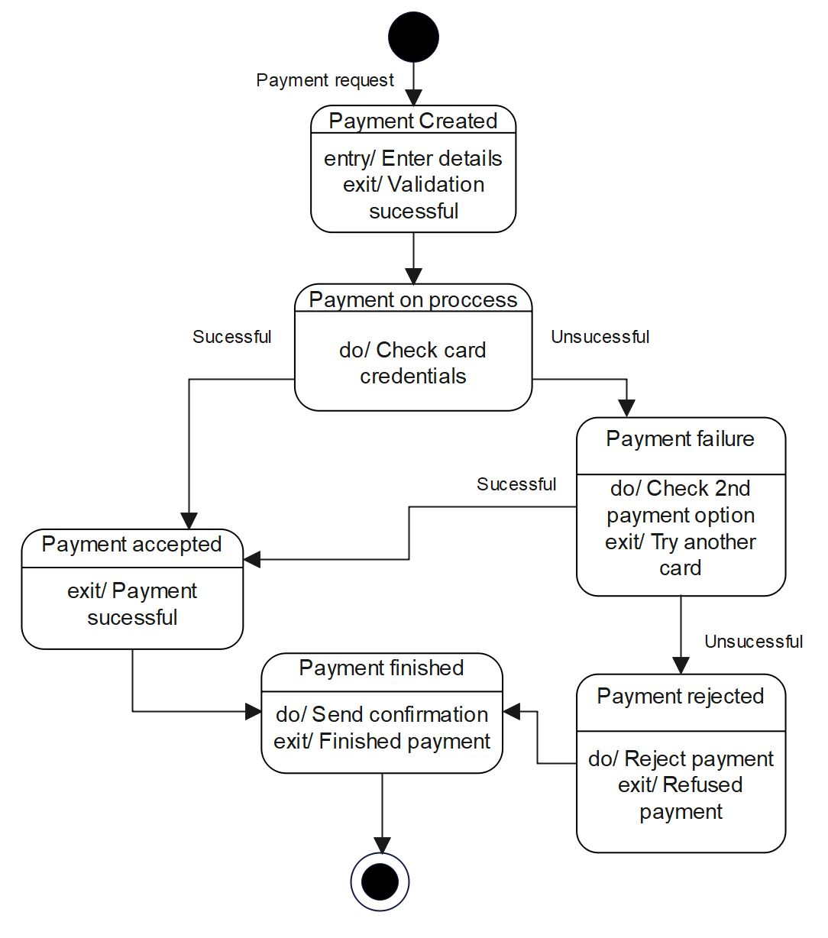

APPENDIX

The appendixes are not always considered part of the actual Requirements Specification and are not always necessary. They may include

* Sample input/output formats, descriptions of cost analysis studies, or results of user surveys;
* Supporting or background information that can help the readers of the Requirements Specification;
* A description of the problems to be solved by the system;
* Special packaging instructions for the code and the media to meet security, export, initial loading, or other requirements.

When appendixes are included, the Requirements Specification should explicitly state whether or not the appendixes are to be considered part of the requirements.

1. **Definitions, Acronyms, and Abbreviations**

Define all terms, acronyms, and abbreviations used in this document.

1. **References**

List all the documents and other materials referenced in this document.

1. **Requirements Traceability Matrix**

The following trace matrix examples show one possible use of naming standards for deliverables (Functional Area-Doc Type-NN). The number has no other meaning than to keep the documents unique. For example, the Bargaining Unit Assignment Process Flow would be BUA-PF-01.

For example (1):

| **Business Requirement** | **Area** | **Deliverables** | **Status** |
| --- | --- | --- | --- |
| BR_LR_01  The system should validate the relationship between Bargaining Unit/Location and Job Class.---Comments: Business Process = "Assigning a Bargaining Unit to an Appointment" (Priority 1) | BUA | BUA-CD-01  Assign BU Conceptual Design | Accepted |
| BUA-PF-01  Derive Bargaining Unit-Process Flow Diagram | Accepted |
| BUA-PF-01  Derive Bargaining Unit-Process Flow Diagram | Accepted |
| BR_LR_09  The system should provide the capability for the Labor Relations Office to maintain the job class/union relationship.---Comments: Business Process = "Maintenance" (Priority 1) | BUA | BUA-CD-01  Assign BU Conceptual Design | Accepted |
| BUA-PF-02  BU Assignment Rules Maint Process Flow Diagram | ReadyForReview |

For example (2):

| **BizReqID** | **Pri** | **Major Area** | **DevTstItems DelivID** | **Deliv Name** | **Status** |
| --- | --- | --- | --- | --- | --- |
| BR_LR_01 | 1 | BUA | BUA-CD-01 | Assign BU Conceptual Design | Accepted |
| BR_LR_01 | 1 | BUA | BUA-DS-02 | Bargaining Unit Assignment DB Modification Description | Accepted |
| BR_LR_01 | 1 | BUA | BUA-PF-01 | Derive Bargaining Unit-Process Flow Diagram | Accepted |
| BR_LR_01 | 1 | BUA | BUA-UCD-01 | BU Assign LR Use Case Diagram | ReadyForReview |
| BR_LR_01 | 1 | BUA | BUA-UCT-001 | BU Assignment by PC Use Case - Add Appointment and Derive UBU | Reviewed |
| BR_LR_01 | 1 | BUA | BUA-UCT-002 | BU Assignment by PC Use Case - Add Appointment (UBU Not Found) | Reviewed |
| BR_LR_01 | 1 | BUA | BUA-UCT-006 | BU Assignment by PC Use Case - Modify Appointment (Removed UBU) | Reviewed |
| BR_LR_09 | 1 | BUA | BUA-CD-01 | Assign BU Conceptual Design | Accepted |
| BR_LR_09 | 1 | BUA | BUA-DS-02 | Bargaining Unit Assignment DB Modification Description | Accepted |
| BR_LR_09 | 1 | BUA | BUA-PF-02 | BU Assignment Rules Maint Process Flow Diagram | Accepted |
| BR_LR_09 | 1 | BUA | BUA-UCD-03 | BU Assign Rules Maint Use Case Diagram | Reviewed |
| BR_LR_09 | 1 | BUA | BUA-UCT-045 | BU Assignment Rules Maint: Successfully Add New Assignment Rule | Reviewed |
| BR_LR_09 | 1 | BUA | BUA-UCT-051 | BU Assignment Rules Maint Use Case: Modify Rule | Reviewed |
| BR_LR_09 | 1 | BUA | BUA-UCT-053 | BU Assignment Rules Maint Use Case - Review Assignment Rules | Reviewed |
| BR_LR_09 | 1 | BUA | BUA-UCT-057 | BU Assignment Rules Maint Use Case: Inactivate Last Rule for a BU | Reviewed |
| BR_LR_09 | 1 | BUA | BUA-UI-02 | BU AssignRules Maint UI Mockups | ReadyForReview |
| BR_LR_09 | 1 | BUA | BUA-TC-021 | BU Assignment Rules Maint Test Case: Add New Rule (Associated Job Class Does Not Exist) – Success | ReadyForReview |
| BR_LR_09 | 1 | BUA | BUA-TC-027 | BU Assignment Rules Maint Test Case: Modify Rule – Success | ReadyForReview |
| BR_LR_09 | 1 | BUA | BUA-TC-035 | BU Assignment Rules Maint Test Case: Add New Rule (Associated Job Class Does Not Exist) - Error Condition | ReadyForReview |
| BR_LR_09 | 1 | BUA | BUA-TC-049 | BU Assignment Rules Maint Test Case: Modify Rule - Error Condition | ReadyForReview |

For example (3):

| **BizReqID** | **CD01** | **CD02** | **CD03** | **CD04** | **UI01** | **UI02** | **UCT01** | **UCT02** | **UCT03** | **TC01** | **TC02** | **TC03** | **TC04** |
| --- | --- | --- | --- | --- | --- | --- | --- | --- | --- | --- | --- | --- | --- |
| BR_LR_01 |  |  | X |  | X |  | X |  |  | X |  | X |  |
| BR_LR_09 | X |  |  | X |  | X |  |  | X |  | X |  | X |
| BR_LR_10 | X |  |  | X |  |  |  |  | X |  | X |  |  |
| BR_LR_11 |  | X |  |  |  |  |  |  |  |  |  |  |  |

1. **Organizing the Requirements**

This section is for information only as an aid in preparing the requirements document.

Detailed requirements tend to be extensive. Give careful consideration to your organization scheme. Some examples of organization schemes are described below:

**By System Mode**

Some systems behave quite differently depending on the mode of operation. For example, a control system may have different sets of functions depending on its mode: training, normal, or emergency.

**By User Class**

Some systems provide different sets of functions to different classes of users. For example, an elevator control system presents different capabilities to passengers, maintenance workers, and fire fighters.

**By Objects**

Objects are real-world entities that have a counterpart within the system. For example, in a patient monitoring system, objects include patients, sensors, nurses, rooms, physicians, medicines, etc. Associated with each object is a set of attributes (of that object) and functions (performed by that object). These functions are also called services, methods, or processes. Note that sets of objects may share attributes and services. These are grouped together as classes.

**By Feature**

A feature is an externally desired service by the system that may require a sequence of inputs to affect the desired result. For example, in a telephone system, features include local call, call forwarding, and conference call. Each feature is generally described in a sequence of stimulus-response pairs, and may include validity checks on inputs, exact sequencing of operations, responses to abnormal situations, including error handling and recovery, effects of parameters, relationships of inputs to outputs, including input/output sequences and formulas for input to output.

**By Stimulus**

Some systems can be best organized by describing their functions in terms of stimuli. For example, the functions of an automatic aircraft landing system may be organized into sections for loss of power, wind shear, sudden change in roll, vertical velocity excessive, etc.

**By Response**

Some systems can be best organized by describing all the functions in support of the generation of a response. For example, the functions of a personnel system may be organized into sections corresponding to all functions associated with generating paychecks, all functions associated with generating a current list of employees, etc.

**By Functional Hierarchy**

When none of the above organizational schemes prove helpful, the overall functionality can be organized into a hierarchy of functions organized by common inputs, common outputs, or common internal data access. Data flow diagrams and data dictionaries can be used to show the relationships between and among the functions and data.

**Additional Comments**

Whenever a new Requirements Specification is contemplated, more than one of the organizational techniques given above may be appropriate. In such cases, organize the specific requirements for multiple hierarchies tailored to the specific needs of the system under specification.

There are many notations, methods, and automated support tools available to aid in the documentation of requirements. For the most part, their usefulness is a function of organization. For example, when organizing by mode, finite state machines or state charts may prove helpful; when organizing by object, object-oriented analysis may prove helpful; when organizing by feature, stimulus-response sequences may prove helpful; and when organizing by functional hierarchy, data flow diagrams and data dictionaries may prove helpful.