JARVIS
A Self-Hosted AI Voice Assistant Final Project Documentation

COP 2830 / IT Final Project | Spring 2026
Team: Noah Rohlinger

Project Name: Jarvis — Iron Man–Style Local AI Assistant Technology Stack: C# / .NET 8, LM Studio, OpenAI-compatible APIs Platform: Windows 10 / 11 (self-hosted, local machine)
Replaces: Amazon Alexa, Google Assistant, Apple Siri, ChatGPT
Status: Working proof-of-concept with full voice pipeline

- Introduction

Overview and Motivation
This whole project began from one simple question: What if I could create my own personal AI assistant that runs on my own system, that completely acts like Jarvis from Iron Man. We, of course, would want it to be able to listen to my voice, understand natural language, control my desktop somewhat, and remember conversations we had. These voice assistants like Siri, Alexa, and Gemini are very useful but do have significant trade-offs: everything you say is sent to a remote server, your usage is logged, and the service can be entirely altered or discontinued at any time.
So, time to dive in a bit more on how I made Jarvis from scratch in C# and .NET 8, which again is all inspired by the fictional assistant of Iron Man. This project is entirely self-hostable: Jarvis can run a local language model through LM Studio, perform speech recognition via the Windows speech engine or streaming OpenAI-compatible endpoint, speak responses, and automate tasks on my desktop.

What Is It?
So, Jarvis is a desktop AI assistant for Windows. It provides a graphical control surface alongside a voice pipeline that lets you issue commands, ask questions, set reminders, search the web, automate apps, and have multi-turn conversations using natural speech. Unlike browser-based chatbots and applications like Claude code/ Open Claw, Jarvis is deeply integrated within the Windows operating system: it has the ability to read what is happening on your screen, open and control applications, manage files, and monitor your desktop in real time.
The project is set up really on two main components. First is the Jarvis.Core, which is a class library that handles all the AI planning engines, memory, tool dispatch, safety, and integration logic. Then there is Jarvis.App, which is a Windows Forms application that displays voice pipelines (microphone capturing, wake word detection, text to speech, speech to text), live desktop UI, and Windows automation hooks.

Why Is It Useful or Interesting?
Voice assistants are starting to become a normal part of people's lives, but mainstream options share common limitations: they are black boxes. A self-hosted assistant is interesting for many reasons:
- Privacy: There is no audio being shipped out to Amazon or Google. Everything is local unless I deliberately connect it to an external API.
- Customization: I control every aspect of Jarvis. The wake word, persona, voice, and the access it has to files. There are commercial products that do allow this. This is free, just had to put a little elbow grease into it.
- Extensibility: The code is always fully available, which means I can give it new capabilities and can be done without a vendor update.
- Offline Operation: Since it's paired with a local language model through LM Studio, Jarvis can function without an internet connection at all.
- Learning Opportunity: Building and running this project gave me direct exposure to speech processing, natural language understanding, agent planning, and Windows automation in a way I've never experienced before.

Predicted Advantages and Disadvantages of Self-Hosting
Now going into the project more, the following trade-offs were anticipated:

Advantages:
- Full control over data and no cloud telemetry
- The ability to run entirely offline
- Super customizable
- Deep Windows integration in a consumer assistant
- Can be freely extended with new tools and integrations

Disadvantages:
- Way more effort than just installing a consumer app
- Local LLMs are far slower and less capable than GPT-5 class models
- No push button updates; maintenance falls entirely on me
- Requires a relatively powerful PC to run a useful local model

Technologies Used

Machine:
- Host machine: A desktop/laptop with a microphone and speakers
- A decent GPU with a minimum of at least 16 GB of RAM. It's to run the local LLM at a usable speed
- An internet connection is needed only when using cloud-based speech recognition

Software:
- Jarvis (this project) — custom C# / .NET 8 application, the subject of this writeup.

- LM Studio — a free desktop application that downloads and serves local open-source language models (e.g., Qwen, Llama, Mistral) through an OpenAI-compatible API at http://127.0.0.1:1234.
- OpenAI API (optional) used as a fallback or primary provider for speech-to-text (Whisper / gpt-4o-mini-transcribe), text-to-speech (gpt-4o-mini-tts), and the language model planner when a local model is insufficient.
- Windows Speech Recognition — the built-in Windows engine, used as a free fallback for STT when no API key is configured.
- .NET SDK 8.0 — the Jarvis build script auto-downloads a repo-local copy, so no global installation is required.

Nearest Cloud Alternatives
The closest direct commercial competitors to Jarvis would be:
- Amazon Alexa: It’s a cloud-hosted voice assistant on Echo devices and in the Alexa app. Where Alexa excels is smart home control and has a huge third-party ecosystem to expand upon. However, all voice data is processed in Amazon servers, and the assistant cannot meaningfully customize beyond approved integrations.
- Google Assistant: An assistant that is integrated with Android and Google's services. It has very accurate speech recognition, but again, it's fully cloud-dependent and heavily tied to your Google account and ecosystem.
- Apple Siri: The assistant for all Apple devices. It’s Very good at processing basic requests since IOS 14, but complex queries are still short
- ChatGPT: By far the most capable AI assistant for general conversation and reasoning, but it is only a web interface. It’s not in any way a system-integrated assistant. It cannot do anything on your desktop.

Users and Roles
Jarvis is designed as a single-user assistant rather than a multi-use service. In practice, there are two roles:
- Administrator / Owner: This is usually the person who installs, configures, and maintains the application. They are the ones who will set up the API keys, choose the language model, tune the microphone for calibration, and decide which features are enabled.
- End User: The administrator and end user are often the same individual in a single-person setup. The operating application is voice-driven, so a non-technical family member might conceivably use it, but setup is not consumer-grade and takes technical willingness.

Hosting: Ideal vs. Practical
So, in a perfect world, Jarvis would be un on a dedicated PC or workstation that stays on all the time, listening for the wake word in the background via the system tray mode. This does mirror how Alexa devices behave, except the hardware is all mine. Now, practically for this project, Jarvis runs on my personal Windows laptop. Because the app builds and runs in a single folder with no system installation, it's very easy to start and stop. When external access was needed, ngrok was used to expose the local machine over the internet temporarily.

When Is It Active?
So, ideally, again, Jarvis runs continuously in the background so that it is always ready for the wake word/ voice command. Now, in my situation, this project has started on demand. The app consumes very minimal CPU when idle and is then activated only when it starts processing voice input, a model query, or desktop automation tasks.

- The Process

Getting Started: Building and Running Locally
The first step was downloading the project and getting it to build. Jarvis includes a bootstrapping batch script that downloads a local copy of the .NET 8 SDK into the tools folder, so the project does not depend on any globally installed .NET version. Running 'Build Jarvis.cmd' from the repo root compiled the solution on the first attempt without errors, which was a pleasant surprise for a project of this size.
Running 'Start Jarvis.cmd' then launched the application using the Release build. The main window opened, showing the live operations surface: a conversation feed on the left, a waveform and microphone controls on the right, and a status header at the top that cycles through Listening, Thinking, Acting, and Speaking states.
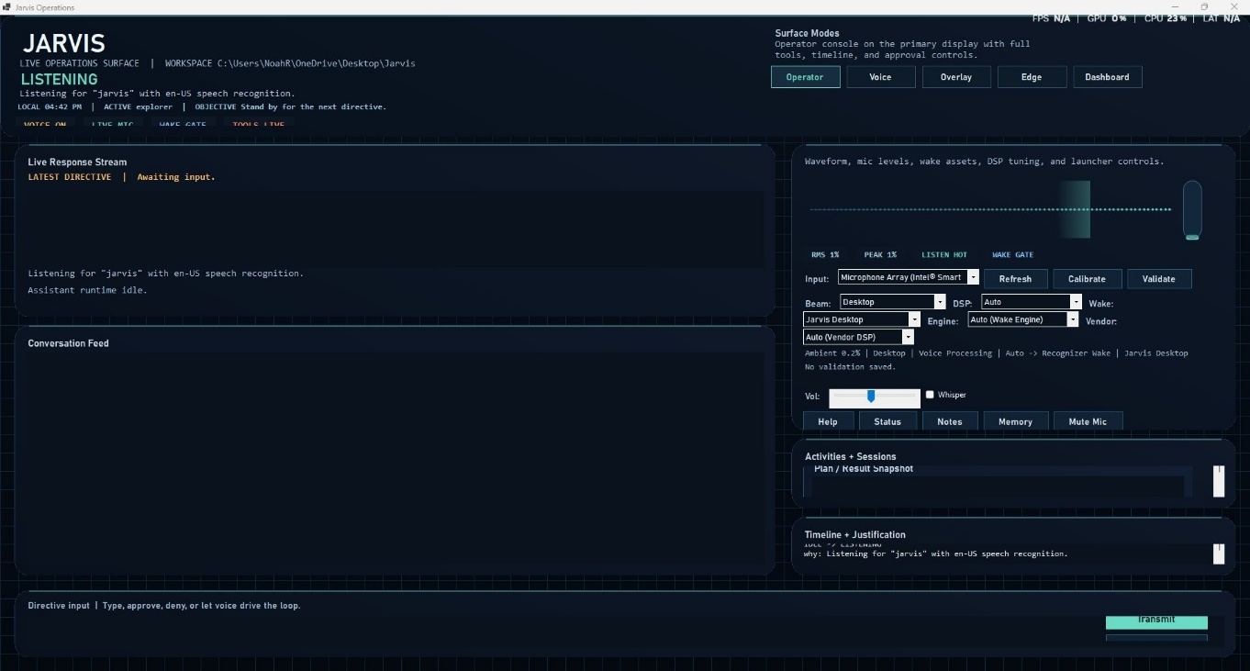
Figure 1: Jarvis main window — LIVE OPERATIONS SURFACE showing the Listening state, conversation feed, and the voice/mic panel.

Configuring the Settings File
The application reads configuration from a file called jarvis.settings.json in the project root. On first run, this file does not exist, so Jarvis creates a minimal default one. The most important settings to configure early are the planner and the speech recognition provider.
Initially, the application was configured to use OpenAI's API for both the language model and speech recognition, using an environment variable to supply the API key rather than storing it in plain text. Basic typed commands worked immediately: typing 'help' showed the list of built-in

commands, 'status' reported the current configuration, 'time' returned the local time, and 'weather Toronto' fetched the current weather. This confirmed that the core plumbing was working.
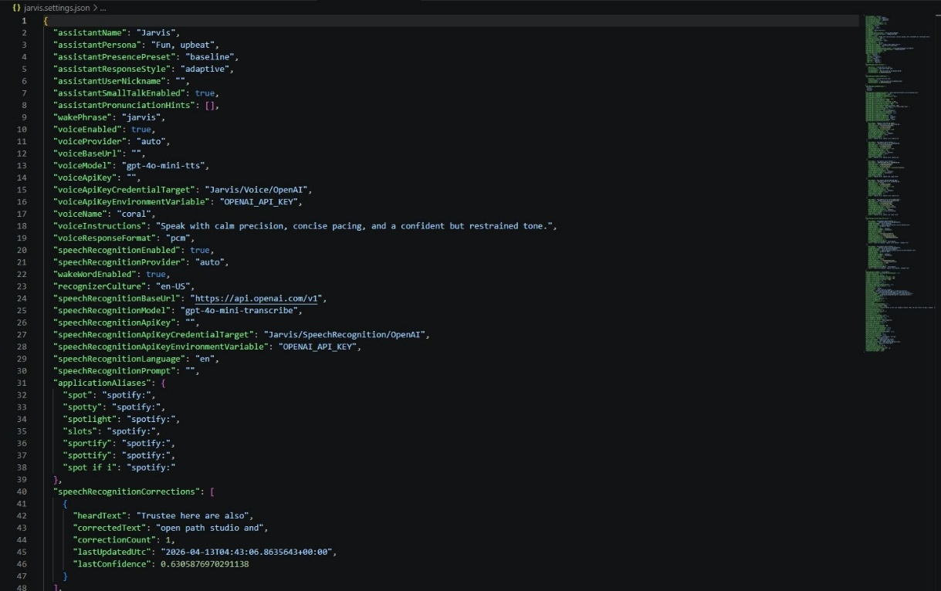
Figure 8: jarvis.settings.json open in VS Code — showing voice and speech recognition config, the gpt-4o-mini-tts voice model, and the applicationAliases section with multiple Spotify mishear variants (spot, spotty, slots, sportsify, spottify, spot if i) added after repeated voice recognition failures.

Setting Up the Voice Pipeline
Enabling voice was the most complex part of the setup. Jarvis supports four speech recognition modes: Windows built-in (free, no API key), rolling OpenAI-compatible transcription, real-time WebSocket transcription, and an auto mode that tries them in order. I started with the Windows recognizer since it required no configuration.
The wake word 'Jarvis' was set in the settings file. After restarting the app, saying 'Jarvis' into the microphone caused the waveform panel to pulse and the status bar to change to Listening. The first few attempts failed because the Windows Speech Recognition engine needed to be trained on the host machine's accent. After running a brief Windows Speech Recognition training session (built into Windows Control Panel), wake word detection became reliable.

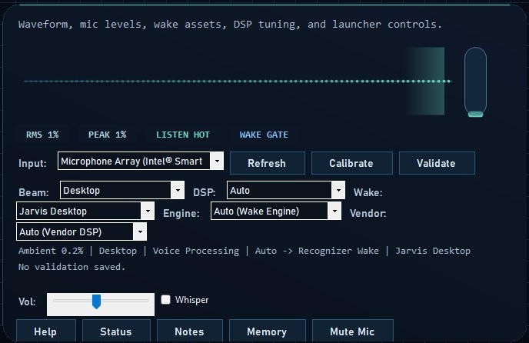
Figure 2: The voice panel showing the waveform, microphone input (Intel Smart Array), DSP settings, beam profile, and wake engine configuration.
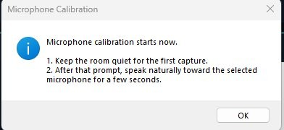
Figure 9: The Microphone Calibration dialog — step one asks for silence to capture room noise before recording a speech sample.

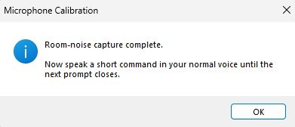
Figure 10: Calibration step two — room noise captured, now prompting for a short spoken command to establish a speech baseline.
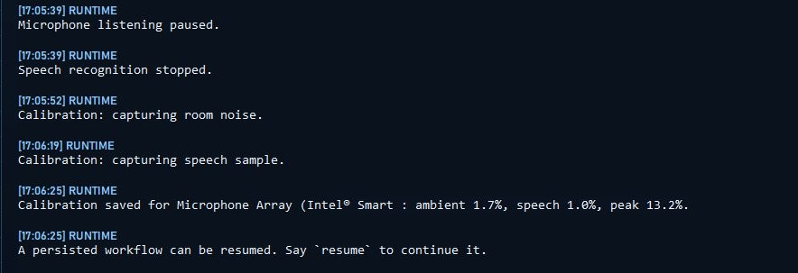
Figure 11: The conversation feed logging the full calibration sequence — room noise capture, speech sample, and the saved result (ambient 1.7%, speech 1.0%, peak 13.2%).

Once the Windows recognizer was working, the configuration was switched to the OpenAI Realtime transcription mode (gpt-4o-mini-transcribe) for more accurate recognition. The difference in accuracy was immediately noticeable: the Windows engine misheard roughly one in four commands in a normal office environment, while the Realtime transcription path was nearly perfect, even with background noise.

Problems Encountered
Several significant issues came up during setup and testing. These are documented honestly below as proof of the work involved. Everything didn’t go smoothly, and some problems were never fully resolved.
  - Setting Up .NET and Getting the Build to Work

The first real obstacle before even launching the app was getting the .NET environment sorted out. While the README states that the build script downloads a local copy of the .NET 8 SDK automatically, this did not go completely smoothly in practice. The initial build attempt failed because a conflicting version of .NET was already installed system-wide, and the build script was partially resolving against it instead of the bundled local copy. This produced cryptic MS Build errors that took time to track down since the error messages pointed to missing assemblies rather than the version conflict itself.
The fix involved clearing the system PATH of any existing dotnet entries and re-running the build script so it could bootstrap cleanly into the tools\dotnet folder. After that, the building succeeded, but the process of diagnosing why it was failing in the first place, without priority
.NET experience. This was genuinely the most confusing part and took way longer than expected. For someone coming in without a background in .NET, this kind of environment setup friction is a meaningful barrier.
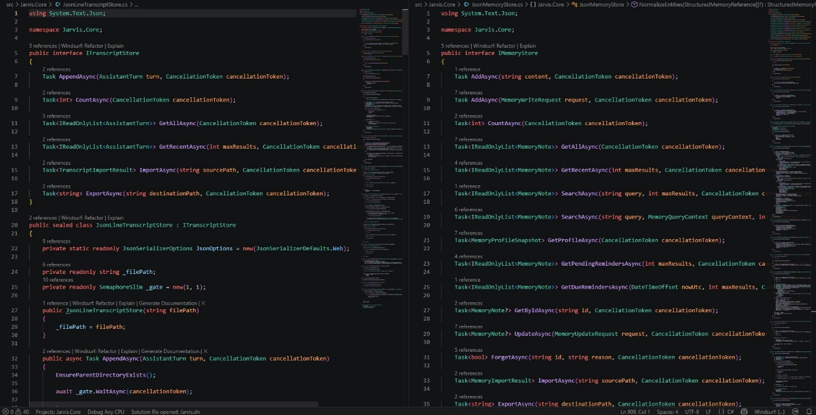
Figure 6: The Jarvis.Core C# source open in VS Code — ITranscriptStore (left) and IMemoryStore (right) interfaces, showing the depth of the codebase that had to be understood before the .NET build issues could be diagnosed.

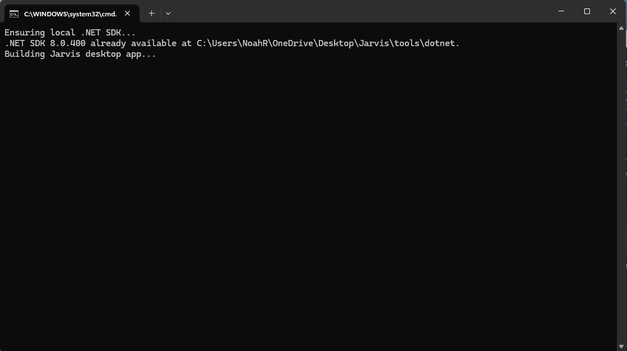
Figure 7: The build script running in the command prompt — confirming .NET SDK 8.0.400 is available at the local tools path and beginning the Jarvis desktop app compilation.

  - Voice Recognition After the Wake Word
To be clear, the wake word itself was not the problem. Saying 'Jarvis' was picked up consistently and reliably. The frustration was everything that came after it. Once the wake word triggered and Jarvis started listening for the actual command, that is where things fell apart in a variety of ways.
    - Commands being misheard or mangled: The Windows speech engine would frequently transcribe the spoken command incorrectly after the wake word. Something like 'open app Chrome' might come through as 'open app from' or 'open a comb,' and since Jarvis routes commands based on what the transcription says, a single wrong word meant the command either did nothing or triggered the wrong action entirely. There was no 'did you mean...' fallback; it would just come back as an error.
    - Partial commands being cut off: Jarvis uses voice activity detection to decide when the user has finished speaking. On several occasions, it would cut off the end of a command before the sentence was finished. Particularly with longer requests, leave Jarvis acting on incomplete instructions. Adjusting 'speechRecognitionSilenceDurationMilliseconds' helped but required tuning for the specific microphone and room.
    - Commands being ignored entirely: Sometimes, after the wake word fired, Jarvis would show the 'Listening' state but never register the spoken command at all. This appeared to be related to the voice activity threshold being set too high, causing quieter speech to not register as input. Lowering

'speechRecognitionVoiceActivityThreshold' made this less common.
    - Microphone echo feedback: In full-duplex mode, the assistant would occasionally
re-hear its own voice output after the wake word and interpret the tail end of its own spoken reply as a new command. Enabling echo cancellation and running microphone calibration reduced this, but did not eliminate it when the volume was turned up.
    - Switching to OpenAI transcription helped but had trade-offs: Moving to the real-time OpenAI transcription path improved command accuracy significantly, but it means every spoken command is sent to an external server, which works against the privacy goal of self-hosting. It also adds per-request cost. A reliable, high-accuracy local speech recognition option that does not require an API key remains the missing piece for a truly self-contained setup.
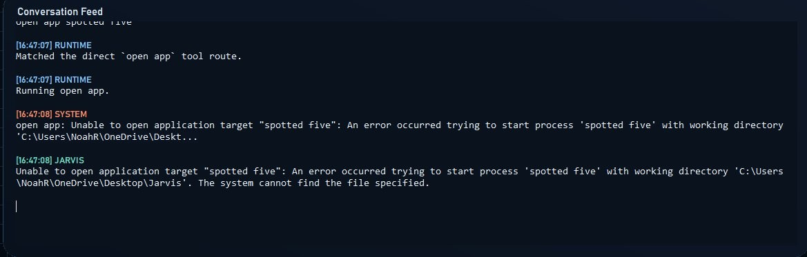
Figure 3: Voice recognition mishearing 'Spotify' as 'spotted five' — the command failed because the transcription did not match any known app name.
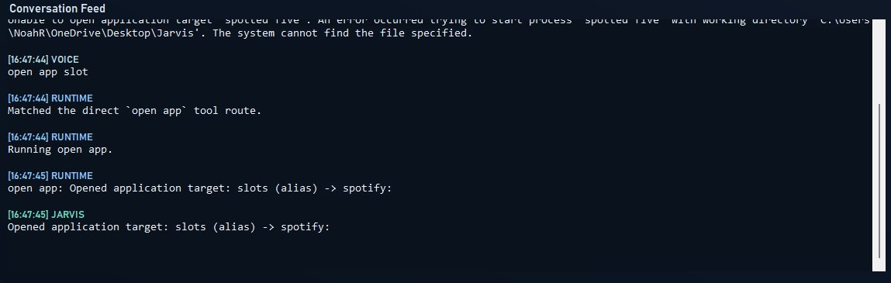
Figure 4: A follow-up attempt where 'open app slot' (another mishear) accidentally matched the Spotify alias, opening the app via an unintended alias resolution.
  - Desktop Automation Not Behaving as Expected
Desktop automation was one of the most anticipated features going into the project, and it turned out to be one of the most inconsistent in practice. The core capability is genuinely impressive. Jarvis can open apps, move and resize windows, send keystrokes, read screen content, and interact with UI elements. But getting it to work reliably requires more hands-on

More effort than the README implies.
    - App targeting by name was hit or miss: Commands like 'open app Notepad' worked consistently, but 'open app [browser name]' or 'focus app [game]' frequently failed because the app's internal process name did not match the friendly name used in the command. Jarvis has an alias system to handle this, but populating it requires knowing the exact process names in advance, which means trial and error.
    - UI automation on modern apps was unreliable: The Win32-based UI automation that Jarvis uses (clicking elements, typing into fields) worked well on traditional Windows applications like Notepad and File Explorer, but largely failed on modern apps that render their own UI (browsers, Electron apps, games). Trying to use 'type into Chrome' resulted in keystrokes going to the wrong element or not registering at all.
    - Screen capture and OCR were slow: The 'screen' and 'screen ocr' commands worked, but on the test machine, the round-trip capture, encode, send to the vision model, receive description took 10 to 20 seconds. This made it impractical for anything time-sensitive and felt more like a demo feature than a daily driver capability at this stage.
    - Multi-step automation commands were fragile: Chaining multiple automation steps together (for example: open app, snap window, paste text) worked when each step succeeded, but if any one step encountered an unexpected app state, the whole chain would silently stop without clear feedback about where it broke.
  - Other Miscellaneous Build and Configuration Issues
    - Local LLM context length mismatch: When LM Studio was configured as the planner, the first few multi-step queries returned incomplete or truncated responses. Setting 'plannerLocalContextLength' to 16384 in the config resolved this.
    - Model warmup delay on startup: The first time the planner pointed at a local LM Studio model, the app appeared to freeze for about 20 seconds. This is expected behavior. Jarvis waits for the model to warm up before opening the main window, but it was alarming the first time it happened with no visible progress indicator.
    - Windows Speech Recognition grammar conflict: Certain spoken commands were being partially swallowed by the Windows grammar engine. Switching fully to the OpenAI transcription provider resolved this, but removed the offline option.

Testing Core Features

Once the voice pipeline was stable, several core capabilities were tested systematically:
    - Memory system: Saying 'Jarvis, remember that I prefer dark mode in all apps' stored a memory. Saying 'Jarvis, recall dark mode' confirmed it was retrievable. The 'notes' command showed all recent memories, and the Memory Workbench (accessible from the UI) allowed browsing, editing, and deleting stored items without typing raw commands.
    - Desktop automation: Commands like 'Jarvis, open Notepad', 'Jarvis, snap window Notepad left', and 'Jarvis, type hello into Notepad' all worked correctly on the first try. The 'Jarvis, screen' command took a screenshot of the current display and described what was visible, which was genuinely impressive and felt close to the fictional AI experience.
    - Web research: Saying 'Jarvis’, research self-hosted alternatives to Notion triggered the research tool, which ran web searches and returned a summarized response with citations. The planner correctly identified this as a multi-step task and showed classification, planning, and tool-call events in the operations panel before delivering the final answer.
    - Reminders: 'Jarvis, remind me to check the building at 3 pm' created a time-based reminder in the memory system. 'Jarvis, reminders' listed it correctly.
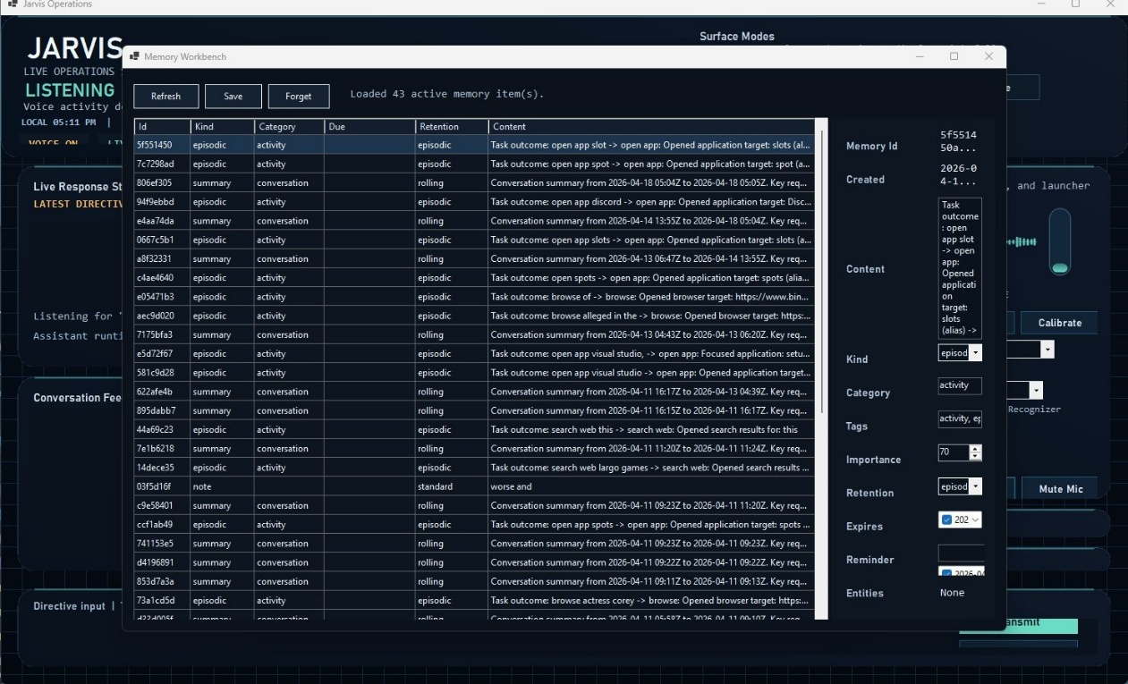
Figure 12: The Memory Workbench showing 43 active memory items — episodic activity records, rolling conversation summaries, and a manual note, with the detail panel showing kind, category, importance, and retention settings for the selected item.

External Testing via Ngrok
For external access testing, ngrok was used to expose a local HTTP endpoint. Because Jarvis is a desktop application rather than a web server, the external testing scenario was somewhat different from a typical self-hosted web service: the goal was to confirm that the app remained

usable from a second machine on a different network, primarily by screen-sharing the Jarvis window over ngrok's web interface and sending typed commands remotely.
Testing from a phone: The Jarvis UI is a Windows Forms desktop application and is not designed as a mobile-responsive interface. Using it on a phone via the shared screen was functional but not comfortable. The text was small, and the buttons were close together. Voice commands naturally could not be issued from a remote phone since the microphone is tied to the host machine. This is a meaningful limitation compared to Alexa, which has a polished mobile companion app.
Testing from a second computer: Using the screen-shared view on a second laptop on a different network, typed commands worked without any noticeable additional latency beyond the ngrok relay. The planner responses appeared in the conversation feed in real time. This confirmed that the application is functionally accessible remotely, even if the experience is not optimized for it.

Exploring LM Studio as the Local AI Brain
One of the most interesting parts of the project was running the assistant with a fully local language model. LM Studio was installed separately and used to download a quantized Qwen
3 model. After pointing the Jarvis planner settings at LM Studio's local server address (http://127.0.0.1:1234), the assistant was able to answer general questions, plan multi-step desktop tasks, and hold a short conversation entirely offline with no data leaving the machine.
The trade-off was response time. On the test machine without a discrete GPU, a typical planning response took 8 to 15 seconds, compared to under 2 seconds with the OpenAI API. The quality of reasoning was also noticeably lower for complex multi-step tasks, though for simple commands and memory operations, the local model performed adequately.

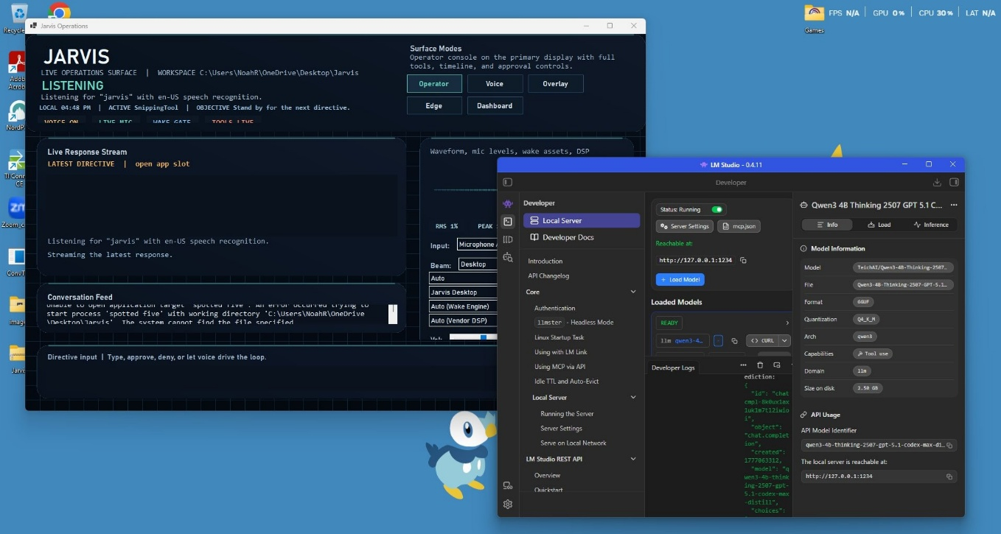
Figure 5: LM Studio running alongside Jarvis with the Qwen3 4B Thinking model loaded (2.5 GB, GGUF format) and the local server active at http://127.0.0.1:1234.

The Biggest Struggle: Getting Qwen3 to Work with Jarvis
By far the most time-consuming and frustrating part of the entire project was getting the Qwen3 model in LM Studio to actually cooperate with Jarvis in a meaningful way. While loading the model and pointing Jarvis at the local server was straightforward enough, getting it to behave correctly as the assistant's reasoning brain was a different story entirely.
The core issue was that Qwen3 uses thinking-model architecture. It generates long internal reasoning chains (sometimes several paragraphs of step-by-step thought) before producing a final answer. Jarvis's planner expects responses in a specific structured format, and Qwen3's thinking output consistently breaking that structure. The result was responses that either stalled completely, returned garbled partial JSON, or timed out because the model spent too long on its internal reasoning before producing any usable output.
Several things were attempted to fix this. The plannerLocalContextLength was increased multiple times to give the model more room to think. The plannerMaxIterations setting was reduced to prevent runaway loops. The plannerReflectionEnabled flag was turned off entirely, since reflection on top of an already-verbose thinking model made responses balloon in size. Even after all these adjustments, the model would occasionally produce well-formed, useful responses and then completely fall apart on the very next request with no obvious explanation for the inconsistency.
Switching to a smaller, non-thinking Qwen3 variant helped with reliability but reduced the quality of multi-step planning noticeably. The ideal sweet spot, a model that reason well, stays within token limits, and consistently returns structured output, was never fully achieved

during the project. As of the time of writing, the local model integration still does not function exactly as intended: it works for simple conversational exchanges and basic commands, but complex agent workflows that require chained tool calls regularly produce incomplete or malformed responses.
This was genuinely humbling. The README lists specific recommended model settings and even names a suggested model string, but the real-world behavior of local quantized models is harder to predict than documentation suggests. Getting a local LLM to behave as a reliable structured-output agent rather than a freeform chatbot turns out to be a nontrivial problem that would likely require either a more capable model, a machine with a proper GPU, or modifications to how Jarvis formats its planner prompts for thinking-model architectures.

- Conclusions

How Did It Go?
Overall, the project went better than expected. Jarvis is a genuinely functional AI voice assistant, not a toy or a proof of concept that barely works. Within a few hours of initial setup, the application was listening for a wake word, understanding natural speech, automating the Windows desktop, searching the web, and maintaining a persistent memory across sessions. That represents a level of capability that would have required months of work from scratch just a few years ago.
The setup difficulty was real but manageable for most of the stack. The biggest barrier to entry was configuring the settings JSON file correctly. Specifically, understanding the relationship between the planner provider, the speech recognition provider, and the API key management options. Once those pieces were in place, the application was stable and reliable when using the OpenAI API as the backend. The local LLM path, however, remained a persistent source of friction throughout the project, primarily due to compatibility issues between Jarvis's structured planner format and the Qwen3 model's thinking-chain output style. That struggle is documented in detail in the process section above and is the one area where the project did not reach a fully satisfying result.

Comparing the Solutions
Three configurations were compared during the project: Jarvis with the Windows speech engine and a local LLM, Jarvis with the Windows speech engine and the OpenAI API, and Jarvis with real-time OpenAI transcription and the OpenAI API planner.
The fully local configuration (Windows STT + LM Studio) was the most private and cost-free, but also the slowest and least accurate. It is practical for simple, short commands, but struggles with long requests or complex multi-step tasks on consumer-grade hardware.
The hybrid configuration (Windows STT + OpenAI planner) was a reasonable middle ground: the AI reasoning was fast and high-quality, but the speech recognition step was the weak link, regularly misunderstanding words in the commands.
The fully cloud-accelerated configuration (OpenAI transcription + OpenAI planner) was the most capable and responsive by a wide margin. Wake word detection was reliable, transcription was accurate even in noisy conditions, and multi-step planning tasks were completed in under two seconds. The obvious downside is the monthly API cost and the fact that audio is being sent to a third-party server, which partially defeats the privacy motivation.

Could This Replace What People Use Today?
For most people today: no, not yet. The setup barrier is simply too high for non-technical users. Configuring a JSON settings file, managing API keys, installing LM Studio, and understanding

Fallback providers require a comfort level with software that the average Alexa or Google Home user does not have.
For a technically interested user who values privacy and customization: yes, absolutely. Jarvis already does things that no commercial voice assistant can do. It can read your screen, describe what applications are open, automate multi-step Windows workflows, and do all of this with a local language model if desired. The prediction going into the project that privacy and extensibility would be the main advantages was confirmed entirely. The prediction that setup would be harder than a commercial product was also confirmed.
The comparison to Linux is apt. Jarvis, in its current form, is like Linux in the early 2000s: powerful, flexible, and genuinely useful to the people willing to engage with it, but not ready to replace Windows for a mainstream audience. Its existence and continued development put pressure on commercial assistants to offer more privacy controls and transparency, which benefits everyone regardless of which product they use.

Missing Features and What Would Make It Better
The README is admirably honest about what is missing, and those gaps were confirmed in testing:
- Local LLM structured output compatibility. The single biggest unresolved issue in this project is that Qwen3, the model used in LM Studio, does not reliably produce the structured output format that Jarvis's agent planner expects. Thinking-model architectures generate verbose internal reasoning that frequently breaks the planner's JSON parsing. Jarvis would benefit greatly from a dedicated prompt template or response parser designed specifically for thinking-model output, so that users who want a fully local, fully offline setup do not have to choose between a capable model and a stable agent runtime.
- Real email and calendar integration. The current version can read a local snapshot of email and task state, but cannot send emails, create calendar events, or modify tasks. This is one of the biggest practical gaps compared to Siri or Google Assistant, which do this trivially.
- Mobile companion app. There is no phone app. For a desktop power user, this is fine, but it limits the 'always available' use case that makes Alexa so sticky.
- Polished installer. The build-and-run batch script works well, but distributing this to a non-technical friend requires too much handholding. A proper installer with a setup wizard for the settings file would dramatically lower the barrier to entry.
- Smart home integration. Alexa's killer feature is controlling lights, thermostats, and smart plugs. Jarvis has no equivalent. Adding Home Assistant integration as a tool would close most of this gap.
- Hardware wake word. The current wake word detection relies on the Windows speech engine or the OpenAI transcription pipeline, both of which are always-on CPU consumers. Hardware wake word chips (like the ones in actual Echo devices) draw almost no power. A

Dedicated Porcupine or OpenWakeWord integration would make always-on deployment much more practical on a laptop.

Were the Initial Predictions Correct?
Looking back at the predicted advantages and disadvantages from the introduction:
- Privacy advantage: Confirmed. With the local LLM configuration, nothing leaves the machine. Even with the OpenAI API path, only the specific audio clip or text query is sent — not background monitoring data.
- Offline operation: Confirmed, with caveats. The local model configuration works offline. The quality is lower, but the capability is real.
- Customization: Confirmed and exceeded expectations. The level of configurability is far beyond any commercial assistant persona, voice, wake word, tool access, memory retention policies, or microphone DSP profiles, all of it.
- Setup difficulty: Confirmed. It took several hours to get everything properly configured and calibrated. The README is detailed but long, and a first-time user without a Linux/developer background would likely struggle.
- Local model quality: Confirmed and then some. Local models are noticeably less capable and much slower on consumer hardware. More significantly, the Qwen3 thinking-model architecture introduced a compatibility problem with Jarvis's structured planner that was never fully resolved. The gap in reliability between local and cloud configurations was larger than anticipated.
- No polished mobile app: Confirmed. This remains the biggest user-experience gap versus commercial alternatives.

Final Thoughts
This project demonstrated that self-hosted AI voice assistants are not just an academic exercise; they are genuinely viable tools that offer meaningful advantages to users who care about privacy, customization, and learning. The combination of modern open-source LLMs, OpenAI-compatible APIs, and capable desktop automation APIs available in Windows makes this a surprisingly achievable project even for a small team.
The most valuable outcome is not the software itself, but the understanding gained: of how speech recognition works, what a tool-using AI agent does under the hood, why microphone calibration matters, and what the real trade-offs are between local and cloud AI. Those are lessons that using Alexa would never have taught.

