Documentation

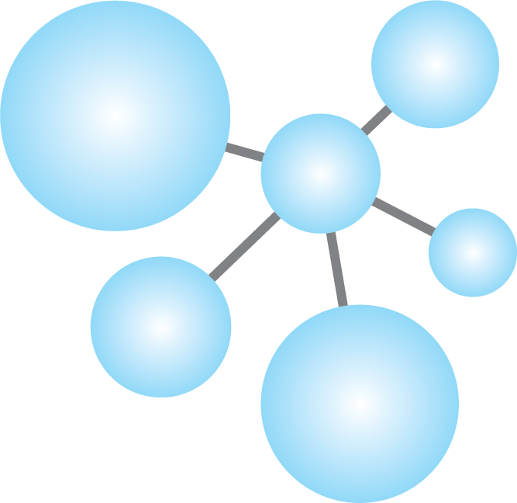

**Group 9**

Lorenz Caliezi

Noah Schmid

Manuel Schüpbach

Olivier Stähli

16. October

Table of Contents

General 3

First steps 3

Workflow 3

Tools 3

Major Challenges 3

Solved 3

Pending 3

Learning Outcome 3

Frontend 5

Design 5

Corporate Design 5

Homepage 6

Subcategory 7

Registration and Log-In 8

Component Hierarchy 9

Implementation 9

Major Challenges 9

Solved 9

Pending 10

Learning Outcome 10

Backend 11

Implementation 11

Major Challenges 11

Solved 11

Pending 11

Learning Outcome 11

# General

## First steps

To get started we all watched the Angular and Ionic tutorial form Maximillian Schwarzmüller. Afterwards, we played with the Scaffolding and then continued to watch more in-depth tutorials about Ionic and Angular.

## Roles

## Workflow

### Tools

We defined 4 tools to facilitate cooperation:

|  |  |  |  |  |
| --- | --- | --- | --- | --- |
| Tool | Purpose | Price | Advantages | Alternatives |
| **Whatsapp** | -Scheduling of meetings  -Sharing information rapidly | Free | -Fastest way of communication | Slack |
| **Slack** | -Sharing documents  -Sharing important information | Free | -Communication in different channels (information is ordered) | Whatsapp |
| **Trello** | -Project Management Tool  -Assigning Tasks | Free | -Project Overview | -Monday  -Basecamp  -Jira |
| **Github** | -Sharing code  -Collecting issues | Free | -State of the art | Gitlab |

Although we considered and tried multiple tools, our decision-making process pretty much came down to the pricing as a main factor. For project management we would have favored Monday or Basecamp.

## Major Challenges

### Solved

* Many collaboration tools are too expensive for a school project
  + → Trello has a free version that is good enough.
* Due to different minors the team members have very different schedules
  + → Defined time periods in which questions via Slack and Whatsapp have to be answered
  + → Shared schedules and defined time frames for meetings
    - Wednesday (17.00-19.00)
    - Monday (17.00-19.00)

## Learning Outcome

* Learned about requirements collection
* Get to know different tools to collaborate effectively (see above)
* Defined guidelines to collaborate successfully:
  + Git Commit Guidelines: <https://chris.beams.io/posts/git-commit/>
  + Response time on Slack <12h
  + Response time on Whatsapp <2h
* Learned about Scrum, Kanban and Lean Startup
* Defined how we use Scrum and Lean Startup
  + 1 Week Sprint
  + Monday, Wednesday and Friday Sprint Meeting

# Frontend

## Design

### Corporate Design

We made our corporate design with the specifications “*festive, classy but not too plain”*, from our Assistant Pascal Andre.

Figure 1: This Photoshop Mock-Up shows our corporate design.

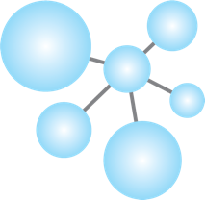Logo:

Font: Gotham Thin, Gotham Book

Colors:

RGB:

#BDBDBD

#08298A

#81DAF5

#FFFFFF

### Homepage

Figure 2: This is what the homepage should look like.

‘Top-Header’ - displays logo, login and registration buttons

‘Upper-Body’ (only displayed on the homepage)

‘Bottom-Header’ – contains the categories which contain the subcategories

Carousel – Shows each subcategory, sorted by category

Section

Footer

### Subcategory

Each subcategory page will look as follows: ­

The search-bar is no longer in the ‘Upper-Body’ but in the ‘Top-Header’.

A filer allows the user to search more strategically

Each subcategory item is displayed with an image, a title, an image and the price.

Figure 3: Each of the main categories is divided into different subcategories, which will be displayed like that. This page shows the subcategory **barbeque** in the category **food and beverage**.

### Registration and Log-In

This is the most urgent part of the design. We intend to implement the log-in and the registration as pop-ups.

Figure 5: The Log-In is a small pop up. The user must enter email and password to log-in. If the user is not a member yet he can switch to the registration by a mouse click below the form.

Figure 4: The Registration is a small pop-up. The only requirements are an email and a password which must be confirmed.

## A picture containing screenshot Description automatically generatedComponent Hierarchy

Figure 6: This is our first draft of the component hierarchy. We identified the most basic and obvious components such that the implementation is achievable (Lean Startup Method).

## Implementation

The front-end team started to implement this hierarchy on 09. October. So far, we have built all the components on figure 6 and designed the top-header. Furthermore, we added a bunch of smaller staff like bootstrap, the favicon etc. *(Status as of 14. October).*

## Major Challenges

### Solved

* Draft a design that is not too complicated to implement
  + → We aimed to think in components and therefore facilitate an easy implementation
* Learning new technologies in a short period of time
  + → Bought Udemy course in angular and ionic
  + → Knowledge sharing: explain difficult concepts to each other to streamline the learning process.

### Pending

* Make profile
* Handle the called verifying link

## Learning Outcome

* Learned how to build a component hierarchy
* Learned how to use Adobe Photoshop (Mock-Ups), Adobe Illustrator (Design-Drafts)
* Get a better understanding of the project through designing the homepage and subcategory
* Defined how the homepage, login, registration and subcategory page will look like
* Learned the basics in Angular and Ionic (in progress)

# Backend

## Implementation

*(Status as of 14. October)*

## Major Challenges

### Solved

* Setup Database
* write code for the different http requests a user can make for login and registration
  + sign up
  + login
  + delete
  + email verification
  + get specific user by id
  + update user information
  + make a function that checks the authentication (the signed token) of a user

### Pending

* Write tests using mocha
* use typescript instead of js
* make good documentation using JSDoc
* how to handle an admin user (seperate database?, special field?)

## Learning Outcome

We learned how to handle HTTP requests on certain paths of the webserver. And how to connect a database to our API to insert users into it. Furthermore we know how to automatically send emails via a SMTP server.