**Noah Stewart - 50706464**

COSC 414 Computer Graphics

Assignment 2

Screenshots demonstrating requirements:

[4 point]  
1. The player needs to eradicate the bacteria by placing the mouse over the bacteria and hitting a button.  
2. The effect of the poison administered is to immediately remove thepoisoned bacteria.

Left Photo: Shows beginning of game

Right Photo: Same game with red bacteria eradicated after click

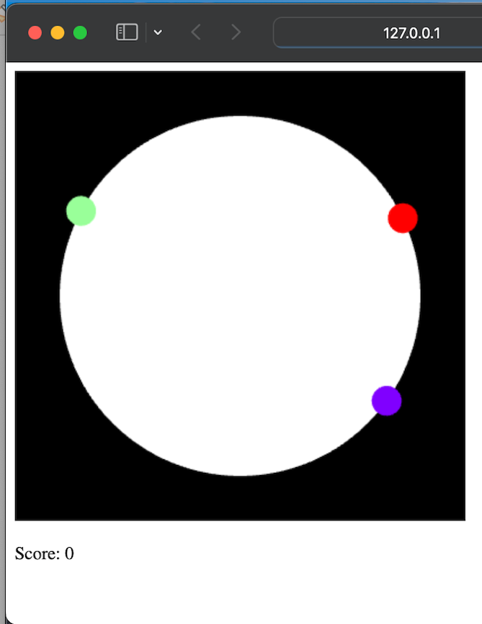

[3 point]  
3. The game gains points through the delays in the user responding and by any specific bacteria reaching a threshold (for example, a 30-degree arc).

Photos: When a bigger bacteria is eradicated it gives a higher score

Left Photo: The first bacteria eradicated gives Score: 133

Right Photo: Same game with magenta bacteria eradicated later in the game giving Score: 309 - 133 = 176

[3 point]  
4. The player wins if all bacteria are poisoned before any two different bacteria reach the threshold mentioned above.

Left Photo: Left photo shows player winning before less than 2 get to the threshold.

Right Photo: Game lost when 2+ bacteria reach threshold

