Viking Motorsports
Digital Dash
Project Proposal
January 3rd, 2015

Sean Koppenhoffer, Rishal Dass
Jaime Rodriquez, Noah Erickson, Chad Thueson

Objective
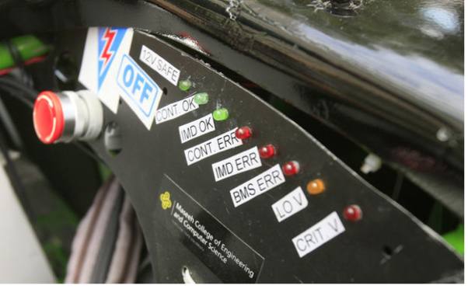Figure 1: Current LED Indicators
The objective of this unit is to provide the operator of the Viking Motorsports Formula SAE electric vehicle with information about the vehicles operation. The information will be gathered from the onboard VCU, deciphered by a main processing unit and displayed on an LCD mounted in the operators view. Mission critical information, such as warnings about battery temperatures, will be displayed on the digital dash.

Motivation
The current system used to warn operators of warning messages is with a simple LED indicator. This results in an array of many LEDs with corresponding labels cluttering up the dash board of the Formula SAE vehicle. The LED indicators on the current Formula SAE electric car can be seen in figure 1. By switching over to a digital dash the LED indicators along with their wires can be removed and the information consolidated into a single system that is easy to manage.

Description
The complete package will be made up of a single enclosed unit. The unit will contain a power supply for the microcontroller and LCD screen, a microcontroller that interprets data from the VCU, and an LCD screen that displays the relevant information. The digital dash unit will have a trans-reflective screen allowing it to be read in sunlight. The unit will also be designed to be small, waterproof and robust.

Components
The microcontroller that will be used is the ATCAN90. The LCD that will be used is the uLCD-35DT-AR from 4Dsystems.

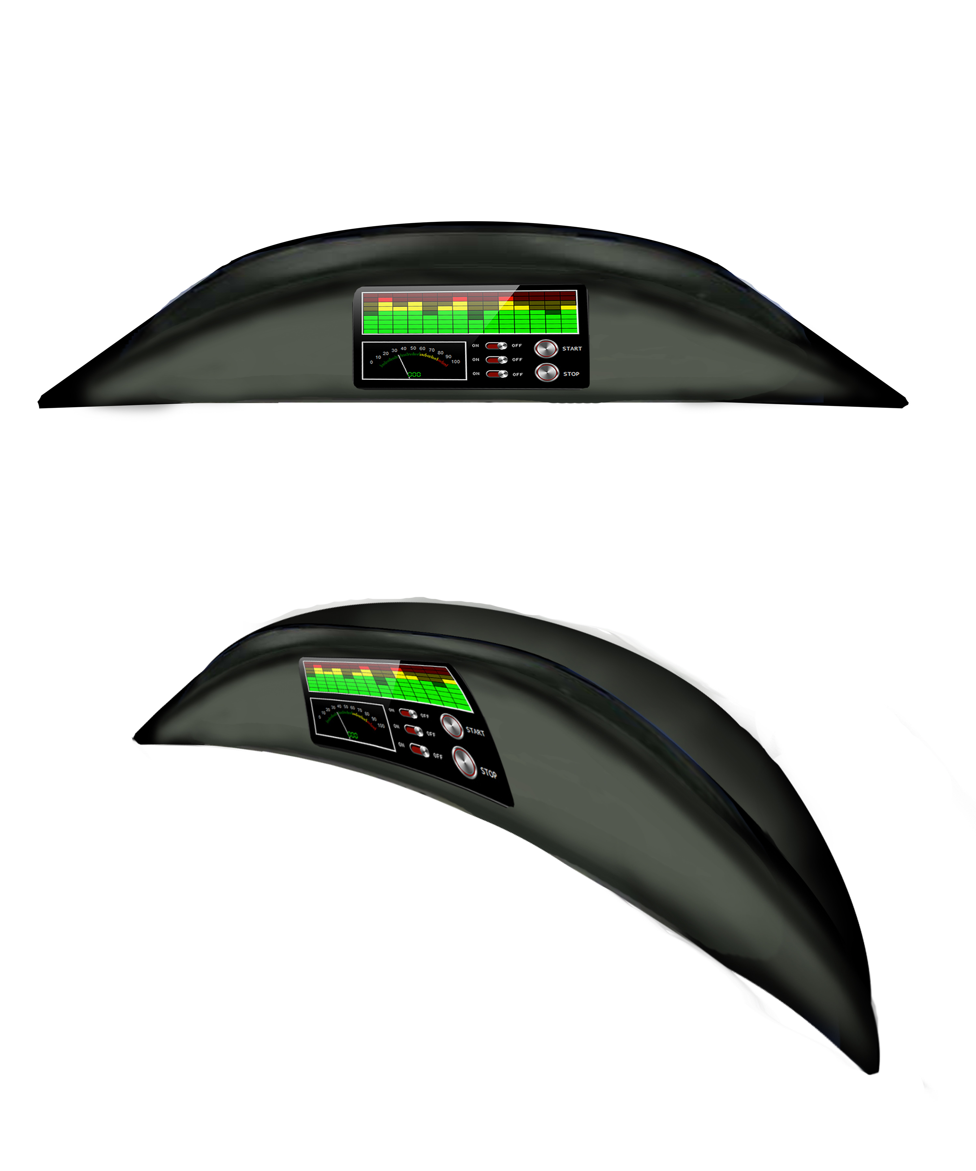Figure 2: Proposed Digital Dash

Figure 3: Block Diagram

