|  |
| --- |
| iNoah |
| roWeb Engine |
| roWeb Engine System |

|  |
| --- |
| noahzao  2013/7/24 |

目录

introduction 3

develop environment 3

engine structure 3

inoah.game 3

rmxp structure 4

base user interface 4

character editor 6

job editor 7

skill editor 8

item editor 9

weapon editor 10

equip editor 11

monster editor 12

monster group editor 13

system config editor 14

data structure 14

Global.as 14

sysConfig.xml 15

languages.xml 15

maps.xml 15

characters.xml 15

jobs.xml 15

skills.xml 16

items.xml 16

weapons.xml 16

equips.xml 16

monsters.xml 16

monsterGroups.xml 16

# ****introduction****

## develop environment

develop platform: win7 flashbuilder4.7 airsdk3.7

target platform: pc, android, ios6, mac

using framework: Starling, Feathers, robotlegs, mornUI, Minimalcomps

# engine structure

[libCommon] –-open source projects package

com.adobe.utils

starling

feathers

pureMVC

interfaces ( ILuaMain )

mornUI

[libDllLua] –-flascc lua5.2 package

com.inoah.lua.LuaMain

[project libCore] ---engine level code

inoah.core

inoah.data.map

inoah.lua

[project libRo] ---game level code

game.ui

inoah.game.ro

[project Client]

Client

## inoah.game

perLoader->Client->GameMediator->dllLua->load( game.lua )->initStarling()->run( game.lua )

ClientD5RoDemo.init()

façade-> new GameMediator

ClientD5RoDemo.tick()

GameMediator-> Starling-> starlingMain->mgrs

[assetMgr, textureMgr, sprMgr, displayMgr, keyMgr]

mornUI.init()->loginView->resInitLoad

GameMediator.onLogin()->initUserInfo()->resLoad()->mainView->mapMgr->battleMgr

mainView->mapView=>alertView=>joyStickView=>chatView=>skillView

mapMgr->mapMediator->changeMapCommand

battleMgr->battleMediator

# rmxp structure

## base user interface

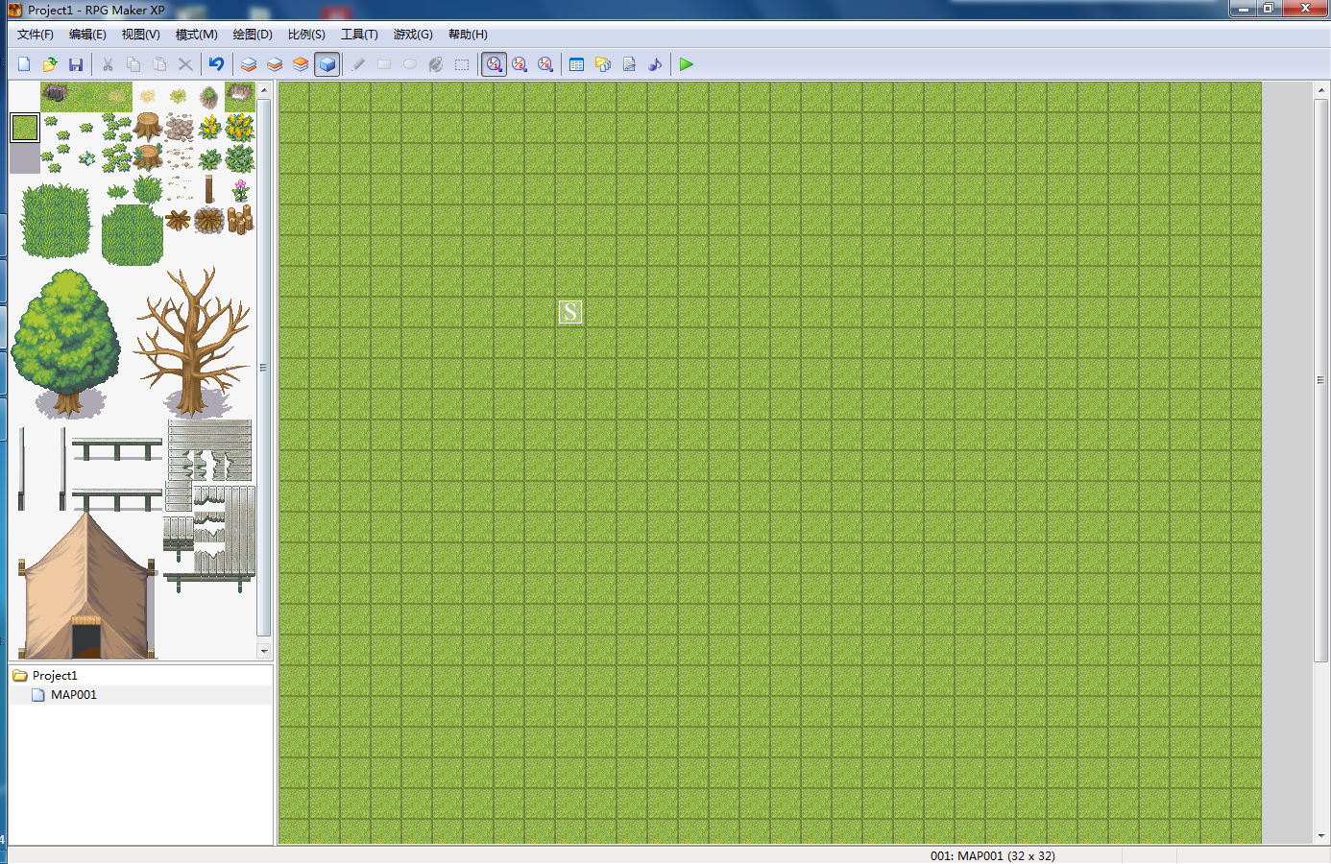

something like rmxp

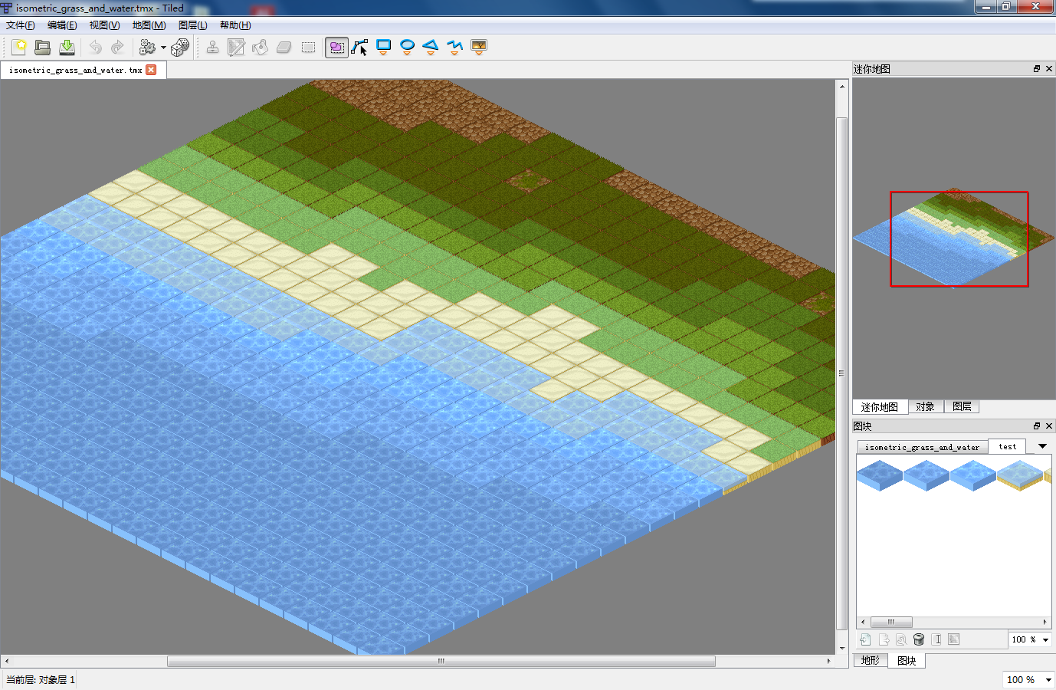

tiled mapeditor

## character editor

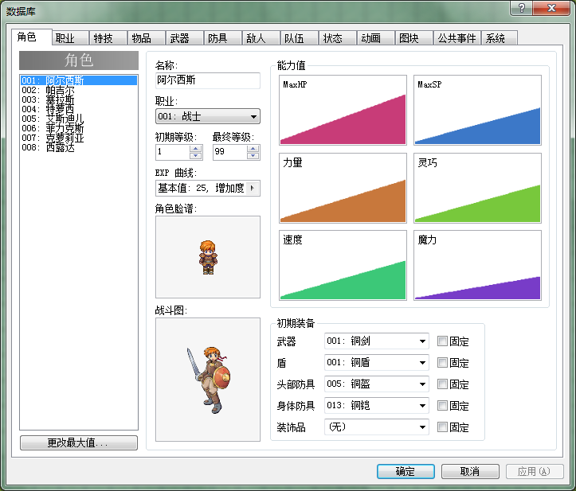

## job editor

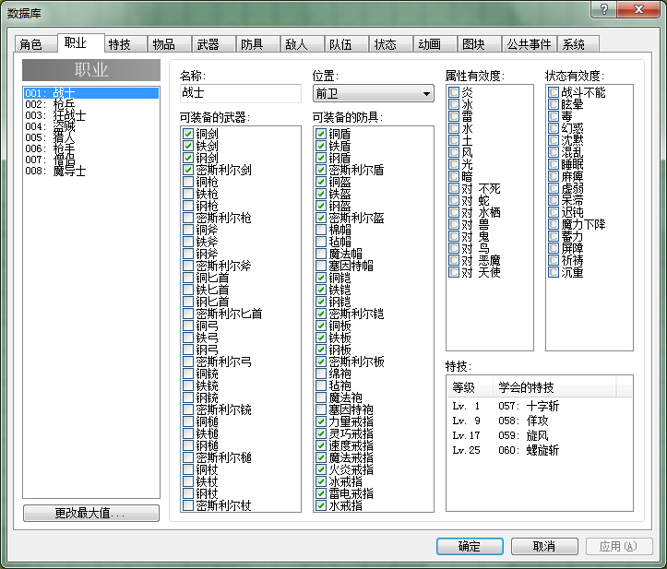

## skill editor

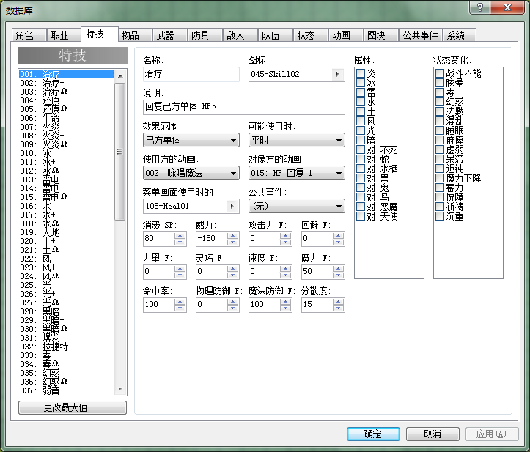

## item editor

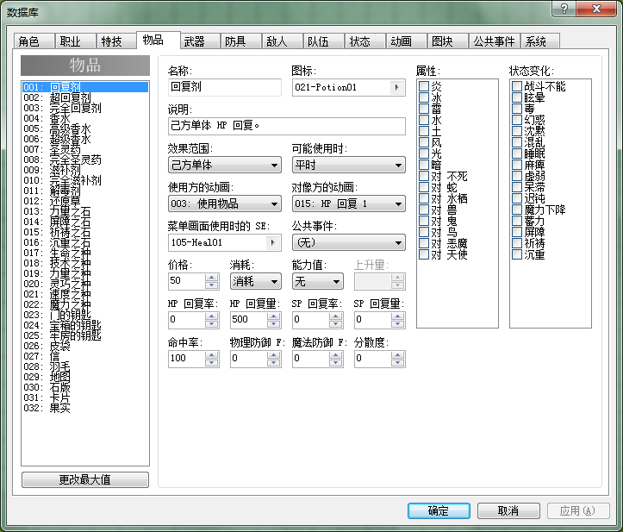

## weapon editor

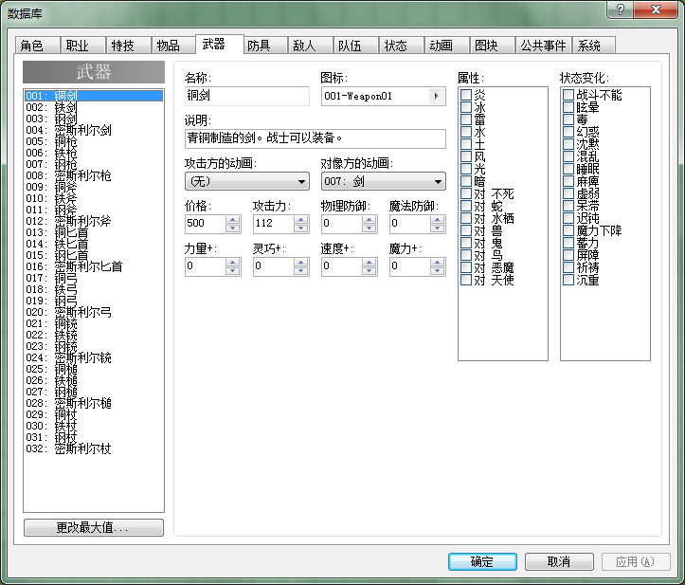

## equip editor

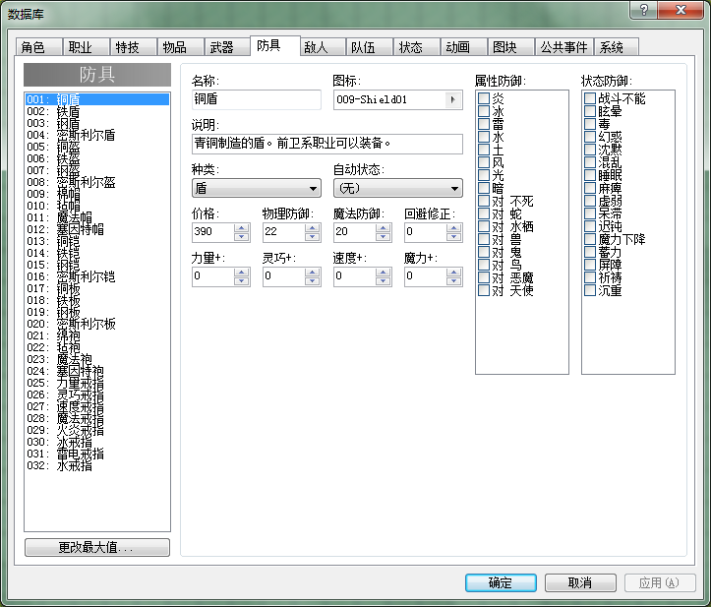

## monster editor

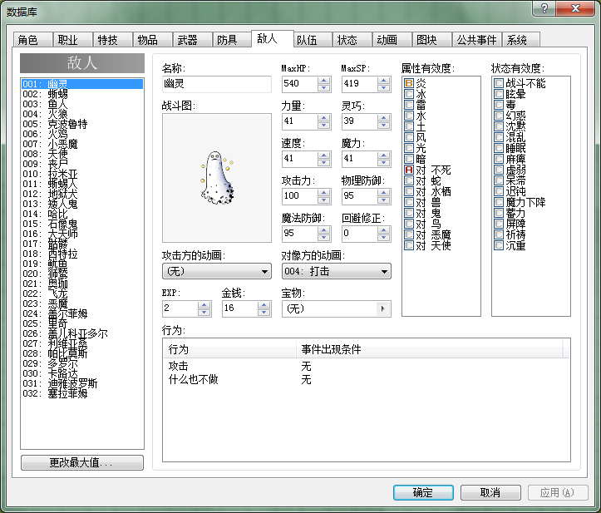

## monster group editor



## system config editor

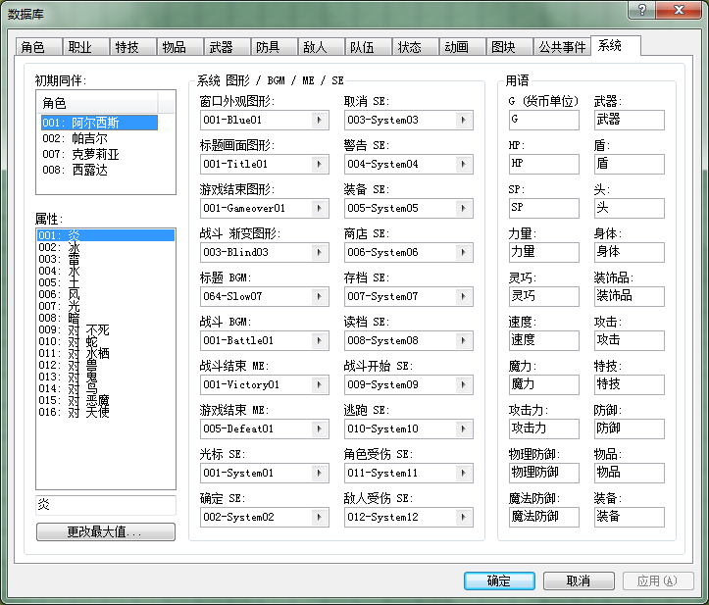

# data structure

## Global.as

IS_MOBILE

SCREEN_W, SCREEN_H

MAP_W, MAP_H

TILE_W, TILE_H

userInfo

debugTxt

ORDET_TIME

MAX_MONSTER_NUM

## sysConfig.xml

## languages.xml

## maps.xml

id

name

parent_id

order

expanded

scroll_x

scroll_y

## characters.xml

id

name

job

currentlv

maxlv

currentexp

characterres

maxhp

maxsp

str

dex

agi

int

weapon

equip

## jobs.xml

not avaliable

## skills.xml

## items.xml

## weapons.xml

## equips.xml

## monsters.xml

## monsterGroups.xml