**WEB – Homework 2**

**Frame of Fame**

**A13 - Students:**

* Paz Fayer – 313599250
* Noa Krispin – 208649285
* Noy Malka – 318980919
* Eden Bar – 205907256

**Subject**:

Online Art Gallery and Marketplace**: Develop a platform for artists to showcase and sell their artwork. Include features for virtual art exhibitions and secure payment processing.

System engineer – Paz Fayer

|  |  |  |
| --- | --- | --- |
| **Completed tasks** | **Assigned tasks** | **Name** |
| V | Use case diagram, payment process, html to JS. | Noa |
| V | Design, login process, architecture. | Eden |
| V | Payment process, API. | Noy |
| V | Word document, MongoDB, architecture. | Paz |

**Architecture diagram:**

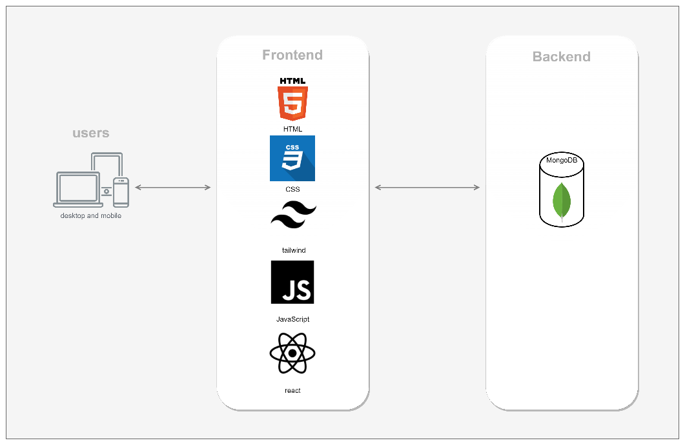

**Use-case diagram:**

