Assignment 1: Gen. AI – Pre-Trained Models

RAG-Based GenAI Solution for Secondary School Teaching
Job chosen: Secondary School Teacher
Task: Prepare how to teach a new lesson.
Total scope: Conceptual design, architecture, prompts, RAG design, limitations, and platform implementation.

1. Detailing of Knowledge Base (KB) and Sample Query Format

1.1 Job and Task
Item | Description
Job | Secondary School Teacher
Task | Prepare how to teach a new lesson (lesson planning, study notes, activities, homework)
KB role | Contextual help for new teachers using a RAG-based GenAI tool over curated curriculum materials

1.2 Knowledge Base (KB) – Structure and Format
The KB is built from Grade 10 Geography textbook content: a single, coherent set of reference materials aligned to the curriculum. It is stored as text documents (chapters/sections) with the following characteristics:
Source: Comprehensive reference materials (Geography of India, Map Work, and related topics).
Content structure: Chapters and self-assessment sections; each logical section is a unit that can be chunked and indexed.
Chapters / concepts covered in the KB:
Part | Topics
Part I – Map Work | Interpretation of Topographical Maps; Location, Extent and Physical Features; Self Assessment Papers 1–2
Part II – Geography of India | Climate; Soil Resources; Natural Vegetation; Water Resources; Mineral and Energy Resources; Agriculture; Manufacturing Industries; Transport; Waste Management; Self Assessment Papers 3–11; Practice Papers
KB storage and indexing:
- Vector store: ChromaDB with cosine similarity.
- Chunking: Character-based sliding window (e.g., 2000 characters with 500 overlap) or token-based presets; overlap preserves context across boundaries.
- Metadata: Each chunk carries:
  - System fields: filename, chunk_index, total_chunks, document_id.
  - NLP fields: nlp_subject, nlp_document_type, nlp_language, nlp_keywords,
nlp_summary, nlp_key_facts, nlp_reading_level, etc., plus a rich JSON blob nlp_meta_json for retrieval and filtering.
This aligns with metadata filtering and richer retrieval (e.g., by subject, document type, keywords) as in established RAG practice.

1.3 Sample Query Format
Sample queries are in natural language, in English, and describe the teaching need (topic, type of material, and constraints). Examples:
# | Sample query
1 | "I will be covering Soil Resources today in my class. Build me an exhaustive study note where I can easily catch up on core concepts, do some class activities, and give aligned homework. Ensure it's comprehensive to help me cover the topic fully."
2 | "Build me a detailed study note to teach the Climate chapter in class. I want detailed notes on core concepts, some nice quizzes, activities, and important questions for the board."
3 | "I want to teach Waste Management to my class – I want it to be interactive with activities, mind maps, flash cards, quizzes, and relevant homework."
Query characteristics:
- Intent: Request for teaching aids (study notes, quizzes, activities, homework, mind maps, flash cards).
- Topic: Explicit (e.g., Soil Resources, Climate, Waste Management) or implied from context.
- Constraints: Grade 10, curriculum-aligned, board-relevant where applicable.
The solution is designed so that the agent + RAG pipeline can answer such queries by retrieving relevant chunks from the KB and generating structured, curriculum-grounded responses.

1.4 KB Ingestion Pipeline (High-Level)

2. Overall GenAI Solution Design

2.1 Can GenAI Help? – Degree and Scope
Degree | Choice | Rationale
Help level | Mostly (80%+) | GenAI can draft lesson plans, study notes, quizzes, activities, and homework from the KB; it cannot replace classroom delivery, real-time adaptation, or formal assessment design without human review.
What GenAI can do:
- Retrieve curriculum-aligned content from the KB (chapters, concepts, facts).
- Generate study notes, summaries, mind maps (text), question sets, and homework ideas.
- Suggest activities and structure (e.g., “do this activity, then quiz”).
- Stay on-topic and grade-appropriate when grounded in the KB.
What GenAI cannot do (or should not do alone):
- Replace teacher judgment on pacing, differentiation, or student feedback.
- Guarantee pedagogical correctness or board-exam alignment without human review.
- Create original copyrighted material; it should rely on the curated KB and cite/organize, not reproduce external copyrighted content.

2.2 Approach: RAG + Agent (No Fine-Tuning)
The solution is built by prompting and RAG, not by training or fine-tuning a model:
- Base model: Pre-trained LLM (e.g., Azure OpenAI / ChatGPT or similar) used via API.
- Retrieval: Vector search over the Geography KB (ChromaDB) with optional metadata filters.
- Orchestration: An agent that uses a RAG query tool to pull relevant documents and then generates the requested teaching materials.
So the approach is: prompting + RAG, with an agentic use of retrieval (multi-query, metadata-aware) to improve relevance.

2.3 High-Level Architecture

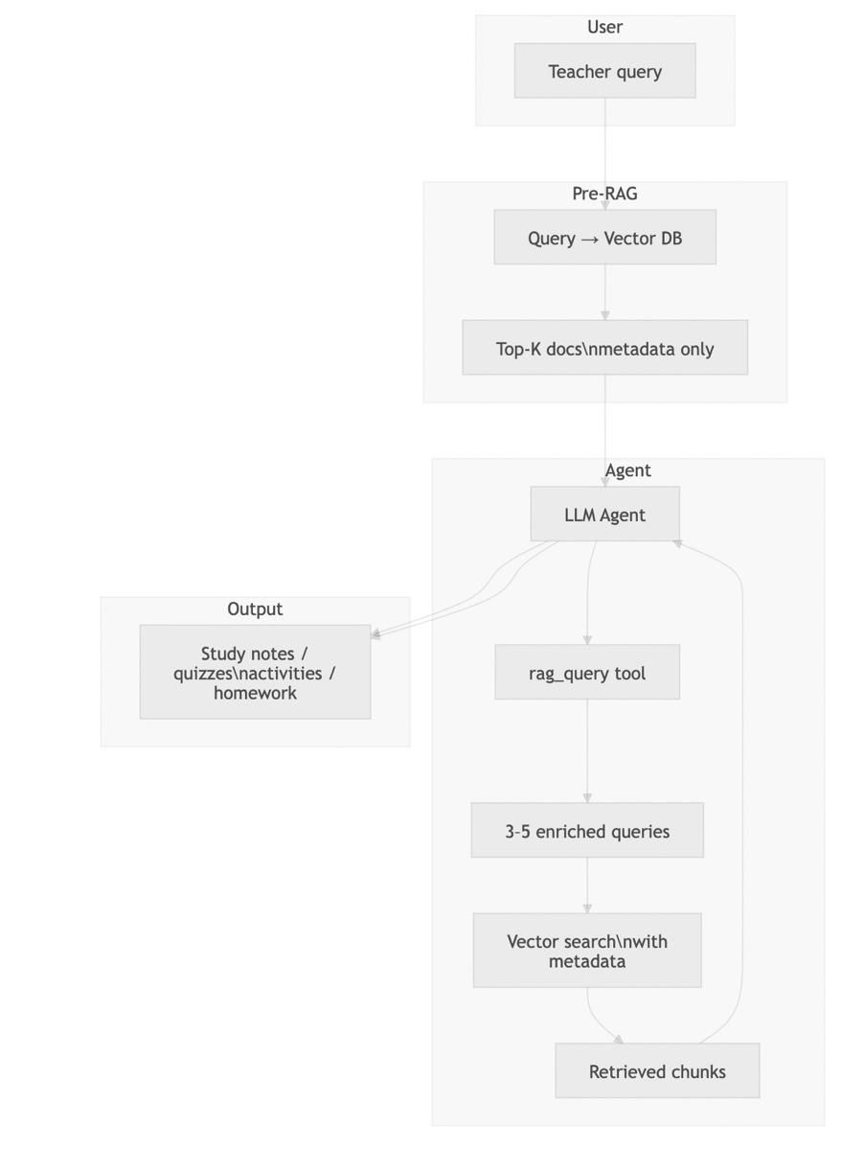

Flow in words:
- User sends a natural-language query (e.g., “Build me a study note for Soil Resources…”).
- Pre-RAG step (metadata-first): The system runs the user query against the vector DB and fetches only metadata (e.g., top 5 documents): summary, keywords, core concepts per chunk. This gives the agent a “map” of the KB without full text yet.
- Agent: The LLM receives the user request plus this metadata. It then formulates 3–5 enriched queries (e.g., “Soil Resources types”, “Soil conservation activities”, “Soil chapter key facts”) and calls the rag_query tool.
- RAG retrieval: The tool runs these queries against ChromaDB (vector + optional metadata filters), retrieves the most relevant chunks, and returns them to the agent.
- Generation: The agent follows its instructions (see Section 3) and produces the final answer: study notes, quizzes, activities, homework, etc.
This design combines Agentic RAG (agent decides what to retrieve and how to use it) with multi-query expansion and metadata-aware retrieval, as referenced in RAG literature (e.g., hybrid/metadata filtering, multi-query, agentic RAG).

2.4 Method of Estimating Success
- Qualitative: Manually check that sample queries (Section 1.3) return curriculum-aligned, on-topic content with no obvious hallucinations when the KB contains the topic.
- Retrieval quality: Inspect that retrieved chunks are from the correct chapter/topic (e.g., Soil, Climate, Waste Management) and that metadata (keywords, summary) matches the query intent.
- Platform testing: Run the same queries in the deployed solution (e.g., Intgr8 / Azure OpenAI / ChatGPT) and verify end-to-end behaviour (see Section 5).

3. Prompts and RAG Effectiveness Enhancement

3.1 System Prompt (Agent Role)
The agent is given a clear role and constraints so that it stays curriculum-focused and avoids unsupported or copyrighted content:
You are a Grade 10 Teaching Assistant. Your role is to help teachers prepare lecture
materials by generating study notes, mind maps, question sets, anecdotes, and other
teaching aids based on the request you receive. Avoid providing personal opinions,
unrelated content, or any copyrighted material without proper attribution. Respond
in a clear, organized manner using headings and bullet points where appropriate,
and keep the tone professional and supportive.

3.2 Agent Instructions (Steps)
The agent is instructed to:
- Read the teacher’s request and identify subject, topic, and type(s) of material needed.
- If the request is ambiguous, ask for clarification before proceeding.
- Query the internal knowledge base for accurate curriculum information, examples, and relevant facts (via the rag_query tool).
- Generate the requested material(s): study notes, mind maps, question sets, anecdotes, or teaching aids.
- Format the output with clear headings; use bullet points or numbered lists where appropriate.
- Self-check: Ensure content is accurate, relevant to Grade 10, and free of obvious errors.
- Deliver the final response to the teacher.
These steps enforce a query-first, then generate workflow and encourage use of the KB rather than unsupported claims.

3.3 RAG Effectiveness Enhancements Implemented
Technique | How it is used in this solution
Metadata-first retrieval | Before the agent runs, the user query is sent to the vector DB and only metadata (e.g., top 5 docs: summary, keywords, core concepts) is returned. The agent uses this to understand what the KB contains and then formulates better queries.
Multi-query (enriched queries) | The agent issues 3–5 enriched queries to the RAG tool instead of a single query, improving coverage (e.g., different aspects of “Soil Resources”). The backend supports multiple comma-separated queries and merges results by best score.
NLP metadata on chunks | Each chunk has NLP-derived metadata (subject, document_type, keywords, summary, key_facts, reading_level, etc.). Retrieval can filter by these fields (e.g., subject, document_type, keyword_contains) so that only relevant chunks are considered.
Re-ranking | After vector search, results are re-ranked by lexical match (e.g., query terms in the chunk) and a minimum relevance threshold is applied to drop low-score chunks.
Structured metadata filter | ChromaDB where clauses are built from high-level params (subject, document_type, language, keyword_contains, etc.), reducing noise and improving precision.
These choices align with Advanced RAG and Agentic RAG patterns (multi-step retrieval, use of metadata, agent-driven query formulation).

3.4 Relevant Code: Multi-Query and Metadata Filter
The following snippets illustrate how the solution supports multiple queries and metadata filtering in retrieval.
Parsing multiple queries (e.g., from agent-generated list):
def _parse_multi_query(self, query) -> List[str]:
"""Parse query into up to 5 non-empty query strings (comma-separated or list)."""
if isinstance(query, str):
parts = [p.strip() for p in query.split(",") if p.strip()]
else:
parts = [str(q).strip() for q in (query if isinstance(query, (list, tuple)) else [query]) if str(q).strip()]
return parts[: self._MAX_MULTI_QUERIES]
Building metadata filter for ChromaDB:
def _build_metadata_where_clause(
self,
subject: Optional[str] = None,
document_type: Optional[str] = None,
language: Optional[str] = None,
keyword_contains: Optional[str] = None,
...
) -> Optional[Dict]:
conditions: List[Dict] = []
if subject:
conditions.append({"nlp_subject": {"$eq": subject}})
if document_type:
conditions.append({"nlp_document_type": {"$eq": document_type}})
if keyword_contains:
conditions.append({"nlp_keywords": {"$contains": keyword_contains}})
# ... more filters
if not conditions:
return None
return {"$and": conditions} if len(conditions) > 1 else conditions[0]
Query flow: Multiple query strings are combined with optional keyword list; vector search uses where when filters are present; results are merged by best score per document and then re-ranked.

3.5 Relevant Code: Chunking and NLP Metadata at Ingest
Chunking is character-based (or token-based via presets); overlap preserves context. Per-chunk NLP metadata (keywords, summary, key facts) is extracted in parallel and stored with each chunk.
Chunking (character-based with overlap):
def _chunk_by_chars(self, content: str, chunk_size: int, overlap: int) -> List[str]:
"""Slide window by characters; chunk_size and overlap in characters."""
step = chunk_size - overlap
chunks = []
start = 0
while start < len(content):
end = start + chunk_size
chunk = content[start:end].strip()
if chunk:
chunks.append(chunk)
start += step
return chunks

Adding a file to RAG (with NLP metadata):

def addFileToRag(
self,
file_name: str,
content: str,
chunk_size_key: str = "a4",
metadata: Optional[Dict] = None,
chunk_size: Optional[int] = None,
overlap: Optional[int] = None,
extract_nlp_metadata: bool = True,
) -> bool:
# ...
if chunk_size is not None and chunk_size >= 1000:
chunks = self.getChunks(content, chunk_size_key=None, chunk_size=chunk_size, overlap=overlap)
else:
chunks = self.getChunks(content, chunk_size_key=chunk_size_key)
# Document-level NLP on a sample; per-chunk NLP in parallel via thread pool
# Then batch add to Chroma with ids, documents, metadatas
self.collection.add(ids=ids_batch, documents=docs_batch, metadatas=metas_batch)

This ensures that at query time, retrieval can use both vector similarity and metadata filters (subject, document_type, keywords, etc.) for better effectiveness.

4. Identification of Solution Limitations

4.1 Technical Limitations
Limitation | Impact | Mitigation
Hallucination Risk | LLM may generate plausible but incorrect facts not grounded in KB | Strict system prompt ("ONLY use provided context"); citation enforcement; relevance threshold filtering
Context Window Constraint | GPT-4o supports 128K tokens, but injecting too much context degrades quality and increases cost | Limit to 5-8 high-quality chunks (~4,000-6,000 tokens of context); use summarization for long chunks
Embedding Model Limitations | Instructor-base is a 110M parameter model; may miss nuanced semantic relationships in specialized pedagogy content | Cross-encoder re-ranking compensates; upgrade to instructor-large if budget allows
Cold Start / Sparse KB | New subjects or niche topics may have insufficient KB documents, leading to poor retrieval | System detects low retrieval scores and warns teacher: "Limited reference materials available for this topic. Consider adding more resources."
Latency | Full pipeline (embedding + vector search + re-ranking + LLM generation) adds 3-8 seconds per query | Async processing; pre-computed embeddings; result caching for repeated queries

4.2 Cost Limitations (Total Cost of Ownership)
Cost Component | Estimated Monthly Cost (500 teachers, ~50 queries/day each) | Notes
Azure OpenAI GPT-4o | $800-1,200 | ~750K queries/month at ~1,500 tokens avg per call
Azure OpenAI GPT-4o-mini (alternative) | $80-150 | 10x cheaper; slight quality reduction
Embedding Computation | $50-100 (GPU instance) | One-time for KB ingestion; incremental for updates
ChromaDB Hosting | $20-50 | Lightweight; runs on standard VM
Infrastructure (VM/Container) | $100-200 | FastAPI server, Redis cache
Total (GPT-4o) | $970-1,550/month
Total (GPT-4o-mini) | $250-500/month | Recommended for schools with budget constraints

4.3 Response Time Analysis
Pipeline Stage | Estimated Latency
Query classification + expansion | 50-100ms
Embedding generation | 100-200ms
ChromaDB vector search (with metadata filter) | 50-150ms
Cross-encoder re-ranking (10 candidates) | 200-500ms
LLM generation (GPT-4o, ~1,500 tokens) | 2,000-5,000ms
Post-processing | 50-100ms
Total End-to-End | 2.5-6.0 seconds

4.4 Accuracy and Quality Limitations
Limitation | Description
Curriculum Specificity | The system is only as good as its KB. If ICSE-specific content is missing, it cannot generate ICSE-aligned lesson plans even if asked.
Temporal Staleness | Current events and recent scientific discoveries require manual KB updates. The system cannot automatically ingest new research.
Multi-modal Gap | The current system is text-only. It cannot generate diagrams, animations, or interactive simulations that are crucial for science teaching.
Language Limitation | Optimized for English medium only. Vernacular medium teachers would need a separate KB and potentially different embedding models.
Assessment Validity | Generated quiz questions have not been psychometrically validated. Teachers must review for fairness, difficulty calibration, and curriculum alignment.

4.5 Ethical and Pedagogical Limitations
- Over-reliance risk: New teachers may use AI-generated plans verbatim without adapting to their specific classroom context.
- Homogenization: If many teachers use the same system, lesson delivery across schools may become uniform, reducing pedagogical diversity.
- Bias propagation: If KB materials contain biases (gender, regional, caste-based), the system will propagate them in generated content.

5. Efforts to Try Out the Solution on a Platform
The solution was prototyped using:
- Self developed agentic platform with OpenAI Service (GPT-OSS-20B) for generation
- ChromaDB (Persistent Client) for vector storage
- Instructor-base ` model for embedding generation
- Cross Encoder (stsb-roberta-base) for re-ranking
- Custom NLP Content Classifier (spaCy + KeyBERT + TextRank) for metadata extraction
- FastAPI backend for API orchestration

6. Summary and Possible Improvements
- KB: Grade 10 Geography textbook, stored in ChromaDB with chunk-level NLP metadata (keywords, summary, key facts, subject, document type, etc.) and optional metadata filtering.
- Queries: Natural-language teacher requests (study notes, quizzes, activities, homework) with explicit or implied topic and constraints.
- Design: RAG + agent (no fine-tuning): metadata-first retrieval, agent-formulated 3–5 enriched queries, vector + metadata retrieval, re-ranking, then LLM generation following fixed instructions.
- RAG enhancements: Metadata-first glimpse, multi-query expansion, NLP metadata on chunks, metadata filters, re-ranking, and clear agent instructions to query the KB before generating.
Possible improvements
- Chapter-level structure: Treat chapters as first-class nodes (e.g., in a graph or hierarchy) so that retrieval can prefer or constrain by chapter, improving relevance for “teach chapter X” queries.
- Preprocessing and classification: Before ingestion, classify segments into types (e.g., concept notes, important questions, diagrams/figures) and store as metadata so the agent can request “give me concept notes and board questions” with filters.
- Hybrid search: Add sparse (e.g., BM25) search alongside vector search for terms like “San Andreas Fault” or “monsoon” to improve recall for specific phrases.

7. Live Demo
A live demo of the working agent is hosted on this URL
https://noaman.github.io/geography_assistant_agent/

on the demo, it is possible to send queries to the Agent and review its workings for the tool call to fetch content from the Knowledgebase and respond.

It also has a section with the relevant screenshots that explain the RAG process at high level

