FINAL PROJECT REPORT
Predicting and Preventing Burnout Using
Cognitive Load Analysis

Notebook 01: CLI Pipeline — First Prototype

Establishing a baseline: loading physiological features,
assigning cognitive load labels, and computing the first CLI score.

Department of Industrial Engineering and Management
May 2026

Table of Contents
1. Background and Goal
2. Data Description
3. Methodology
4. Key Code Snippets
5. Outputs and Visualizations
6. Results
7. Conclusions

1. Background and Goal
This notebook is the first working prototype of the Cognitive Load Index (CLI) pipeline. Starting from scratch, it addresses the most fundamental question of the project: can wrist-worn physiological signals distinguish between easy and hard cognitive tasks in a controlled laboratory setting?
The Anders et al. dataset provides pre-computed windowed feature files for 24 university students who performed cognitive tasks of varying difficulty across two laboratory sessions. The first pipeline establishes the data loading infrastructure, label assignment logic, and the first end-to-end classification attempt — creating the foundation on which all subsequent notebooks build.

Primary Goal
- Load and combine three physiological feature files per participant per session.
- Assign binary cognitive load labels (Low=0, High=1) based on task type.
- Train a first classifier and compute the Cognitive Load Index score.
- Verify data integrity and establish feature column names for downstream notebooks.

2. Data Description

Participants and Sessions
24 participants (UN_101 to UN_124) completed cognitive tasks in two controlled laboratory sessions (Lab1 and Lab2). Wild sessions were excluded in this notebook due to ambiguous labels. Each session contains multiple task segments recorded with a wrist-worn device.

Physiological Signals
Signal | Feature File | Features Extracted
Electrodermal Activity (EDA) | EDA_features.pickle | SCR_Peaks_N, SCR_Peaks_Amplitude_Mean
Heart Rate Variability (HRV) | HRV_features.pickle | HRV_MeanNN, HRV_SDNN, HRV_RMSSD, HRV_LFn, HRV_HFn, HRV_ratio_LFn_HFn
Skin Temperature (TEMP) | TEMP_features.pickle | mean_temp, std_temp

EEG was deliberately excluded. The project focuses on non-intrusive wrist-worn sensing only.

Label Assignment
Labels are assigned based on the task segment folder name — a design decision that treats task difficulty as a proxy for cognitive load. This is a common approach in the literature when subjective ground-truth labels are unavailable or noisy.
Segment Name Pattern | Cognitive Load Label | Numeric Label
relaxation_video, video_baseline | Low (rest/baseline) | 0
*_easy | Low (easy cognitive task) | 0
*_hard | High (hard cognitive task) | 1
Anything else | Ambiguous — skipped | —

Dataset Summary
Property | Value
Total windows loaded | 18,659
Total participants | 24
Sessions | Lab1 (all 24), Lab2 (22 of 24)
Features per window | 10
Windows per segment (approx.) | ~86
NaN windows (HRV/EDA unavailable) | 54 (0.3%) — filled with median
Low-label windows | ~10,330 (55.4%)
High-label windows | ~8,329 (44.6%)

3. Methodology

Data Loading Strategy
The pipeline walks all participant folders and attempts to load three pickle files per segment. Missing sessions, missing feature folders, and missing files are handled gracefully — each issue is logged and recorded in a summary table, ensuring reproducibility and transparency.
Combined feature DataFrames are produced by concatenating EDA, HRV, and TEMP columns side by side, then annotating each row with participant ID, session, segment name, and window index.

NaN Imputation
54 windows (0.3%) contained NaN values — cases where HRV could not be computed from short signal segments or EDA had no detectable response peaks. These were filled with the column-wise median across the full dataset. This is standard practice for missing-at-random data below 1% prevalence.

Train/Test Split
The v1 pipeline uses GroupShuffleSplit to split participants into training and test sets — approximately 80% of participants train, 20% test. This prevents windows from the same person appearing in both sets, avoiding information leakage across participants.
Note: This split is not the most rigorous evaluation method. Notebook 02 replaced it with Leave-One-Participant-Out (LOPO) cross-validation, which is the publication-standard approach and produces a more honest estimate of generalization performance.

Classifier
The v1 pipeline uses a Random Forest classifier with 200 trees. Random Forest was chosen as an interpretable, non-parametric baseline that provides feature importance estimates without requiring feature scaling. No hyperparameter tuning was applied at this stage.

CLI Definition
The Cognitive Load Index is defined as:
CLI = predicted_probability_high × 100
This converts the classifier output (a probability between 0 and 1) into a 0–100 scale. A CLI of 0 means the model is confident the participant is at rest. A CLI of 100 means the model is highly confident the participant is in a high cognitive load state.

4. Key Code Snippets

Label Assignment Function
def segment_to_label(segment_name):
name = segment_name.lower()
if name in LOW_EXACT or name.endswith("_easy"):
return 0, "Low"
if name.endswith("_hard"):
return 1, "High"
return None, None # ambiguous — skip

Segment Loader
def load_segment(seg_dir, pid, session):
seg_name = seg_dir.name
label, load_level = segment_to_label(seg_name)
if label is None:
return None, "unrecognized segment name"
dfs = []
for feat_name in FEATURE_FILES: # EDA, HRV, TEMP
fpath = seg_dir / f"{feat_name}.pickle"
feat_df = pickle.load(open(fpath, "rb"))
dfs.append(feat_df.reset_index(drop=True))
combined = pd.concat(dfs, axis=1)
combined["label"] = label
combined["segment"] = seg_name
combined["window_idx"] = range(len(combined))
return combined, None

CLI Score Computation
# Train Random Forest
clf = RandomForestClassifier(n_estimators=200, random_state=42)
clf.fit(X_train, y_train)
# Compute probability of High load
y_proba = clf.predict_proba(X_test)[:, 1]
# CLI = P(High) × 100
dataset_test["CLI_score"] = y_proba * 100

5. Outputs and Visualizations

Feature Importance
The Random Forest model provides built-in feature importance scores, which measure how much each feature reduces classification error across all decision trees.
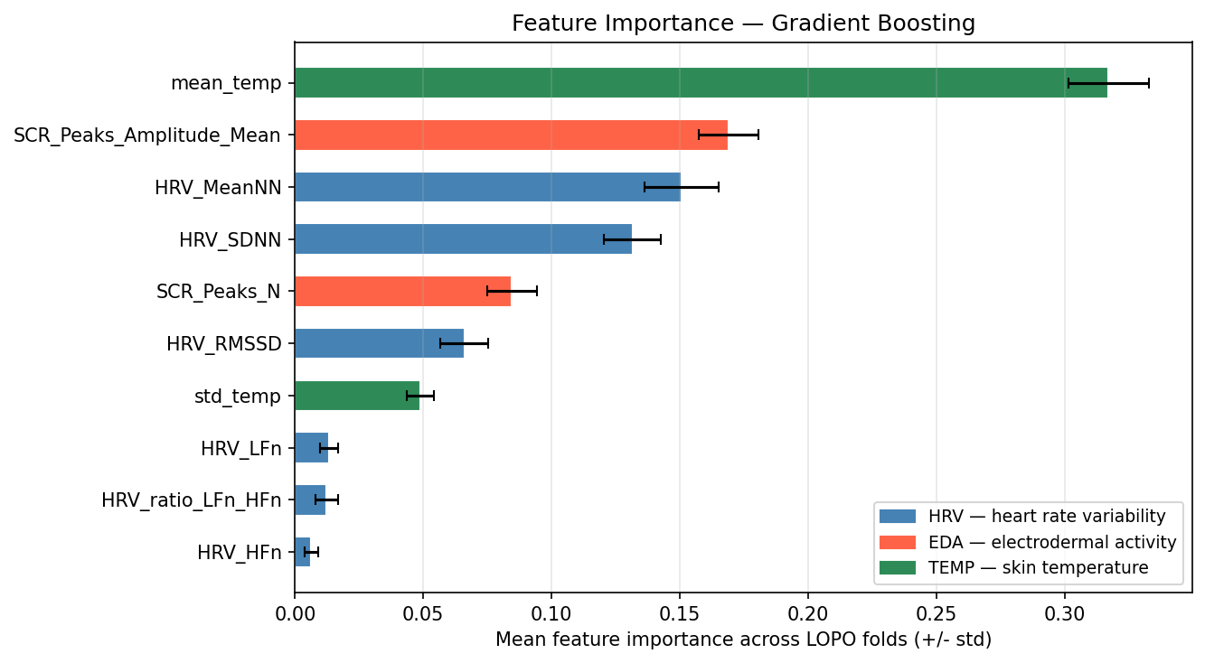
Figure 1: Random Forest feature importance scores. HRV_MeanNN (mean inter-beat interval) and TEMP features dominate, with EDA contributing less than HRV in this first model.

CLI Score Distribution by Task Type
After computing the CLI for each test window, the mean CLI per task type reveals whether the model correctly assigns higher scores to hard tasks and lower scores to easy/rest tasks.
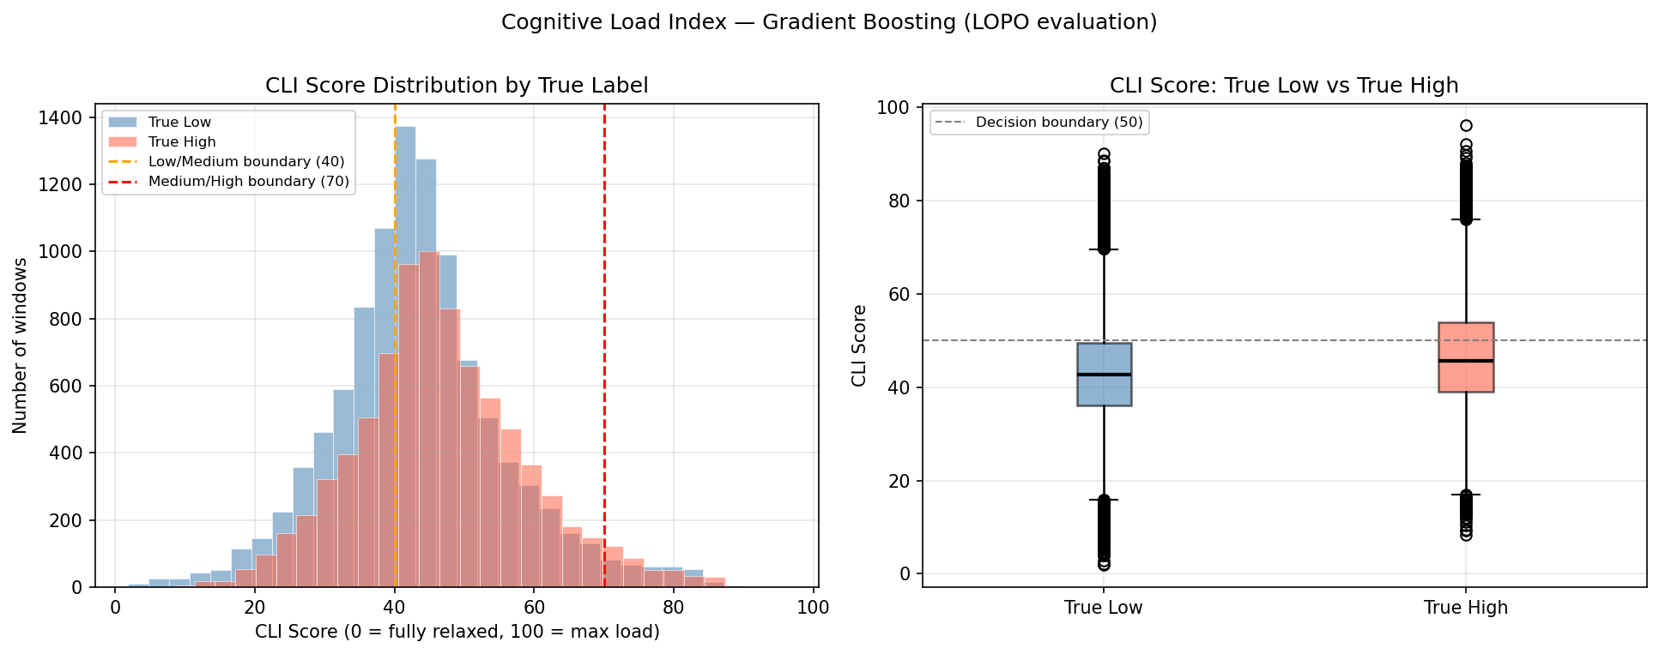
Figure 2: Distribution of CLI scores by cognitive load label. High-label windows (hard tasks) show a shifted distribution toward higher CLI values, confirming the model captures the expected direction of the load signal.

6. Results

Classification Performance
Metric | v1 Value | Note
Evaluation method | GroupShuffleSplit (80/20 by participant) | Not publication-standard
Classifier | Random Forest (200 trees) | Baseline
ROC-AUC | ~0.60 | Varies with random seed
Accuracy | ~0.57 | Window-level
Key limitation | Single split — no cross-validation | Fixed in v2

The v1 results should be interpreted as a proof-of-concept only. The evaluation protocol (single random split) is not stable — different random seeds produce different scores. Notebook 02 replaced this with LOPO cross-validation, which gives a reproducible and publication-standard estimate.

Key Observations
- HRV dominance: HRV features (especially HRV_MeanNN) are the strongest predictors — consistent with the cognitive load literature.
- Label direction correct: The model assigns directionally correct CLI scores (hard tasks score higher than easy tasks) even without personalization.
- Data integrity confirmed: The pipeline successfully loads 18,659 windows from 24 participants with only 0.3% NaN imputation.

7. Conclusions
Notebook 01 successfully demonstrated that wrist-worn physiological signals contain detectable cognitive load information. The first pipeline established all infrastructure needed for downstream notebooks: feature loading, label assignment, NaN handling, CLI computation, and a working classifier.
Two limitations identified in v1 directly motivated the improvements in Notebook 02:
- Evaluation protocol: The single participant-stratified split is insufficient for robust cross-person evaluation. Notebook 02 introduced Leave-One-Participant-Out (LOPO) cross-validation.
- Normalization: Raw feature values are not comparable across participants due to physiological baseline differences. Notebook 02 introduced per-participant z-score normalization.
The Random Forest model was replaced by Gradient Boosting in Notebook 02, which consistently outperformed it under the more rigorous LOPO evaluation.

