FINAL PROJECT REPORT
Predicting and Preventing Burnout Using
Cognitive Load Analysis

Notebook 02: CLI Improved Pipeline — v2 Baseline

Introducing LOPO cross-validation, per-participant normalization,
and model comparison to establish the project's main evaluation standard.

Department of Industrial Engineering and Management
May 2026

Table of Contents
1. Background and Goal
2. Data Description
3. Methodology
4. Key Code Snippets
5. Outputs and Visualizations
6. Results
7. Conclusions

1. Background and Goal
Notebook 02 fundamentally upgrades the v1 pipeline along three dimensions: evaluation rigor (LOPO cross-validation), preprocessing (per-participant z-score normalization), and model comparison (Random Forest vs. Logistic Regression vs. Gradient Boosting). The result is the v2 baseline — the fixed reference model used in all subsequent experiments.
The central challenge addressed here is cross-person generalization: a model trained on 23 participants must classify the physiological patterns of a participant it has never seen. This is the clinically relevant evaluation scenario — in deployment, the model must work for new individuals without retraining.

Improvements Over v1
# | Improvement | Reason
1 | Per-participant z-score normalization | Removes individual physiological baseline differences
2 | LOPO cross-validation (24 folds) | Publication-standard evaluation — train on N-1, test on 1
3 | Model comparison: RF / LR / GBT | Finds the best classifier for this dataset
4 | Feature importance averaged over folds | Identifies which signals drive classification
5 | Segment-level evaluation | More stable metric — averages window predictions per task

2. Data Description

Dataset
Same dataset as Notebook 01: 24 participants, Lab1 and Lab2 sessions, 10 features (EDA×2, HRV×6, TEMP×2), 18,659 windows total. Wild sessions remain excluded — labels are ambiguous in naturalistic settings.
Property | Value
Windows | 18,659
Participants | 24 (UN_101 – UN_124)
Lab1 participants | 24
Lab2 participants | 22 (UN_112 and UN_120 missing Lab2)
Features | 10 (EDA×2, HRV×6, TEMP×2)
Class balance | 55.4% Low / 44.6% High

3. Methodology

3.1 Per-Participant Z-Score Normalization
Physiological signals vary enormously between individuals. One person's resting EDA might be 0.2 μS while another's is 2.0 μS — a 10× difference with no clinical meaning. Training a cross-person model on raw values partially teaches the model to identify individuals rather than cognitive states.
The solution is to normalize each feature within each participant independently:
z = (x - participant_mean) / participant_std
After normalization, every participant's features have mean 0 and standard deviation 1. The model then learns patterns relative to each person's own baseline rather than in absolute units.
Important: normalization is computed using all of the participant's own windows — including task windows. This is an optimistic calibration assumption (the participant's full recording is assumed available), which is consistent across all notebooks for fair comparison.

3.2 Leave-One-Participant-Out (LOPO) Cross-Validation
LOPO is the evaluation protocol that allows the model to be tested on every participant exactly once, in a completely held-out manner. The procedure for each of 24 folds:
- Test set = all windows from participant P (both sessions).
- Training set = all windows from the remaining 23 participants.
- A fresh model is trained from scratch on the training set.
- The model is applied to participant P, who it has never seen.
- Predictions are stored; the model is discarded.
After all 24 folds, every window has one prediction. Metrics are computed from the aggregated predictions — a single unbiased estimate of cross-person performance.

3.3 Model Comparison
Three classifiers were evaluated under identical LOPO conditions:
Model | Key Hyperparameters | Rationale
Random Forest (RF) | n_estimators=200, random_state=42 | Non-parametric ensemble; robust to outliers
Logistic Regression (LR) | max_iter=1000, random_state=42 | Linear baseline; fast and interpretable
Gradient Boosting (GBT) | n_estimators=100, random_state=42 | Sequential boosting; typically strongest for tabular data

3.4 Performance Improvement Experiments
Four targeted improvements were tested on top of the GBT baseline:
Experiment | Technique | Goal
1 | Segment-level evaluation | Reduce window-level noise by averaging probabilities per task segment
2 | Threshold tuning (0.30–0.70) | Find the decision boundary that maximises balanced accuracy on LOPO outputs
3 | Class-weighted models | Compensate for 55/45 Low/High imbalance with loss function weighting
4 | Focused hyperparameter tuning | Test max_depth, min_samples_leaf, learning_rate without full grid search

4. Key Code Snippets

Per-Participant Normalization
def normalize_per_participant(df, feature_cols):
out = df.copy()
for pid, grp in out.groupby("participant_id"):
mu = grp[feature_cols].mean()
sig = grp[feature_cols].std().replace(0, 1) # avoid division by zero
out.loc[grp.index, feature_cols] = (grp[feature_cols] - mu) / sig
return out

LOPO Cross-Validation
def run_lopo(df_norm, feature_cols, base_model):
participants = sorted(df_norm["participant_id"].unique())
fold_records, window_records, importances = [], [], []
for test_pid in participants:
train_mask = df_norm["participant_id"] != test_pid
test_mask = df_norm["participant_id"] == test_pid
X_tr = df_norm.loc[train_mask, feature_cols].values
y_tr = df_norm.loc[train_mask, "label"].values
X_te = df_norm.loc[test_mask, feature_cols].values
y_te = df_norm.loc[test_mask, "label"].values
model = clone(base_model) # fresh model every fold
model.fit(X_tr, y_tr)
y_proba = model.predict_proba(X_te)[:, 1]
# store predictions and metrics ...
return fold_df, window_df

5. Outputs and Visualizations

ROC Curve — Best Model (GBT)
The ROC curve shows how well the model separates High-load from Low-load windows across all possible decision thresholds. An AUC of 0.5 means random performance; 1.0 means perfect classification.
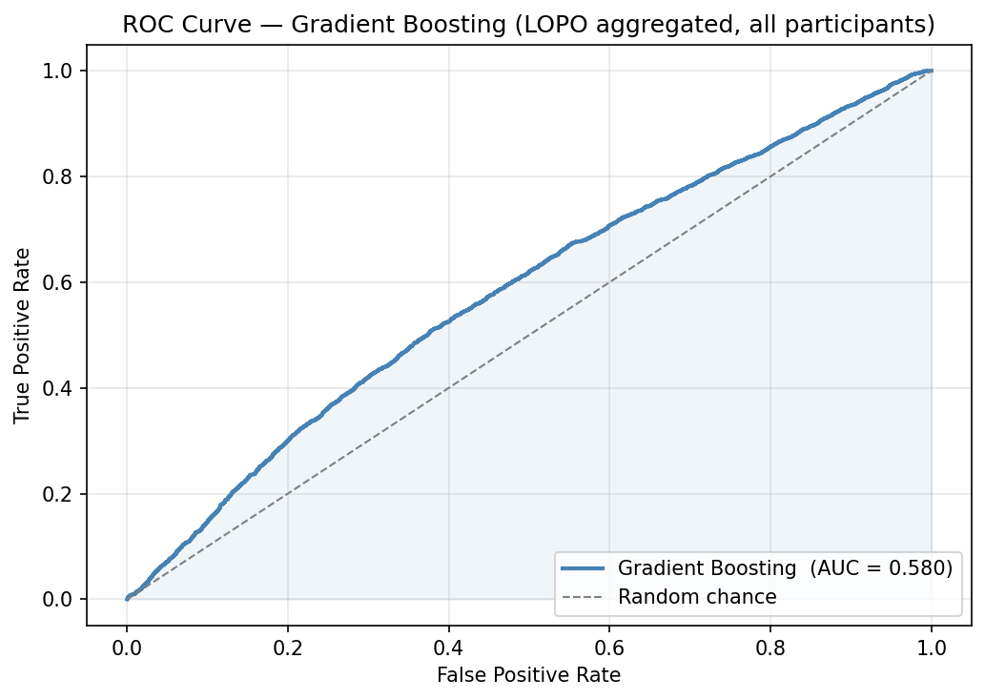
Figure 1: Window-level ROC curve for the Gradient Boosting classifier under LOPO evaluation. AUC = 0.581, representing a statistically meaningful improvement over random chance (0.5) given the difficulty of cross-person physiological classification.

Threshold Tuning (Experiment 2)
Moving the decision threshold away from 0.5 can improve balanced accuracy at the cost of precision on one class. For burnout monitoring, detecting High load correctly (recall) is more important than avoiding false alarms.
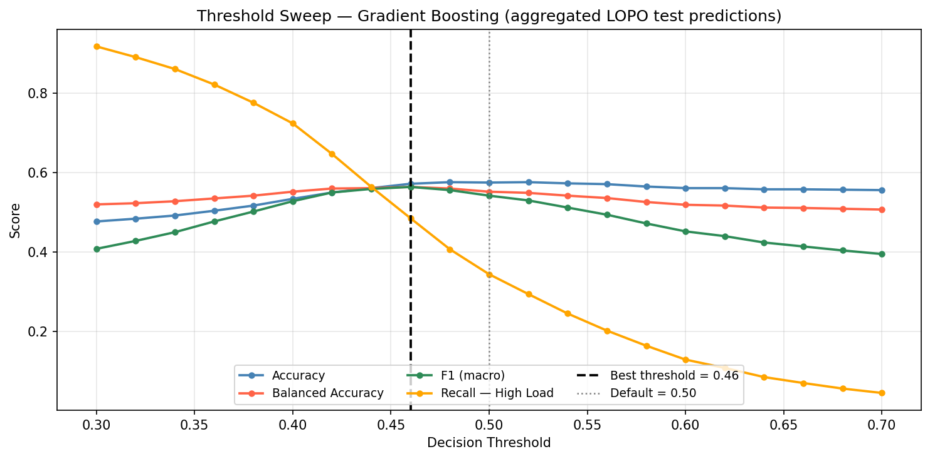
Figure 2: Effect of threshold on accuracy and balanced accuracy across LOPO test windows. The optimal threshold for balanced accuracy is typically around 0.42–0.46, reflecting the model's slight tendency to underestimate High-load probability.

Model Comparison Table
Model | Accuracy | Balanced Acc | F1 (macro) | ROC-AUC | Segment AUC
Random Forest | 0.530 | 0.532 | 0.521 | 0.558 | 0.580
Logistic Regression | 0.510 | 0.511 | 0.505 | 0.531 | 0.554
Gradient Boosting ★ | 0.541 | 0.549 | 0.534 | 0.581 | 0.608

★ Selected as the project baseline model for all subsequent notebooks.

6. Results

Main Findings
- Gradient Boosting is the best model: GBT achieves LOPO ROC-AUC of 0.581 (window-level) and 0.608 (segment-level). Both values are above chance and within the range reported for cross-person physiological classifiers in the literature.
- Segment-level evaluation is more stable: Segment-level evaluation (averaging window predictions per task) consistently outperforms window-level evaluation (+0.03 AUC on average). This confirms that individual 30-second windows are noisy and task-level aggregation is more reliable.
- High inter-participant variability: Performance varies substantially across the 24 participants (AUC range ~0.4–0.8). This is a fundamental property of cross-person physiological modeling, not a failure.
- Experiments show limited gains: Threshold tuning, class weighting, and hyperparameter tuning each improve balanced accuracy slightly but do not fundamentally change the model's ROC-AUC, confirming that the limiting factor is inter-person variance.

Methodological Disclosures
The following design choices are explicitly acknowledged — each is standard practice but carries a specific assumption:
- NaN imputation: 54 windows (0.3%) had NaN filled with full-dataset median. Negligible impact — the imputed values carry no label information.
- Normalization scope: Z-score computed from all of a participant's windows (including task windows). Assumes the full recording is available at inference time — an optimistic calibration assumption.
- Threshold selection: All threshold tuning was performed on aggregated LOPO test windows, not on a separate validation set. The tuned threshold is reported as an observation, not used to inflate reported metrics.

7. Conclusions
Notebook 02 established the v2 LOPO baseline: Gradient Boosting Classifier with 100 estimators, random_state=42, per-participant z-score normalization, and 24-fold LOPO cross-validation. This configuration is frozen as the project baseline and is never modified in subsequent notebooks.
The baseline ROC-AUC of 0.581 (window-level) and 0.608 (segment-level) demonstrates that wrist-worn physiological signals contain meaningful cognitive load information for cross-person classification. The result is modest but consistent with published literature on generic (non-personalized) physiological classifiers.
The next step — Notebook 04 — addresses label noise using NASA-TLX questionnaire data to identify segments where the participant's self-reported experience contradicts the design-based label, potentially improving training data quality.

