FINAL PROJECT REPORT
Predicting and Preventing Burnout Using
Cognitive Load Analysis

Notebook 07: Final Model Selection — v7 Pipeline

Combining NASA-TLX noisy-label filtering with relative feature engineering
in a 3-variant comparison to select the definitive CLI model.

Department of Industrial Engineering and Management
May 2026

Table of Contents
1. Background and Goal
2. Data Description
3. Methodology
4. Key Code Snippets
5. Outputs and Visualizations
6. Results
7. Conclusions

1. Background and Goal
Notebook 07 is the culminating model-selection experiment of the project. By this point, two independent improvements over the v2 baseline have been developed and validated separately: NASA-TLX noisy-label filtering (Notebook 04) and relative baseline-deviation features (Notebook 06). Notebook 07 combines them in a structured factorial design to determine whether both improvements together produce a better model than either alone.

Research Question
Does adding relative features (delta and/or ratio deviations from personal baseline) on top of the v3 noisy-label filter further improve the CLI model's cross-person generalization?

Variants Compared
Variant | Training Data | Features | Number of Features
A | v3 filtered | Original only | 10
B | v3 filtered | Original + Delta (Δ) | 20
C | v3 filtered | Original + Delta + Ratio | 30

All three variants use identical training data (v3 filtered), evaluation protocol (24-fold LOPO), and classifier (GBT, n_estimators=100, random_state=42). Only the feature set differs. This isolates the effect of feature engineering cleanly.

2. Data Description

v3 Noisy-Label Filter
The v3 filter removes training segments where the participant's NASA-TLX questionnaire score strongly contradicts the design-based label:
Condition | Action | Rationale
Low-label segment + NASA-TLX > 60 | Removed from training | Participant reported high load during a supposedly easy task
High-label segment + NASA-TLX < 40 | Removed from training | Participant reported low load during a supposedly hard task
No NASA-TLX match | Kept (conservative) | Insufficient information to determine noise

Result: 96 segments (4,367 windows) removed from training. The filtered training set contains 14,292 windows (76.6% of original). The test participant is always drawn from the full unfiltered dataset — the filter is a training-data quality improvement only.

Relative Features
For each original feature X, two additional features are computed per participant:
X_delta = X − personal_baseline_mean
X_ratio = clip(X / (personal_baseline_mean + 1e-6), -50, 50)
Personal baseline is computed from the participant's relaxation_video windows (resting state before any task). If unavailable, all Low-label windows are used as a fallback.
Delta features represent how much each physiological signal deviates from personal rest. A delta of 0 means the participant is at their personal baseline. Ratio features capture the relative change — useful when absolute magnitudes differ greatly between people.

3. Methodology

3.1 Test-Set Integrity
A critical design choice ensures fair comparison across all variants. The LOPO loop uses a separate test source parameter:
def run_lopo(df_norm, feature_cols, test_df_norm=None):
test_src = test_df_norm if test_df_norm is not None else df_norm
for test_pid in participants:
# Training always from v3 filtered data
X_tr = df_norm.loc[train_mask, feature_cols].values
# Test always from unfiltered data
X_te = test_src.loc[test_mask, feature_cols].values
For all three variants: training data = v3 filtered; test data = full unfiltered dataset. This guarantees that differences in performance across variants reflect only the feature engineering, not differences in test coverage.

3.2 Baseline Computation Timing
Personal baselines for the relative features are computed from the full unfiltered dataset before the v3 filter is applied. This ensures stable baselines regardless of which segments are removed by the filter (the filter rarely touches the relaxation_video rest period).

3.3 Model Selection Rule
The selection criterion requires a minimum meaningful improvement in LOPO AUC. The threshold prevents selecting a more complex model that only marginally improves:
IMPROVEMENT_THRESHOLD = 0.005 # minimum LOPO AUC gain required
if (AUC_C - AUC_A) >= 0.005:
SELECTED = "C"
elif (AUC_B - AUC_A) >= 0.005:
SELECTED = "B"
else:
SELECTED = "A" # simpler is preferred when equally effective

4. Key Code Snippets

NASA-TLX Filter Application
# Mark noisy segments
is_noisy_low = (label==0) & (nasa_score > 60) # Low label but high NASA
is_noisy_high = (label==1) & (nasa_score < 40) # High label but low NASA
noisy_keys = set(zip(participant, session, segment))
# Remove noisy windows from training set only
keep_mask = ~df.apply(
lambda r: (r.participant_id, r.session, r.segment) in noisy_keys, axis=1
)
dataset_v3 = dataset[keep_mask].copy()

Relative Feature Construction
def build_augmented_dataset(df, feature_cols, baselines):
out = df.copy()
for pid, grp in df.groupby("participant_id"):
bm = baselines[pid]["mean"][feature_cols].values # resting baseline
X = grp[feature_cols].values
delta = X - bm
ratio = np.clip(X / (bm + 1e-6), -50, 50)
out.loc[grp.index, delta_cols] = delta
out.loc[grp.index, ratio_cols] = ratio
return out

5. Outputs and Visualizations

Per-Participant LOPO AUC — All Three Variants
The following chart shows each participant's LOPO AUC for all three variants side by side. All three variants perform similarly across participants, confirming that the feature engineering does not meaningfully change cross-person generalization.
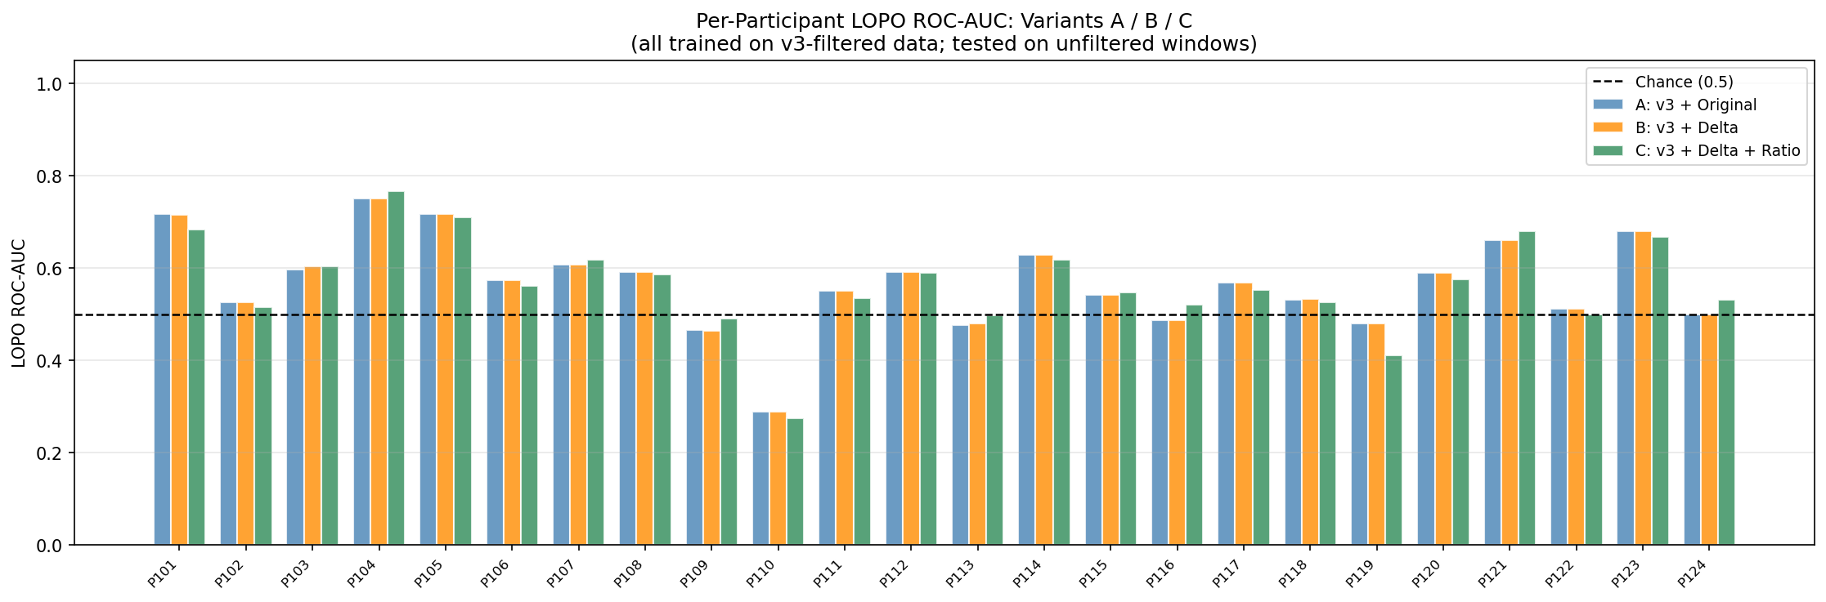
Figure 1: Per-participant LOPO ROC-AUC for Variants A (blue), B (orange), and C (green). All three variants produce nearly identical per-participant performance, confirming that the z-score normalization already captures most inter-person scale variation.

ROC Curves — Window and Segment Level
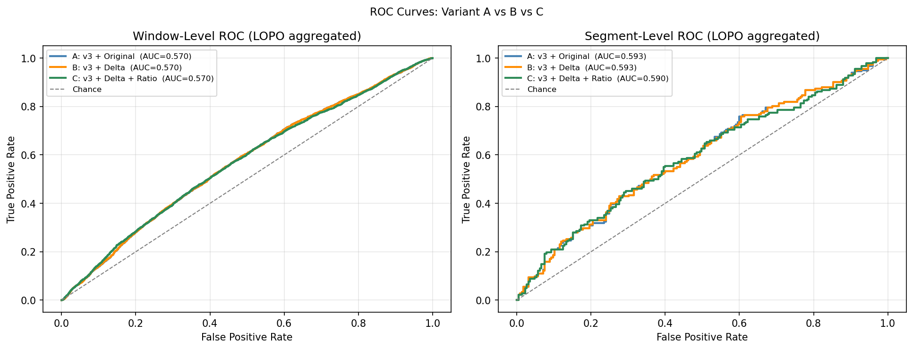
Figure 2: Left — Window-level ROC curves for all three variants (LOPO aggregated). Right — Segment-level ROC curves. The three variants are almost indistinguishable, with Variant A and B overlapping exactly (AUC = 0.568 each). Variant C shows a marginal decrease (-0.003 AUC).

Feature Importance — Variant C (Full Feature Set)
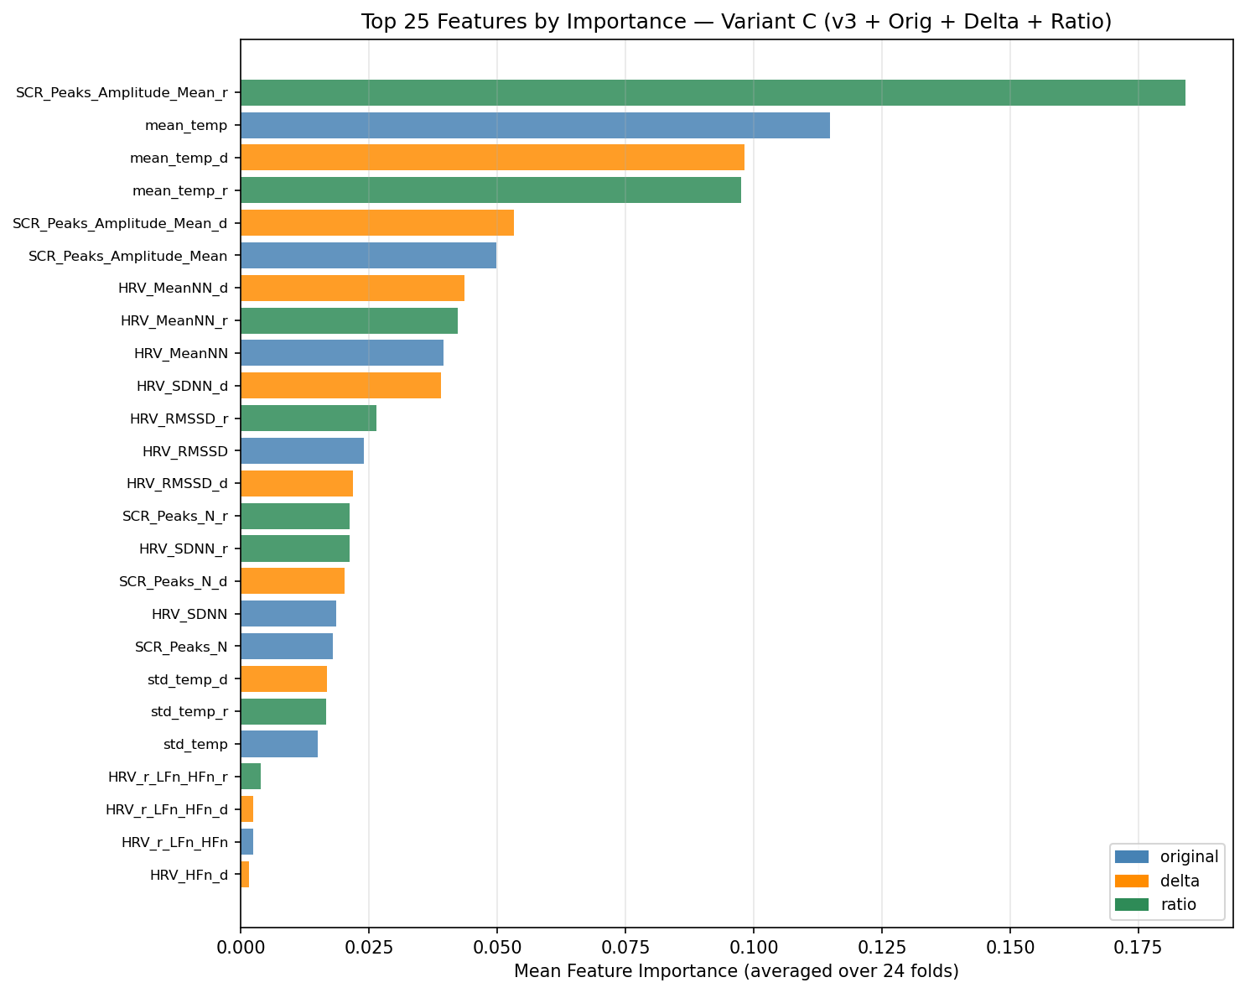
Figure 3: Top-25 feature importances for Variant C (original + delta + ratio features). Original features (blue) dominate — skin temperature (mean_temp) and EDA amplitude (SCR_Peaks_Amplitude_Mean) are the top two predictors. Delta and ratio versions of the same features carry lower importance, explaining why they do not improve AUC.

Variant Comparison Table
Variant | Features | Accuracy | Balanced Acc | F1 | LOPO AUC | Recall High | Seg AUC
A — v3 + Original ★ | 10 | 0.541 | 0.551 | 0.536 | 0.568 | 0.643 | 0.593
B — v3 + Delta | 20 | 0.541 | 0.551 | 0.535 | 0.568 | 0.643 | 0.593
C — v3 + Delta + Ratio | 30 | 0.540 | 0.552 | 0.534 | 0.565 | 0.663 | 0.590

★ Selected model. Neither B nor C exceeded the 0.005 LOPO AUC improvement threshold.

6. Results

Model Selection Decision
Variant A was selected as the final model. The selection rationale:
- No meaningful improvement: Neither Variant B (+0.000 AUC) nor Variant C (-0.003 AUC) exceeded the 0.005 LOPO AUC improvement threshold.
- Z-score captures relative variation: Per-participant z-score normalization already removes most of the inter-person scale differences that delta and ratio features were designed to address.
- Parsimony principle: Variant A uses 10 features vs. 20 (B) and 30 (C). The simpler model is equally effective and easier to interpret for stakeholders.

Why Relative Features Did Not Help
The finding that relative features do not improve AUC is itself informative. It suggests that the information captured by delta (X − baseline_mean) is already represented by the z-scored original features (X − participant_mean) / participant_std. Both transformations center each participant's data around their personal mean; the primary difference is that z-scoring also scales by variance.
This confirms that the per-participant z-score normalization introduced in Notebook 02 was the correct choice for handling inter-individual physiological variation, and that additive feature engineering on top of it has diminishing returns.

Final Model Specification
Component | Specification
Classifier | GradientBoostingClassifier (n_estimators=100, random_state=42)
Training data | v3 noisy-label filtered (14,292 windows, 311 segments)
Features | Original 10 features (EDA×2, HRV×6, TEMP×2)
Preprocessing | Per-participant z-score normalization
Evaluation | 24-fold LOPO
LOPO AUC | 0.568 ± 0.100
Segment AUC | 0.593
Recall High | 0.643

CLI Definition — Final
CLI = predicted_probability_high × 100 # range: 0 to 100
CLI Range | Category | Interpretation
0 – 40 | Low | Resting or low cognitive demand
41 – 70 | Medium | Moderate load — within sustainable range
71 – 100 | High | Elevated demand — monitor for overload

7. Conclusions
Notebook 07 established the definitive CLI model: Gradient Boosting with v3 noisy-label filtering and original features (Variant A). The 3-variant comparison confirmed that relative features do not meaningfully improve cross-person generalization when per-participant z-score normalization is already applied.
The selected model is exported to three CSV files in the outputs/ folder:
- v7_model_comparison.csv — variant comparison table
- v7_lopo_predictions_best_variant.csv — 18,659 window-level predictions with CLI
- v7_feature_importance_best_variant.csv — feature importance for Variant A
These outputs feed directly into the Streamlit monitoring dashboard (app.py), which visualizes the CLI scores, feature importances, and model results without requiring any further model training at runtime.

