FINAL PROJECT REPORT
Predicting and Preventing Burnout Using
Cognitive Load Analysis

Notebook 08: Wild Data — Exploratory CLI Visualization

EXPLORATORY ONLY. Applying the final selected model to naturalistic
"in-the-wild" recordings to assess real-world CLI behavior.

Department of Industrial Engineering and Management
May 2026

Table of Contents
1. Background and Goal
2. Data Description
3. Methodology
4. Key Code Snippets
5. Outputs and Visualizations
6. Results
7. Conclusions

IMPORTANT NOTE: This notebook is exploratory only. Wild session data was NOT used for model training or model selection. No accuracy, AUC, or F1 metrics are computed for Wild data — there is no validated ground-truth label for cognitive load in naturalistic settings. The CLI values presented here reflect how the Lab-trained model responds to Wild physiological patterns.

1. Background and Goal
The final CLI model was selected in Notebook 07 based entirely on Lab1 and Lab2 data. Wild sessions were excluded from model development because they present two fundamental challenges that make supervised evaluation inappropriate:
- Ambiguous labels: Wild segment names encode ambient conditions (e.g., high_stress_high_mw) rather than controlled task difficulty. These conditions do not map directly to the Low/High labels used in training.
- Incomplete coverage: Not all participants have Wild sessions, and the number of segments per participant varies from 3 to 22. This unequal coverage introduces additional bias into any evaluation.
Despite these limitations, applying the trained model to Wild data provides valuable exploratory insight: how do the physiological patterns recorded in naturalistic settings compare to the controlled laboratory conditions the model was trained on? The Streamlit dashboard includes a dedicated Wild Exploration section, clearly marked as exploratory.

What This Notebook Establishes
- Feasibility of applying the Lab-trained model to Wild data without retraining.
- CLI distribution in Wild sessions (mean, range, category breakdown).
- Directional consistency: do high-stress Wild segments show higher CLI than low-stress ones?
- Comparison of CLI statistics between Lab (LOPO evaluation) and Wild (exploratory).

2. Data Description

Wild Session Structure
Wild feature files are organized differently from Lab sessions. Each participant's Wild/Features/ folder contains sub-folders named by recording condition:
UN_101/Wild/Features/
hig_stress_hig_mw_16/ <- high stress, high mind-wandering, recording #16
EDA_features.pickle
HRV_features.pickle
TEMP_features.pickle
low_stress_low_mw_1/
...
The segment name encodes three aspects of the recording context: stress level (hig/low), mind-wandering level (hig/nor/low), and a recording number. EEG files are present but deliberately excluded — consistent with the main pipeline.

Wild Data Statistics
Property | Value
Participants with Wild data | 22 of 24 (UN_103 and UN_120 excluded)
Total Wild windows | 25,448
Total Wild segments | 201
Average segments per participant | ~9
Wild conditions observed | 12 (combinations of stress × mind-wandering level)
Feature coverage | 10/10 features (identical to Lab)
CLI mean (Wild) | 55.3
CLI range (Wild) | 1.7 – 95.1

Wild vs Lab — Structural Differences
Aspect | Lab Sessions | Wild Sessions
Recording setting | Controlled laboratory | Naturalistic environment
Task type | Standardized cognitive tasks | Ambient daily activities
Label source | Task design (easy/hard) | Ambient condition (stress/MW)
Ground truth | Design-based (Low/High) | None — no validated label
Sessions available | All 24 participants | 22 participants
Used in model training | Yes (v3 filtered) | No

3. Methodology

3.1 Training Setup
Since Wild participants are entirely separate recordings (not held-out Lab participants), the appropriate setup is to train one model on ALL 24 Lab participants' v3-filtered data, then apply it to Wild as fully unseen data.
This contrasts with the LOPO setup in Notebooks 02–07, where one Lab participant was held out per fold. Here, Wild is the "new person" equivalent — the model has never seen any Wild physiological patterns during training.

3.2 Wild Data Normalization
Wild data is normalized using the same per-participant z-score method as Lab data. Each participant's Wild windows are normalized using the mean and std of their own Wild windows — the same optimistic calibration assumption used throughout the project.
Wild recordings lack a clean relaxation_video baseline equivalent (no pre-task rest period was recorded). Using all Wild windows as the normalization reference is the most conservative available option.

3.3 Wild Condition Parsing
def parse_wild_condition(seg_name):
stress = "high" if "hig_stress" in name else "low"
if "hig_mw" in name: mw = "high_MW"
elif "low_mw" in name: mw = "low_MW"
elif "nor_mw" in name: mw = "normal_MW"
return f"{stress}_stress_{mw}"

4. Key Code Snippets

Wild Feature Loading
def load_wild_features():
for pdir in sorted(DATA_ROOT.glob("UN_*")):
wild_feat_dir = pdir / "Wild" / "Features"
if not wild_feat_dir.exists():
continue
for sd in sorted(wild_feat_dir.iterdir()): # each is a segment
dfs = []
for feat_name in ["EDA_features","HRV_features","TEMP_features"]:
feat_df = pickle.load(open(sd / f"{feat_name}.pickle","rb"))
dfs.append(feat_df)
combined = pd.concat(dfs, axis=1)
combined["wild_condition"] = parse_wild_condition(sd.name)
all_segs.append(combined)

Apply Final Model to Wild
# Train on ALL Lab participants (v3 filtered)
final_model = GradientBoostingClassifier(n_estimators=100, random_state=42)
final_model.fit(X_train_lab, y_train_lab)
# Apply to Wild as unseen data
y_proba_wild = final_model.predict_proba(X_wild)[:, 1]
wild_df["CLI"] = (y_proba_wild * 100).round(1)
wild_df["CLI_category"] = wild_df["CLI"].apply(
lambda v: "Low" if v<=40 else "Medium" if v<=70 else "High"
)

5. Outputs and Visualizations

CLI Distribution in Wild Sessions
The CLI histogram shows the distribution of predicted cognitive load scores across all 25,448 Wild windows. The right panel shows the mean CLI broken down by Wild condition (high/low stress × high/low mind-wandering).
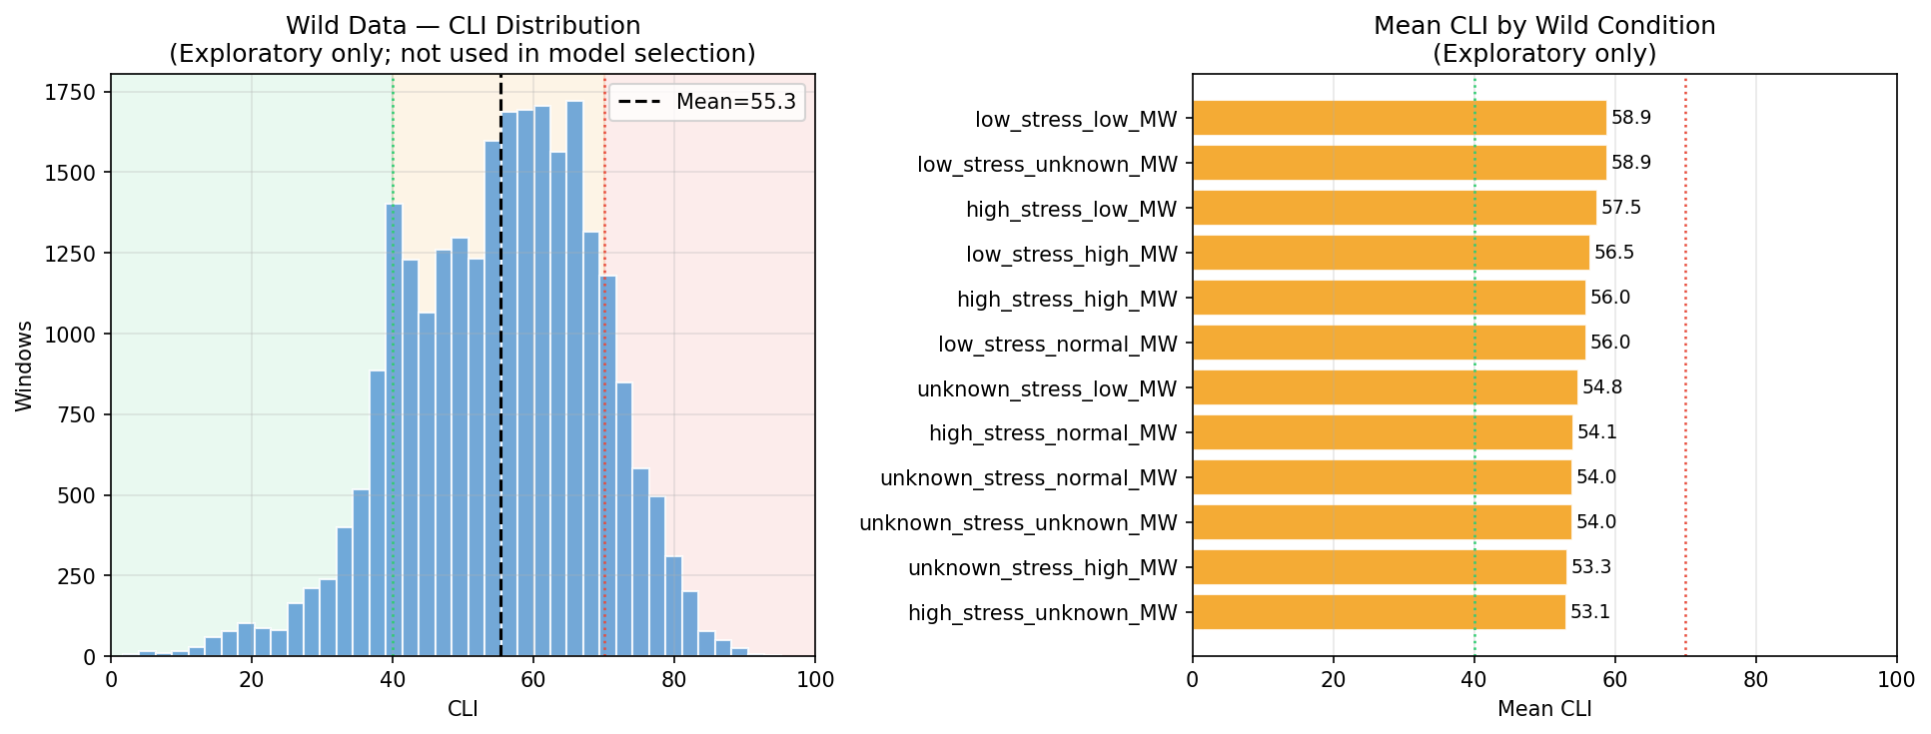
Figure 1: Left — CLI score distribution across all Wild windows (mean = 55.3). The distribution peaks in the Medium range (41–70), similar to Lab data. Right — Mean CLI by Wild condition. High-stress conditions tend to show higher mean CLI than low-stress conditions, which is directionally consistent with the model's training objective.

CLI Over Time — Sample Participants
The time-series plot shows CLI values for four sample participants across their Wild segments. Each colored dot represents one 30-second window. Vertical lines mark segment boundaries.
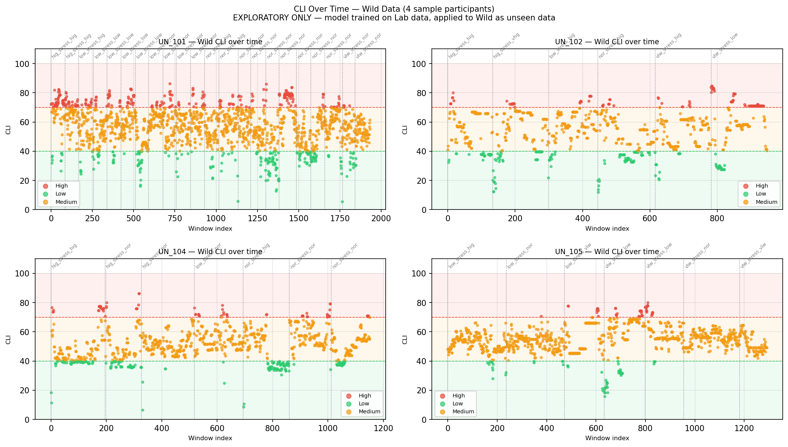
Figure 2: CLI over time for four sample participants in Wild sessions. The model produces plausible variation across segments — participants show fluctuating load levels consistent with natural activity variation. Note: no ground-truth labels are available to validate these scores.

Lab vs Wild Comparison
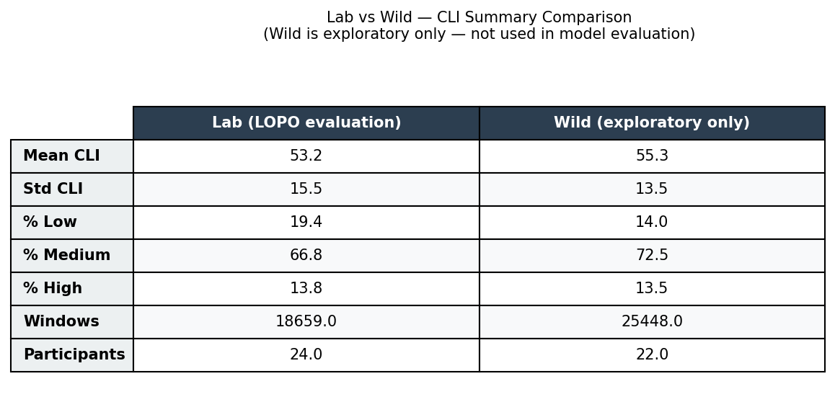
Figure 3: Summary comparison table between Lab (LOPO evaluation) and Wild (exploratory). The mean CLI is slightly higher in Wild (55.3 vs 53.2 in Lab), and the proportion of High-category windows is similar. The distributions are broadly comparable, suggesting the model generalizes reasonably to naturalistic physiological patterns.

Lab vs Wild — Numerical Comparison
Metric | Lab (LOPO evaluation) | Wild (exploratory)
Participants | 24 | 22
Total windows | 18,659 | 25,448
Mean CLI | 53.2 | 55.3
% Low (0–40) | 19.4% | 14.0%
% Medium (41–70) | 66.8% | 72.5%
% High (71–100) | 13.8% | 13.5%
Model evaluation | LOPO AUC = 0.568 | Exploratory — no AUC computed

Lab values are from 24-fold LOPO cross-validation (each participant held out). Wild values are exploratory applications of a model trained on ALL Lab participants.

6. Results

What the Exploratory Application Shows
- Plausible value range: The CLI distribution in Wild data (mean 55.3, range 1.7–95.1) is broadly similar to Lab data, confirming the model does not produce degenerate or extreme predictions on naturalistic recordings.
- Directional consistency: High-stress Wild conditions tend to produce higher mean CLI than low-stress conditions, which is directionally consistent with the model's training objective.
- Category distribution similar: The proportion of High-category windows (13.5%) is nearly identical between Lab and Wild, suggesting the model's threshold behavior is stable across contexts.

What Cannot Be Concluded
- No model accuracy on Wild: No AUC, F1, or accuracy metrics are reported for Wild data. There is no validated cognitive load label for Wild segments.
- Scores not directly comparable: A CLI of 60 in a Wild session is not directly comparable to a CLI of 60 in a Lab session. The normalization reference is different (Wild windows vs. Lab windows).
- Context confounds: Wild recording conditions (sensor placement, movement artifacts, environmental noise) differ from Lab. This adds noise that the model was not trained to handle.

7. Conclusions
Notebook 08 demonstrates that the final CLI model, trained on controlled Lab data, produces plausible and interpretable results when applied to naturalistic Wild recordings. This exploratory finding strengthens the real-world relevance argument for the CLI framework without making claims about model accuracy in naturalistic settings.
The Wild Exploration section of the Streamlit dashboard presents these results with a clear disclaimer. Reviewers and stakeholders can explore CLI patterns across participants and Wild conditions while understanding the exploratory nature of the visualization.
Key takeaway: the physiological signal structure in Wild data is sufficiently similar to Lab data that the model generalizes without producing nonsensical outputs. This supports the long-term feasibility of deploying the CLI framework in less controlled, more realistic workplace monitoring scenarios.
File Created | Description
outputs/wild_cli_exploration.csv | 25,448 Wild window predictions with CLI and condition labels
nb08_wild_cli_distribution.png | CLI histogram + condition breakdown
nb08_wild_cli_timeseries.png | CLI over time — 4 sample participants
nb08_lab_vs_wild_comparison.png | Lab vs Wild summary comparison table

