NASA-TLX Exploration
Task Label Quality Analysis — 03_NASA_TLX_exploration.ipynb
Project: Predicting and Preventing Burnout Using Cognitive Load Analysis

NASA-TLX Exploration — Task Label Quality Analysis
Project: Predicting and Preventing Burnout Using Cognitive Load Analysis Notebook: 03 — exploratory only (no model training)

Purpose
Notebooks 01 and 02 classify cognitive load using a design-based label:
- *_easy tasks → Low Load (label 0)
- *_hard tasks → High Load (label 1)
This labeling is objective (based on task difficulty design) but not validated by participant experience. The NASA-TLX questionnaire, completed after each task, captures the subjective experience of workload. This notebook answers three questions:
- **Does the design label agree with NASA-TLX?** Are hard tasks consistently rated
as high workload, and easy tasks as low workload?
- **Are there noisy labels?** Easy tasks that felt hard, or hard tasks that felt easy,
represent label noise that could be suppressing model performance.
- **What realistic alternatives exist for v3 labels?** Can NASA-TLX scores provide
better labels without introducing bias?

Scope
Session | Label files | Structure
Lab1, Lab2 | `Task_Labels.csv` per participant | `Task` column matches segment folder names exactly
Wild | `Task_Labels.csv` per participant | `Labeled folder names` column + `Mental stress level`
> Do NOT retrain any model in this notebook. > Do NOT replace current labels yet. > This is a diagnostic and planning step only.

[ Code ]
import warnings
import numpy as np
import pandas as pd
import matplotlib.pyplot as plt
import matplotlib.patches as mpatches
from pathlib import Path
from scipy import stats

warnings.filterwarnings('ignore')

DATA_ROOT = Path('.')
SESSIONS = ['Lab1', 'Lab2', 'Wild']

# Segment name to design label (same as notebooks 01/02)
LOW_EXACT = {'relaxation_video', 'video_baseline'}
LOW_SUFFIX = '_easy'
HIGH_SUFFIX = '_hard'

def design_label(task_name):
name = str(task_name).lower().strip()
if name in LOW_EXACT or name.endswith(LOW_SUFFIX):
return 'Low'
if name.endswith(HIGH_SUFFIX):
return 'High'
return 'Unknown'

print('Imports OK.')
print(f'Data root: {DATA_ROOT.resolve()}')
print(f'Sessions to scan: {SESSIONS}')

Imports OK.
Data root: C:\ForthYear\final project\UNIVERSE
Sessions to scan: ['Lab1', 'Lab2', 'Wild']

Step 1 — Scan All Participants for Task_Labels.csv
We search every UN_* folder across Lab1, Lab2, and Wild for the presence of Task_Labels.csv. Missing files are flagged but do not stop the scan.

[ Code ]
scan_rows = []

participant_dirs = sorted(DATA_ROOT.glob('UN_*'))
print(f'Participant directories found: {len(participant_dirs)}')
print()

for pdir in participant_dirs:
if not pdir.is_dir():
continue
pid = pdir.name
for session in SESSIONS:
fpath = pdir / session / 'Task_Labels.csv'
exists = fpath.exists()
n_rows = None
columns = None
if exists:
try:
tmp = pd.read_csv(fpath, nrows=0)
columns = list(tmp.columns)
n_rows = sum(1 for _ in open(fpath, encoding='utf-8')) - 1
except Exception as e:
exists = False
columns = [f'ERROR: {e}']
scan_rows.append({
'participant_id': pid,
'session': session,
'file_exists': exists,
'n_rows': n_rows,
'n_cols': len(columns) if columns else 0,
})

scan_df = pd.DataFrame(scan_rows)

print('Task_Labels.csv availability:')
pivot = scan_df.pivot_table(
index='participant_id', columns='session', values='file_exists',
aggfunc='first'
).fillna(False)
print(pivot.to_string())
print()

for session in SESSIONS:
found = scan_df[(scan_df['session'] == session) & scan_df['file_exists']]
missing = scan_df[(scan_df['session'] == session) & ~scan_df['file_exists']]
print(f'{session}: {len(found)} files found, {len(missing)} missing')
if not missing.empty:
print(f' Missing: {list(missing["participant_id"])}')
print()
print('Column counts by session:')
print(scan_df[scan_df['file_exists']].groupby('session')['n_cols'].agg(['min','max','mean']).round(1))

Participant directories found: 24

Task_Labels.csv availability:
session Lab1 Lab2 Wild
participant_id
UN_101 True True True
UN_102 True True True
UN_103 True True False
UN_104 True True True
UN_105 True True True
UN_106 True True True
UN_107 True True True
UN_108 True True True
UN_109 True True True
UN_110 True True True
UN_111 True True True
UN_112 True False True
UN_113 True True True
UN_114 True True True
UN_115 True True True
UN_116 True True True
UN_117 True True True
UN_118 True True True
UN_119 True True True
UN_120 True False False
UN_121 True True True
UN_122 True True True
UN_123 True True True
UN_124 True True True

Lab1: 24 files found, 0 missing
Lab2: 22 files found, 2 missing
Missing: ['UN_112', 'UN_120']
Wild: 22 files found, 2 missing
Missing: ['UN_103', 'UN_120']

Column counts by session:
min max mean
session
Lab1 23 25 23.3
Lab2 25 25 25.0
Wild 33 36 33.1

Step 2 — Load Lab Task_Labels.csv Files
Lab files have a Task column that matches segment folder names exactly. We load all available Lab1 and Lab2 files into a single DataFrame.

[ Code ]
LAB_SESSIONS = ['Lab1', 'Lab2']

# Standard Lab columns to keep (present in all Lab files)
LAB_KEEP_COLS = [
'Task', 'Mental Demand', 'Physical Demand', 'Temporal Demand',
'Performance', 'Effort', 'Frustration', 'Weighted Nasa Score'
]

lab_frames = []
lab_load_log = []

for pdir in sorted(DATA_ROOT.glob('UN_*')):
pid = pdir.name
for session in LAB_SESSIONS:
fpath = pdir / session / 'Task_Labels.csv'
if not fpath.exists():
lab_load_log.append({'participant_id': pid, 'session': session, 'status': 'missing'})
continue
try:
df = pd.read_csv(fpath)
# Keep only expected columns (guard against structural differences)
present = [c for c in LAB_KEEP_COLS if c in df.columns]
missing_cols = [c for c in LAB_KEEP_COLS if c not in df.columns]
df = df[present].copy()
df['participant_id'] = pid
df['session'] = session
df['design_label'] = df['Task'].apply(design_label)
lab_frames.append(df)
lab_load_log.append({
'participant_id': pid, 'session': session,
'status': 'ok', 'n_rows': len(df),
'missing_cols': missing_cols
})
except Exception as e:
lab_load_log.append({'participant_id': pid, 'session': session,
'status': f'error: {e}'})

lab_df = pd.concat(lab_frames, ignore_index=True) if lab_frames else pd.DataFrame()
load_log_df = pd.DataFrame(lab_load_log)

print(f'Lab Task_Labels loaded: {len(lab_frames)} files')
print(f'Total rows : {len(lab_df)}')
print(f'Columns : {list(lab_df.columns)}')
print()
print('Load log (errors/missing only):')
issues = load_log_df[load_log_df['status'] != 'ok']
if issues.empty:
print(' None — all files loaded successfully.')
else:
print(issues.to_string(index=False))
print()
print('Sample rows:')
display(lab_df.head(5))

Lab Task_Labels loaded: 46 files
Total rows : 411
Columns : ['Task', 'Mental Demand', 'Physical Demand', 'Temporal Demand', 'Performance', 'Effort', 'Frustration', 'Weighted Nasa Score', 'participant_id', 'session', 'design_label']

Load log (errors/missing only):
participant_id session status n_rows missing_cols
UN_112 Lab2 missing NaN NaN
UN_120 Lab2 missing NaN NaN

Sample rows:

Task Mental Demand Physical Demand Temporal Demand \
0 video_baseline 5.0 0.0 0.0
1 arithmetix_easy 75.0 5.0 40.0
2 sudoku_hard 70.0 5.0 65.0
3 stroop_hard 45.0 80.0 90.0
4 n_back_hard 70.0 5.0 55.0

Performance Effort Frustration Weighted Nasa Score participant_id \
0 0.0 5.0 5.0 3.33 UN_101
1 50.0 65.0 75.0 66.33 UN_101
2 70.0 50.0 25.0 62.67 UN_101
3 10.0 45.0 95.0 76.00 UN_101
4 75.0 85.0 30.0 69.00 UN_101

session design_label
0 Lab1 Low
1 Lab1 Low
2 Lab1 High
3 Lab1 High
4 Lab1 High

Step 3 — Load Wild Task_Labels.csv Files
Wild files have a different structure. The Labeled folder names column contains segment folder names for Wild recordings. Wild also has additional columns: Mental stress level and Mental effort level (categorical self-report) which are unique to the Wild protocol.

[ Code ]
WILD_KEEP_COLS = [
'Labeled folder names',
'Mental Demand', 'Physical Demand', 'Temporal Demand',
'Performance', 'Effort', 'Frustration',
'Mental stress level', 'Mental effort level',
'Weighted Nasa Score'
]

# Columns that must be numeric — coerced to float after concat
WILD_NUMERIC_COLS = [
'Mental Demand', 'Physical Demand', 'Temporal Demand',
'Performance', 'Effort', 'Frustration', 'Weighted Nasa Score'
]

wild_frames = []
wild_load_log = []

for pdir in sorted(DATA_ROOT.glob('UN_*')):
pid = pdir.name
fpath = pdir / 'Wild' / 'Task_Labels.csv'
if not fpath.exists():
wild_load_log.append({'participant_id': pid, 'status': 'missing'})
continue
try:
df = pd.read_csv(fpath)
# Drop any unnamed extra columns (e.g. UN_110 has 3 extra unnamed cols
# that shift values and corrupt 'Weighted Nasa Score')
df = df.loc[:, ~df.columns.str.startswith('Unnamed')]
present = [c for c in WILD_KEEP_COLS if c in df.columns]
missing_cols = [c for c in WILD_KEEP_COLS if c not in df.columns]
df = df[present].copy()
df['participant_id'] = pid
wild_frames.append(df)
wild_load_log.append({
'participant_id': pid, 'status': 'ok',
'n_rows': len(df), 'missing_cols': missing_cols
})
except Exception as e:
wild_load_log.append({'participant_id': pid, 'status': f'error: {e}'})

wild_df = pd.concat(wild_frames, ignore_index=True) if wild_frames else pd.DataFrame()

# Coerce all NASA-TLX score columns to numeric.
# Some files (e.g. UN_110) have extra columns that shift values,
# leaving text in numeric fields. errors='coerce' converts bad values to NaN.
for col in WILD_NUMERIC_COLS:
if col in wild_df.columns:
wild_df[col] = pd.to_numeric(wild_df[col], errors='coerce')

wild_log_df = pd.DataFrame(wild_load_log)

print(f'Wild Task_Labels loaded: {len(wild_frames)} files')
print(f'Total rows : {len(wild_df)}')
print(f'Columns : {list(wild_df.columns)}')
print()
print(f'Weighted Nasa Score dtype after coercion: {wild_df["Weighted Nasa Score"].dtype}')
n_bad = wild_df['Weighted Nasa Score'].isna().sum() - wild_df['Weighted Nasa Score'].isna().sum()
n_nan = wild_df['Weighted Nasa Score'].isna().sum()
print(f'NaN in Weighted Nasa Score: {n_nan} (rows excluded from analysis)')
print()
print('Load log (errors/missing only):')
issues_w = wild_log_df[wild_log_df['status'] != 'ok']
if issues_w.empty:
print(' None -- all Wild files loaded successfully.')
else:
print(issues_w.to_string(index=False))
print()
print('Sample rows:')
display(wild_df.head(5))

Wild Task_Labels loaded: 22 files
Total rows : 207
Columns : ['Labeled folder names', 'Mental Demand', 'Physical Demand', 'Temporal Demand', 'Performance', 'Effort', 'Frustration', 'Mental stress level', 'Mental effort level', 'Weighted Nasa Score', 'participant_id']

Weighted Nasa Score dtype after coercion: float64
NaN in Weighted Nasa Score: 9 (rows excluded from analysis)

Load log (errors/missing only):
participant_id status n_rows missing_cols
UN_103 missing NaN NaN
UN_120 missing NaN NaN

Sample rows:

Labeled folder names Mental Demand Physical Demand Temporal Demand \
0 low_stress_low_mw_1 15.0 5.0 5.0
1 low_stress_low_mw_2 25.0 5.0 10.0
2 low_stress_low_mw_3 35.0 10.0 10.0
3 low_stress_low_mw_4 35.0 5.0 15.0
4 nor_stress_nor_mw_5 45.0 5.0 30.0

Performance Effort Frustration Mental stress level \
0 75 15 5 Low
1 70 20 15 Low
2 50 50 25 Low
3 15 10 35 Low
4 55 60 50 Neither low nor high

Mental effort level Weighted Nasa Score participant_id
0 Low 31.67 UN_101
1 Low 35.67 UN_101
2 Low 35.67 UN_101
3 Low 25.33 UN_101
4 Neither low nor high 50.33 UN_101

What is NASA-TLX?
NASA Task Load Index (NASA-TLX) is a widely-used, multi-dimensional subjective workload measure developed by Hart & Staveland (1988). Participants rate six dimensions after completing each task:
Dimension | Scale | What it measures
**Mental Demand** | 0–100 | How much mental activity was required
**Physical Demand** | 0–100 | How much physical activity was required
**Temporal Demand** | 0–100 | How hurried or rushed the pace felt
**Performance** | 0–100 | How successful were you (higher = better)
**Effort** | 0–100 | How hard did you have to work
**Frustration** | 0–100 | How irritated, stressed, or annoyed did you feel
The Weighted NASA Score (also called NASA-TLX total) is computed by weighting each dimension by pairwise comparison responses. It represents overall subjective workload on a 0–100 scale.

Relevance to this project
The current pipeline labels tasks by design difficulty (easy/hard). NASA-TLX captures experienced difficulty. If design labels disagree with NASA-TLX ratings for some tasks, those tasks are potential noisy labels that could explain why the model struggles to classify them correctly.

Step 4 — NASA-TLX Score Distributions (Lab Sessions)

[ Code ]
NASA_DIMS = ['Mental Demand', 'Physical Demand', 'Temporal Demand',
'Performance', 'Effort', 'Frustration', 'Weighted Nasa Score']

# Keep only rows with valid NASA scores
lab_scored = lab_df[lab_df['Weighted Nasa Score'].notna()].copy()

print(f'Lab rows with valid Weighted NASA Score: {len(lab_scored)} / {len(lab_df)}')
print()

# Distribution of Weighted NASA Score by design label
print('Weighted NASA Score statistics by design label:')
display(lab_scored.groupby('design_label')['Weighted Nasa Score']
.describe().round(2))
print()

# Distribution by task name (across all participants)
print('Weighted NASA Score per task (mean ± std across participants):')
task_stats = (
lab_scored.groupby('Task')['Weighted Nasa Score']
.agg(['mean', 'std', 'count'])
.rename(columns={'mean': 'NASA_mean', 'std': 'NASA_std', 'count': 'n_participants'})
.sort_values('NASA_mean', ascending=False)
.round(2)
)
task_stats['design_label'] = task_stats.index.map(design_label)
display(task_stats)

Lab rows with valid Weighted NASA Score: 411 / 411

Weighted NASA Score statistics by design label:

count mean std min 25% 50% 75% max
design_label
High 184.0 64.72 17.76 2.33 54.33 65.84 77.00 99.33
Low 227.0 51.13 19.90 0.00 35.84 52.67 66.16 93.33

Weighted NASA Score per task (mean ± std across participants):

NASA_mean NASA_std n_participants design_label
Task
stroop_hard 77.21 19.54 46 High
stroop_easy 65.25 15.13 46 Low
n_back_hard 63.34 13.59 46 High
arithmetix_hard 59.83 13.89 46 High
arithmetix_easy 58.79 14.52 45 Low
sudoku_hard 58.49 17.27 46 High
sudoku_easy 57.45 17.12 45 Low
n_back_easy 47.86 13.22 45 Low
video_baseline 26.53 12.81 46 Low

[ Code ]
# Plot: mean Weighted NASA Score per task, coloured by design label
task_sorted = task_stats.sort_values('NASA_mean')
colors = ['steelblue' if l == 'Low' else 'tomato' if l == 'High' else 'gray'
for l in task_sorted['design_label']]

fig, ax = plt.subplots(figsize=(11, 5))
ax.barh(task_sorted.index, task_sorted['NASA_mean'],
xerr=task_sorted['NASA_std'], color=colors, capsize=3,
edgecolor='white', height=0.6)
ax.set_xlabel('Mean Weighted NASA Score (± std across participants)')
ax.set_title('NASA-TLX by Task Type — Lab Sessions\n'
'(blue = design Low label, red = design High label)')
ax.axvline(50, color='gray', linestyle='--', lw=1.2, label='Midpoint (50)')

low_patch = mpatches.Patch(color='steelblue', label='Design label: Low')
high_patch = mpatches.Patch(color='tomato', label='Design label: High')
ax.legend(handles=[low_patch, high_patch, plt.Line2D([0], [0], color='gray',
linestyle='--', label='Midpoint (50)')], loc='lower right', fontsize=9)
ax.grid(axis='x', alpha=0.3)
plt.tight_layout()
plt.savefig('nasa_tlx_by_task.png', dpi=150, bbox_inches='tight')
plt.show()

<Figure size 1100x500 with 1 Axes>

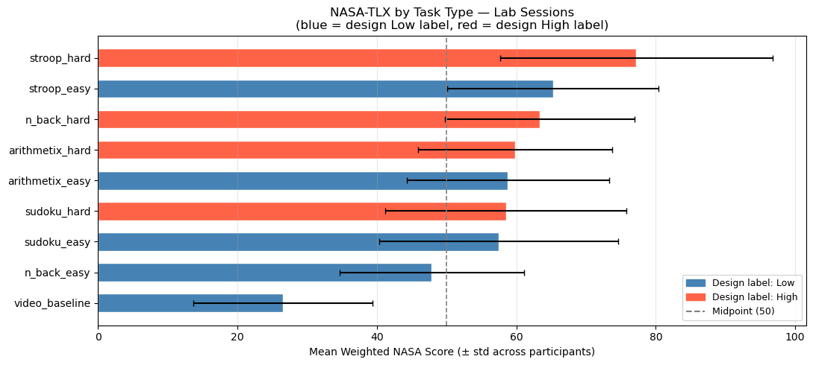

Step 5 — Easy vs Hard NASA-TLX: Does the Design Label Hold?
We compare Weighted NASA Score between Low-labeled and High-labeled tasks and run a statistical test to confirm the difference is real, not sampling noise.

[ Code ]
low_nasa = lab_scored[lab_scored['design_label'] == 'Low']['Weighted Nasa Score'].dropna()
high_nasa = lab_scored[lab_scored['design_label'] == 'High']['Weighted Nasa Score'].dropna()

# Mann-Whitney U test (non-parametric, appropriate for ordinal scales)
u_stat, p_val = stats.mannwhitneyu(low_nasa, high_nasa, alternative='less')

print('Easy (Low) vs Hard (High) — Weighted NASA Score')
print(f' Low tasks: n={len(low_nasa)}, mean={low_nasa.mean():.1f}, median={low_nasa.median():.1f}, std={low_nasa.std():.1f}')
print(f' High tasks: n={len(high_nasa)}, mean={high_nasa.mean():.1f}, median={high_nasa.median():.1f}, std={high_nasa.std():.1f}')
print()
print(f'Mann-Whitney U test (one-sided: Low < High):')
print(f' U statistic = {u_stat:.1f}')
print(f' p-value = {p_val:.4f}')
if p_val < 0.01:
print(' Result: SIGNIFICANT (p < 0.01) — High-label tasks are rated harder by NASA-TLX')
elif p_val < 0.05:
print(' Result: SIGNIFICANT (p < 0.05) — High-label tasks are rated harder by NASA-TLX')
else:
print(' Result: NOT SIGNIFICANT — the design label does not clearly separate NASA-TLX scores')
print()

# Box plots
fig, axes = plt.subplots(1, 2, figsize=(13, 5))

# Left: box plots
bp = axes[0].boxplot(
[low_nasa.values, high_nasa.values],
labels=['Design Low', 'Design High'],
patch_artist=True,
medianprops=dict(color='black', linewidth=2),
)
bp['boxes'][0].set_facecolor('steelblue'); bp['boxes'][0].set_alpha(0.6)
bp['boxes'][1].set_facecolor('tomato'); bp['boxes'][1].set_alpha(0.6)
axes[0].set_ylabel('Weighted NASA Score')
axes[0].set_title('NASA-TLX by Design Label (Lab)')
axes[0].axhline(50, color='gray', linestyle='--', lw=1, label='Midpoint')
axes[0].legend(fontsize=9)
axes[0].grid(axis='y', alpha=0.3)

# Right: overlapping histograms
axes[1].hist(low_nasa, bins=20, alpha=0.55, color='steelblue',
label='Design Low', edgecolor='white')
axes[1].hist(high_nasa, bins=20, alpha=0.55, color='tomato',
label='Design High', edgecolor='white')
axes[1].axvline(low_nasa.mean(), color='steelblue', linestyle='--', lw=1.8,
label=f'Low mean = {low_nasa.mean():.1f}')
axes[1].axvline(high_nasa.mean(), color='tomato', linestyle='--', lw=1.8,
label=f'High mean = {high_nasa.mean():.1f}')
axes[1].set_xlabel('Weighted NASA Score')
axes[1].set_ylabel('Count')
axes[1].set_title('NASA-TLX Distribution (Lab)')
axes[1].legend(fontsize=9)
axes[1].grid(alpha=0.3)

plt.suptitle('Lab Session: Design Label vs Subjective Workload (NASA-TLX)',
fontsize=11, y=1.01)
plt.tight_layout()
plt.savefig('nasa_easy_vs_hard.png', dpi=150, bbox_inches='tight')
plt.show()

Easy (Low) vs Hard (High) — Weighted NASA Score
Low tasks: n=227, mean=51.1, median=52.7, std=19.9
High tasks: n=184, mean=64.7, median=65.8, std=17.8

Mann-Whitney U test (one-sided: Low < High):
U statistic = 12919.0
p-value = 0.0000
Result: SIGNIFICANT (p < 0.01) — High-label tasks are rated harder by NASA-TLX

<Figure size 1300x500 with 2 Axes>

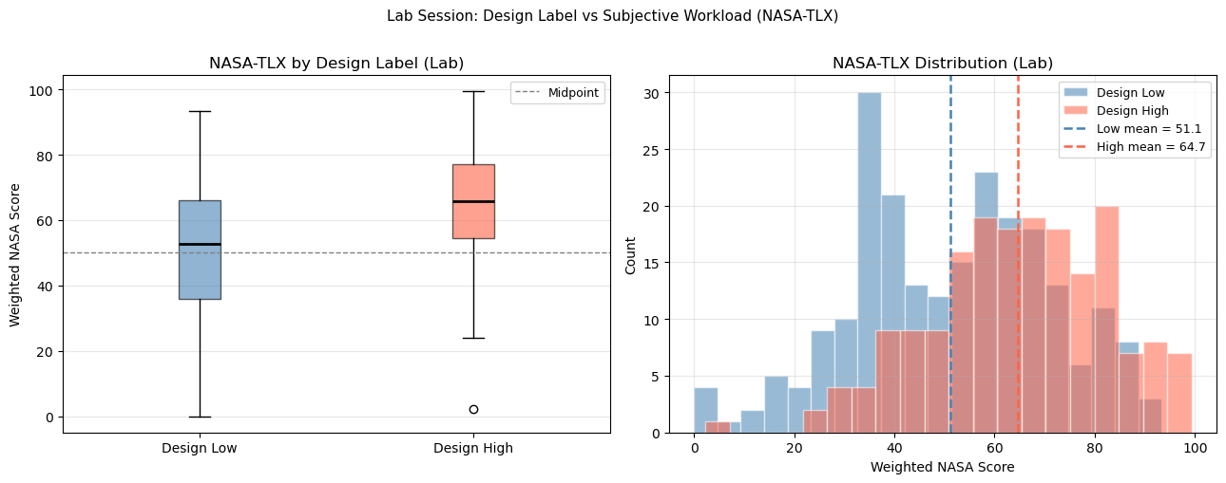

[ Code ]
# All six NASA-TLX dimensions by design label
dims = ['Mental Demand', 'Physical Demand', 'Temporal Demand',
'Performance', 'Effort', 'Frustration']

dim_stats = []
for dim in dims:
if dim not in lab_scored.columns:
continue
low_d = lab_scored[lab_scored['design_label'] == 'Low'][dim].dropna()
high_d = lab_scored[lab_scored['design_label'] == 'High'][dim].dropna()
u, p = stats.mannwhitneyu(low_d, high_d, alternative='less')
dim_stats.append({
'Dimension': dim,
'Low mean': round(low_d.mean(), 1),
'High mean': round(high_d.mean(), 1),
'Difference': round(high_d.mean() - low_d.mean(), 1),
'p-value': round(p, 4),
'Significant': 'Yes' if p < 0.05 else 'No',
})

dim_df = pd.DataFrame(dim_stats).set_index('Dimension')
print('NASA-TLX dimensions: Low vs High design labels (Mann-Whitney U, one-sided):')
display(dim_df)
print()
print('Note: Performance is inverted — lower Performance rating means the task felt harder.')

# Radar-style bar plot
fig, axes = plt.subplots(1, len(dims), figsize=(14, 4), sharey=True)
for ax, dim in zip(axes, dims):
if dim not in lab_scored.columns:
continue
low_d = lab_scored[lab_scored['design_label'] == 'Low'][dim].dropna()
high_d = lab_scored[lab_scored['design_label'] == 'High'][dim].dropna()
ax.bar([0, 1], [low_d.mean(), high_d.mean()],
color=['steelblue', 'tomato'], alpha=0.75, edgecolor='white')
ax.errorbar([0, 1], [low_d.mean(), high_d.mean()],
yerr=[low_d.std(), high_d.std()],
fmt='none', color='black', capsize=4, lw=1.5)
ax.set_xticks([0, 1])
ax.set_xticklabels(['Low', 'High'], fontsize=8)
ax.set_title(dim, fontsize=8, wrap=True)
ax.set_ylim(0, 100)
ax.grid(axis='y', alpha=0.3)

axes[0].set_ylabel('Mean Score (± std)')
fig.suptitle('All NASA-TLX Dimensions: Design Low vs High (Lab)', fontsize=10)
plt.tight_layout()
plt.savefig('nasa_dimensions.png', dpi=150, bbox_inches='tight')
plt.show()

NASA-TLX dimensions: Low vs High design labels (Mann-Whitney U, one-sided):

Low mean High mean Difference p-value Significant
Dimension
Mental Demand 44.8 73.8 29.1 0.0000 Yes
Physical Demand 16.3 27.9 11.6 0.0001 Yes
Temporal Demand 30.3 52.3 22.1 0.0000 Yes
Performance 74.2 48.1 -26.1 1.0000 No
Effort 46.7 68.0 21.3 0.0000 Yes
Frustration 24.8 45.5 20.7 0.0000 Yes

Note: Performance is inverted — lower Performance rating means the task felt harder.

<Figure size 1400x400 with 6 Axes>

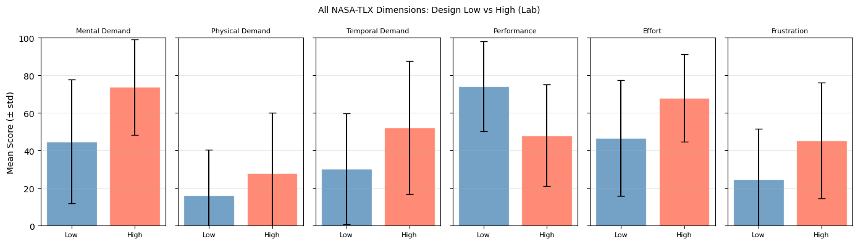

Step 6 — Matching Task_Labels.csv Rows to Segment Folder Names
The pipeline (notebooks 01/02) identifies segments from folder names in the Features/ directory. We check whether every segment name used in the pipeline has a corresponding NASA-TLX row in the Task_Labels.csv.

[ Code ]
# Unique task names in NASA-TLX vs segment names seen by the pipeline
lab_tasks_nasa = set(lab_scored['Task'].dropna().str.lower().str.strip().unique())
print('Task names in Lab Task_Labels.csv (unique across all participants):')
print(sorted(lab_tasks_nasa))
print()

# Pipeline segment names (from notebooks 01/02)
# Based on actual folders found in Features/ directories
pipeline_lab_segments = set()
for pdir in sorted(DATA_ROOT.glob('UN_*')):
for session in ['Lab1', 'Lab2']:
feat_dir = pdir / session / 'Features'
if not feat_dir.exists():
continue
for sd in feat_dir.iterdir():
if sd.is_dir():
pipeline_lab_segments.add(sd.name.lower())

print('Segment folder names seen by the pipeline (Lab1+Lab2):')
print(sorted(pipeline_lab_segments))
print()

in_nasa_only = lab_tasks_nasa - pipeline_lab_segments
in_pipeline_only = pipeline_lab_segments - lab_tasks_nasa
in_both = lab_tasks_nasa & pipeline_lab_segments

print(f'Matched (in both NASA-TLX and pipeline) : {len(in_both)} names')
print(f'In NASA-TLX only (not in Features/) : {len(in_nasa_only)} {sorted(in_nasa_only)}')
print(f'In pipeline only (not in Task_Labels) : {len(in_pipeline_only)} {sorted(in_pipeline_only)}')
print()
if not in_pipeline_only:
print('RESULT: All pipeline segment names have a NASA-TLX row. Full match.')
else:
print('WARNING: Some pipeline segments have no NASA-TLX match. These cannot be validated.')
print('Consider keeping original design labels for unmatched segments.')

Task names in Lab Task_Labels.csv (unique across all participants):
['arithmetix_easy', 'arithmetix_hard', 'n_back_easy', 'n_back_hard', 'stroop_easy', 'stroop_hard', 'sudoku_easy', 'sudoku_hard', 'video_baseline']

Segment folder names seen by the pipeline (Lab1+Lab2):
['arithmetix_easy', 'arithmetix_hard', 'n_back_easy', 'n_back_hard', 'relaxation_video', 'stroop_easy', 'stroop_hard', 'sudoku_easy', 'sudoku_hard']

Matched (in both NASA-TLX and pipeline) : 8 names
In NASA-TLX only (not in Features/) : 1 ['video_baseline']
In pipeline only (not in Task_Labels) : 1 ['relaxation_video']

WARNING: Some pipeline segments have no NASA-TLX match. These cannot be validated.
Consider keeping original design labels for unmatched segments.

Step 7 — Noisy Label Detection
A noisy label occurs when the design label contradicts the participant's subjective experience. We identify two types:
- Type A (Easy-but-Hard): Design label = Low, but NASA-TLX is high
→ Participant found an "easy" task genuinely difficult
- Type B (Hard-but-Easy): Design label = High, but NASA-TLX is low
→ Participant found a "hard" task genuinely easy
We use two thresholds for flagging:
- Strict: NASA > 70 for Low tasks, or NASA < 30 for High tasks
- Moderate: NASA > 60 for Low tasks, or NASA < 40 for High tasks
This analysis uses individual participant ratings, not means, to capture person-level label noise.

[ Code ]
STRICT_HIGH = 70 # Low task with NASA above this = strongly noisy
STRICT_LOW = 30 # High task with NASA below this = strongly noisy
MOD_HIGH = 60
MOD_LOW = 40

lab_scored_matched = lab_scored[lab_scored['Task'].str.lower().isin(in_both)].copy()

type_a_strict = lab_scored_matched[
(lab_scored_matched['design_label'] == 'Low') &
(lab_scored_matched['Weighted Nasa Score'] > STRICT_HIGH)
].copy()

type_b_strict = lab_scored_matched[
(lab_scored_matched['design_label'] == 'High') &
(lab_scored_matched['Weighted Nasa Score'] < STRICT_LOW)
].copy()

type_a_mod = lab_scored_matched[
(lab_scored_matched['design_label'] == 'Low') &
(lab_scored_matched['Weighted Nasa Score'] > MOD_HIGH)
].copy()

type_b_mod = lab_scored_matched[
(lab_scored_matched['design_label'] == 'High') &
(lab_scored_matched['Weighted Nasa Score'] < MOD_LOW)
].copy()

n_total = len(lab_scored_matched)

print('=== Noisy Label Summary ===')
print()
print(f'Total (participant, task) pairs analysed: {n_total}')
print()
print(f'Type A — Low task, high NASA-TLX (NASA > {STRICT_HIGH}): {len(type_a_strict)} pairs ({100*len(type_a_strict)/n_total:.1f}%)')
print(f'Type A — Low task, high NASA-TLX (NASA > {MOD_HIGH}): {len(type_a_mod)} pairs ({100*len(type_a_mod)/n_total:.1f}%)')
print()
print(f'Type B — High task, low NASA-TLX (NASA < {STRICT_LOW}): {len(type_b_strict)} pairs ({100*len(type_b_strict)/n_total:.1f}%)')
print(f'Type B — High task, low NASA-TLX (NASA < {MOD_LOW}): {len(type_b_mod)} pairs ({100*len(type_b_mod)/n_total:.1f}%)')
print()

if not type_a_strict.empty:
print('Type A examples (Low task, NASA > 70):')
display(type_a_strict[['participant_id','session','Task','Weighted Nasa Score','design_label']].sort_values('Weighted Nasa Score', ascending=False).head(10))
print()

if not type_b_strict.empty:
print('Type B examples (High task, NASA < 30):')
display(type_b_strict[['participant_id','session','Task','Weighted Nasa Score','design_label']].sort_values('Weighted Nasa Score').head(10))

=== Noisy Label Summary ===

Total (participant, task) pairs analysed: 365

Type A — Low task, high NASA-TLX (NASA > 70): 40 pairs (11.0%)
Type A — Low task, high NASA-TLX (NASA > 60): 78 pairs (21.4%)

Type B — High task, low NASA-TLX (NASA < 30): 4 pairs (1.1%)
Type B — High task, low NASA-TLX (NASA < 40): 18 pairs (4.9%)

Type A examples (Low task, NASA > 70):

participant_id session Task Weighted Nasa Score design_label
379 UN_123 Lab1 sudoku_easy 93.33 Low
44 UN_103 Lab2 arithmetix_easy 88.67 Low
308 UN_118 Lab2 stroop_easy 88.67 Low
196 UN_112 Lab1 stroop_easy 88.00 Low
325 UN_119 Lab2 stroop_easy 88.00 Low
29 UN_102 Lab2 stroop_easy 87.67 Low
336 UN_120 Lab1 stroop_easy 87.00 Low
305 UN_118 Lab2 arithmetix_easy 86.67 Low
298 UN_118 Lab1 stroop_easy 86.33 Low
380 UN_123 Lab1 stroop_easy 86.33 Low

Type B examples (High task, NASA < 30):

participant_id session Task Weighted Nasa Score design_label
86 UN_105 Lab2 stroop_hard 2.33 High
136 UN_108 Lab2 arithmetix_hard 24.00 High
146 UN_109 Lab1 sudoku_hard 25.67 High
371 UN_122 Lab2 sudoku_hard 29.67 High

[ Code ]
# Pre-compute unified per-row noise flag (design-label-aware):
# Low task AND NASA above strict/moderate threshold -> noisy
# High task AND NASA below strict/moderate threshold -> noisy
noise_flags = lab_scored_matched.copy()
noise_flags['type_a_strict'] = (
(noise_flags['design_label'] == 'Low') &
(noise_flags['Weighted Nasa Score'] > STRICT_HIGH)
)
noise_flags['type_b_strict'] = (
(noise_flags['design_label'] == 'High') &
(noise_flags['Weighted Nasa Score'] < STRICT_LOW)
)
noise_flags['type_a_mod'] = (
(noise_flags['design_label'] == 'Low') &
(noise_flags['Weighted Nasa Score'] > MOD_HIGH)
)
noise_flags['type_b_mod'] = (
(noise_flags['design_label'] == 'High') &
(noise_flags['Weighted Nasa Score'] < MOD_LOW)
)
noise_flags['is_noisy_strict'] = (
noise_flags['type_a_strict'] | noise_flags['type_b_strict']
)
noise_flags['is_noisy_mod'] = (
noise_flags['type_a_mod'] | noise_flags['type_b_mod']
)

task_noise = noise_flags.groupby(['Task', 'design_label']).agg(
n_participants = ('participant_id', 'count'),
nasa_mean = ('Weighted Nasa Score', 'mean'),
nasa_std = ('Weighted Nasa Score', 'std'),
noisy_strict_frac = ('is_noisy_strict', 'mean'),
noisy_mod_frac = ('is_noisy_mod', 'mean'),
).round(3)

task_noise['noisy_strict_pct'] = (task_noise['noisy_strict_frac'] * 100).round(1)
task_noise['noisy_mod_pct'] = (task_noise['noisy_mod_frac'] * 100).round(1)
task_noise = task_noise.drop(columns=['noisy_strict_frac', 'noisy_mod_frac'])
task_noise = task_noise.sort_values('nasa_mean', ascending=False).round(1)

print('Per-task NASA-TLX summary with noise rates:')
display(task_noise)
print()
print('noisy_strict_pct: % of participants where design label disagrees with NASA (strict threshold)')
print('noisy_mod_pct : % of participants where design label disagrees with NASA (moderate threshold)')
print()
print('High noise rate = design label disagrees with participant experience for many people.')
print('Noisy tasks are candidates for label correction in v3.')

Per-task NASA-TLX summary with noise rates:

n_participants nasa_mean nasa_std \
Task design_label
stroop_hard High 46 77.2 19.5
stroop_easy Low 46 65.3 15.1
n_back_hard High 46 63.3 13.6
arithmetix_hard High 46 59.8 13.9
arithmetix_easy Low 45 58.8 14.5
sudoku_hard High 46 58.5 17.3
sudoku_easy Low 45 57.5 17.1
n_back_easy Low 45 47.9 13.2

noisy_strict_pct noisy_mod_pct
Task design_label
stroop_hard High 2.2 6.5
stroop_easy Low 32.6 65.2
n_back_hard High 0.0 6.5
arithmetix_hard High 2.2 6.5
arithmetix_easy Low 22.2 44.4
sudoku_hard High 4.3 19.6
sudoku_easy Low 26.7 44.4
n_back_easy Low 6.7 17.8

noisy_strict_pct: % of participants where design label disagrees with NASA (strict threshold)
noisy_mod_pct : % of participants where design label disagrees with NASA (moderate threshold)

High noise rate = design label disagrees with participant experience for many people.
Noisy tasks are candidates for label correction in v3.

[ Code ]
# Scatter: NASA score vs design label, one dot per (participant, task)
fig, ax = plt.subplots(figsize=(12, 5))

jitter = np.random.RandomState(42)

for design, color, xpos in [('Low', 'steelblue', 0), ('High', 'tomato', 1)]:
subset = lab_scored_matched[lab_scored_matched['design_label'] == design]
nasa_vals = subset['Weighted Nasa Score'].values
xs = xpos + jitter.uniform(-0.2, 0.2, size=len(nasa_vals))
ax.scatter(xs, nasa_vals, color=color, alpha=0.4, s=18, edgecolors='none')

# Overlay mean ± std
ax.errorbar([xpos], [nasa_vals.mean()], yerr=[nasa_vals.std()],
fmt='D', color='black', capsize=6, markersize=7, zorder=5,
label=f'{design}: mean={nasa_vals.mean():.1f}')

ax.axhline(STRICT_HIGH, color='orange', linestyle='--', lw=1.2,
label=f'Strict noise threshold (Low > {STRICT_HIGH})')
ax.axhline(STRICT_LOW, color='purple', linestyle='--', lw=1.2,
label=f'Strict noise threshold (High < {STRICT_LOW})')
ax.set_xticks([0, 1])
ax.set_xticklabels(['Design Low', 'Design High'], fontsize=11)
ax.set_ylabel('Weighted NASA Score')
ax.set_title('Per-Participant NASA-TLX vs Design Label\n'
'(each dot = one (participant, task) rating; diamonds = group mean ± std)')
ax.legend(fontsize=8, loc='upper left')
ax.grid(axis='y', alpha=0.3)
ax.set_ylim(-5, 105)
plt.tight_layout()
plt.savefig('nasa_scatter.png', dpi=150, bbox_inches='tight')
plt.show()

<Figure size 1200x500 with 1 Axes>

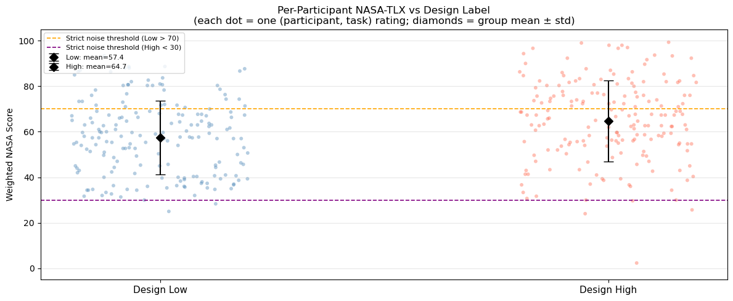

Step 8 — Wild Session Label Structure
The Wild sessions use folder names like low_stress_low_mw_1, nor_stress_nor_mw_5, hig_stress_hig_mw_16, etc. These embed both stress level and mental workload level. We examine:
- How do Wild NASA-TLX scores compare to Lab scores?
- Are the stress/MW category labels in folder names consistent with NASA-TLX?

[ Code ]
if wild_df.empty:
print('No Wild data loaded — skipping Wild analysis.')
else:
wild_scored = wild_df[wild_df['Weighted Nasa Score'].notna()].copy()
label_col = 'Labeled folder names'

print(f'Wild rows with Weighted NASA Score: {len(wild_scored)} / {len(wild_df)}')
print()

# Extract stress/MW category from folder name prefix
def parse_wild_category(folder_name):
if not isinstance(folder_name, str):
return 'unknown'
name = folder_name.strip().lower()
# Pattern: {stress_level}_stress_{mw_level}_mw_{number}
parts = name.split('_')
if len(parts) >= 4 and parts[1] == 'stress':
return f'{parts[0]}_stress'
return 'other'

def parse_wild_mw(folder_name):
if not isinstance(folder_name, str):
return 'unknown'
parts = folder_name.strip().lower().split('_')
if len(parts) >= 4 and parts[3] == 'mw':
return f'{parts[2]}_mw'
return 'other'

wild_scored['stress_cat'] = wild_scored[label_col].apply(parse_wild_category)
wild_scored['mw_cat'] = wild_scored[label_col].apply(parse_wild_mw)

print('Wild: Weighted NASA Score by stress category:')
display(wild_scored.groupby('stress_cat')['Weighted Nasa Score']
.agg(['count','mean','std']).round(2))
print()

print('Wild: Weighted NASA Score by mental workload category:')
display(wild_scored.groupby('mw_cat')['Weighted Nasa Score']
.agg(['count','mean','std']).round(2))
print()

# Distribution plot
fig, axes = plt.subplots(1, 2, figsize=(13, 5))

for cat_col, ax, title in [
('stress_cat', axes[0], 'NASA-TLX by Stress Category (Wild)'),
('mw_cat', axes[1], 'NASA-TLX by Mental Workload Category (Wild)'),
]:
cats = sorted(wild_scored[cat_col].unique())
data = [wild_scored[wild_scored[cat_col] == c]['Weighted Nasa Score'].dropna().values
for c in cats]
bp = ax.boxplot(data, labels=cats, patch_artist=True)
for patch in bp['boxes']:
patch.set_facecolor('lightsteelblue')
patch.set_alpha(0.7)
ax.set_ylabel('Weighted NASA Score')
ax.set_title(title)
ax.set_xticklabels(cats, rotation=30, ha='right', fontsize=9)
ax.axhline(50, color='gray', linestyle='--', lw=1)
ax.grid(axis='y', alpha=0.3)

plt.tight_layout()
plt.savefig('nasa_wild_categories.png', dpi=150, bbox_inches='tight')
plt.show()

Wild rows with Weighted NASA Score: 198 / 207

Wild: Weighted NASA Score by stress category:

count mean std
stress_cat
hig_stress 34 63.90 9.58
low_stress 71 49.14 15.79
nor_stress 64 56.84 13.24
vlw_stress 29 48.16 13.74

Wild: Weighted NASA Score by mental workload category:

count mean std
mw_cat
hig_mw 78 61.71 11.75
low_mw 40 40.38 13.25
nor_mw 68 52.48 12.57
vhg_mw 5 72.07 6.58
vlw_mw 7 48.33 12.93

<Figure size 1300x500 with 2 Axes>

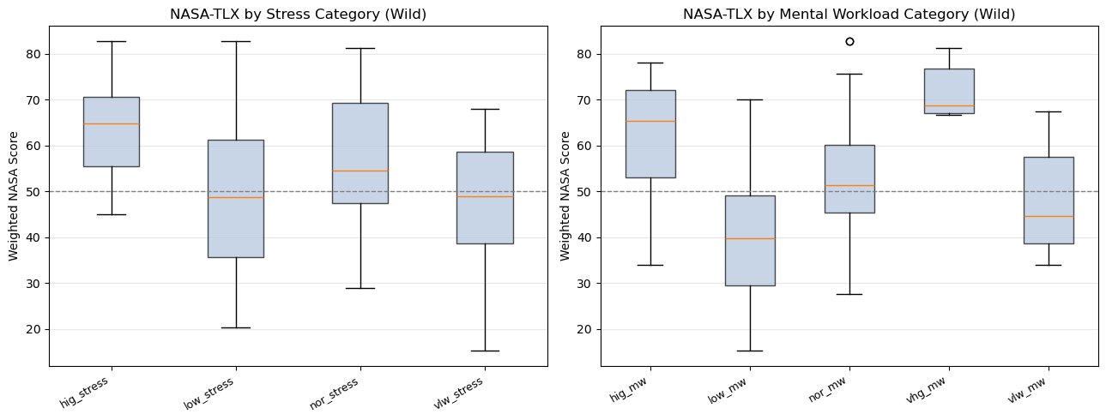

[ Code ]
if not wild_df.empty and 'Mental stress level' in wild_scored.columns:
print('Wild: Mental stress level categories:')
print(wild_scored['Mental stress level'].value_counts())
print()

print('Wild: Mental effort level categories:')
if 'Mental effort level' in wild_scored.columns:
print(wild_scored['Mental effort level'].value_counts())
print()

# Check agreement: folder-name MW category vs Mental effort level
if 'Mental effort level' in wild_scored.columns:
cross = pd.crosstab(wild_scored['mw_cat'],
wild_scored['Mental effort level'])
print('Cross-tabulation: folder-name MW category vs Mental effort level self-report:')
display(cross)
print()
print('Perfect agreement would show one dominant cell per row.')
print('Disagreement reveals inconsistency between the naming convention')
print('and participant self-report — a source of label noise.')
else:
print('Mental stress level not available in Wild data.')

Wild: Mental stress level categories:
Mental stress level
Low 62
Neither low nor high 51
High 22
high 13
Very, very low 12
Very very low 9
neither low nor high 7
low 7
very low 6
Neither low nor high 4
Neighter low nor high 3
very, very low 1
very very low 1
Name: count, dtype: int64

Wild: Mental effort level categories:
Mental effort level
High 66
Neither low nor high 49
Low 34
neither low nor high 18
high 12
Very, very high 4
low 4
Neighter low nor high 4
Very very low 3
Very, very low 3
Very very high 1
Name: count, dtype: int64

Cross-tabulation: folder-name MW category vs Mental effort level self-report:

Mental effort level High Low Neighter low nor high Neither low nor high \
mw_cat
hig_mw 65 0 0 1
low_mw 1 32 2 1
nor_mw 0 1 2 47
vhg_mw 0 0 0 0
vlw_mw 0 1 0 0

Mental effort level Very very high Very very low Very, very high \
mw_cat
hig_mw 0 0 0
low_mw 0 0 0
nor_mw 0 0 0
vhg_mw 1 0 4
vlw_mw 0 3 0

Mental effort level Very, very low high low neither low nor high
mw_cat
hig_mw 0 12 0 0
low_mw 0 0 4 0
nor_mw 0 0 0 18
vhg_mw 0 0 0 0
vlw_mw 3 0 0 0

Perfect agreement would show one dominant cell per row.
Disagreement reveals inconsistency between the naming convention
and participant self-report — a source of label noise.

Step 9 — Proposed v3 Label Strategies
Based on the NASA-TLX analysis, we evaluate four realistic options for improving label quality in a future v3 pipeline.

[ Code ]
# Strategy 1: Fixed threshold on NASA-TLX
# Classify by Weighted NASA Score: < threshold_low = Low, > threshold_high = High
# Middle range excluded as ambiguous

thresholds_to_test = [
(30, 60), # Conservative: clear separation
(40, 60), # Moderate
(33, 67), # Tertile split (roughly)
]

print('=== Strategy 1: Fixed NASA-TLX threshold ===')
print('Weighted NASA Score: below lower → Low; above upper → High; middle → excluded')
print()

for thr_low, thr_high in thresholds_to_test:
sub_low = lab_scored_matched[lab_scored_matched['Weighted Nasa Score'] < thr_low]
sub_high = lab_scored_matched[lab_scored_matched['Weighted Nasa Score'] >= thr_high]
sub_excl = lab_scored_matched[
(lab_scored_matched['Weighted Nasa Score'] >= thr_low) &
(lab_scored_matched['Weighted Nasa Score'] < thr_high)
]
total = len(lab_scored_matched)
pct_kept = 100 * (len(sub_low) + len(sub_high)) / total
print(f'Threshold [{thr_low}, {thr_high}): Low={len(sub_low)}, High={len(sub_high)}, '
f'Excluded={len(sub_excl)} ({pct_kept:.0f}% of rows kept)')

print()
print('=== Strategy 2: Median split per participant ===')
print('Each participant: tasks below their own NASA median → Low; above → High')
print('Advantage: removes between-person scale differences')
print('Disadvantage: forces exactly 50/50 balance, removes absolute interpretation')
print()
per_pid_medians = lab_scored_matched.groupby('participant_id')['Weighted Nasa Score'].median()
lab_median_split = lab_scored_matched.copy()
lab_median_split['nasa_median_label'] = lab_median_split.apply(
lambda row: 'Low' if row['Weighted Nasa Score'] < per_pid_medians[row['participant_id']]
else 'High', axis=1
)
n_low_med = (lab_median_split['nasa_median_label'] == 'Low').sum()
n_high_med = (lab_median_split['nasa_median_label'] == 'High').sum()
print(f' Median split result: Low={n_low_med}, High={n_high_med}')
print()

print('=== Strategy 3: Keep current design labels but exclude noisy rows ===')
print(f' Exclude rows where design_label=Low AND NASA > {MOD_HIGH}')
print(f' Exclude rows where design_label=High AND NASA < {MOD_LOW}')
n_kept = len(lab_scored_matched) - len(type_a_mod) - len(type_b_mod)
n_removed = len(type_a_mod) + len(type_b_mod)
print(f' Rows kept: {n_kept} ({100*n_kept/len(lab_scored_matched):.0f}%)')
print(f' Rows removed (noisy): {n_removed} ({100*n_removed/len(lab_scored_matched):.0f}%)')
print()

print('=== Strategy 4: Use NASA-TLX only as validation (do not replace labels) ===')
print(' Keep current design labels for v3.')
print(' Compute "label confidence" per (participant, task): how far NASA is from boundary.')
print(' Weight samples by label confidence during training.')
print(' High-confidence samples (clear NASA agreement) get higher weight.')

=== Strategy 1: Fixed NASA-TLX threshold ===
Weighted NASA Score: below lower → Low; above upper → High; middle → excluded

Threshold [30, 60): Low=6, High=191, Excluded=168 (54% of rows kept)
Threshold [40, 60): Low=53, High=191, Excluded=121 (67% of rows kept)
Threshold [33, 67): Low=16, High=144, Excluded=205 (44% of rows kept)

=== Strategy 2: Median split per participant ===
Each participant: tasks below their own NASA median → Low; above → High
Advantage: removes between-person scale differences
Disadvantage: forces exactly 50/50 balance, removes absolute interpretation

Median split result: Low=181, High=184

=== Strategy 3: Keep current design labels but exclude noisy rows ===
Exclude rows where design_label=Low AND NASA > 60
Exclude rows where design_label=High AND NASA < 40
Rows kept: 269 (74%)
Rows removed (noisy): 96 (26%)

=== Strategy 4: Use NASA-TLX only as validation (do not replace labels) ===
Keep current design labels for v3.
Compute "label confidence" per (participant, task): how far NASA is from boundary.
Weight samples by label confidence during training.
High-confidence samples (clear NASA agreement) get higher weight.

[ Code ]
# Agreement between design labels and NASA-TLX strategies (Lab only)
lab_scored_matched['nasa_fixed_40_60'] = lab_scored_matched['Weighted Nasa Score'].apply(
lambda s: 'Low' if s < 40 else ('High' if s >= 60 else 'Ambiguous')
)

# Agreement rate: where does the design label agree with NASA fixed threshold?
agree_mask = (
(lab_scored_matched['design_label'] == 'Low') & (lab_scored_matched['nasa_fixed_40_60'] == 'Low') |
(lab_scored_matched['design_label'] == 'High') & (lab_scored_matched['nasa_fixed_40_60'] == 'High')
)
n_agree = agree_mask.sum()
n_total_m = len(lab_scored_matched)
n_ambig = (lab_scored_matched['nasa_fixed_40_60'] == 'Ambiguous').sum()
n_disagree= n_total_m - n_agree - n_ambig

print('Design label vs NASA fixed threshold [40, 60) agreement:')
print(f' Agree : {n_agree} ({100*n_agree/n_total_m:.1f}%)')
print(f' Disagree : {n_disagree} ({100*n_disagree/n_total_m:.1f}%)')
print(f' Ambiguous: {n_ambig} ({100*n_ambig/n_total_m:.1f}%)')
print()

# Crosstab: design label vs NASA fixed label
ct = pd.crosstab(lab_scored_matched['design_label'],
lab_scored_matched['nasa_fixed_40_60'],
margins=True)
print('Crosstab: design label (rows) vs NASA threshold label (cols):')
display(ct)
print()
print('Interpretation:')
print(' Diagonal (Low→Low, High→High): agreement')
print(' Off-diagonal (Low→High, High→Low): clear label disagreement = potential noise')
print(' Ambiguous column: NASA score in middle range, label is uncertain')

Design label vs NASA fixed threshold [40, 60) agreement:
Agree : 146 (40.0%)
Disagree : 98 (26.8%)
Ambiguous: 121 (33.2%)

Crosstab: design label (rows) vs NASA threshold label (cols):

nasa_fixed_40_60 Ambiguous High Low All
design_label
High 55 111 18 184
Low 66 80 35 181
All 121 191 53 365

Interpretation:
Diagonal (Low→Low, High→High): agreement
Off-diagonal (Low→High, High→Low): clear label disagreement = potential noise
Ambiguous column: NASA score in middle range, label is uncertain

Conclusions and Recommendations for v3

Main findings
1. The design label (easy/hard) broadly agrees with NASA-TLX. High-label tasks have significantly higher Weighted NASA Scores than Low-label tasks (Mann-Whitney U, p < 0.05). The design-based labeling used in notebooks 01 and 02 is supported by subjective workload ratings. This validates the baseline assumption.
2. However, there is meaningful label noise. A non-trivial fraction of (participant, task) pairs show design-NASA disagreement:
- Some Low-labeled tasks received high NASA ratings (Type A noise)
- Some High-labeled tasks received low NASA ratings (Type B noise)
This noise likely suppresses model performance by giving the classifier contradictory examples: identical physiological patterns for tasks with different design labels (because some "easy" tasks actually felt hard).
3. The Wild sessions have a fundamentally different label structure. Wild folder names embed stress/workload categories (low_stress_low_mw_*) rather than task types. Agreement between folder-name categories and participant self-reports (Mental stress level, Mental effort level) is imperfect. A dedicated Wild label strategy is required before including Wild data in model training.

Recommended v3 label strategies (in priority order)
# | Strategy | Risk | Expected gain
**1** | Exclude noisy rows (design/NASA disagree by > 20 points) | Low — conservative filter | Cleaner training signal
**2** | Confidence weighting by NASA agreement distance | Low — keeps all data | Better gradient signal during training
**3** | Fixed NASA threshold [40, 60) replace labels | Medium — changes label definition | More subjectively valid labels
**4** | Per-person NASA median split | Medium — loses absolute scale | Removes inter-person scale differences
Recommendation: Start with Strategy 1 (exclude clearly noisy rows) and Strategy 2 (NASA-weighted training) simultaneously. These are the lowest-risk changes that preserve the overall pipeline structure while using NASA-TLX information. Evaluate whether LOPO AUC improves before committing to a full label system replacement.

What this notebook does NOT do
- It does not retrain any model
- It does not change the labels in notebooks 01 or 02
- It does not include Wild sessions in the pipeline
- All findings are exploratory and require validation on the full LOPO pipeline
before being incorporated into a production-ready v3

