CLI v6 — Relative Feature Analysis
06_CLI_relative_features_analysis.ipynb
Project: Predicting and Preventing Burnout Using Cognitive Load Analysis

CLI v6 — Relative Feature Analysis
Project: Predicting and Preventing Burnout Using Cognitive Load Analysis Notebook: 06 — Relative (Baseline-Deviation) Features

Motivation
Notebooks 01–05 classify cognitive load from absolute physiological feature values. A persistent challenge is that absolute physiology differs strongly between people: what counts as high EDA or low HRV for one participant may be the other person's resting state. The cross-person GBT model must implicitly learn to handle this inter-individual variability.
This notebook tests a direct approach: instead of only giving the model absolute values, also give it features that express deviation from each participant's own resting baseline.

Two derived feature types
For every original feature X, two new features are computed:
- Delta — absolute deviation from baseline:
X_delta = X - baseline_mean
- Ratio — relative deviation from baseline:
X_ratio = X / (baseline_mean + epsilon)
These features are zero (or one) at baseline and grow in magnitude as the participant deviates from their own resting state — regardless of their absolute physiological level.

Baseline calibration scenario
For each participant, baseline statistics are estimated from their `relaxation_video` windows only. If that segment is unavailable, all Low-label windows serve as fallback.
This is a realistic calibration scenario, not a leakage-free research protocol:
- The test participant's baseline is computed from their own Low windows
- The test participant is still fully unseen to the model during training
- Only their pre-task resting windows are used to anchor the feature scale
The model is never retrained on the test participant. Only the coordinate system of their features changes — the same GBT model trained on 23 other participants is applied unchanged.

What this is NOT
- Not personalized model training
- Not adding new physiological signals
- Not filtering the test data
- Not changing the labels

Ablation design
Three feature sets are compared using the same LOPO protocol and GBT model:
Ablation | Features | Purpose
A1 — Original | Absolute features only | Baseline (equivalent to v2)
A2 — Orig + Delta | Absolute + deviation | Test if deviations help
A3 — Orig + Delta + Ratio | All three groups | Test if relative scaling adds further value
This ablation isolates the contribution of each feature group and guards against the risk that ratio features add noise without adding signal.

[ Code ]
import pickle
import warnings
import numpy as np
import pandas as pd
import matplotlib.pyplot as plt
import matplotlib.patches as mpatches
from pathlib import Path
from sklearn.base import clone
from sklearn.ensemble import GradientBoostingClassifier
from sklearn.metrics import (
accuracy_score, balanced_accuracy_score, f1_score,
roc_auc_score, recall_score, roc_curve, auc as sklearn_auc,
)

warnings.filterwarnings('ignore')
RANDOM_SEED = 42
np.random.seed(RANDOM_SEED)

DATA_ROOT = Path('.')
SESSIONS = ['Lab1', 'Lab2']
FEATURE_FILES = ['EDA_features', 'HRV_features', 'TEMP_features']

LOW_EXACT = {'relaxation_video', 'video_baseline'}
LOW_SUFFIX = '_easy'
HIGH_SUFFIX = '_hard'
RELAX_SEGS = {'relaxation_video', 'video_baseline'}

EPSILON = 1e-6 # denominator guard in ratio computation
RATIO_CLIP = 50 # clip ratio features to [-50, 50] before normalization

BASE_MODEL = GradientBoostingClassifier(n_estimators=100, random_state=RANDOM_SEED)

print('Imports OK.')
print(f'Model : {BASE_MODEL.__class__.__name__} (n_estimators=100, same as v2)')
print(f'Epsilon: {EPSILON} Ratio clip: +/-{RATIO_CLIP}')

Imports OK.
Model : GradientBoostingClassifier (n_estimators=100, same as v2)
Epsilon: 1e-06 Ratio clip: +/-50

Step 1 — Load Feature Dataset
Same loader as all previous notebooks. Labels assigned by design: easy/relaxation = Low (0), hard = High (1). Lab1 + Lab2 sessions only. EDA + HRV + TEMP features. No filtering.

[ Code ]
def segment_to_label(segment_name):
name = segment_name.lower()
if name in LOW_EXACT or name.endswith(LOW_SUFFIX):
return 0, 'Low'
if name.endswith(HIGH_SUFFIX):
return 1, 'High'
return None, None

def load_segment(seg_dir, pid, session):
seg_name = seg_dir.name
label, load_level = segment_to_label(seg_name)
if label is None:
return None
dfs = []
for feat_name in FEATURE_FILES:
fpath = seg_dir / f'{feat_name}.pickle'
if not fpath.exists():
return None
with open(fpath, 'rb') as f:
feat_df = pickle.load(f)
if not isinstance(feat_df, pd.DataFrame):
feat_df = pd.DataFrame(feat_df)
dfs.append(feat_df.reset_index(drop=True))
combined = pd.concat(dfs, axis=1)
combined['label'] = label
combined['load_level'] = load_level
combined['participant_id'] = pid
combined['session'] = session
combined['segment'] = seg_name
combined['window_idx'] = range(len(combined))
return combined

def load_all_features():
all_segs = []
for pdir in sorted(DATA_ROOT.glob('UN_*')):
if not pdir.is_dir():
continue
for session in SESSIONS:
fp = pdir / session / 'Features'
if not fp.exists():
continue
for sd in sorted(d for d in fp.iterdir() if d.is_dir()):
df = load_segment(sd, pdir.name, session)
if df is not None:
all_segs.append(df)
return pd.concat(all_segs, ignore_index=True)

dataset = load_all_features()

META_COLS = ['label', 'load_level', 'participant_id', 'session', 'segment', 'window_idx']
FEATURE_COLS = [c for c in dataset.columns if c not in META_COLS]

nan_count = dataset[FEATURE_COLS].isnull().sum().sum()
dataset[FEATURE_COLS] = dataset[FEATURE_COLS].fillna(dataset[FEATURE_COLS].median())

print(f'Dataset: {dataset.shape[0]:,} windows, {len(FEATURE_COLS)} features')
print(f'Participants: {dataset["participant_id"].nunique()}')
print(f'NaN cells filled: {nan_count}')
print()
print('Class balance:')
print(dataset['load_level'].value_counts().to_frame('windows'))

Dataset: 18,659 windows, 10 features
Participants: 24
NaN cells filled: 54

Class balance:
windows
load_level
Low 10330
High 8329

Step 2 — Relative Feature Construction

Why relative features may help
When a model trains on 23 participants and tests on the 24th, it must cope with the fact that absolute physiological values differ between people. A GBT tree splits on thresholds like "EDA_mean > 3.2" — but 3.2 μS might be elevated stress for person A and normal resting state for person B. The tree's threshold generalizes poorly across different physiological baselines.
Relative features sidestep this by expressing each window in terms of how much it deviates from that person's own resting state. A threshold of "EDA_mean_delta > 1.0" means the same thing for everyone: one unit above their personal resting level.

Absolute vs relative physiology
Absolute (current) | Relative (this notebook)
EDA = 4.2 μS | EDA_delta = +1.8 above resting
HRV_RMSSD = 28 ms | HRV_delta = -5 below resting
TEMP_mean = 32.1 C | TEMP_ratio = 0.97× resting level
The relative features don't replace absolute features — they supplement them. The model receives all three groups and can learn from whichever representation is most discriminative for each feature.

Why this is not personalization
- The GBT model is not retrained on the test participant
- No labeled task data from the test participant is ever used
- Only the test participant's Low/relaxation windows are used — for calibration only
- This is equivalent to asking a new employee to complete a 5-minute rest before
their first monitoring session (the same scenario as notebook 05)

Baseline computation
For each participant, baseline statistics (mean) are computed from:
- **`relaxation_video` windows** — pure rest baseline (preferred)
- **All Low-label windows** — fallback if relaxation_video is unavailable
The ratio denominator uses baseline_mean + epsilon to guard against near-zero values. Ratio features are clipped to [-50, 50] before normalization to suppress outliers from participants whose baseline_mean is very close to zero for certain features.

[ Code ]
def compute_participant_baselines(dataset, feature_cols):
# Returns dict: pid -> {mean: Series, n_calib_windows: int, calib_type: str}
records = {}
for pid, grp in dataset.groupby('participant_id'):
relax_mask = grp['segment'].str.lower().isin(RELAX_SEGS)
if relax_mask.sum() > 0:
calib_data = grp.loc[relax_mask, feature_cols]
calib_type = 'relaxation_video'
else:
low_mask = grp['label'] == 0
calib_data = grp.loc[low_mask, feature_cols]
calib_type = 'all_low_fallback'
records[pid] = {
'mean': calib_data.mean(),
'n_calib_windows': len(calib_data),
'calib_type': calib_type,
}
return records

def build_augmented_dataset(dataset, feature_cols, baselines,
epsilon=EPSILON, clip=RATIO_CLIP):
# Adds delta and ratio columns for every original feature
out = dataset.copy()
delta_cols = [f'{c}_delta' for c in feature_cols]
ratio_cols = [f'{c}_ratio' for c in feature_cols]

for col in delta_cols + ratio_cols:
out[col] = np.nan

for pid, grp in dataset.groupby('participant_id'):
bm = baselines[pid]['mean'][feature_cols].values # (n_features,)
X = grp[feature_cols].values # (n_windows, n_features)

delta = X - bm
ratio = np.clip(X / (bm + epsilon), -clip, clip)

out.loc[grp.index, delta_cols] = delta
out.loc[grp.index, ratio_cols] = ratio

return out, delta_cols, ratio_cols

def normalize_per_participant(df, feature_cols):
# Per-column z-score per participant (same as v2)
out = df.copy()
for pid, grp in out.groupby('participant_id'):
mu = grp[feature_cols].mean()
sig = grp[feature_cols].std().replace(0, 1)
out.loc[grp.index, feature_cols] = (grp[feature_cols] - mu) / sig
return out

print('Feature engineering functions defined.')

Feature engineering functions defined.

[ Code ]
# Compute per-participant baselines
baselines = compute_participant_baselines(dataset, FEATURE_COLS)

baseline_log = pd.DataFrame([
{'participant': pid,
'calib_type': v['calib_type'],
'n_calib_windows': v['n_calib_windows']}
for pid, v in sorted(baselines.items())
])
print('Calibration baseline summary:')
display(baseline_log)
print()
print('Calibration source:')
print(baseline_log['calib_type'].value_counts().to_string())
print()

# Build the augmented dataset (adds _delta and _ratio columns)
dataset_aug, DELTA_COLS, RATIO_COLS = build_augmented_dataset(
dataset, FEATURE_COLS, baselines
)
ALL_COLS = FEATURE_COLS + DELTA_COLS + RATIO_COLS
FEAT_A1 = FEATURE_COLS # Ablation 1: original only
FEAT_A2 = FEATURE_COLS + DELTA_COLS # Ablation 2: original + delta
FEAT_A3 = ALL_COLS # Ablation 3: original + delta + ratio

print(f'Feature set sizes:')
print(f' A1 Original only : {len(FEAT_A1)}')
print(f' A2 Original + Delta : {len(FEAT_A2)}')
print(f' A3 Original + Delta+Ratio: {len(FEAT_A3)}')
print()

# Sanity check
n_inf = np.isinf(dataset_aug[RATIO_COLS].values).sum()
n_nan = dataset_aug[RATIO_COLS].isnull().sum().sum()
print(f'Ratio feature quality — NaN: {n_nan} Inf: {n_inf}')
print()

# Normalize all augmented columns once.
# Since normalization is per-column and per-participant, normalizing all columns
# together gives identical results for each column as normalizing them separately.
dataset_aug_norm = normalize_per_participant(dataset_aug, ALL_COLS)
print(f'Normalization complete. Augmented dataset shape: {dataset_aug_norm.shape}')

Calibration baseline summary:

participant calib_type n_calib_windows
0 UN_101 relaxation_video 92
1 UN_102 relaxation_video 91
2 UN_103 relaxation_video 92
3 UN_104 relaxation_video 92
4 UN_105 relaxation_video 92
5 UN_106 relaxation_video 92
6 UN_107 relaxation_video 92
7 UN_108 relaxation_video 92
8 UN_109 relaxation_video 92
9 UN_110 relaxation_video 92
10 UN_111 relaxation_video 92
11 UN_112 relaxation_video 46
12 UN_113 relaxation_video 92
13 UN_114 relaxation_video 92
14 UN_115 relaxation_video 92
15 UN_116 relaxation_video 92
16 UN_117 relaxation_video 92
17 UN_118 relaxation_video 92
18 UN_119 relaxation_video 92
19 UN_120 relaxation_video 46
20 UN_121 relaxation_video 91
21 UN_122 relaxation_video 92
22 UN_123 relaxation_video 92
23 UN_124 relaxation_video 92

Calibration source:
calib_type
relaxation_video 24

Feature set sizes:
A1 Original only : 10
A2 Original + Delta : 20
A3 Original + Delta+Ratio: 30

Ratio feature quality — NaN: 0 Inf: 0

Normalization complete. Augmented dataset shape: (18659, 36)

Step 3 — LOPO Cross-Validation
A single run_lopo function handles all three ablations. It accepts any normalized dataset and a list of feature columns to use, so the same 24-fold LOPO logic applies to A1, A2, and A3 without code duplication.
Feature importances are collected from each fold and averaged across folds. This provides a stable estimate of which features the GBT relied on most.

[ Code ]
def _fold_metrics(y_te, y_pred, y_proba, test_pid):
try:
auc_val = roc_auc_score(y_te, y_proba)
except ValueError:
auc_val = np.nan
return {
'participant': test_pid,
'accuracy': round(accuracy_score(y_te, y_pred), 3),
'f1_macro': round(f1_score(y_te, y_pred, average='macro',
zero_division=0), 3),
'roc_auc': round(auc_val, 3) if not np.isnan(auc_val) else np.nan,
'balanced_acc': round(balanced_accuracy_score(y_te, y_pred), 3),
'recall_high': round(recall_score(y_te, y_pred, pos_label=1,
zero_division=0), 3),
}

def run_lopo(df_norm, feature_cols, label=''):
participants = sorted(df_norm['participant_id'].unique())
fold_records, window_records, importances = [], [], []

if label:
print(f'LOPO ({label}): {len(participants)} folds, {len(feature_cols)} features ...')

for k, test_pid in enumerate(participants):
train_mask = df_norm['participant_id'] != test_pid
test_mask = df_norm['participant_id'] == test_pid

X_tr = df_norm.loc[train_mask, feature_cols].values
y_tr = df_norm.loc[train_mask, 'label'].values
X_te = df_norm.loc[test_mask, feature_cols].values
y_te = df_norm.loc[test_mask, 'label'].values

model = clone(BASE_MODEL)
model.fit(X_tr, y_tr)
importances.append(model.feature_importances_)

y_proba = model.predict_proba(X_te)[:, 1]
y_pred = (y_proba >= 0.5).astype(int)

fold_records.append(_fold_metrics(y_te, y_pred, y_proba, test_pid))
meta = df_norm.loc[test_mask,
['participant_id','session','segment','label']].copy()
meta['proba_high'] = y_proba
window_records.append(meta)

if label and (k + 1) % 6 == 0:
print(f' fold {k+1}/{len(participants)} done')

fold_df = pd.DataFrame(fold_records)
window_df = pd.concat(window_records, ignore_index=True)
imp_mean = np.mean(importances, axis=0)
return fold_df, window_df['label'].values, window_df['proba_high'].values, window_df, imp_mean

def segment_level_metrics(window_df, threshold=0.5):
seg = (
window_df
.groupby(['participant_id','session','segment'], sort=False)
.agg(proba_mean=('proba_high','mean'), true_label=('label','first'))
.reset_index()
)
y_true = seg['true_label'].values
y_proba = seg['proba_mean'].values
y_pred = (y_proba >= threshold).astype(int)
try:
auc_val = roc_auc_score(y_true, y_proba)
except ValueError:
auc_val = np.nan
return {
'n_segments': len(seg),
'accuracy': round(accuracy_score(y_true, y_pred), 3),
'balanced_acc': round(balanced_accuracy_score(y_true, y_pred), 3),
'f1_macro': round(f1_score(y_true, y_pred, average='macro',
zero_division=0), 3),
'roc_auc': round(auc_val, 3) if not np.isnan(auc_val) else np.nan,
'recall_high': round(recall_score(y_true, y_pred, pos_label=1,
zero_division=0), 3),
}, seg

print('LOPO functions defined.')

LOPO functions defined.

Step 4 — Run Ablation Study
Three LOPO runs: 24 folds each, same GBT model, same evaluation. Total: 72 model fits. Expected runtime: 4–8 minutes.

[ Code ]
print('=' * 60)
print('Ablation 1 — Original features only (v2 equivalent)')
print('=' * 60)
fold_a1, y_true_a1, y_proba_a1, win_a1, imp_a1 = run_lopo(
dataset_aug_norm, FEAT_A1, label='A1-original'
)
print()

print('=' * 60)
print('Ablation 2 — Original + Delta features')
print('=' * 60)
fold_a2, y_true_a2, y_proba_a2, win_a2, imp_a2 = run_lopo(
dataset_aug_norm, FEAT_A2, label='A2-orig+delta'
)
print()

print('=' * 60)
print('Ablation 3 — Original + Delta + Ratio features')
print('=' * 60)
fold_a3, y_true_a3, y_proba_a3, win_a3, imp_a3 = run_lopo(
dataset_aug_norm, FEAT_A3, label='A3-orig+delta+ratio'
)
print()

seg_a1, seg_df_a1 = segment_level_metrics(win_a1)
seg_a2, seg_df_a2 = segment_level_metrics(win_a2)
seg_a3, seg_df_a3 = segment_level_metrics(win_a3)

def fold_summary(fold_df, label):
print(f'--- {label} ---')
for col in ['accuracy', 'balanced_acc', 'f1_macro', 'roc_auc', 'recall_high']:
vals = fold_df[col].dropna()
print(f' {col:<15}: {vals.mean():.3f} +/- {vals.std():.3f}')
print()

fold_summary(fold_a1, 'A1 Original only')
fold_summary(fold_a2, 'A2 Original + Delta')
fold_summary(fold_a3, 'A3 Original + Delta + Ratio')

print(f'Segment AUC:')
print(f' A1 Original only : {seg_a1["roc_auc"]:.3f}')
print(f' A2 Original + Delta : {seg_a2["roc_auc"]:.3f}')
print(f' A3 Original+Delta+Ratio: {seg_a3["roc_auc"]:.3f}')

============================================================
Ablation 1 — Original features only (v2 equivalent)
============================================================
LOPO (A1-original): 24 folds, 10 features ...
fold 6/24 done
fold 12/24 done
fold 18/24 done
fold 24/24 done

============================================================
Ablation 2 — Original + Delta features
============================================================
LOPO (A2-orig+delta): 24 folds, 20 features ...
fold 6/24 done
fold 12/24 done
fold 18/24 done
fold 24/24 done

============================================================
Ablation 3 — Original + Delta + Ratio features
============================================================
LOPO (A3-orig+delta+ratio): 24 folds, 30 features ...
fold 6/24 done
fold 12/24 done
fold 18/24 done
fold 24/24 done

--- A1 Original only ---
accuracy : 0.577 +/- 0.046
balanced_acc : 0.555 +/- 0.048
f1_macro : 0.541 +/- 0.055
roc_auc : 0.581 +/- 0.087
recall_high : 0.346 +/- 0.100

--- A2 Original + Delta ---
accuracy : 0.576 +/- 0.047
balanced_acc : 0.554 +/- 0.048
f1_macro : 0.540 +/- 0.055
roc_auc : 0.581 +/- 0.087
recall_high : 0.344 +/- 0.099

--- A3 Original + Delta + Ratio ---
accuracy : 0.581 +/- 0.048
balanced_acc : 0.559 +/- 0.051
f1_macro : 0.545 +/- 0.059
roc_auc : 0.587 +/- 0.086
recall_high : 0.351 +/- 0.107

Segment AUC:
A1 Original only : 0.608
A2 Original + Delta : 0.606
A3 Original+Delta+Ratio: 0.611

[ Code ]
def make_row(label, n_feats, fold_df, seg_metrics):
fd = fold_df.dropna(subset=['roc_auc'])
return {
'Variant': label,
'N Features': n_feats,
'Accuracy': round(fd['accuracy'].mean(), 3),
'Balanced Acc': round(fd['balanced_acc'].mean(), 3),
'F1 (macro)': round(fd['f1_macro'].mean(), 3),
'LOPO AUC': round(fd['roc_auc'].mean(), 3),
'Recall High': round(fd['recall_high'].mean(), 3),
'Segment AUC': seg_metrics['roc_auc'],
'Seg Recall High': seg_metrics['recall_high'],
}

rows = [
make_row('A1 — Original only', len(FEAT_A1), fold_a1, seg_a1),
make_row('A2 — Orig + Delta', len(FEAT_A2), fold_a2, seg_a2),
make_row('A3 — Orig + Delta + Ratio', len(FEAT_A3), fold_a3, seg_a3),
]
comp_df = pd.DataFrame(rows).set_index('Variant')

print('=' * 75)
print('ABLATION COMPARISON TABLE')
print('=' * 75)
display(comp_df)
print()

numeric_cols = ['Accuracy', 'Balanced Acc', 'F1 (macro)', 'LOPO AUC',
'Recall High', 'Segment AUC', 'Seg Recall High']
print('Delta vs A1 (original only):')
v_a1 = {col: float(comp_df.loc['A1 — Original only', col]) for col in numeric_cols}
for row_label in ['A2 — Orig + Delta', 'A3 — Orig + Delta + Ratio']:
print(f' {row_label}:')
for col in numeric_cols:
v = float(comp_df.loc[row_label, col])
d = v - v_a1[col]
sgn = '+' if d >= 0 else ''
print(f' {col:<18}: {v:.3f} ({sgn}{d:.3f})')

===========================================================================
ABLATION COMPARISON TABLE
===========================================================================

N Features Accuracy Balanced Acc F1 (macro) \
Variant
A1 — Original only 10 0.577 0.555 0.541
A2 — Orig + Delta 20 0.576 0.554 0.540
A3 — Orig + Delta + Ratio 30 0.581 0.559 0.545

LOPO AUC Recall High Segment AUC Seg Recall High
Variant
A1 — Original only 0.581 0.346 0.608 0.335
A2 — Orig + Delta 0.581 0.344 0.606 0.335
A3 — Orig + Delta + Ratio 0.587 0.351 0.611 0.346

Delta vs A1 (original only):
A2 — Orig + Delta:
Accuracy : 0.576 (-0.001)
Balanced Acc : 0.554 (-0.001)
F1 (macro) : 0.540 (-0.001)
LOPO AUC : 0.581 (+0.000)
Recall High : 0.344 (-0.002)
Segment AUC : 0.606 (-0.002)
Seg Recall High : 0.335 (+0.000)
A3 — Orig + Delta + Ratio:
Accuracy : 0.581 (+0.004)
Balanced Acc : 0.559 (+0.004)
F1 (macro) : 0.545 (+0.004)
LOPO AUC : 0.587 (+0.006)
Recall High : 0.351 (+0.005)
Segment AUC : 0.611 (+0.003)
Seg Recall High : 0.346 (+0.011)

[ Code ]
participants_sorted = sorted(fold_a1['participant'].values)
x = np.arange(len(participants_sorted))
width = 0.26

fd_a1 = fold_a1.set_index('participant')
fd_a2 = fold_a2.set_index('participant')
fd_a3 = fold_a3.set_index('participant')

auc_a1 = [fd_a1.loc[p, 'roc_auc'] if p in fd_a1.index else np.nan for p in participants_sorted]
auc_a2 = [fd_a2.loc[p, 'roc_auc'] if p in fd_a2.index else np.nan for p in participants_sorted]
auc_a3 = [fd_a3.loc[p, 'roc_auc'] if p in fd_a3.index else np.nan for p in participants_sorted]

fig, ax = plt.subplots(figsize=(15, 5))
ax.bar(x - width, auc_a1, width=width, color='steelblue', alpha=0.78,
label='A1: Original', edgecolor='white')
ax.bar(x, auc_a2, width=width, color='darkorange', alpha=0.78,
label='A2: +Delta', edgecolor='white')
ax.bar(x + width, auc_a3, width=width, color='seagreen', alpha=0.78,
label='A3: +Delta+Ratio', edgecolor='white')
ax.axhline(0.5, color='black', linestyle='--', lw=1.2, label='Chance (0.5)')
ax.set_xticks(x)
ax.set_xticklabels([p.replace('UN_', 'P') for p in participants_sorted],
rotation=45, ha='right', fontsize=9)
ax.set_ylabel('LOPO ROC-AUC')
ax.set_title('Per-Participant LOPO ROC-AUC: Ablation A1 vs A2 vs A3')
ax.legend(loc='upper right')
ax.grid(axis='y', alpha=0.3)
ax.set_ylim(0, 1.05)
plt.tight_layout()
plt.savefig('nb06_participant_auc.png', dpi=150, bbox_inches='tight')
plt.show()

# Participants where A3 > A1
gains = [(p, auc_a1[i], auc_a3[i], round(auc_a3[i]-auc_a1[i], 3))
for i, p in enumerate(participants_sorted)
if not np.isnan(auc_a1[i]) and not np.isnan(auc_a3[i])]
improved = [g for g in gains if g[3] > 0]
declined = [g for g in gains if g[3] < 0]
print(f'A3 vs A1 — improved: {len(improved)} declined: {len(declined)}')

<Figure size 1500x500 with 1 Axes>

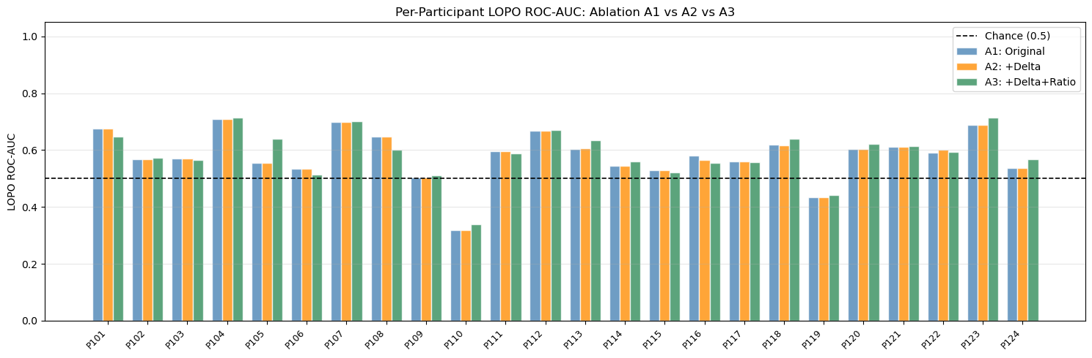

A3 vs A1 — improved: 16 declined: 8

[ Code ]
fig, axes = plt.subplots(1, 2, figsize=(13, 5))

palette = [('A1: Original', y_true_a1, y_proba_a1, 'steelblue'),
('A2: +Delta', y_true_a2, y_proba_a2, 'darkorange'),
('A3: +Delta+Ratio', y_true_a3, y_proba_a3, 'seagreen')]

for label, y_true, y_proba, color in palette:
fpr, tpr, _ = roc_curve(y_true, y_proba)
a = sklearn_auc(fpr, tpr)
axes[0].plot(fpr, tpr, color=color, lw=2, label=f'{label} (AUC={a:.3f})')

axes[0].plot([0, 1], [0, 1], '--', color='gray', lw=1, label='Chance')
axes[0].set_xlabel('False Positive Rate')
axes[0].set_ylabel('True Positive Rate')
axes[0].set_title('Window-Level ROC (LOPO aggregated)')
axes[0].legend(fontsize=8)
axes[0].grid(alpha=0.3)

seg_palette = [('A1: Original', seg_df_a1, 'steelblue'),
('A2: +Delta', seg_df_a2, 'darkorange'),
('A3: +Delta+Ratio', seg_df_a3, 'seagreen')]

for label, seg_df_plot, color in seg_palette:
fpr_s, tpr_s, _ = roc_curve(seg_df_plot['true_label'], seg_df_plot['proba_mean'])
a_s = sklearn_auc(fpr_s, tpr_s)
axes[1].plot(fpr_s, tpr_s, color=color, lw=2, label=f'{label} (AUC={a_s:.3f})')

axes[1].plot([0, 1], [0, 1], '--', color='gray', lw=1, label='Chance')
axes[1].set_xlabel('False Positive Rate')
axes[1].set_ylabel('True Positive Rate')
axes[1].set_title('Segment-Level ROC (LOPO aggregated)')
axes[1].legend(fontsize=8)
axes[1].grid(alpha=0.3)

plt.suptitle('Ablation ROC Curves: A1 vs A2 vs A3', fontsize=11)
plt.tight_layout()
plt.savefig('nb06_roc_curves.png', dpi=150, bbox_inches='tight')
plt.show()

<Figure size 1300x500 with 2 Axes>

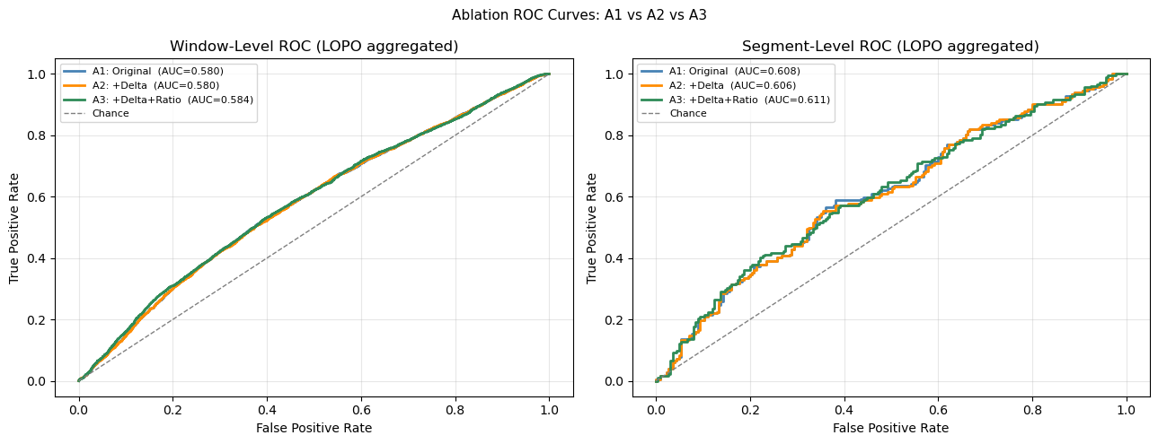

[ Code ]
# Feature importance for A3 (full relative model), averaged over 24 folds
imp_df = pd.DataFrame({'feature': list(FEAT_A3), 'importance': imp_a3})
imp_df['group'] = 'original'
imp_df.loc[imp_df['feature'].str.endswith('_delta'), 'group'] = 'delta'
imp_df.loc[imp_df['feature'].str.endswith('_ratio'), 'group'] = 'ratio'

top_n = 25
top = imp_df.nlargest(top_n, 'importance').reset_index(drop=True)

color_map = {'original': 'steelblue', 'delta': 'darkorange', 'ratio': 'seagreen'}
bar_colors = top['group'].map(color_map).values

fig, ax = plt.subplots(figsize=(10, 8))
ax.barh(range(len(top)), top['importance'].values, color=bar_colors, alpha=0.85)
ax.set_yticks(range(len(top)))
labels_short = (top['feature']
.str.replace('_delta', '_d', regex=False)
.str.replace('_ratio', '_r', regex=False))
ax.set_yticklabels(labels_short.values, fontsize=8)
ax.invert_yaxis()
ax.set_xlabel('Mean Feature Importance (averaged over 24 folds)')
ax.set_title(f'Top {top_n} Features by Importance — A3 (Orig + Delta + Ratio)')
patches = [mpatches.Patch(color=c, label=l) for l, c in color_map.items()]
ax.legend(handles=patches, loc='lower right', fontsize=9)
ax.grid(axis='x', alpha=0.3)
plt.tight_layout()
plt.savefig('nb06_feature_importance.png', dpi=150, bbox_inches='tight')
plt.show()

print('Feature importance by group (A3):')
group_summary = imp_df.groupby('group')['importance'].agg(['mean', 'sum']).round(4)
print(group_summary.to_string())
print()

# Identify top-2 original features (used in distribution plot below)
top2_orig = (imp_df[imp_df['group'] == 'original']
.nlargest(2, 'importance')['feature']
.tolist())
print(f'Top-2 original features for distribution plot: {top2_orig}')

<Figure size 1000x800 with 1 Axes>

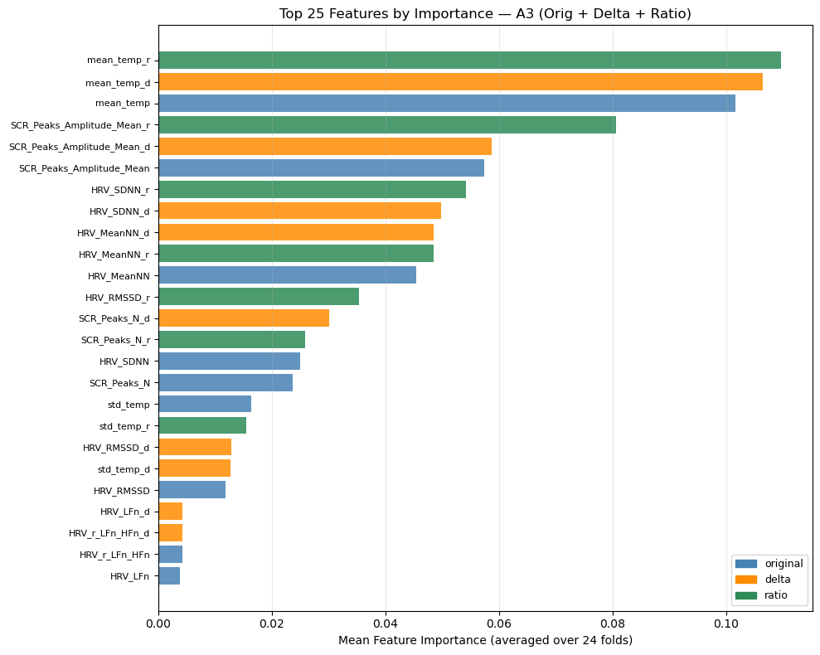

Feature importance by group (A3):
mean sum
group
delta 0.0330 0.3302
original 0.0291 0.2911
ratio 0.0379 0.3787

Top-2 original features for distribution plot: ['mean_temp', 'SCR_Peaks_Amplitude_Mean']

[ Code ]
# Correlation analysis: original vs delta vs ratio for a sample of 5 features
# Use the top-5 original features by importance in A1
imp_df_a1 = pd.DataFrame({'feature': list(FEAT_A1), 'importance': imp_a1})
top5_orig = imp_df_a1.nlargest(5, 'importance')['feature'].tolist()

corr_cols = []
for f in top5_orig:
corr_cols += [f, f'{f}_delta', f'{f}_ratio']

corr_data = dataset_aug_norm[corr_cols].dropna()
corr_matrix = corr_data.corr()

short = [c.replace('_delta', '_d').replace('_ratio', '_r') for c in corr_cols]

fig, ax = plt.subplots(figsize=(12, 10))
im = ax.imshow(corr_matrix.values, cmap='RdBu_r', vmin=-1, vmax=1, aspect='auto')
plt.colorbar(im, ax=ax, shrink=0.75, label='Pearson r')
ax.set_xticks(range(len(corr_cols)))
ax.set_yticks(range(len(corr_cols)))
ax.set_xticklabels(short, rotation=90, fontsize=7)
ax.set_yticklabels(short, fontsize=7)
ax.set_title('Correlation Matrix: Original / Delta / Ratio\n(top-5 features by A1 importance)')
plt.tight_layout()
plt.savefig('nb06_correlation.png', dpi=150, bbox_inches='tight')
plt.show()

print('Pairwise correlations (original <-> relative):')
for f in top5_orig:
r_od = corr_matrix.loc[f, f'{f}_delta']
r_or = corr_matrix.loc[f, f'{f}_ratio']
r_dr = corr_matrix.loc[f'{f}_delta', f'{f}_ratio']
print(f' {f[:30]:<30}: orig-delta={r_od:+.3f} orig-ratio={r_or:+.3f} delta-ratio={r_dr:+.3f}')

<Figure size 1200x1000 with 2 Axes>

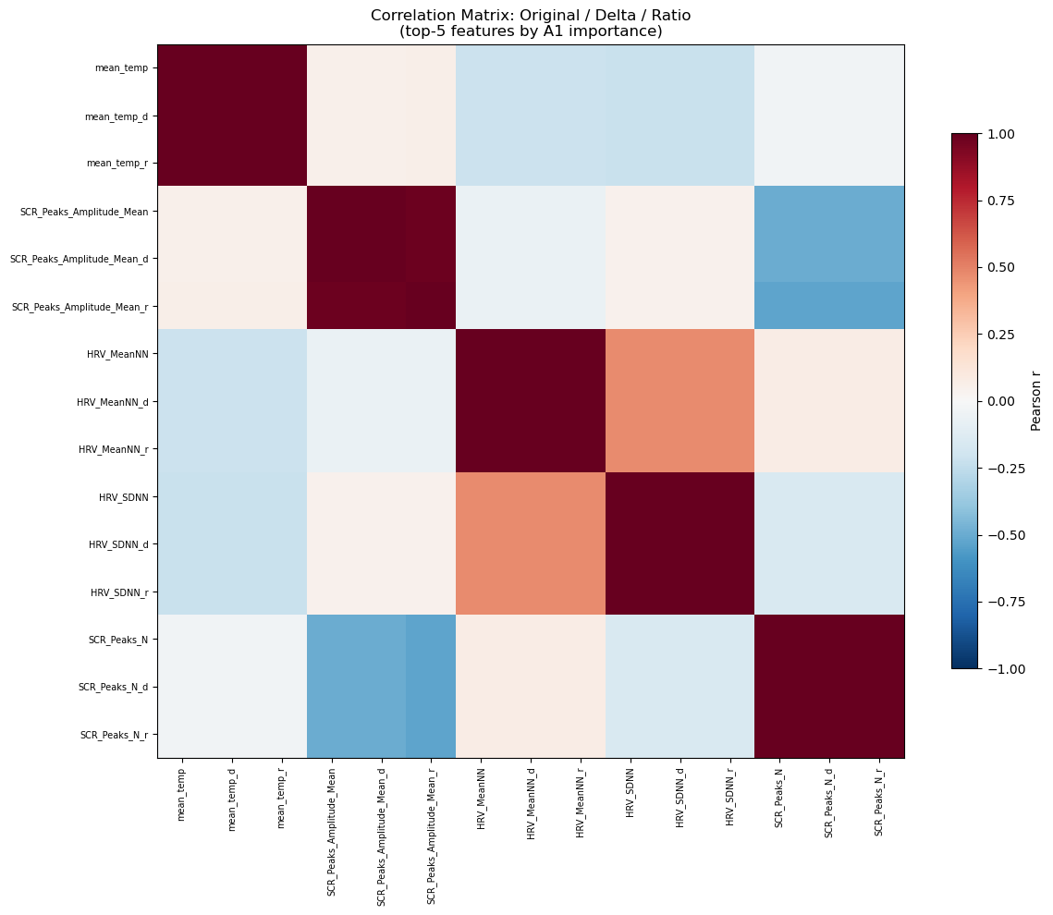

Pairwise correlations (original <-> relative):
mean_temp : orig-delta=+1.000 orig-ratio=+1.000 delta-ratio=+1.000
SCR_Peaks_Amplitude_Mean : orig-delta=+1.000 orig-ratio=+0.977 delta-ratio=+0.977
HRV_MeanNN : orig-delta=+1.000 orig-ratio=+1.000 delta-ratio=+1.000
HRV_SDNN : orig-delta=+1.000 orig-ratio=+1.000 delta-ratio=+1.000
SCR_Peaks_N : orig-delta=+1.000 orig-ratio=+1.000 delta-ratio=+1.000

[ Code ]
# Distribution of top-2 original features: Low vs High, for each representation
fig, axes = plt.subplots(2, 3, figsize=(14, 8))
class_colors = {0: 'steelblue', 1: 'tomato'}
class_labels = {0: 'Low', 1: 'High'}

for row, feat in enumerate(top2_orig[:2]):
feat_versions = [feat, f'{feat}_delta', f'{feat}_ratio']
col_titles = ['Original (absolute)', 'Delta (deviation)', 'Ratio (relative scale)']

for col, (fv, title) in enumerate(zip(feat_versions, col_titles)):
ax = axes[row, col]
for lv in [0, 1]:
vals = dataset_aug_norm.loc[dataset_aug_norm['label'] == lv, fv].dropna()
ax.hist(vals, bins=40, alpha=0.55,
color=class_colors[lv], label=class_labels[lv], density=True)
ax.set_title(f'{title}\n{fv[:35]}', fontsize=8)
ax.set_xlabel('Normalized value', fontsize=8)
ax.set_ylabel('Density', fontsize=8)
ax.tick_params(labelsize=7)
if row == 0 and col == 0:
ax.legend(fontsize=8)
ax.grid(alpha=0.2)

plt.suptitle('Feature Distributions by Class: Original vs Delta vs Ratio\n(Top-2 features by A3 importance)', fontsize=10)
plt.tight_layout()
plt.savefig('nb06_distributions.png', dpi=150, bbox_inches='tight')
plt.show()

<Figure size 1400x800 with 6 Axes>

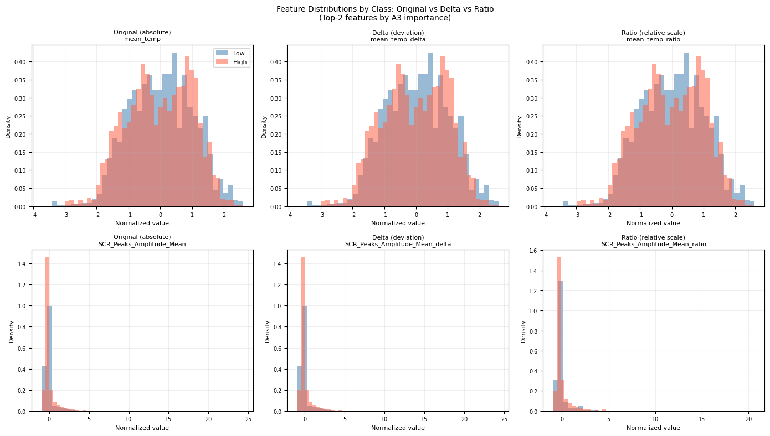

Conclusion — Interpreting the Results

What was tested
This notebook added delta (absolute deviation from personal baseline) and ratio (current-to-baseline ratio) features to the existing absolute physiological features, and tested whether they improve cross-person cognitive load prediction in LOPO evaluation.
A three-way ablation was used:
- A1 — original features only (v2 equivalent)
- A2 — original + delta
- A3 — original + delta + ratio
The same GBT model, LOPO protocol, labels, and normalization were used throughout.

If A2 or A3 improve performance vs A1
- **Inter-person feature scale mismatch was a limiting factor.** The cross-person model
struggled because absolute physiological thresholds do not generalize well. Expressing features relative to each participant's resting baseline gave the model information that the absolute features could not provide.
- **The ablation points to which feature group drove the improvement.** If A2 improves
but A3 does not add further, delta features are sufficient and ratio features add noise. If A3 further improves on A2, ratio features capture a complementary signal (multiplicative scaling) that delta alone misses.
- **Practical implication.** A brief pre-task baseline session improves the model's
ability to work with a new, unseen participant. This motivates including a short onboarding calibration in any deployed wearable CLI system.

If A2 and A3 do not improve vs A1
- **The per-participant z-score normalization already accounts for baseline differences.**
The z-scoring in v2 normalizes each participant's features to zero mean and unit variance, effectively centering each person's distribution. After z-scoring, the delta features are highly correlated with the original features (as the correlation analysis in c15 reveals) and therefore add little new information.
- **The bottleneck is not feature representation.** If even personalized relative
features do not help, the signal-to-noise ratio in the physiological features themselves may be the limiting factor — not how we scale them. This would point toward richer feature engineering, longer signal windows, or additional modalities.
- **GBT with 100 trees may underfit the wider feature space.** Tripling feature
count without increasing model capacity is a known risk. A degradation in A3 compared to A2 (but not A1) would indicate the ratio features add noise that 100 shallow trees cannot filter. This is an honest limitation of fixing n_estimators=100 across all ablations.

What this analysis is — and is not
This IS | This is NOT
A controlled ablation of relative feature engineering | Full personalization
A test using the same model, labels, and protocol | Hyperparameter optimization
An honest comparison of absolute vs relative features | A claim of production-ready accuracy
A calibration-based scenario (Low windows only) | Use of any test-participant task labels

Connection to the project narrative
This notebook completes the progressive improvement story:
Notebook | Contribution
02 | Established the v2 baseline with LOPO and normalization
03 | Identified label noise via NASA-TLX questionnaire
04 | Tested noisy-label filtering (v3) as a training data improvement
05 | Tested baseline calibration as a normalization improvement
06 | Tested relative feature engineering as a feature representation improvement
Each notebook addresses one dimension of the cross-person generalization problem. Together they form a systematic analysis of the factors limiting CLI performance for new, unseen participants.

