Omega parameter per weeks of windows
1 week 1,195.4265
2 weeks 1,833.9068
4 weeks 2,523.135
8 weeks 3,551.469
12 weeks 6,692.433
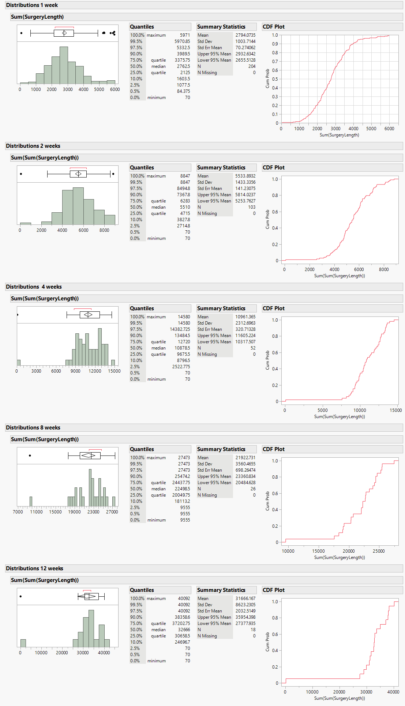

Distributions 1 week

Sum(SurgeryLength)
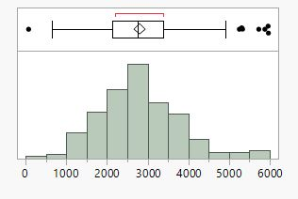

Quantiles

100.0% | maximum | 5971
99.5% |  | 5970.85
97.5% |  | 5332.5
90.0% |  | 3989.5
75.0% | quartile | 3375.75
50.0% | median | 2762.5
25.0% | quartile | 2125
10.0% |  | 1603.5
2.5% |  | 1077.5
0.5% |  | 84.375
0.0% | minimum | 70

Summary Statistics

Mean | 2794.0735
Std Dev | 1003.7144
Std Err Mean | 70.274062
Upper 95% Mean | 2932.6342
Lower 95% Mean | 2655.5128
N | 204
N Missing | 0

CDF Plot
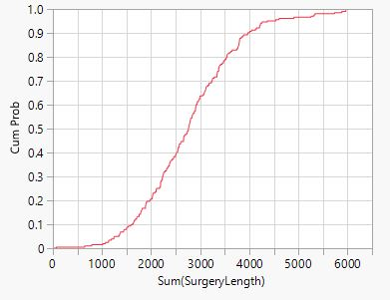

Distributions 2 weeks

Sum(Sum(SurgeryLength))
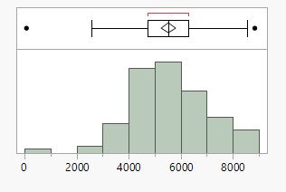

Quantiles

100.0% | maximum | 8847
99.5% |  | 8847
97.5% |  | 8494.8
90.0% |  | 7367.8
75.0% | quartile | 6283
50.0% | median | 5510
25.0% | quartile | 4715
10.0% |  | 3827.8
2.5% |  | 2714.8
0.5% |  | 70
0.0% | minimum | 70

Summary Statistics

Mean | 5533.8932
Std Dev | 1433.3356
Std Err Mean | 141.23075
Upper 95% Mean | 5814.0237
Lower 95% Mean | 5253.7627
N | 103
N Missing | 0

CDF Plot
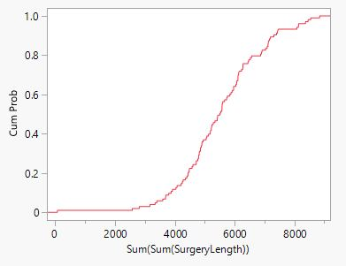

Distributions 4 weeks

Sum(Sum(SurgeryLength))
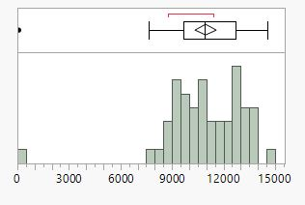

Quantiles

100.0% | maximum | 14580
99.5% |  | 14580
97.5% |  | 14382.725
90.0% |  | 13484.5
75.0% | quartile | 12720
50.0% | median | 10878.5
25.0% | quartile | 9675.5
10.0% |  | 8796.5
2.5% |  | 2522.775
0.5% |  | 70
0.0% | minimum | 70

Summary Statistics

Mean | 10961.365
Std Dev | 2312.6963
Std Err Mean | 320.71328
Upper 95% Mean | 11605.224
Lower 95% Mean | 10317.507
N | 52
N Missing | 0

CDF Plot
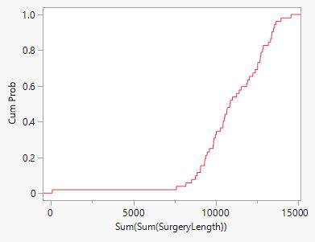

Distributions 8 weeks

Sum(Sum(SurgeryLength))
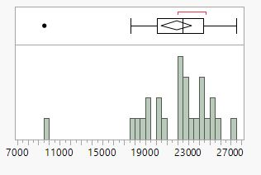

Quantiles

100.0% | maximum | 27473
99.5% |  | 27473
97.5% |  | 27473
90.0% |  | 25474.2
75.0% | quartile | 24437.75
50.0% | median | 22498.5
25.0% | quartile | 20049.75
10.0% |  | 18113.2
2.5% |  | 9555
0.5% |  | 9555
0.0% | minimum | 9555

Summary Statistics

Mean | 21922.731
Std Dev | 3560.4655
Std Err Mean | 698.26474
Upper 95% Mean | 23360.834
Lower 95% Mean | 20484.628
N | 26
N Missing | 0

CDF Plot
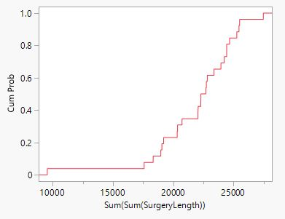

Distributions 12 weeks

Sum(Sum(SurgeryLength))
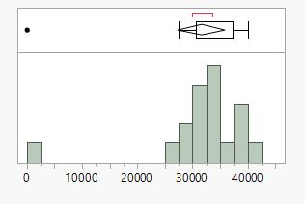

Quantiles

100.0% | maximum | 40092
99.5% |  | 40092
97.5% |  | 40092
90.0% |  | 38358.6
75.0% | quartile | 37202.75
50.0% | median | 32666
25.0% | quartile | 30658.5
10.0% |  | 24696.7
2.5% |  | 70
0.5% |  | 70
0.0% | minimum | 70

Summary Statistics

Mean | 31666.167
Std Dev | 8623.2305
Std Err Mean | 2032.5149
Upper 95% Mean | 35954.398
Lower 95% Mean | 27377.935
N | 18
N Missing | 0

CDF Plot
