Ketamine-Induced Analgesia and Dissociation Show Distinct Behavioral and Neural Correlates

Noam Goldway 1,2,3,4, Itamar Jalon 3,6, Yara Agbaria 2,3,4, Yotam Pasternak 5,7, Roy Sar-El 5,8, Dan Mirelman 5,9, Noam Sarna 3,10, Nili Green 3,4, Talma Hendler* 2,3,4,5, Haggai Sharon* 2,3,4,5,11

1.Department of Neuroimaging, Institute of Psychiatry, Psychology and Neuroscience, King’s College London, London, United Kingdom
2.Sagol School of Neuroscience, Tel Aviv University, Tel Aviv, Israel
3.Sagol Brain Institute, Wohl Institute for Advanced Imaging, Tel Aviv Sourasky Medical Center, Tel Aviv, Israel
4. The Institute for Psychedelic Research, Tel Aviv University, Tel Aviv, Israel
5. Gray Faculty of Medical and Health Sciences, Tel Aviv University, Tel Aviv, Israel
6.Princeton Neuroscience Institute, Princeton, NJ, USA
7.Department of Internal Medicine, Tel Aviv Sourasky Medical Center, Tel Aviv, Israel
8.Department of Psychiatry, Tel-Aviv Sourasky Medical Center & Sackler Faculty of Medicine, Tel Aviv University, Israel
9.Institute of Oncology, Tel Aviv Sourasky Medical Center, Tel Aviv, Israel
10. The School of Psychological Sciences, Tel Aviv University, Tel Aviv, Israel
11.Department of Anesthesiology and Critical Care Medicine, Institute of Pain Medicine, Tel Aviv Sourasky Medical Center, Tel Aviv-Yafo, Israel

*Equal contribution status

Correspondence concerning this manuscript should be addressed to Noam Goldway
(noam.goldway@kcl.ac.uk), Department of Neuroimaging, King’s College London,
London, UK De Crespigny Park, SE5 8AF

Abstract
Ketamine produces both analgesic and dissociative effects, but whether analgesia depends on dissociation remains debated. This question is part of a broader discussion on whether the subjective experiences elicited by psychoactive drugs are necessary for their therapeutic benefits. Here, we tested whether ketamine-induced analgesia and dissociation show separable behavioral and neural signatures, supporting functional separation.

In a within-subject, placebo-controlled fMRI study, 37 healthy volunteers (21 female) underwent two sessions: intravenous ketamine (0.4 mg/kg bolus over 10 minutes followed by 0.4 mg/kg/h continuous infusion) or saline placebo. Individually calibrated thermal pain stimuli were applied to the right leg during scanning. Dissociative states were measured repeatedly using the Clinician-Administered Dissociative States Scale. Whole-brain univariate and multivariate analyses, as well as network-based functional connectivity analyses, were performed.
Ketamine induced both analgesia (session × pain intensity interaction: F(1,54) = 11.22, p < .001) and dissociation (main effect of session: F(1,32) = 57.44, p < .001), and the two corresponded to distinct neural indices. Greater pain was associated with increased univariate activity in regions such as the anterior insula, as well as with stronger expression of a pain-predictive multivoxel pattern (ρ = .6, p < .001), whereas higher dissociation intensity was selectively associated with reduced default mode network connectivity (ρ = .49, p < .01). Neurobehavioral markers of pain and dissociation did not covary (ρ = −.24 to .32, all p > .09), consistent with distinct neural correlates of ketamine’s analgesic and dissociative effects.
Key words: Ketamine, Analgesia, Dissociation, Pain, Default mode network, Neurologic Pain Signature

Introduction

As the therapeutic potential of serotonergic psychedelics (e.g., psilocybin, LSD) and dissociative agents (e.g., ketamine) has come under renewed scientific investigation^{1–4}, a key question has emerged: to what extent are their clinical benefits dependent on the altered states of consciousness they induce? While some regard the subjective experience as an epiphenomenon of neurochemical action, others argue it is integral to therapeutic efficacy^{5–7}.
An interesting case is the relationship between dissociation and analgesia. Dissociation is a disruption or discontinuity in the normal functioning of cognitive modules such as affect, memory, identity, perception, and motor control⁸ and is often measured along three dimensions: detachment from self (depersonalization), detachment from surroundings (derealization), and discontinuation of ongoing experience⁹. Clinically, dissociative states were shown to be related to pain hyposensitivity in borderline personality disorder (BPD), and in PTSD^{10–13}. Pharmacologically, both dissociation and analgesia can be induced using ketamine^{14–16}. The co-occurrence of dissociation and reduced pain sensitivity in both clinical and pharmacological contexts has led some to speculate about a mechanistic link between the two phenomena. The dissociative state, wherein an individual feels disconnected from their own body and affective state, can potentially modify the threatening, unpleasant nature of the pain experience. This modification can lead to an analgesic effect where the pain is perceived as less intense¹⁷. An alternate perspective suggests that the analgesic and dissociative effects are independent, stemming from different mechanisms. This debate is fueled by mixed results. Support for the notion that the two effects are correlated can be found in clinical guidelines¹⁸ and empirical findings demonstrating that similar plasma concentrations of ketamine and its metabolites are needed to produce its analgesic and mind-altering effects¹⁹. However, other studies suggest that ketamine’s analgesic and dissociative effects are not correlated^{20,21}. The question of whether dissociative and analgesic effects of ketamine have distinct mechanisms remains open. A potential approach to address this question could involve examining ketamine's impact on the neural systems that underlie its analgesic and dissociative effects.

The cortical mechanisms supporting acute pain are well-characterized and include activation across a broad network of brain regions such as the insula, dorsal Anterior Cingulate Cortex (dACC), primary (S1) and secondary (S2) somatosensory cortices, and subcortical regions including the thalamus, basal ganglia, amygdala, and periaqueductal gray (PAG)²². Early research indicates that ketamine reduces pain related activation in areas such as the S2, insula, and dACC²³.

The neural mechanisms underlying ketamine-induced dissociation remain less well characterized. Most imaging work has examined resting-state functional connectivity, but findings are heterogeneous, with studies reporting decreased, increased, or unchanged connectivity depending on the networks examined, dose, timing, vigilance state, and analytic approach^{24–29}. Despite this variability, the DMN has received particular attention, given its proposed role in self-referential and higher-order cognitive processes that may be disrupted during dissociative states^{30–32}.

In the current study, our aim was to examine whether the analgesic and dissociative effects of ketamine correspond to the same or distinct neural signatures. A total of thirty-seven healthy volunteers (mean age 29.7 ± 3.21 years, 21 females) were enrolled in the study (ClinicalTrials.gov Identifier: NCT02037503), with 33 completing the full procedure (mean age 30.1 ± 3.09 years, 18 females), see supplementary for full details. Each volunteer participated in two sessions: one involving the administration of a placebo (IV saline) and the other involving the administration of racemic ketamine (initial bolus of .4 mg/kg IV over 10 minutes, followed by a continuous drip of .4 mg/kg/h). Before administering either substance, participants underwent a pain calibration procedure (see methods). Approximately ten minutes after the conclusion of the initial bolus infusion, participants responded to a verbally administered Clinician-Administered Dissociative States Scale (CADSS) to assess their dissociative state⁹ (figure 1.A). Afterward, participants took part in an fMRI scan in which they received both a painful and non-painful thermal stimulus (figure 1.B).

We hypothesized that, compared to placebo, ketamine would reduce pain intensity and increase feelings of dissociation. Drawing on previous studies (e.g.,²³), we anticipated that the analgesic effect of ketamine would be associated with decreased activity in multiple brain regions known to mediate pain perception, including somatosensory areas, the anterior insula, and the dACC. We then examined whether changes in neural activation related to ketamine’s analgesic effects also correspond to individual differences in dissociation ratings. Furthermore, we tested whether dissociation would be correlated with alterations in network connectivity across large-scale brain networks.

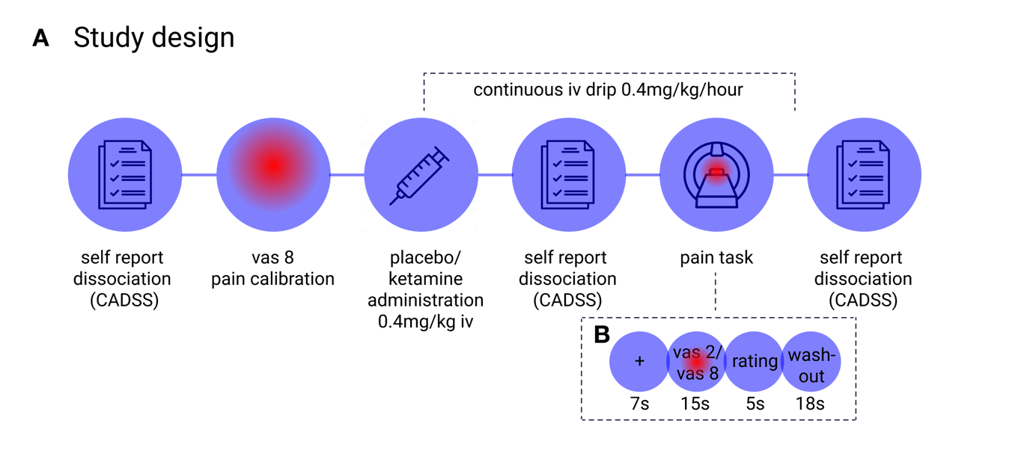

Figure 1

Materials and methods
The study, approved by the Tel-Aviv Sourasky Medical Center institutional review board (IRB) (ClinicalTrials.gov Identifier: NCT02037503), employed a single-blind, placebo-controlled, within-subjects design. Participants completed two experimental sessions in which they received placebo (IV infusion of saline .9% NaCl) or ketamine via intravenous infusion (.4 mg/kg IV over 10 minutes, followed by a continuous drip of .4 mg/kg/h using an infusion pump³³). Following task training and individualized pain calibration, participants underwent fMRI scanning that included the “pain task”^{34,35}. Dissociative symptoms were assessed using the CADSS⁹ at three time points in each session: pre-infusion, post-bolus (10 min after completion of the bolus infusion), and end of infusion (figure 1.A). For all analyses relating dissociation to pain outcomes, dissociation was operationalized using post-bolus CADSS scores, which captured peak dissociative intensity. Analyses in the present report focus exclusively on behavioral and neural responses during the physical pain task; other tasks and questionnaires are reported elsewhere.
The study employed a fixed-order design in which the placebo session always preceded the ketamine session. This order was intentional to minimize expectancy effects: reversing the order would create an imbalance in blinding—participants receiving ketamine first would necessarily know their second session is placebo, while those beginning with placebo would know ketamine follows, creating comparable expectancy biases. The interval between sessions averaged 24.0 ± 17.1 days.
Thirty-seven healthy volunteers were enrolled (mean age 29.7 ± 3.21 years; 21 females, 16 males), and 33 completed the full procedure (mean age 30.1 ± 3.09 years; 18 females, 15 males). All participants had a mean body weight of 61.6 ± 9.4 kg (range: 43–81 kg) and received weight-based dosing (0.4 mg/kg bolus, 0.4 mg/kg/h infusion).
Physical pain was assessed using a previously established thermal stimulation paradigm (figure 1.B)^{34,35}, which also included an additional mental pain condition not examined here. Participants received painful and nonpainful thermal stimuli applied to the right lower leg and rated perceived pain intensity following each trial. Stimulus intensities were individually calibrated for each participant and session to equate subjective pain levels across individuals^{36–38}.
Functional MRI data were acquired on a 3T Siemens Prisma scanner using a gradient-echo echo-planar imaging (EPI) sequence with the following parameters: repetition time (TR) = 2.5 seconds, echo time (TE) = 35 milliseconds, flip angle = 84°, slice thickness = 2 mm, in-plane voxel size = 2 × 2 mm, field of view = 176× 176 mm, matrix size = 88 × 88 voxels. Data were acquired using simultaneous multi-slice (SMS) excitation with a factor of 2, yielding 74 contiguous axial slices covering the entire brain. Each functional run consisted of 444 volumes. Phase-encoding direction was posterior-anterior, and susceptibility-induced distortion correction was performed using a fieldmap-based approach. Preprocessing was performed using fMRIPrep³⁹, followed by spatial smoothing and first-level general linear model (GLM) analyses implemented in SPM12. Task-related neural responses were modeled using canonical hemodynamic response functions, and subject-level contrast maps were entered into random-effects group analyses. Nuisance regressors included six head motion parameters and their derivatives, quadratics, and squared derivatives (totaling 24), framewise displacement (FD), and 18 physiological regressors (e.g., heart rate and respiration). Volumes with FD > .4 mm were marked as motion outliers and scrubbed.
To quantify pain-related neural responses, we applied the Neurological Pain Signature (NPS), a validated multivariate brain pattern shown to reliably predict physical pain intensity⁴⁰. NPS expression was computed for each condition and participant by applying the established voxel-wise weights to individual activation maps, yielding a scalar measure of pain-related neural activity^{41–44}.
To examine ketamine-related changes in large-scale brain organization, we conducted functional connectivity analyses during the pain paradigm. After standard preprocessing and denoising, we used group-level independent component analysis (ICA) to identify canonical large-scale functional networks^{45–47} (Supplementary Table S1). Within-network connectivity was compared between ketamine and placebo sessions.
Statistical analyses were conducted using mixed-effects models with maximal random-effects structures, where possible, to assess within-subject drug effects. Whole-brain fMRI results were corrected for multiple comparisons using false discovery rate (FDR) procedures. Additional details about the methods can be found in the supplementary material.
Results
Behavioral results
Effect of ketamine on pain perception
Calibration temperatures did not differ between placebo and ketamine sessions (non-painful: placebo = 41.7 ± 1.94°C, ketamine = 41.8 ± 1.98°C; painful: placebo = 46.1 ± 1.52°C, ketamine = 45.9 ± 1.72°C; all p > .25), indicating comparable stimulus intensity across conditions.
To assess ketamine’s effect on pain perception, we fit a mixed-effects model with session (ketamine vs. placebo) and stimulus intensity (painful vs. non-painful) as predictors. Painful stimuli elicited substantially higher pain ratings than non-painful stimuli (F(1,27) = 239.74, p < .001). Ketamine significantly reduced pain perception, as reflected in a main effect of session (F(1,54) = 34.88, p < .001) and a session × intensity interaction (F(1,54) = 11.22, p < .001). Post-hoc tests showed that ketamine selectively reduced ratings for painful stimuli (t(54) = 6.55, p < .001), with no significant effect on non-painful stimuli (t(54) = 1.81, p = .076; Figure 2.A). Including session-specific calibrated temperature as a covariate did not improve model fit (χ²(1) = 2.66, p = 0.103).
Effect of ketamine on dissociative state
To assess ketamine’s effects on dissociation, we fit a linear mixed-effects model with session (ketamine/placebo), time point, CADSS subscale (depersonalization, derealization, amnesia), and their interactions as predictors. Ketamine robustly increased subjective dissociation, as indicated by a strong main effect of session (F(1,32.07) = 57.44, p < .001). This effect peaked after infusion onset, reflected in a significant session × time point interaction (F(2,477.73) = 109.51, p < .001). Ketamine significantly increased scores across all dissociation subscales between the pre-infusion and post-bolus time points (all p < .001), whereas no corresponding changes were observed in the placebo session (all p > .9; Figure 2.B). Ketamine-induced dissociation did not vary with participant body weight (Figure S1).
To test our primary question: whether dissociation is related to pain perception under ketamine, we examined Spearman correlations between pain-related and dissociation measures. Dissociation was indexed at the post-bolus peak using CADSS total and subscale scores, and pain was indexed using three complementary measures: ketamine–placebo differences in pain ratings, pain–no-pain contrasts, and pain ratings for high-intensity stimuli under ketamine. Dissociation measures were moderately to strongly intercorrelated (ρ = .47–.85, all p < .011), with the exception of amnesia and depersonalization, which were not significantly associated (ρ = .28, p = .151). Pain indices were also strongly intercorrelated (ρ = .67–.80, all p < .001), indicating internal consistency within each domain. However, dissociation measures showed no significant associations with any pain index (ρ = −.24 to .32, all p > .09), providing no evidence for a relationship between subjective dissociation and pain perception during ketamine administration (Figure 2C).

Figure 2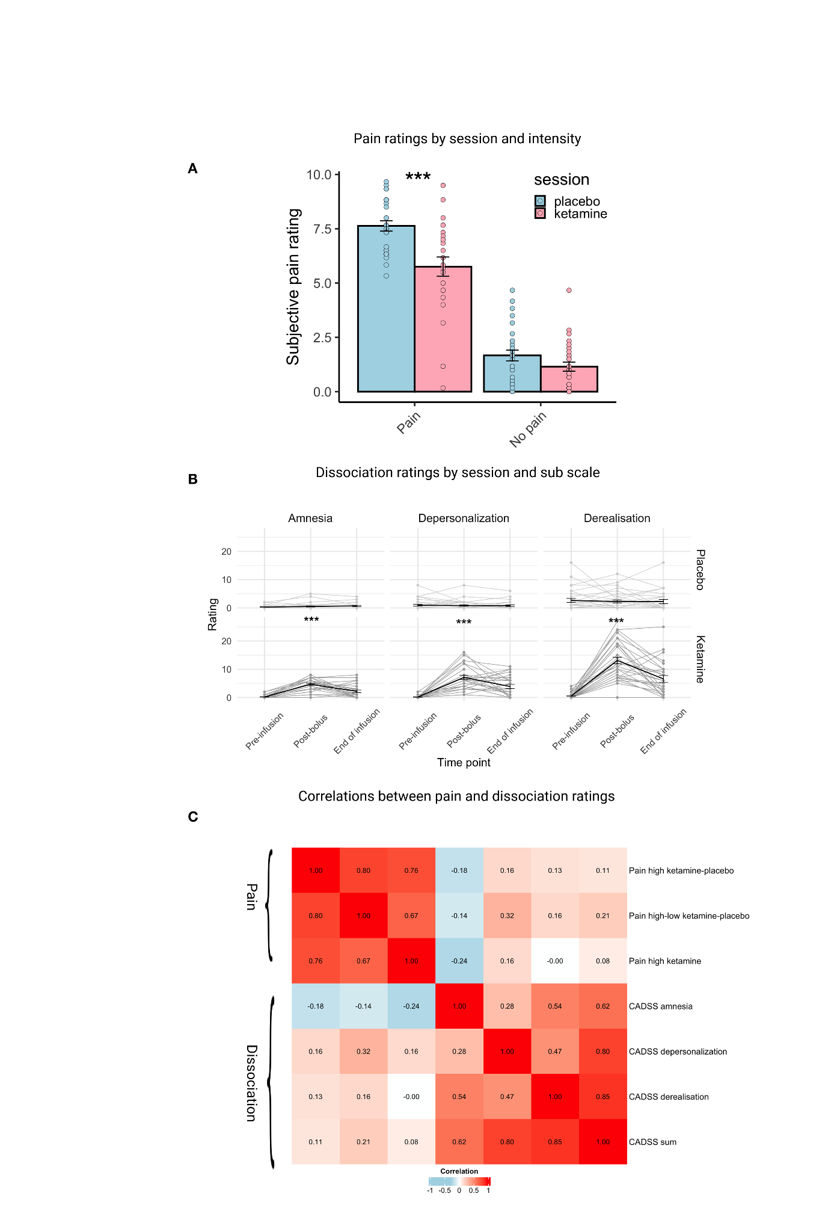

fMRI results
Pain response: univariate analysis
Placebo session
A whole-brain contrast of painful versus non-painful stimulation during the placebo session (n = 32) revealed robust activation in canonical pain-related regions, including the anterior insula, dACC, dorsolateral prefrontal cortex (dlPFC), S1, and supramarginal gyrus/secondary somatosensory cortex (S2; Figure 3.A; Table 1). Results were thresholded at a voxelwise cluster-forming threshold of p < .001 (FDR corrected), with cluster-level FDR correction at p < .05. During the ketamine session, no clusters survived the primary threshold. At a more liberal threshold (voxelwise p < .005 uncorrected; cluster-level FDR p < .05), a weaker but similar painful > non-painful pattern emerged, along with two non-painful > painful clusters in the precuneus/posterior cingulate and S1/precentral gyrus (Figure 3.B and Supplementary Table S5).
Brain region | L/R | Cluster size | peak p-value | MNI coordinates
 |  |  |  | x | y | z
Anterior insula /Opercular Cortex | R | 1090 | <.001 | 56 | 8 | 4
Anterior insula / Opercular Cortex | L | 709 | <.001 | -44 | 2 | 6
S2 | R | 329 | <.001 | 62 | -28 | 26
ACC |  | 313 | <.001 | 4 | 8 | 46
S2 | L | 229 | <.001 | -56 | -30 | 24
Dorsolateral Prefrontal cortex | R | 68 | <.001 | 36 | 48 | 26
Cerebellum | R | 23 | <.001 | 32 | -54 | -28
S1 | R | 16 | <.001 | 52 | 6 | 44
Dorsal Striatum | L | 16 | <.001 | -26 | 6 | 0
Table 1
Effects of Ketamine on univariate pain related brain activation
To assess ketamine’s effects on regional pain-related activity, we analyzed mean activation within cortical clusters identified in the painful versus non-painful contrast during the placebo session. Mean beta values were entered into a linear mixed-effects model with stimulus intensity (painful vs. non-painful), session (placebo vs. ketamine), and region of interest (ROI) as predictors (n = 28).
Across regions, painful stimulation elicited stronger activation than non-painful stimulation, as reflected in a robust main effect of intensity (F(1,702) = 124.27, p < .001). Activation magnitude differed across ROIs (F(6,702) = 8.11, p < .001), and ketamine was associated with an overall reduction in activation, indicated by a main effect of session (F(1,702) = 43.05, p < .001). Importantly, a significant intensity × session interaction (F(1,702) = 16.45, p < .001) indicated that ketamine selectively attenuated pain-related neural responses. Post hoc analyses showed that the difference between painful and non-painful activation was reduced under ketamine across all pain-sensitive ROIs, including bilateral anterior insula, dACC, dlPFC, S1, and bilateral S2 (all p ≤ .014; Figure 3.C; Supplementary Tables S6–S7). We also tested whether individually calibrated stimulus temperature explained additional variance in ROI activation beyond the categorical intensity predictor. Adding calibrated temperature significantly improved model fit (χ²(1) = 9.11, p = .003), and its effect depended on both condition and session (intensity × session × calibration temp: F(1, 681) = 7.16, p = .008), with a shallower activation-temperature slope under ketamine than placebo. This indicates that ketamine reduced not only the overall magnitude of pain-related activation but also the sensitivity of pain-responsive regions to graded noxious input (see Figure S2 and Supplementary Tables S8–S11).
Correspondence between univariate pain-related brain activation and pain ratings
To assess whether activation in pain-related ROIs corresponded to participants’ subjective experience of pain, we computed within-session Spearman correlations between differences in pain ratings (pain – no pain) and corresponding differences in ROI activation (pain – no pain), separately for the placebo and ketamine sessions. In the placebo session, activation in pain-responsive ROIs was positively correlated with reported pain intensity (mean ρ = .369, range: .134–.528). Significant correlations were observed in four ROIs: left anterior insula (ρ = .528, p = .0046), right anterior insula (ρ = .463, p = .015), left S2 (ρ = .460, p = .016), and right S2 (ρ = .427, p = .026). Correlations in other ROIs, including the dACC, right dlPFC, and right S1, were positive but did not reach significance. In the ketamine session, the overall strength of correlations was numerically higher (mean ρ = .532, range: .344–.656), and six of seven ROIs showed significant associations with pain ratings. These included the left anterior insula (ρ = .656, p < .001), right anterior insula (ρ = .561, p = .002), dACC (ρ = .651, p < .001), right dlPFC (ρ = .570, p = .002), right S1 (ρ = .448, p = .019), and right S2 (ρ = .491, p = .009). The left S2 showed a nonsignificant but positive correlation (ρ = .344, p = .079). All p values are uncorrected. Notably, Steiger's test for non-overlapping dependent correlations revealed no significant differences in any ROI (all p > .11), indicating that ketamine did not significantly alter the strength of brain–pain coupling. These results indicate that subjective pain intensity is univariately represented in most pain-related ROIs, and this relationship is consistent across both placebo and ketamine administration (see Figure 3.D and Supplementary Table S12).
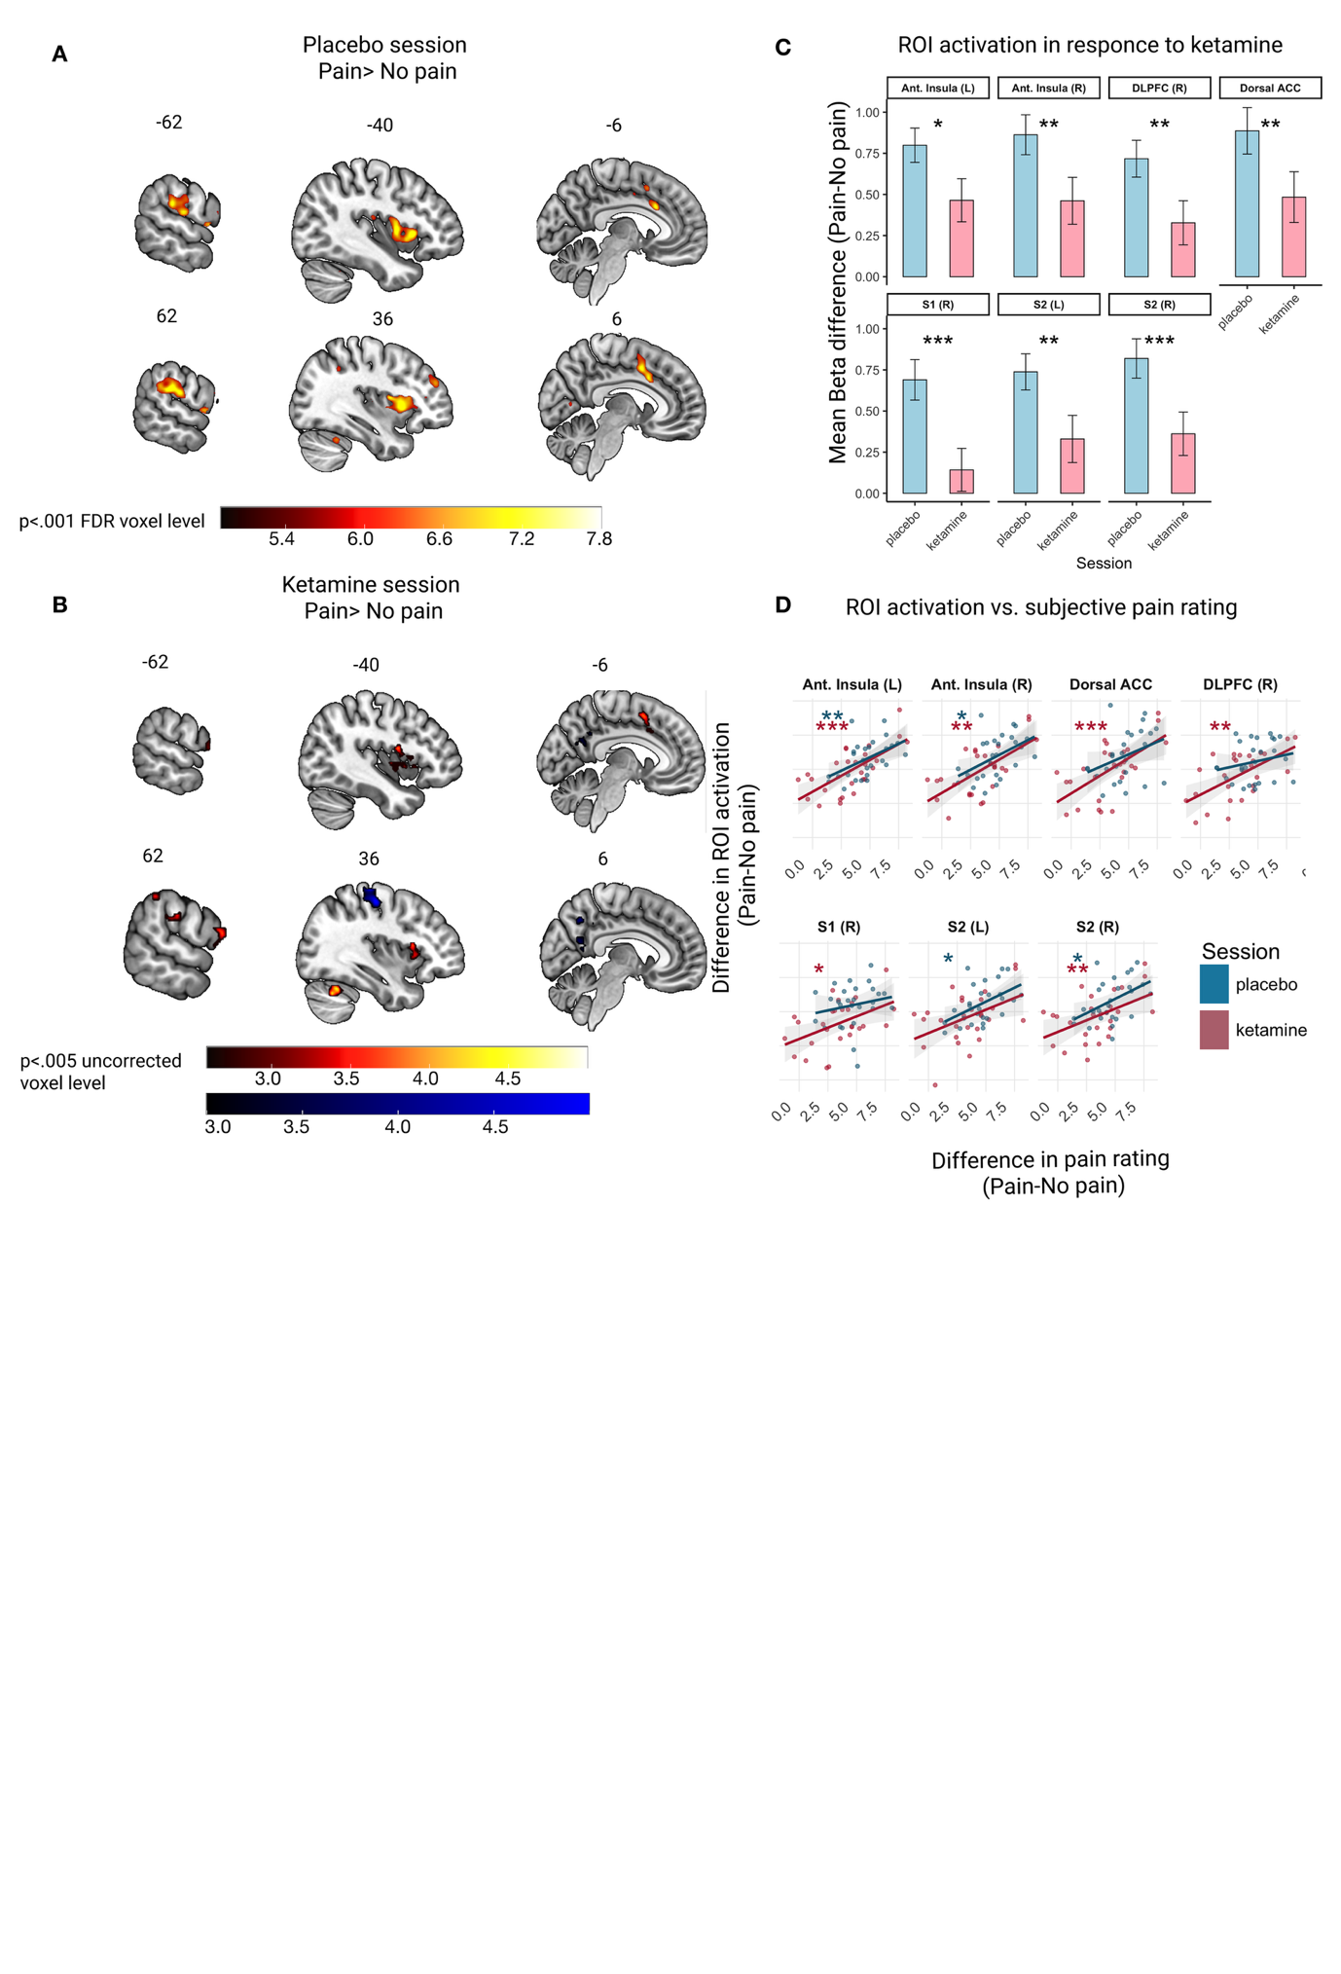Figure 3
Correspondence between univariate pain-related brain activation and dissociation ratings
To test whether pain-related brain activation under ketamine reflected subjective pain experience specifically, rather than dissociative symptoms, we examined whether dissociation explained additional variance in activation of pain-sensitive ROIs. For each ROI, we computed the difference in activation between high- and low-pain conditions during the ketamine session. Activation differences were first modeled as a function of subjective pain ratings (pain–no pain), and dissociation ratings, indexed as ketamine–placebo changes in CADSS subscales, were then added to assess incremental explanatory value.
Subjective pain ratings significantly predicted activation differences in most pain-sensitive regions (p < .05), except for right S1 (p = .09). In contrast, dissociation ratings did not explain additional variance in any ROI (all p > .63; Supplementary Table S13). These results indicate that ketamine-induced reductions in pain-related brain activation track subjective pain experience without a corresponding contribution from dissociative effects.
Pain response: multivariate analysis
We next examined the NPS, a validated multivoxel biomarker of subjective pain intensity^{40,48}. A linear mixed-effects model with task condition (painful vs. non-painful) and session (placebo vs. ketamine) revealed higher NPS responses during painful relative to non-painful stimulation (F(1,26) = 42.91, p < .001). NPS expression was reduced under ketamine, as indicated by a main effect of session (F(1,26) = 4.71, p = .039) and a condition × session interaction (F(1,26) = 5.43, p = .028). Post hoc analyses showed that NPS responses to painful stimuli were significantly lower during the ketamine session compared with placebo (t(41.4) = 3.04, p = .004), with no difference for non-painful stimuli (t(41.4) = 0.73, p = .47). Importantly, the NPS continued to reliably distinguish painful from non-painful stimulation in both the placebo (t(49) = 6.60, p < .001) and ketamine sessions (t(49) = 3.74, p < .001; Figure 4.A).
Correspondence between multivariate pain-related brain activation and pain ratings
We next tested whether the relationship between subjective pain ratings and NPS expression was preserved under ketamine. Spearman correlations between pain ratings and NPS responses revealed strong associations during high-pain stimulation in both the placebo (ρ = .64, p < .001) and ketamine (ρ = .60, p < .001) sessions, indicating that the NPS remained a reliable marker of subjective pain under ketamine (Figure 4.B,C). Importantly, dissociation ratings did not explain additional variance in NPS expression beyond pain ratings alone (p = .28; Supplementary Table S14), suggesting that multivariate pain-related brain activity under ketamine does not track dissociative experience.
Neural correlates of dissociative states
We next asked whether neural indices previously linked to ketamine-induced dissociation could explain individual variability, and whether such indices were specific to dissociation or also related to analgesia. Given ketamine’s described effects on large-scale brain networks^{24,25,27,49,50}, we examined its impact on network-level functional connectivity during the pain task.
We assessed within-network connectivity across five canonical networks (DMN, SN, frontoparietal, sensorimotor, and dorsal attention networks). Ketamine significantly reduced within-network connectivity in the DMN (t = −5.38, p < .001) (Figure 4.D), whereas effects on other networks were not significant (all p > .343; Supplementary Figure S3).
To determine whether ketamine-induced changes in DMN connectivity were related to dissociation, we correlated session-wise differences in DMN connectivity (placebo– ketamine) with peak post-bolus dissociation ratings. Reduced DMN connectivity was significantly associated with higher dissociation scores (CADSS total: ρ = .49, p < .01; Figure 4.E). Subscale analyses revealed significant associations with derealization (ρ = .58, p = .005) and amnesia (ρ = .37, p = .05), but not depersonalization (ρ = .24, p = .23). In contrast, changes in DMN connectivity were not associated with ketamine-related reductions in pain ratings (ρ = −.06, p = .78) or with pain ratings during the ketamine session (ρ = −.07, p = .72). These findings indicate that ketamine-related reductions in DMN connectivity are selectively linked to dissociative experience, rather than to its analgesic effects.
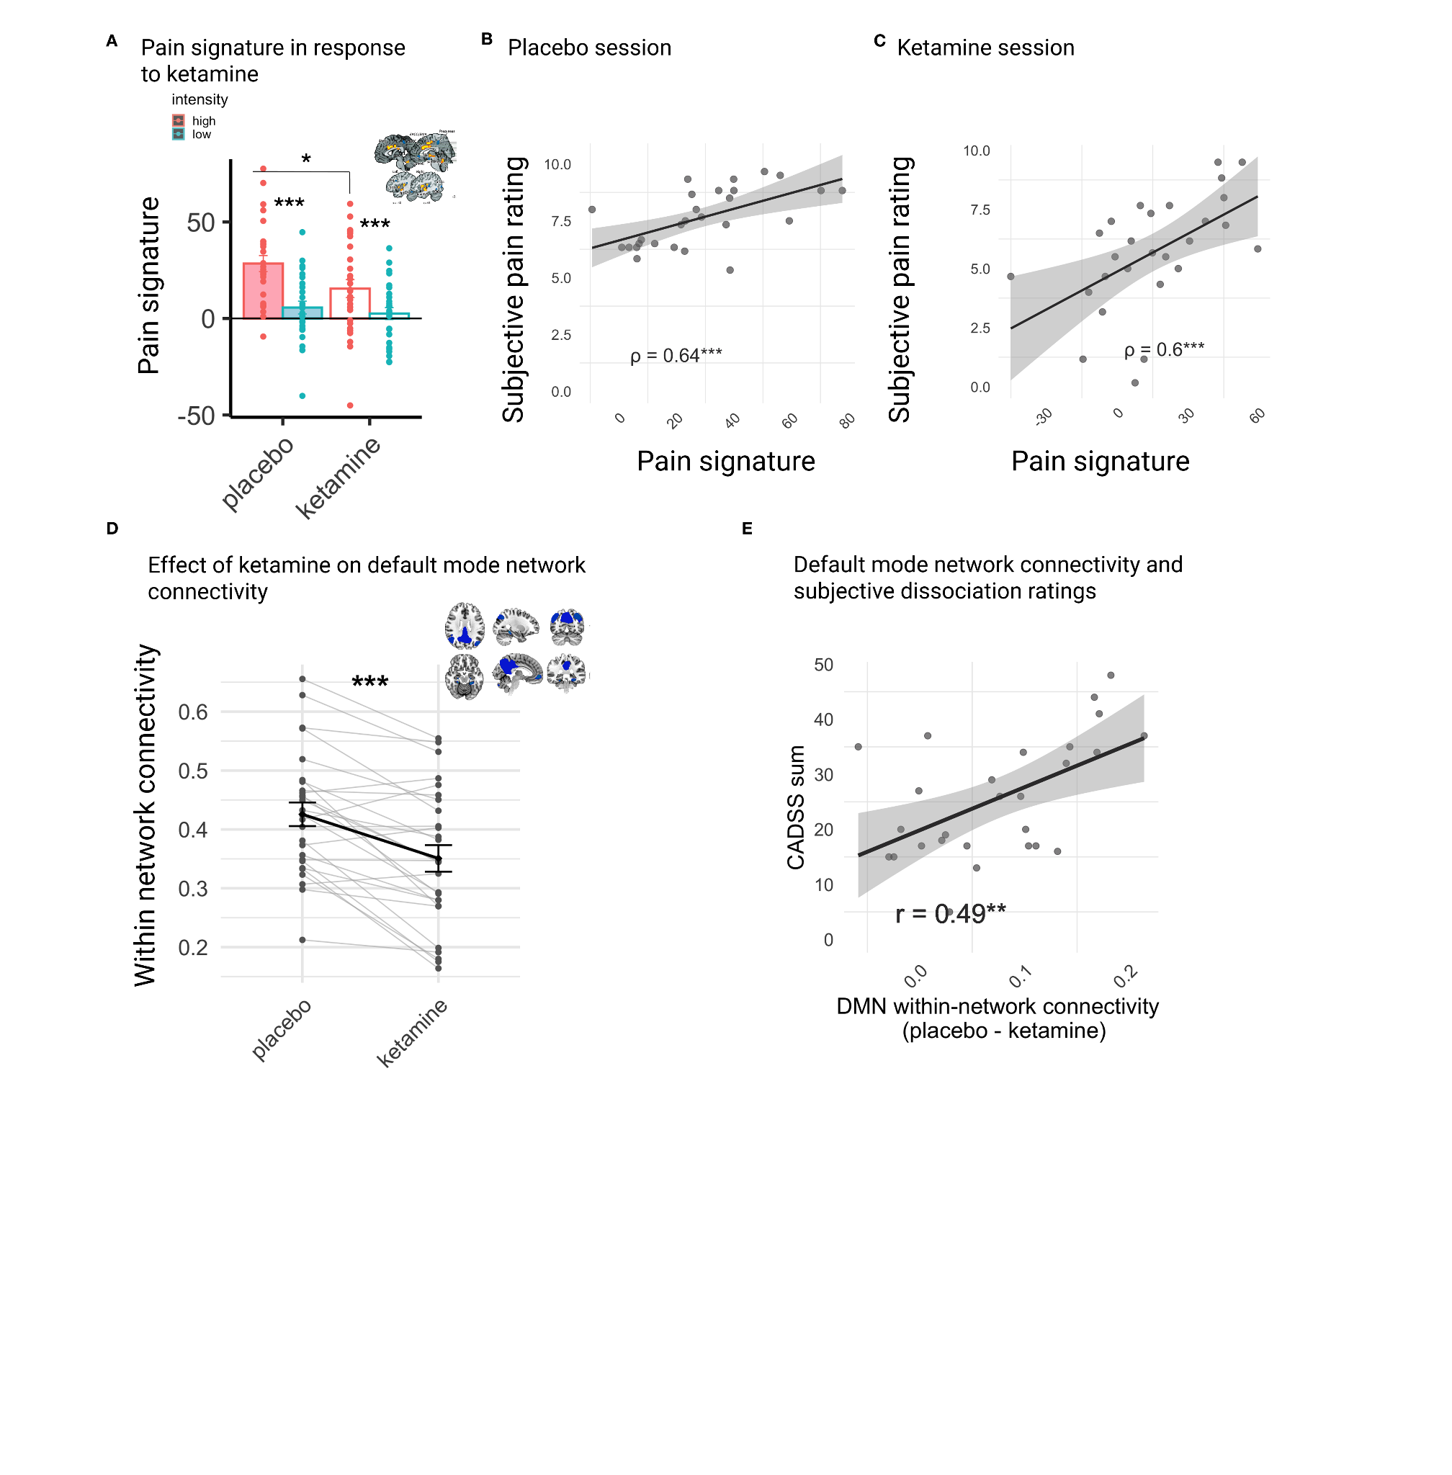
Figure 4
Discussion
Following ketamine administration, participants reported reduced pain intensity, which was accompanied by decreased activation in a pain-responsive network of brain regions including the insula, dACC, and secondary somatosensory cortex. Concurrently, we observed a dissociative experience linked to the reduced connectivity of the DMN. We observed no correlation between the intensity of dissociative experiences and the analgesic effects of ketamine at both the behavioral and neural levels.
Ketamine induced a uniform reduction in pain-related brain activation. This observation aligns with previous studies on ketamine, which reported decreased pain-related activation across the brain^{23,51}. Despite these reductions, ketamine did not alter the correlation between brain activation and the subjective experience of pain. Correlation with self-reported pain was observed in the activation of brain areas such as the anterior insula and S2, as well as in the multivoxel expression of the NPS, in both the ketamine and placebo sessions. This suggests that while ketamine may decrease the overall magnitude of the pain response, it does not inherently change the neural representation of pain. These results cannot distinguish between top-down and bottom-up analgesia. However, one mechanism that might be consistent with these data is that ketamine reduces the overall nociceptive input to the cortex, potentially through spinal mechanisms⁵². This aligns with findings from animal studies, which show that ketamine disrupts nociceptive transmission between the spine and the supraspinal pain systems⁵³.
The DMN has long been the focus of studies examining the effects of psychoactive drugs on changes in the sense of self^{32,54,55}. The DMN is predominantly active during mental simulation processes and may contribute to high-level, modality-invariant representations of concepts, which are key to the feeling of coherent identity and sense of self^{30,56}. Interestingly, compounds acting through markedly different receptor mechanisms, serotonergic psychedelics^{57–61}, dissociative anesthetics (NMDA antagonist)^{24,49}, the entactogen MDMA (a serotonin and dopamine releaser)⁶², and cannabinoids (CB1 agonists)^{63,64}, all produce alterations in self-experience and have been associated with changes in DMN connectivity, motivating the proposal that DMN modulation constitutes a common neural correlate of drug-induced alterations in self-experience^{65–68}. Our finding that ketamine-induced reductions in DMN connectivity tracked dissociative experience aligns with this broader literature. That said, the DMN-centric framing has been shaped in part by influential theoretical accounts that placed it at the heart of psychedelic action^{55,69}, and emerging evidence suggests the actual neural footprint of these drugs may be considerably broader⁶¹. Notably, the DMN has also been suggested to play a role in pain perception: it is deactivated during sensory aversive perception, and increased DMN activity is involved when shifting attention away from the pain⁷⁰. Moreover, shifts in self-related experience can coincide with changes in pain perception. For example, mindfulness meditation has been associated with reduced pain catastrophizing, less negative appraisal of impending pain, and reduced unpleasantness during painful stimulation^{71–73}. This has motivated the idea that DMN changes accompanying altered self-experience could also be relevant for how pain is being processed. However, meditation-related modulation of pain most consistently affects activity in the insula, ACC, PFC, and amygdala, regions commonly implicated in pain processing, while DMN effects are less consistent⁷⁴. This pattern suggests that even when the context of pain shifts (e.g., appraisal, attention, affective meaning), pain relief may primarily track modulation within pain-responsive systems. Consistent with this framing, in our data ketamine-related DMN reduced connectivity tracked dissociative experience, whereas analgesia tracked reduced pain-evoked activation and reduced NPS expression, without corresponding links to dissociation.

Several recent studies have directly tested whether ketamine’s dissociative effects are linked to its analgesic effects, but they have reached different conclusions. One experiment paired ketamine with midazolam, a sedative expected to attenuate ketamine-related dissociative symptoms²⁰. Pain and dissociation were repeatedly assessed across time. To test whether dissociation contributed to analgesia, dissociation scores were added as an additional (time-varying) predictor to the pain-over-time models; dissociation did not explain additional variance in pain beyond the time terms. A follow-up experiment induced sevoflurane general anesthesia with and without an adjunct ketamine bolus; pain and CADSS were assessed before induction and after recovery²¹. Again, CADSS scores did not explain additional variance in pain intensity or pain quality, consistent with separable analgesic and dissociative effects. In both studies, dissociation measures did not account for pain outcomes, supporting the view that ketamine’s analgesic effects are separable from its dissociative effects. In contrast, a blood-level–based modeling study concluded that ketamine’s analgesic and psychoactive effects are linked because they appear at similar drug concentrations and unfold over a similar time course¹⁹. In that analysis, measured S-ketamine concentrations predicted both changes in pressure pain threshold and perceptual disturbance with comparable dose-sensitivity and similar onset/offset dynamics. Notably, none of these studies incorporated brain imaging, which adds an important level of evidence by testing whether pain-related neural markers track analgesia independently of dissociation-related network changes.
Our study has several limitations. First, we used a fixed-order, saline-placebo-controlled design rather than a randomized-order or active-comparator design. Because ketamine has a distinctive subjective profile, randomized-order designs may still compromise effective blinding by creating asymmetric expectancy: participants who receive ketamine first may infer that the second session is placebo, whereas those who receive placebo first may remain uncertain.^{75–78} Active comparators, such as midazolam or other benzodiazepines, may improve masking by producing subjective drug effects in the control condition, but would also introduce their own effects on arousal, cognition, and fMRI signals, complicating interpretation of the findings.⁷⁵ Within these constraints, the fixed-order saline-controlled design standardized session order and avoided introducing a second pharmacological signal into the imaging analysis. However, because drug condition was confounded with session order, effects of habituation, task repetition, or expectancy cannot be excluded. Complete blinding is difficult in ketamine studies, but expectancy alone is unlikely to fully explain our findings, given the convergence of subjective analgesia with brain-based nociceptive markers. Prior placebo neuroimaging work suggests that expectancy can substantially reduce reported pain while having only small or absent effects on validated nociceptive markers such as the NPS^{41,79}. Second, interpreting BOLD responses under ketamine is methodologically challenging because ketamine can affect cerebral blood flow and neurovascular coupling, complicating the attribution of BOLD changes to neural activity alone^{80–82}. We mitigated this concern by modeling physiological noise with PhysIO⁸³. Future studies combining BOLD with arterial-spin-labeling could better separate neural from hemodynamic effects. Third, several of our analyses are correlational and cannot establish causal mechanisms linking ketamine’s dissociative and analgesic effects. Future work could combine neuroimaging with targeted pharmacological manipulations that block specific receptor systems implicated in ketamine’s effects (e.g., opioid or dopaminergic pathways). It may also be informative to compare ketamine with lamotrigine, which reduces presynaptic glutamate release and has been reported to attenuate ketamine-induced psychological disturbances (including dissociative symptoms) as well as central nervous system effects^{84–87}. Such approaches could help disentangle which signaling pathways contribute to distinct dimensions of ketamine’s effects on experience and pain. Fourth, we did not incorporate objective plasma ketamine levels in the present analyses. Although blood samples were collected, technical issues prevented reliable quantification. Finally, dissociation was assessed using the CADSS, a gold-standard clinician-administered measure⁹. However, because the full CADSS is a relatively long, clinician-rated measure, it is typically administered at only a small number of time points, which limits the temporal resolution with which dissociative fluctuations can be related to pain and neural responses; brief short-form variants (e.g., CADSS-6) have been developed to facilitate easier clinical monitoring during ketamine infusions⁸⁸. Future work employing such brief measures at repeated intervals could enable finer-grained temporal mapping of dissociative fluctuations onto concurrent pain experience and neural activity, directly testing whether analgesia tracks moment-to-moment changes in dissociative state. In addition, the CADSS captures only part of ketamine’s acute phenomenology⁸⁹, and broader alterations in consciousness and related experiential dimensions may not be fully captured by the CADSS and could show different relationships with analgesia.
To conclude, this study suggests that the analgesic and dissociative effects of ketamine are distinct and correspond to different neural signatures. This finding supports the idea that in at least some of its clinical uses, a drug's subjective effects on consciousness can be separate from its clinical benefits. While the dissociative effects of ketamine could potentially have their own clinical advantages, they do not directly account for its analgesic properties. Notably, a direct within-study comparator that isolates ketamine's pharmacology from its dissociative effects remains a valuable future direction.

Author Contributions
N.G. conceived and designed the study, led the investigation, data collection, curation, and formal analysis, and drafted the original manuscript. T.H. provided supervision, secured funding, and contributed to statistical oversight. I.J. contributed to data preprocessing, formal analysis and edited the manuscript. Y.P., R.S.-E., and D.M. were responsible for participant recruitment, supervision, and study procedure management. N.S. and N.G. contributed to data collection and management. Y.A. supported statistical analysis and preprocessing. H.S. supervised project development, provided statistical consultation, and critically reviewed manuscript drafts. All authors reviewed and approved the final manuscript.

Data Availability Statement
The code and data supporting the findings of this study are publicly available via the Open Science Framework (OSF): https://osf.io/k4wy5/

Competing Interests
T.H. is the Scientific Advisory Board Chairperson and Chief Medical Scientist at GrayMatters Health. This affiliation is unrelated to the present study. All other authors declare no competing interests.

Figure Legends

Figure 1. Experimental Procedure and fMRI Task. (A) Overview of the experimental procedure. (B) Experimental paradigm: Each trial of the pain task lasted 45s and started with a 7s fixation cross. Participants then experienced a sensation they previously rated as either painful (VAS 8) or non-painful (VAS 2) for 15s. Afterwards, they rated their experience on a ten-point scale. To mitigate carryover effects between trials, an 18s visuospatial control task was introduced, during which participants viewed an arrow pointing either left or right and identified its direction.

Figure 2: Behavioral Results. (A): Subjective pain ratings for painful and non-painful stimuli during the imaging pain task. The ketamine intervention led to a reduction in subjective pain intensity for the painful condition, but not for the non-painful condition. Points represent individual mean ratings for each subject in each condition. Bars represent the group means, and error bars indicate Standard Error of the Mean (SEM). (B). Dissociation Ratings: Dissociation levels were assessed using the CADSS at three intervals during each session: pre-infusion-60 minutes before the infusion began, 'post bolus'- 10 min after completion of the bolus infusion, and 'end of infusion'-30 minutes following the end of the infusion. Each set of three points connected by lines represents the subjective dissociation ratings across these time points for a given subscale of the CADSS questionnaire (amnesia, depersonalization, derealization). Thicker black lines indicate the mean ratings for each subscale. Error bars represent the SEM. (C). Spearman Correlation Coefficient Matrix: This matrix displays the correlation coefficients between self-reported measures of pain and dissociation. The numbers within the matrix represent the correlation coefficients, where darker shades of red indicate stronger positive correlations, and darker shades of blue signify stronger negative correlations. * p<.05, **p<.005, *** p<.001

Figure 3: (A) Whole-brain activation map for the contrast of painful > non-painful stimulation during the placebo session, thresholded at voxel-wise p < .001 FDR-corrected with cluster-level FDR correction at p < .05. Warmer colors indicate higher t-values. (B) Whole-brain activation map for the same contrast during the ketamine session, shown at a more liberal voxel-wise threshold of p < .005 uncorrected with cluster-level FDR correction at p < .05. Warmer colors indicate greater activation for painful > non-painful stimulation; cooler colors indicate greater activation for non-painful > painful stimulation. (C) Mean pain-related activation (painful – non-painful beta difference) in pain-responsive regions of interest across placebo and ketamine sessions. ROIs were defined from the placebo-session contrast shown in panel A. Error bars indicate SEM. (D) Relationship between pain-rating differences and ROI-activation differences (painful – non-painful) across sessions. Points represent individual participants; lines and shaded bands show linear fits and 95% confidence intervals. Asterisks denote within-session Spearman correlations between pain-rating difference and ROI-activation difference, color-coded by session. * p < .05, ** p < .005, *** p < .001. P values in panel D are uncorrected.

Figure 4: Neural correlates of ketamine's analgesic and dissociative effects. (A) The NPS biomarker predicted a stronger pain response in the painful condition during the placebo session compared to the ketamine session. In both sessions, this biomarker predicted a stronger pain response in the painful condition compared to the non-painful condition. Points represent individual mean NPS expression for each subject in each condition. Bars represent group means, and error bars indicate the SEM. (B,C) During both placebo and ketamine sessions, there was a significant correlation between subjective pain ratings for high-intensity painful stimuli and NPS responses during the painful condition. Shaded areas depict 95% confidence intervals. (D) Ketamine led to a reduction in within-network connectivity of the Default Mode Network (DMN). Each pair of points connected by lines represents the mean Pearson correlation between all brain areas constituting the DMN (presented in blue at the top right of the panel) for each session. Thicker black lines indicate the mean correlation at the group level. Error bars represent SEM. (E) Subjective dissociation ratings were correlated with a reduction in connectivity within DMN nodes. Shaded areas depict 95% confidence intervals.

Table Legends

Table 1. Pain-evoked brain activation during the placebo session. All clusters survived a voxelwise threshold of p < .001 (FDR corrected) with cluster-level FDR correction at p < .05

References:

1. Nutt, D. & Carhart-Harris, R. The Current Status of Psychedelics in Psychiatry. JAMA Psychiatry 78, 121–122 (2021).
2. Elman, I., Pustilnik, A. & Borsook, D. Beating pain with psychedelics: Matter over mind? Neurosci. Biobehav. Rev. 134, 104482 (2022).
3. Krystal, J. H., Abdallah, C. G., Sanacora, G., Charney, D. S. & Duman, R. S. Ketamine: A Paradigm Shift for Depression Research and Treatment. Neuron 101, 774–778 (2019).
4. Bell, R. F. & Kalso, E. A. Ketamine for pain management. Pain Rep 3, e674 (2018).
5. Yaden, D. B., Earp, B. D. & Griffiths, R. R. Ethical Issues Regarding Nonsubjective Psychedelics as Standard of Care. Camb. Q. Healthc. Ethics 31, 464–471 (2022).
6. Olson, D. E. The Subjective Effects of Psychedelics May Not Be Necessary for Their Enduring Therapeutic Effects. ACS Pharmacol Transl Sci 4, 563–567 (2021).
7. Yaden, D. B. & Griffiths, R. R. The Subjective Effects of Psychedelics Are Necessary for Their Enduring Therapeutic Effects. ACS Pharmacol Transl Sci 4, 568–572 (2021).
8. Spiegel, D. et al. Dissociative disorders in DSM-5. Depress. Anxiety 28, E17-45 (2011).
9. Bremner, J. D. et al. Measurement of dissociative states with the Clinician-Administered Dissociative States Scale (CADSS). J. Trauma. Stress 11, 125–136 (1998).
10. Bohus, M. et al. Pain perception during self-reported distress and calmness in patients with borderline personality disorder and self-mutilating behavior. Psychiatry Res. 95, 251–260 (2000).
11. Ludäscher, P. et al. Pain sensitivity and neural processing during dissociative states in patients with borderline personality disorder with and without comorbid posttraumatic stress disorder: a pilot study. J. Psychiatry Neurosci. 35, 177–184 (2010).
12. Defrin, R., Schreiber, S. & Ginzburg, K. Paradoxical Pain Perception in Posttraumatic Stress Disorder: The Unique Role of Anxiety and Dissociation. J. Pain 16, 961–970 (2015).
13. Schmahl, C. et al. Pain sensitivity is reduced in borderline personality disorder, but not in posttraumatic stress disorder and bulimia nervosa. World J. Biol. Psychiatry 11, 364–371 (2010).
14. Krystal, J. H. et al. Subanesthetic effects of the noncompetitive NMDA antagonist, ketamine, in humans. Psychotomimetic, perceptual, cognitive, and neuroendocrine responses. Arch. Gen. Psychiatry 51, 199–214 (1994).
15. Hocking, G. & Cousins, M. J. Ketamine in chronic pain management: an evidence-based review. Anesth. Analg. 97, 1730–1739 (2003).
16. Persson, J. Ketamine in pain management. CNS Neurosci. Ther. 19, 396–402 (2013).
17. Mashour, G. A. Ketamine Analgesia and Psychedelia: Can We Dissociate Dissociation? Anesthesiology vol. 136 675–677 (2022).
18. Schwenk, E. S. et al. Consensus Guidelines on the Use of Intravenous Ketamine Infusions for Acute Pain Management From the American Society of Regional Anesthesia and Pain Medicine, the American Academy of Pain Medicine, and the American Society of Anesthesiologists. Reg. Anesth. Pain Med. 43, 456–466 (2018).
19. Olofsen, E. et al. Ketamine Psychedelic and Antinociceptive Effects Are Connected. Anesthesiology 136, 792–801 (2022).
20. Gitlin, J. et al. Dissociative and Analgesic Properties of Ketamine Are Independent. Anesthesiology 133, 1021–1028 (2020).
21. Hahm, E. Y. et al. Dissociative and analgesic properties of ketamine are independent and unaltered by sevoflurane general anesthesia. Pain Rep 6, e936 (2021).
22. Bushnell, M. C., Ceko, M. & Low, L. A. Cognitive and emotional control of pain and its disruption in chronic pain. Nat. Rev. Neurosci. 14, 502–511 (2013).
23. Sprenger, T. et al. Imaging pain modulation by subanesthetic S-(+)-ketamine. Anesth. Analg. 103, 729–737 (2006).
24. Scheidegger, M. et al. Ketamine decreases resting state functional network connectivity in healthy subjects: implications for antidepressant drug action. PLoS One 7, e44799 (2012).
25. Bonhomme, V. et al. Resting-state Network-specific Breakdown of Functional Connectivity during Ketamine Alteration of Consciousness in Volunteers. Anesthesiology 125, 873–888 (2016).
26. Driesen, N. R. et al. Relationship of resting brain hyperconnectivity and schizophrenia-like symptoms produced by the NMDA receptor antagonist ketamine in humans. Mol. Psychiatry 18, 1199–1204 (2013).
27. Mueller, F. et al. Pharmacological fMRI: Effects of subanesthetic ketamine on resting-state functional connectivity in the default mode network, salience network, dorsal attention network and executive control network. Neuroimage Clin 19, 745–757 (2018).
28. Ait Bentaleb, K., Boisvert, M., Tourjman, V. & Potvin, S. A meta-analysis of functional neuroimaging studies of ketamine administration in healthy volunteers. J. Psychoactive Drugs 56, 211–224 (2024).
29. Kotoula, V., Webster, T., Stone, J. & Mehta, M. A. Resting-state connectivity studies as a marker of the acute and delayed effects of subanaesthetic ketamine administration in healthy and depressed individuals: A systematic review. Brain Neurosci. Adv. 5, 23982128211055424 (2021).
30. Smallwood, J. et al. The default mode network in cognition: a topographical perspective. Nat. Rev. Neurosci. 22, 503–513 (2021).
31. Lanius, R. A., Terpou, B. A. & McKinnon, M. C. The sense of self in the aftermath of trauma: lessons from the default mode network in posttraumatic stress disorder. Eur. J. Psychotraumatol. 11, 1807703 (2020).
32. Vesuna, S. et al. Deep posteromedial cortical rhythm in dissociation. Nature 586, 87–94 (2020).
33. D’Souza, D. C. et al. Glycine transporter inhibitor attenuates the psychotomimetic effects of ketamine in healthy males: preliminary evidence. Neuropsychopharmacology 37, 1036–1046 (2012).
34. Woo, C.-W. et al. Separate neural representations for physical pain and social rejection. Nat. Commun. 5, 5380 (2014).
35. Kross, E., Berman, M. G., Mischel, W., Smith, E. E. & Wager, T. D. Social rejection shares somatosensory representations with physical pain. Proc. Natl. Acad. Sci. U. S. A. 108, 6270–6275 (2011).
36. Buhle, J. & Wager, T. D. Does meditation training lead to enduring changes in the anticipation and experience of pain? Pain vol. 150 382–383 (2010).
37. Wager, T. D. et al. Placebo-induced changes in FMRI in the anticipation and experience of pain. Science 303, 1162–1167 (2004).
38. Wager, T. D., Scott, D. J. & Zubieta, J.-K. Placebo effects on human mu-opioid activity during pain. Proc. Natl. Acad. Sci. U. S. A. 104, 11056–11061 (2007).
39. Esteban, O. et al. fMRIPrep: a robust preprocessing pipeline for functional MRI. Nat. Methods 16, 111–116 (2019).
40. Wager, T. D. et al. An fMRI-based neurologic signature of physical pain. N. Engl. J. Med. 368, 1388–1397 (2013).
41. Zunhammer, M., Bingel, U., Wager, T. D. & Placebo Imaging Consortium. Placebo Effects on the Neurologic Pain Signature: A Meta-analysis of Individual Participant Functional Magnetic Resonance Imaging Data. JAMA Neurol. 75, 1321–1330 (2018).
42. Han, X. et al. Effect sizes and test-retest reliability of the fMRI-based neurologic pain signature. Neuroimage 247, 118844 (2022).
43. López-Solà, M. et al. The neurologic pain signature responds to nonsteroidal anti-inflammatory treatment vs placebo in knee osteoarthritis. Pain Rep 7, e986 (2022).
44. Weber, K. A., Ii et al. Evidence for decreased Neurologic Pain Signature activation following thoracic spinal manipulation in healthy volunteers and participants with neck pain. Neuroimage Clin 24, 102042 (2019).
45. Whitfield-Gabrieli, S. & Nieto-Castanon, A. Conn: a functional connectivity toolbox for correlated and anticorrelated brain networks. Brain Connect. 2, 125–141 (2012).
46. Calhoun, V. D., Adali, T., Pearlson, G. D. & Pekar, J. J. A method for making group inferences from functional MRI data using independent component analysis. Hum. Brain Mapp. 14, 140–151 (2001).
47. Yeo, B. T. T. et al. The organization of the human cerebral cortex estimated by intrinsic functional connectivity. J. Neurophysiol. 106, 1125–1165 (2011).
48. Wager, T. D. Using Neuroimaging to Understand Pain: Pattern Recognition and the Path from Brain Mapping to Mechanisms. The Brain Adapting with Pain: Contributions of Neuroimaging Technology to Pain Mechanisms 23–36 (2015).
49. Zacharias, N. et al. Ketamine effects on default mode network activity and vigilance: A randomized, placebo-controlled crossover simultaneous fMRI/EEG study. Hum. Brain Mapp. 41, 107–119 (2020).
50. Marguilho, M., Figueiredo, I. & Castro-Rodrigues, P. A unified model of ketamine’s dissociative and psychedelic properties. J. Psychopharmacol. 37, 14–32 (2023).
51. Rogers, R., Wise, R. G., Painter, D. J., Longe, S. E. & Tracey, I. An investigation to dissociate the analgesic and anesthetic properties of ketamine using functional magnetic resonance imaging. Anesthesiology 100, 292–301 (2004).
52. Denda, S. et al. Central nuclei and spinal pathways in feedback inhibitory spinal cord potentials in ketamine-anaesthetized rats. Br. J. Anaesth. 76, 258–265 (1996).
53. Ohtani, M. et al. Effects of ketamine on nociceptive cells in the medial medullary reticular formation of the cat. Anesthesiology 51, 414–417 (1979).
54. Zhu, X. et al. Evidence of a dissociation pattern in resting-state default mode network connectivity in first-episode, treatment-naive major depression patients. Biol. Psychiatry 71, 611–617 (2012).
55. Carhart-Harris, R. L. & Friston, K. J. REBUS and the Anarchic Brain: Toward a Unified Model of the Brain Action of Psychedelics. Pharmacol. Rev. 71, 316–344 (2019).
56. Satpute, A. B. & Lindquist, K. A. The Default Mode Network’s Role in Discrete Emotion. Trends Cogn. Sci. 23, 851–864 (2019).
57. Carhart-Harris, R. L. et al. Neural correlates of the psychedelic state as determined by fMRI studies with psilocybin. Proc. Natl. Acad. Sci. U. S. A. 109, 2138–2143 (2012).
58. Tagliazucchi, E. et al. Increased global functional connectivity correlates with LSD-induced ego dissolution. Curr. Biol. 26, 1043–1050 (2016).
59. Palhano-Fontes, F. et al. The psychedelic state induced by ayahuasca modulates the activity and connectivity of the default mode network. PLoS One 10, e0118143 (2015).
60. Timmermann, C. et al. Human brain effects of DMT assessed via EEG-fMRI. Proc. Natl. Acad. Sci. U. S. A. 120, e2218949120 (2023).
61. Gattuso, J. J. et al. Default Mode Network Modulation by Psychedelics: A Systematic Review. Int. J. Neuropsychopharmacol. 26, 155–188 (2023).
62. Müller, F. et al. MDMA-induced changes in within-network connectivity contradict the specificity of these alterations for the effects of serotonergic hallucinogens. Neuropsychopharmacology 46, 545–553 (2021).
63. Bossong, M. G. et al. Default mode network in the effects of Δ9-Tetrahydrocannabinol (THC) on human executive function. PLoS One 8, e70074 (2013).
64. Wall, M. B. et al. Dissociable effects of cannabis with and without cannabidiol on the human brain’s resting-state functional connectivity. J. Psychopharmacol. 33, 822–830 (2019).
65. Nour, M. M. & Carhart-Harris, R. L. Psychedelics and the science of self-experience. Br. J. Psychiatry 210, 177–179 (2017).
66. Pomarol-Clotet, E. et al. Psychological effects of ketamine in healthy volunteers. Phenomenological study. Br. J. Psychiatry 189, 173–179 (2006).
67. van der Kolk, B. A. et al. Effects of MDMA-assisted therapy for PTSD on self-experience. PLoS One 19, e0295926 (2024).
68. Mathew, R. J., Wilson, W. H., Humphreys, D., Lowe, J. V. & Weithe, K. E. Depersonalization after marijuana smoking. Biol. Psychiatry 33, 431–441 (1993).
69. Carhart-Harris, R. L. et al. The entropic brain: a theory of conscious states informed by neuroimaging research with psychedelic drugs. Front. Hum. Neurosci. 8, 20 (2014).
70. Kucyi, A. & Davis, K. D. The dynamic pain connectome. Trends Neurosci. 38, 86–95 (2015).
71. Zorn, J., Abdoun, O., Bouet, R. & Lutz, A. Mindfulness meditation is related to sensory-affective uncoupling of pain in trained novice and expert practitioners. Eur. J. Pain 24, 1301–1313 (2020).
72. Lutz, A., McFarlin, D. R., Perlman, D. M., Salomons, T. V. & Davidson, R. J. Altered anterior insula activation during anticipation and experience of painful stimuli in expert meditators. Neuroimage 64, 538–546 (2013).
73. Brown, C. A. & Jones, A. K. P. Meditation experience predicts less negative appraisal of pain: electrophysiological evidence for the involvement of anticipatory neural responses. Pain 150, 428–438 (2010).
74. Fan, C. et al. Effects of meditation on neural responses to pain: A systematic review and meta-analysis of fMRI studies. Neurosci. Biobehav. Rev. 162, 105735 (2024).
75. Muthukumaraswamy, S. D., Forsyth, A. & Lumley, T. Blinding and expectancy confounds in psychedelic randomized controlled trials. Expert Rev. Clin. Pharmacol. 14, 1133–1152 (2021).
76. Colloca, L. & Fava, M. What should constitute a control condition in psychedelic drug trials? Nat. Ment. Health 2, 1152–1160 (2024).
77. Szigeti, B. & Heifets, B. D. Expectancy effects in psychedelic trials. Biol. Psychiatry Cogn. Neurosci. Neuroimaging 9, 512–521 (2024).
78. Butler, M., Jelen, L. & Rucker, J. Expectancy in placebo-controlled trials of psychedelics: if so, so what? Psychopharmacology (Berl.) 239, 3047–3055 (2022).
79. Botvinik-Nezer, R. et al. Placebo treatment affects brain systems related to affective and cognitive processes, but not nociceptive pain. Nat. Commun. 15, 6017 (2024).
80. Abel, K. M. et al. Ketamine and fMRI BOLD signal: distinguishing between effects mediated by change in blood flow versus change in cognitive state. Hum. Brain Mapp. 18, 135–145 (2003).
81. De Simoni, S. et al. Test-retest reliability of the BOLD pharmacological MRI response to ketamine in healthy volunteers. Neuroimage 64, 75–90 (2013).
82. Forsyth, A. et al. Modulation of simultaneously collected hemodynamic and electrophysiological functional connectivity by ketamine and midazolam. Hum. Brain Mapp. 41, 1472–1494 (2020).
83. Kasper, L. et al. The PhysIO Toolbox for Modeling Physiological Noise in fMRI Data. J. Neurosci. Methods 276, 56–72 (2017).
84. Anand, A. et al. Attenuation of the neuropsychiatric effects of ketamine with lamotrigine: support for hyperglutamatergic effects of N-methyl-D-aspartate receptor antagonists. Arch. Gen. Psychiatry 57, 270–276 (2000).
85. Abdallah, C. G. et al. Prefrontal Connectivity and Glutamate Transmission: Relevance to Depression Pathophysiology and Ketamine Treatment. Biol Psychiatry Cogn Neurosci Neuroimaging 2, 566–574 (2017).
86. Deakin, J. F. W. et al. Glutamate and the neural basis of the subjective effects of ketamine: a pharmaco-magnetic resonance imaging study. Arch. Gen. Psychiatry 65, 154–164 (2008).
87. Doyle, O. M. et al. Quantifying the attenuation of the ketamine pharmacological magnetic resonance imaging response in humans: a validation using antipsychotic and glutamatergic agents. J. Pharmacol. Exp. Ther. 345, 151–160 (2013).
88. Rodrigues, N. B. et al. A simplified 6-Item clinician administered dissociative symptom scale (CADSS-6) for monitoring dissociative effects of sub-anesthetic ketamine infusions. J. Affect. Disord. 282, 160–164 (2021).
89. Mathai, D. S., Meyer, M. J., Storch, E. A. & Kosten, T. R. The relationship between subjective effects induced by a single dose of ketamine and treatment response in patients with major depressive disorder: A systematic review. J. Affect. Disord. 264, 123–129 (2020).

