Response to Reviewers: NPP-26-0025
Associate Editor (Comments to the Author)
Comment
Your well-written paper has been reviewed by experts in the field, who noted numerous strengths of this novel study including the use of well-validated pain and dissociation measures and the timeliness and relevance of the question regarding ketamine's therapeutic mechanisms. While strengths were noted, reviewers identified several areas to address including expanding methodological details related to session order, drug blinding procedures, CADSS timepoint selection, scanning parameters, and participant characteristics. In addition to the reviewers' comments, we suggest adding statistics to the Abstract as appropriate and including male/female breakdown of the sample.
Response
We thank the Editor and the three reviewers for their thoughtful and constructive engagement with our manuscript. The reviews converged on several important themes, such as interpretive scope, additional methodological details, and the appropriate framing of mechanistic claims, and the revision is organized around addressing these issues. Below we summarize the principal changes; full point-by-point responses follow.
1. Reframed interpretive scope. Following Reviewer #1, we have revised the title, abstract, aim statement, results, discussion, and conclusion to frame our findings as evidence of dissociable neural and behavioral correlates rather than mechanistic separation. The revised title now reads "Ketamine-Induced Analgesia and Dissociation Show Distinct Behavioral and Neural Correlates", and the Discussion introduces an explicit distinction between neural/phenomenological dissociability (which our data support) and full mechanistic independence (which would require designs beyond the scope of this study).
2. New analyses. We have added several analyses that strengthen the interpretation of our findings:
- A whole-brain map of pain-evoked activation under ketamine (new panel in Figure 3) and a corresponding supplementary table.
- A new analysis showing that ketamine reduces not only the magnitude but also the slope of pain-related ROI activation as a function of objective stimulus temperature, revealing an additional dimension of ketamine's analgesic action.
- A formal Steiger's test comparing brain–pain correlations across placebo and ketamine sessions, replacing the previous qualitative statement.
3. Expanded Methods and Supplementary Information. In response to the Editor's and reviewers' requests, we have expanded the Methods, primarily in the Supplementary Information, to provide additional detail on participant characteristics, the pain-task design, the CADSS protocol and timepoint selection, and full fMRI acquisition parameters.
4. Expanded discussion of blinding, expectancy, and design constraints. Per Reviewer #1 and Reviewer #2, the Discussion now addresses directly how the convergence between subjective analgesia and brain-based nociceptive markers constrains an expectancy-only account and explains the rationale for the fixed-order saline-controlled design relative to randomized-order and active-comparator alternatives.
5. Framing of the DMN literature. Per Reviewer #2, we have revised both the Introduction's characterization of ketamine's resting-state effects and the Discussion's DMN section.
Addressing the Editor's specific requests. We have (i) added relevant statistics to the Abstract, including directionality of the univariate effects, and (ii) reported the male/female breakdown of the sample in the Methods.
We believe these revisions have strengthened the manuscript and we are grateful for the opportunity to address the reviewers' comments. Detailed responses to each reviewer follow.

Reviewer #1 (Comments to the Author)
Comment
This manuscript aims to address an important question regarding the relationship between ketamine's analgesic and dissociative effects, and the study is carefully conducted with behavioral and neuroimaging analyses. However, several issues related to interpretation and scope limit the strength of the conclusions as currently framed.
Response
We thank the reviewer for their careful reading of our manuscript and for the constructive comments, which have improved the framing of the work. The reviewer's comments converged on an important distinction between neural and phenomenological dissociability, which our data can support, and full mechanistic independence, which would require designs beyond the scope of the present study. This distinction now serves as an organizing principle for the revised manuscript.
In response to the reviewer's comments, we have made the following major revisions:
- Reframed the manuscript's interpretive scope. We revised the title, abstract, aim statement, results, discussion, and conclusion to describe our findings as evidence of dissociable neural and behavioral correlates rather than mechanistic separation. We introduced an explicit distinction in the discussion between neural/phenomenological dissociability and mechanistic independence, and we have retained and strengthened the Limitations statement.
- Added a new analysis of pain sensitivity to objective stimulus temperature. Prompted by the reviewer's question about baseline pain sensitivity, we conducted a follow-up analysis showing that ketamine reduced not only the magnitude of pain-related ROI activation but also the slope relating objective stimulus temperature to neural activation. This reveals an additional dimension of ketamine's analgesic action and is now reported in the results, with full model output and a new supplementary figure.
- Expanded the discussion of blinding and expectancy. We now address directly how the convergence between subjective analgesia and brain-based nociceptive markers (NPS expression, pain-evoked ROI activation) constrains an expectancy-only account of our findings.
We address each of the reviewer's specific comments in detail below.
Comment

- The manuscript frames the findings as evidence of mechanistic separation between analgesia and dissociation. While the data demonstrate dissociable behavioral and neural correlates, a placebo-controlled fMRI study in healthy volunteers cannot establish mechanistic or causal independence. Revising the language in the Abstract, Results, and Conclusions to reflect this distinction would strengthen the manuscript.
Response
We agree that our design cannot establish full mechanistic or causal independence. We have revised the language throughout the manuscript to reflect this distinction:
- Title revised from "The Analgesic and Dissociative Properties of Ketamine are Separate and Correspond to Distinct Neural Mechanisms" to "Ketamine-Induced Analgesia and Dissociation Show Distinct Behavioral and Neural Correlates".
- Abstract revised to remove the phrase "supporting mechanistic separation." The concluding abstract sentence now reads: "Neurobehavioral markers of pain and dissociation did not covary, consistent with distinct neural correlates of ketamine's analgesic and dissociative effects."
- Introduction (aim statement) revised from "determine whether the analgesic and dissociative effects of ketamine are mediated by the same or distinct neural mechanisms" to "examine whether the analgesic and dissociative effects of ketamine correspond to the same or distinct neural signatures."
- Results (univariate ROI section) revised to: "…track subjective pain experience without a corresponding contribution from dissociative effects."
- Results (NPS section) revised to: "…suggesting that multivariate pain-related brain activity under ketamine does not track dissociative experience."
- Conclusion revised from "mediated by different neural systems" to "the analgesic and dissociative effects of ketamine are distinct and correspond to different neural signatures."
- We have retained the Limitations section statement that "our analyses are correlational and cannot establish causal mechanisms," which we believe appropriately frames the inferential scope of the findings.
Comment
2. Although thermal stimuli were individually calibrated, it is unclear whether baseline pain ratings were comparable across sessions and whether baseline pain sensitivity was explicitly accounted for in behavioral and imaging analyses.
Response
We first note that the original manuscript reported that calibration temperatures did not differ between sessions (non-painful: placebo = 41.7 ± 1.94 °C, ketamine = 41.8 ± 1.98 °C; painful: placebo = 46.1 ± 1.52 °C, ketamine = 45.9 ± 1.72 °C; all p > .25), establishing comparable stimulus intensity across conditions (p. 5).
Prompted by this comment, we performed a follow-up analysis testing whether individually calibrated temperature contributes independent variance to our behavioral and ROI outcomes. Adding calibration temperature to the behavioral (self-reported pain) model did not significantly improve fit (χ²(1) = 2.66, p = .103), indicating that subjective pain ratings were already well-accounted for by the intensity × session structure and that baseline pain sensitivity did not confound the behavioral effect of ketamine.
In the ROI model, however, including calibration temperature significantly improved fit (χ²(1) = 9.11, p = 0.0025). All main findings from the original ROI analysis were preserved. Beyond the variance explained by our categorical pain/no-pain regressor, objective calibration temperature modulated ROI activation, and this modulation interacted with session:
Effect | df | F | p
Intensity × calib_temp | 1, 686.08 | 21.44 | < .001
Session × calib_temp | 1, 684.61 | 4.53 | .034
Intensity × Session × calib_temp | 1, 680.99 | 7.16 | .008
Specifically, the slope relating objective stimulus temperature to pain-responsive ROI activation was shallower under ketamine than under placebo (0.080 vs 0.149). This reveals an additional dimension of ketamine's action: beyond reducing overall pain-related neural activation, ketamine also reduced the sensitivity of pain-responsive regions to objective thermal input. We have added this finding to the Results section (p. 9) and full model output can be found in the supplementary material (Supplementary Tables S8–S11). We have also added a supplementary figure (Figure S2), illustrating the change in relation between brain-related ROI activation and objective stimulus temperature. We thank the reviewer for prompting an analysis that strengthens the mechanistic interpretation of our imaging results.
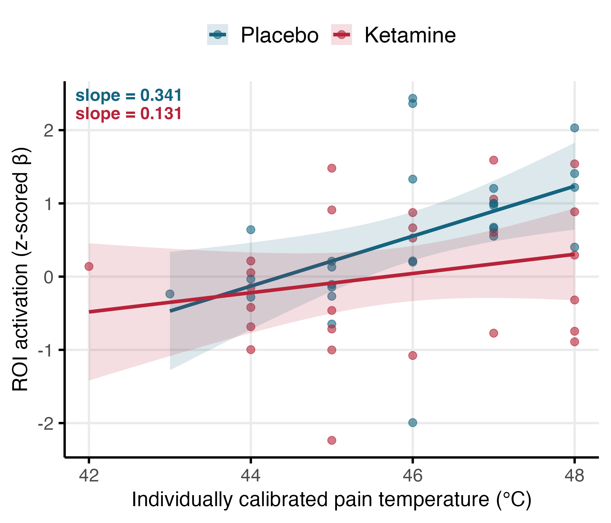
Figure S2. Ketamine selectively attenuates pain-responsive ROI sensitivity to objective stimulus temperature. Each point represents a participant's mean z-scored β across pain-responsive ROIs, plotted against their individually calibrated stimulus temperature. Lines show linear fits with 95% confidence intervals. Blue = placebo session; red = ketamine session. The placebo slope was steeper than the ketamine slope.
Changes made to the manuscript
Results p. 9
We also tested whether individually calibrated stimulus temperature explained additional variance in ROI activation beyond the categorical intensity predictor. Adding calibrated temperature significantly improved model fit (χ²(1) = 9.11, p = .003), and its effect depended on both condition and session (intensity × session × calibration temp: F(1, 681) = 7.16, p = .008), with a shallower activation-temperature slope under ketamine than placebo. This indicates that ketamine reduced not only the overall magnitude of pain-related activation but also the sensitivity of pain-responsive regions to graded noxious input (see Figure S2 and Supplementary Tables S8–S11).
Comment
3. The authors appropriately acknowledge in the limitations that ketamine's overt psychoactive effects may compromise blinding. This acknowledgment is welcome; however, these factors should continue to be considered when interpreting and framing the results.
Response
We agree that blinding considerations should inform the interpretation of the findings. Accordingly, we have expanded the Discussion to address this directly. We now note that while complete blinding is difficult to achieve given ketamine's distinctive subjective profile, expectancy alone is unlikely to fully account for the results: prior placebo neuroimaging work has established that expectancy can substantially reduce self-reported pain while having only small or absent effects on validated nociceptive brain markers such as the NPS (Zunhammer et al. 2018; Botvinik-Nezer et al. 2024). The convergence of subjective analgesia with reduced NPS expression and attenuated pain-evoked ROI activation in the present study is therefore difficult to attribute to expectancy alone. The revised text appears on p. 15 of the manuscript.
Changes made to the manuscript
Discussion p. 15
Our study has several limitations. First, we used a fixed-order, saline-placebo-controlled design rather than a randomized-order or active-comparator design. Because ketamine has a distinctive subjective profile, randomized-order designs may still compromise effective blinding by creating asymmetric expectancy: participants who receive ketamine first may infer that the second session is placebo, whereas those who receive placebo first may remain uncertain(Muthukumaraswamy, Forsyth, and Lumley 2021; Colloca and Fava 2024; Szigeti and Heifets 2024; Butler, Jelen, and Rucker 2022). Active comparators, such as midazolam or other benzodiazepines, may improve masking by producing subjective drug effects in the control condition, but would also introduce their own effects on arousal, cognition, and fMRI signals, complicating interpretation of the findings (Muthukumaraswamy, Forsyth, and Lumley 2021). Within these constraints, the fixed-order saline-controlled design standardized session order and avoided introducing a second pharmacological signal into the imaging analysis. However, because drug condition was confounded with session order, effects of habituation, task repetition, or expectancy cannot be excluded. Complete blinding is difficult in ketamine studies, but expectancy alone is unlikely to fully explain our findings, given the convergence of subjective analgesia with brain-based nociceptive markers. Prior placebo neuroimaging work suggests that expectancy can substantially reduce reported pain while having only small or absent effects on validated nociceptive markers such as the NPS (Zunhammer et al. 2018; Botvinik-Nezer et al. 2024).
Comment
4. Lack of an active analgesic comparator is noted by the authors, and it underscores the need to temper claims about mechanistic separation. In the absence of a non-dissociative analgesic control, it is not possible to determine whether ketamine-induced analgesia occurs independently of dissociation.
Response
We agree that, in the absence of a within-study non-dissociative analgesic comparator, our design cannot establish full pharmacological isolation of ketamine's analgesic effects from its dissociative effects. We have accordingly been careful to frame our findings as evidence of neural and phenomenological dissociability, that the two effects engage separable neural systems and do not covary across individuals, rather than as evidence of complete mechanistic independence, which would indeed require a comparator arm. To make this distinction explicit, we have revised the concluding paragraph of the Discussion (see below) and expanded the Limitations section to acknowledge this constraint more directly.
Within this more circumscribed framing, three lines of evidence support our interpretation:
- The neural signature of ketamine-induced analgesia is consistent with established non-dissociative analgesia profiles. The NPS was originally derived from fMRI responses to thermal pain in healthy participants (Wager et al. 2013) and has since been shown to be reduced by analgesic manipulations acting through non-dissociative mechanisms, including remifentanil/opioid analgesia, NSAID analgesia, mindfulness meditation, and spinal manipulation (López-Solà et al. 2022; Riegner et al. 2025; Weber et al. 2019). Similarly, the cortical regions attenuated under ketamine, anterior insula, dACC, S1, S2, and dlPFC, overlap with regions consistently engaged in evoked pain processing (Peyron, Laurent, and García-Larrea 2000; Apkarian et al. 2005; Duerden and Albanese 2013) and modulated by non-dissociative analgesic interventions (Wise et al. 2002; López-Solà et al. 2022; Nakata, Sakamoto, and Kakigi 2014; Weber et al. 2019). Thus, while a direct within-study comparator would provide stronger evidence, the literature provides an indirect benchmark: the neural profile of ketamine analgesia falls within the well-characterized signature of non-dissociative analgesia, rather than appearing qualitatively distinct.
- Within our dataset, analgesia and dissociation showed a double dissociation across neural systems. Reduced DMN connectivity tracked dissociation but not analgesia, whereas reductions in pain-evoked ROI activation and NPS expression tracked analgesia but not dissociation. We acknowledge that, without a non-dissociative analgesic comparator, we cannot determine whether DMN connectivity would remain unaffected by non-dissociative analgesics.
- Independent studies using comparator-style designs reach convergent conclusions. Gitlin et al. (2020) paired ketamine with midazolam, which attenuates ketamine's dissociative effects, and Hahm et al. (2021) assessed ketamine analgesia under sevoflurane-induced general anesthesia. Both reported that analgesia was preserved when dissociative experience was attenuated, converging with our within-subject neural findings. We also propose lamotrigine-adjunct designs as a key future direction (Discussion, p. 15) to enable direct within-study pharmacological dissection.
To make the scope of our claims more explicit, we have revised the concluding paragraph of the Discussion:
Changes made to the manuscript
Discussion, p. 16
To conclude, this study suggests that the analgesic and dissociative effects of ketamine are distinct and correspond to different neural signatures. This finding supports the idea that in at least some of its clinical uses, a drug's subjective effects on consciousness can be separate from its clinical benefits. While the dissociative effects of ketamine could potentially have their own clinical advantages, they do not directly account for its analgesic properties. Notably, a direct within-study comparator that isolates ketamine's pharmacology from its dissociative effects, remains a valuable future direction.
Comment
5. Overall, the findings should be framed as evidence of dissociable behavioral and neural signatures rather than mechanistic separation.
Response
We thank the reviewer for this summary framing recommendation, which we fully endorse. As detailed in our responses to Comments 1 and 4, we have systematically revised the language throughout the manuscript, including the title, abstract, aim statement, results, discussion, and conclusion, to frame our findings as evidence of dissociable behavioral and neural signatures rather than mechanistic separation. Specifically, the title now reads "Ketamine-Induced Analgesia and Dissociation Show Distinct Behavioral and Neural Correlates", the abstract and conclusion describe "distinct neural correlates" rather than "distinct neural mechanisms," and we have introduced an explicit distinction in the Discussion between neural and phenomenological dissociability (which our data support) and full mechanistic independence. We believe these revisions, taken together, bring the framing of the manuscript into alignment with the reviewer's recommendation.

Reviewer #2 (Comments to the Author)
Comment
Goldway et al. test the overlap in functional brain networks associated with dissociation vs. analgesia from ketamine and find that independent circuits contribute to each. The design of the study is solid (e.g., repeated measures, larger sample than most acute hallucinogen studies, rigorous motion/nuisance regression, use of an event-related design for evoking pain, control analyses), and my concerns below could be easily addressed (they largely involve oversights in the literature and more methodological details).
Response
We thank the reviewer for the careful and constructive evaluation of our manuscript, and for recognizing the strengths of the study. In response to the reviewer's comments, we have (i) sharpened the framing of the univariate findings in the Abstract to make directionality explicit; (ii) refined the terminology used to describe psychoactive compounds in the Introduction, defining drug classes by pharmacological mechanism; (iii) revised our characterization of ketamine's effects on resting-state network connectivity to better reflect the heterogeneity of the existing literature; (iv) substantially expanded the Methods, primarily in the Supplementary Information, to provide full detail on task design, drug administration, blinding, inter-session interval, scanning parameters, etc.; (v) added new whole-brain analyses, including a direct map of pain-evoked activation during the ketamine session and a formal Steiger's test comparing brain–pain correlations across sessions; (vi) corrected inconsistencies in the reporting of correlation strengths and figure callouts; and (vii) expanded the Discussion to provide a more thorough treatment of the fixed-order design, alternative masking strategies, and the temporal-resolution limitations of clinician-administered dissociation measures. We also added a broader pharmacological context for the role of the DMN across compounds that produce alterations in self-experience. We believe these revisions have strengthened the manuscript and address each of the reviewer's specific concerns, which we respond to point-by-point below
Comment
- Given that some might only read the Abstract, it could be helpful to discuss the directionality of the univariate effects (i.e., greater insula activity was associated with greater pain).
Response
We have revised the Abstract to make the directionality of the univariate effects explicit. The relevant sentence now reads:

Changes made to the manuscript
Abstract p. 2
Ketamine induced both analgesia (session × pain intensity interaction: F(1,54) = 11.22, p < .001) and dissociation (main effect of session: F(1,32) = 57.44, p < .001), and the two corresponded to distinct neural indices. Greater pain was associated with increased univariate activity in regions such as the anterior insula, as well as with stronger expression of a pain-predictive multivoxel pattern, whereas higher dissociation intensity was selectively associated with reduced default mode network connectivity (ρ = .49, p < .01). Neurobehavioral markers of pain and dissociation did not covary (ρ = −.24 to .32, all p > .09), consistent with distinct neural correlates of ketamine’s analgesic and dissociative effects.
Comment

- Introduction: "As the mechanisms underlying the therapeutic effects of mind altering drugs have come under renewed investigation..." Various "mind altering" drugs, such as alcohol, benzodiazepines, amphetamine, cannabis, opioids, GHB, etc. have been studied for decades. I think what is meant here is that hallucinogens are specifically being studied more in recent years. I realize "hallucinogen" is not the preferred term for some due to historical baggage, and "psychedelic" is not preferred either due to some limiting this term to 5-HT2A acting hallucinogens, but the statement as it stands ignores other psychoactive drug research, and whatever term is used can be defined by its pharmacology.
Response
We thank the reviewer for this clarification. We agree that "mind altering drugs" was imprecise. We have revised the sentence to refer specifically to serotonergic psychedelics and dissociative agents, rather than using a broad umbrella term. Because the meaning of “psychedelic” remains actively debated (O’Donnell et al. 2023), we now define the relevant drug classes by pharmacological mechanism rather than relying on contested nomenclature.
“As the therapeutic potential of serotonergic psychedelics (e.g., psilocybin, LSD) and dissociative agents (e.g., ketamine, esketamine) has come under renewed scientific investigation”
Changes made to the manuscript
Introduction, p. 2
As the therapeutic potential of serotonergic psychedelics (e.g., psilocybin, LSD) and dissociative agents (e.g., ketamine) has come under renewed scientific investigation
Comment
- "Although findings vary, there has been consistent observation that ketamine leads to the disintegration of the Default Mode Network (DMN) and Salience Network (SN)." Are these actually consistent effects? While some references found decreases, there are studies reporting no impact or increases in within-network DMN connectivity. Across all these studies, decreases/lack of changes/increases sound like a null effect. It is also unclear that consistent changes were found in within-network SN connectivity. Even if effects leaned toward decreases, "disintegration" may not be an appropriate term given mixed findings and likely preserved network structure. The broader literature story is more mixed than often presented.
Response
The original wording overstated the consistency of these findings. Resting-state studies of ketamine have indeed reported a mix of decreases, increases, and null effects on DMN within-network connectivity, and SN findings have been similarly heterogeneous and less well-characterized. In light of this, we have revised the passage to reflect the variability in the literature and have removed the SN from the introduction's literature review.
Changes made to the manuscript
Introduction, p. 3
The neural mechanisms underlying ketamine-induced dissociation remain less well characterized. Most imaging work has examined resting-state functional connectivity, but findings are heterogeneous, with studies reporting decreased, increased, or unchanged connectivity depending on the networks examined, dose, timing, vigilance state, and analytic approach (Scheidegger et al. 2012; Bonhomme et al. 2016; Driesen et al. 2013; Mueller et al. 2018; Ait Bentaleb et al. 2024; Kotoula et al. 2021). Despite this variability, the DMN has received particular attention, given its proposed role in self-referential and higher-order cognitive processes that may be disrupted during dissociative states (Smallwood et al. 2021; Lanius, Terpou, and McKinnon 2020; Vesuna et al. 2020).
Comment
- In general, the Methods could be filled out more. For example: how painful vs. non-painful condition was defined; task details (trial count/duration); whether drug order was counterbalanced; participant blinding/expectancy details; prior ketamine use; days between study arms; inclusion/exclusion criteria; scanning parameters; and full CADSS expansion/description.
Response
Due to word limitations in the main text, we have addressed these requested methodological details in the Supplementary Material. The additions include further information on the pain-task design, drug-order design and blinding considerations, prior ketamine use, interval between study arms, inclusion and exclusion criteria, scanning parameters, and the CADSS assessment. The specific additions are listed below.
Changes made to the manuscript
Supplementary Information p.1
Participants
A total of 37 participants were enrolled in the study (mean age 29.68 ± 3.21 years, 21 females). Of these, four participants completed only a single session, leaving 33 participants who underwent the two-session procedure (mean age 30.1 ± 3.09 years, 18 females). Four participants encountered technical difficulties or requested to discontinue during the fMRI pain paradigm, resulting in the exclusion of their data from certain analyses. Nevertheless, their data were incorporated into the behavioral analysis. One participant had abnormal neurological findings that were discovered during the second scan and was excluded from the fMRI analyses. All participants had a minimum of 12 years of education, no reported psychiatric or neurological disorders (including ADHD), no current use of psychoactive drugs, and were native Hebrew speakers. With the exception of one female participant, all participants were right-handed. Informed written consent was obtained from all participants in accordance with the Tel-Aviv Sourasky Medical Center institutional review board (IRB) committee guidelines ClinicalTrials.gov Identifier: NCT02037503. Participants received monetary compensation at a rate of 50 NIS per hour. Participants were recruited through social media advertisements, and the screening process aimed to ensure the inclusion of physically and mentally healthy individuals who met the MRI scanning criteria. To account for the ketamine infusion, individuals with psychotic disorders (including first-degree relatives with such diagnoses), cardiovascular disorders, frequent alcohol use (> once a week), cannabis use (> once a month), or other drug use (> once every 3 months) were excluded. Sessions were separated by a mean of 24.0 ± 17.1 days. 16 participants reported prior ketamine use.
Overview of the experimental design
This study was conducted at the Sagol Brain Institute, Tel-Aviv Sourasky Medical Center, Tel-Aviv, Israel, using a single-blind, placebo-controlled, within-subjects design. Upon arrival at the laboratory, participants received a detailed explanation of the experimental protocol and provided written informed consent. Participants first completed a training session to familiarize themselves with the experimental tasks to be performed in the MRI scanner. A battery of self-report questionnaires was administered at multiple time points; questionnaires not relevant to the present report are described elsewhere. Subsequently, an individualized pain calibration procedure was conducted to determine stimulus intensities corresponding to subjective pain thresholds. Following calibration, participants were escorted to a resting room where certified physicians inserted intravenous catheters. Each experimental session involved administration of either placebo or ketamine via intravenous infusion, delivered in two stages: an initial bolus followed by a continuous maintenance infusion. The placebo session was always conducted first, and participants were blind to the infusion condition. Participants were informed that one session would involve an active compound and the other a placebo but were not informed of session order. This fixed-order design was adopted to minimize differential expectancy effects: counterbalancing would create asymmetric unblinding, as participants receiving ketamine first would infer that their second session was placebo. Approximately ten minutes after completion of the bolus infusion, dissociative symptoms were assessed using a verbally administered version of the CADSS(Bremner et al. 1998), administered by the experimenter. Participants then completed a cognitive task that is not examined in the present manuscript. Participants subsequently underwent a ~60-minute MRI scanning session, which included a high-resolution anatomical scan, a double-echo gradient-echo field map sequence, and multiple functional MRI tasks. These included both physical and social pain paradigms(Kross et al. 2011; Woo et al. 2014), as well as additional tasks not reported here. The present manuscript focuses exclusively on behavioral and neuroimaging data from the physical pain task; results from the social pain task will be reported separately. At the conclusion of the MRI session, participants were disconnected from the intravenous infusion and completed an additional set of self-report questionnaires.
Physical Pain fMRI Task
To investigate physical pain, we employed a previously established protocol(Kross et al. 2011). The task comprised 12 trials per session: 6 painful trials and 6 non-painful trials. The painful condition used thermal stimuli individually calibrated to a subjective intensity of 8/10 on a visual analog scale (VAS); the non-painful condition used stimuli calibrated to 2/10. Calibration was performed separately for each session prior to scanning (Buhle and Wager 2010; Wager et al. 2004; Wager, Scott, and Zubieta 2007). The total task duration was approximately 18 minutes. Each trial lasted 45-s and began with a 7-s fixation cross. Subsequently, participants experienced a 15-s thermal stimulation period. During this period, participants viewed a fixation cross and focused on the sensations they experienced as a hot (pain) or warm (no pain) stimulus was applied (1.5-s temperature ramp up/down, 12 s at peak temperature). They then rated the pain they experienced using a ten-point scale (0 = not painful; 10 = very painful). To reduce carryover effects between trials, participants then performed an 18-s visuospatial control task in which they saw an arrow pointing left or right and were asked to indicate which direction the arrow was pointing.
fMRI Data Acquisition
Scans were conducted using a Siemens 3T Prisma Magnetom VD13 echo speed scanner equipped with a 20-channel head coil at the Wohl Institute for Advanced Imaging, Tel-Aviv Sourasky Medical Center. Structural scans included a T1-weighted 3D axial spoiled gradient echo (SPGR) pulse sequence (TR/TE = 1,860/2.74 ms, flip angle = 8°, voxel size = 1 x 1 x 1 mm, field of view = 256 × 256 mm, slice thickness = 1 mm). Functional whole-brain scans for all fMRI tasks followed an interleaved bottom-to-top order and utilized a T2*-weighted gradient echo-planar imaging EPI sequence with simultaneous multi-slice (SMS) acquisition (TR = 2,500 ms, TE = 35 ms, flip angle = 84°, voxel size = 2 × 2 × 2 mm isotropic, 74 axial slices, SMS acceleration factor = 2, phase-encoding direction = posterior-to-anterior). A total of 444 volumes were acquired per functional run. Multi-echo GE images were obtained for field mapping before the functional scan, with geometrical and orientational correspondence to the functional runs. Additional sequence parameters included TE = [4.92,7.38] ms, TR = 400 ms, FA = 60, and voxel size: 3.4×3.4×3.0 mm.
Comment
- Methods text about training/calibration and scanning may imply calibration occurred just before fMRI (post-infusion), whereas Figure 1 suggests calibration occurred prior to drug infusion.
Response
The session sequence was accurately described in the original manuscript. In each session, participants arrived at the lab, were oriented to the laboratory environment, completed self-report questionnaires, underwent pain calibration, and were then introduced to the medical doctor who administered either placebo or ketamine. Following an additional self-report assessment, participants entered the scanner and completed the pain task.
Wording of the manuscript:
Methods p. 5
Following task training and individualized pain calibration, participants underwent fMRI scanning that included the “pain task” (Woo et al. 2014; Kross et al. 2011)
Supplementary Information p. 1
This study was conducted at the Sagol Brain Institute, Tel-Aviv Sourasky Medical Center, Tel-Aviv, Israel, using a single-blind, placebo-controlled, within-subjects design. Upon arrival at the laboratory, participants received a detailed explanation of the experimental protocol and provided written informed consent. Participants first completed a training session to familiarize themselves with the experimental tasks to be performed in the MRI scanner. A battery of self-report questionnaires was administered at multiple time points; questionnaires not relevant to the present report are described elsewhere. Subsequently, an individualized pain calibration procedure was conducted to determine stimulus intensities corresponding to subjective pain thresholds. Following calibration, participants were escorted to a resting room where certified physicians inserted intravenous catheters. Each experimental session involved administration of either placebo or ketamine via intravenous infusion, delivered in two stages: an initial bolus followed by a continuous maintenance infusion. The placebo session was always conducted first, and participants were blind to the infusion condition. […] Approximately ten minutes after completion of the bolus infusion, dissociative symptoms were assessed using a verbally administered version of the CADSS (Bremner et al. 1998), administered by the experimenter. Participants then completed a cognitive task that is not examined in the present manuscript. Participants subsequently underwent a ~60-minute MRI scanning session, which included a high-resolution anatomical scan, a double-echo gradient-echo field map sequence, and multiple functional MRI tasks.
Comment
- Methods: clarify which CADSS timepoint was used for analysis and justify that choice. If post-bolus CADSS was used, discuss whether post-pain-task CADSS might be temporally closer to fMRI during the pain task.
Response
The post-bolus dissociation assessment was conducted approximately 10 minutes after completion of the bolus infusion and was used as the primary dissociation outcome for neural analyses. Following this assessment, participants continued to receive a continuous IV ketamine infusion, intended to maintain ketamine exposure during the scanning period by compensating for ongoing metabolism. The final CADSS assessment was collected after the pain task, but only after the continuous infusion had stopped and participants had been allowed to take a bathroom break and refresh themselves. We therefore considered the post-bolus time point to provide the closest standardized estimate of dissociation during the fMRI pain task.
Comment
- Results ordering: it may be more intuitive to report null effects on pain calibration between sessions before reporting ketamine effects on subjective pain.
Response
We agree with the reviewer that calibration differences should be reported before subjective pain effects. This was already the ordering used in the Results section: we first report that calibration temperatures did not differ between placebo and ketamine sessions, indicating comparable stimulus intensity across conditions, and then report ketamine’s effects on subjective pain ratings. We have retained this ordering and clarified the wording where needed.
Wording of the manuscript:
Results p.6
Calibration temperatures did not differ between placebo and ketamine sessions (non-painful: placebo = 41.7 ± 1.94°C, ketamine = 41.8 ± 1.98°C; painful: placebo = 46.1 ± 1.52°C, ketamine = 45.9 ± 1.72°C; all p > .25), indicating comparable stimulus intensity across conditions.
To assess ketamine’s effect on pain perception, we fit a mixed-effects model with session (ketamine vs. placebo) and stimulus intensity (painful vs. non-painful) as predictors. Painful stimuli elicited substantially higher pain ratings than non-painful stimuli (F(1,27) = 239.74, p < .001). Ketamine significantly reduced pain perception, as reflected in a main effect of session (F(1,54) = 34.88, p < .001) and a session × intensity interaction (F(1,54) = 11.22, p < .001). Post-hoc tests showed that ketamine selectively reduced ratings for painful stimuli (t(54) = 6.55, p < .001), with no significant effect on non-painful stimuli (t(54) = 1.81, p = .076; Figure 2.A).
Comment
- Related to days between arms: potential post-acute ketamine effects raise possible carryover concerns if sessions were close in time.
Response
We agree that post-acute ketamine effects are an important consideration in within-subjects ketamine studies. In our design, however, all participants received placebo in their first session and ketamine in their second session. Because no participant was exposed to ketamine prior to either session contributing to our analyses, post-acute ketamine carryover from a prior session is not a possible source of confounding here. The mean interval between sessions was 24.0 ± 17.1 days, which we report in the Methods.
Comment
- Report average weight and range. Consider whether weight-based dosing produced equivalent effects across participants (e.g., plot subjective effects vs. dose; consider dose as a factor if needed).
Response
Participants had a mean body weight of 61.6 ± 9.4 kg (range: 43–81 kg). To assess whether weight-based dosing produced equivalent effects across participants, we examined the correlation between body weight and ketamine-induced dissociation (CADSS). Body weight was not significantly associated with dissociation scores (r = 0.04, p = .86; see Supplementary Figure S1), indicating adequate dose equivalence across the sample.
Changes made to the manuscript
Supplementary Information p. 11

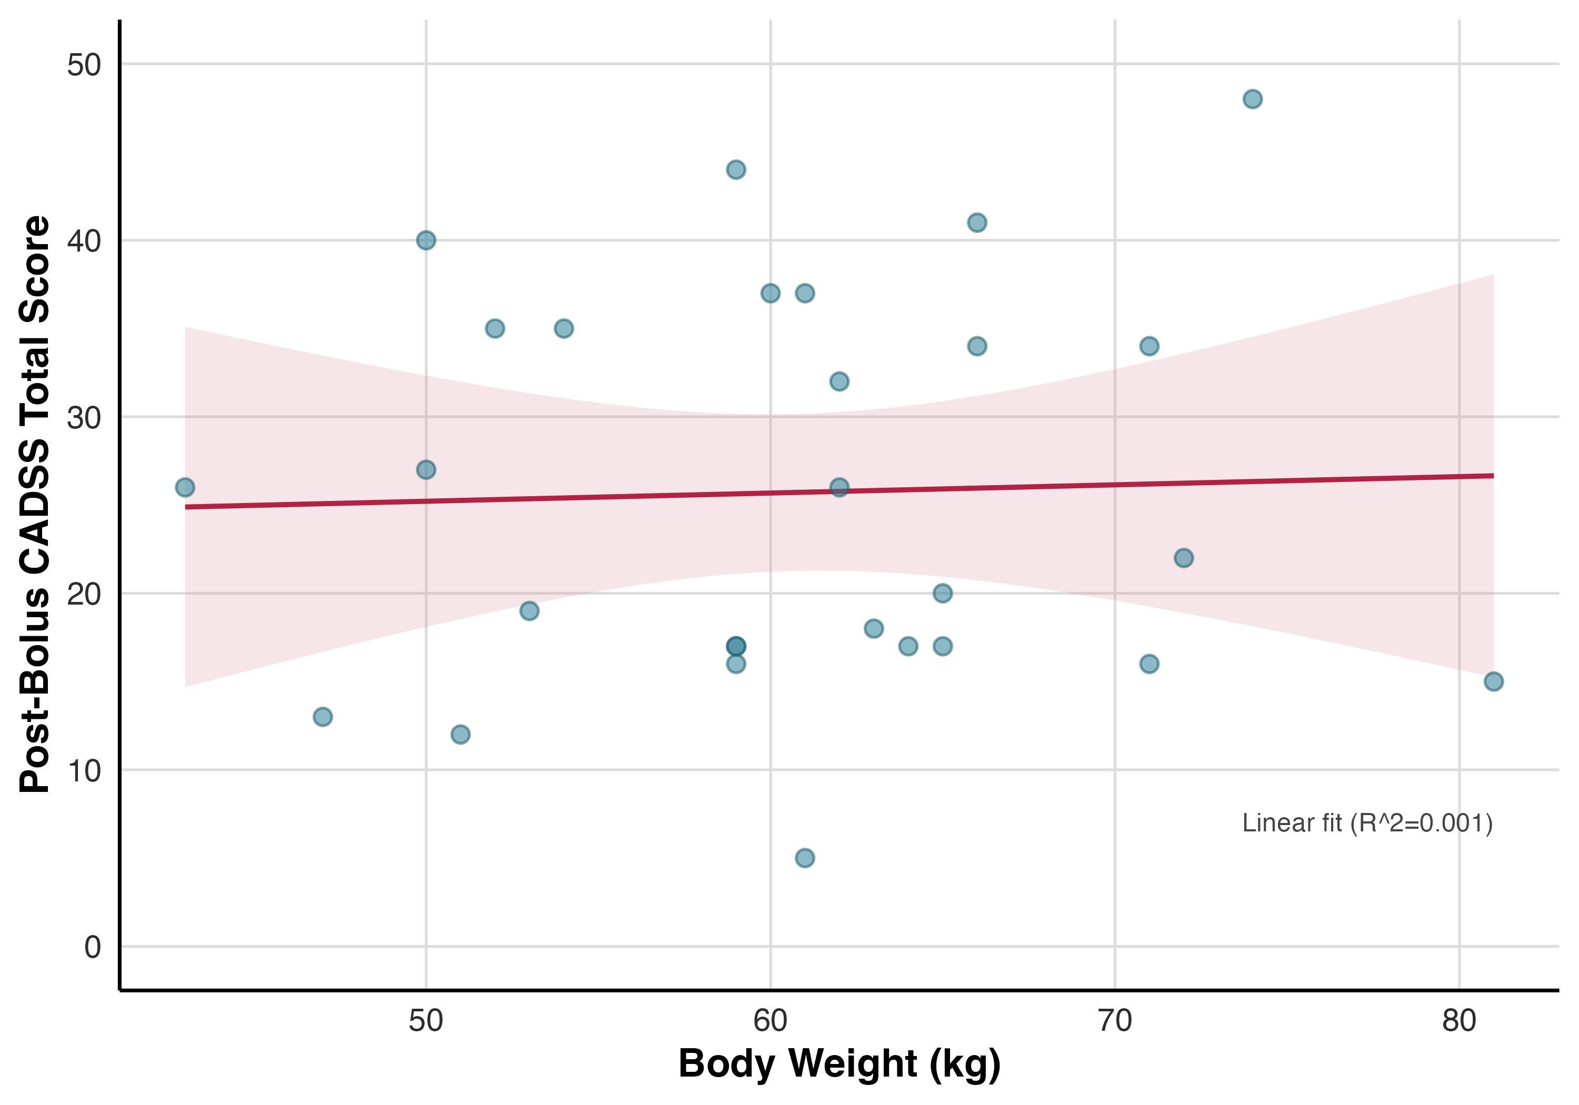
Figure S1. Relationship between body weight and post-bolus dissociative symptom severity (CADSS total score) during ketamine administration. Points represent individual participants; the solid line shows the linear fit with shaded 95% confidence interval. No significant association was observed (Pearson r = 0.04, p = 0.855).
Results p. 7
Effect of ketamine on dissociative state
To assess ketamine’s effects on dissociation, we fit a linear mixed-effects model with session (ketamine/placebo), time point, CADSS subscale (depersonalization, derealization, amnesia), and their interactions as predictors. Ketamine robustly increased subjective dissociation, as indicated by a strong main effect of session (F(1,32.07) = 57.44, p < .001). This effect peaked after infusion onset, reflected in a significant session × time point interaction (F(2,477.73) = 109.51, p < .001). Ketamine significantly increased scores across all dissociation subscales between the pre-infusion and post-bolus time points (all p < .001), whereas no corresponding changes were observed in the placebo session (all p > .9; Figure 2.B). Ketamine-induced dissociation was not correlated with participant body weight. Supplementary Tables S2–S4 and figures S1.
Comment
- Wording/interpretation issue: describing rho=.28 as "weaker" while rho=.32 is described as "no evidence" appears inconsistent.
Response
The reviewer is correct. We have revised the wording in the main text.
Changes made to the manuscript
Results p. 7
Dissociation measures were moderately to strongly intercorrelated (ρ = .47–.85, all p < .011), with the exception of no association between amnesia and depersonalization (ρ = .28, p = .151). Pain indices were also strongly intercorrelated (ρ = .67–.80, all p < .001), indicating internal consistency within each domain. However, dissociation measures showed no significant associations with any pain index (ρ = −.24 to .32, all p > .09), providing no evidence for a relationship between subjective dissociation and pain perception during ketamine administration (Figure 2C).
Comment
- It would be useful to show the brain map of reductions in activation to painful stimuli under ketamine and compare to pain-responsive regions in Figure 3A.
Response
We added a new panel to Figure 3 showing the reduction in pain-evoked activation under ketamine, allowing direct comparison with the regions engaged by painful stimulation under placebo. We have also added the corresponding analysis to the main Results section and report the full statistical output in the Supplementary Materials. The relevant revisions to the manuscript text are provided below.
Changes made to the manuscript
Results p. 9
A whole-brain contrast of painful versus non-painful stimulation during the placebo session (n = 32) revealed robust activation in canonical pain-related regions, including the anterior insula, dACC, dorsolateral prefrontal cortex (dlPFC), S1, and supramarginal gyrus/secondary somatosensory cortex (S2; Figure 3.A; Table 1). Results were thresholded at a voxelwise cluster-forming threshold of p < .001 (FDR corrected), with cluster-level FDR correction at p < .05. During the ketamine session, no clusters survived the primary threshold. At a more liberal threshold (voxelwise p < .005 uncorrected; cluster-level FDR p < .05), a weaker but similar painful > non-painful pattern emerged, along with two non-painful > painful clusters in the precuneus/posterior cingulate and S1/precentral gyrus (Figure 3.B; Supplementary Table S5).
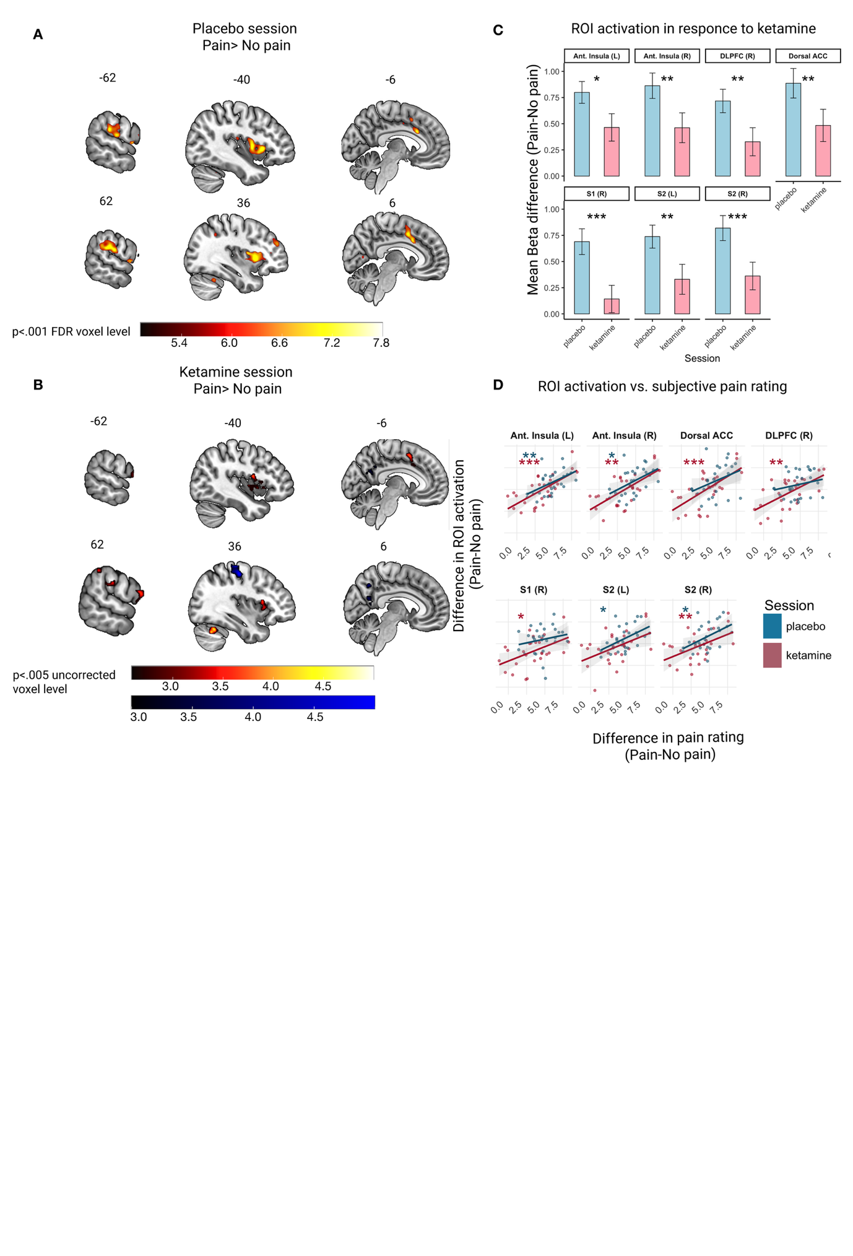
Figure 3: (A) Whole-brain activation map for the contrast of painful > non-painful stimulation during the placebo session, thresholded at voxel-wise p < .001 FDR-corrected with cluster-level FDR correction at p < .05. Warmer colors indicate higher t-values. (B) Whole-brain activation map for the same contrast during the ketamine session, shown at a more liberal voxel-wise threshold of p < .005 uncorrected with cluster-level FDR correction at p < .05. Warmer colors indicate greater activation for painful > non-painful stimulation; cooler colors indicate greater activation for non-painful > painful stimulation. (C) Mean pain-related activation (painful – non-painful beta difference) in pain-responsive regions of interest across placebo and ketamine sessions. ROIs were defined from the placebo-session contrast shown in panel A. Error bars indicate SEM. (D) Relationship between pain-rating differences and ROI-activation differences (painful – non-painful) across sessions. Points represent individual participants; lines and shaded bands show linear fits and 95% confidence intervals. Asterisks denote within-session Spearman correlations between pain-rating difference and ROI-activation difference, color-coded by session. * p < .05, ** p < .005, *** p < .001. P values in panel D are uncorrected.
Supplementary Information p. 11

Brain region | L/R | Cluster size | Peak p-value | MNI coordinates (mm)
 |  |  |  | x | y | z
Anterior insula / Opercular Cortex | R | 608 | <.001 | 56 | 12 | 14
S1 / Precentral Gyrusᵃ | R | 422 | <.001 | 34 | −20 | 54
Anterior insula / Opercular Cortex | L | 278 | <.001 | −34 | 14 | 12
Precuneusaᵃ |  | 249 | <.001 | 10 | −58 | 22
SMA / ACC |  | 241 | <.001 | −12 | 12 | 50
Cerebellum | R | 184 | <.001 | 36 | −56 | −28
Opercular Cortex / Insular Cortex | L | 166 | <.001 | −56 | 4 | 14
S2 / Supramarginal Gyrus | R | 134 | <.001 | 60 | −36 | 44
Supplementary Table S5. Pain-evoked brain activation during the ketamine session. Clusters reflect the painful > non-painful contrast, except those marked ᵃ, which reflect non-painful > painful stimulation. All clusters survived a voxelwise cluster-forming threshold of p < .005 (uncorrected) and cluster-level FDR correction at p < .05.
Comment
- Clarify whether ROI correlations were corrected for multiple comparisons. If uncorrected, report this explicitly. Also discuss why neural activation-pain correlations appear numerically larger under ketamine despite reduced pain.
Response
The ROI-wise brain–pain correlations were uncorrected for multiple comparisons, and we have now stated this explicitly in the Results and in the Figure 3 caption (see above). We have also clarified the interpretation of the numerically larger correlations observed in the ketamine session. Although the correlation coefficients were descriptively higher under ketamine, a formal comparison using Steiger’s test for non-overlapping dependent correlations showed no significant between-session differences in any ROI (all p > .11). We therefore do not interpret the numerical difference as evidence that ketamine strengthened brain–pain coupling.
Changes made to the manuscript
Results p. 10-11.
Correspondence between univariate pain-related brain activation and pain ratings
To assess whether activation in pain-related ROIs corresponded to participants’ subjective experience of pain, we computed within-session Spearman correlations between differences in pain ratings (pain – no pain) and corresponding differences in ROI activation (pain – no pain), separately for the placebo and ketamine sessions. In the placebo session, activation in pain-responsive ROIs was positively correlated with reported pain intensity (mean ρ = .369, range: .134–.528). Significant correlations were observed in four ROIs: left anterior insula (ρ = .528, p = .0046), right anterior insula (ρ = .463, p = .015), left S2 (ρ = .460, p = .016), and right S2 (ρ = .427, p = .026). Correlations in other ROIs, including the dACC, right dlPFC, and right S1, were positive but did not reach significance. In the ketamine session, the overall strength of correlations was numerically higher (mean ρ = .532, range: .344–.656), and six of seven ROIs showed significant associations with pain ratings. These included the left anterior insula (ρ = .656, p < .001), right anterior insula (ρ = .561, p = .002), dACC (ρ = .651, p < .001), right dlPFC (ρ = .570, p = .002), right S1 (ρ = .448, p = .019), and right S2 (ρ = .491, p = .009). The left S2 showed a nonsignificant but positive correlation (ρ = .344, p = .079). All p values are uncorrected. Notably, Steiger's test for non-overlapping dependent correlations revealed no significant differences in any ROI (all p > .11), indicating that ketamine did not significantly alter the strength of brain–pain coupling. These results indicate that subjective pain intensity is univariately represented in most pain-related ROIs, and this relationship is consistent across both placebo and ketamine administration (see Figure 3.D and Supplementary Table S12).
Comment
13) Possible figure-callout issue: Figures 3D/3E/3F may not be referenced correctly in the main text.
Response
We have corrected the figure callouts in the main text to ensure that Figures 3D/3E/3F are referenced appropriately.
Comment
14) Discussion statement that ketamine "did not alter" brain-pain correlation may be too strong if not directly tested.
Response
We agree that, in the absence of a formal statistical test, this claim may have been overstated. To address this, we added a formal analysis comparing the strength of the brain–pain correlations between placebo and ketamine sessions using Steiger’s test for dependent correlations. This analysis showed no significant between-session differences in any ROI (all p > .11), indicating that ketamine did not significantly alter the strength of brain–pain coupling. This analysis is now reported in the Results section (p. 11).
Comment
15) Discussion wording on DMN and "mind-altering drugs" could be refined, including reference alignment and broader pharmacology context.
Response
In response to this comment, we have substantially revised this section of the Discussion (p. 14) and added broader context from the pharmacological literature on drug-induced alterations in self-experience and large-scale network connectivity.
Changes made to the manuscript
Discussion p. 14
The DMN has long been the focus of studies examining the effects of psychoactive drugs on changes in the sense of self (Zhu et al. 2012; Vesuna et al. 2020; R. L. Carhart-Harris and Friston 2019). The DMN is predominantly active during mental simulation processes and may contribute to high-level, modality-invariant representations of concepts, which are key to the feeling of coherent identity and sense of self (Satpute and Lindquist 2019; Smallwood et al. 2021). Interestingly, compounds acting through markedly different receptor mechanisms, serotonergic psychedelics (Robin L. Carhart-Harris et al. 2012; Tagliazucchi et al. 2016; Palhano-Fontes et al. 2015; Timmermann et al. 2023; Gattuso et al. 2023), dissociative anesthetics (NMDA antagonist) (Scheidegger et al. 2012; Zacharias et al. 2020), the entactogen MDMA (a serotonin and dopamine releaser) (Müller et al. 2021), and cannabinoids (CB1 agonists) (Bossong et al. 2013; Wall et al. 2019), all produce alterations in self-experience and have been associated with changes in DMN connectivity, motivating the proposal that DMN modulation constitutes a common neural correlate of drug-induced alterations in self-experience (Nour and Carhart-Harris 2017; Pomarol-Clotet et al. 2006; van der Kolk et al. 2024; Mathew et al. 1993). Our finding that ketamine-induced reductions in DMN connectivity tracked dissociative experience aligns with this broader literature. That said, the DMN-centric framing has been shaped in part by influential theoretical accounts that placed it at the heart of psychedelic action (R. L. Carhart-Harris and Friston 2019; Robin L. Carhart-Harris et al. 2014), and emerging evidence suggests the actual neural footprint of these drugs may be considerably broader (Gattuso et al. 2023).
Comment
16) Fixed-order design (placebo always preceding ketamine) should be stated earlier, not only in Discussion.
Response
We agree that the fixed-order design should be clear before the Discussion. In the submitted manuscript, this information was stated in the Methods section, where we noted that the placebo session always preceded the ketamine session. Method section (p. 5)
The study employed a fixed-order design in which the placebo session always preceded the ketamine session. This order was intentional to minimize expectancy effects: reversing the order would create an imbalance in blinding—participants receiving ketamine first would necessarily know their second session is placebo, while those beginning with placebo would know ketamine follows, creating comparable expectancy biases. To minimize habituation, the interval between sessions averaged 24.0 ± 17.1 days.
Comment
17) Clarify expectancy/blinding logic for fixed vs randomized order and discuss alternative masking strategies.
Response
We agree that the rationale for the fixed-order, saline-controlled design warranted clearer articulation, and we have expanded the Discussion to address it. In the revised Discussion (P 15-16), we now explicitly explain the asymmetric unblinding problem that randomized-order designs face in psychoactive-drug studies: namely, that ketamine's distinctive subjective effects mean participants who receive active drug first reliably identify it and become effectively unblinded for the placebo session, while those who receive placebo first remain genuinely uncertain. This generates between-subject heterogeneity in expectancy that is confounded with assignment order. We have added a fuller treatment of alternative masking strategies, active comparators, or between-subjects designs, and explained why each carries trade-offs that are particularly problematic for a mechanistic fMRI study.
Changes made to the manuscript
Discussion p.15-16
Our study has several limitations. First, we used a fixed-order, saline-placebo-controlled design rather than a randomized-order or active-comparator design. Because ketamine has a distinctive subjective profile, randomized-order designs may still compromise effective blinding by creating asymmetric expectancy: participants who receive ketamine first may infer that the second session is placebo, whereas those who receive placebo first may remain uncertain.(Muthukumaraswamy, Forsyth, and Lumley 2021; Colloca and Fava 2024; Szigeti and Heifets 2024; Butler, Jelen, and Rucker 2022) Active comparators, such as midazolam or other benzodiazepines, may improve masking by producing subjective drug effects in the control condition, but would also introduce their own effects on arousal, cognition, and fMRI signals, complicating interpretation of the findings. (Muthukumaraswamy, Forsyth, and Lumley 2021) Within these constraints, the fixed-order saline-controlled design standardized session order and avoided introducing a second pharmacological signal into the imaging analysis. However, because drug condition was confounded with session order, effects of habituation, task repetition, or expectancy cannot be excluded.
Comment
18) Limitation: dissociation was not measured in an event-related manner during fMRI. Consider discussing objective complementary proxies (e.g., missed/incorrect task responses), acknowledging feasibility constraints.
Response
We agree that a more temporally sensitive measure of dissociation during fMRI would allow us to relate momentary fluctuations in dissociative experience to individual pain trials or pain-evoked neural responses. Indeed, recent ketamine and psychedelic studies highlight the value of higher-resolution subjective sampling, including repeated visual analogue ratings of ketamine’s psychedelic-like effects and real-time subjective intensity ratings during psychedelic neuroimaging (Olofsen et al. 2022; Timmermann et al. 2023).
Basic task-performance measures can index broad cognitive features such as vigilance, sustained attention and response readiness (Lim and Dinges 2008), but generic task indices do not map specifically onto the multidimensional subjective state of dissociation. Although ketamine affects multiple cognitive domains, including working memory, semantic memory, vigilance, and time perception, these effects do not constitute a specific behavioral marker of dissociation. Where associations between ketamine-induced subjective symptoms and task performance have been reported, they are symptom- and task-specific: for example, thought disorder has been linked to reductions in working-memory performance, and distortions in subjective time have been examined alongside selective impairments in perceptual timing accuracy (Adler et al. 1998; Coull et al. 2011). Other ketamine fMRI work demonstrates that altered-state-related neural effects can occur without gross impairment in task accuracy or reaction time (Hack et al. 2023). Taken together, these findings suggest that no general behavioral measure currently serves as a reliable, general-purpose objective index of dissociation. We address this point further in the Discussion (p. 16).
Changes made to the manuscript
Discussion p.16
Finally, dissociation was assessed using the CADSS, a gold-standard clinician-administered measure (Bremner et al. 1998), however, because the full CADSS is a relatively long, clinician-rated measure, it is typically administered at only a small number of time points, which limits the temporal resolution with which dissociative fluctuations can be related to pain and neural responses; brief short-form variants (e.g., CADSS-6) have been developed to facilitate easier clinical monitoring during ketamine infusions (Rodrigues et al. 2021). Future work employing such brief measures at repeated intervals could enable finer-grained temporal mapping of dissociative fluctuations onto concurrent pain experience and neural activity, directly testing whether analgesia tracks moment-to-moment changes in dissociative state.

Reviewer #3 (Comments to the Author)
This manuscript by Goldway and colleagues describes a well-thought-out experimental approach to testing whether ketamine's dissociative and analgesic effects are driven by the same mechanisms. Using well-described techniques and assays to assess their endpoints (thermal pain, CADSS), the authors find limited correlation between those responses during a steady-state infusion; furthermore, ketamine reliably reduces activation in a validated pain-responsive network (defined by BOLD fMRI), in which variance is much better explained by pain rather than dissociation ratings. The question of whether ketamine's many behavioral/therapeutic effects can be mechanistically separated should be of substantial general interest. The data are convincing, the writing is clear, and the conclusions in the Discussion are appropriately conservative.
A few comments:

Comment
1. Timing of questionnaires: clarify which CADSS timepoint was used for the key pain-related correlation analyses (post-bolus or post-infusion).
Response
The post-bolus CADSS assessment was used for all pain-related correlation analyses. This timepoint was selected for two reasons: (1) it captured peak dissociative intensity, with CADSS scores highest at post-bolus and declining by the end of infusion across all subscales (Figure 2B); and (2) it provided the most standardized estimate of dissociative state during the fMRI pain task. The post-bolus assessment was conducted approximately 10 minutes after completion of the bolus infusion, after which participants continued to receive a continuous IV ketamine infusion during scanning. By contrast, the final CADSS assessment was administered only after the continuous infusion had been discontinued and after participants had taken a short break. We have made this explicit in the Methods (p. 5).
Changes made to the manuscript
Methods p.5
The study, approved by the Tel-Aviv Sourasky Medical Center institutional review board (IRB) (ClinicalTrials.gov Identifier: NCT02037503), employed a single-blind, placebo-controlled, within-subjects design. Participants completed two experimental sessions in which they received placebo (IV infusion of saline .9% NaCl)) or ketamine via intravenous infusion (.4 mg/kg IV over 10 minutes, followed by a continuous drip of .4 mg/kg/h using an infusion pump (D’Souza et al. 2012)). Following task training and individualized pain calibration, participants underwent fMRI scanning that included the “pain task” (Woo et al. 2014; Kross et al. 2011). Dissociative symptoms were assessed using the CADSS (Bremner et al. 1998) at three time points in each session: pre-infusion, post-bolus (10 min after completion of the bolus infusion), and end of infusion (figure 1.A). For all analyses relating dissociation to pain outcomes, dissociation was operationalized using post-bolus CADSS scores, which captured peak dissociative intensity.
Comment

2. Provide infusion duration data (per participant if available) and more detail on CADSS timing relative to ketamine exposure, as changing effect-site levels may influence interpretation.
Response
Ketamine was administered per protocol as a 10-minute IV bolus (0.4 mg/kg) followed by a continuous maintenance infusion (0.4 mg/kg/h) sustained throughout scanning to maintain effect-site levels. Total infusion duration was 176.0 ± 20.7 minutes on average, with a median of 178.7 minutes (IQR: 165.6–185.7).
Timestamps linking the end of the bolus to the post-bolus CADSS questionnaire were recoverable for 18 of 33 participants who completed the ketamine session. Among these, the delay from bolus end to CADSS completion averaged 10.95 minutes (SD = 2.63; Median = 10.40 minutes; IQR = 8.63–13.70; Range = 7.53–15.70 minutes), reflecting a relatively standardized post-bolus assessment window. CADSS scores in this subsample (total: M = 26.22, SD = 10.80; subscales: Amnesia M = 5.00, Depersonalization M = 7.56, Derealization M = 13.67) were comparable to those observed in the full sample, suggesting the subset was not systematically unrepresentative. To directly test whether timing variability influenced ratings, we correlated delay duration with CADSS total and subscale scores; no significant associations were found across any dissociation dimension (CADSS total: r = −0.10, p = .689; ρ = −0.21, p = .406; all subscales p > .21; see figure below), suggesting that individual differences in assessment timing did not bias dissociation ratings.
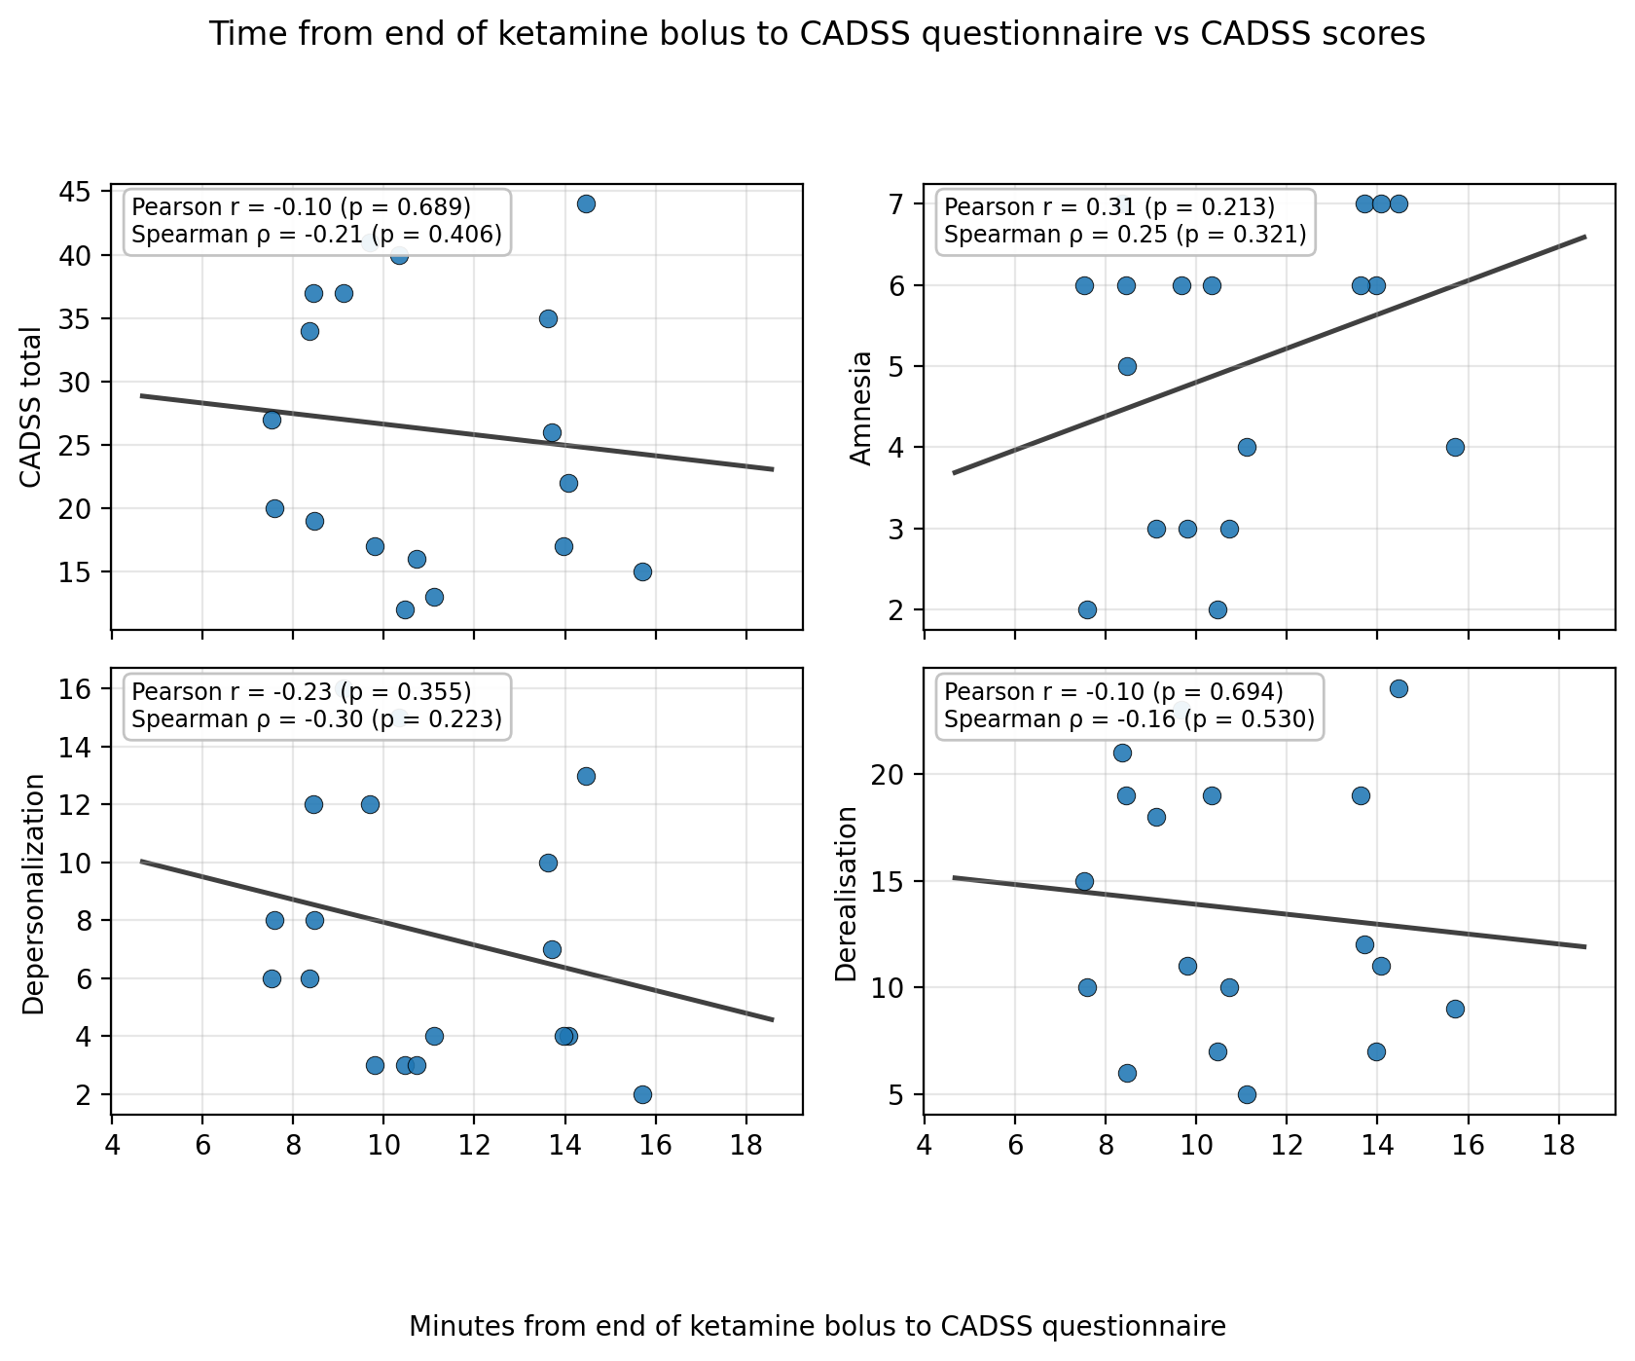
Relationship between CADSS assessment timing and dissociation severity during the ketamine session (n = 18). Each panel plots minutes from the end of the ketamine bolus to CADSS questionnaire completion against CADSS total score and subscale scores (Amnesia, Depersonalization, Derealization). Solid lines show OLS fits across the observed range. No significant associations were found (all Pearson r and Spearman ρ p > .21). Timestamps were available for 18 of 33 participants who completed the ketamine session. This analysis is provided here for the reviewer; given the partial subsample, we did not include it in the published Supplementary
Comment
3. The weak pain-CADSS relationship may partly reflect lower CADSS dynamic range relative to pain ratings.
Response
We thank the reviewer for raising this important psychometric concern: an attenuated correlation could in principle reflect restricted variance in either measure. We addressed this by evaluating the dynamic range of both CADSS and pain ratings, alongside reliability.
Dynamic range
CADSS dynamic range. Post-bolus CADSS total scores during the ketamine session spanned 5–48 (theoretical maximum ≈ 92), with Mean = 24.94, SD = 10.77, IQR = [17, 34], and coefficient of variation (CoV) = 43.2%. The observed range encompasses roughly half of the scale's theoretical span. Benchmarking against published 0.4–0.5 mg/kg IV ketamine studies (van Schalkwyk et al. 2018; Acevedo-Diaz et al. 2020; Pomarol-Clotet et al. 2006; Sajid et al. 2024), our standard deviation falls within the range reported in prior ketamine studies, indicating that CADSS variability in our sample was not unusually restricted.
Pain rating dynamic range. Although painful trials were calibrated to a target of 8/10, the pain ratings that entered our brain–pain–dissociation correlations exhibited substantial spread during the ketamine session: painful-trial ratings had Mean = 5.76, SD = 2.34, range 0.17–9.50 (CoV = 40.6%), and the pain-difference index (painful – non-painful) used for the ROI correlations had Mean = 4.61, SD = 2.41, range 0.00–9.50 (CoV = 52.3%). Calibration tightened the placebo-session distribution near the 8/10 target (SD = 1.25), but ketamine's analgesic action introduced ample variability in the ketamine-session ratings, which are the values relevant to the pain–dissociation correlations.
Reliability
CADSS. The CADSS is a well-validated measure of acute dissociative states, with strong internal consistency and convergent validity reported in the original validation (Bremner et al. 1998) and in independent samples (Mertens and Daniels 2022). To verify that our sample exhibited variability comparable to other ketamine studies, we compared our post-bolus CADSS total scores (mean = 24.94, SD = 10.77; range 5–48) to published values following 0.4–0.5 mg/kg IV ketamine (van Schalkwyk et al. 2018; Acevedo-Diaz et al. 2020; Pomarol-Clotet et al. 2006; Sajid et al. 2024). The standard deviation in our data is comparable to that reported in these prior studies, indicating that our CADSS distribution did not exhibit restricted variability relative to the literature.
Pain ratings. As pain ratings are a single-item NRS, the relevant reliability index is within-session consistency across repeated trials. We computed split-half reliability across the six painful (VAS-8) trials per participant per session, randomly partitioning trials into 3+3 halves over 5,000 bootstrap iterations. The mean split-half Pearson correlation was r = 0.87 (bootstrap 95% interval: 0.81–0.91), yielding a Spearman–Brown corrected reliability of R = 0.93.
Implication. Together, the wide observed ranges, comparable coefficients of variation, and high reliability of both measures place a high ceiling on the correlation that could theoretically be detected. Our observed correlations (ρ = −0.24 to .32) fall well below that ceiling, suggesting that the null pain–dissociation relationship is unlikely to reflect psychometric limitations of either measure.
Comment
4. Interpreting BOLD under ketamine can be challenging; acknowledge this methodological issue and explain how your analysis choices mitigate (but may not eliminate) this concern.
Response
We agree with the reviewer that interpreting BOLD signals under ketamine requires caution, as ketamine may influence both neural activity and downstream vascular or physiological contributions to the BOLD response (Abel et al. 2003; De Simoni et al. 2013; Forsyth et al. 2020). Several features of our preprocessing and analytic approach were designed to mitigate this concern.
First, physiological noise was modeled with the PhysIO toolbox (Kasper et al. 2017), generating cardiac, respiratory, and vascular-related nuisance regressors for the GLM. This approach aligns with pharmacological fMRI recommendations and addresses a key concern in ketamine imaging, where BOLD effects may be sensitive to motion and physiological-noise correction (McMillan et al. 2020, 2019; Forsyth et al. 2020).
Second, our main analyses centered on task-evoked, within-subject contrasts rather than absolute BOLD magnitude or resting-state amplitude. Specifically, our pain-related neural measures were derived from painful-versus-non-painful contrasts within each session, with each participant serving as their own control.
Third, several internal patterns of our results argue against a purely vasculogenic interpretation. (i) The Neurologic Pain Signature continued to discriminate painful from non-painful trials under ketamine and to track subjective pain intensity (ρ = 0.60, p < .001), indicating that the BOLD signal carried fine-grained, pain-specific information that would not be expected from a non-specific vascular effect. (ii) Brain–pain rating correlations within pain-responsive ROIs were preserved (and numerically stronger) under ketamine, again inconsistent with global signal degradation.
Nevertheless, we acknowledge that these steps cannot fully exclude ketamine-related effects on baseline perfusion, vascular reactivity, or neurovascular coupling (Abel et al., 2003; De Simoni et al., 2013). We have therefore added an explicit acknowledgment of this limitation in the Discussion p. 16.
Changes made to the manuscript
Discussion p.16
Second, interpreting BOLD responses under ketamine is methodologically challenging because ketamine can affect cerebral blood flow and neurovascular coupling, complicating the attribution of BOLD changes to neural activity alone (Abel et al. 2003; De Simoni et al. 2013; Forsyth et al. 2020). We mitigated this concern by modeling physiological noise with PhysIO (Kasper et al. 2017). Future studies combining BOLD with arterial-spin-labeling could better separate neural from hemodynamic effects
References
Abel, Kathryn M., Matthew P. G. Allin, Katarzyna Kucharska-Pietura, Chris Andrew, Steve Williams, Anthony S. David, and Mary L. Phillips. 2003. “Ketamine and FMRI BOLD Signal: Distinguishing between Effects Mediated by Change in Blood Flow versus Change in Cognitive State.” Human Brain Mapping 18 (2): 135–45.
Acevedo-Diaz, Elia E., Grace W. Cavanaugh, Dede Greenstein, Christoph Kraus, Bashkim Kadriu, Carlos A. Zarate, and Lawrence T. Park. 2020. “Comprehensive Assessment of Side Effects Associated with a Single Dose of Ketamine in Treatment-Resistant Depression.” Journal of Affective Disorders 263 (February): 568–75.
Adler, C. M., T. E. Goldberg, A. K. Malhotra, D. Pickar, and A. Breier. 1998. “Effects of Ketamine on Thought Disorder, Working Memory, and Semantic Memory in Healthy Volunteers.” Biological Psychiatry 43 (11): 811–16.
Ait Bentaleb, Karim, Mélanie Boisvert, Valérie Tourjman, and Stéphane Potvin. 2024. “A Meta-Analysis of Functional Neuroimaging Studies of Ketamine Administration in Healthy Volunteers.” Journal of Psychoactive Drugs 56 (2): 211–24.
Apkarian, A. Vania, M. Catherine Bushnell, Rolf-Detlef Treede, and Jon-Kar Zubieta. 2005. “Human Brain Mechanisms of Pain Perception and Regulation in Health and Disease.” European Journal of Pain (London, England) 9 (4): 463–84.
Bonhomme, Vincent, Audrey Vanhaudenhuyse, Athena Demertzi, Marie-Aurélie Bruno, Oceane Jaquet, Mohamed Ali Bahri, Alain Plenevaux, et al. 2016. “Resting-State Network-Specific Breakdown of Functional Connectivity during Ketamine Alteration of Consciousness in Volunteers.” Anesthesiology 125 (5): 873–88.
Bossong, Matthijs G., J. Martijn Jansma, Hendrika H. van Hell, Gerry Jager, René S. Kahn, and Nick F. Ramsey. 2013. “Default Mode Network in the Effects of Δ9-Tetrahydrocannabinol (THC) on Human Executive Function.” PloS One 8 (7): e70074.
Botvinik-Nezer, Rotem, Bogdan Petre, Marta Ceko, Martin A. Lindquist, Naomi P. Friedman, and Tor D. Wager. 2024. “Placebo Treatment Affects Brain Systems Related to Affective and Cognitive Processes, but Not Nociceptive Pain.” Nature Communications 15 (1): 6017.
Bremner, J. D., J. H. Krystal, F. W. Putnam, S. M. Southwick, C. Marmar, D. S. Charney, and C. M. Mazure. 1998. “Measurement of Dissociative States with the Clinician-Administered Dissociative States Scale (CADSS).” Journal of Traumatic Stress 11 (1): 125–36.
Buhle, Jason, and Tor D. Wager. 2010. “Does Meditation Training Lead to Enduring Changes in the Anticipation and Experience of Pain?” Pain. Ovid Technologies (Wolters Kluwer Health).
Butler, Matt, Luke Jelen, and James Rucker. 2022. “Expectancy in Placebo-Controlled Trials of Psychedelics: If so, so What?” Psychopharmacology 239 (10): 3047–55.
Carhart-Harris, R. L., and K. J. Friston. 2019. “REBUS and the Anarchic Brain: Toward a Unified Model of the Brain Action of Psychedelics.” Pharmacological Reviews 71 (3): 316–44.
Carhart-Harris, Robin L., David Erritzoe, Tim Williams, James M. Stone, Laurence J. Reed, Alessandro Colasanti, Robin J. Tyacke, et al. 2012. “Neural Correlates of the Psychedelic State as Determined by FMRI Studies with Psilocybin.” Proceedings of the National Academy of Sciences of the United States of America 109 (6): 2138–43.
Carhart-Harris, Robin L., Robert Leech, Peter J. Hellyer, Murray Shanahan, Amanda Feilding, Enzo Tagliazucchi, Dante R. Chialvo, and David Nutt. 2014. “The Entropic Brain: A Theory of Conscious States Informed by Neuroimaging Research with Psychedelic Drugs.” Frontiers in Human Neuroscience 8 (February): 20.
Colloca, Luana, and Maurizio Fava. 2024. “What Should Constitute a Control Condition in Psychedelic Drug Trials?” Nature Mental Health 2 (10): 1152–60.
Coull, Jennifer T., Hannah Morgan, Victoria C. Cambridge, James W. Moore, Francesco Giorlando, Ram Adapa, Philip R. Corlett, and Paul C. Fletcher. 2011. “Ketamine Perturbs Perception of the Flow of Time in Healthy Volunteers.” Psychopharmacology 218 (3): 543–56.
De Simoni, S., A. J. Schwarz, O. G. O’Daly, A. F. Marquand, C. Brittain, C. Gonzales, S. Stephenson, S. C. R. Williams, and M. A. Mehta. 2013. “Test-Retest Reliability of the BOLD Pharmacological MRI Response to Ketamine in Healthy Volunteers.” NeuroImage 64 (January): 75–90.
Driesen, N. R., G. McCarthy, Z. Bhagwagar, M. Bloch, V. Calhoun, D. C. D’Souza, R. Gueorguieva, et al. 2013. “Relationship of Resting Brain Hyperconnectivity and Schizophrenia-like Symptoms Produced by the NMDA Receptor Antagonist Ketamine in Humans.” Molecular Psychiatry 18 (11): 1199–1204.
D’Souza, Deepak Cyril, Nagendra Singh, Jacqueline Elander, Michelle Carbuto, Brian Pittman, Joanna Udo de Haes, Magnus Sjogren, Pierre Peeters, Mohini Ranganathan, and Jacques Schipper. 2012. “Glycine Transporter Inhibitor Attenuates the Psychotomimetic Effects of Ketamine in Healthy Males: Preliminary Evidence.” Neuropsychopharmacology: Official Publication of the American College of Neuropsychopharmacology 37 (4): 1036–46.
Duerden, Emma G., and Marie-Claire Albanese. 2013. “Localization of Pain-Related Brain Activation: A Meta-Analysis of Neuroimaging Data.” Human Brain Mapping 34 (1): 109–49.
Forsyth, Anna, Rebecca McMillan, Doug Campbell, Gemma Malpas, Elizabeth Maxwell, Jamie Sleigh, Juergen Dukart, Jörg Hipp, and Suresh D. Muthukumaraswamy. 2020. “Modulation of Simultaneously Collected Hemodynamic and Electrophysiological Functional Connectivity by Ketamine and Midazolam.” Human Brain Mapping 41 (6): 1472–94.
Gattuso, James J., Daniel Perkins, Simon Ruffell, Andrew J. Lawrence, Daniel Hoyer, Laura H. Jacobson, Christopher Timmermann, et al. 2023. “Default Mode Network Modulation by Psychedelics: A Systematic Review.” The International Journal of Neuropsychopharmacology / Official Scientific Journal of the Collegium Internationale Neuropsychopharmacologicum 26 (3): 155–88.
Gitlin, Jacob, Shubham Chamadia, Joseph J. Locascio, Breanna R. Ethridge, Juan C. Pedemonte, Eunice Y. Hahm, Reine Ibala, et al. 2020. “Dissociative and Analgesic Properties of Ketamine Are Independent.” Anesthesiology 133 (5): 1021–28.
Hack, Laura M., Xue Zhang, Boris D. Heifets, Trisha Suppes, Peter J. van Roessel, Jerome A. Yesavage, Nancy J. Gray, et al. 2023. “Ketamine’s Acute Effects on Negative Brain States Are Mediated through Distinct Altered States of Consciousness in Humans.” Nature Communications 14 (1): 6631.
Hahm, Eunice Y., Shubham Chamadia, Joseph J. Locascio, Juan C. Pedemonte, Jacob Gitlin, Jennifer Mekonnen, Reine Ibala, et al. 2021. “Dissociative and Analgesic Properties of Ketamine Are Independent and Unaltered by Sevoflurane General Anesthesia.” Pain Reports 6 (2): e936.
Kasper, Lars, Steffen Bollmann, Andreea O. Diaconescu, Chloe Hutton, Jakob Heinzle, Sandra Iglesias, Tobias U. Hauser, et al. 2017. “The PhysIO Toolbox for Modeling Physiological Noise in FMRI Data.” Journal of Neuroscience Methods 276 (January): 56–72.
Kolk, Bessel A. van der, Julie B. Wang, Rachel Yehuda, Leah Bedrosian, Allison R. Coker, Charlotte Harrison, Michael Mithoefer, Berra Yazar-Klosinki, Amy Emerson, and Rick Doblin. 2024. “Effects of MDMA-Assisted Therapy for PTSD on Self-Experience.” PloS One 19 (1): e0295926.
Kotoula, Vasileia, Toby Webster, James Stone, and Mitul A. Mehta. 2021. “Resting-State Connectivity Studies as a Marker of the Acute and Delayed Effects of Subanaesthetic Ketamine Administration in Healthy and Depressed Individuals: A Systematic Review.” Brain and Neuroscience Advances 5 (January): 23982128211055424.
Kross, Ethan, Marc G. Berman, Walter Mischel, Edward E. Smith, and Tor D. Wager. 2011. “Social Rejection Shares Somatosensory Representations with Physical Pain.” Proceedings of the National Academy of Sciences of the United States of America 108 (15): 6270–75.
Lanius, Ruth A., Braeden A. Terpou, and Margaret C. McKinnon. 2020. “The Sense of Self in the Aftermath of Trauma: Lessons from the Default Mode Network in Posttraumatic Stress Disorder.” European Journal of Psychotraumatology 11 (1): 1807703.
Lim, Julian, and David F. Dinges. 2008. “Sleep Deprivation and Vigilant Attention.” Annals of the New York Academy of Sciences 1129 (1): 305–22.
López-Solà, Marina, Jesus Pujol, Jordi Monfort, Joan Deus, Laura Blanco-Hinojo, Ben J. Harrison, and Tor D. Wager. 2022. “The Neurologic Pain Signature Responds to Nonsteroidal Anti-Inflammatory Treatment vs Placebo in Knee Osteoarthritis.” Pain Reports 7 (2): e986.
Mathew, R. J., W. H. Wilson, D. Humphreys, J. V. Lowe, and K. E. Weithe. 1993. “Depersonalization after Marijuana Smoking.” Biological Psychiatry 33 (6): 431–41.
McMillan, Rebecca, Anna Forsyth, Doug Campbell, Gemma Malpas, Elizabeth Maxwell, Juergen Dukart, Joerg F. Hipp, and Suresh Muthukumaraswamy. 2019. “Temporal Dynamics of the Pharmacological MRI Response to Subanaesthetic Ketamine in Healthy Volunteers: A Simultaneous EEG/FMRI Study.” Journal of Psychopharmacology (Oxford, England) 33 (2): 219–29.
McMillan, Rebecca, Rachael Sumner, Anna Forsyth, Doug Campbell, Gemma Malpas, Elizabeth Maxwell, Carolyn Deng, et al. 2020. “Simultaneous EEG/FMRI Recorded during Ketamine Infusion in Patients with Major Depressive Disorder.” Progress in Neuro-Psychopharmacology & Biological Psychiatry 99 (109838): 109838.
Mertens, Yoki L., and Judith K. Daniels. 2022. “The Clinician-Administered Dissociative States Scale (CADSS): Validation of the German Version.” Journal of Trauma & Dissociation: The Official Journal of the International Society for the Study of Dissociation (ISSD) 23 (4): 366–84.
Mueller, Felix, Francesco Musso, Markus London, Peter de Boer, Norman Zacharias, and Georg Winterer. 2018. “Pharmacological FMRI: Effects of Subanesthetic Ketamine on Resting-State Functional Connectivity in the Default Mode Network, Salience Network, Dorsal Attention Network and Executive Control Network.” NeuroImage. Clinical 19 (June): 745–57.
Müller, Felix, Friederike Holze, Patrick Dolder, Laura Ley, Patrick Vizeli, Alain Soltermann, Matthias E. Liechti, and Stefan Borgwardt. 2021. “MDMA-Induced Changes in within-Network Connectivity Contradict the Specificity of These Alterations for the Effects of Serotonergic Hallucinogens.” Neuropsychopharmacology: Official Publication of the American College of Neuropsychopharmacology 46 (3): 545–53.
Muthukumaraswamy, Suresh D., Anna Forsyth, and Thomas Lumley. 2021. “Blinding and Expectancy Confounds in Psychedelic Randomized Controlled Trials.” Expert Review of Clinical Pharmacology 14 (9): 1133–52.
Nakata, Hiroki, Kiwako Sakamoto, and Ryusuke Kakigi. 2014. “Meditation Reduces Pain-Related Neural Activity in the Anterior Cingulate Cortex, Insula, Secondary Somatosensory Cortex, and Thalamus.” Frontiers in Psychology 5 (December): 1489.
Nour, Matthew M., and Robin L. Carhart-Harris. 2017. “Psychedelics and the Science of Self-Experience.” The British Journal of Psychiatry: The Journal of Mental Science 210 (3): 177–79.
O’Donnell, Kelley C., Daniel E. Roberts, Terence H. W. Ching, Gianni Glick, Noam Goldway, Natalie Gukasyan, Jamila Hokansen, et al. 2023. “What Is in a Name? The Many Meanings of ‘Psychedelic.’” Psychedelic Medicine 1 (4): 187–89.
Olofsen, Erik, Jasper Kamp, Thomas K. Henthorn, Monique van Velzen, Marieke Niesters, Elise Sarton, and Albert Dahan. 2022. “Ketamine Psychedelic and Antinociceptive Effects Are Connected.” Anesthesiology 136 (5): 792–801.
Palhano-Fontes, Fernanda, Katia C. Andrade, Luis F. Tofoli, Antonio C. Santos, Jose Alexandre S. Crippa, Jaime E. C. Hallak, Sidarta Ribeiro, and Draulio B. de Araujo. 2015. “The Psychedelic State Induced by Ayahuasca Modulates the Activity and Connectivity of the Default Mode Network.” PloS One 10 (2): e0118143.
Peyron, R., B. Laurent, and L. García-Larrea. 2000. “Functional Imaging of Brain Responses to Pain. A Review and Meta-Analysis (2000).” Neurophysiologie Clinique [Clinical Neurophysiology] 30 (5): 263–88.
Pomarol-Clotet, E., G. D. Honey, G. K. Murray, P. R. Corlett, A. R. Absalom, M. Lee, P. J. McKenna, E. T. Bullmore, and P. C. Fletcher. 2006. “Psychological Effects of Ketamine in Healthy Volunteers. Phenomenological Study.” The British Journal of Psychiatry: The Journal of Mental Science 189 (August): 173–79.
Riegner, Gabriel, Jon Dean, Tor D. Wager, and Fadel Zeidan. 2025. “Mindfulness Meditation and Placebo Modulate Distinct Multivariate Neural Signatures to Reduce Pain.” Biological Psychiatry 97 (1): 81–88.
Rodrigues, Nelson B., Roger S. McIntyre, Orly Lipsitz, Yena Lee, Danielle S. Cha, Margarita Shekotikhina, Maj Vinberg, et al. 2021. “A Simplified 6-Item Clinician Administered Dissociative Symptom Scale (CADSS-6) for Monitoring Dissociative Effects of Sub-Anesthetic Ketamine Infusions.” Journal of Affective Disorders 282 (March): 160–64.
Sajid, Sumra, Hanga C. Galfalvy, John G. Keilp, Ainsley K. Burke, J. John Mann, and Michael F. Grunebaum. 2024. “Acute Dissociation and Ketamine’s Antidepressant and Anti-Suicidal Ideation Effects in a Midazolam-Controlled Trial.” The International Journal of Neuropsychopharmacology 27 (4): yae017.
Satpute, Ajay B., and Kristen A. Lindquist. 2019. “The Default Mode Network’s Role in Discrete Emotion.” Trends in Cognitive Sciences 23 (10): 851–64.
Schalkwyk, Gerrit I. van, Samuel T. Wilkinson, Larry Davidson, Wendy K. Silverman, and Gerard Sanacora. 2018. “Acute Psychoactive Effects of Intravenous Ketamine during Treatment of Mood Disorders: Analysis of the Clinician Administered Dissociative State Scale.” Journal of Affective Disorders 227 (February): 11–16.
Scheidegger, Milan, Martin Walter, Mick Lehmann, Coraline Metzger, Simone Grimm, Heinz Boeker, Peter Boesiger, Anke Henning, and Erich Seifritz. 2012. “Ketamine Decreases Resting State Functional Network Connectivity in Healthy Subjects: Implications for Antidepressant Drug Action.” PloS One 7 (9): e44799.
Smallwood, Jonathan, Boris C. Bernhardt, Robert Leech, Danilo Bzdok, Elizabeth Jefferies, and Daniel S. Margulies. 2021. “The Default Mode Network in Cognition: A Topographical Perspective.” Nature Reviews. Neuroscience 22 (8): 503–13.
Szigeti, Balázs, and Boris D. Heifets. 2024. “Expectancy Effects in Psychedelic Trials.” Biological Psychiatry: Cognitive Neuroscience and Neuroimaging 9 (5): 512–21.
Tagliazucchi, Enzo, Leor Roseman, Mendel Kaelen, Csaba Orban, Suresh D. Muthukumaraswamy, Kevin Murphy, Helmut Laufs, et al. 2016. “Increased Global Functional Connectivity Correlates with LSD-Induced Ego Dissolution.” Current Biology 26 (8): 1043–50.
Timmermann, Christopher, Leor Roseman, Sharad Haridas, Fernando E. Rosas, Lisa Luan, Hannes Kettner, Jonny Martell, et al. 2023. “Human Brain Effects of DMT Assessed via EEG-FMRI.” Proceedings of the National Academy of Sciences of the United States of America 120 (13): e2218949120.
Vesuna, Sam, Isaac V. Kauvar, Ethan Richman, Felicity Gore, Tomiko Oskotsky, Clara Sava-Segal, Liqun Luo, et al. 2020. “Deep Posteromedial Cortical Rhythm in Dissociation.” Nature 586 (7827): 87–94.
Wager, Tor D., Lauren Y. Atlas, Martin A. Lindquist, Mathieu Roy, Choong-Wan Woo, and Ethan Kross. 2013. “An FMRI-Based Neurologic Signature of Physical Pain.” The New England Journal of Medicine 368 (15): 1388–97.
Wager, Tor D., James K. Rilling, Edward E. Smith, Alex Sokolik, Kenneth L. Casey, Richard J. Davidson, Stephen M. Kosslyn, Robert M. Rose, and Jonathan D. Cohen. 2004. “Placebo-Induced Changes in FMRI in the Anticipation and Experience of Pain.” Science (New York, N.Y.) 303 (5661): 1162–67.
Wager, Tor D., David J. Scott, and Jon-Kar Zubieta. 2007. “Placebo Effects on Human Mu-Opioid Activity during Pain.” Proceedings of the National Academy of Sciences of the United States of America 104 (26): 11056–61.
Wall, Matthew B., Rebecca Pope, Tom P. Freeman, Oliwia S. Kowalczyk, Lysia Demetriou, Claire Mokrysz, Chandni Hindocha, et al. 2019. “Dissociable Effects of Cannabis with and without Cannabidiol on the Human Brain’s Resting-State Functional Connectivity.” Journal of Psychopharmacology (Oxford, England) 33 (7): 822–30.
Weber, Kenneth A., Ii, Tor D. Wager, Sean Mackey, James M. Elliott, Wen-Ching Liu, and Cheryl L. Sparks. 2019. “Evidence for Decreased Neurologic Pain Signature Activation Following Thoracic Spinal Manipulation in Healthy Volunteers and Participants with Neck Pain.” NeuroImage. Clinical 24 (October): 102042.
Wise, Richard G., Richard Rogers, Deborah Painter, Susanna Bantick, Alexander Ploghaus, Pauline Williams, Garth Rapeport, and Irene Tracey. 2002. “Combining FMRI with a Pharmacokinetic Model to Determine Which Brain Areas Activated by Painful Stimulation Are Specifically Modulated by Remifentanil.” NeuroImage 16 (4): 999–1014.
Woo, Choong-Wan, Leonie Koban, Ethan Kross, Martin A. Lindquist, Marie T. Banich, Luka Ruzic, Jessica R. Andrews-Hanna, and Tor D. Wager. 2014. “Separate Neural Representations for Physical Pain and Social Rejection.” Nature Communications 5 (November): 5380.
Zacharias, Norman, Francesco Musso, Felix Müller, Florian Lammers, Andreas Saleh, Markus London, Peter de Boer, and Georg Winterer. 2020. “Ketamine Effects on Default Mode Network Activity and Vigilance: A Randomized, Placebo-Controlled Crossover Simultaneous FMRI/EEG Study.” Human Brain Mapping 41 (1): 107–19.
Zhu, Xueling, Xiang Wang, Jin Xiao, Jian Liao, Mingtian Zhong, Wei Wang, and Shuqiao Yao. 2012. “Evidence of a Dissociation Pattern in Resting-State Default Mode Network Connectivity in First-Episode, Treatment-Naive Major Depression Patients.” Biological Psychiatry 71 (7): 611–17.
Zunhammer, Matthias, Ulrike Bingel, Tor D. Wager, and Placebo Imaging Consortium. 2018. “Placebo Effects on the Neurologic Pain Signature: A Meta-Analysis of Individual Participant Functional Magnetic Resonance Imaging Data.” JAMA Neurology 75 (11): 1321–30.

