Supplementary Information for:
Ketamine-Induced Analgesia and Dissociation Show Distinct Behavioral and Neural Correlates

Methods
Participants
A total of 37 participants were enrolled in the study (mean age 29.68 ± 3.21 years, 21 females). Of these, four participants completed only a single session, leaving 33 participants who underwent the two-session procedure (mean age 30.1 ± 3.09 years, 18 females). Four participants encountered technical difficulties or requested to discontinue during the fMRI pain paradigm, resulting in the exclusion of their data from certain analyses. Nevertheless, their data were incorporated into the behavioral analysis. One participant had abnormal neurological findings that were discovered during the second scan and was excluded from the fMRI analyses. All participants had a minimum of 12 years of education, no reported psychiatric or neurological disorders (including ADHD), no current use of psychoactive drugs, and were native Hebrew speakers. With the exception of one female participant, all participants were right-handed. Informed written consent was obtained from all participants in accordance with the Tel-Aviv Sourasky Medical Center institutional review board (IRB) committee guidelines ClinicalTrials.gov Identifier: NCT02037503. Participants received monetary compensation at a rate of 50 NIS per hour. Participants were recruited through social media advertisements, and the screening process aimed to ensure the inclusion of physically and mentally healthy individuals who met the MRI scanning criteria. To account for the ketamine infusion, individuals with psychotic disorders (including first-degree relatives with such diagnoses), cardiovascular disorders, frequent alcohol use (> once a week), cannabis use (> once a month), or other drug use (> once every 3 months) were excluded. Sessions were separated by a mean of 24.0 ± 17.1 days. 16 participants reported prior ketamine use.

Overview of the experimental design
This study was conducted at the Sagol Brain Institute, Tel-Aviv Sourasky Medical Center, Tel-Aviv, Israel, using a single-blind, placebo-controlled, within-subjects design. Upon arrival at the laboratory, participants received a detailed explanation of the experimental protocol and provided written informed consent. Participants first completed a training session to familiarize themselves with the experimental tasks to be performed in the MRI scanner. A battery of self-report questionnaires was administered at multiple time points; questionnaires not relevant to the present report are described elsewhere. Subsequently, an individualized pain calibration procedure was conducted to determine stimulus intensities corresponding to subjective pain thresholds. Following calibration, participants were escorted to a resting room where certified physicians inserted intravenous catheters. Each experimental session involved administration of either placebo or ketamine via intravenous infusion, delivered in two stages: an initial bolus followed by a continuous maintenance infusion. The placebo session was always conducted first, and participants were blind to the infusion condition. Participants were informed that one session would involve an active compound and the other a placebo but were not informed of session order. This fixed-order design was adopted to minimize differential expectancy effects: counterbalancing would create asymmetric unblinding, as participants receiving ketamine first would infer that their second session was placebo. Approximately ten minutes after completion of the bolus infusion, dissociative symptoms were assessed using a verbally administered version of the CADSS¹, administered by the experimenter. Participants then completed a cognitive task that is not examined in the present manuscript. Participants subsequently underwent a ~60-minute MRI scanning session, which included a high-resolution anatomical scan, a double-echo gradient-echo field map sequence, and multiple functional MRI tasks. These included both physical and social pain paradigms^{2,3}, as well as additional tasks not reported here. The present manuscript focuses exclusively on behavioral and neuroimaging data from the physical pain task; results from the social pain task will be reported separately. At the conclusion of the MRI session, participants were disconnected from the intravenous infusion and completed an additional set of self-report questionnaires.
Ketamine/ placebo administration protocol
We based our ketamine administration regimen on a previously established subanesthetic protocol⁴ and pilot testing in our laboratory. The goal was to elicit robust subjective (dissociative) effects while maintaining participants’ ability to follow instructions and complete behavioral tasks. Participants received an intravenous bolus of racemic ketamine (0.4 mg/kg over 10 min), followed by a continuous infusion (0.4 mg/kg/h) delivered by infusion pump, to maintain a relatively stable exposure during task performance. In the placebo session, participants received intravenous saline (0.9% NaCl) in a volume matched to the ketamine infusion. Total infusion duration was 176.0 ± 20.7 minutes on average, with a median of 178.7 minutes (IQR: 165.6–185.7).
Self-reported dissociation
To assess dissociation, we used the Clinician-Administered Dissociative State Scale (CADSS), a well-established tool in this context^{1,5}. The ketamine-specific version of CADSS comprises 23 clinician-administered items, each rated on a scale from 0 (no effect) to 4 (extreme effect). These items evaluate various aspects, including changes in body sensation, perception of time and environment, memory function, and alterations in the sense of reality. The CADSS organizes these items into three subscales: depersonalization, derealization, and amnesia. Numerous randomized-controlled trials have utilized CADSS to evaluate the acute psychoactive impacts of ketamine^{6–9}.
Physical Pain fMRI Task
To investigate physical pain, we employed a previously established protocol². The task comprised 12 trials per session: 6 painful trials and 6 non-painful trials. The painful condition used thermal stimuli individually calibrated to a subjective intensity of 8/10 on a visual analog scale (VAS); the non-painful condition used stimuli calibrated to 2/10. Calibration was performed separately for each session prior to scanning^{10–12}. The total task duration was approximately 18 minutes. Each trial lasted 45-s and began with a 7-s fixation cross. Subsequently, participants experienced a 15-s thermal stimulation period. During this period, participants viewed a fixation cross and focused on the sensations they experienced as a hot (pain) or warm (no pain) stimulus was applied (1.5-s temperature ramp up/down, 12 s at peak temperature). They then rated the pain they experienced using a ten-point scale (0 = not painful; 10 = very painful). To reduce carryover effects between trials, participants then performed an 18-s visuospatial control task in which they saw an arrow pointing left or right and were asked to indicate which direction the arrow was pointing.

fMRI Data Acquisition
Scans were conducted using a Siemens 3T Prisma Magnetom VD13 echo speed scanner equipped with a 20-channel head coil at the Wohl Institute for Advanced Imaging, Tel-Aviv Sourasky Medical Center. Structural scans included a T1-weighted 3D axial spoiled gradient echo (SPGR) pulse sequence (TR/TE = 1,860/2.74 ms, flip angle = 8°, voxel size = 1 x 1 x 1 mm, field of view = 256 × 256 mm, slice thickness = 1 mm). Functional whole-brain scans for all fMRI tasks followed an interleaved bottom-to-top order and utilized a T2*-weighted gradient echo-planar imaging EPI sequence with simultaneous multi-slice (SMS) acquisition (TR = 2,500 ms, TE = 35 ms, flip angle = 84°, voxel size = 2 × 2 × 2 mm isotropic, 74 axial slices, SMS acceleration factor = 2, phase-encoding direction = posterior-to-anterior). A total of 444 volumes were acquired per functional run. Multi-echo GE images were obtained for field mapping before the functional scan, with geometrical and orientational correspondence to the functional runs. Additional sequence parameters included TE = [4.92,7.38] ms, TR = 400 ms, FA = 60, and voxel size: 3.4×3.4×3.0 mm.

Anatomical Preprocessing:

Within the fMRIPrep¹³ framework, each T1-weighted (T1w) image underwent intensity non-uniformity (INU) correction using 'N4BiasFieldCorrection’ v2.1.0 from 'AntsApplyTransforms' (ANTs version 2.2.0). The T1w reference was subsequently skull-stripped using the 'antsBrainExtraction.sh' workflow (from ANTs), with OASIS30-ANTs as the target template. Brain tissue segmentation (CSF, WM, GM) was conducted on the brain-extracted T1w using 'FAST' (FSL version 5.0.9). A T1w-reference map was generated after INU correction and registration of the T1w image using 'mri_robust_template' (FreeSurfer version 6.0.1). Volume-based spatial normalization to MNI152NLin2009cAsym standard space was accomplished through nonlinear registration with the 'antsRegistration' tool of ANTs version 2.2.0, employing brain-extracted versions of both the T1w reference and the T1w template, with the ICBM 152 nonlinear Asymmetrical template version 2009 as the target.

Functional Preprocessing:
A reference volume and its skull-stripped counterpart were generated using fMRIPrep¹³, and susceptibility-induced distortion correction was performed using a fieldmap-based approach. The BOLD reference was co-registered to the T1-weighted image using MCFLIRT (FSL 5.0.9) with nine degrees of freedom to account for residual distortions. Head-motion parameters were estimated relative to the BOLD reference. BOLD runs were slice-time corrected using AFNI’s 3dTshift (version 16.2.07), and their time series were resampled to native space after applying head motion correction transformations. Confounding time series, including framewise displacement (FD), DVARS, and three region-wise global signals (from CSF, white matter, and whole-brain masks), were calculated. Physiological regressors were included using component-based noise correction (CompCor). After high pass filtering the BOLD time series, both temporal (tCompCor) and anatomical (aCompCor) variants were computed. Six tCompCor components were extracted from the top 5% most variable voxels within the subcortical mask. For aCompCor, six components were extracted from the intersection of the subcortical mask with the CSF and WM masks (projected to native space). For each decomposition, only the k components explaining at least 50% of the variance were retained. Given the importance of controlling for physiological noise in ketamine studies¹⁴, we used the PhysIO toolbox¹⁵; https://translationalneuromodeling.github.io/tapas) to model respiratory, cardiac, and vascular activity and included the resulting physiological regressors alongside the CompCor regressors in first-level models. All resampling was performed using a single interpolation step that combined relevant transformations. Volumetric resampling was performed using ANTs with Lanczos interpolation to minimize smoothing artifacts. Surface resampling was performed using FreeSurfer’s mri_vol2surf. Many internal operations of fMRIPrep employed Nilearn, particularly for BOLD processing (see: https://fmriprep.readthedocs.io/en/stable/workflows.html). In first-level analyses, the confounds file included the following regressors: six head motion estimates, their quadratic terms and temporal derivatives (24 total), the standard deviation of DVARS, six aCompCor components, framewise displacement (FD), and 18 physiological regressors. Volumes with FD > 0.4 mm were flagged as motion outliers and scrubbed from analysis¹⁶ (Siegel et al., 2014). Finally, spatial smoothing was applied using SPM12 with a 6 mm full-width at half-maximum kernel.
GLM analysis
Preprocessed images were spatially smoothed with a 6 mm FWHM kernel using SPM12. First-level analyses modeled boxcar regressors convolved with the canonical hemodynamic response function for pain stimulation (15 s), affect rating (8 s), a visuospatial control task (18 s), and fixation (7 s). The TR was 2.5 seconds. Nuisance regressors included six head motion parameters and their derivatives, quadratics, and squared derivatives (totaling 24), framewise displacement (FD), and 18 physiological regressors (e.g., heart rate and respiration). First-level models were estimated using SPM12, and individual contrast maps were carried forward into random-effects group analyses.
Neurological Pain Signature (NPS)
We used the Neurologic Pain Signature (NPS), a previously validated multivariate spatial pattern that reliably and selectively predicts physical pain intensity in humans. The NPS includes weighted contributions from regions such as the dACC, anterior insula, medial thalamus, and somatosensory cortices¹⁷. Application of the NPS to a new dataset involves multiplying these established voxel-wise weights by the corresponding voxels in each activation map and summing the products to yield a scalar pattern-expression value for each participant and condition. The procedure has been used in several prior studies^{18–21}.
Functional connectivity
We conducted a functional connectivity analysis via the CONN toolbox (CONN 20a)²². For this analysis, we first imported into CONN the data that was pre-processed in fMRIPrep based on the SPM.mat files that were constructed for the 1st-level GLM. Thus, the confound regressors were similar to those used in the neural activation GLMs, apart from the aCompCor regressors which we re-computed in CONN. The following additional pre-processing steps were performed with the CONN toolbox. First, masks of white matter, grey matter, and cerebrospinal fluid were produced by performing segmentation on the structural image of each subject. In addition to the confound regressors imported from the SPM.mat, the following confounds were regressed out during the denoising step: (1) the first five principal components of the CSF and white matter signals, based on the aCompCor method, and (2) task-related BOLD signals by performing linear detrending. Bandpass temporal filtering was performed to remove slowly fluctuating signals (.0008 Hz) such as scanner drift. To account for variance explained by all experimental conditions, all task conditions were defined as experimental conditions in the setup phase in CONN.
Network connectivity analysis
To identify relevant functional networks, we performed group-level independent component analysis (ICA) using the CONN toolbox²², following standard procedures. Extracted components were labeled using the built-in overlap tool comparing each component with a canonical brain-network parcellation²³ . This process identified five networks of interest: the Default Mode Network (DMN), Salience Network (SN), Fronto-Parietal Network (FPN), Sensorimotor Network (SMN), and Dorsal Attention Network (DAN) (see Supplementary Table S1).
Network extraction procedure
Group-level ICA was conducted using the CONN toolbox, applying the G1 FastICA algorithm²⁴. The number of components was fixed at 20. A three-step principal component analysis (PCA) was applied during preprocessing. This process initially reduced individual participant data, segmented it into distinct independent components, and subsequently estimated spatial maps and corresponding time courses using the GICA3 algorithm. Following ICA decomposition, a nonparametric analysis was applied to the group-level spatial component maps to assess statistical significance across subjects.
Connectivity Analysis
Within-network connectivity was computed for each participant and session using the CONN toolbox's built-in ROI-to-ROI correlation function. Specifically, we calculated the pairwise Pearson correlation coefficients between all ROI pairs within each network, using BOLD time series extracted from the pain task. The mean correlation coefficient within each network was used as a measure of within-network connectivity. Differences in these values between ketamine and placebo sessions were analyzed at the second level.
 | Coordinates (MNI) |  |  | Network
ROI Label | X | Y | Z
Posterior Cingulate Cortex (PCC) | 0 | -54 | 31 | DMN
Inferior Parietal Lobule R | 44 | -65 | 33 | DMN
Inferior Parietal Lobule L | -37 | 73 | 38 | DMN
Ventromedial Prefrontal Cortex | 0 | 54 | -6 | DMN
Parahippocampal Gyrus R | 25 | -36 | -17 | DMN
Parahippocampal Gyrus L | -27 | -40 | -13 | DMN
Anterior Cingulate Cortex | 0 | 18 | 41 | SN
Dorsolateral Prefrontal Cortex R | 32 | 45 | 28 | SN
Dorsolateral Prefrontal Cortex L | -33 | 44 | 27 | SN
Supramarginal Gyrus R | 53 | -43 | 40 | SN
Supramarginal Gyrus L | -36 | -50 | 43 | SN
Insular Cortex R | 45 | 16 | 0 | SN
Insular Cortex L | -40 | 15 | 3 | SN
Posterior Cingulate Cortex | 0 | -25 | 28 | SN
Mid Temporal Lobe L | -56 | -41 | 9 | Frontoparietal
Middle Frontal Gyrus R | 52 | 24 | 4 | Frontoparietal
Middle Frontal Gyrus L | -51 | 22 | 2 | Frontoparietal
Precuneus R | 2 | -55 | 43 | Frontoparietal
Precentral Gyrus L | -43 | 1 | 53 | Frontoparietal
Parietal Supplementary Area | -22 | -79 | 37 | Frontoparietal
Somatosensory Area R | 50 | -12 | 33 | Sensorimotor
Somatosensory Area L | -52 | -12 | 28 | Sensorimotor
Sensorymotor Cortex | 2 | -23 | 60 | Sensorimotor
Intraprietal Sulcus R | 44 | -32 | 52 | Dorsal Attention
Intraprietal Sulcus L | -39 | -28 | 53 | Dorsal Attention
Supplementary Motor Area | -2 | -4 | 53 | Dorsal Attention
Premotor Area L | -57 | 4 | 36 | Dorsal Attention
Premotor Area R | 58 | 9 | 33 | Dorsal Attention
Supplementary Table S1. Regions of interest (ROIs) used in the within-network connectivity analysis, grouped by functional network affiliation. Network labels correspond to components derived from group ICA and matched to canonical functional networks as defined by Yeo et al.²³. These ROIs served as the basis for calculating within-network connectivity metrics in the ROI-to-ROI analysis.
Statistical analysis
We used R version 4.1.0 and MATLAB R2021a for statistical analyses. Mixed-effects regression models were conducted using the optimizer “bobyqa” with one million model iterations in the afex package version 1.3-1²⁵. Models included the maximal random-effects structure (i.e., random intercepts, slopes, and their correlations across fixed effects for each subject) to minimize Type I error²⁶. If a model didn’t converge, we reduced the random-effects structure. For all linear models, the significance of fixed effects was determined by an ANOVA using the Kenward-Roger method to calculate degrees of freedom. Post hoc comparisons were conducted using the emmeans package (version 1.8.7). Primary whole-brain fMRI analyses applied voxel-wise FDR correction at p < .001 and cluster-level FDR correction at p < .05. The ketamine-session map shown in Figure 3B was additionally examined at voxel-wise p < .005 uncorrected with cluster-level FDR correction at p < .05.

Results
Effect of ketamine on dissociative state
Effect | df | F | p-value
Time Point | 2, 476.15 | 104.25 | <.001
Session | 1, 32.07 | 57.44 | <.001
Subscale | 2, 464.23 | 64.1 | <.001
Time Point X Session | 2, 477.73 | 109.51 | <.001
Time Point X Subscale | 4, 464.23 | 8.19 | <.001
Session X Subscale | 2, 464.23 | 9.87 | <.001
Time Point X Session X Subscale | 4, 464.23 | 11.15 | <.001
Supplementary Table S2. Output of the Linear mixed-effects model: rating~time_point*session*sub_scale+(1+session|subji). This model examines the effects of time point (pre-infusion, post-bolus, end of infusion), session (ketamine vs. placebo), and their interaction on CADSS dissociation ratings, including random intercepts and slopes for session by subject.

Contrast | Time Point | Estimate | SE | df | t-ratio | p-value
Ketamine–Placebo | End of infusion | 3.21 | 0.555 | 97.9 | 5.785 | <.0001
Ketamine–Placebo | Post-bolus | 7.13 | 0.509 | 76.4 | 13.999 | <.0001
Ketamine–Placebo | Pre-infusion | -1.05 | 0.519 | 80.6 | -2.019 | 0.0468
Supplementary Table S3. Post-Hoc tests for each time point in the placebo - ketamine contrast for Supplementary Table S2.

Contrast | Session | Subscale | Estimate | SE | df | t-ratio | p-value
Post-bolus–End of infusion | Placebo | Amnesia | -0.041 | 0.714 | 471 | -0.057 | .955
Post-bolus–End of infusion | Placebo | Depersonalization | 0.185 | 0.714 | 471 | 0.26 | .872
Post-bolus–End of infusion | Placebo | Derealisation | 0.118 | 0.714 | 471 | 0.165 | .869
Post-bolus–End of infusion | Ketamine | Amnesia | 2.431 | 0.707 | 468 | 3.439 | .001
Post-bolus–End of infusion | Ketamine | Depersonalization | 3.151 | 0.707 | 468 | 4.458 | <.001
Post-bolus–End of infusion | Ketamine | Derealisation | 6.448 | 0.707 | 468 | 9.121 | <.001
Pre-infusion–Post-bolus | Placebo | Amnesia | -0.233 | 0.678 | 466 | -0.344 | .955
Pre-infusion–Post-bolus | Placebo | Depersonalization | 0.109 | 0.678 | 466 | 0.161 | .872
Pre-infusion–Post-bolus | Placebo | Derealisation | 0.425 | 0.678 | 466 | 0.626 | .797
Pre-infusion–Post-bolus | Ketamine | Amnesia | -4.556 | 0.672 | 465 | -6.777 | <.001
Pre-infusion–Post-bolus | Ketamine | Depersonalization | -7.011 | 0.672 | 465 | -10.429 | <.001
Pre-infusion–Post-bolus | Ketamine | Derealisation | -12.667 | 0.672 | 465 | -18.843 | <.001
Supplementary Table S4. Post-Hoc tests for each time point in the placebo - ketamine and time point contrast for Supplementary Table S2.

To verify dose equivalence across the weight range (43–81 kg; mean 61.6 ± 9.4 kg), we examined the relationship between body weight and dissociation at the post-bolus assessment on the ketamine session. Body weight was not significantly correlated with post-bolus CADSS total score (Pearson r = 0.04, p = 0.86), indicating that weight-based dosing produced comparable dissociative responses across participants.
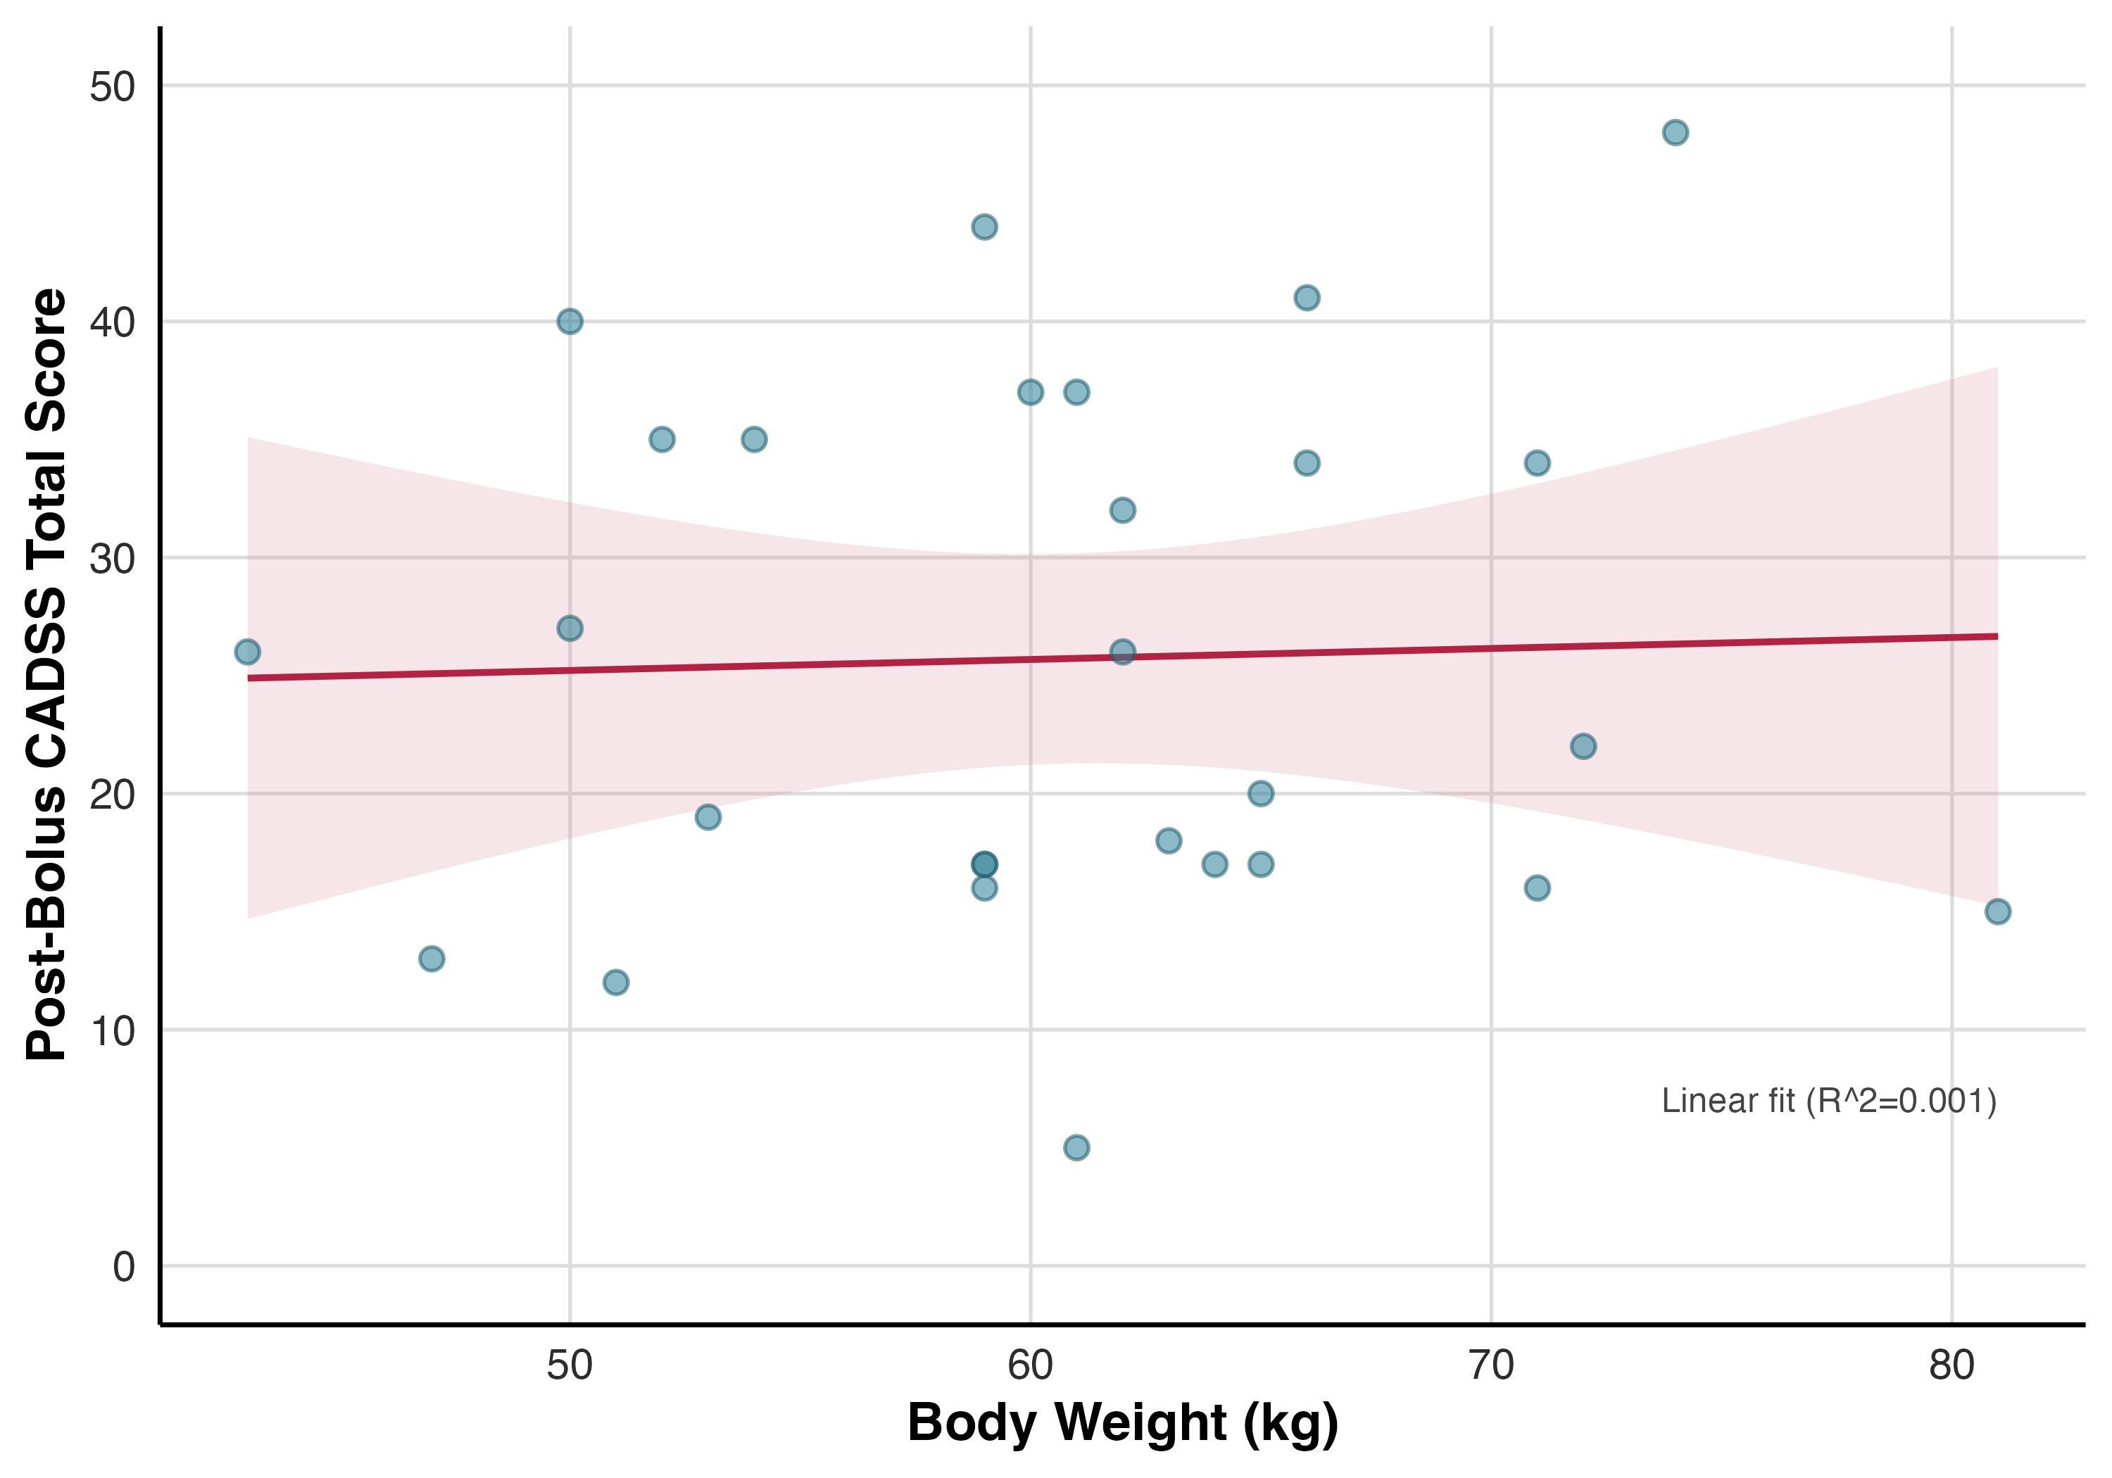
Supplementary Figure S1. Relationship between body weight and post-bolus dissociative symptom severity (CADSS total score) during ketamine administration. Points represent individual participants; the solid line shows the linear fit with shaded 95% confidence interval. No significant association was observed (Pearson r = 0.04, p = 0.855).

Brain region | L/R | Cluster size | Peak p-value | MNI coordinates (mm)
 |  |  |  | x | y | z
Anterior insula / Opercular Cortex | R | 608 | <.001 | 56 | 12 | 14
S1 / Precentral Gyrusᵃ | R | 422 | <.001 | 34 | −20 | 54
Anterior insula / Opercular Cortex | L | 278 | <.001 | −34 | 14 | 12
Precuneusᵃ |  | 249 | <.001 | 10 | −58 | 22
SMA / ACC |  | 241 | <.001 | −12 | 12 | 50
Cerebellum | R | 184 | <.001 | 36 | −56 | −28
Opercular Cortex / Insular Cortex | L | 166 | <.001 | −56 | 4 | 14
S2 / Supramarginal Gyrus | R | 134 | <.001 | 60 | −36 | 44
Supplementary Table S5. Pain-evoked brain activation during the ketamine session. Clusters reflect the painful > non-painful contrast, except those marked ᵃ, which reflect non-painful > painful stimulation. All clusters survived a voxelwise cluster-forming threshold of p < .005 (uncorrected) and cluster-level FDR correction at p < .05.

Effect | df | F | p-value
Intensity | 1, 702 | 124.27 | <.001
Session | 1, 702 | 43.05 | <.001
ROI | 6, 702 | 8.11 | <.001
Intensity × Session | 1, 702 | 16.45 | <.001
Intensity × ROI | 6, 702 | 0.47 | 0.831
Session × ROI | 6, 702 | 0.17 | 0.986
Intensity × Session × ROI | 6, 702 | 0.06 | 0.999
Supplementary Table S6. Full model output for the effects of Ketamine on pain related brain activation. beta~intensity*session*ROI+(1|subji).
ROI | Contrast | Estimate | SE | df | t | p-value
Ant. Insula (L) | Placebo- Ketamine | 0.335 | 0.136 | 338 | 2.463 | 0.014
Ant. Insula (R) | Placebo- Ketamine | 0.401 | 0.136 | 338 | 2.953 | 0.003
dACC | Placebo- Ketamine | 0.403 | 0.136 | 338 | 2.965 | 0.003
DLPFC (R) | Placebo- Ketamine | 0.390 | 0.136 | 338 | 2.868 | 0.004
S1 (R) | Placebo- Ketamine | 0.548 | 0.136 | 338 | 4.030 | <.001
S2 (L) | Placebo- Ketamine | 0.408 | 0.136 | 338 | 3.000 | 0.003
S2 (R) | Placebo- Ketamine | 0.458 | 0.136 | 338 | 3.367 | <.001

Supplementary Table S7. Post-Hoc tests for each ROI in the placebo - ketamine contrast
Effect of calibrated temperature on ROI activation
Effect | df | F | p-value
intensity | 1, 688.31 | 20.22 | <.001
session | 1, 684.76 | 4.05 | .045
ROI | 6, 674.01 | 1.16 | .324
calib temp | 1, 633.37 | 18.60 | <.001
intensity × session | 1, 681.37 | 6.86 | .009
intensity × ROI | 6, 674.01 | 0.83 | .545
session × ROI | 6, 674.01 | 0.61 | .726
intensity × calib temp | 1, 686.08 | 21.44 | <.001
session × calib temp | 1, 684.61 | 4.53 | .034
ROI × calib temp | 6, 674.01 | 1.04 | .399
intensity × session × ROI | 6, 674.01 | 0.06 | .999
intensity × session × calib temp | 1, 680.99 | 7.16 | .008
intensity × ROI × calib temp | 6, 674.01 | 0.87 | .515
session × ROI × calib temp | 6, 674.01 | 0.63 | .706
intensity × session × ROI × calib temp | 6, 674.01 | 0.05 | .999
Supplementary Table S8. ANOVA-style output from the linear mixed-effects model: beta_scale ~ intensity * session * ROI * calib_temp + (1 | subji).
Simple slopes of calibrated temperature by intensity
intensity | calib_temp slope | SE | t | p-value
no-pain | 0.0372 | 0.0283 | 1.315 | .189
pain | 0.1924 | 0.0343 | 5.608 | <.001
Supplementary Table S9. Simple slopes of calib_temp by intensity from the full interaction model (unadjusted p-values).
Simple slopes of calibrated temperature by session
session | calib_temp slope | SE | t | p-value
ketamine | 0.0803 | 0.0273 | 2.937 | .003
placebo | 0.1493 | 0.0346 | 4.320 | <.001
Supplementary Table S10. Simple slopes of calib_temp by session from the full interaction model (unadjusted p-values).
Simple slopes of calibrated temperature by intensity within session
intensity | session | calib_temp slope | SE | t | p-value
no-pain | ketamine | 0.0459 | 0.0317 | 1.450 | .148
pain | ketamine | 0.1147 | 0.0376 | 3.052 | .002
no-pain | placebo | 0.0286 | 0.0376 | 0.759 | .448
pain | placebo | 0.2700 | 0.0471 | 5.737 | <.001
Supplementary Table S11. Simple slopes of calib_temp by intensity within each session from the full interaction model (unadjusted p-values).
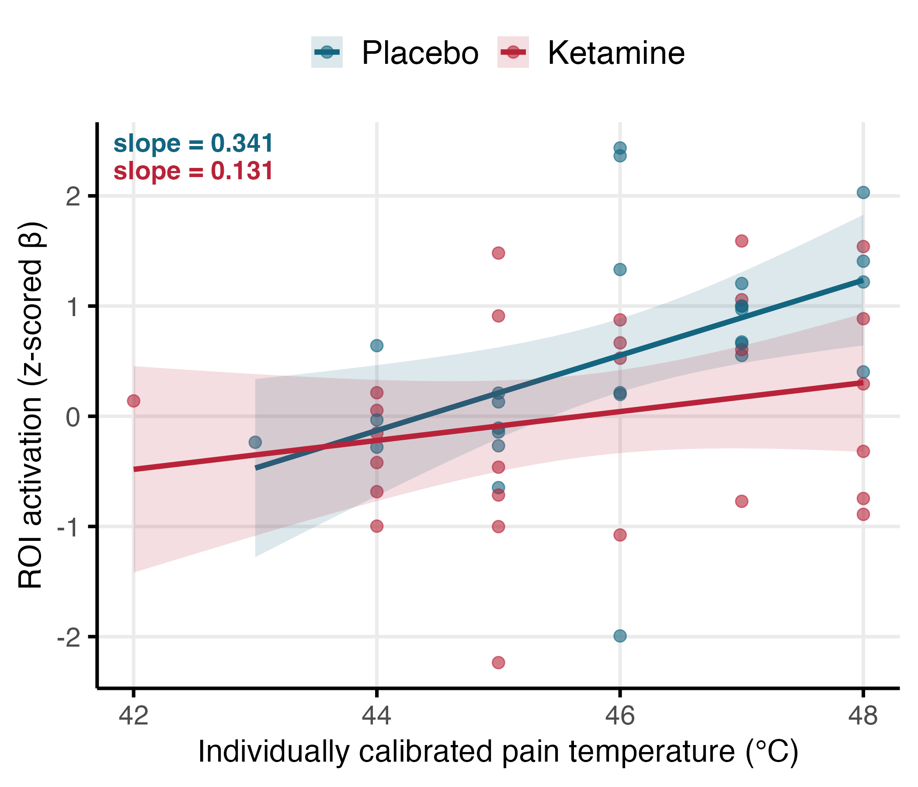
Supplementary Figure S2. Ketamine selectively attenuates pain-responsive ROI sensitivity to objective stimulus temperature. Each point represents a participant's mean z-scored β across pain-responsive ROIs, plotted against their individually calibrated stimulus temperature. Lines show linear fits with 95% confidence intervals. Blue = placebo session; red = ketamine session. The placebo slope was steeper than the ketamine slope.

ROI | Session | Spearman’s ρ | p-value
Ant. Insula (L) | Placebo | 0.528 | 0.005
Ant. Insula (L) | Ketamine | 0.656 | <.001
Ant. Insula (R) | Placebo | 0.463 | 0.015
Ant. Insula (R) | Ketamine | 0.561 | 0.002
DLPFC (R) | Placebo | 0.213 | 0.286
DLPFC (R) | Ketamine | 0.570 | 0.002
dACC | Placebo | 0.359 | 0.066
dACC | Ketamine | 0.651 | <.001
S1 (R) | Placebo | 0.134 | 0.504
S1 (R) | Ketamine | 0.448 | 0.019
S2 (L) | Placebo | 0.460 | 0.016
S2 (L) | Ketamine | 0.344 | 0.079
S2 (R) | Placebo | 0.427 | 0.026
S2 (R) | Ketamine | 0.491 | 0.009
Supplementary Table S12. Spearman correlation between ROI activation difference and pain rating difference. This table reports Spearman’s rank correlation coefficients (ρ) and associated p-values for the relationship between activation difference (high – low pain) in each region of interest (ROI) and the corresponding subjective pain rating difference, separately for the placebo and ketamine sessions.

ROI | Pain‑Only p | Depersonalization p | Derealization p | Amnesia p | Model Comparison p
Ant. Insula (L) | 0.0009 | 0.825 | 0.98 | 0.827 | 0.969
Ant. Insula (R) | 0.0030 | 0.58 | 0.7 | 0.703 | 0.853
dACC | 0.0030 | 0.892 | 0.965 | 0.655 | 0.922
DLPFC (R) | 0.0054 | 0.62 | 0.661 | 0.449 | 0.761
S1 (R) | 0.0885 | 0.384 | 0.875 | 0.258 | 0.632
S2 (L) | 0.0400 | 0.6 | 0.312 | 0.795 | 0.777
S2 (R) | 0.0330 | 0.983 | 0.662 | 0.845 | 0.968

ROI | F | df1 | df2 | Adj R² (Pain‑Only) | Adj R² (Full) | AIC (Pain‑Only) | AIC (Full)
Ant. Insula (L) | 0.081 | 3 | 22 | 0.429 | 0.358 | 44.6 | 50.3
Ant. Insula (R) | 0.261 | 3 | 22 | 0.394 | 0.335 | 50.8 | 55.9
dACC | 0.160 | 3 | 22 | 0.375 | 0.305 | 55.9 | 61.3
DLPFC (R) | 0.390 | 3 | 22 | 0.336 | 0.283 | 50.1 | 54.7
S1 (R) | 0.584 | 3 | 22 | 0.199 | 0.156 | 53.6 | 57.6
S2 (L) | 0.367 | 3 | 22 | 0.173 | 0.105 | 59.5 | 64.2
S2 (R) | 0.084 | 3 | 22 | 0.208 | 0.110 | 53.8 | 59.5
Supplementary Table S13. Model results for pain-related brain activation during ketamine administration. This table presents results from two linear models fitted separately for each region of interest (ROI). The Pain Only Model includes subjective pain ratings as the sole predictor of brain activation. The Pain and Dissociation (full) model adds dissociation subscale scores (Depersonalization, Derealization, Amnesia) to the model. The table reports p-values for each dissociation predictor, the model comparison p-value (P Model Comparison) based on ANOVA, adjusted R² for both models, and model AICs. A significant p-value in the model comparison supports the added explanatory value of including dissociation scores.
Outcome | Pain Only Model p | Depersonalization p | Derealization p | Amnesia p | ANOVA p | F-stat | df1 | df2
NPS | 0.01 | 0.568 | 0.067 | 0.717 | 0.277 | 1.37 | 3 | 22

Adj. R² (Pain Only Model Model) | Adj. R² (Pain And Dissociation Model) | AIC (Pain Only Model ) | AIC (Pain And Dissociation Model)
0.27 | 0.3018 | 244 | 245
Supplementary Table S14. Model results for pain-related multivariate brain activation during ketamine administration. This table presents results from two linear models fitted separately predicting the multi-voxel biomarker for the subjective intensity of pain: the Neurologic Pain Signature. The Pain Only Model includes subjective pain ratings as the sole predictor of brain activation. The Pain and Dissociation Model add dissociation subscale scores (Depersonalization, Derealization, Amnesia) to the model. The table reports p-values for each dissociation predictor, the model comparison p-value (P Model Comparison) based on ANOVA, adjusted R² for both models, and model AICs.

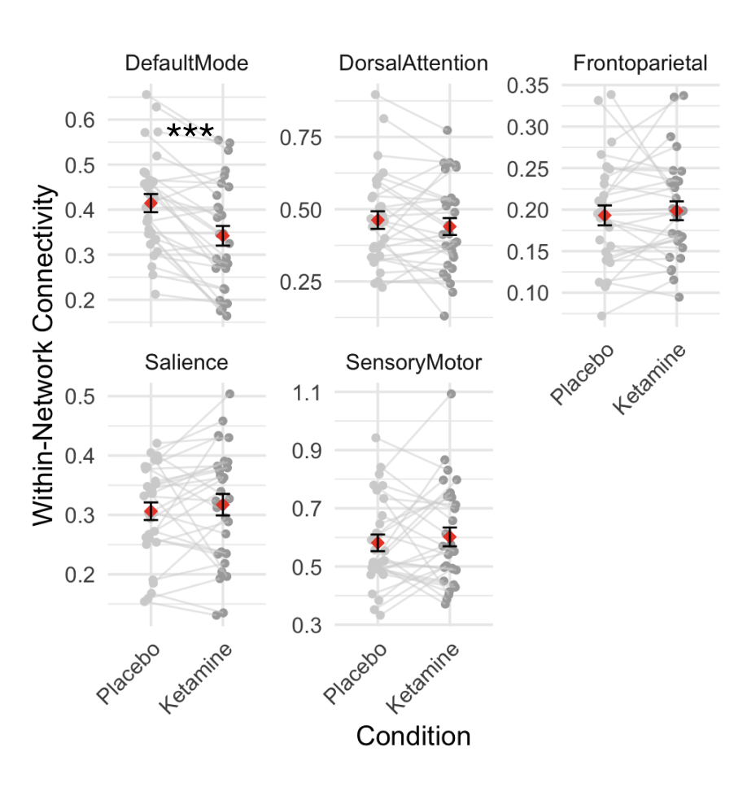
Supplementary Figure S3. Effects of ketamine on within-network functional connectivity across brain networks. Connectivity values were extracted from the pain task fMRI data in each session and computed within the following networks: Default Mode Network, Dorsal Attention Network, Frontoparietal Network, Salience Network, and Somato Motor Network . Individual subject trajectories are shown in grey, with red diamonds representing the group mean and error bars indicating the standard error of the mean. *** p<.001
References

1. Bremner, J. D. et al. Measurement of dissociative states with the Clinician-Administered Dissociative States Scale (CADSS). J. Trauma. Stress 11, 125–136 (1998).
2. Kross, E., Berman, M. G., Mischel, W., Smith, E. E. & Wager, T. D. Social rejection shares somatosensory representations with physical pain. Proc. Natl. Acad. Sci. U. S. A. 108, 6270–6275 (2011).
3. Woo, C.-W. et al. Separate neural representations for physical pain and social rejection. Nat. Commun. 5, 5380 (2014).
4. D’Souza, D. C. et al. Glycine transporter inhibitor attenuates the psychotomimetic effects of ketamine in healthy males: preliminary evidence. Neuropsychopharmacology 37, 1036–1046 (2012).
5. van Schalkwyk, G. I., Wilkinson, S. T., Davidson, L., Silverman, W. K. & Sanacora, G. Acute psychoactive effects of intravenous ketamine during treatment of mood disorders: Analysis of the Clinician Administered Dissociative State Scale. J. Affect. Disord. 227, 11–16 (2018).
6. Diazgranados, N. et al. A randomized add-on trial of an N-methyl-D-aspartate antagonist in treatment-resistant bipolar depression. Arch. Gen. Psychiatry 67, 793–802 (2010).
7. Murrough, J. W. et al. Ketamine for rapid reduction of suicidal ideation: a randomized controlled trial. Psychol. Med. 45, 3571–3580 (2015).
8. Singh, J. B. et al. A Double-Blind, Randomized, Placebo-Controlled, Dose-Frequency Study of Intravenous Ketamine in Patients With Treatment-Resistant Depression. Am. J. Psychiatry 173, 816–826 (2016).
9. Zarate, C. A., Jr & Niciu, M. J. Ketamine for depression: evidence, challenges and promise. World Psychiatry 14, 348–350 (2015).
10. Buhle, J. & Wager, T. D. Does meditation training lead to enduring changes in the anticipation and experience of pain? Pain vol. 150 382–383 (2010).
11. Wager, T. D. et al. Placebo-induced changes in FMRI in the anticipation and experience of pain. Science 303, 1162–1167 (2004).
12. Wager, T. D., Scott, D. J. & Zubieta, J.-K. Placebo effects on human mu-opioid activity during pain. Proc. Natl. Acad. Sci. U. S. A. 104, 11056–11061 (2007).
13. Esteban, O. et al. fMRIPrep: a robust preprocessing pipeline for functional MRI. Nat. Methods 16, 111–116 (2019).
14. McMillan, R. et al. Temporal dynamics of the pharmacological MRI response to subanaesthetic ketamine in healthy volunteers: A simultaneous EEG/fMRI study. J. Psychopharmacol. 33, 219–229 (2019).
15. Kasper, L. et al. The PhysIO Toolbox for Modeling Physiological Noise in fMRI Data. J. Neurosci. Methods 276, 56–72 (2017).
16. Siegel, J. S. et al. Statistical improvements in functional magnetic resonance imaging analyses produced by censoring high-motion data points. Hum. Brain Mapp. 35, 1981–1996 (2014).
17. Wager, T. D. et al. An fMRI-based neurologic signature of physical pain. N. Engl. J. Med. 368, 1388–1397 (2013).
18. Woo, C.-W. et al. Quantifying cerebral contributions to pain beyond nociception. Nat. Commun. 8, 14211 (2017).
19. Zunhammer, M., Bingel, U., Wager, T. D. & Placebo Imaging Consortium. Placebo Effects on the Neurologic Pain Signature: A Meta-analysis of Individual Participant Functional Magnetic Resonance Imaging Data. JAMA Neurol. 75, 1321–1330 (2018).
20. Han, X. et al. Effect sizes and test-retest reliability of the fMRI-based neurologic pain signature. Neuroimage 247, 118844 (2022).
21. López-Solà, M. et al. The neurologic pain signature responds to nonsteroidal anti-inflammatory treatment vs placebo in knee osteoarthritis. Pain Rep 7, e986 (2022).
22. Whitfield-Gabrieli, S. & Nieto-Castanon, A. Conn: a functional connectivity toolbox for correlated and anticorrelated brain networks. Brain Connect. 2, 125–141 (2012).
23. Yeo, B. T. T. et al. The organization of the human cerebral cortex estimated by intrinsic functional connectivity. J. Neurophysiol. 106, 1125–1165 (2011).
24. Calhoun, V. D., Adali, T., Pearlson, G. D. & Pekar, J. J. A method for making group inferences from functional MRI data using independent component analysis. Hum. Brain Mapp. 14, 140–151 (2001).
25. Singmann, H. et al. afex: Analysis of factorial experiments. Comprehensive R Archive Network (CRAN). Preprint at (2016).
26. Barr, D. J., Levy, R., Scheepers, C. & Tily, H. J. Random effects structure for confirmatory hypothesis testing: Keep it maximal. J. Mem. Lang. 68, (2013).

