Lab 1
From CTI to SOC Investigation and MITRE ATT&CK Mapping

1. CTI Report
Microsoft Threat Intelligence. Photo ZIP campaign targeting hospitality industry delivers Node.js implant for persistent access. Microsoft Security Blog, June 25, 2026. https://www.microsoft.com/en-us/security/blog/2026/06/25/photo-zip-campaign-targeting-hospitality-industry-delivers-node-js-implant-persistent-access/
Microsoft Threat Intelligence reported an active, multi-stage campaign targeting hotel and hospitality organizations in Europe and Asia since April 2026. The affected devices were mainly Windows machines used by front desk, reception and reservation staff. Microsoft did not attribute the campaign to a known actor and states that its final objective is unclear, but assesses that the heavy focus on obfuscation and persistence may indicate preparation for follow-on activity.
The attack starts when a user downloads a photo-themed ZIP archive through the browser, in some cases from a link in a phishing email relayed through Calendly and Google redirects. The archive contains a shortcut disguised as an image (IMG-/PHOTO-<numbers>.png.lnk). Opening it launches obfuscated PowerShell that decodes a URL, downloads a second script to %TEMP% and runs it. Next, node.exe runs a JavaScript implant from the user's AppData folder. The attacker then adds Microsoft Defender exclusions for executables in the Temp folder, runs them, copies payloads to ProgramData and creates Run and RunOnce registry keys for persistence. Infected hosts beacon to C2 servers over non-standard ports, and on some devices Microsoft also observed headless browser automation, an IP geolocation lookup and forced shutdowns.

2. Attack Flow
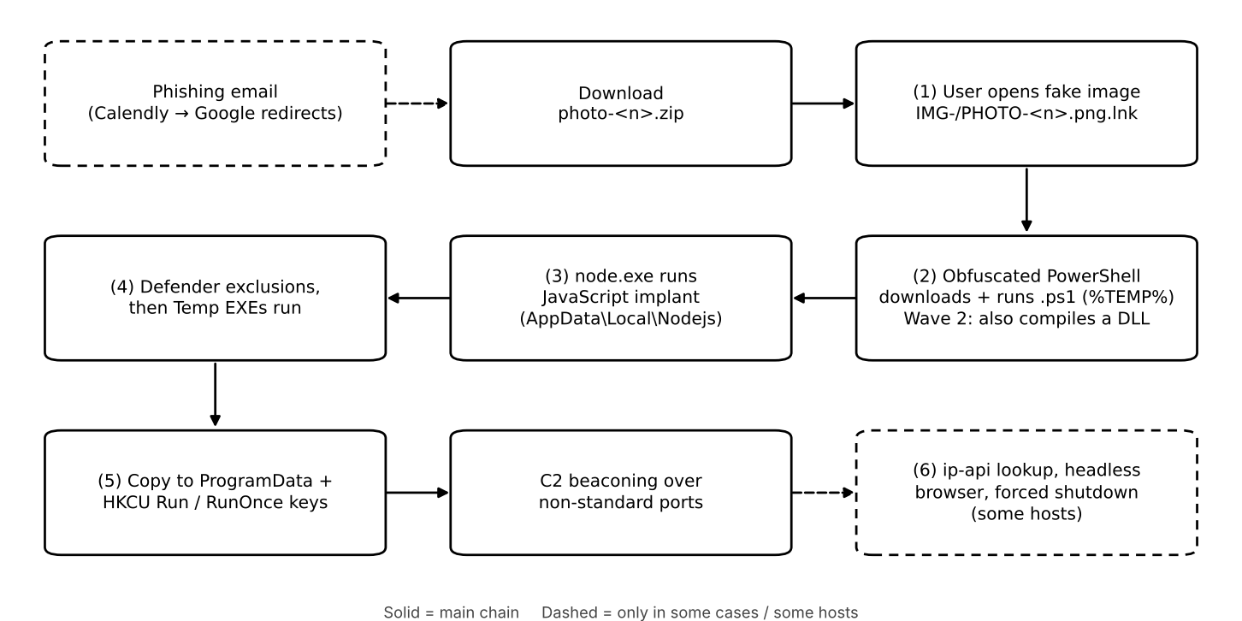
Numbers match the behaviors in the mapping table. Facts vs. interpretation: we did not treat the following as facts, because the report itself does not confirm them: the final objective of the campaign (the report says it is unclear), execution of the Wave 2 DLL (it was compiled but not seen loaded), and what the headless browser actually did (Microsoft infers automation only from the command line).

3. ATT&CK Mapping (ATT&CK Enterprise v20)
Observed behavior | ATT&CK tactic | Technique / ID | Evidence and mapping rationale | SOC telemetry / investigation
1. User opens a fake image shortcut (.png.lnk) from a downloaded ZIP | Execution  Stealth | User Execution: Malicious File (T1204.002)  Masquerading: Double File Extension (T1036.007) | The infection starts only when the user opens IMG-/PHOTO-<n>.png.lnk. Windows hides the .lnk extension, so the file looks like a PNG image. | Process creation: explorer.exe opens a .lnk from Downloads, followed by powershell.exe.
2. Obfuscated PowerShell downloads a .ps1 to %TEMP% and runs it | Execution  Command and Control  Stealth | PowerShell (T1059.001)  Ingress Tool Transfer (T1105)  Command Obfuscation (T1027.010) | Figs. 9–15 show PowerShell with -ep bypass, a download with iwr -OutFile to %TEMP%, and the URL hidden as encoded numbers inside the command line. | Process creation with command line (4688 / Sysmon 1), PowerShell 4104, proxy/DNS logs.
3. node.exe runs a JavaScript implant from AppData\Local\Nodejs | Execution | JavaScript (T1059.007) | Fig. 3: node.exe runs a random .js file with a domain as an argument. The report does not describe the C2 protocol, so we did not map T1071. | Process creation of node.exe from the user profile and its network connections.
4. Defender exclusions added for EXEs in the Temp folder | Defense Impairment | Disable or Modify Tools (T1685) | Fig. 5: Add-MpPreference -ExclusionProcess, seconds before those EXEs run. No sub-technique of T1685 covers antivirus exclusions. | Defender event 5007, registry changes under Windows Defender\Exclusions.
5. Run / RunOnce registry keys | Persistence | Registry Run Keys / Startup Folder (T1547.001) | Fig. 7: HKCU RunOnce points to an EXE in ProgramData; HKCU Run points to node.exe. | Sysmon 13 on Run/RunOnce, EDR autostart alerts.
6. Lookup to ip-api[.]com (some hosts) | Discovery | System Location Discovery (T1614), uncertain | ip-api is an IP geolocation service, and T1614 covers this kind of lookup. Microsoft mapped it to T1016 (see section 5). | Proxy/DNS logs with the full request URL.
Note: the report maps the Defender exclusions to T1562.001 under Defense Evasion. In ATT&CK v19 (April 2026), Defense Evasion was split into Stealth and Defense Impairment, and T1562.001 was merged into T1685, so we used the current ID.

4. SOC Investigation Notes
Behavior 2 – PowerShell download and execution. Telemetry: process creation with command line (4688 / Sysmon 1), Script Block Logging (4104), proxy/DNS. Tier 1: check whether PowerShell was started by explorer.exe right after a .lnk from a ZIP was opened, and whether PowerShell is normal on a front-desk PC; an unknown destination domain means escalate. Tier 2: rebuild the process tree to see what ran next (node.exe), read the decoded script in event 4104, search other hosts for the same domain and pattern, and isolate affected hosts.
Behavior 4 – Defender exclusions. Telemetry: Defender Operational event 5007, registry changes under Windows Defender\Exclusions, PowerShell running Add-MpPreference. Tier 1: was the change made by an IT tool (Intune/GPO) with a change record, or by PowerShell in a user session? An excluded Temp path with no record means escalate. Tier 2: match the exclusion time with execution of the excluded files, check their hashes, review exclusions on other hosts, remove them and verify tamper protection. Open question: how the process had admin rights, which the report does not explain.
Behavior 5 – Run/RunOnce persistence. Telemetry: Sysmon 13 on HKCU Run/RunOnce, EDR autostart alerts, reg.exe process creation. Tier 1: a value pointing to a random ProgramData folder or to AppData\Local\Nodejs, with a random name and written by reg.exe from a script, means escalate. Tier 2: remove both keys (the report shows the Node.js Run key survived after one payload was blocked), check whether RunOnce is recreated after logon, and confirm cleanup after a reboot.
ATT&CK describes behavior, so none of these alerts proves malicious intent on its own; IT staff also use PowerShell, add exclusions and create Run keys. The decision depends on context.

5. Uncertain Mapping
Behavior 6 (ip-api lookup). We mapped it to System Location Discovery (T1614), because ip-api is an IP geolocation service and T1614 covers this kind of lookup. Microsoft mapped it to System Network Configuration Discovery (T1016), while describing it as a "geolocation lookup" in the same table. Another option is Internet Connection Discovery (T1016.001), if the request was only a connectivity check.
Evidence that would decide it:
- The full request URL: location fields (country, city) support T1614; requesting only the IP supports T1016.
- Whether the implant behaved differently by country after the lookup, which would strongly support T1614.
- The implant's .js code, which is not published in the report.
Decision: we keep T1614 and mark it as uncertain.

References
Microsoft Threat Intelligence report (above). https://www.microsoft.com/en-us/security/blog/2026/06/25/photo-zip-campaign-targeting-hospitality-industry-delivers-node-js-implant-persistent-access/
MITRE ATT&CK Enterprise v20. https://attack.mitre.org/

