**Multi-Grid**

One-dimensional boundary value problem:

$-u^{''}\left(x\right)= f\left(x\right) , 0<x<1$, Grid: $h=\frac{1}{N} , xi=ih , i=0, 1, …,N$

For $f\left(x\right)=0$

**Initial guess: $v\left(x\right)=(sin\left(\frac{40π}{N}\right)+\sin\left(\frac{16π}{N}\right)+sin⁡(\frac{3π}{N}))*1/3$**

For boundaries: $u\left(0\right)=0, u\left(1\right)=0$, MY CUSTOM GRAPH:

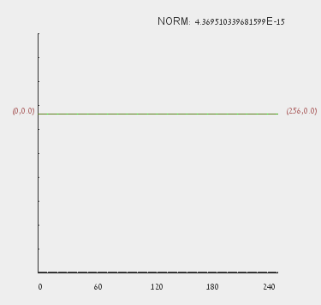 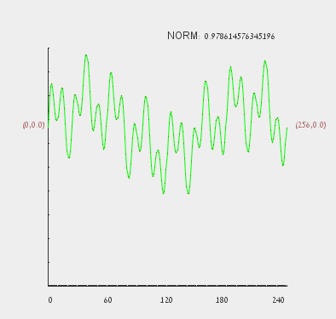

Output result:

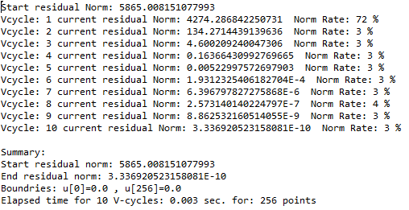

Execution result for 2^20 points and 40 V-cycles:

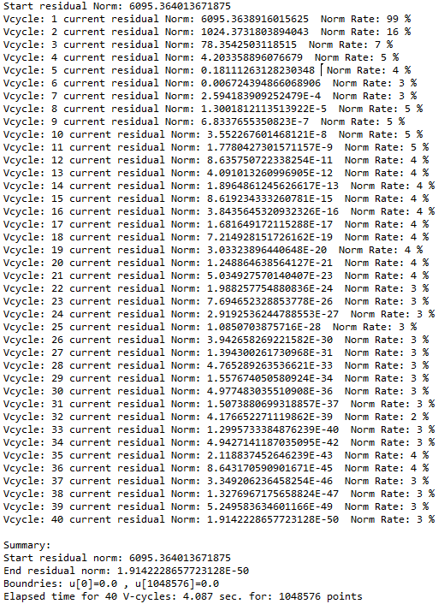

For $f\left(x\right)=1$ we expect to get negative parabola: Now with Matlab graph

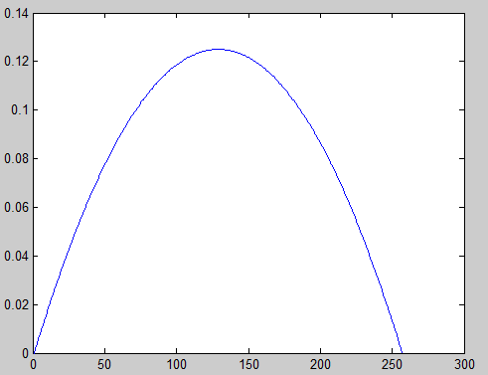

Output result:

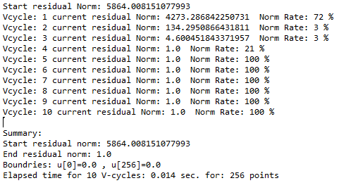

**Initial guess: $v\left(x\right)=(sin\left(\frac{6π}{N}\right)+\sin\left(\frac{32π}{N}\right)+sin⁡(\frac{π}{N}))*1/3$**

For boundaries: $u\left(0\right)=-1, u\left(1\right)=1$, for **N = 512**, MY CUSTOM GRAPH:

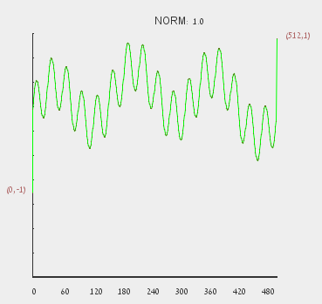 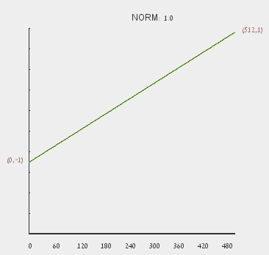

Output result:

