**Maman 12 report**

**Noam Salomonski**

**303161194**

Loader.DataSet loads the database from pkl, and shows the required visualizations.

Counting occurrences of every digit (in the y vectors) in all train/validation/test sets gives the following histogram:

{0: 6903, 1: 7877, 2: 6990, 3: 7141, 4: 6824, 5: 6313, 6: 6876, 7: 7293, 8: 6825, 9: 6958}

Showing 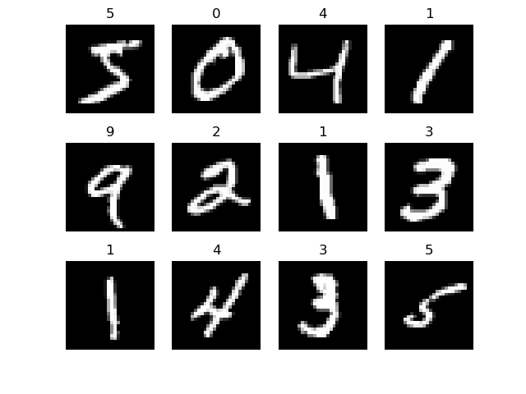

Question 1 – KNN:

Showing the results for k=1..10:

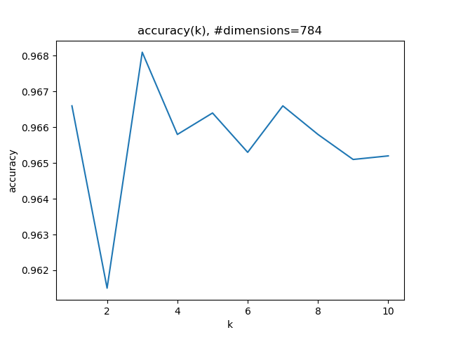

We can see the accuracy for k=3 is 0.968. [the graph starts from 0, but k from 1]

In case of a tie in “votes”, the lower digit is selected.

**Question 2 – PCA:**

b.

The average digit is the same if calculated in pca or in feature (pixel) space, because of linearity.

Here it is in feature space:

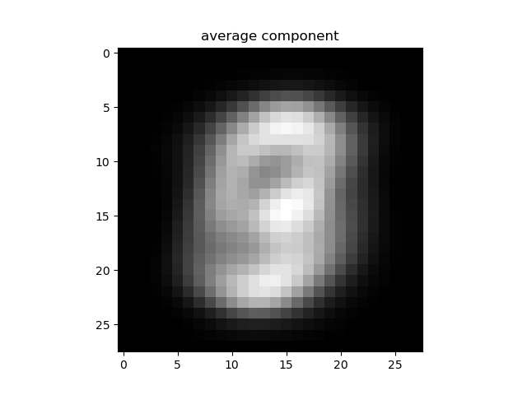

The first 6 strongest components in feature space:

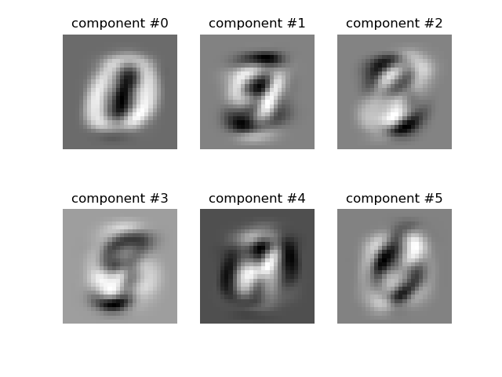

Cumulative variance which is explained by (sorted) principal components (1 is all the variance).

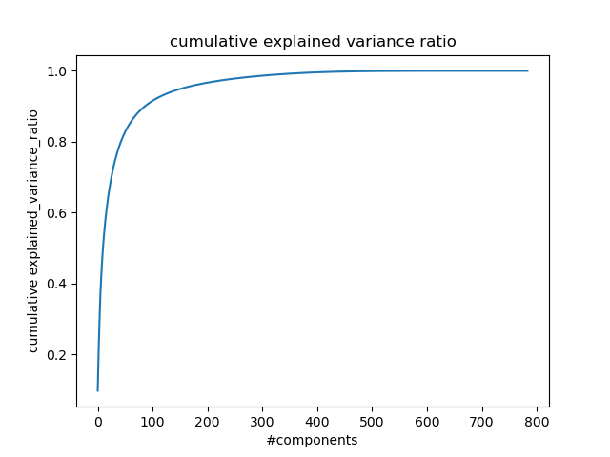

If we want to preserve 80% of the variance, we need the first 44 components. For 95%, we need 154 components.

Calculated using calculate_n_components_required.

Reducing the dimensionality to 2 by using the strongest 2 components and giving each label its own color yields the following:

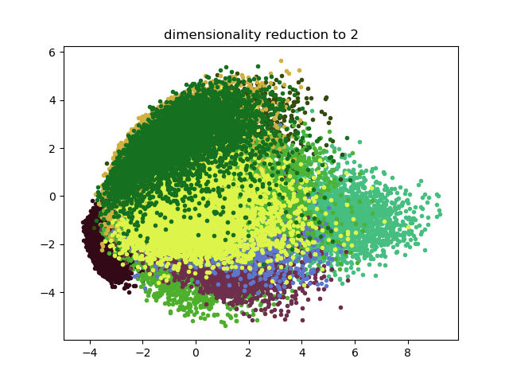

f.

When repeating question 1 with 2 dimensions:

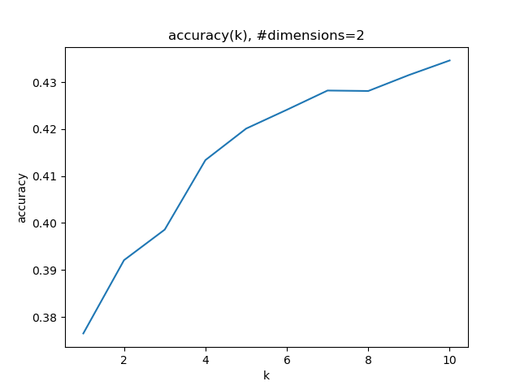

Best k is 10. Accuracy is very low, because there are not enough dimensions. Computation is noticeably faster.

With 10 dimensions:

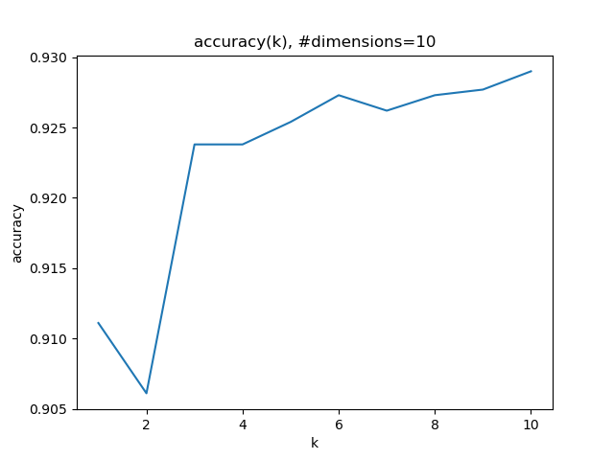

Best k is 10. Better accuracy, but not as good as before.

With 20 dimensions

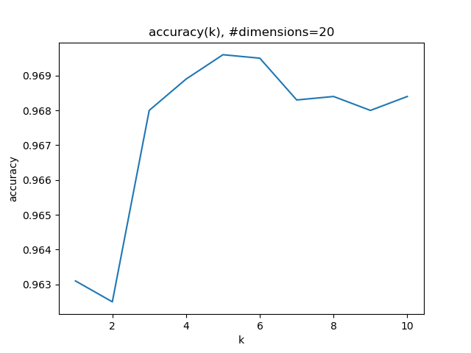

Best k is 5, and accuracy is even better than with all dimensions!

**For transforming a digit to a lower dimension:**

reduced_components = pca.components_.T[:, :dim]  
reduced_data = np.dot(data - pca.mean_, reduced_components)

meaning: reduce the mean from the digit’s data in feature space, then matrix-multiply by the first dim pca vectors.

**For transforming a digit back from pca space:**

data_original = np.dot(pc_data, pca.components_[:dim, :]) + pca.mean_

meaning do the exact opposite:

multiply by the 1st dim components (transposed == inverse), then add the mean.

Results for different dimensions:

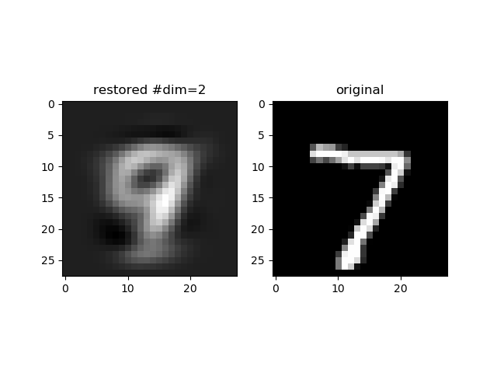

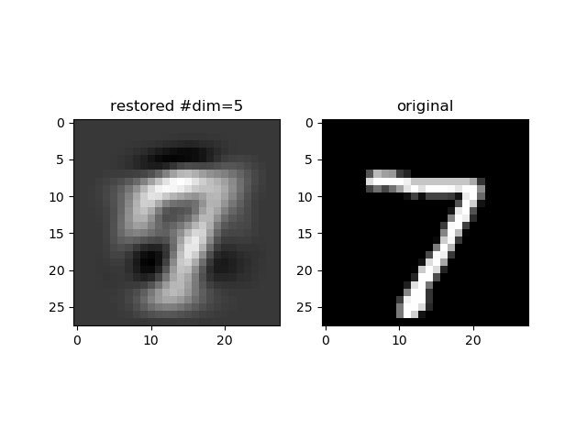

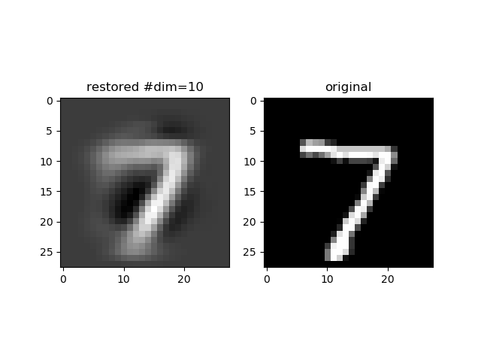

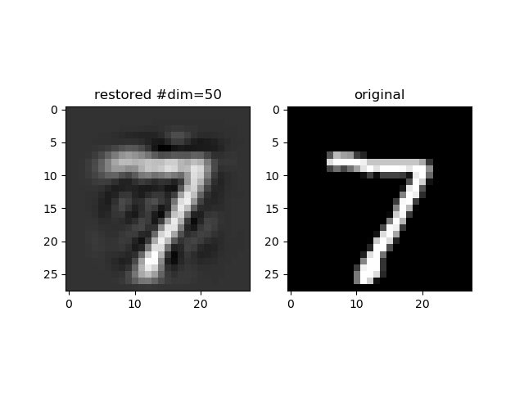

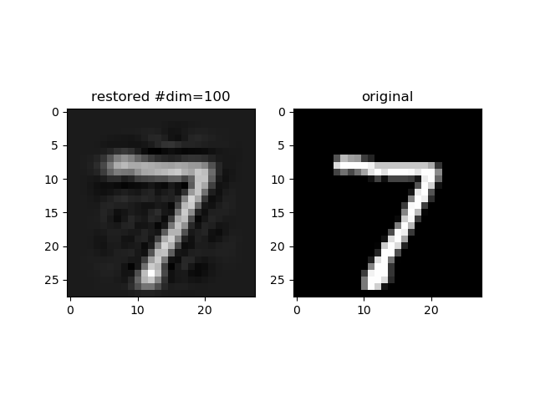

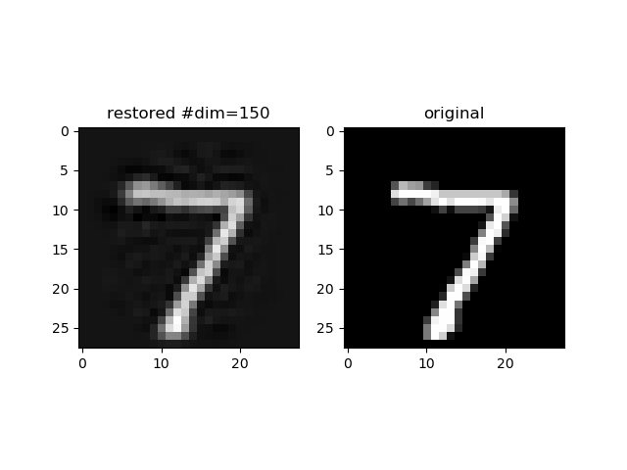

We can indeed see that the more dimensions we keep, the better the reconstruction gets.