**Question 2:**

For train size 80%:

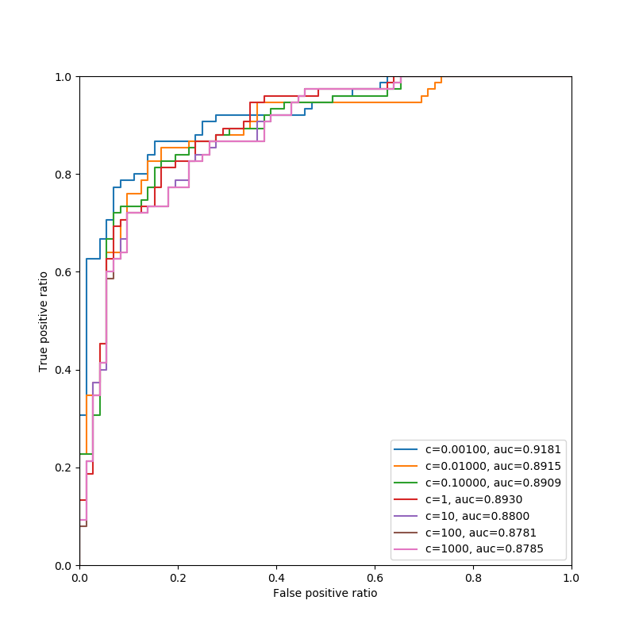

We can see the best auc is for c=0.001.

For train size 50%:

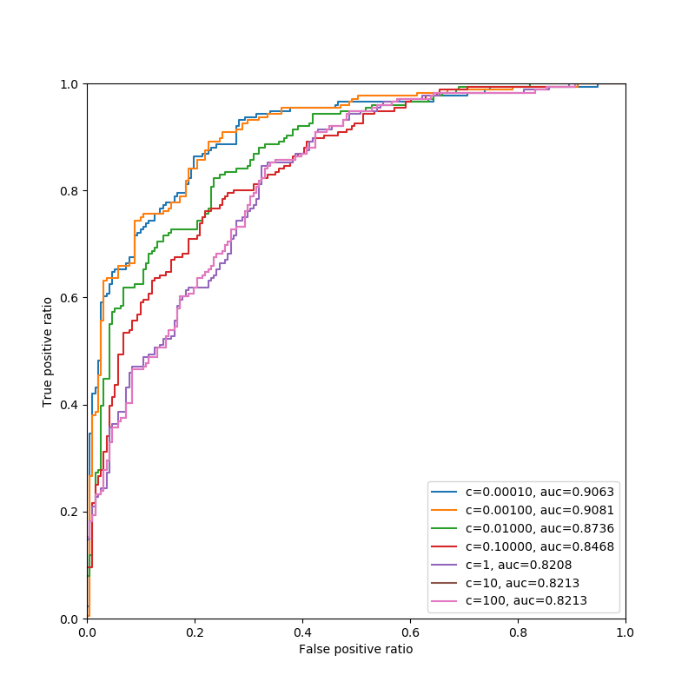

Train size 10%:

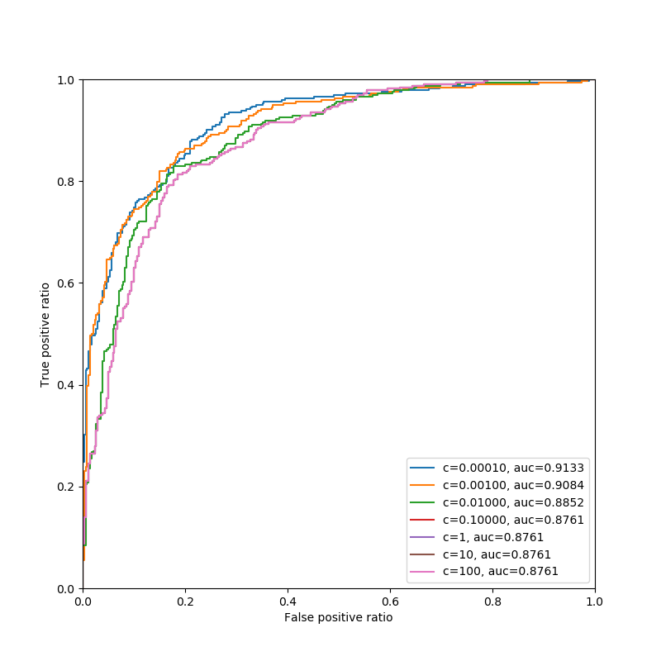

I apologize for not answering the question “What was the average result”. Generating those results on my computer takes all night, and I didn’t have the time.