Types of stimulus: pain/no pain

Modality: rejection/ physical

4 runs (counter balance): each run is either rejection or physical

In each run consist of 8 trails (should be randomize and that randomization should be documented):

1. Fixation (7s)
2. Stimuli (15s):

|  |  |  |
| --- | --- | --- |
|  | Pain | No pain |
| Physical (1.5-s temperature ramp up/down, 12 s at peak temperature) | VAS 8 | VAS 2 |
| Rejection: (I) headshot photograph (II)  cue phrases | Ex-partner with text | Close Friend with text |

1. 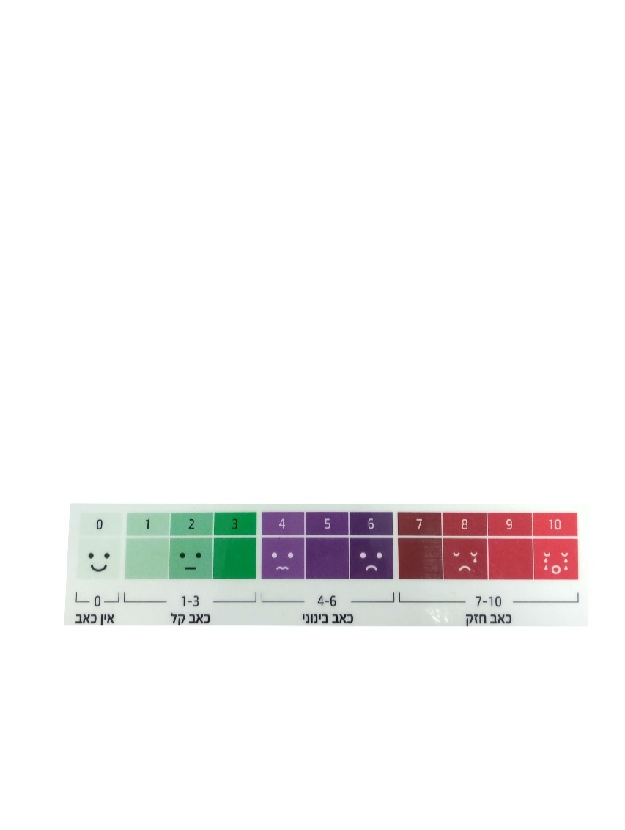Rating (5s): VAS
2. Washout (18s)- an arrow pointing left or right and participants are asked to indicate which direction the arrow is pointing (duration 750ms, ISI 1500ms, trials amount: 8)