Internal Product

IAB Rising Star Ad Units

Sojern is proud to support IAB Rising Star Ad Units. These brand-friendly ad units are bigger, bolder and offer multiple styles that are both rich and interactive.

**Billboard Portrait Filmstrip**

These are all highly engaging ad units, in premium publisher environments with the technology to **scale** and **optimize** in **real-time**.

**Billboard**

970x250 large billboard with full close-ability

This large, front and center interactive unit is designed to catch the users’ attention immediately. It’s page-top position, offers more space and greater functionality for video, animation and interaction.

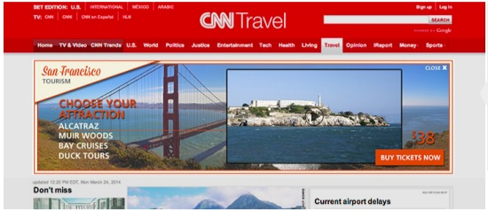

Opportunity: The Billboard essentially offers a large, prominently placed blank canvas allowing the advertiser to tell their story however they want.

**Portrait**

300x1050 tall with three expandable apps (one large and two small)

The Portrait is a high impact, advanced in-banner ad unit that offers prominent branding and large real estate to capture the users attention. The large canvas is segmented into three units (apps) that can be customized to include several highly interactive features and content. These interactive elements provide the user with a highly immersive 300x1050 ad experience.

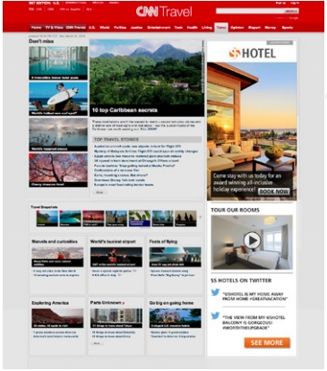

Opportunity: Run highly interactive, content-driven ads with a clear content hierarchy. Using this format, you can present a highly visual, eye-catching experience in the top module, and some interesting supplementary functionality in the two secondary units.

**Filmstrip**

300x3000 / In-page display area: 300x600

The Filmstrip is a high impact, breakthrough in-banner ad unit that enables enhanced creative story-telling capabilities within a single ad creative. Within this in-page display ad unit, the user sees the initial 300x600 frame and can then scroll up and down within the Filmstrip to explore and interact with all five frames of the 300x3000 Filmstrip ad unit. Advertisers submit one 300x3000 Filmstrip containing five different frames. The Filmstrip is then served through the 300x600 ad space.

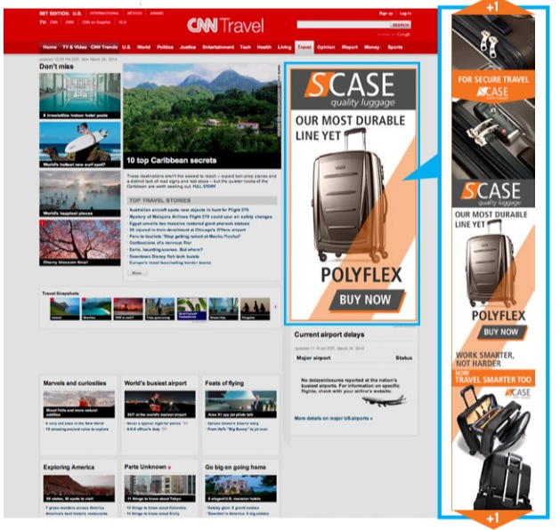

Opportunity: Tell the brands story as users navigate the frames of the filmstrip. The frames can correspond to the five steps of the typical purchase funnel, or present a unique and creative information flow.

**Sample Site List:**

AE&E Networks

Star Tribune

BBC Properties

Glam Media

Time

Tribune Broadcasting

Cafe Mom

MLB

ABC Digital Media

Gourmet Ads

Homeaway

Bonnier Corporation

Associated Press

Viacom

Salary.com

BizJournals

SheKnows

Whitepages

**Pricing**

$20 dCPM (add margin on top of this price)

**Getting Started**

To gain access to Rising Star ad units, you follow the same set-up as you would for any other creative layout. Simply upload the creative to the platform and select all inventory sources. Even though it's currently only available through a subset of inventory sources:

Improve Digital

Rubicon

App Nexus

Pubmatic

The above list may change and thus selecting all inventory sources will allow for campaigns to run on all inventory as it becomes available.

**For detailed specifications and style guide please refer to:**

Billboard

<http://www.iab.net/media/file/IAB_Billboard_Style_Guide.pdf>

Filmstrip

<http://www.iab.net/media/file/IAB_Filmstrip_Style_Guide_v3.pdf>

Portrait

<http://www.iab.net/media/file/IAB_300x1050_style_guide_v3.pdf>

**Inventory/Forecasting**

Currently, the Filmstrip is difficult to forecast as it is served through the 300x600 ad space and pulls non-expandable impressions as well.

As this is fairly new to the platform, the actual inventory run for Billboard and Portrait ad units has been small, forecasting against these layouts based on won impressions is difficult.