Florentine map tiles — divide-and-conquer split
Source: new1.clean.sim.json
Split into 68 tiles (max 5 segments each). 293 segments total; 1 loop-closure duplicate introduced. Each tile is a standalone .sim.json that loads in SimStudio.
Strategy: BFS-grow from peripheral seed segments inward, ` prioritizing edges that close loops within the growing tile over edges that only extend it outward. Tile assignment is by polyline midpoint of each segment.

Tile layout — full map
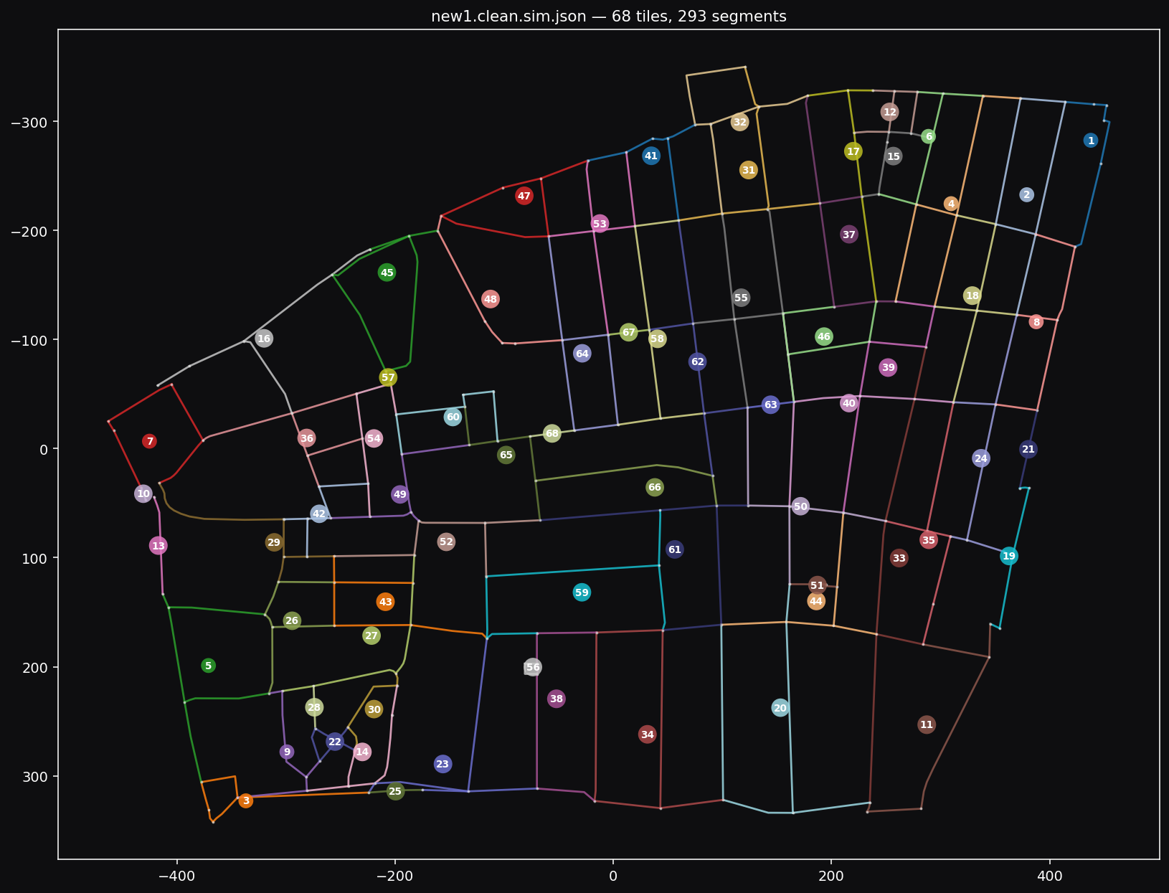
Each numbered circle marks one tile's centroid. Colors are arbitrary — they just visually separate adjacent tiles. Detailed per-tile renders follow.

Tiles
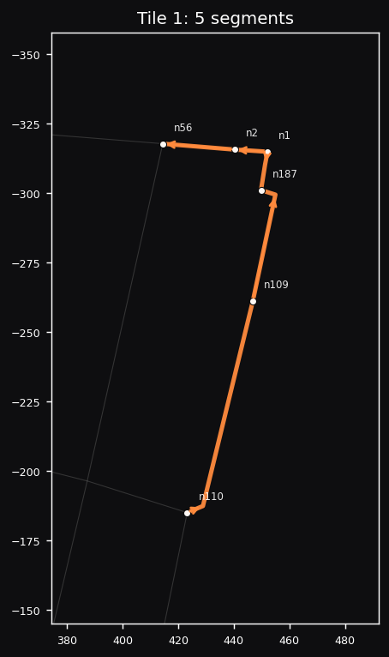  Tile 1  5 segments · 6 nodes  File: tile_001.sim.json  Segments: seg1, seg148, seg149, seg314, seg360 | 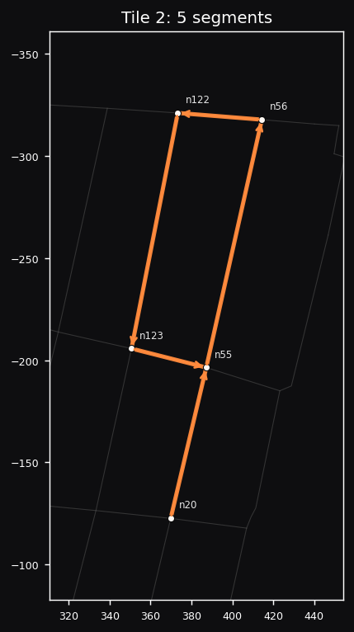  Tile 2  5 segments · 5 nodes  File: tile_002.sim.json  Segments: seg361, seg47, seg46, seg226, seg94
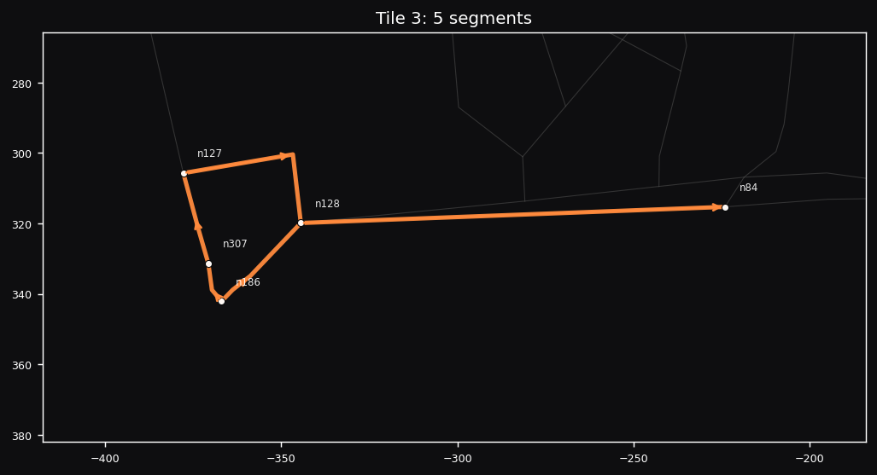  Tile 3  5 segments · 5 nodes  File: tile_003.sim.json  Segments: seg444, seg446, seg147, seg97, seg248 | 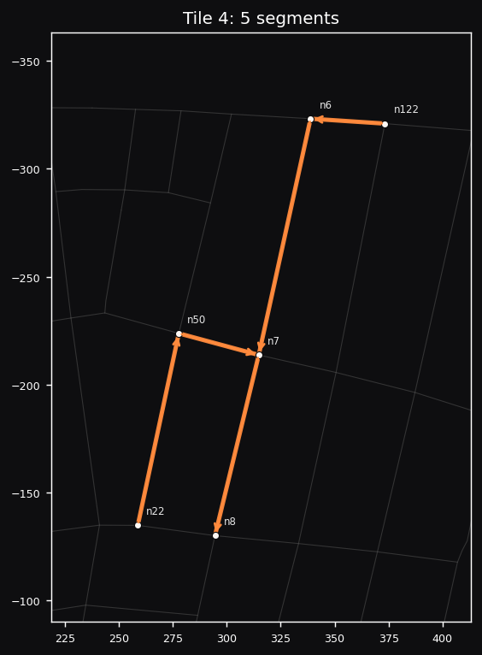  Tile 4  5 segments · 6 nodes  File: tile_004.sim.json  Segments: seg364, seg4, seg5, seg224, seg41
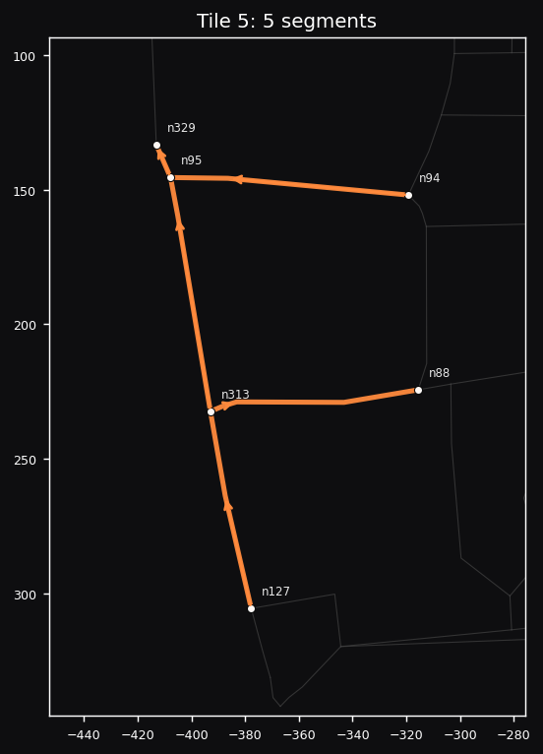  Tile 5  5 segments · 6 nodes  File: tile_005.sim.json  Segments: seg447, seg332, seg448, seg76, seg394 | 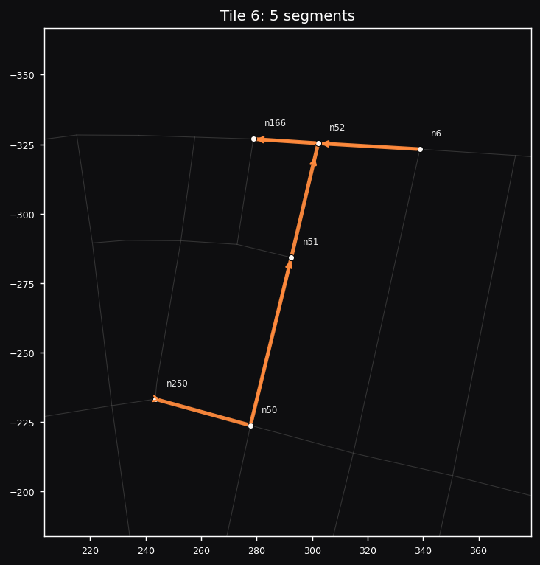  Tile 6  5 segments · 6 nodes  File: tile_006.sim.json  Segments: seg131, seg43, seg365, seg42, seg223
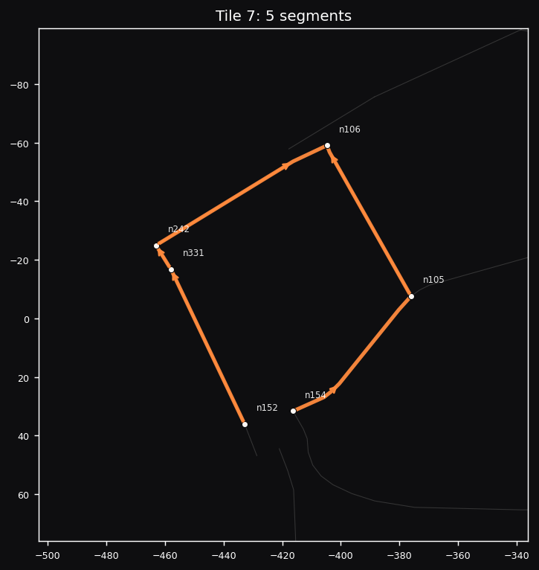  Tile 7  5 segments · 6 nodes  File: tile_007.sim.json  Segments: seg398, seg397, seg208, seg84, seg118 | 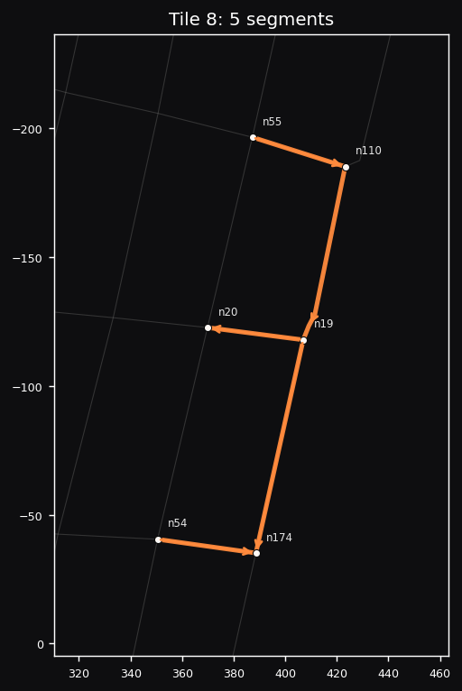  Tile 8  5 segments · 6 nodes  File: tile_008.sim.json  Segments: seg308, seg465, seg15, seg138, seg201
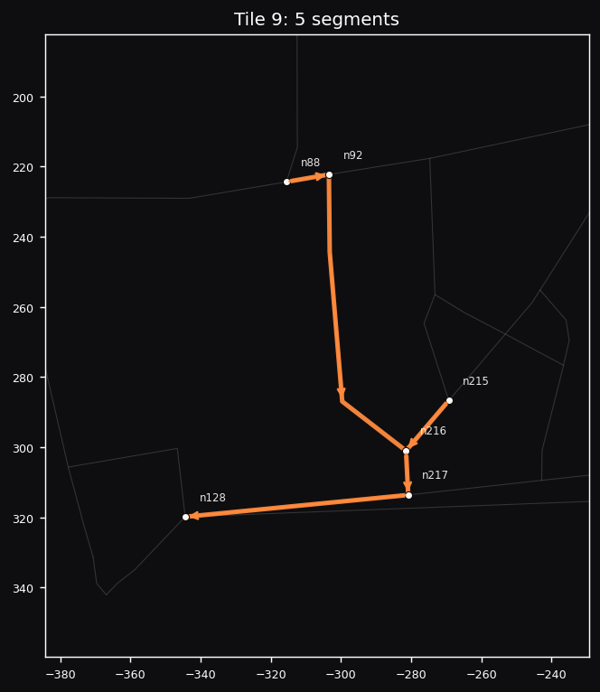  Tile 9  5 segments · 6 nodes  File: tile_009.sim.json  Segments: seg337, seg175, seg174, seg244, seg73 | 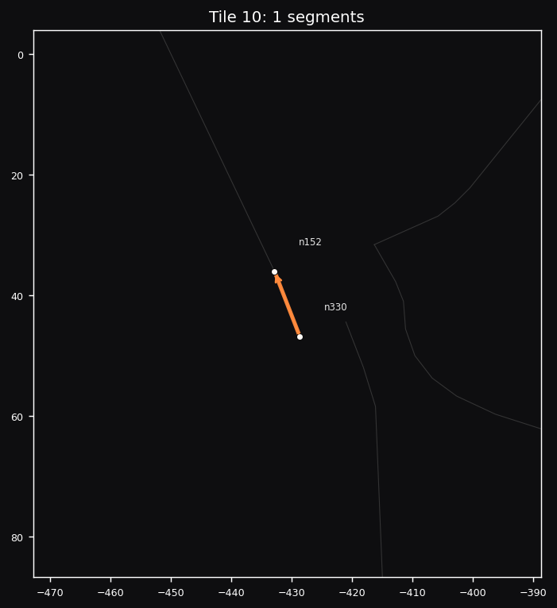  Tile 10  1 segments · 2 nodes  File: tile_010.sim.json  Segments: seg396
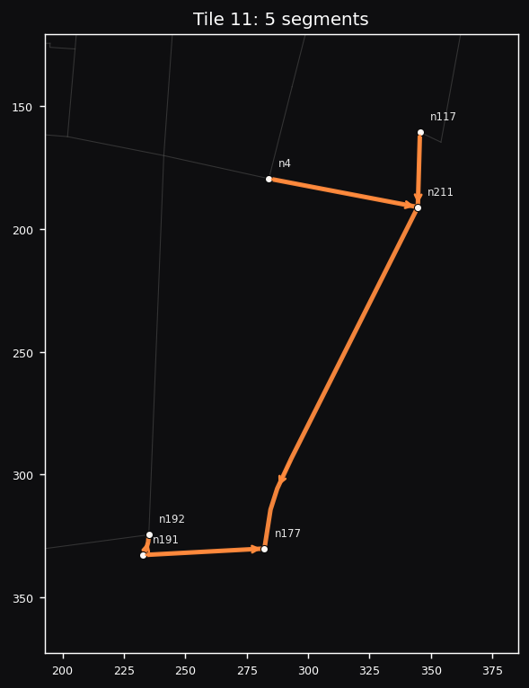  Tile 11  5 segments · 6 nodes  File: tile_011.sim.json  Segments: seg324, seg151, seg388, seg3, seg389 | 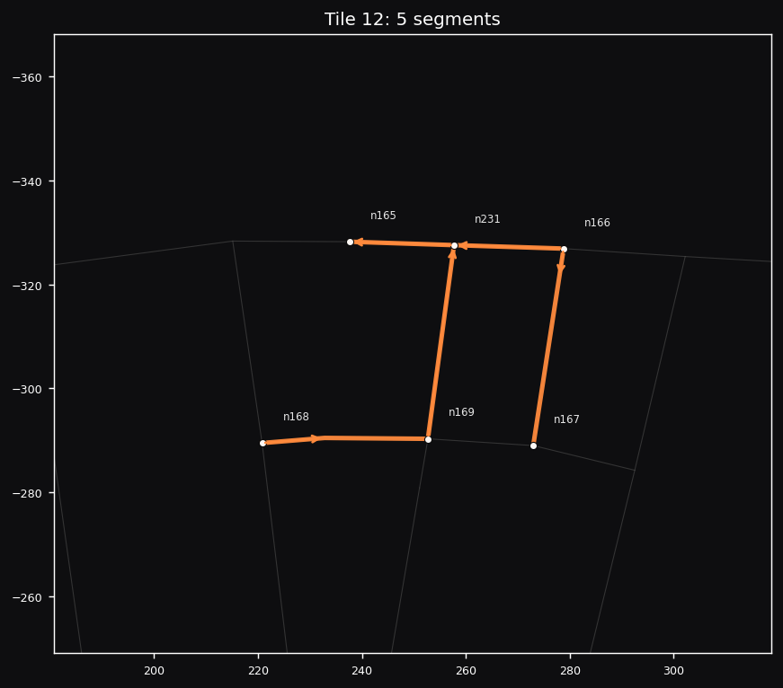  Tile 12  5 segments · 6 nodes  File: tile_012.sim.json  Segments: seg366, seg194, seg367, seg134, seg133
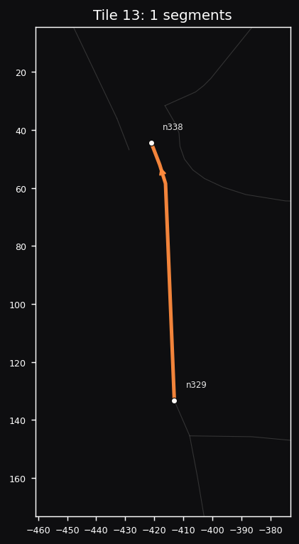  Tile 13  1 segments · 2 nodes  File: tile_013.sim.json  Segments: seg450 | 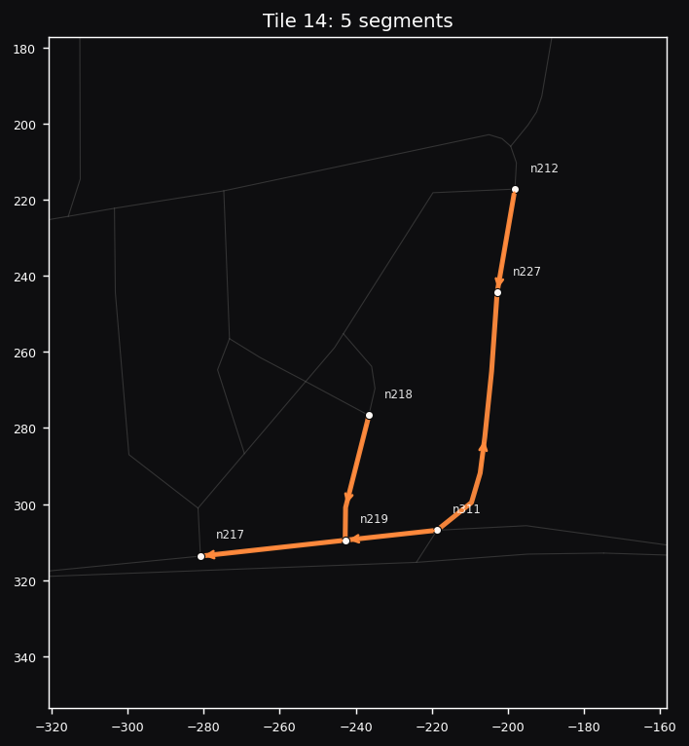  Tile 14  5 segments · 6 nodes  File: tile_014.sim.json  Segments: seg336, seg177, seg335, seg331, seg330
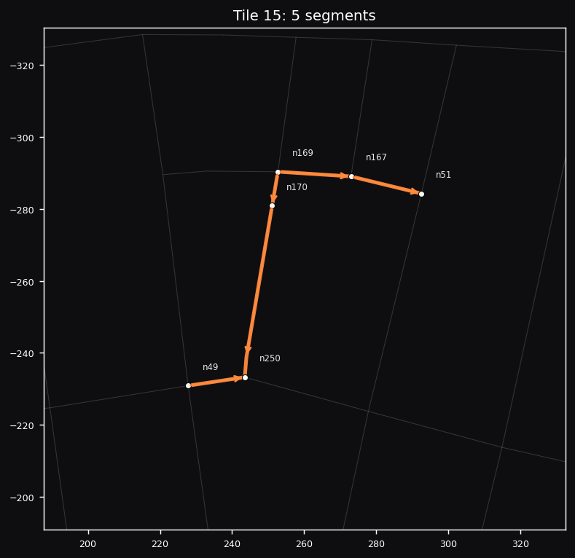  Tile 15  5 segments · 6 nodes  File: tile_015.sim.json  Segments: seg218, seg217, seg135, seg216, seg222 | 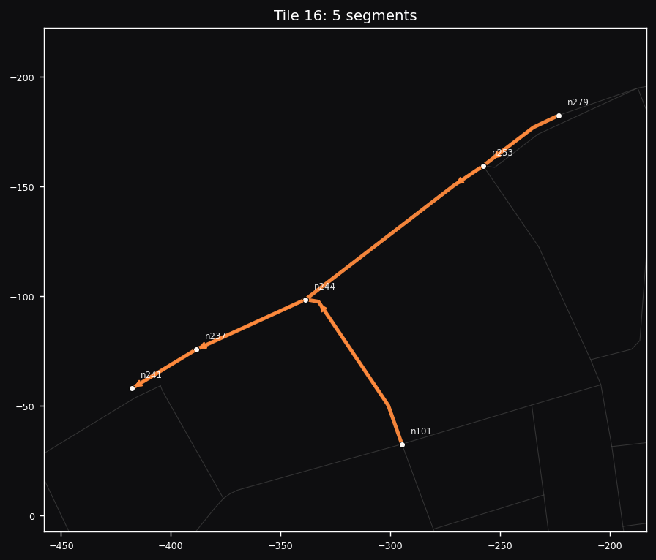  Tile 16  5 segments · 6 nodes  File: tile_016.sim.json  Segments: seg291, seg210, seg285, seg267, seg286
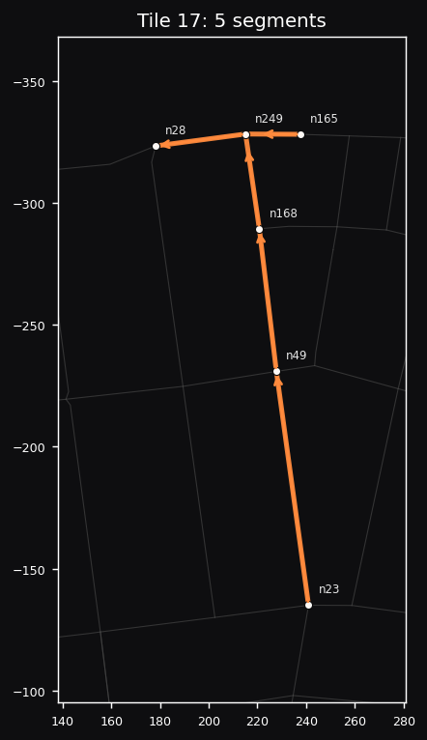  Tile 17  5 segments · 6 nodes  File: tile_017.sim.json  Segments: seg368, seg215, seg214, seg229, seg40 | 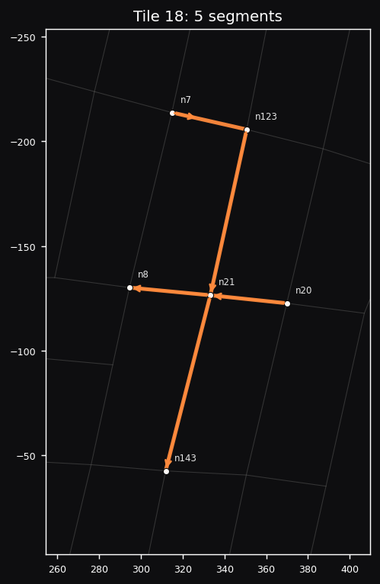  Tile 18  5 segments · 6 nodes  File: tile_018.sim.json  Segments: seg225, seg95, seg16, seg17, seg434
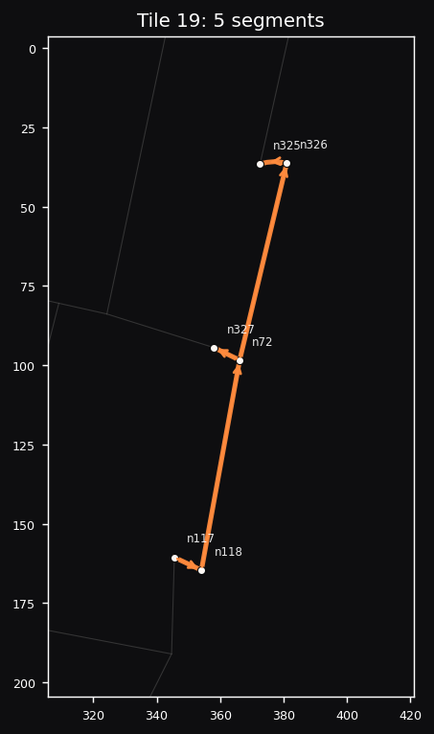  Tile 19  5 segments · 6 nodes  File: tile_019.sim.json  Segments: seg91, seg168, seg378, seg376, seg379 | 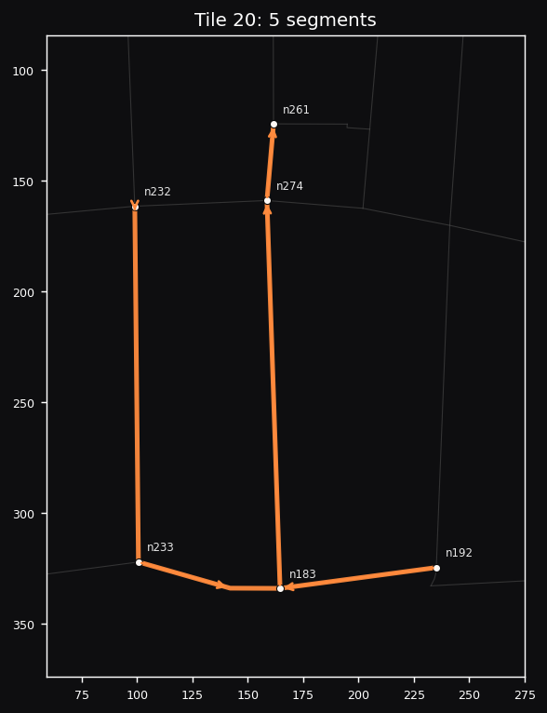  Tile 20  5 segments · 6 nodes  File: tile_020.sim.json  Segments: seg343, seg252, seg317, seg318, seg195
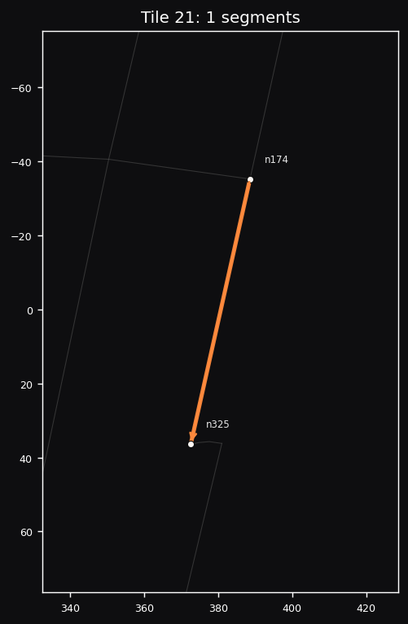  Tile 21  1 segments · 2 nodes  File: tile_021.sim.json  Segments: seg374 | 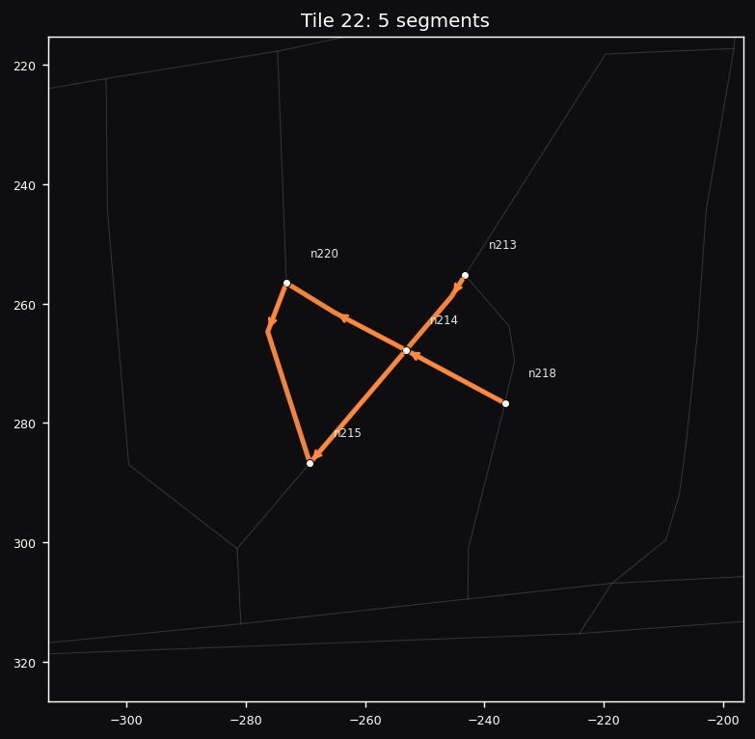  Tile 22  5 segments · 5 nodes  File: tile_022.sim.json  Segments: seg181, seg173, seg179, seg172, seg178
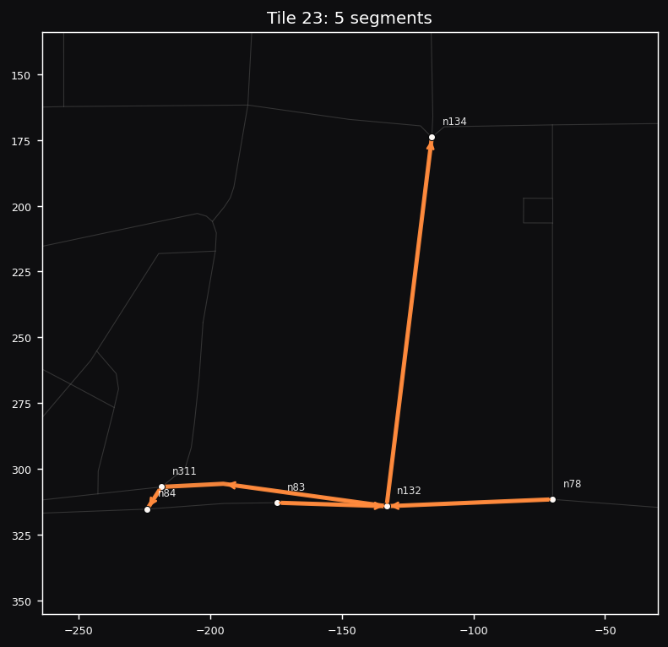  Tile 23  5 segments · 6 nodes  File: tile_023.sim.json  Segments: seg333, seg356, seg102, seg355, seg430 | 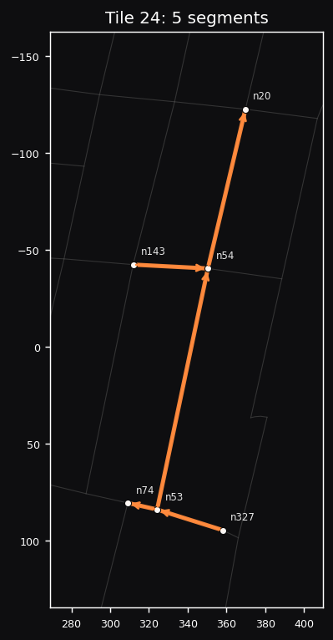  Tile 24  5 segments · 6 nodes  File: tile_024.sim.json  Segments: seg45, seg44, seg381, seg382, seg200
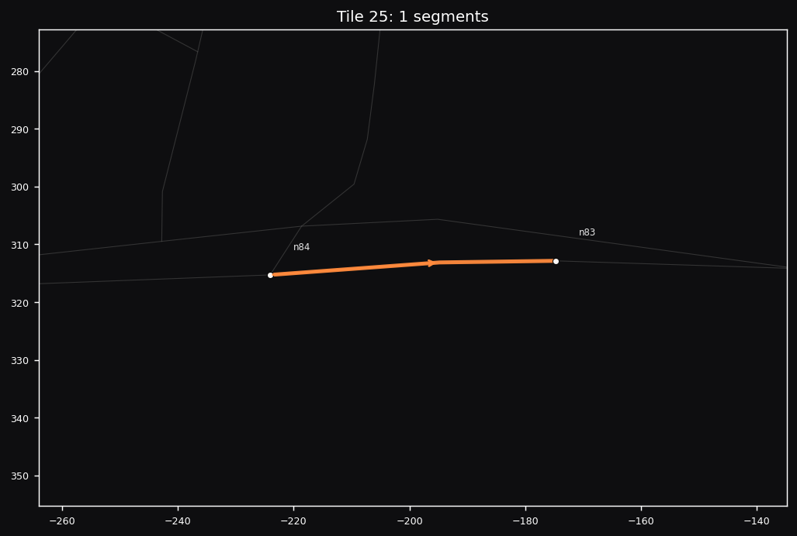  Tile 25  1 segments · 2 nodes  File: tile_025.sim.json  Segments: seg334 | 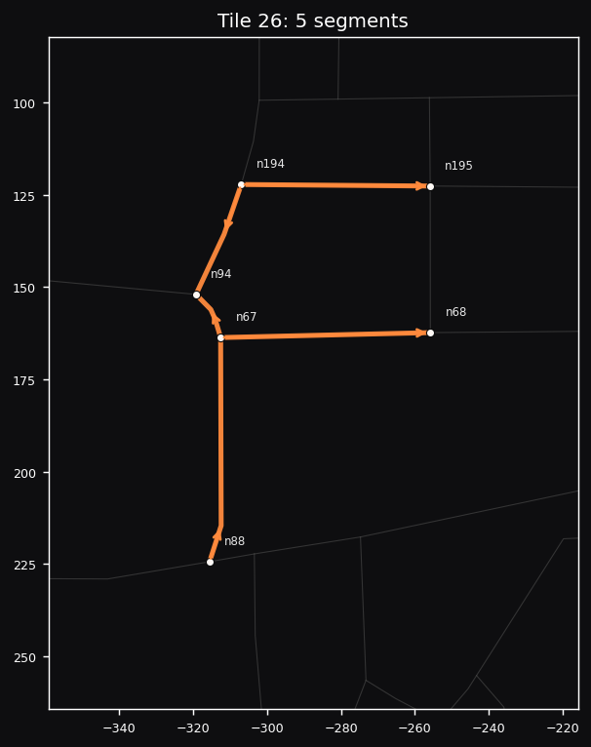  Tile 26  5 segments · 6 nodes  File: tile_026.sim.json  Segments: seg69, seg55, seg182, seg185, seg155
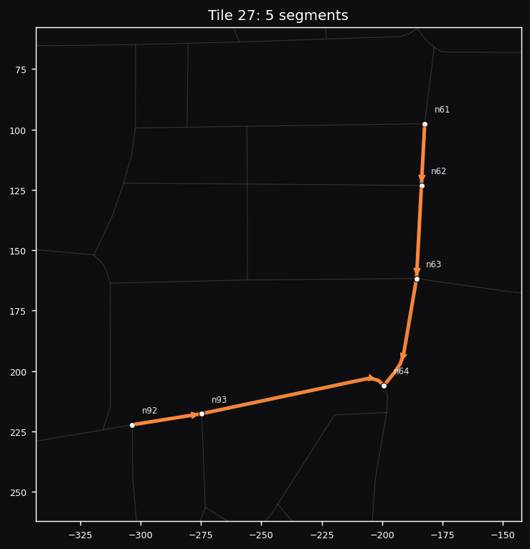  Tile 27  5 segments · 6 nodes  File: tile_027.sim.json  Segments: seg74, seg75, seg53, seg52, seg51 | 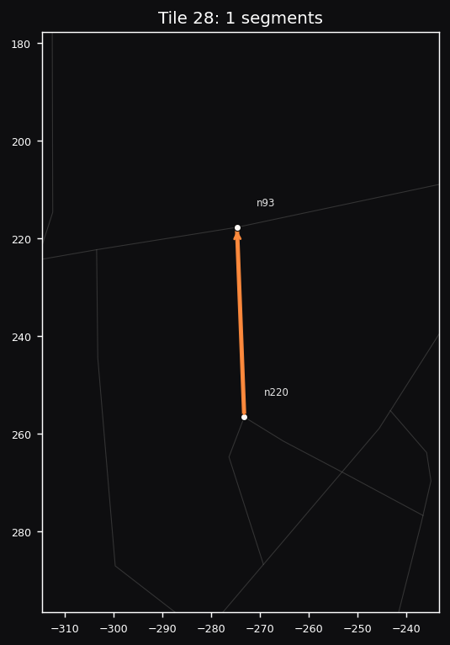  Tile 28  1 segments · 2 nodes  File: tile_028.sim.json  Segments: seg180
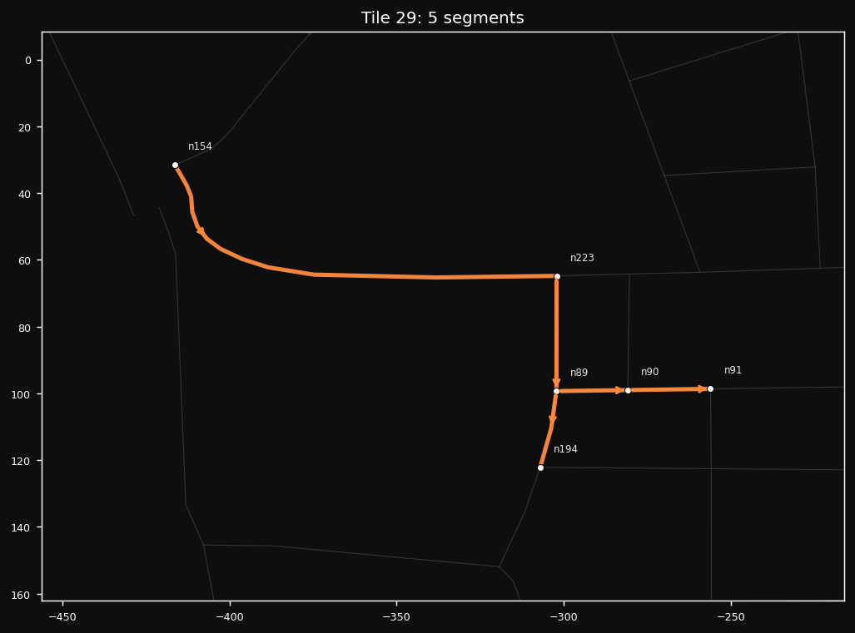  Tile 29  5 segments · 6 nodes  File: tile_029.sim.json  Segments: seg186, seg183, seg70, seg71, seg184 | 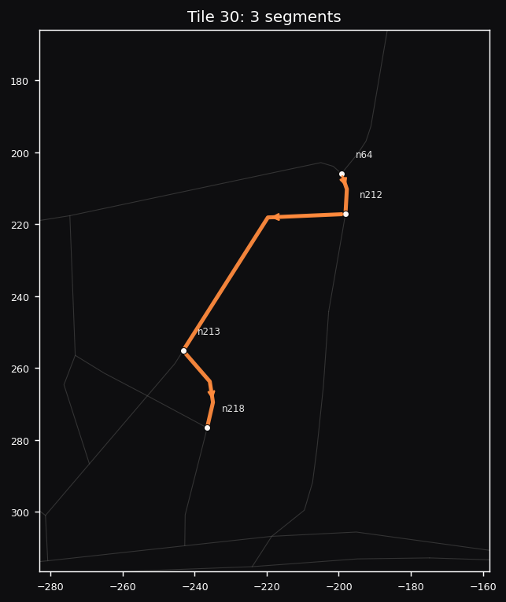  Tile 30  3 segments · 4 nodes  File: tile_030.sim.json  Segments: seg176, seg171, seg329
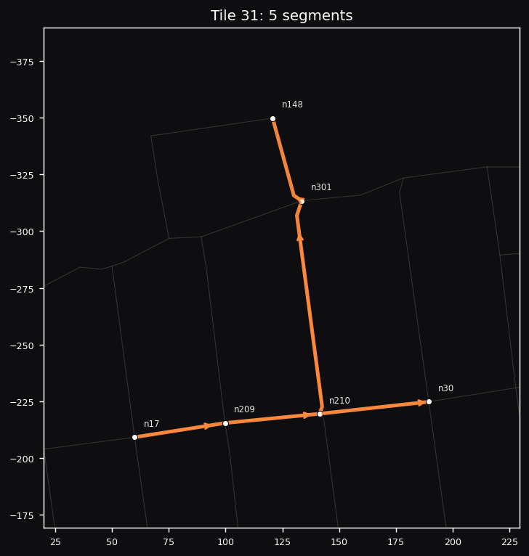  Tile 31  5 segments · 6 nodes  File: tile_031.sim.json  Segments: seg232, seg243, seg167, seg220, seg166 | 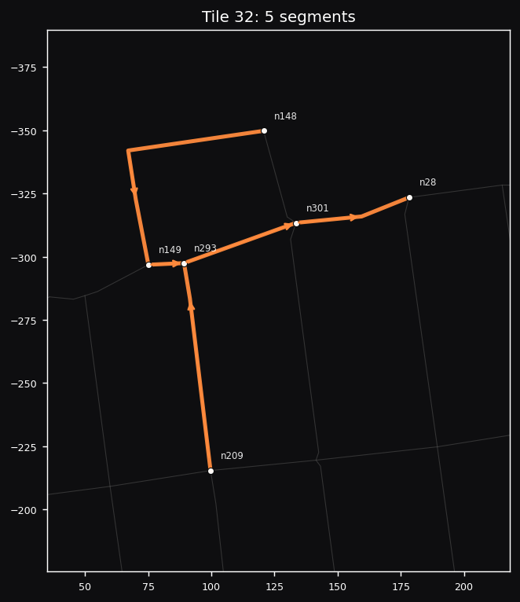  Tile 32  5 segments · 6 nodes  File: tile_032.sim.json  Segments: seg303, seg294, seg295, seg412, seg113
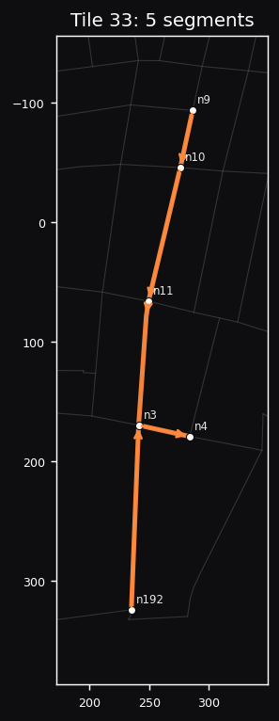  Tile 33  5 segments · 6 nodes  File: tile_033.sim.json  Segments: seg152, seg2, seg9, seg8, seg7 | 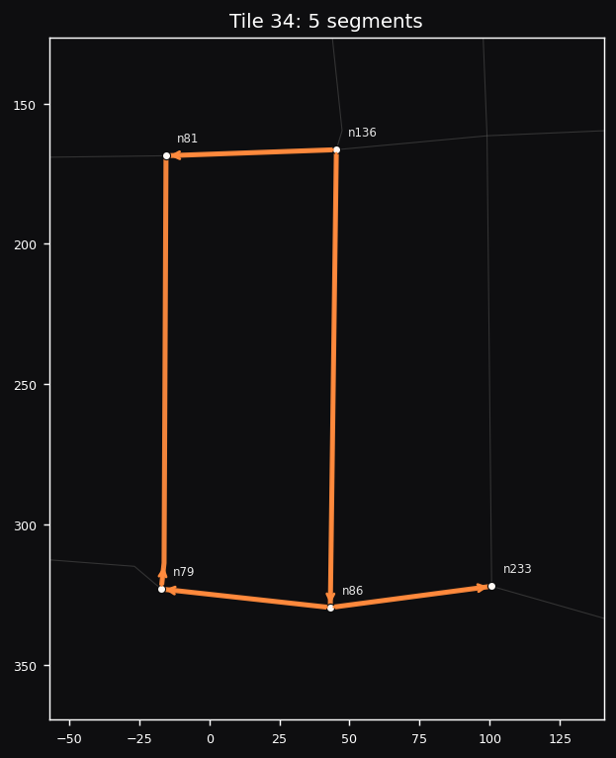  Tile 34  5 segments · 5 nodes  File: tile_034.sim.json  Segments: seg328, seg105, seg326, seg65, seg421
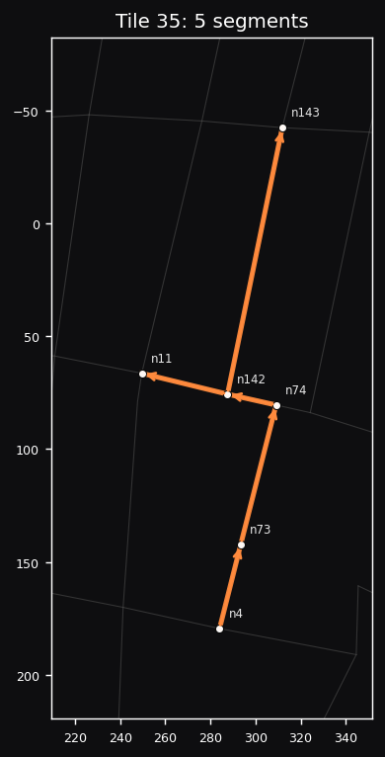  Tile 35  5 segments · 6 nodes  File: tile_035.sim.json  Segments: seg59, seg60, seg383, seg110, seg384 | 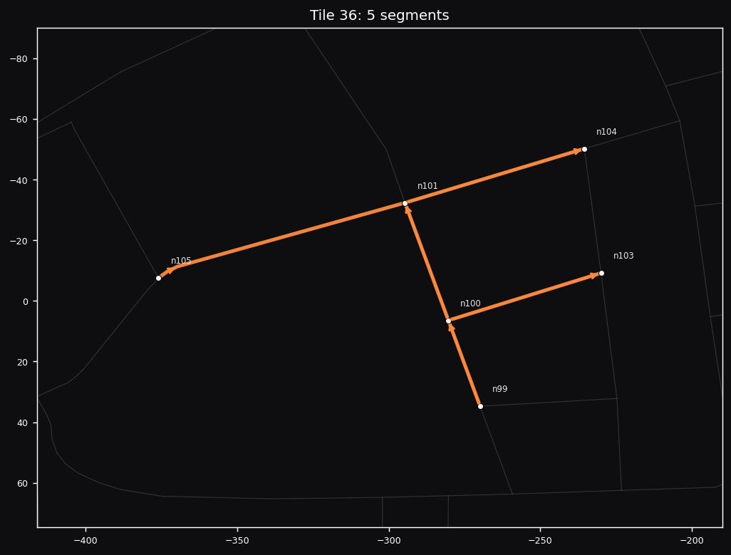  Tile 36  5 segments · 6 nodes  File: tile_036.sim.json  Segments: seg119, seg80, seg79, seg313, seg120
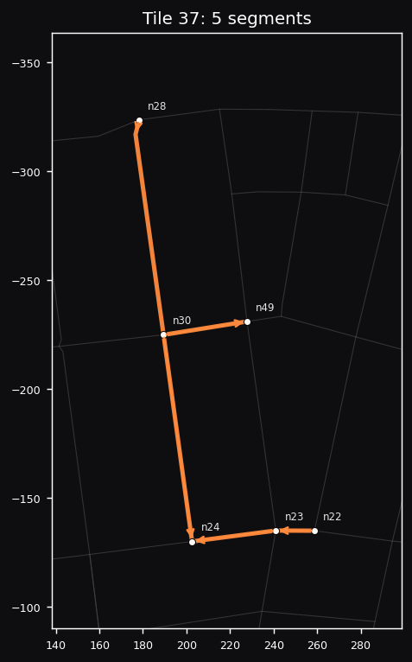  Tile 37  5 segments · 6 nodes  File: tile_037.sim.json  Segments: seg24, seg25, seg221, seg20, seg19 | 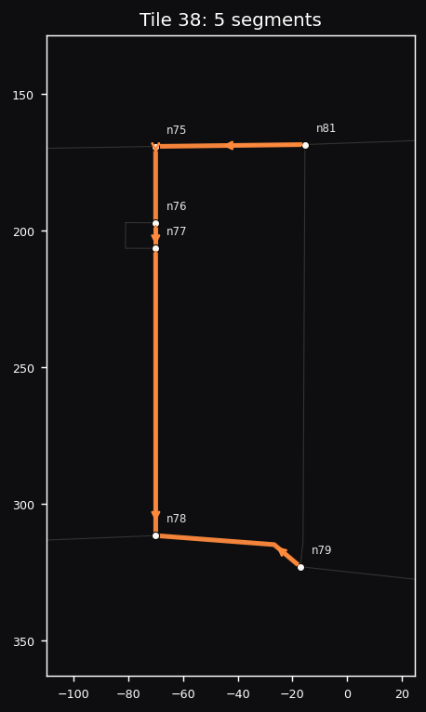  Tile 38  5 segments · 6 nodes  File: tile_038.sim.json  Segments: seg327, seg63, seg62, seg61, seg436
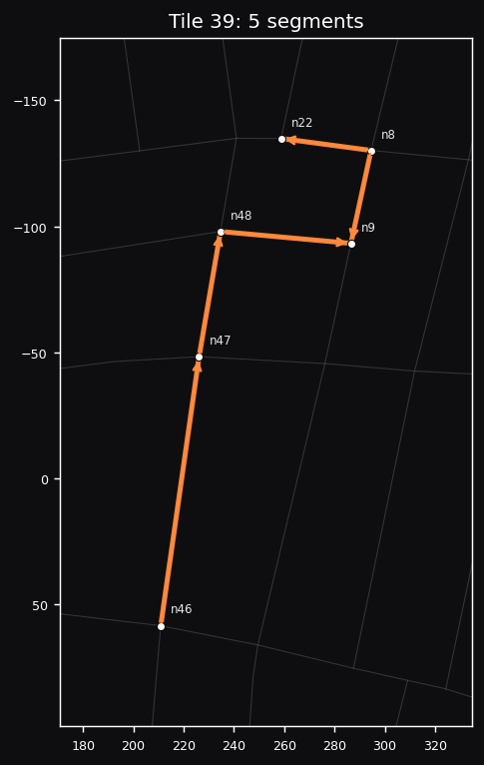  Tile 39  5 segments · 6 nodes  File: tile_039.sim.json  Segments: seg6, seg18, seg235, seg38, seg37 | 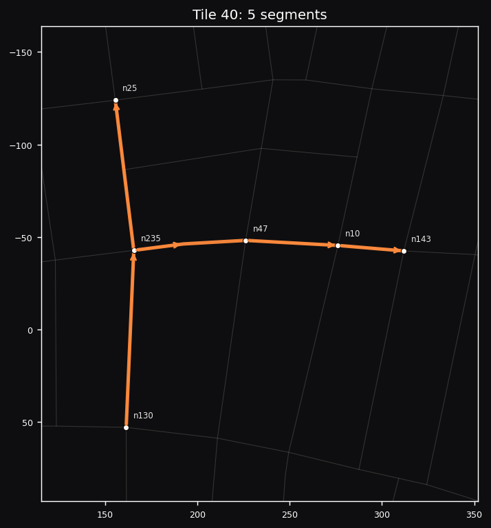  Tile 40  5 segments · 6 nodes  File: tile_040.sim.json  Segments: seg199, seg198, seg197, seg254, seg255
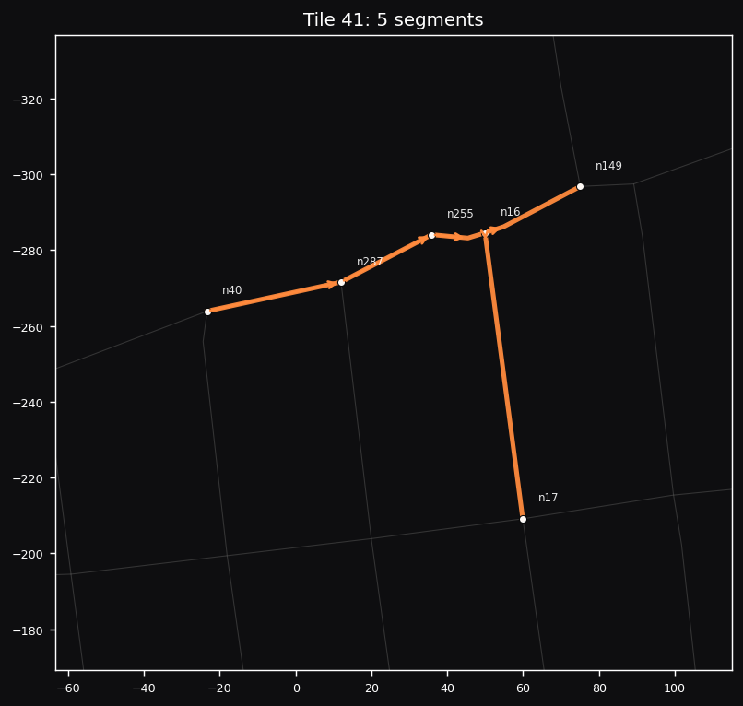  Tile 41  5 segments · 6 nodes  File: tile_041.sim.json  Segments: seg296, seg13, seg279, seg278, seg277 | 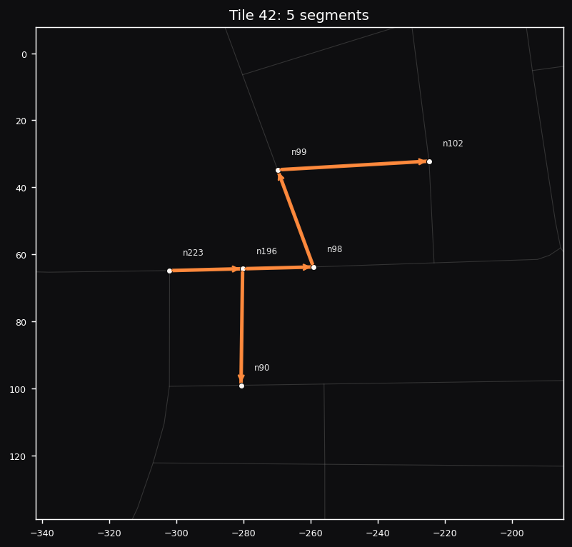  Tile 42  5 segments · 6 nodes  File: tile_042.sim.json  Segments: seg187, seg157, seg460, seg78, seg399
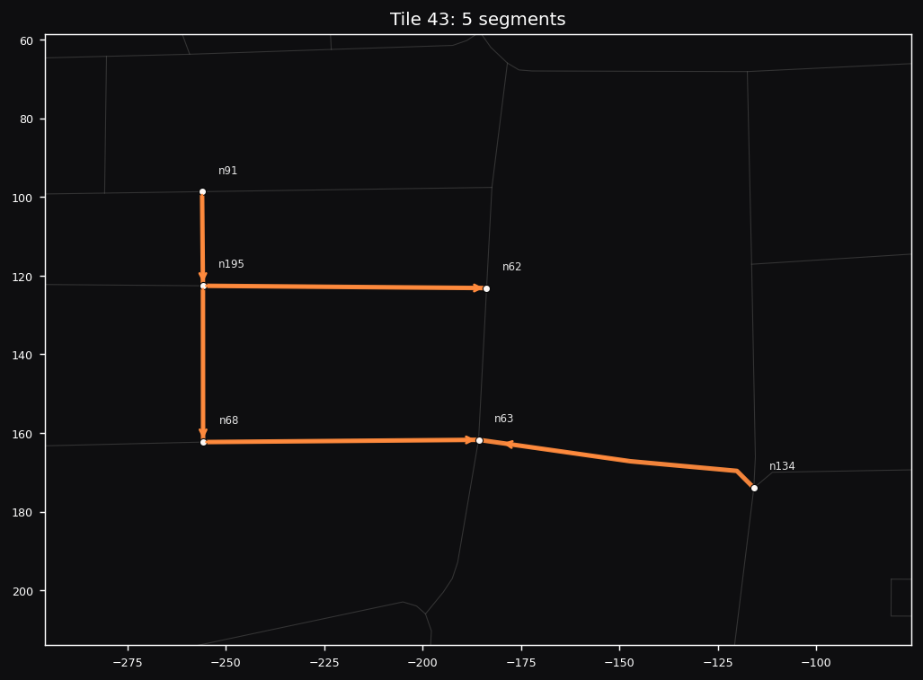  Tile 43  5 segments · 6 nodes  File: tile_043.sim.json  Segments: seg237, seg156, seg236, seg56, seg246 | 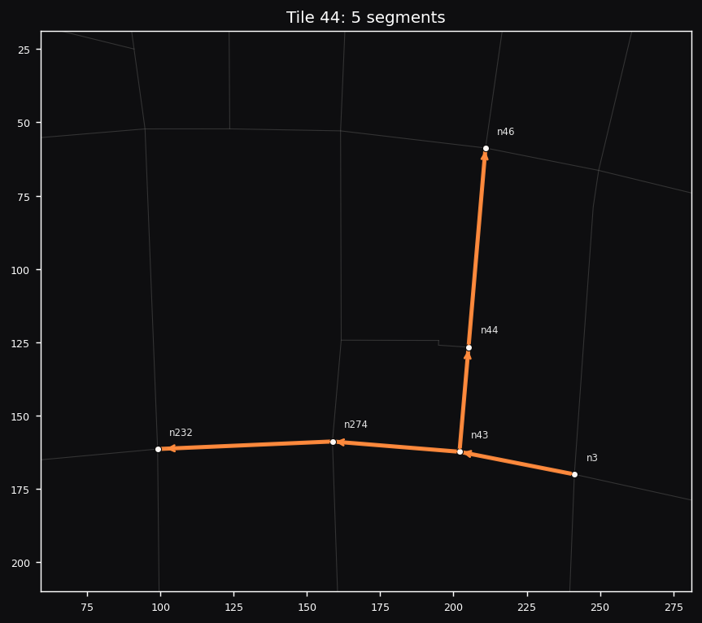  Tile 44  5 segments · 6 nodes  File: tile_044.sim.json  Segments: seg435, seg35, seg418, seg36, seg419
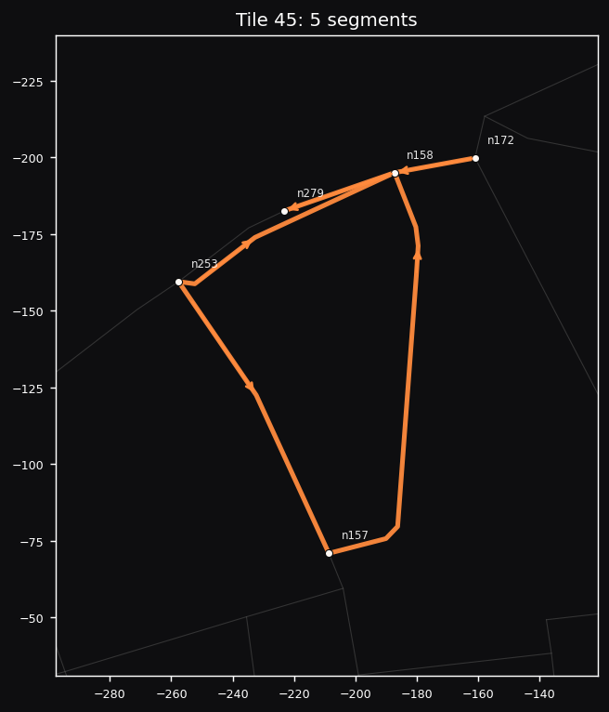  Tile 45  5 segments · 5 nodes  File: tile_045.sim.json  Segments: seg281, seg283, seg125, seg265, seg266 | 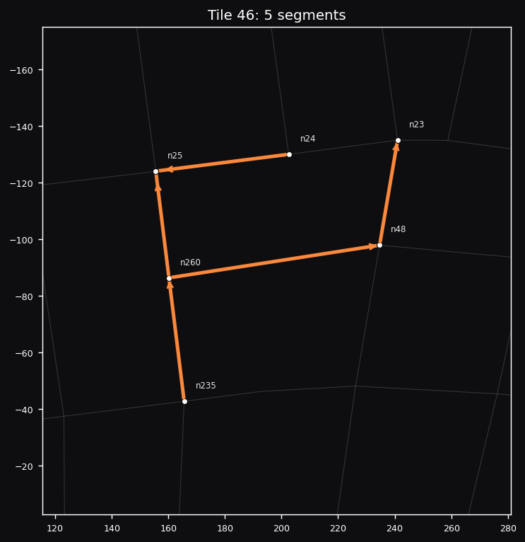  Tile 46  5 segments · 6 nodes  File: tile_046.sim.json  Segments: seg39, seg234, seg321, seg322, seg21
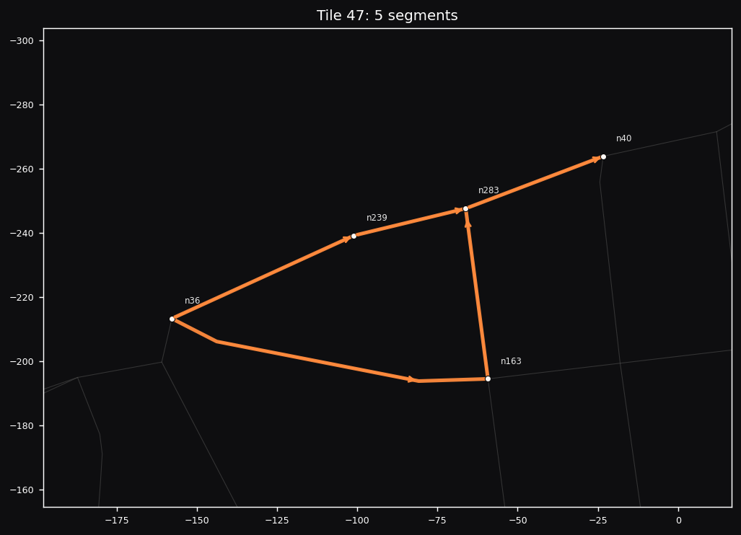  Tile 47  5 segments · 5 nodes  File: tile_047.sim.json  Segments: seg276, seg274, seg270, seg403, seg401 | 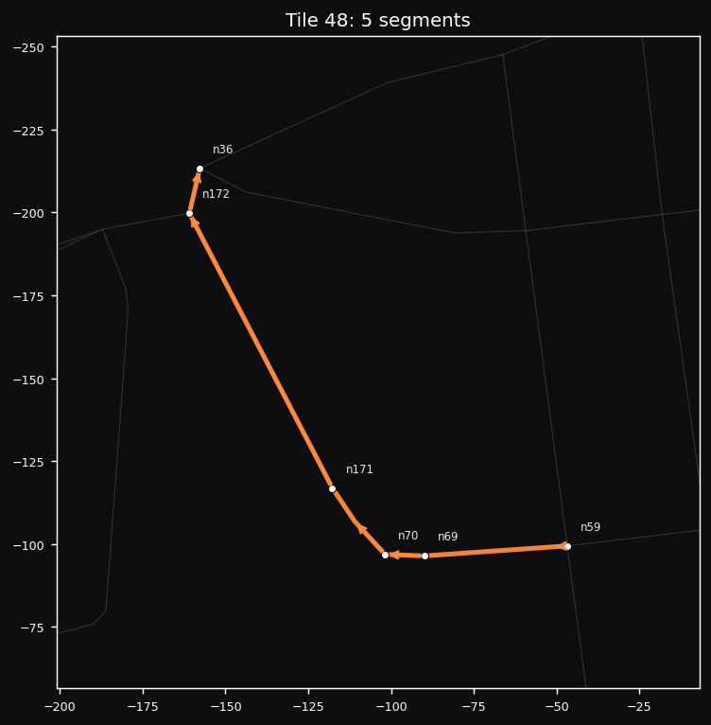  Tile 48  5 segments · 6 nodes  File: tile_048.sim.json  Segments: seg30, seg136, seg219, seg57, seg170
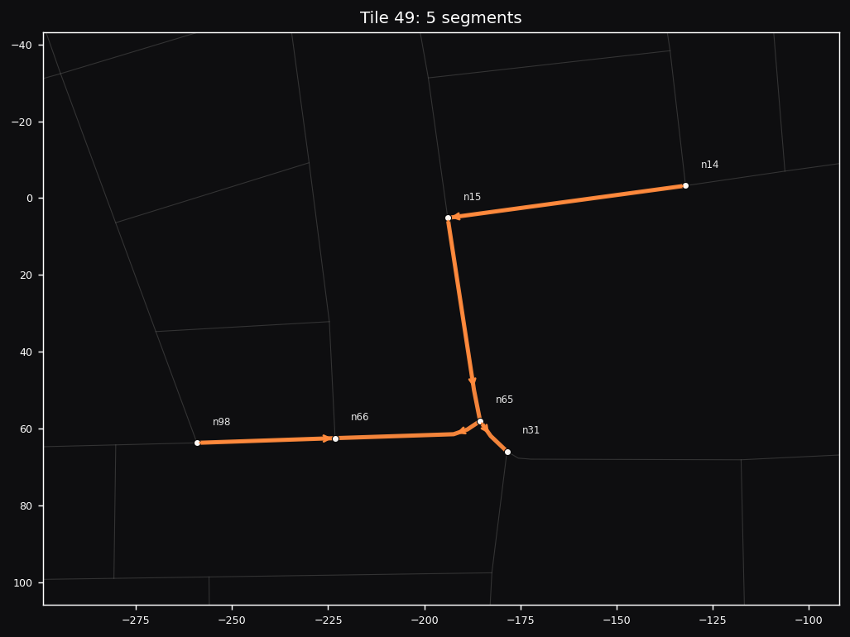  Tile 49  5 segments · 6 nodes  File: tile_049.sim.json  Segments: seg461, seg54, seg260, seg261, seg12 | 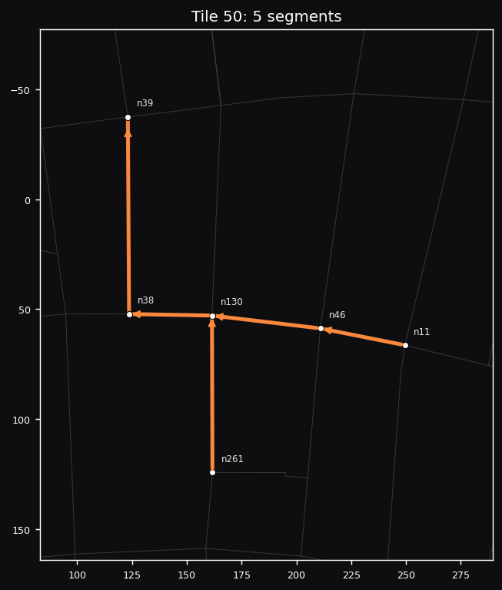  Tile 50  5 segments · 6 nodes  File: tile_050.sim.json  Segments: seg385, seg386, seg99, seg319, seg31
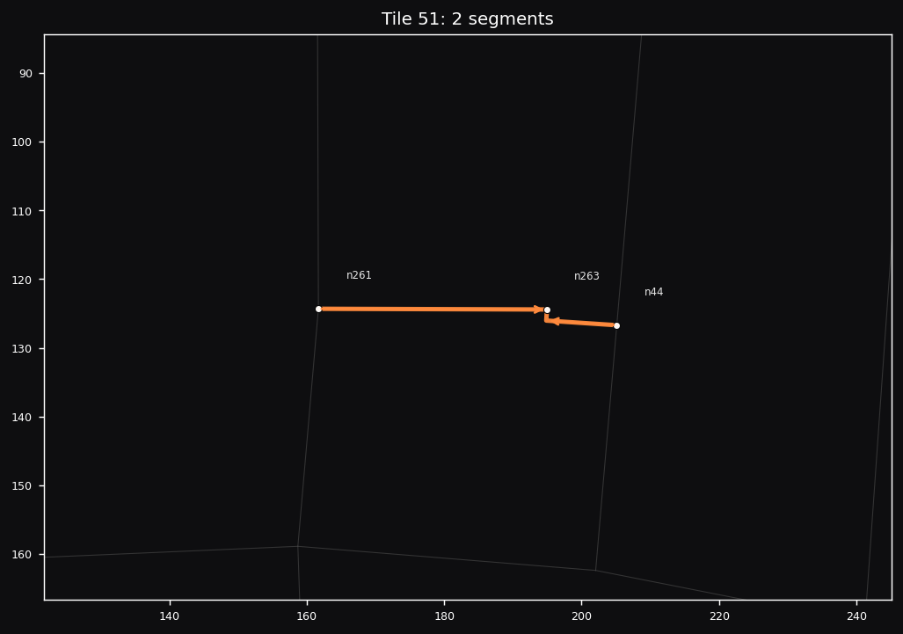  Tile 51  2 segments · 3 nodes  File: tile_051.sim.json  Segments: seg239, seg241 | 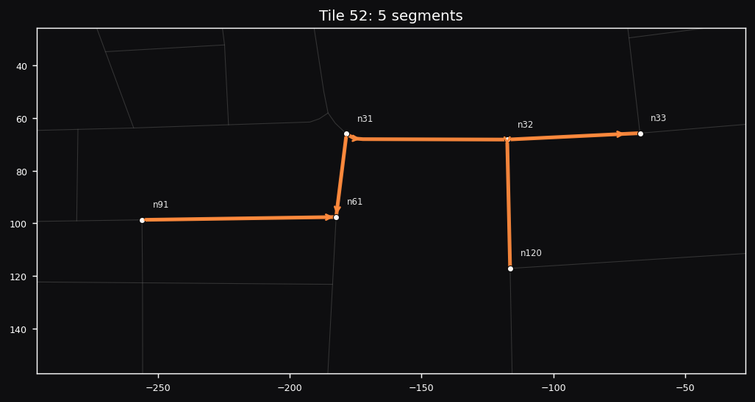  Tile 52  5 segments · 6 nodes  File: tile_052.sim.json  Segments: seg72, seg50, seg26, seg27, seg424
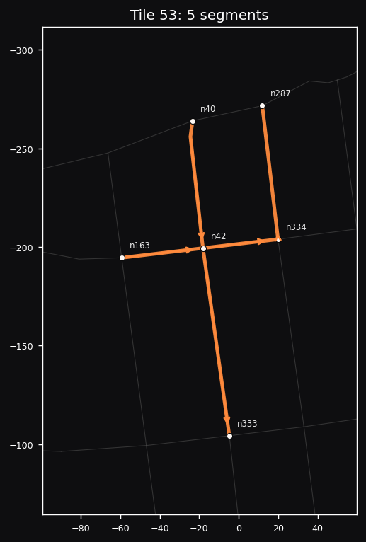  Tile 53  5 segments · 6 nodes  File: tile_053.sim.json  Segments: seg407, seg405, seg34, seg402, seg404 | 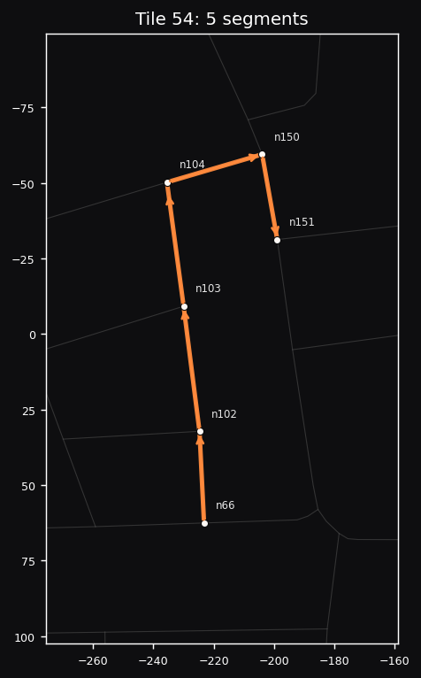  Tile 54  5 segments · 6 nodes  File: tile_054.sim.json  Segments: seg83, seg82, seg121, seg81, seg114
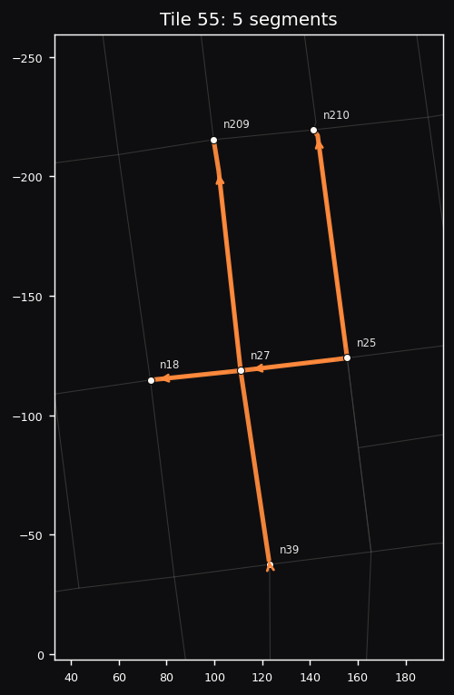  Tile 55  5 segments · 6 nodes  File: tile_055.sim.json  Segments: seg256, seg22, seg32, seg411, seg454 | 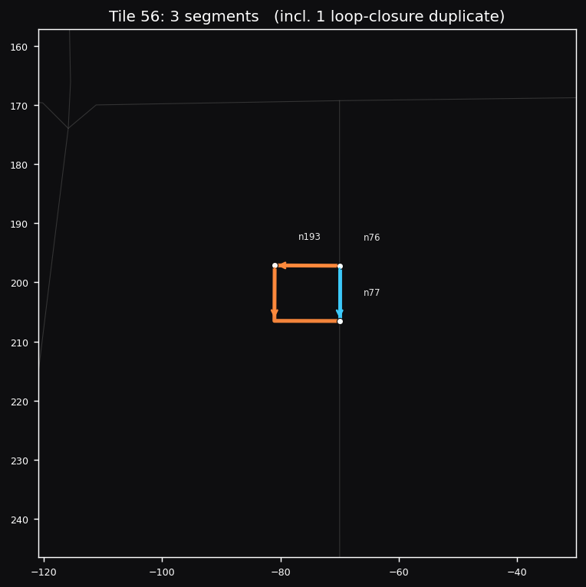  Tile 56  3 segments · 3 nodes  File: tile_056.sim.json  Segments: seg153, seg154, seg62  Includes 1 loop-closure duplicate
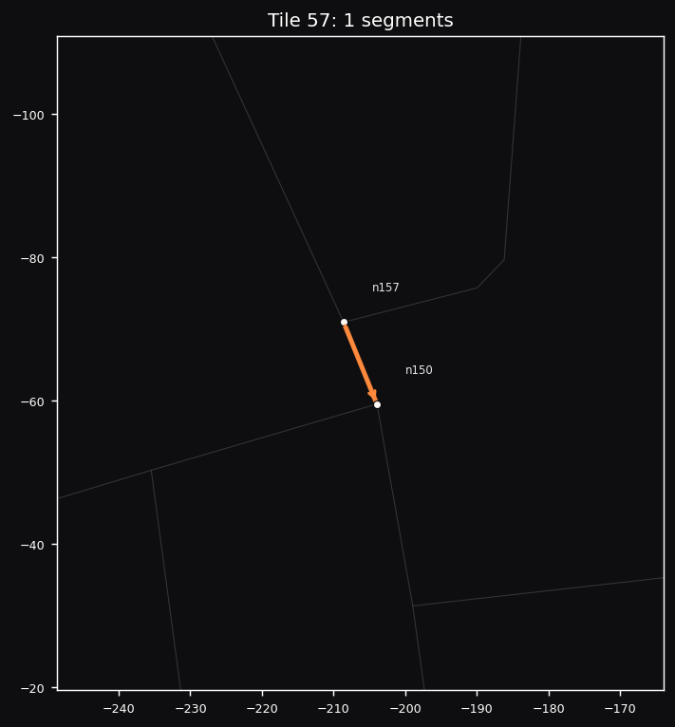  Tile 57  1 segments · 2 nodes  File: tile_057.sim.json  Segments: seg284 | 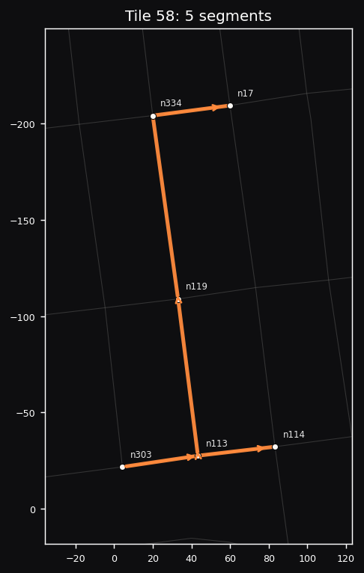  Tile 58  5 segments · 6 nodes  File: tile_058.sim.json  Segments: seg409, seg410, seg92, seg89, seg429
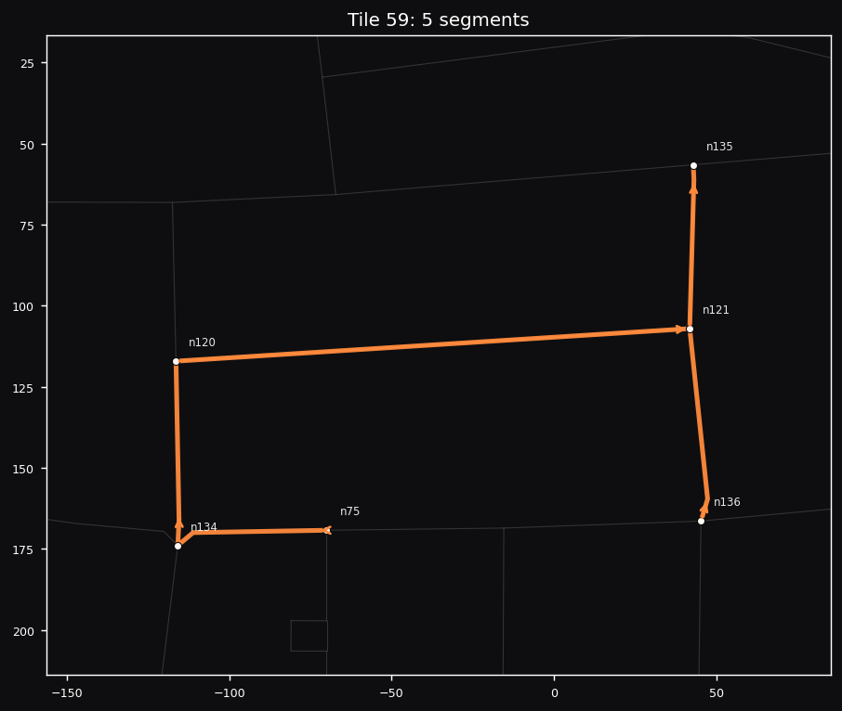  Tile 59  5 segments · 6 nodes  File: tile_059.sim.json  Segments: seg437, seg247, seg93, seg188, seg189 | 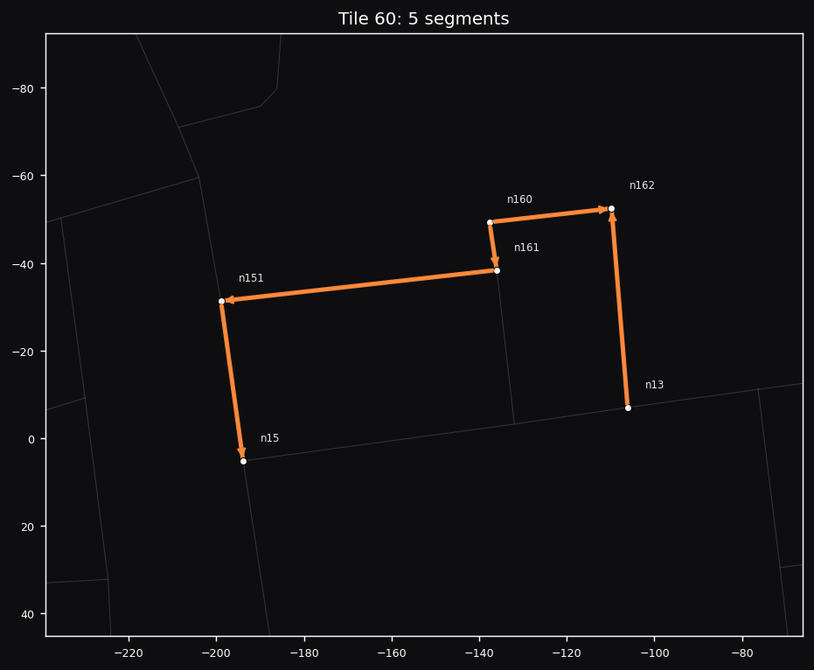  Tile 60  5 segments · 6 nodes  File: tile_060.sim.json  Segments: seg115, seg128, seg127, seg129, seg206
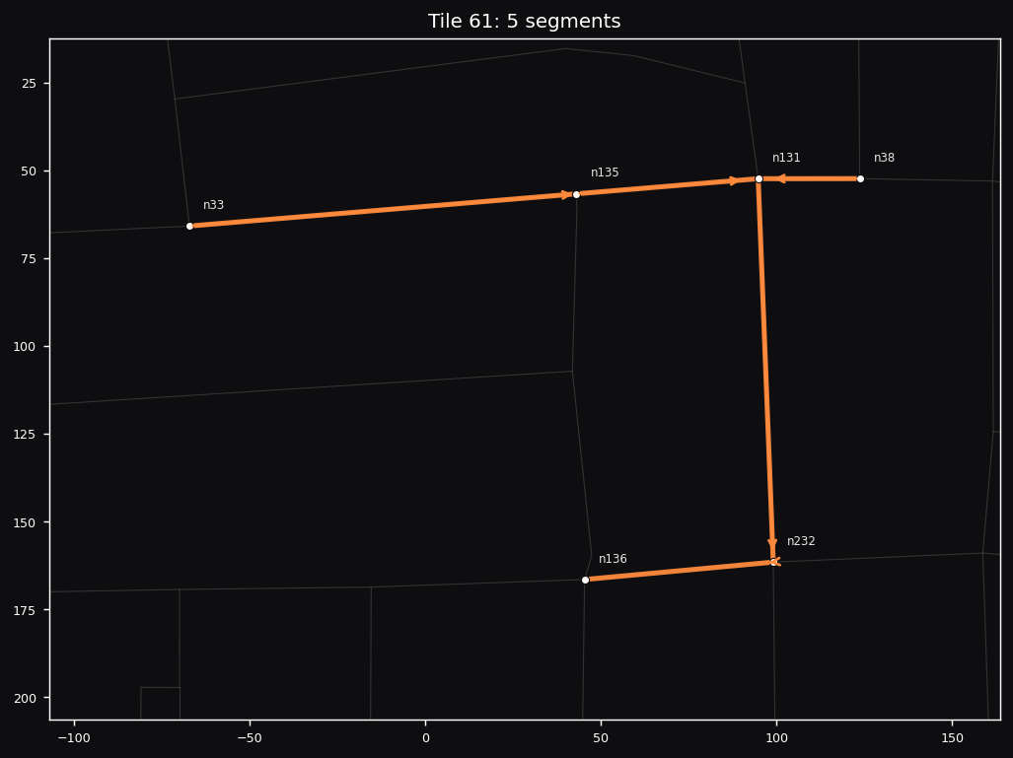  Tile 61  5 segments · 6 nodes  File: tile_061.sim.json  Segments: seg420, seg416, seg100, seg104, seg103 | 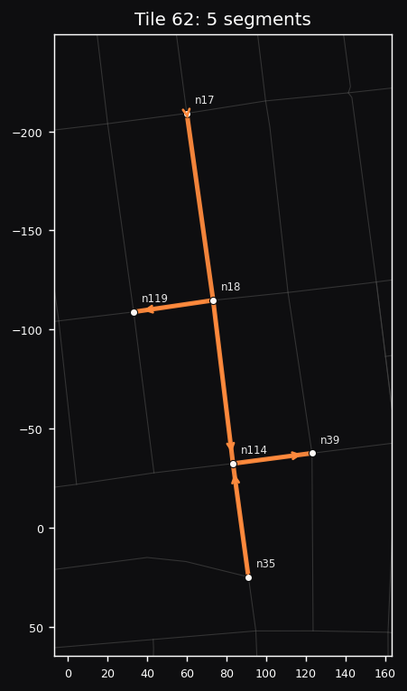  Tile 62  5 segments · 6 nodes  File: tile_062.sim.json  Segments: seg14, seg413, seg203, seg458, seg455
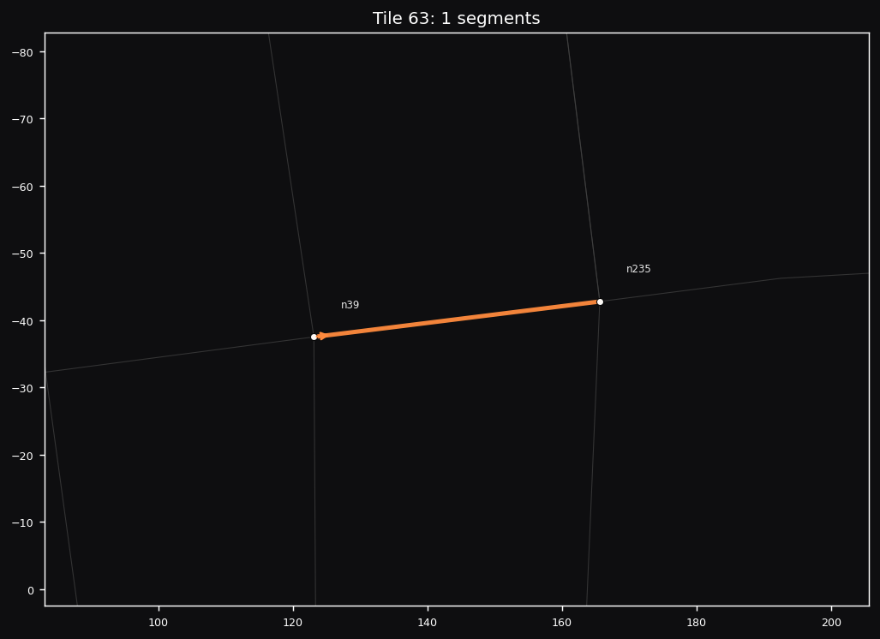  Tile 63  1 segments · 2 nodes  File: tile_063.sim.json  Segments: seg459 | 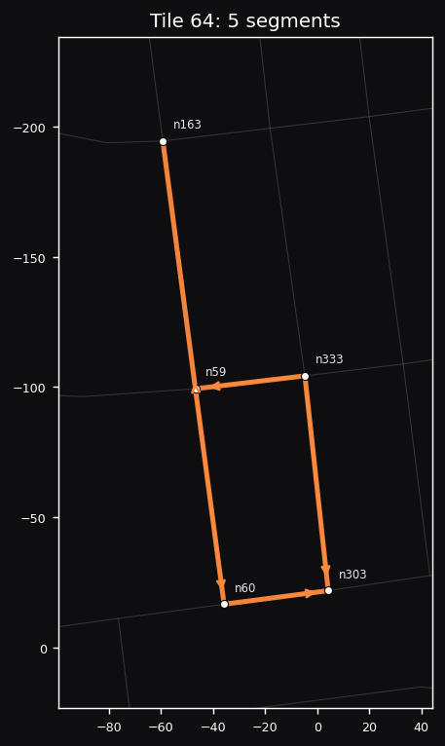  Tile 64  5 segments · 5 nodes  File: tile_064.sim.json  Segments: seg130, seg49, seg306, seg406, seg457
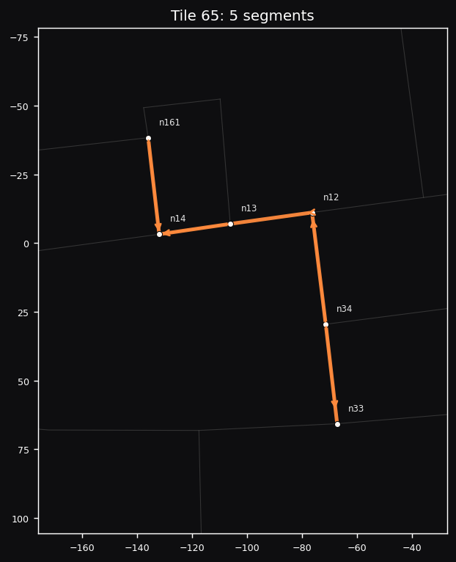  Tile 65  5 segments · 6 nodes  File: tile_065.sim.json  Segments: seg428, seg11, seg10, seg124, seg28 | 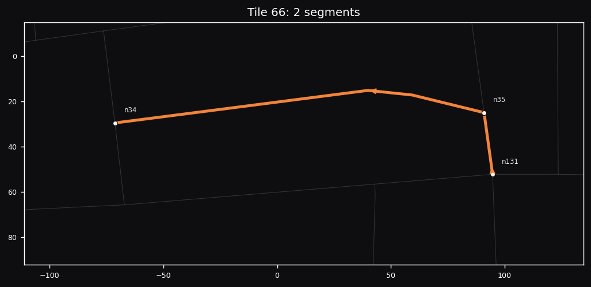  Tile 66  2 segments · 3 nodes  File: tile_066.sim.json  Segments: seg202, seg29
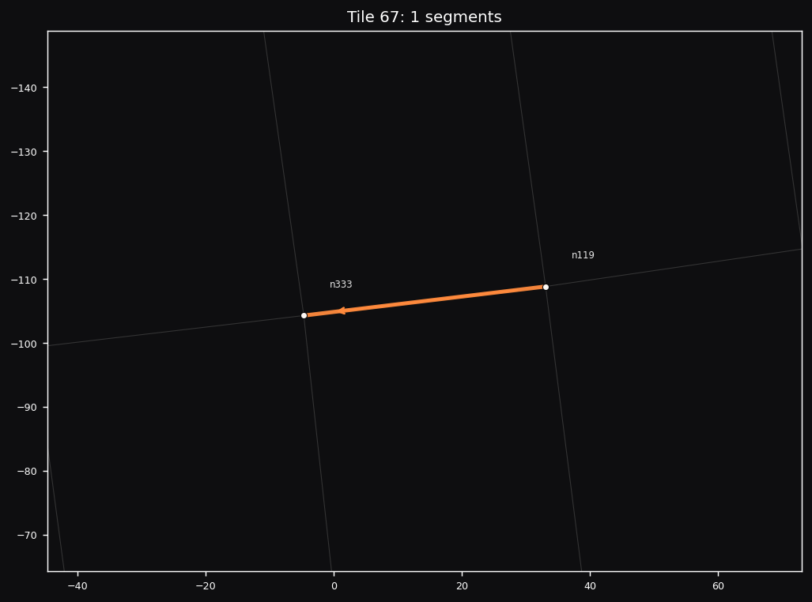  Tile 67  1 segments · 2 nodes  File: tile_067.sim.json  Segments: seg456 | 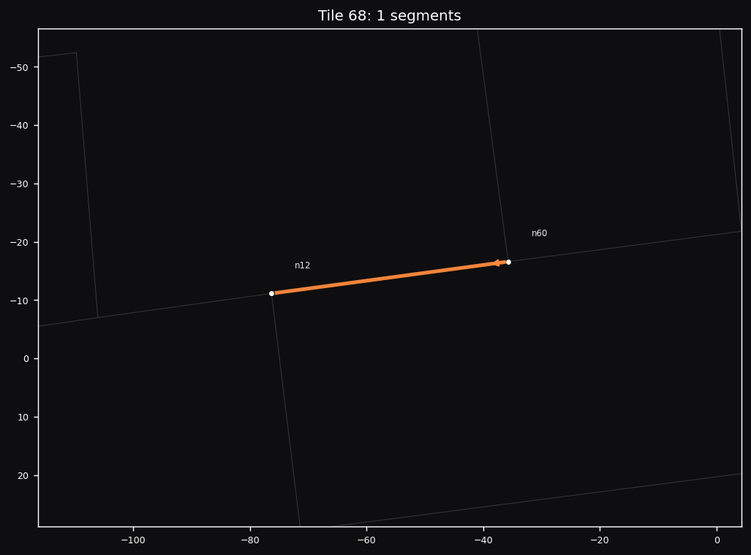  Tile 68  1 segments · 2 nodes  File: tile_068.sim.json  Segments: seg422

