Tracking Audit Report
Generated: 2026-05-11 12:45:03 Simulation: /sessions/nifty-dreamy-turing/mnt/final proj/outputs/_sample_audit_report

Executive Summary
Overall tracking quality is **medium** — RMSE 0.44 m with 45% prediction-only rows; the filter coasts noticeably but stays near truth. The biggest error source is *GPS measurement noise / bias*. Most suspicious behavior: recurring 'sensor_dropout' anomalies (4 occurrences). Best-performing sensor: Camera; weakest: GPS. Weakest time window: t = 3.0–4.0 s (mean err 0.58 m). The system relied heavily on prediction-only Kalman rows (45% of all rows). GPS measurements appear unreliable — see the sensor-quality section.
Scorecard — quick reference; full evidence in the diagnostic sections below.
- Overall quality: **medium** — RMSE 0.44 m with 45% prediction-only rows; the filter coasts noticeably but stays near truth
- Biggest error source: GPS measurement noise / bias
- Most suspicious behavior: recurring 'sensor_dropout' anomalies (4 occurrences)
- Best sensor: Camera
- Weakest sensor: GPS
- Weakest time window: t = 3.0–4.0 s (mean err 0.58 m)
- Relied on prediction-only rows: yes (45% of all rows)
- Too few sensor measurements: no
- Suspicious noisy sensor: GPS
- Vehicle fragmentation suspected: no

Simulation Summary
Total tracks detected | 1
Meaningful tracks (reported) | 1
Filtered / skipped tracks | 0
Trajectory rows | 238
Prediction-only rows | 108
Segment transitions | 1
Anomalies detected | 4
Global RMSE | 0.44 m
Global max error | 1.42 m
GPS measurements accepted | 13
Camera measurements accepted | 39
DAS measurements accepted | 93

Sensor Coverage Analysis
Across 1 track(s) the audit recorded 13 GPS, 39 camera and 93 DAS measurements plus 108 prediction-only rows (45.4% of all rows). 4 time window(s) had only one sensor type active (see fragmentation / FOV sections for the likely cause).
Track | GPS | Cam | DAS | Pred | Rows | %pred | Longest meas-gap (s)
T000001 | 13 | 39 | 93 | 108 | 238 | 45.4 | 0.80
- 4 time window(s) had only one sensor type active (see fragmentation / FOV sections for the likely cause).
- 1 time window(s) had no real sensor update of any kind — Kalman ran on prediction alone.

ℹ Sensor coverage looks sufficient
What happened: GPS=13, Cam=39, DAS=93, prediction-only=45.4%, longest gap=0.80 s.
What it probably means: Track T000001 received a balanced mix of measurements with no large gap. The Kalman has enough evidence to stay close to truth.
Why it matters: Healthy coverage is the baseline for trustworthy tracking.
Confirmed evidence:
- GPS = 13 measurements, Camera = 39, DAS = 93.
- Prediction-only rows = 45.4% of the track.
- Longest gap between real measurements = 0.80 s (track duration = 11.85 s).

Sensor Quality / Noise Analysis
Per-sensor noise / bias is computed by comparing each accepted measurement against the oracle ground truth at the same timestep. ‘σ vs err’ flags whether the reported sigma matches reality — a ratio far from 1.0 means the sensor model is mis-calibrated.
Sensor | N | Mean err (m) | Max err (m) | RMSE (m) | Bias x (m) | Bias y (m) | Mean sigma | Sigma vs err
GPS | 13 | 4.35 | 6.56 | 4.68 | 0.03 | -1.43 | 2.80 | σ ≈ actual
Camera | 39 | 0.37 | 0.84 | 0.43 | -0.00 | -0.04 | 0.33 | σ ≈ actual
DAS | 93 | 0.49 | 1.15 | 0.55 | -0.04 | -0.02 | 0.36 | σ ≈ actual

ℹ GPS behaves as expected
What happened: GPS: mean err 4.35, σ 2.80, bias (0.03, -1.43).
What it probably means: GPS mean error and bias are consistent with the reported σ — no immediate noise / calibration concern.
Why it matters: This sensor is likely a reliable contributor to the fusion.
Confirmed evidence:
- 13 GPS measurements compared to ground truth.
- Mean error = 4.35, max error = 6.56, RMSE = 4.68.
- Bias = (Δx=0.03, Δy=-1.43).
- Mean reported σ = 2.80.

ℹ Camera behaves as expected
What happened: Camera: mean err 0.37, σ 0.33, bias (-0.00, -0.04).
What it probably means: Camera mean error and bias are consistent with the reported σ — no immediate noise / calibration concern.
Why it matters: This sensor is likely a reliable contributor to the fusion.
Confirmed evidence:
- 39 Camera measurements compared to ground truth.
- Mean error = 0.37, max error = 0.84, RMSE = 0.43.
- Bias = (Δx=-0.00, Δy=-0.04).
- Mean reported σ = 0.33.

ℹ DAS behaves as expected
What happened: DAS: mean err 0.49, σ 0.36, bias (-0.04, -0.02).
What it probably means: DAS mean error and bias are consistent with the reported σ — no immediate noise / calibration concern.
Why it matters: This sensor is likely a reliable contributor to the fusion.
Confirmed evidence:
- 93 DAS measurements compared to ground truth.
- Mean error = 0.49, max error = 1.15, RMSE = 0.55.
- Bias = (Δx=-0.04, Δy=-0.02).
- Mean reported σ = 0.36.

Error Spike Investigation
Every detected spike or jump is paired with the local sensor context (what was available before / during / after) and a rule-based explanation that distinguishes confirmed facts from likely causes.
- No major error spikes were detected in any track.

Track Fragmentation Analysis
1 oracle vehicle(s) were observed across 1 track ID(s). Each oracle vehicle maps to a single track — no fragmentation suspected.
Vehicle | # tracks | Tracks | Filtered tracks
veh1 | 1 | T000001 [0.15-12.00s, 238 rows] | —

Segment Transition Analysis
Compares the segment transitions the report would emit against the transitions implied by oracle lane_id over time. Mismatches usually indicate a coverage / drift issue rather than a transition-logic bug.
Track | Vehicle | Reported transitions | Oracle transitions | Match
T000001 | veh1 | seg1→seg2@7.40s | seg2 | no

⚠ Segment transition inconsistency
What happened: Track T000001: 1 reported vs 0 oracle transitions.
What it probably means: The report shows more transitions than the oracle indicates — the segment assignment is flickering between adjacent segments, probably because the estimated position is on a boundary.
Why it matters: Segment transitions are how the report tells the story of the vehicle's journey; missing or extra ones distort that story.
Confirmed evidence:
- Reported transitions: 1 (seg1→seg2@7.40s).
- Oracle transitions inside this track's time window: 0 (seg2).
- Track time window: t = 0.15–12.00 s.
Possible explanations (hypotheses):
- Estimated position is oscillating across a segment boundary.
- Lane-to-segment mapping has overlapping centroids near the boundary.
Recommended next checks:
- Compare reported vs oracle segment IDs on the trajectory plot.
- Decide whether segment_id should be assigned from oracle position instead of estimated position for reporting purposes.

Camera Geometry / FOV Analysis
Per-track camera measurement counts, time windows of camera presence, and a sanity check on the camera σ vs actual error. Conclusions about FOV are heuristic — the audit data does not carry the camera polygon itself.
Track | Cam meas | Cam window (s) | Pre-tr / post-tr | Mean σ | Mean err
T000001 | 39 | 11.75 | 26/13 | 0.33 | 0.37

DAS Quality Analysis
DAS measurement counts, SNR distribution, and the Kalman error in DAS-only windows. Where SNR data is available, correlations with tracking error are flagged as evidence of σ-from-SNR mis-calibration.
Track | DAS meas | Mean SNR | Min SNR | Low-SNR rows | Mean err
T000001 | 93 | 40.82 | 13.54 | 0 | 0.30

Kalman Behavior Analysis
For each track the Kalman is evaluated on: how often it received real updates (vs prediction), whether σ grows in gaps and shrinks after measurements, and whether the reported σ matches the actual error. Strong mismatches indicate a tuning issue — not a bug.
Track | % pred-only | σ growth in gaps | σ shrink after meas | σ vs actual err
T000001 | 45.4 | 33/35 | 32/35 | σ ≈ err (healthy)

ℹ Kalman behaves correctly
What happened: σ tracks actual error, σ grows during gaps, shrinks after measurements.
What it probably means: All meaningful tracks show the textbook Kalman pattern: uncertainty rises while coasting and falls when sensor data returns, and the reported uncertainty matches the actual error well.
Why it matters: No tuning intervention needed for the filter itself.
Confirmed evidence:
- 1/1 tracks classified healthy.

Recommendations & Next Investigations
Concrete checks aggregated from the diagnostic sections. Items are ordered by severity (critical → warning → info) and de-duplicated. Each is linked to the interpretation that suggested it.
- (Segment transition inconsistency) Compare reported vs oracle segment IDs on the trajectory plot.
- (Segment transition inconsistency) Decide whether segment_id should be assigned from oracle position instead of estimated position for reporting purposes.

Track T000001 — vehicle veh1
Vehicle ID (oracle) | veh1
Duration | 11.85 s
True distance traveled | 193.5 m
Estimated distance | 188.3 m
RMSE | 0.34 m
Max error | 0.96 m
GPS measurements | 13
Camera measurements | 39
DAS measurements | 93
Prediction-only rows | 108
Segments visited | seg1 → seg2
Segment transitions | 1
Max coasting gap | 0.80 s

Trajectory
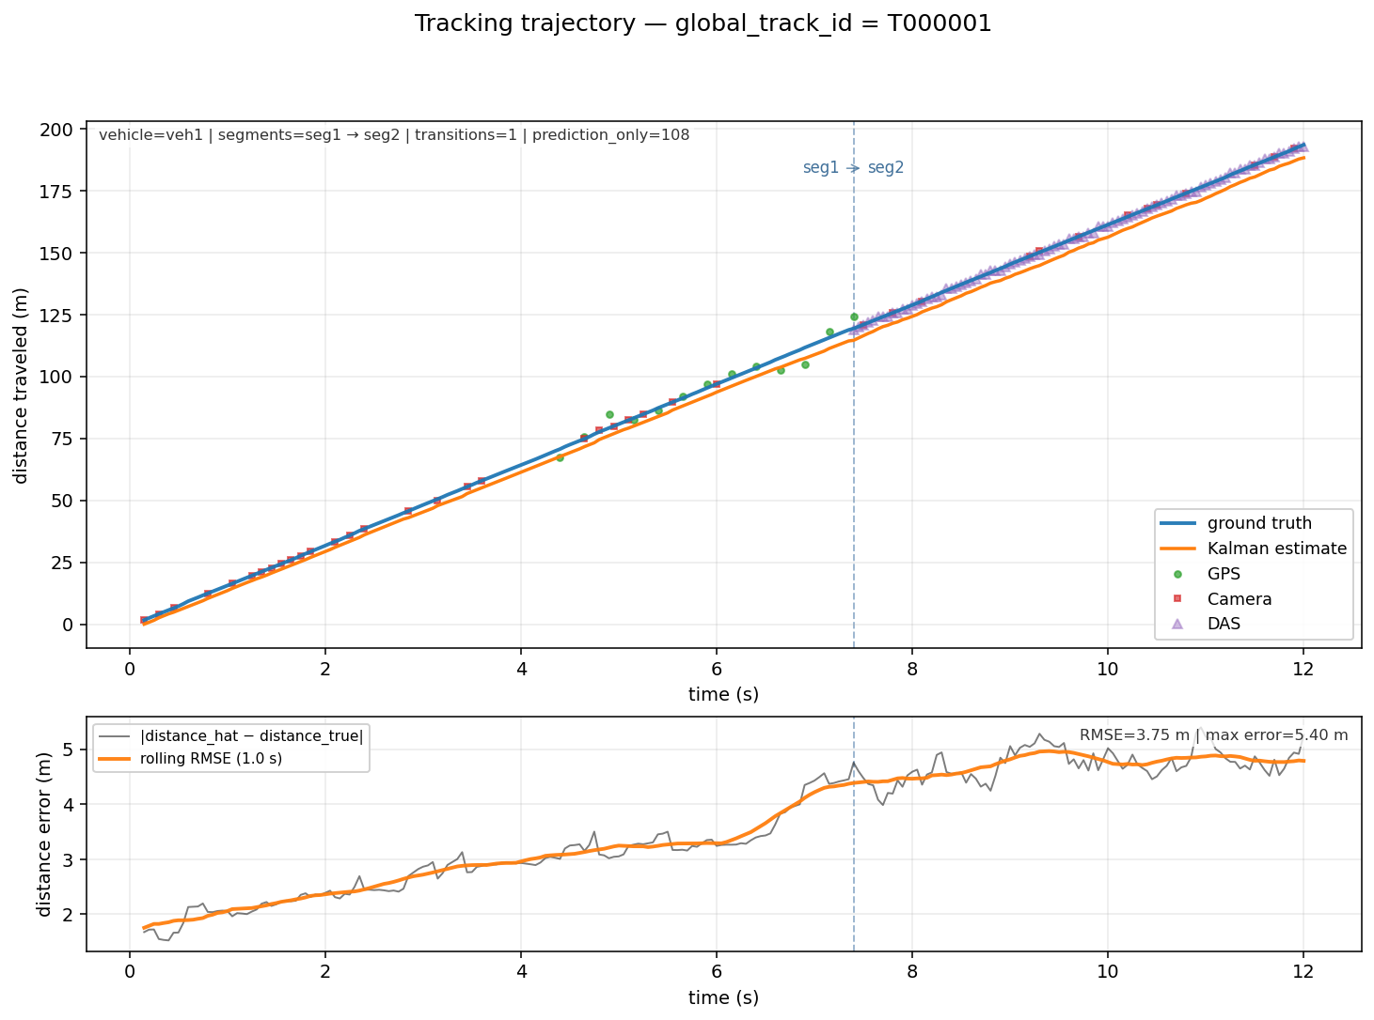

Error Over Time (with sensor windows)
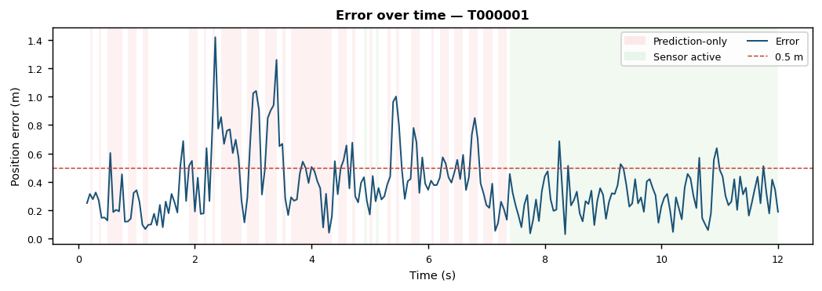

Sensor Activity (Gantt)
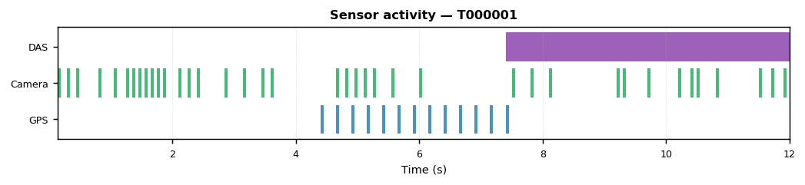

Anomalies
- Camera dropout of 1.00 s (t=3.65–4.65 s).
Before: sensors=Camera, segment=seg1, mean error=0.6 m.
During: sensors=Camera, GPS, mean error=0.4 m, 19/21 rows prediction-only.
After: sensors=Camera, GPS, segment=seg1, mean error=0.4 m.
- Camera dropout of 1.45 s (t=6.05–7.50 s).
Before: sensors=Camera, GPS, segment=seg1, mean error=0.5 m.
During: sensors=Camera, DAS, GPS, mean error=0.4 m, 22/30 rows prediction-only.
After: sensors=Camera, DAS, segment=seg2, mean error=0.3 m.
→ Error recovered to 0.3 m after the anomaly.
- Camera dropout of 1.05 s (t=8.15–9.20 s).
Before: sensors=Camera, DAS, GPS, segment=seg1 → seg2, mean error=0.2 m.
During: sensors=Camera, DAS, mean error=0.3 m.
After: sensors=Camera, DAS, segment=seg2, mean error=0.3 m.
- Camera dropout of 0.65 s (t=10.85–11.50 s).
Before: sensors=Camera, DAS, segment=seg2, mean error=0.2 m.
During: sensors=Camera, DAS, mean error=0.4 m.
After: sensors=Camera, DAS, segment=seg2, mean error=0.3 m.
→ Error recovered to 0.3 m after the anomaly.

Segment Transitions
1 transition(s) across all meaningful tracks.
Track | Time (s) | From segment | To segment
T000001 | 7.40 | seg1 | seg2

8.1 Sensor σ Calibration Check
Compares each sensor's declared measurement noise (sigma_m) against the actual error computed from ground truth. A well-calibrated sensor has mean actual error ≈ mean declared σ. If actual error > 1.2×σ the Kalman filter is over-trusting that sensor and the R-matrix entry should be increased.
Sensor | N meas. | Mean actual err (m) | Max actual err (m) | RMSE (m) | Mean declared σ (m) | Actual / σ ratio | % over-trusted | Verdict
GPS | 13 | 4.354 | 6.560 | 4.677 | 2.799 | 1.56 | 69.2% | ⚠ Over-trusted
Camera | 39 | 0.372 | 0.840 | 0.434 | 0.325 | 1.15 | 46.2% | ✓ Well-calibrated
DAS | 93 | 0.487 | 1.149 | 0.548 | 0.359 | 1.36 | 51.6% | ⚠ Over-trusted
- GPS: actual error is 1.56× declared σ (mean err 4.35 m vs σ 2.80 m). Increase R_gps in the Kalman noise matrix.
- Camera: calibration healthy (actual/σ = 1.15).
- DAS: actual error is 1.36× declared σ (mean err 0.49 m vs σ 0.36 m). Increase R_das in the Kalman noise matrix.

8.2 Per-Axis Error Breakdown (X vs Y)
Scalar RMSE hides directional bias. A dominant Y error (lateral) usually points to insufficient lateral process noise (Q_yy too small) or missing sensors that constrain cross-track position. A dominant X error (longitudinal) suggests speed-model mismatch.

Track T000001 — veh1
Axis | Mean |error| (m) | RMSE (m) | Signed bias (m) | Dominant?
X (longitudinal) | 0.169 | 0.209 | -0.016 | —
Y (lateral) | 0.298 | 0.384 | -0.004 | Yes
- ⚠ Y (lateral) error dominates by 1.8×. Consider increasing Q_yy (lateral process noise) so the filter tracks lateral motion more responsively.

8.3 Sensor Coverage Timeline
Each row represents one second of simulation time. ✓ = at least one accepted measurement; — = sensor silent (filter coasted). Seconds where ALL sensors are silent are the main source of position drift.

Track T000001 — veh1
Second (s) | GPS | Camera | DAS | Status
0–1 | — | ✓ | — | ✓ sensor active
1–2 | — | ✓ | — | ✓ sensor active
2–3 | — | ✓ | — | ✓ sensor active
3–4 | — | ✓ | — | ✓ sensor active
4–5 | ✓ | ✓ | — | ✓ sensor active
5–6 | ✓ | ✓ | — | ✓ sensor active
6–7 | ✓ | — | — | ✓ sensor active
7–8 | ✓ | ✓ | ✓ | ✓ sensor active
8–9 | — | ✓ | ✓ | ✓ sensor active
9–10 | — | ✓ | ✓ | ✓ sensor active
10–11 | — | ✓ | ✓ | ✓ sensor active
11–12 | — | ✓ | ✓ | ✓ sensor active
12–13 | — | — | ✓ | ✓ sensor active
13–14 | — | — | — | ✗ prediction only
Dead seconds (all sensors silent): 1 / 14 (7%)

8.4 Cold-Start Latency
Time from the first trajectory row to the first moment the position error drops below 0.5 m. A long cold-start indicates the filter is initialized far from the true position or the initial covariance P₀ is too small.
Track | Vehicle | Track start (s) | First error < 0.5 m at (s) | Cold-start latency (s) | Initial error (m)
T000001 | veh1 | 0.150 | 0.150 | 0.000 s | 0.251

8.5 Speed vs Position Error
Position error bucketed by estimated vehicle speed. If error grows with speed, the process noise Q or motion model is misspecified for high-speed dynamics. If error is flat, sensor dropout is the dominant driver.
Speed bucket | N rows | Mean error (m) | Max error (m) | Trend vs prev
0–5 m/s | 0 | — | — | —
5–10 m/s | 0 | — | — | —
10–15 m/s | 42 | 0.426 | 1.259 | —
15–20 m/s | 196 | 0.363 | 1.418 | ↓ shrinking
20+ m/s | 0 | — | — | —
- ✓ Error does not strongly correlate with speed — sensor dropout is the primary error driver, not model mismatch.

