Tracking Audit Report
Generated: 2026-05-11 09:45:02 Simulation: /sessions/nifty-dreamy-turing/mnt/final proj/outputs/_sample_audit_report

Executive Summary
Overall tracking quality is **medium** — RMSE 0.46 m with 44% prediction-only rows; the filter coasts noticeably but stays near truth. The biggest error source is *GPS measurement noise / bias*. Most suspicious behavior: recurring 'sensor_dropout' anomalies (4 occurrences). Best-performing sensor: Camera; weakest: GPS. Weakest time window: t = 2.0–3.0 s (mean err 0.60 m). The system relied heavily on prediction-only Kalman rows (44% of all rows). GPS measurements appear unreliable — see the sensor-quality section.
Scorecard — quick reference; full evidence in the diagnostic sections at the end of this report.
- Overall quality: **medium** — RMSE 0.46 m with 44% prediction-only rows; the filter coasts noticeably but stays near truth
- Biggest error source: GPS measurement noise / bias
- Most suspicious behavior: recurring 'sensor_dropout' anomalies (4 occurrences)
- Best sensor: Camera
- Weakest sensor: GPS
- Weakest time window: t = 2.0–3.0 s (mean err 0.60 m)
- Relied on prediction-only rows: yes (44% of all rows)
- Too few sensor measurements: no
- Suspicious noisy sensor: GPS
- Vehicle fragmentation suspected: no
Note: every claim below is tagged as confirmed (from the data), likely (consistent with the data), hypothesis (possible but unverified), or next check (a concrete follow-up).

Simulation Summary
Total tracks detected | 1
Meaningful tracks (reported) | 1
Filtered / skipped tracks | 0
Trajectory rows | 235
Prediction-only rows | 103
Segment transitions | 1
Anomalies detected | 4
Global RMSE | 0.46 m
Global max error | 1.11 m
GPS measurements accepted | 13
Camera measurements accepted | 41
DAS measurements accepted | 93

Track T000001 — vehicle veh1
Vehicle ID (oracle) | veh1
Duration | 11.70 s
True distance traveled | 182.5 m
Estimated distance | 175.5 m
RMSE | 0.41 m
Max error | 0.89 m
GPS measurements | 13
Camera measurements | 41
DAS measurements | 93
Prediction-only rows | 103
Segments visited | seg1 → seg2
Segment transitions | 1
Max coasting gap | 0.45 s

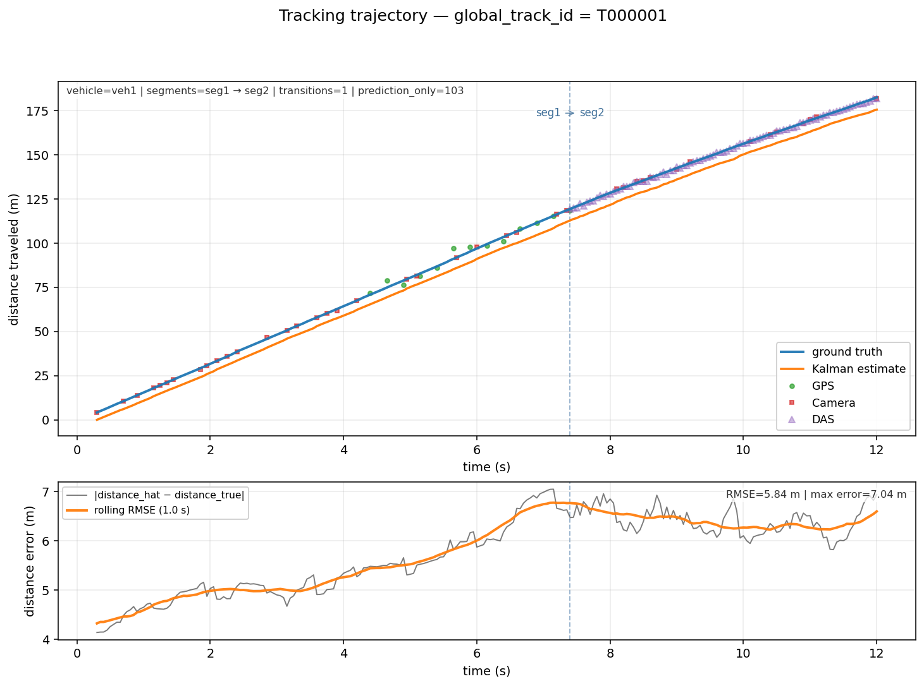

Anomalies
- Camera dropout of 0.70 s (t=4.25–5.70 s).
Before: sensors=Camera, segment=seg1, mean error=0.3 m.
During: sensors=Camera, GPS, mean error=0.4 m, 21/30 rows prediction-only.
After: sensors=Camera, GPS, segment=seg1, mean error=0.5 m.
- Camera dropout of 0.70 s (t=6.65–8.10 s).
Before: sensors=Camera, GPS, segment=seg1, mean error=0.5 m.
During: sensors=Camera, DAS, GPS, mean error=0.5 m, 10/30 rows prediction-only.
After: sensors=Camera, DAS, segment=seg2, mean error=0.3 m.
→ Error recovered to 0.3 m after the anomaly.
- Camera dropout of 0.85 s (t=9.25–10.10 s).
Before: sensors=Camera, DAS, segment=seg2, mean error=0.3 m.
During: sensors=Camera, DAS, mean error=0.5 m.
After: sensors=Camera, DAS, segment=seg2, mean error=0.2 m.
→ Error recovered to 0.2 m after the anomaly.
- Camera dropout of 0.85 s (t=11.15–12.00 s).
Before: sensors=Camera, DAS, segment=seg2, mean error=0.2 m.
During: sensors=Camera, DAS, mean error=0.4 m.
After: sensors=Camera, DAS, segment=seg2, mean error=0.6 m.

Segment Transitions
1 transition(s) across all meaningful tracks.
Track | Time (s) | From segment | To segment
T000001 | 7.40 | seg1 | seg2

Diagnostic Analysis
The sections below interpret the tracking data — what worked, what looks suspicious, what may explain the errors, and what to investigate next. Each interpretation lists confirmed evidence, possible hypotheses, and concrete next checks separately so the reader can tell facts from speculation.

Sensor Coverage Analysis
Across 1 track(s) the audit recorded 13 GPS, 41 camera and 93 DAS measurements plus 103 prediction-only rows (43.8% of all rows). 4 time window(s) had only one sensor type active (see fragmentation / FOV sections for the likely cause).
Track | GPS | Cam | DAS | Pred | Rows | %pred | Longest meas-gap (s)
T000001 | 13 | 41 | 93 | 103 | 235 | 43.8 | 0.45
- 4 time window(s) had only one sensor type active (see fragmentation / FOV sections for the likely cause).

ℹ Sensor coverage looks sufficient
What happened: GPS=13, Cam=41, DAS=93, prediction-only=43.8%, longest gap=0.45 s.
What it probably means: Track T000001 received a balanced mix of measurements with no large gap. The Kalman has enough evidence to stay close to truth.
Why it matters: Healthy coverage is the baseline for trustworthy tracking.
Confirmed evidence:
- GPS = 13 measurements, Camera = 41, DAS = 93.
- Prediction-only rows = 43.8% of the track.
- Longest gap between real measurements = 0.45 s (track duration = 11.70 s).

Sensor Quality / Noise Analysis
Per-sensor noise / bias is computed by comparing each accepted measurement against the oracle ground truth at the same timestep. ‘σ vs err’ flags whether the reported sigma matches reality — a ratio far from 1.0 means the sensor model is mis-calibrated.
Sensor | N | Mean err (m) | Max err (m) | RMSE (m) | Bias x (m) | Bias y (m) | Mean sigma | Sigma vs err
GPS | 13 | 3.45 | 6.68 | 3.82 | 0.49 | 1.26 | 2.80 | σ ≈ actual
Camera | 41 | 0.39 | 1.06 | 0.46 | 0.05 | -0.03 | 0.33 | σ ≈ actual
DAS | 93 | 0.56 | 1.64 | 0.64 | -0.09 | -0.02 | 0.41 | σ ≈ actual

ℹ GPS behaves as expected
What happened: GPS: mean err 3.45, σ 2.80, bias (0.49, 1.26).
What it probably means: GPS mean error and bias are consistent with the reported σ — no immediate noise / calibration concern.
Why it matters: This sensor is likely a reliable contributor to the fusion.
Confirmed evidence:
- 13 GPS measurements compared to ground truth.
- Mean error = 3.45, max error = 6.68, RMSE = 3.82.
- Bias = (Δx=0.49, Δy=1.26).
- Mean reported σ = 2.80.

ℹ Camera behaves as expected
What happened: Camera: mean err 0.39, σ 0.33, bias (0.05, -0.03).
What it probably means: Camera mean error and bias are consistent with the reported σ — no immediate noise / calibration concern.
Why it matters: This sensor is likely a reliable contributor to the fusion.
Confirmed evidence:
- 41 Camera measurements compared to ground truth.
- Mean error = 0.39, max error = 1.06, RMSE = 0.46.
- Bias = (Δx=0.05, Δy=-0.03).
- Mean reported σ = 0.33.

ℹ DAS behaves as expected
What happened: DAS: mean err 0.56, σ 0.41, bias (-0.09, -0.02).
What it probably means: DAS mean error and bias are consistent with the reported σ — no immediate noise / calibration concern.
Why it matters: This sensor is likely a reliable contributor to the fusion.
Confirmed evidence:
- 93 DAS measurements compared to ground truth.
- Mean error = 0.56, max error = 1.64, RMSE = 0.64.
- Bias = (Δx=-0.09, Δy=-0.02).
- Mean reported σ = 0.41.

Error Spike Investigation
Every detected spike or jump is paired with the local sensor context (what was available before / during / after) and a rule-based explanation that distinguishes confirmed facts from likely causes.
- No major error spikes were detected in any track.

Track Fragmentation Analysis
1 oracle vehicle(s) were observed across 1 track ID(s). Each oracle vehicle maps to a single track — no fragmentation suspected.
Vehicle | # tracks | Tracks | Filtered tracks
veh1 | 1 | T000001 [0.30-12.00s, 235 rows] | —

Segment Transition Analysis
Compares the segment transitions the report would emit against the transitions implied by oracle lane_id over time. Mismatches usually indicate a coverage / drift issue rather than a transition-logic bug.
Track | Vehicle | Reported transitions | Oracle transitions | Match
T000001 | veh1 | seg1→seg2@7.40s | seg2 | no

⚠ Segment transition inconsistency
What happened: Track T000001: 1 reported vs 0 oracle transitions.
What it probably means: The report shows more transitions than the oracle indicates — the segment assignment is flickering between adjacent segments, probably because the estimated position is on a boundary.
Why it matters: Segment transitions are how the report tells the story of the vehicle's journey; missing or extra ones distort that story.
Confirmed evidence:
- Reported transitions: 1 (seg1→seg2@7.40s).
- Oracle transitions inside this track's time window: 0 (seg2).
- Track time window: t = 0.30–12.00 s.
Possible explanations (hypotheses):
- Estimated position is oscillating across a segment boundary.
- Lane-to-segment mapping has overlapping centroids near the boundary.
Recommended next checks:
- Compare reported vs oracle segment IDs on the trajectory plot.
- Decide whether segment_id should be assigned from oracle position instead of estimated position for reporting purposes.

Camera Geometry / FOV Analysis
Per-track camera measurement counts, time windows of camera presence, and a sanity check on the camera σ vs actual error. Conclusions about FOV are heuristic — the audit data does not carry the camera polygon itself.
Track | Cam meas | Cam window (s) | Pre-tr / post-tr | Mean σ | Mean err
T000001 | 41 | 11.70 | 27/14 | 0.33 | 0.39

DAS Quality Analysis
DAS measurement counts, SNR distribution, and the Kalman error in DAS-only windows. Where SNR data is available, correlations with tracking error are flagged as evidence of σ-from-SNR mis-calibration.
Track | DAS meas | Mean SNR | Min SNR | Low-SNR rows | Mean err
T000001 | 93 | 40.76 | 10.06 | 0 | 0.38

Kalman Behavior Analysis
For each track the Kalman is evaluated on: how often it received real updates (vs prediction), whether σ grows in gaps and shrinks after measurements, and whether the reported σ matches the actual error. Strong mismatches indicate a tuning issue — not a bug.
Track | % pred-only | σ growth in gaps | σ shrink after meas | σ vs actual err
T000001 | 43.8 | 32/32 | 31/32 | σ ≈ err (healthy)

ℹ Kalman behaves correctly
What happened: σ tracks actual error, σ grows during gaps, shrinks after measurements.
What it probably means: All meaningful tracks show the textbook Kalman pattern: uncertainty rises while coasting and falls when sensor data returns, and the reported uncertainty matches the actual error well.
Why it matters: No tuning intervention needed for the filter itself.
Confirmed evidence:
- 1/1 tracks classified healthy.

Recommendations & Next Investigations
Concrete checks aggregated from the diagnostic sections. Items are ordered by severity (critical → warning → info) and de-duplicated. Each is linked to the interpretation that suggested it.
- (Segment transition inconsistency) Compare reported vs oracle segment IDs on the trajectory plot.
- (Segment transition inconsistency) Decide whether segment_id should be assigned from oracle position instead of estimated position for reporting purposes.

Sensor σ Calibration Check
Compares each sensor's declared measurement noise (sigma_m) against the actual error computed from ground truth. A well-calibrated sensor has mean actual error ≈ mean declared σ. If actual error exceeds 1.2×σ, the Kalman filter is over-trusting that sensor and the R matrix entry should be increased.
Sensor | N meas. | Mean actual err (m) | Max actual err (m) | RMSE (m) | Mean declared σ (m) | Actual / σ ratio | % over-trusted | Verdict
GPS | 13 | 3.454 | 6.683 | 3.816 | 2.799 | 1.23 | 53.8% | ⚠ Over-trusted
Camera | 41 | 0.392 | 1.063 | 0.463 | 0.334 | 1.18 | 41.5% | ✓ Well-calibrated
DAS | 93 | 0.556 | 1.636 | 0.638 | 0.408 | 1.36 | 58.1% | ⚠ Over-trusted
- ⚠ GPS: actual error is 1.23× declared σ (mean err 3.45 m vs σ 2.80 m). Increase R_gps in the Kalman noise matrix.
- ✓ Camera: calibration healthy (actual/σ = 1.18).
- ⚠ DAS: actual error is 1.36× declared σ (mean err 0.56 m vs σ 0.41 m). Increase R_das in the Kalman noise matrix.

Per-Axis Error Breakdown (X vs Y)
Scalar RMSE hides directional bias. A dominant Y error (lateral) usually points to insufficient lateral process noise (Q_yy too small) or missing sensors that constrain cross-track position. A dominant X error (longitudinal) suggests speed-model mismatch.

Track T000001 — veh1
Axis | Mean |error| (m) | RMSE (m) | Signed bias (m) | Dominant?
X (longitudinal) | 0.182 | 0.230 | -0.007 | —
Y (lateral) | 0.313 | 0.397 | +0.019 | Yes
- ⚠ Y (lateral) error dominates by 1.7×. Consider increasing Q_yy (lateral process noise) so the filter tracks lateral motion more responsively.

Sensor Coverage Timeline
Each row represents one second of simulation time. ✓ = at least one accepted measurement from that sensor arrived; — = that sensor was silent (filter coasted on prediction). Seconds where ALL sensors are silent are marked as prediction-only — these are the main source of position drift.

Track T000001 — veh1
Second (s) | GPS | Camera | DAS | Status
0–1 | — | ✓ | — | ✓ sensor active
1–2 | — | ✓ | — | ✓ sensor active
2–3 | — | ✓ | — | ✓ sensor active
3–4 | — | ✓ | — | ✓ sensor active
4–5 | ✓ | ✓ | — | ✓ sensor active
5–6 | ✓ | ✓ | — | ✓ sensor active
6–7 | ✓ | ✓ | — | ✓ sensor active
7–8 | ✓ | ✓ | ✓ | ✓ sensor active
8–9 | — | ✓ | ✓ | ✓ sensor active
9–10 | — | ✓ | ✓ | ✓ sensor active
10–11 | — | ✓ | ✓ | ✓ sensor active
11–12 | — | ✓ | ✓ | ✓ sensor active
12–13 | — | ✓ | ✓ | ✓ sensor active
13–14 | — | — | — | ✗ prediction only
Dead seconds (all sensors silent): 1 / 14 (7%)

Cold-Start Latency
Time elapsed from the first trajectory row to the first moment the position error drops below 0.5 m. A long cold-start indicates the filter is initialized far from the true position, or the initial state covariance P₀ is too small to pull the estimate toward truth quickly. Tuning the initial state (x₀, P₀) or adding a high-weight early measurement can shorten this window.
Track | Vehicle | Track start (s) | First error < 0.5 m at (s) | Cold-start latency (s) | Initial error (m)
T000001 | veh1 | 0.300 | 0.300 | 0.000 s | 0.236

Speed vs Position Error
Position error is bucketed by the estimated vehicle speed at each Kalman step. If error grows with speed the process noise Q or the motion model is misspecified for high-speed dynamics. If error is roughly flat across speeds, sensor dropout — not model mismatch — is the dominant error driver.
Speed bucket | N rows | Mean error (m) | Max error (m) | Trend vs prev
0–5 m/s | 0 | — | — | —
5–10 m/s | 3 | 0.586 | 0.656 | —
10–15 m/s | 95 | 0.375 | 0.943 | ↓ shrinking
15–20 m/s | 137 | 0.400 | 1.112 | → stable
20+ m/s | 0 | — | — | —
- ✓ Error does not strongly correlate with speed — sensor dropout is the primary error driver, not model mismatch.

