1.DANH SÁCH
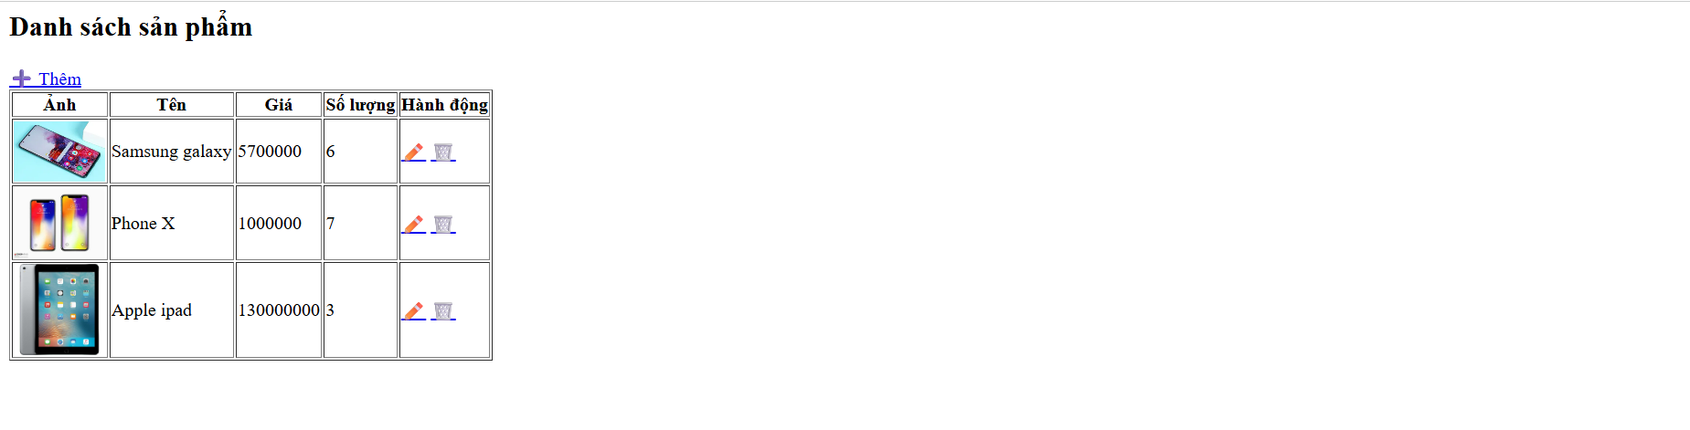
2.THEM SAN PHAM
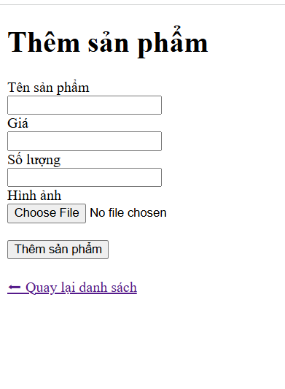
3.CHINH SUA SAN PHAM
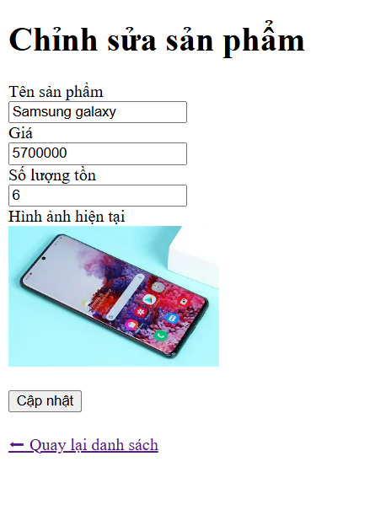

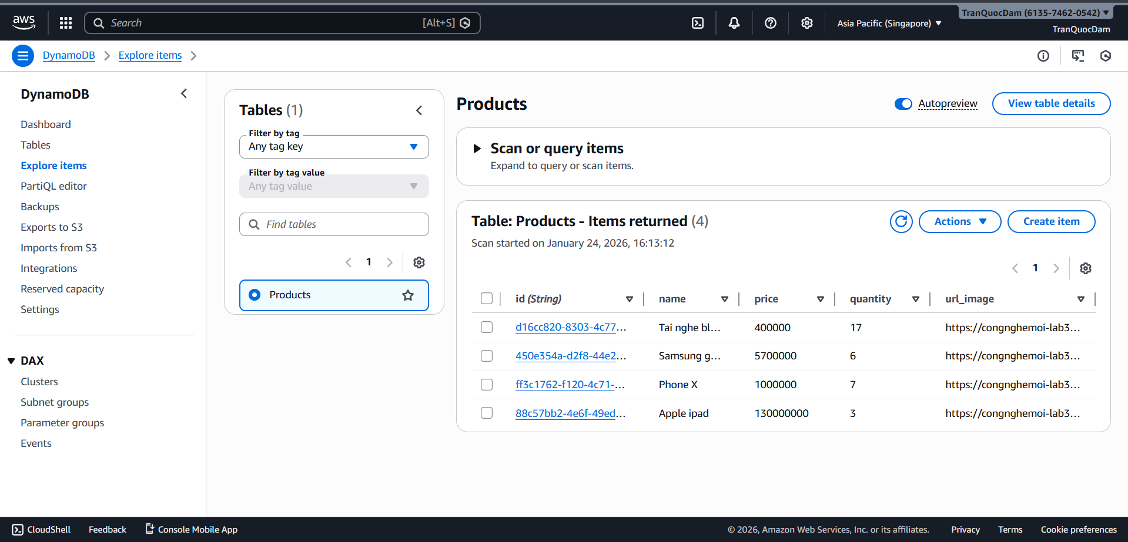

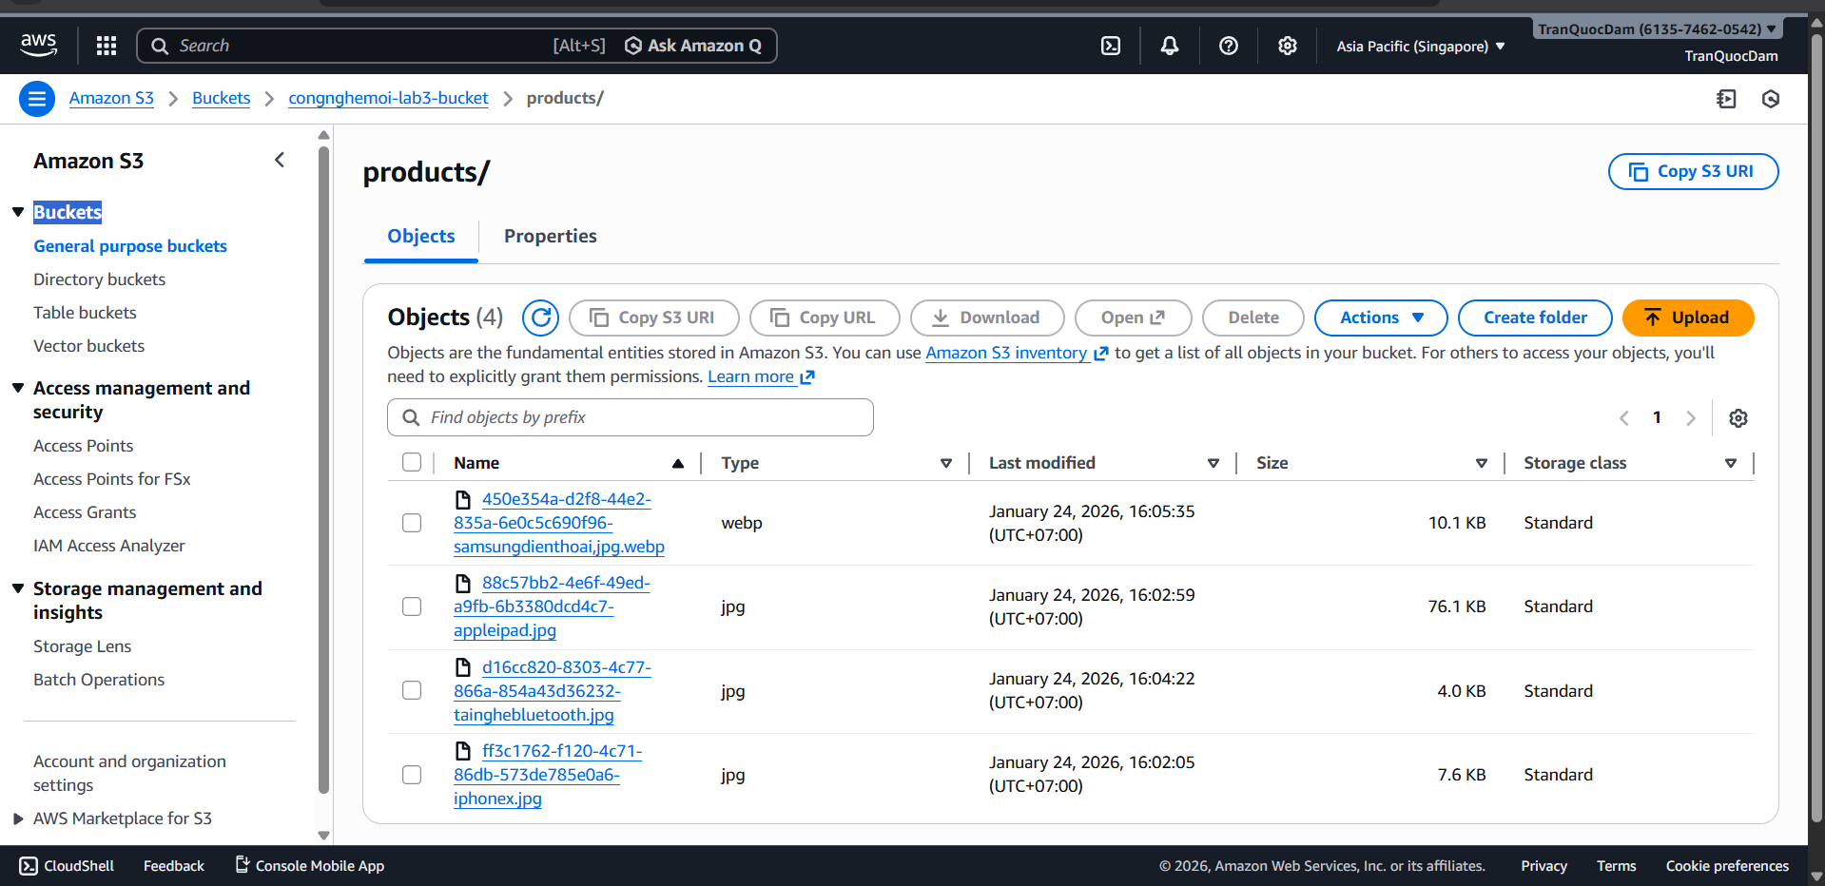

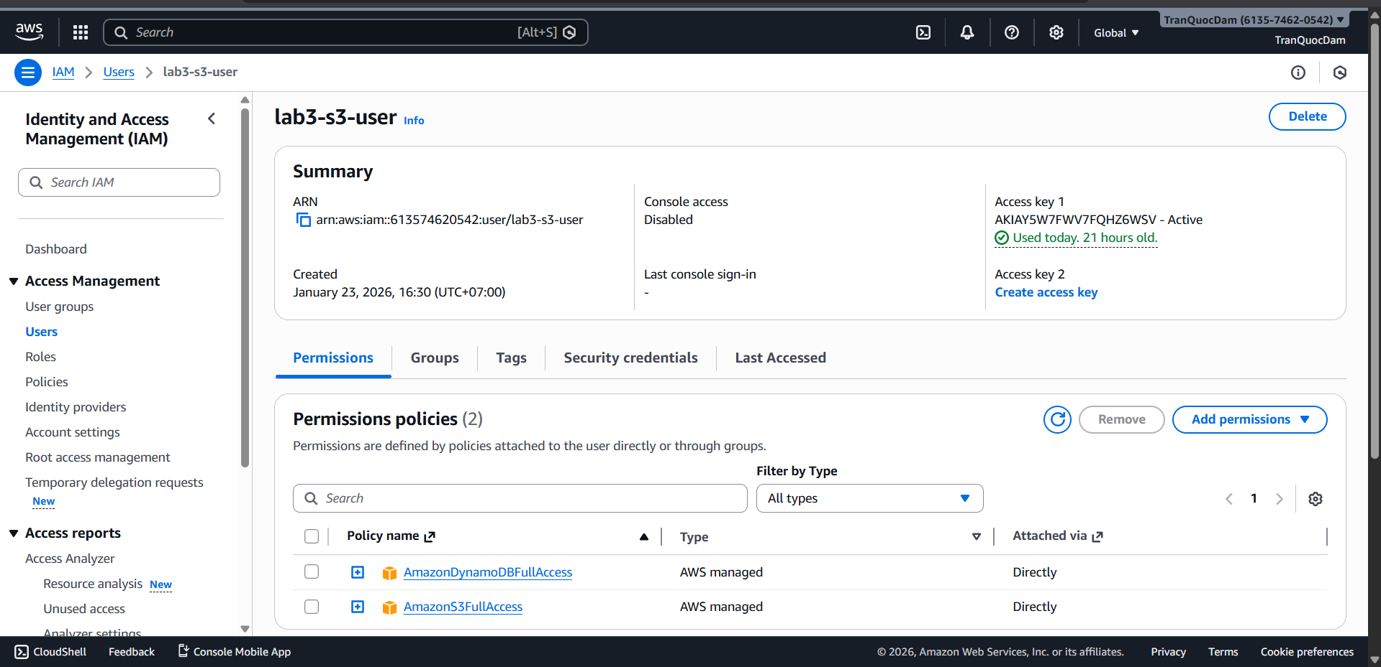

LINK GITHUB: https://github.com/noat04/22645251_NguyenDanhMinhToan_CNM

