**GUI DESIGN**

**Delivery Infomation**

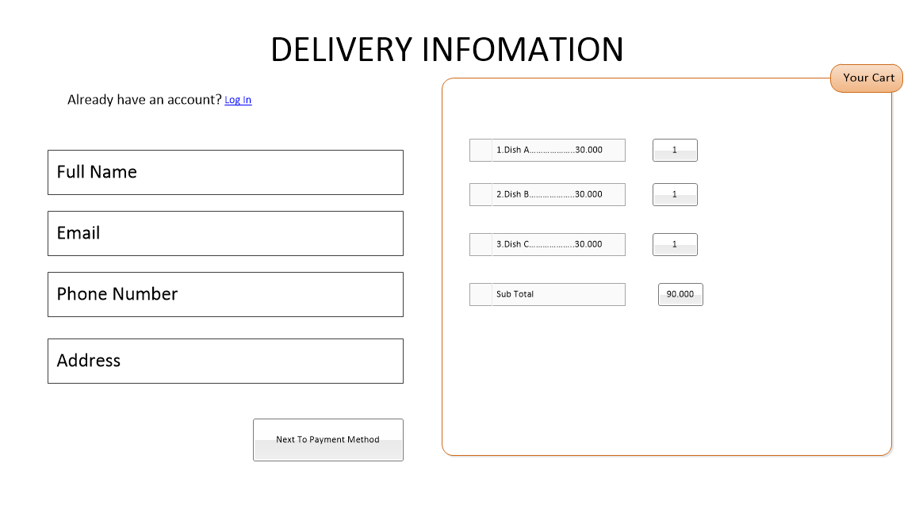

|  |  |
| --- | --- |
| Purpose | Customer provide information to delivery product |
| Connect From | Menu bar, Cart |
| Connect to | Payment Method |
| Validation | * **Name** * Not Blank * 6 – 30 Characters * **Email** * Not Blank * 6 – 50 Characters * Follow format Email * **Address** * Not Blank * 5 – 100 Characters * **Phone Number** * Not Blank * Minimum 10 number |
| Initial values | * Cart Infomation * Field information is blank |
| Events | * Click next to payment method to go payment method page |

**Payment Method**

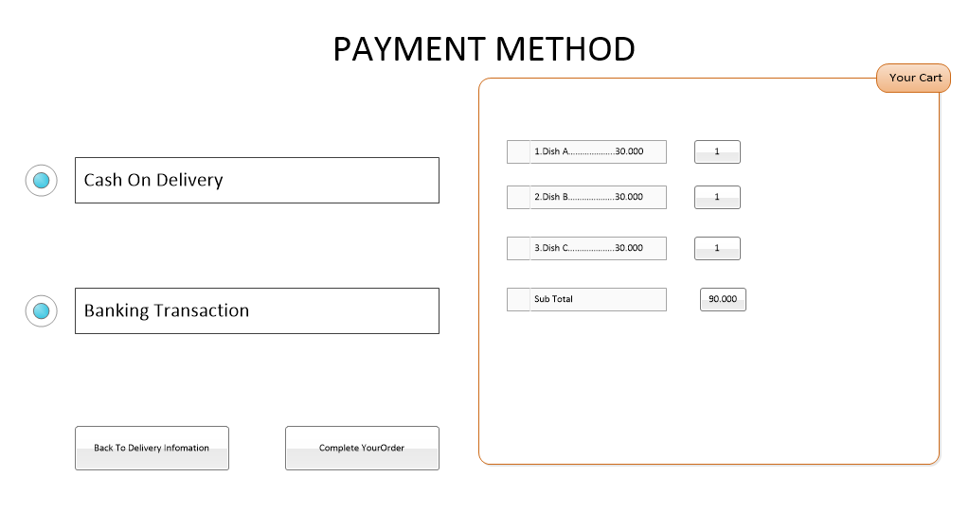

**Bỏ phần Banking Method**

|  |  |
| --- | --- |
| Purpose | Ask for payment method customer want to pay |
| Connect From | Delivery infomation |
| Connect to | Payment confirm |
| Validation | * **Payment method** * One method payment must be choose |
| Initial values | * Cart item |
| Events | * Click complete your order go to payment confirm |

**Payment confirm**

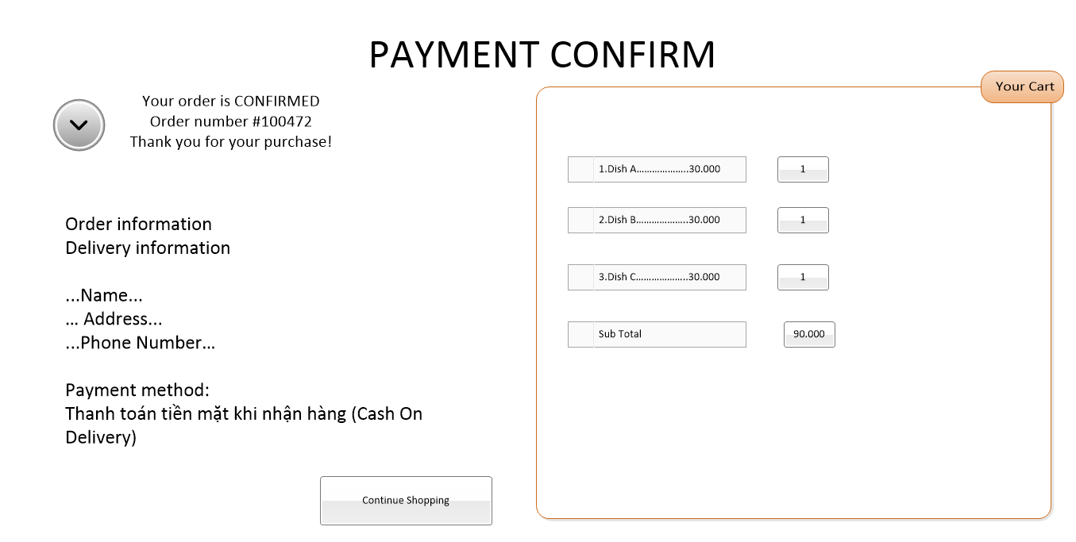

|  |  |
| --- | --- |
| Purpose | Confirm information delivery |
| Connect From | Payment method |
| Connect to | Menu bar |
| Validation |  |
| Initial values | * Cart list * Infomaton of customer |
| Events | * Click “continue shoping” to back menu bar |

**Login / Register**

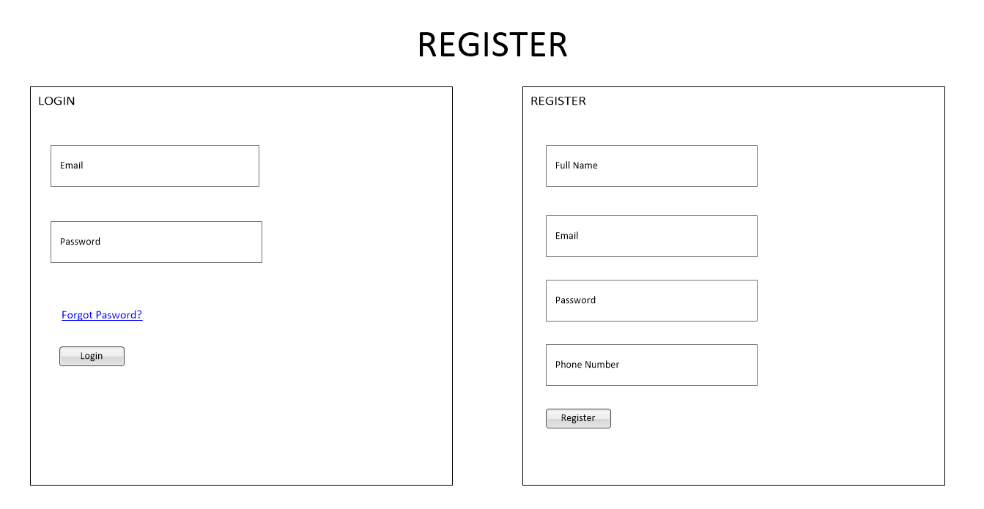

|  |  |
| --- | --- |
| Purpose | Login / Register account |
| Connect From | Menu bar |
| Connect to | Account management |
| Validation | * Name   Not Blank  5 – 30 Characters   * Password   Not Blank  5 – 30 Characters   * Address   Not Blank  5 – 100 Characters   * Phone number   Not Blank  10 – 11 characters |
| Initial values | * All filed blank |
| Events | * Click Login button to login * Click register to register account |

**Account Mnagement**

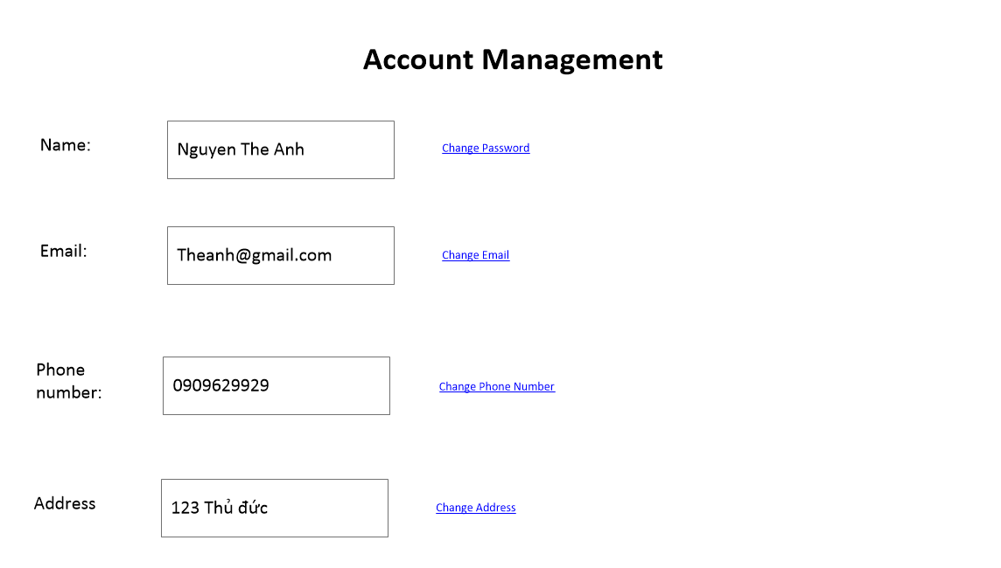

**Thêm phần Search Account**

|  |  |
| --- | --- |
| Purpose | Management personal information of customer |
| Connect From | Menu bar |
| Connect to | Menu bar |
| Validation |  |
| Initial values | * Information of customer |
| Events | * Click change password to change password * Click change email to change email * Click change phone number to change phone number * Click change address to change address |
|  |  |