**GUI DESIGN**

**INDEX**

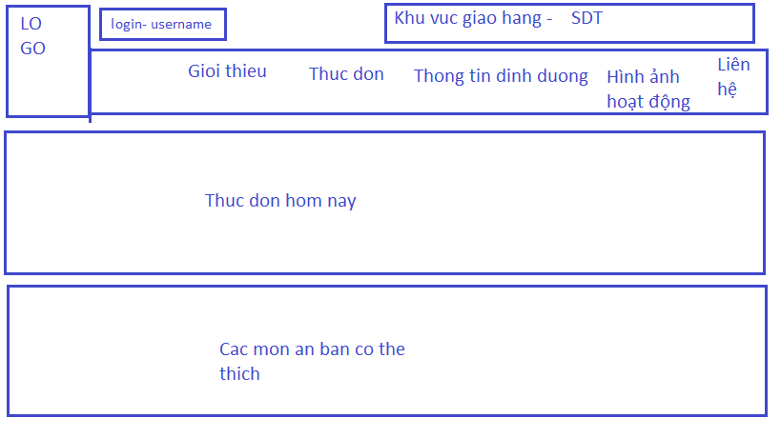

|  |  |
| --- | --- |
| Purpose | Homepage |
| Connect From |  |
| Connect to | Menu – About us – Contact - Infomation – Activities |
| Validation |  |
| Initial values | * Dishes Today * Dishes Suggest * Navar bar |
| Events | * Have all active of Order page * Click detail to go detail + Add info view dish * Click link on navar bar to go other page |

**ADMIN HOME PAGE**

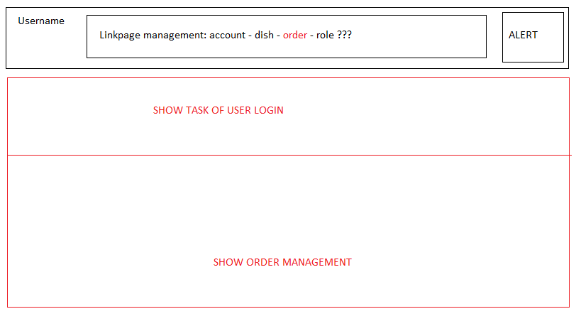

Show order management động với phân quyền

|  |  |
| --- | --- |
| Purpose | **ADMIN HOME PAGE** |
| Connect From | Login |
| Connect to | Other management page |
| Validation |  |
| Initial values | * Navar bar * Alert (number task user need to do) * task user need to do * SHOW ORDER INFO |
| Events | * Click to go to oher management page |

|  |  |
| --- | --- |
| Purpose | Summary orders detail and make a confirmation on order succeed |
| Connect From | Order Info |
| Connect to | Homepage |
| Validation |  |
| Initial values | * Customer info and order details |
| Events | * Click “OK” to collapse this modal |

**Role Management**

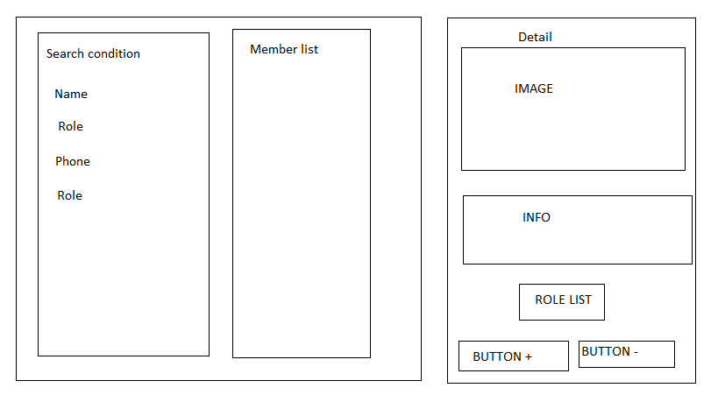

|  |  |
| --- | --- |
| Purpose | Role management |
| Connect From | Admin menu bar |
| Connect to | Add/Update/View Role |
| Validation |  |
| Initial values | * Role list * Employee list |
| Events | * Search employee * Add or delete role * Go to edit information of employee page |

**Menu management**

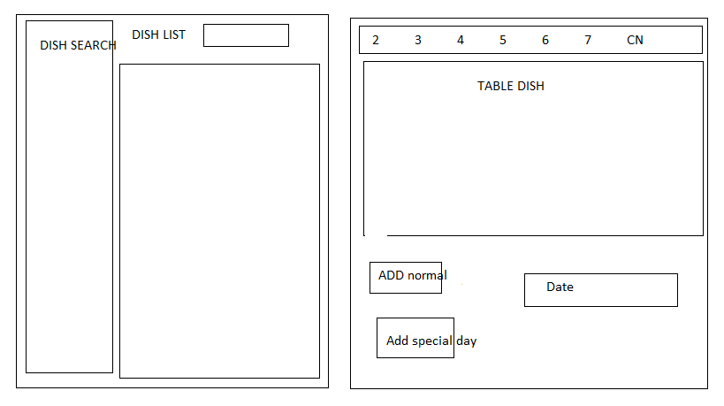

**Bỏ chức năng special day**

|  |  |
| --- | --- |
| Purpose | Add/Update/View an Menu |
| Connect From | Admin page |
| Connect to | Dish Management |
| Validation |  |
| Initial values | * Dish list * Menu |
| Events | * Add / Remove Dish from Menu |