

|  |  |  |  |  |
| --- | --- | --- | --- | --- |
| **Guide Teacher:** Mr. Le Thanh Nhan | | |  | |
| **Class:** F2 – 13 – 1605 – S0 |  | | | |
| **Group No.:** 04 |  | | | |
| **Tên thành viên trong nhóm:** | Full Name | | | Student ID |
|  | 1. | Nguyen Kim Minh Hang | | Student955312 |
|  | 2. | Nguyen Thanh Hau | | Student953310 |
|  | 3. | Dang Van Phung | | Student959563 |
|  |  |  | |  |

***Feb - 2017***

🙢🙡🟑🙣🙠

**Wheely**

**Make it Grow**

**INDEX**

**Review 1** 4

***Acknowledgement:*** 5

**I. Introduction** 5

**II. Problem Definition** 5

**II.1. Existing Scenario.** 5

**II.2. Propose Solution.** 5

**III. Customer Requirement Specification (CRS)** 7

III.1. Shop Leader: 7

III.2. Admin 7

**V. System Requirement Specification** 9

**Task Sheet 1** **Error! Bookmark not defined.**

**Review 2** 11

**I.** **Data Flow Diagram:** 11

**II.** **Entity Relationship Diagram** 14

**III.** **Entity Details** 14

III.1 Admin 14

III.2 Leader 15

III.3 Shop 15

III.4 ListSale 16

III.5 Revenue 16

III.6 Expense 17

III.7 Type 17

**IV. Table Design** 18

**V.Database Relationship Diagram** 24

**VI.Algorithm.** 25

VI.1. Login 25

VI.2.1 New Leader. 26

VI. 2.2. Update Leader. 27

VI.2.3. Delete Leader. 28

VI.3.1. New Shop. 29

VI.3.2. Update Shop. 30

VI. 3.3. Delete Mobile Shop. 31

VI.4.1. New Type. 32

VI. 4.2. Update Type. 33

VI. 4.3. Delete Type. 34

VI. 5.1. New Revenue 35

VI .5.2. Update Revenue 36

VI . 5.3. Delete Revenue 37

VI. 6.1. New Expense 38

VI. 6.2. Update Expense 39

VI. 6.3. Delete Expense 40

VI. 7.1. Search Information. 41

**Task Sheet 2** **Error! Bookmark not defined.**

**Review 3** 44

**I.GUI Design.** 43

I.1. Login 43

I.2 Add Leader 44

I.3 View Leader 47

I.4 Update Leader 49

I.5 Change Password 52

I.6 Add Shop 54

I.7 View Shop 57

I.8 Update Shop 59

I.9 Type Management 62

I.10 Add Revenue 65

I.11 View Revenue 67

I.12 Update Revenue 69

I.13 Expense Management 71

I.14 Statement 74

**II. Testing Document** 76

**III. Final Checklist** 77

**Task sheet 3** 78

**REVIEW 1**

# ***Acknowledgement:***

We would like to thank Aptech Centre, which has helped us implement this subject.

Thanks to the guidance from our teacher – Mr. Le Thanh Nhan.

Finally, thanks to all members who participate in this Project.

🙠🙢🙠🙢🙠🙢🙠🙢🙠🙢

# **I. Introduction**

Wheely is a management software which helps us to manage small mobile shops. In this case, a bread selling shops. This is also considered a frame software which use for all kind of business chain.

# **II. Problem Definition**

* Provide mobile shop chain details
* Provide leader details
* Provide product details
* Make a daily report on revenue and expense for further strategy

**II.1. Existing Scenario.**

By unstoppable growing up, each bread shop has to serve more than 100 customers per day, and we have more than 500 shops like that. A huge data is need to be handled, and this software has to do the job.

**II.2. Propose Solution.**

There are two kinds of login into system following:

1. **Shop Leader:**

* Make a daily Revenue and Expense
* View their Shop profile
* View and update their own profile

1. **Admin:**

* Administrators have highest permission of system
* Creating Leader Profile and provide account
* Creating Mobile Shop Profile
* Creating Product
* View the statement per shop and per date

# **III. Customer Requirement Specification (CRS)**

## III.1. Shop Leader:

1. **Input:**

Revenue/Expense for making a daily cash flow report.

Their profile information

1. **Process:**

Add/Edit/Delete Revenue and Expense.

Update leader profile

1. **Output:**

Confirm create/ edit/ delete daily Revenue and Expense action

View their profile

View shop profile

View Revenue and Expense report

## III.2. Admin

1. **Input:**

Leader information

Shop information

Product Information

Shop ID and Date for searching statement

1. **Process:**

Add/Delete Leader profile.

Add/Edit/Delete shop.

Add/Edit/Delete product.

1. **Output:**

Confirm create/ edit/ delete Leader profile action

Confirm create/ edit/ delete mobile shop profile action

Confirm create/ edit/ delete mobile product action

View statement per date and per Shop ID

# **V. System Requirement Specification**

**Hardware**

* 1.0 GHz x86 Processor, Pentium III-compatible processor or faster.
* 1.4 GHz x64 Processor, AMD Opteron, AMD Athlon 64, Intel Xeon with Intel EM64T support, Intel Pentium IV with EM64T support or faster.
* 1.0 GB RAM. Recommended 2.0 GHz or faster.
* 2.0 GB of Hard disk free.
* Screen require VGA at least 1024x768 pixel resolution or higher.

**Software**

* Windows 7 32 or 64-bit. Recommended at least Windows Server 2003.
* Windows Installer 4.5 or a later version.
* SQL Server 2008.
* Netbeans 6.9 or later.
* JDK 1.4 or later.

**REVIEW 2**

1. **Data Flow Diagram:**

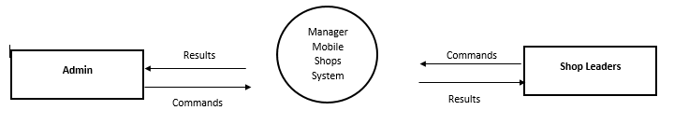

**Figure: DFD level 0 – Context Diagram**

DFD Context Diagram of system includes:

* Two external: Admin, Shop Leader.
* One main process: Manager Mobile Shops System Process.

The operation of the system: When two external entities have requirement to system, they will send commands, the system will process and return the results for two external entities.

**Admin**

Admin takes responsibility for three processes:

Process 1: Manage Leader

* Add Shop Leader.
* Delete Shop Leader.
* View Shop Leader Information.
* One data store: Leader Information.

Process 2: Manage Shop Chain

* Add Shop Chain
* Update Shop Chain.
* Delete Shop Chain.
* View Shop profile.
* One data store: Shop Information.

Process 3: Manage Product Type

* Add Type
* Update Type
* Delete Type
* View Type
* One data store: Type Information.

**Shop Leader**

Leader takes responsibility for three processes:

Process1: Daily Revenue

* Add Revenue (once a day).
* Update Revenue (current date only).
* Delete Revenue (which is existed more than 10 years).
* View Revenue.
* One data store: daily Revenue information

Process2: Daily Expense

* Add Expense (once a day).
* Update Expense (current date only).
* Delete Expense (which is existed more than 10 years).
* View Revenue.
* One data store: daily Revenue information

Process3: Update profile

* Update profile.
* One data store: Leader information

1. **Entity Relationship Diagram**

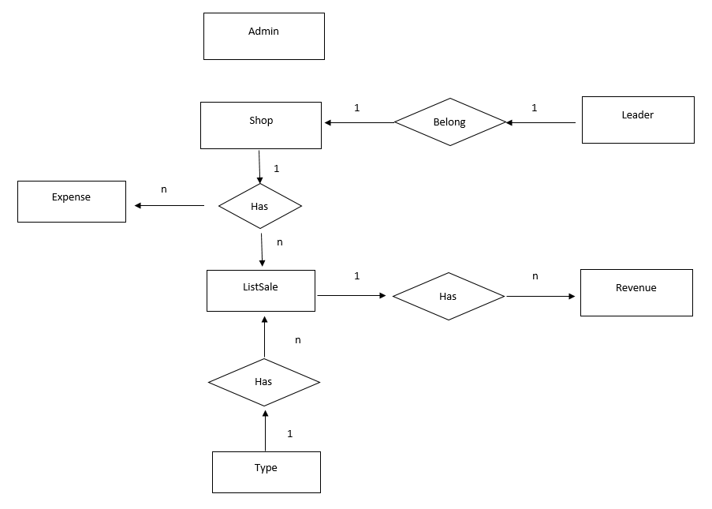

1. **Entity Details**

## III.1 Admin

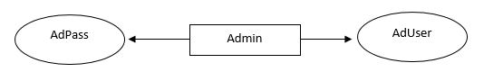

## III.2 Leader

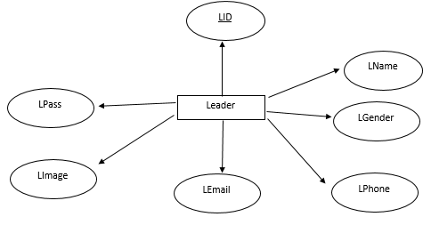

## III.3 Shop

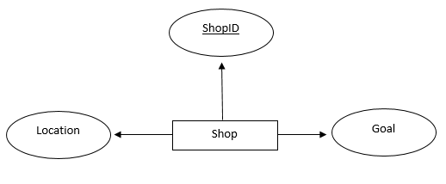

## III.4 ListSale

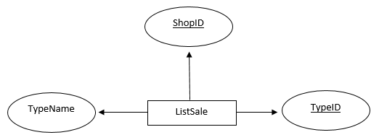

## III.5 Revenue

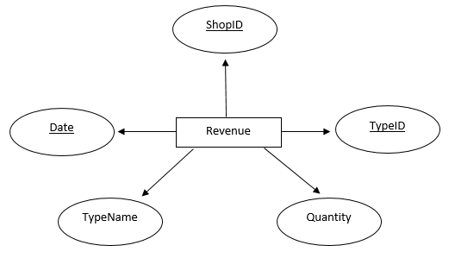

## III.6 Expense

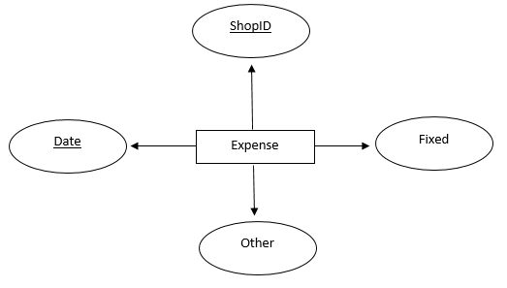

## III.7 Type

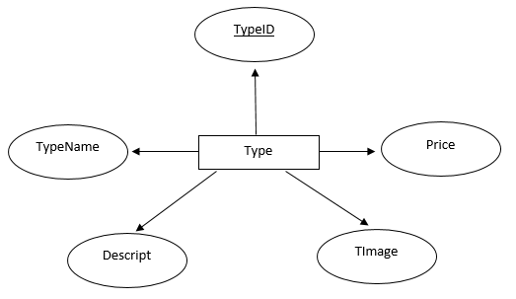

# **IV. Table Design**

|  |  |  |  |  |  |
| --- | --- | --- | --- | --- | --- |
| **Table: Admin** | | | | | |
| **Column Number** | **Column Name** | **Data Type** | **Key** | **Constraint** | **Description** |
| 1 | AdUser | varchar(20) |  | Not Null | Admin username |
| 2 | AdPass | varchar(20) |  | Not Null | Admin password |

|  |  |  |  |  |  |
| --- | --- | --- | --- | --- | --- |
| **Table: Leader** | | | | | |
| **Column Number** | **Column Name** | **Data Type** | **Key** | **Constraint** | **Description** |
| 1 | LID | varchar(10) | Primary key | Not Null | Stores the identification number of Leader |
| 2 | LName | varchar(50) |  | Not Null | Full name |
| 3 | LBirth | varchar(30) |  | Not Null | Birthday |
| 4 | LGender | varchar(10) |  | Not Null | Gender |
| 5 | LPhone | varchar(20) |  | Not Null | Phone number |
| 6 | LEmail | varchar(50) |  | Not Null  Unique | Email |
| 7 | LPass | varchar(20) |  | Not Null | Password |
| 8 | LImage | varchar(50) |  | Not Null | Image of leader |
| 9 | ShopID | varchar(10) | Foreign Key | Not Null | Stores the identification number of Shop |

|  |  |  |  |  |  |
| --- | --- | --- | --- | --- | --- |
| **Table: Shop** | | | | | |
| **Column Number** | **Column Name** | **Data Type** | **Key** | **Constraint** | **Description** |
| 1 | ShopID | varchar(10) | Primary key | Not Null | Stores the identification number of Shop |
| 2 | Location | varchar(50) |  | Not Null | Location working of shop |
| 3 | Goal | int |  | Not Null | The daily business goal which shop must achieve |

|  |  |  |  |  |  |
| --- | --- | --- | --- | --- | --- |
| **Table: ListSale** | | | | | |
| **Column Number** | **Column Name** | **Data Type** | **Key** | **Constraint** | **Description** |
| 1 | ShopID | Varchar(10) | Primary key | Not Null | Stores the identification number of Shop |
| 2 | TypeID | Varchar(10) | Primary Key, Foreign Key | Not Null | Stores the identification number of Product Type |
| 3 | TypeName | Varchar(30) |  | Not Null | Name of product |

|  |  |  |  |  |  |
| --- | --- | --- | --- | --- | --- |
| **Table: Revenue** | | | | | |
| **Column Number** | **Column Name** | **Data Type** | **Key** | **Constraint** | **Description** |
| 1 | Date | Date | Primary key | Default | Stores the current date of making revenue |
| 2 | ShopID | Varchar(10) | Primary Key, Foreign Key | Not Null | Stores the identification number of Shop |
| 3 | TypeID | Varchar(10) | Primary Key, Foreign Key | Not Null | Stores the identification number of Product Type |
| 4 | TypeName | Varchar(30) |  | Not Null | Name of product |
| 5 | Quantity | Int |  | Not Null |  |

|  |  |  |  |  |  |
| --- | --- | --- | --- | --- | --- |
| **Table:Expense** | | | | | |
| **Column Number** | **Column Name** | **Data Type** | **Key** | **Constraint** | **Description** |
| 1 | Date | Date | Primary key | Default | Stores the current date of making revenue |
| 2 | ShopID | Varchar(10) | Primary Key, Foreign Key | Not Null | Stores the identification number of Shop |
| 3 | Fixed | Int |  | Not Null | Fixed cost |
| 4 | Other | Int |  | Not Null | Other cost |

|  |  |  |  |  |  |
| --- | --- | --- | --- | --- | --- |
| **Table:Type** | | | | | |
| **Column Number** | **Column Name** | **Data Type** | **Key** | **Constraint** | **Description** |
| 1 | TypeID | Varchar(10) | Primary Key | Not Null | Stores the identification number of Product Type |
| 2 | TypeName | Varchar(30) |  | Not Null | Name of product |
| 3 | Price | Int |  | Not Null | Price of product |
| 4 | Descript | Varchar(50) |  |  | Description of product |
| 5 | Timage | Varchar(50) |  |  | Image of product |

# **V.Database Relationship Diagram**

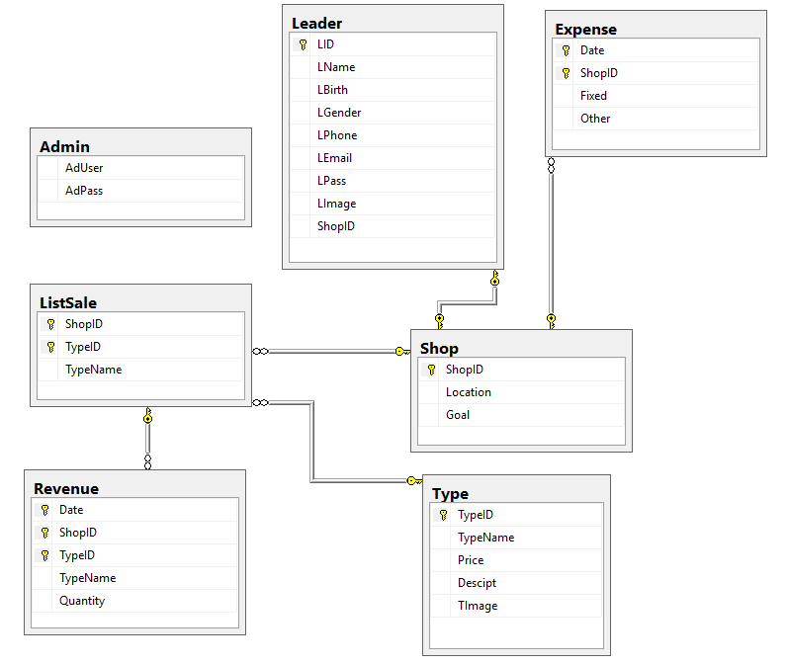

# **VI.Algorithm.**

## VI.1. Login

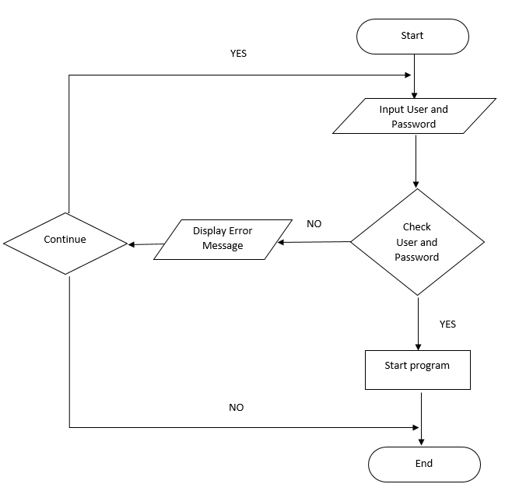

## VI.2.1 New Leader.

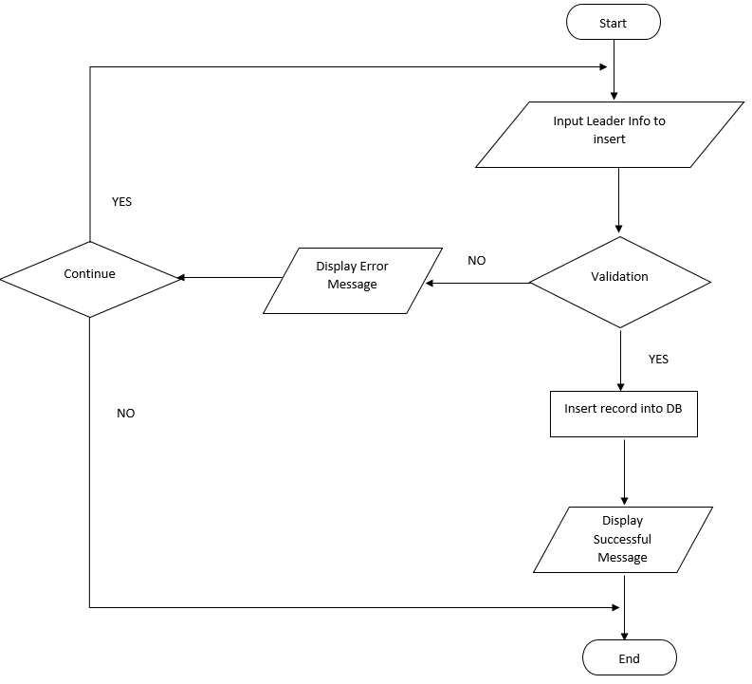

## VI. 2.2. Update Leader.

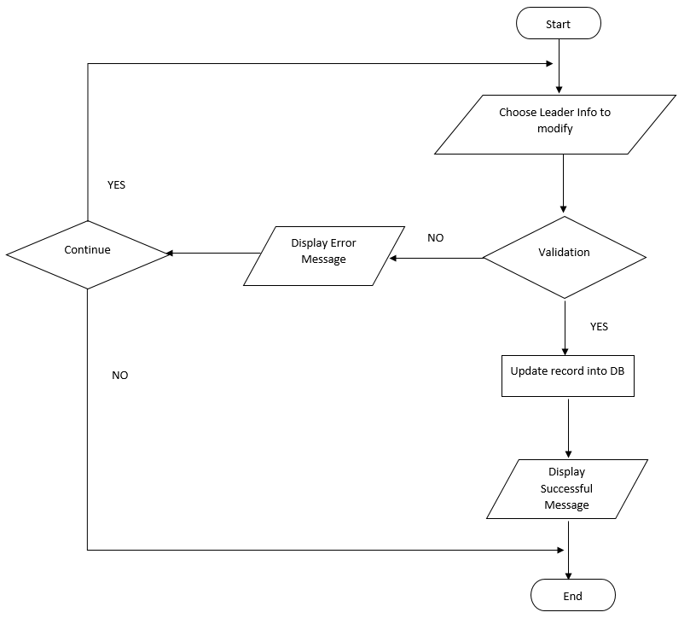

## VI.2.3. Delete Leader.

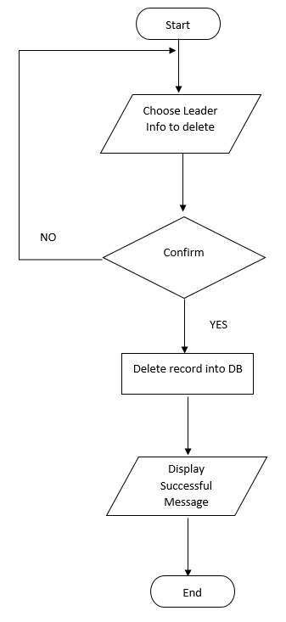

## VI.3.1. New Shop.

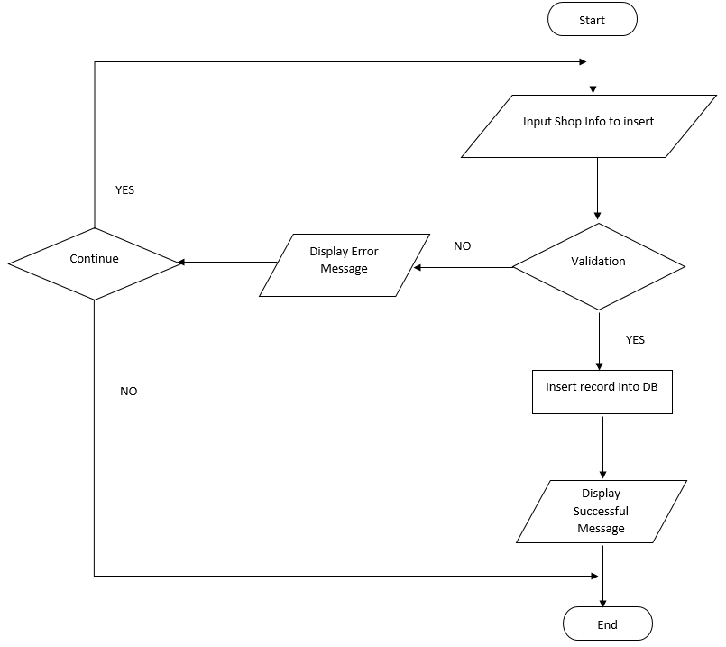

## VI.3.2. Update Shop.

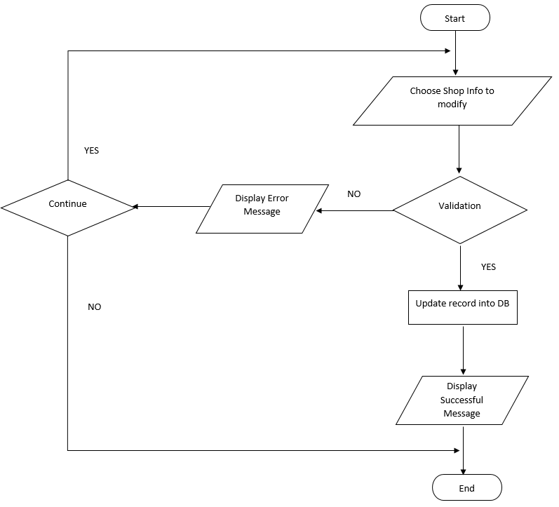

## VI. 3.3. Delete Mobile Shop.

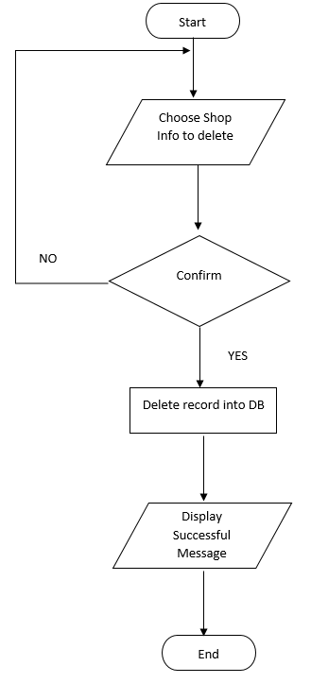

## VI.4.1. New Type.

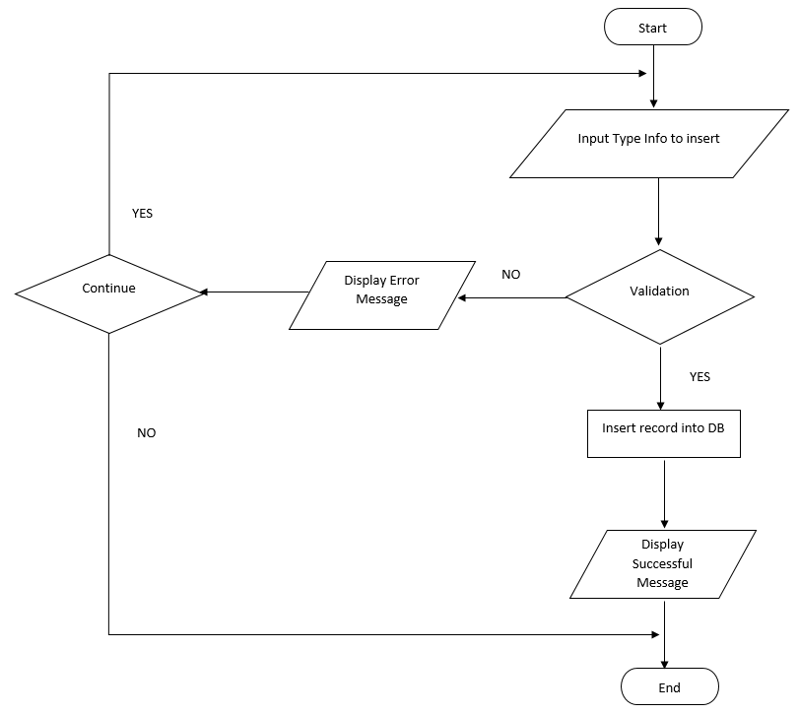

## VI. 4.2. Update Type.

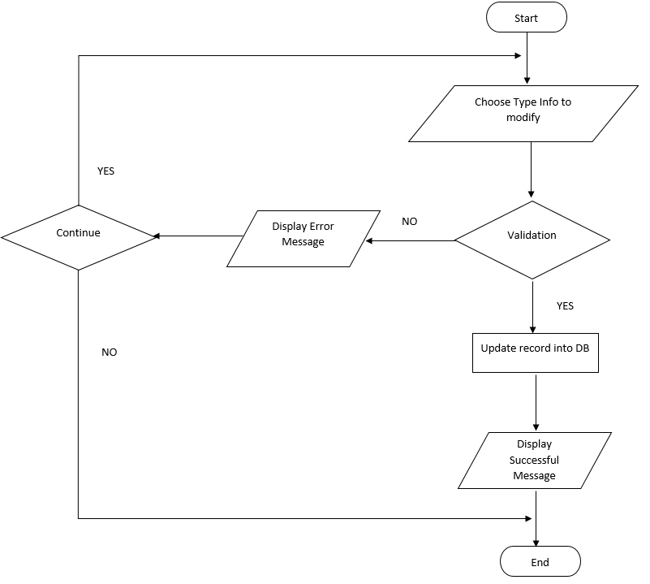

## VI. 4.3. Delete Type.

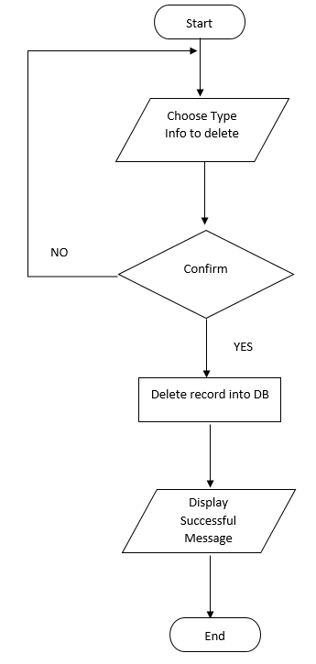

## VI. 5.1. New Revenue

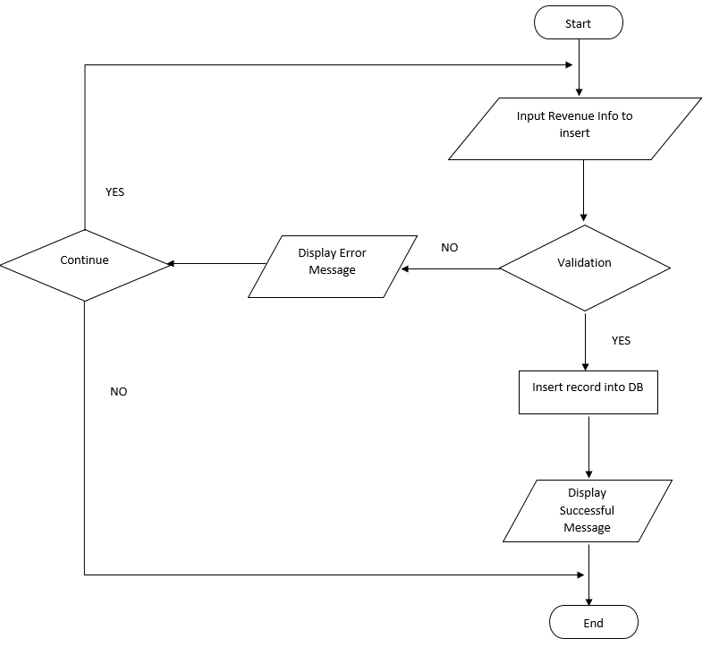

## VI .5.2. Update Revenue

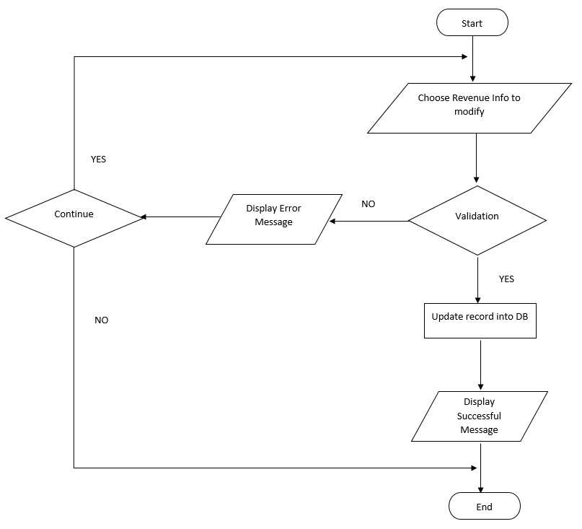

## VI . 5.3. Delete Revenue

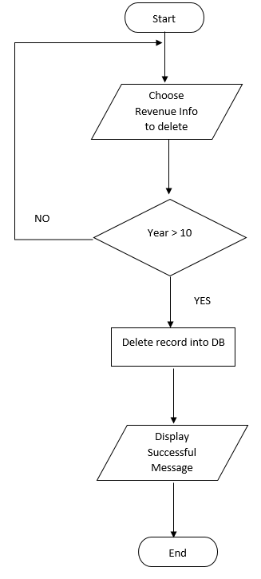

## VI. 6.1. New Expense

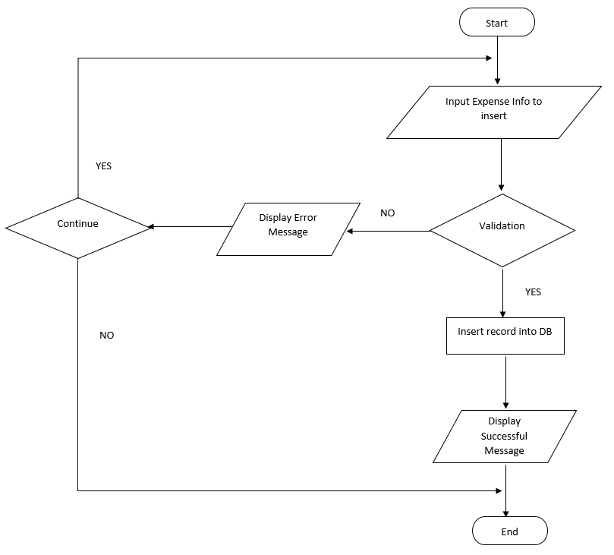

## VI. 6.2. Update Expense

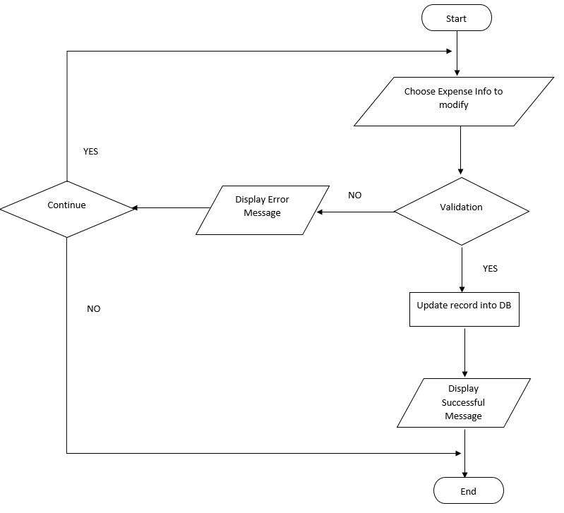

## VI. 6.3. Delete Expense

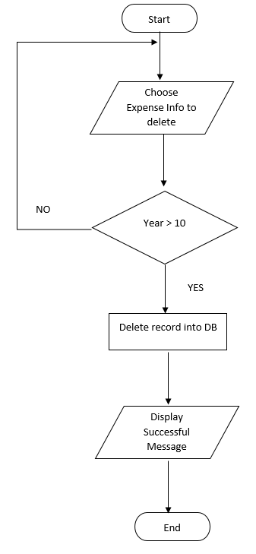

## VI. 7.1. Search Information.

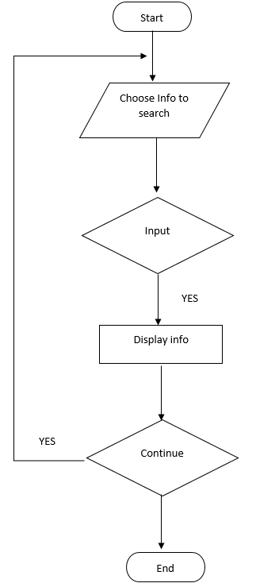

**REVIEW 3**

# **I.GUI Design.**

## I.1. Login

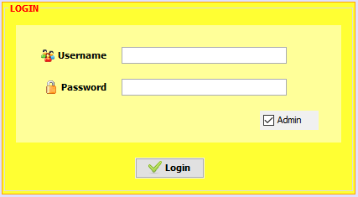

|  |  |
| --- | --- |
| Purpose | Get and check account information for connecting to database |
| Connect From |  |
| Connect to |  |
| Validation | * All fields * Not blank |
| Initial values |  |
| Events | When check “Admin” – Login with Admin permission  When Click button “Login” – If succesfull, the menu will be displayed |

## I.2 Add Leader

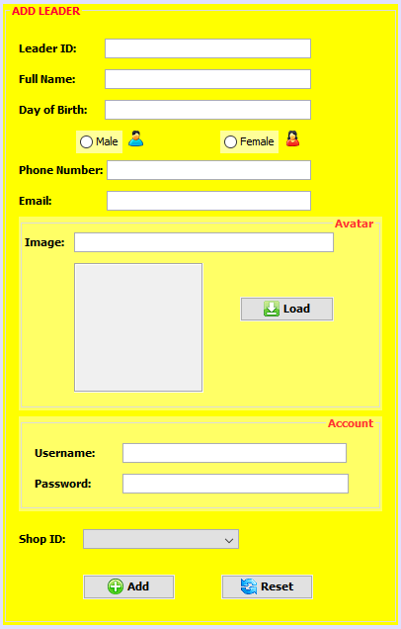

|  |  |
| --- | --- |
| Purpose | Add information of Leaders into database |
| Connect From |  |
| Connect to |  |
| Validation | * **Leader ID** * Not blank * Must be typed with format “LXXX” * Leader ID is not already existed * **Full Name** * Not blank * Must has more than 4 characters * Must uppercase first letter * Al least one white space per word * **Day of Birth** * Not blank * Date format “yyyy-mm-dd” * Between 18 – 30 years old * Not including white space * **Phone:** * Not blank * Between 10 – 15 digits * Phone format “0XXXXXXXXX” * Not including white space * **Email** * Not blank * Email format “xxxx@xxxx.com” * Not including white space * **Username** * Not blank * Must have more than 4 characters * Not including white space * Username is not already existed * **Password** * Not blank * Not including white space * Must have more than 4 characters * Click button “Add” , all information will be checked validation * All fields are set disabled for the first launch |
| Initial values | * Male gender was selected by default * The list of Shop ID being not yet registered will show |
| Events | * Click “Load”, image will be loaded for preview * Click button “Add”, all information added Leader in database * Click button “Reset”, all field come to be default mode |

## I.3 View Leader

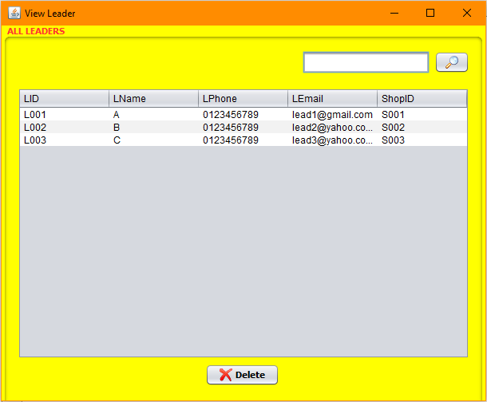

|  |  |
| --- | --- |
| Purpose | View and search information of Leader on Leader table in database |
| Connect From |  |
| Connect to | Leader_Update.java |
| Validation | * Type Leader ID format for searching |
| Initial values |  |
| Events | * Choose one record, or else error message will be showed when clicking button “Modify” or button “Delete” * Click button “Delete”, information of Leader will be deleted in database * Click button “Modify”, it moves to Leader_Update.java * Click “Search”, information of Leader will be searched in database |

## I.4 Update Leader

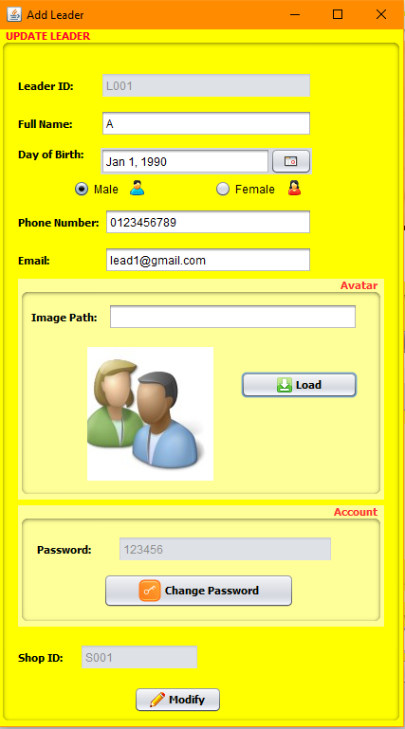

|  |  |
| --- | --- |
| Purpose | Update information of Leaders into database |
| Connect From |  |
| Connect to |  |
| Validation | * **Leader ID** * disabled * **Full Name** * Not blank * Must has more than 4 characters * Must uppercase first letter * Al least one white space per word * **Day of Birth** * Not blank * Date format “yyyy-mm-dd” * Between 18 – 30 years old * Not including white space * **Phone:** * Not blank * Between 10 – 15 digits * Phone format “0XXXXXXXXX” * Not including white space * **Email** * Not blank * Email format “xxxx@xxxx.com” * Not including white space * **Username** * disabled * **Password** * Not blank * Not including white space * Must have more than 4 characters * **Shop ID** * disabled * Click button “Add” , all information will be checked validation |
| Initial values | * ID of Leader was chosen from Leader_View * Username of Leader was chosen from Leader_View * Shop ID of Leader was chosen from Leade_View |
| Events | * Click “Load”, image will be loaded for preview * Click button “Modify”, all information will be updated Leader in database |

## I.5 Change Password

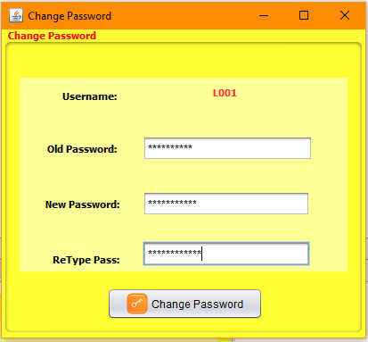

|  |  |
| --- | --- |
| Purpose | Add information of Shop into database |
| Connect From |  |
| Connect to |  |
| Validation | * **Old Password** * Not blank * Must be the same with the reference in database * **New Password** * Not blank * Not including white space * Al least 4 characters * **Retype Password** * Not blank * The same with the new one |
| Initial values | * Username corresponding with each account |
| Events | * Click “Change Password”, the old wil be replaced with the new one |

## I.6 Add Shop

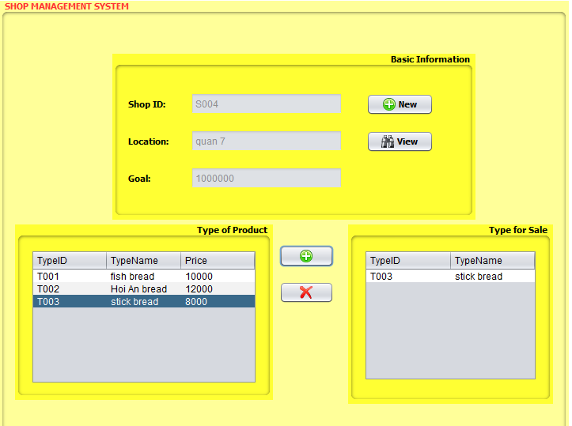

|  |  |
| --- | --- |
| Purpose | Add information of Shop into database |
| Connect From |  |
| Connect to |  |
| Validation | * **Shop ID** * Not blank * Shop ID format: SXXX * Shop ID is not already existed * **Location** * Not blank * Must has more than 4 characters * Al least one white space per word * **Goal** * Not blank * Digit format * At least 500,000VND * **Type for Sale** * Choose at least one from Type of Product * Click button “New” , button label wil change into “Save” * Click button “Save” , all information will be checked validation * All fields are set disabled for the first launch |
| Initial values | * All type of product will be showed |
| Events | * Click “Save”, information of Shop will be inserted into database * Click “View” leads app to Shop View window * Choose a type from product table, then click “+” for adding type for sale, that type will move from List to Sale * Choose a type from Sale, then click “-” for removing type for sale, that type will move from Sale to List |

## I.7 View Shop

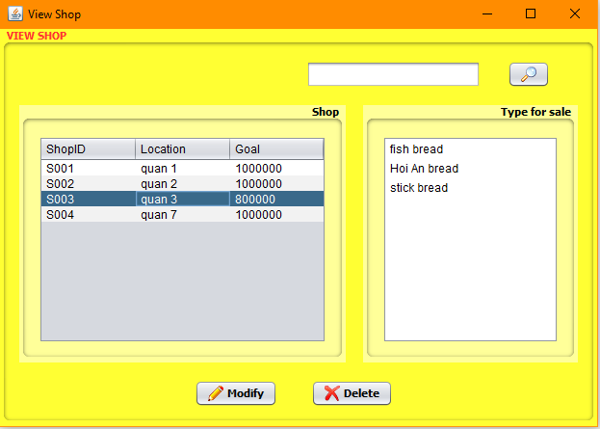

|  |  |
| --- | --- |
| Purpose | View and search information of Shop in database |
| Connect From |  |
| Connect to | Shop_Update.java |
| Validation | * Type Shop ID format for searching |
| Initial values | * All shop information will be showed in panel Shop * Choose any one record, the product types for sale corresponding with shop will show |
| Events | * Choose one record, or else error message will be showed when clicking button “Modify” or button “Delete” * Click button “Delete”, information of Shop will be deleted in database * Click button “Modify”, it moves to Shop_Update.java * Click “Search”, information of Shop will be searched in database |

## I.8 Update Shop

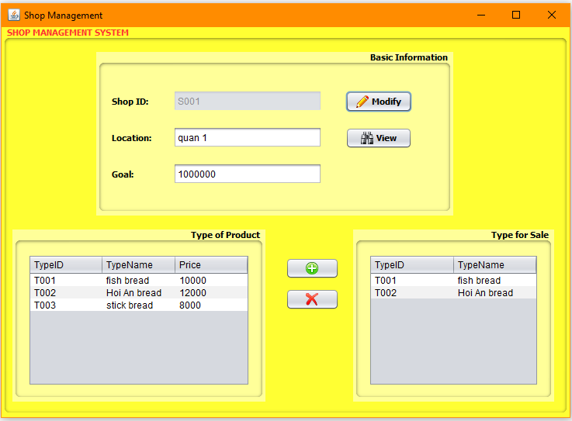

|  |  |
| --- | --- |
| Purpose | Update information of Shop into database |
| Connect From |  |
| Connect to |  |
| Validation | * **Shop ID** * Disabled * **Location** * Not blank * Must has more than 4 characters * Al least one white space per word * **Goal** * Not blank * Digit format * At least 500,000VND * **Type for Sale** * Choose at least one from Type of Product * Click button “Modify” , button label wil change into “Save” * Click button “Save” , all information will be checked validation |
| Initial values | * All type of product will be showed |
| Events | * Click “Save”, information of Shop will be updated into database * Click “View” leads app to Shop View window * Choose a type from product table, then click “+” for adding type for sale, that type will move from List to Sale * Choose a type from Sale, then click “-” for removing type for sale, that type will move from Sale to List |

## I.9 Type Management

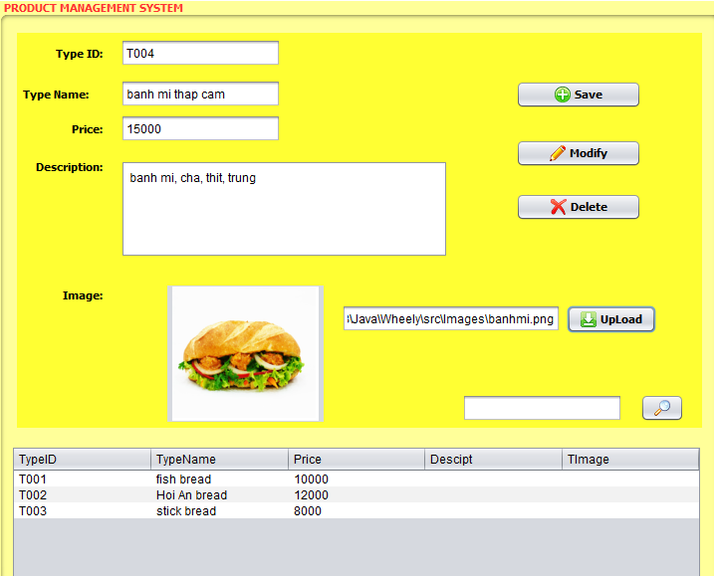

|  |  |
| --- | --- |
| Purpose | Add information of Product Type into database |
| Connect From |  |
| Connect to |  |
| Validation | * **Type ID** * Format : TXXX * Not blank * **Type Name** * Not blank * At least 4 characters * At least one white space * **Price** * Not blank * Between 10,000 VND – 20,000 VND * Digit format * **Description** * At least one white space per word * Click “New”, button label changes into “Save” * Click button “Save” , all information will be checked validation * All fields are set disabled for the first launch * Type ID is disabled when click “Modify” |
| Initial values | All field are initialized with values from a record chosen |
| Events | * Choose any record from table or an error message will show when clicking “Modify” or “Delete” |

## I.10 Add Revenue

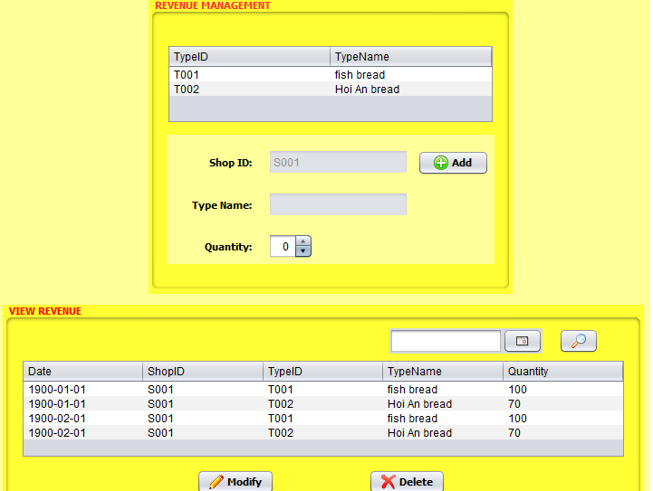

|  |  |
| --- | --- |
| Purpose | Add revenue of each Product type into database (for each day) |
| Connect From |  |
| Connect to |  |
| Validation | * **Shop ID** * Disabled * **Type Name** * Disabled * **Quantity** * Not blank * Digit format * Click “Add”, button label changes into “Save” * Click button “Save” , all information will be checked validation * Allow insert data once a day |
| Initial values | Type for Sale corresponding with Shop ID will load into table  Shop ID was initial corresponding with Lead permission login  Type Name was initial with values from a record chosen |
| Events | * Click “Save”, revenue will insert into database by each type for one shop and current date, the type chosen in table will disapear * Click “View” leads app to View Revenue window |

## I.11 View Revenue



|  |  |
| --- | --- |
| Purpose | View and search information of Revenue in database |
| Connect From |  |
| Connect to | Revenue_Update.java |
| Validation | * Type date format for searching * Only dates last longer 10 years and current date allowed for deleting |
| Initial values | * All revenue information will be showed in panel Shop |
| Events | * Click button “Delete”, information of revenue of will be deleted in database * Click button “Modify”, it moves to Revenue_Update.java * Click “Search”, information of Revenue will be searched in database |

## I.12 Update Revenue

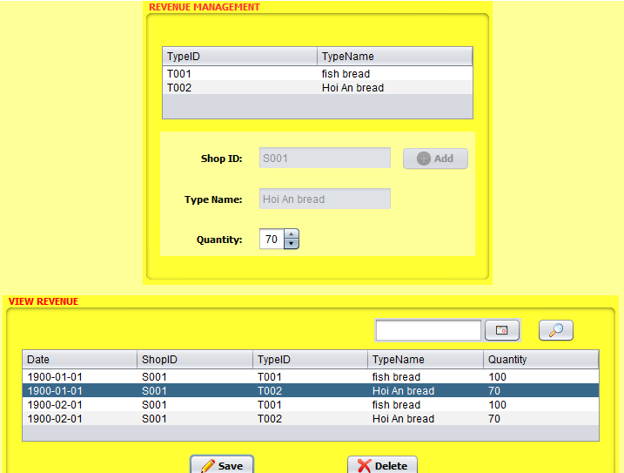

|  |  |
| --- | --- |
| Purpose | Update revenue of each Product type into database (for current date) |
| Connect From |  |
| Connect to |  |
| Validation | * **Shop ID** * Disabled * **Type Name** * Disabled * **Quantity** * Not blank * Digit format * Click “Modify”, button label changes into “Save” * Click button “Save” , all information will be checked validation |
| Initial values | Type for Sale corresponding with current date revenue will load into table  Shop ID was initial corresponding with Lead permission login  Type Name and Quantity was initial with values from a record chosen |
| Events | * Choose any one record or an error message will show when clicking “Save”, revenue will update into database by each type for one shop and current date |

## I.13 Expense Management

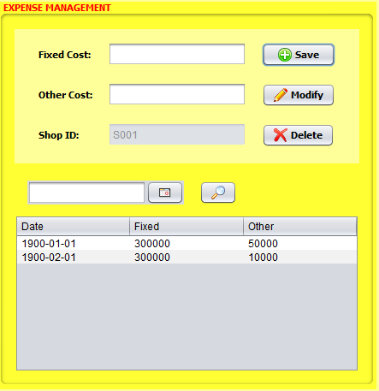

|  |  |
| --- | --- |
| Purpose | Add information of Expense into database |
| Connect From |  |
| Connect to |  |
| Validation | * **Fixed Cost** * Digit formart * Not blank * At least 300,000 VND * **Other Cost** * Not blank * Digit format * **Shop ID** * Disabled * Click “New”, button label changes into “Save” * Click button “Save” , all information will be checked validation, allow insert data only once a day * All fields are set disabled for the first launch * Type Date format for searching * Only allowing delete any record which lasts than 10 years and current date |
| Initial values | All field are initialized with values from a record chosen  Shop ID was initial corresponding with Lead permission login |
| Events | * Choose any record from table or an error message will show when clicking “Modify” or “Delete” |

## I.14 Statement

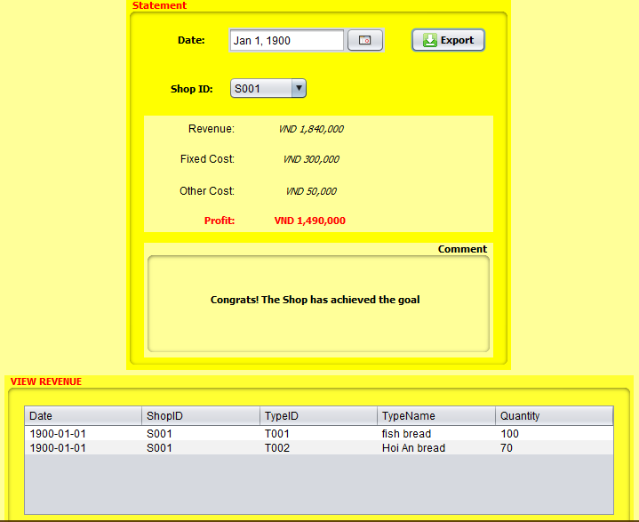

|  |  |
| --- | --- |
| Purpose | Display information of Expense and Revenue statement from database |
| Connect From |  |
| Connect to |  |
| Validation | * **Date** * Date formart “yyyy-mm-dd” * Not blank * **Shop ID** * Not blank |
| Initial values |  |
| Events | * Click “Export” will display information of Statement of Revenue and Expense per date and per shop * This also compares Revenue and Goal of each shop and display the comment. |

# **II. Testing Document**

|  |  |  |
| --- | --- | --- |
| **S.No.** | **Features Tested** | **Remarks** |
| 1. | Database | OK |
| 2. | GUI | OK |
| 3. | Load Data in each file | OK |
| 4. | Insert function | OK |
| 5. | Modify function | OK |
| 6. | Delete function | OK |
| 7. | Validation | OK |

# **III. Final Checklist**

|  |  |  |
| --- | --- | --- |
| **S.No.** | **Aspect tested** | **Suggestion/Remarks** |
| 1. | Have all the modules been properly integrated and are they completely functional? | OK |
| 2. | Does each unit meet its objective and purpose?  Are all the validations happening as specified in Process Design? | OK |
| 3. | Have all Design and Coding standards been followed and implemented? | OK |
| 4. | Is the GUI design consistent all over? | OK |
| 5. | Are the codes working as per the specification? | OK |
| 6. | Does the application’s functionality resolve the client problem, and satisfy his needs completely? | OK |
| 7. | Have the hardware and software been correctly chosen? | OK |
| 8. | Additional features and utilities that give value addition to the entire project | OK |

# **Task sheet 3**

|  |  |  |  |  |  |  |  |
| --- | --- | --- | --- | --- | --- | --- | --- |
| **No** | **Member** | **Contents** | **Form Name** | **Activity Plan** | **Date of Preparation of Activity Plan** | | |
| **Planed Start Date** | **Actual Start Date** | **Actual Days** | **Status** |
| 1 | Nguyen Kim Minh Hang | Statement | Statement.java | 15/2/2017 | 15/2/2017 | 10 | OK |
| 2 | View Revenue | Revenue_View.java | 10 | OK |
| 3 | Delete Revenue | 10 | OK |
| 4 | Add Revenue | Revenue.java | 10 | OK |
| 5 | Update Revenue | Revenue_Update.java | 10 | OK |
| 6 | View Expense | Expense.java | 10 | OK |
| 7 | Delete Expense | 10 | OK |
| 8 | Add Expense | 10 | OK |
| 9 | Update Expense | 10 | OK |
|  | | | | | | | |
| 1 | Nguyen Thanh Hau | View Leader | Leader_View.java | 15/2/2017 | 15/2/2017 | 10 | OK |
| 2 | Delete Leader | 10 | OK |
| 3 | Add Leader | Leader.java | 10 | OK |
| 4 | Update Leader | Leader_Update.java | 10 | OK |
|  | | | | | | | |
| 1 | Dang Van Phung | View Shop | Shop_View.java | 15/2/2017 | 15/2/2017 | 10 | OK |
| 2 | Delete Shop | 10 | OK |
| 3 | Add Shop | Shop.java | 20 | OK |
| 4 | Update Shop | Shop_Update.java | 20 | OK |
| 5 | View Type | TMS.java | 15/2/2017 | 15/2/2017 | 10 | OK |
| 6 | Delete Type | 10 | OK |
| 7 | Add Type | 20 | OK |
| 8 | Update Type | 20 | OK |