**README**

**Specs**: ubuntu machine, python3, puremagic module.

**How to run the project**:

1. Run the server – ‘python3 main.py’
2. Run each client from the following clients:
   1. Client1 – clean client
   2. Client2 – sends mail with an attached file that contains a virus signature
   3. Client3 – sends mail with suspicious file name
   4. Client4 – sends mail with different type of file attached then what is written
   5. Client5 – sends mail with a redirected link

**Example**:

In the first shell window:

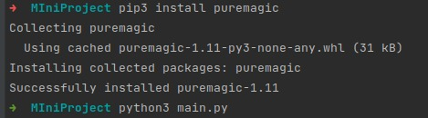

In the second window:

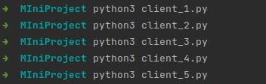

After which the results will be:

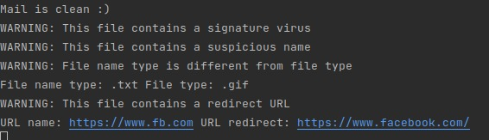

Noa Tshuva and Nitzan Hochman