**PART 1**

**Query**

**geometry, Area_Acres,Length_mil**

**var** rows = data[**'rows'**];

**Alert 1.**

This information comes from the GIS map

**rows**

alert(**"L-407 rows"** + rows);

Subbasin, geometry-coord., Area, Length

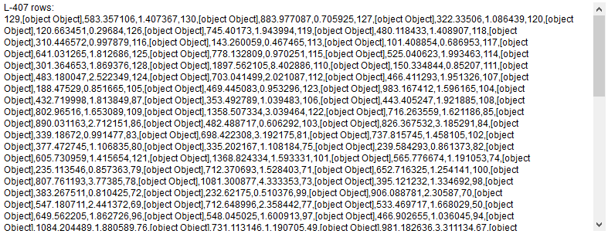

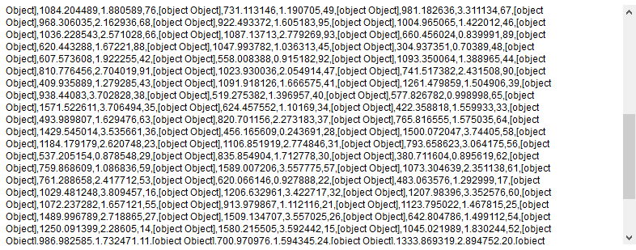

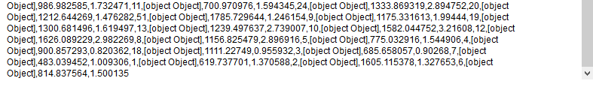

**Alert 2.**

alert(rows.**length**);*//E:*

row: 130

alert(**"Type rows: "** + **typeof 'rows'**);

String

**Alert 3.**

alert(rows[0]);

**129,[object Object],583.357106,1.407367**

alert(**"Type row[0]: "** + **typeof 'rows[0]'**);

String

alert(rows[0][1]);

row[0][1]: [object Object]

alert(rows[0][1][**'geometry'**]);

row[0][1]['geometry']: [object Object]

alert(**"row[0][1][1]: "** + rows[0][1][1]);

row[0][1][1]: undefined

alert (**"Sub-basin: "**+ rows[i][0]+**" Area: "**+ rows[i][2]+**" stream: "**+ rows[i][3])

alert (**"geometry "**+i+**":"**+rows[i][1][**'geometry'**][**'coordinates'**]);

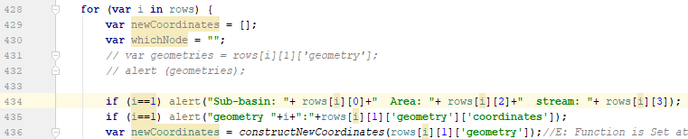

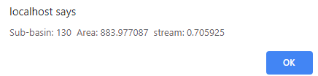

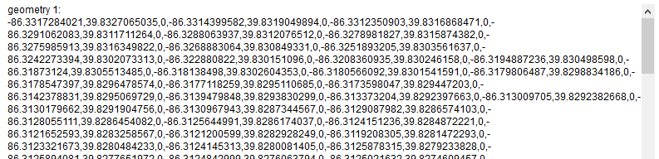

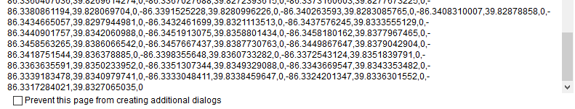

**PART 2**

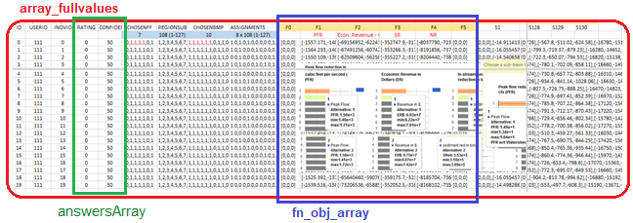

**console**.log(**"L.969 full values of 'wholeTable':"** + ***JSON***.stringify (***array_fullvalues***));

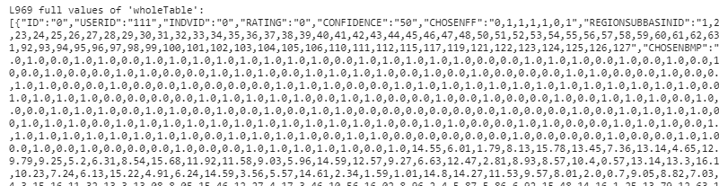

**subBMP**

**bmpArray = [subBMP-alt1, subBMP-alt2, subBMP-alt3, …, subBMP-alt20]**

*//E: 'bmpArray' gets the 'CHOSENBMP' of the current alternative starting from alternative 0 to 20. For example for alternative 1 is:*





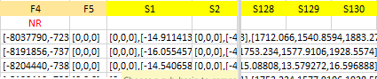

**subBasinArrayStart =** REGIONSUBBASINID as array, for the current alternative, starts from 0 to 20. For example, this is for alternative 0.





**subBasinArray =** REGIONSUBBASINID as dictionary, for the current alternative, starts from 0 to 20. For example, this is for alternative 0.

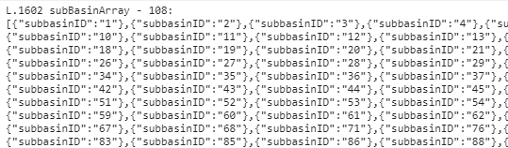

**assArray =** ASSIGNMENTS for the current alternative, starts from 0 to 20

**PFR_meanVals_array, Cost_meanVals_array, SR_meanVals_array, NR_meanVals_array**

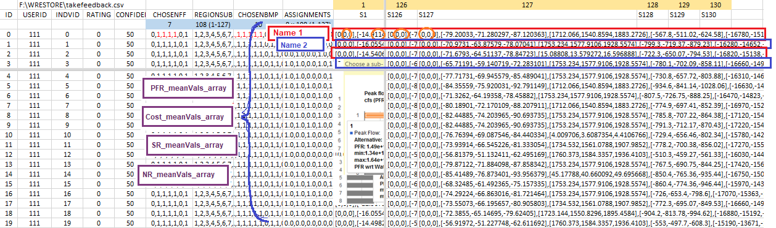

NR_meanVals_array

SR_meanVals_array

Cost_meanVals_array

PFR_meanVals_array

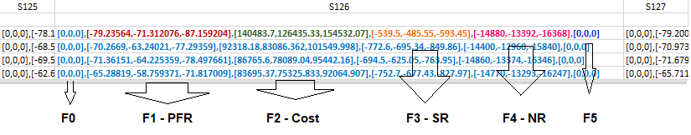

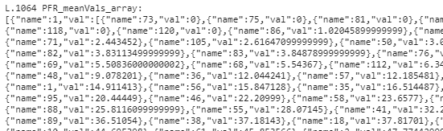

**PART3**

**subBasinArray**

This information comes from MySQL Database. It gives values for each of 108 subbasins

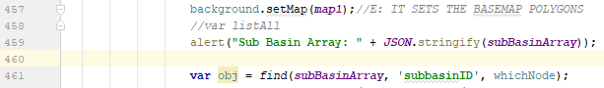

It gives 130 times this

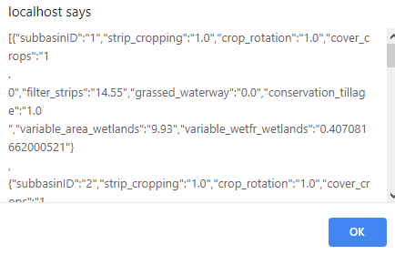

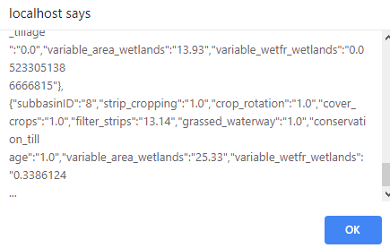

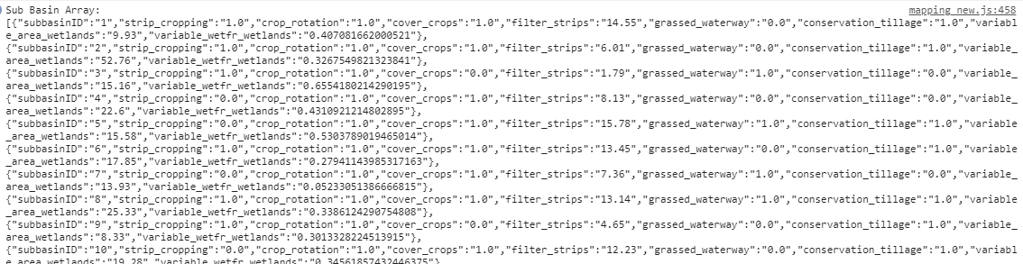

**forMapArray**

**console**.log(**"L.1348 forMapArray: \n"**+ ***JSON***.stringify(***forMapArray***));

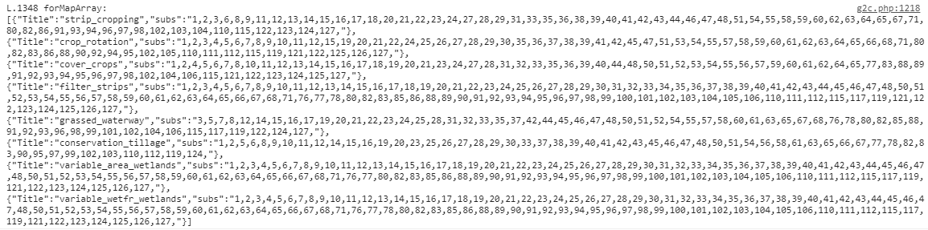

**PART 3**

*alert (obj);*

Note: ‘find’ function searches the match watershed



It gives this, 130 times

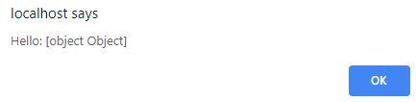

alert (***JSON***.stringify(obj, **null**, 4));



It gives this, 130 times

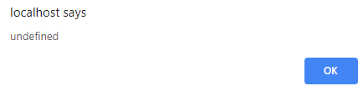

*alert (listAll);*

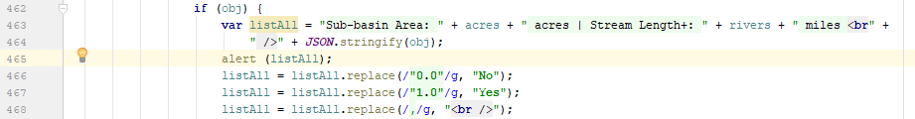

Before

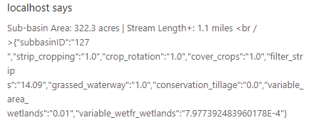

After

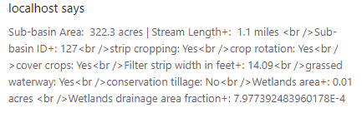

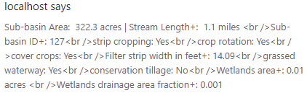

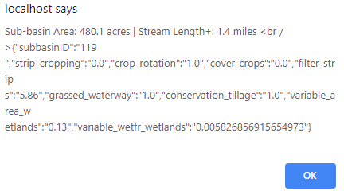, The blue box is “obj”

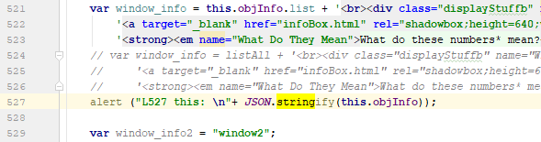

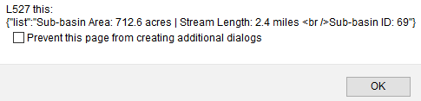



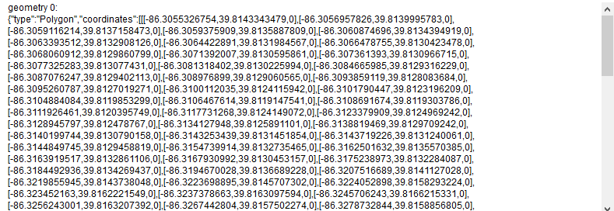

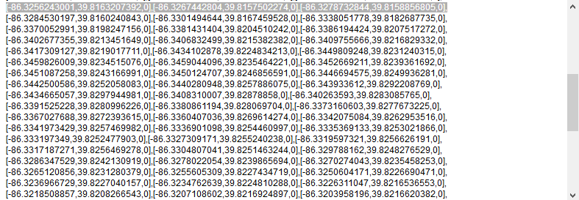

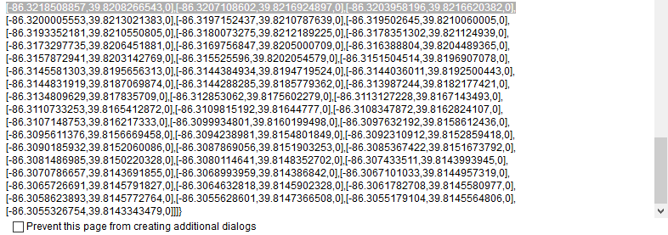

**if** (i==0) alert(**"features: "** + i + **" \n "** + ***JSON***.stringify(***map_data***.**features**[i]));

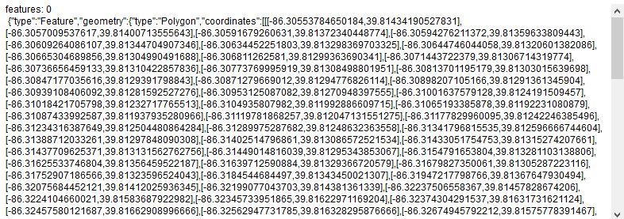

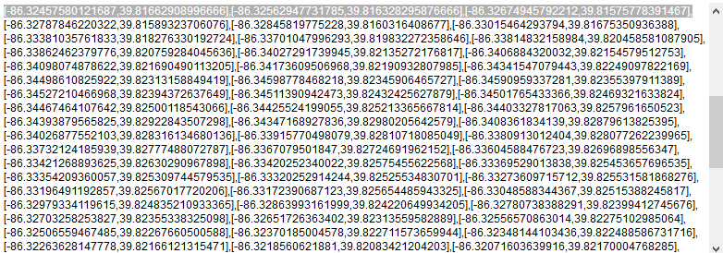

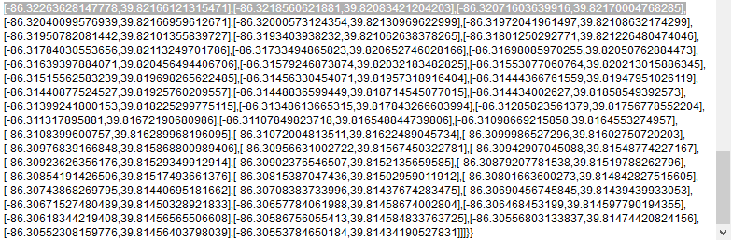

**if** (i==0)alert(**"features: "**+i+**" \n "**+***JSON***.stringify(***map_data***.**features**[i].**geometry**));

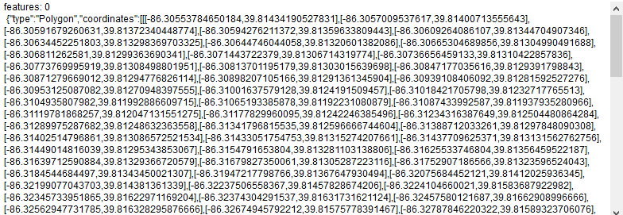

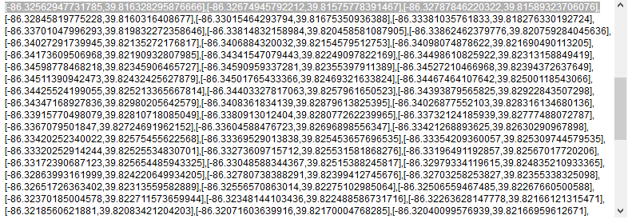

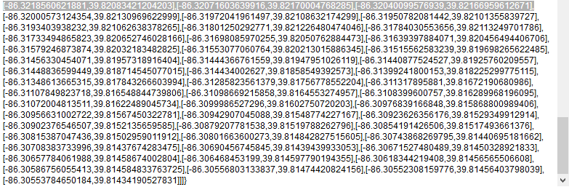

Chart libraries

<https://naver.github.io/billboard.js/demo/#Chart.StackedBarChart>

<https://naver.github.io/billboard.js/>

<https://geoviz.ceoas.oregonstate.edu/neocarto/>

Stack overflow

<https://stackoverflow.com/questions/10888958/country-boundries-using-google-map-api-v3/37092260#37092260>

<https://stackoverflow.com/questions/39106230/style-multiple-geojson-files-with-the-google-maps-javascript-api-v3-data-layer/39107656>

chrome does not update

<https://groups.google.com/forum/#!topic/google-chrome-developer-tools/gysw_3qgMMs>

**console**.log (**"heat_pfr a: \n"** + ***JSON***.stringify (***heatpfra***))

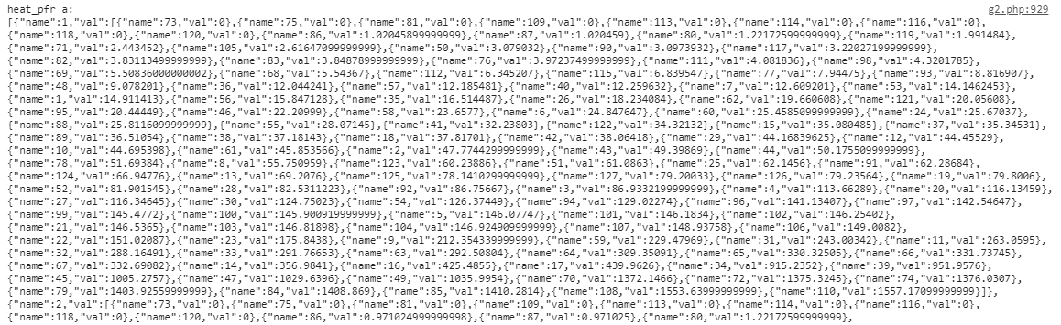

NOT SURE ABOUT THESE CHANGES

Change 1

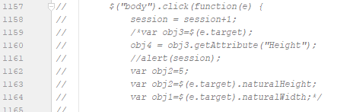

Change 2

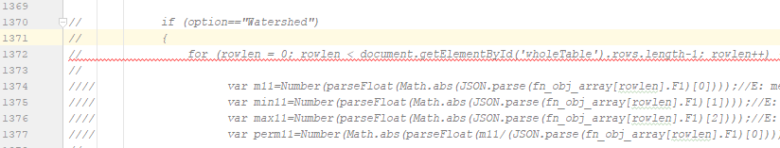

Json for polygons

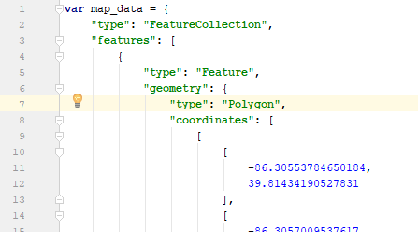

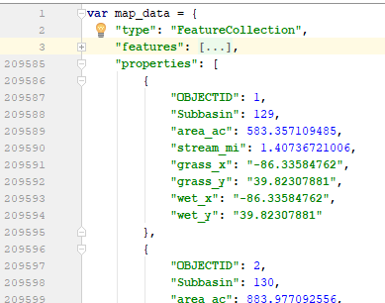

CHNAGES for Dairy McKay

1. The database (mentioned in MySQL) “takefeedback” for ecw

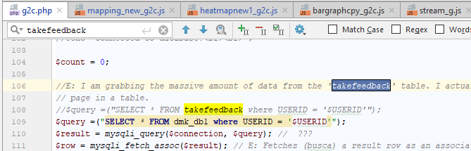

1. DATA (2 lines) L.46 L.47

Change the JSON (js) data

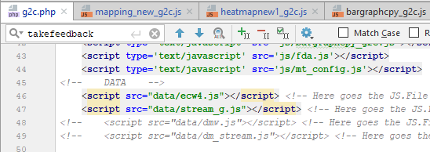

1. Map center position L.51

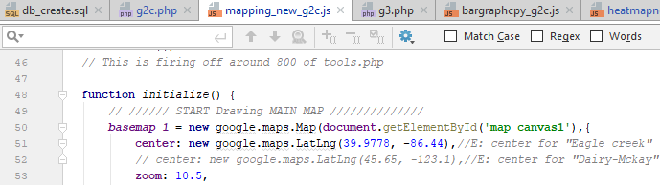

1. The type of variable “toString” (1 line) in “mapping_new_g2.js”

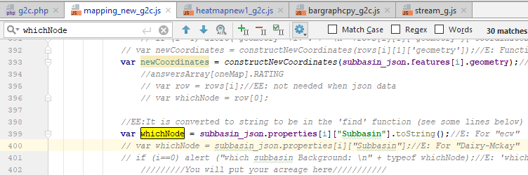

1. Change the length of “PFR_meanVals_array” from to 126 to 38 (4 times)

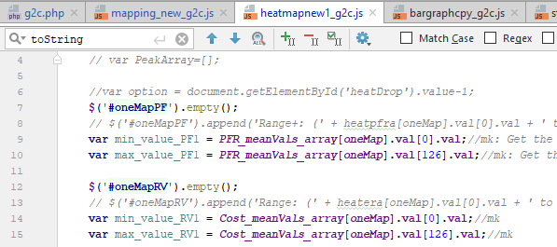

1. The type of variable “toString” (8 lines)

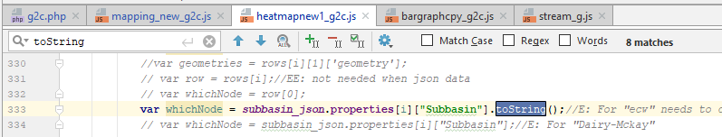

1. Make sure that json data of watershed and stream have the following characteristic:

* No “multipolygon”.
* Kip the same name of features, such as: “Subbasin”, “area_ac”, etc.

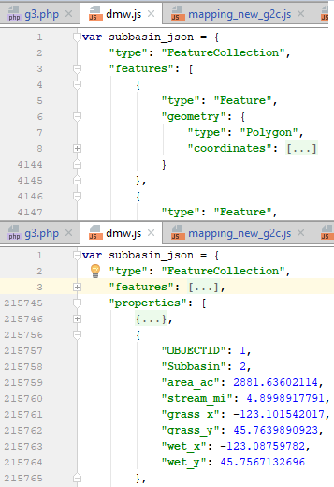 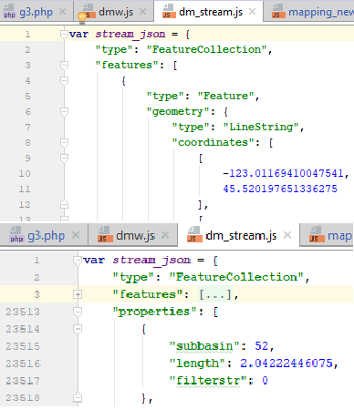

1. Dsdsasdsa

