Contents

ArcGIS.Desktop.Core.Geoprocessing 1

Overview 1

How to execute a tool – basic concept 2

Passing .Net non-string objects to ExecuteToolAsync 2

A trick to get (or visualize) correct parameter sequence 3

Supported native .NET types 3

How to execute a tool – details 4

Setting geoprocessing environment 4

Example 1 5

Example 2 5

Open a geoprocessing tool dialog. 6

Example 1 6

Example 2 6

Using the delegate GPToolExecuteEventHandler 7

Still to do 8

ShowMessageBox 8

The geoprocessing public APIs are exposed through the ArcGIS.Desktop.Core.Geoprocessing namespace in the ArcGIS Pro API Reference Guide.

The core useful methods, enumerators and interfaces for geoprocessing tasks are available in this namespace.

# ArcGIS.Desktop.Core.Geoprocessing

## Overview

You will use the ExecuteToolAsync method to run any geoprocessing tool.

## How to execute a tool – basic concept

To run (or execute) a tool, in the most case, you just pass two required (along with some optional) arguments to ExecuteToolAsync method, which are:

1. Name of the tool: tool name passed as a string and is specified as follows:

toolbox_alias.ToolName (alias and tool name are separated by a dot)

You can get the correct alias and tool name from drag-dropping a tool in Python window or from tool’s help page.

Example (python window and .Net):

Python window: arcpy.analysis.Buffer(…) or arcpy.Buffer_analysis(..)

.Net: “analysis.Buffer” // a string

1. Arguments to ExecuteToolAsync: Pass all the parameter values of the geoprocessing tool in an IEnumerable of type string. For convenience use MakeValueArray() and MakeEnviromentArray()

Make sure the sequence of parameter values of the tool matches exactly with the sequence specified in tool’s reference (help) page. You can also get the sequence by drag-dropping the tool in Python window. Or from the context menu of the tool itself:

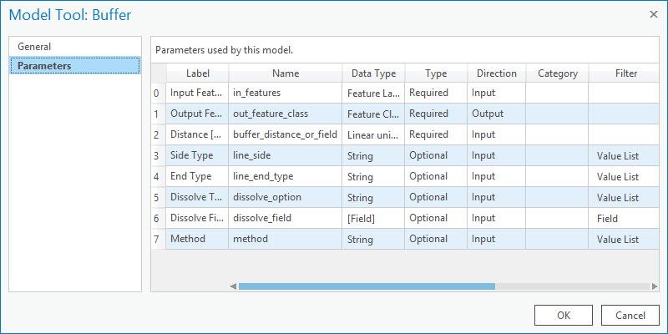

*Note*: Tool parameters are arranged on tool’s dialog as per GUI design and do not always follow the sequence specified in tool help page.

Example (python window and .Net)

Python window: input_features, out_feature_class, buffer_distance, ….

// pass values with same sequence as in Python API.

.Net: var args = MakeValueArray(“path_to_output”, “out_fc_name”, “Polyline”)

So, a call to ExecuteToolAsync will be:

Geoprocessing.ExecuteToolAsync(“management.CreateFeatureClass”, args)

## Passing .Net non-string objects to ExecuteToolAsync

In many scenarios, passing a Layer, geometry created while interacting with the map, Envelope or Extent, SpatialReference or a Table as an argument to a geoprocessing tool may be necessary. In such cases, MakeValueArray method~~, which converts such objects to string, can be used.~~

Say, we have to pass the first argument as a Layer object and the 2nd and 3rd as strings, then we can pack the arguments in a List<string> either of two ways:

1. Convert all three (one object and two strings) to parametrs at once –:

MakeValueArray(layerObject, “second_param_value”, 33)

Note:

1. MakeValueArray( var1, val2) 🡪 returns 2 parameters
2. MakeValueArray(var1, list(a, b, c) 🡪 also returns 2 parameters where second is MultiValue of a,b,c

### Supported native .NET types

The following .Net types will be supported in ArcGIS Pro 1.1:

Scalars – long, short, float, double, date, string

ArcGIS.Core.Geometry.SpatialReference

ArcGIS.Core.Geometry – point, line, polygon

ArcGIS.Core.Geometry.Envelope – supporting GP types of GPExtentEnv, GPExtent, GPEneveope

ArcGIS.Core.Data.Field – supporting GPField and list of fields for GPFieldList

ArcGIS.Desktop.Mapping – Layer, StandaloneTable

ArcGIS.Core.Data.Dataset – Table, FeatureClass

## How to execute a tool – details

Until now only the required parameters of ExecuteToolAsync is discussed. However, there are 4 optional parameters. The full syntax is:

(awaitable) Task<IGPResult> Geoprocessing.ExecuteToolAsync( string toolpath,

IEnumerable<string> parameters,

[ IEnumerable<KeyVluePair<string, string>> envs = null ],

[ CancellationToken? cancelToken = null ],

[ GPToolExecuteEventHandler callback = null ],

[ GPExecuteToolFlags flags = GPExecuteToolFlags.Default ])

Usage:

var x = await ExecuteToolAsync( …………. );

## Setting geoprocessing environment

The third parameter of ExecuteToolAsync method is an IEnumerable. You pass pair(s) of values as argument to set the environment: Use helper function MakeEnviromentArray()

This parameter is optional – if you don’t want to set any specific environment, just pass null.

var envs = MakeEnviromentArray(workspace: @"c:\temp", extent: "0 0 12 14");

await ExecuteToolAsync(“toolbox.tool”, args, envs);

Example 1: Simplest tool execution

private async Task<int> ExecuteGetCount()

{

var gp_result = await Geoprocessing.ExecuteTool("management.GetCount", new string[] { @"C:\data\Hydrants.shp"} );

int count = 0

if (!gp_result.IsFailed)

{

count = Convert.ToInt32(gp_result.Values[0]);

System.Windows.Forms.MessageBox.Show("Result : " + count);

}

ShowMessageBox(gp_result.Messages, “GP Messages”, gp_result.IsFailed ? GPMessageBoxStyle.Error : GPMessageBoxStyle.Default)

return count;

}