Actor_centrality.gephi:

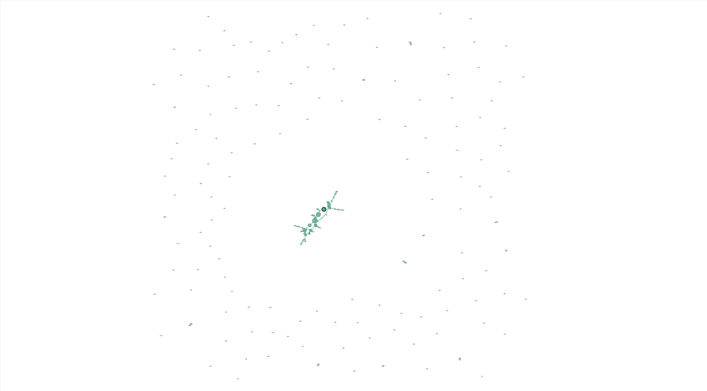

Since we took the top 250 movies, we find a huge ring of unconnected actors surrounding a large group of actors who act in many of the top 250 movies.

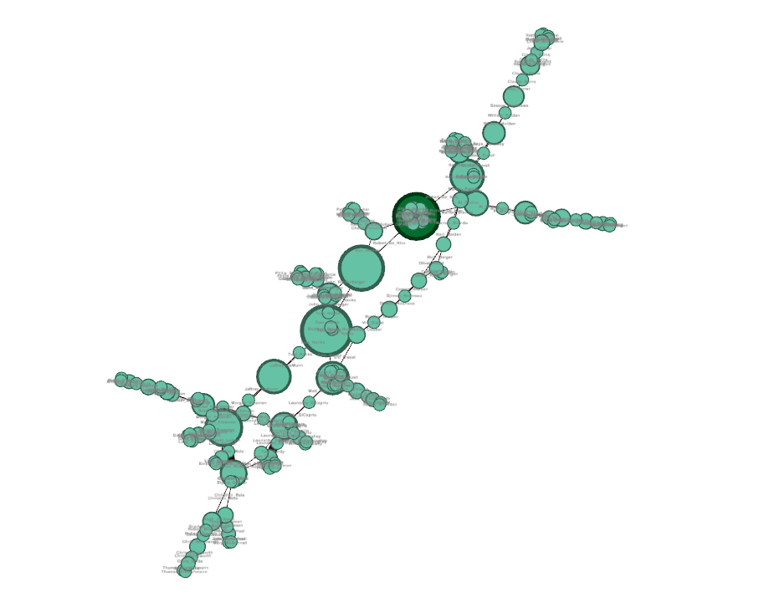

Actors in the main connection include Morgan Freeman, Leonardo DiCaprio, Tom Hardy, Christian Bale, Hugh Jackman, Scarlett Johansson, Chris Hemsworth, Brad Pitt, Robert De Niro, and Tom Hanks. This is most likely due to the superhero movies (The Avengers and its supporting films) as well as Batman and then the odd film here and there that allow them to connect to one another.