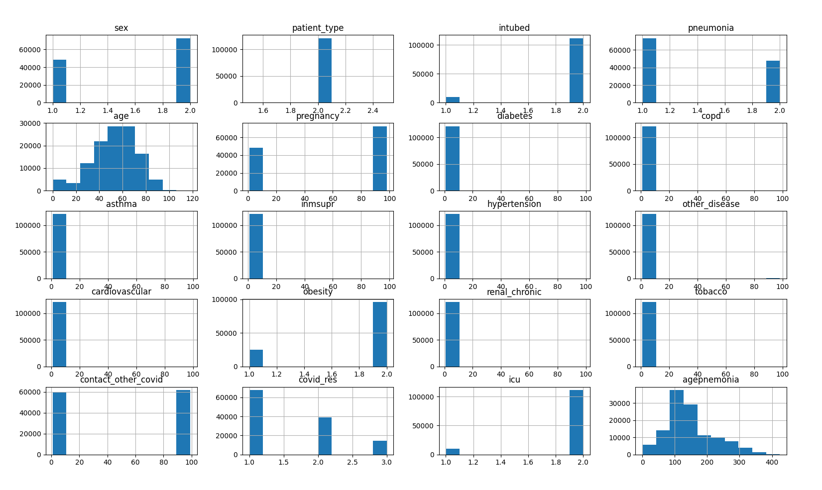

As we could see here, the undetermined covid results are too little and could be droped. I pondered on filling data points for the unspecified dslots but it meant that I would be creating data “uninfluenced” by the other factors which would hurt the model. I decided that removing the unspecified data points from covid res would reduce error without significantly decreasing the dataset we are given.